Learning Log
BMIH6002 Managing Food & Beverage Operations

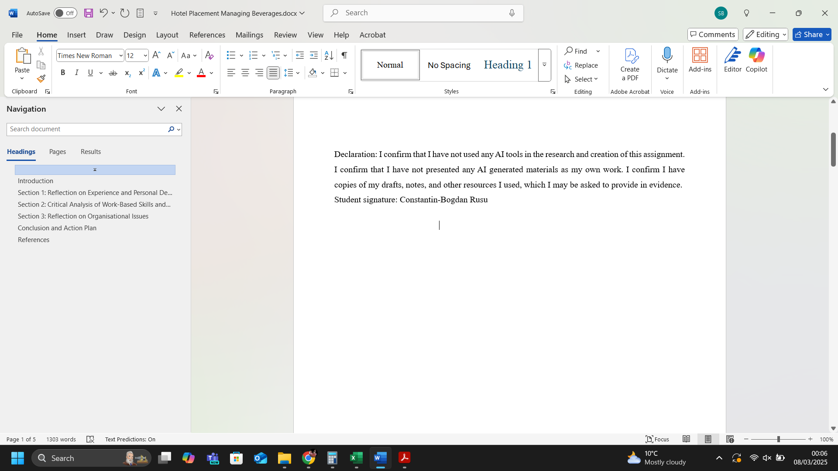

Table of Contents
Introduction 2
Section 1: Reflection ​ 2
Section 2: Critical Analysis of Work-Based Skills and Technical Knowledge ​ 4
Section 3: Reflection on Organisational Issues ​ 5
Conclusion and Action Plan ​ 5
References 6

Introduction
I completed my placement at Premier Inn Stansted Airport, where the Food and Beverage (F&B) encompasses managing breakfast services, handling customer complaints, and ensuring an overall positive guest experience. My learning objectives for the placement were as follows:
- To understand the operational aspects of the F&B department.
- To develop skills in customer service and complaint resolution.
- To gain experience in managing and participating in breakfast service operations.
- To learn about the booking system and its management.

Section 1: Reflection ​
My experience during placement will be analysed using Gibbs’ reflective cycle (Gibbs, 1988).
Description
During my placement, I had the opportunity to thoroughly understand the various operational aspects of the F&B department. This included overseeing the preparation and timely delivery of breakfast, coordinating with kitchen staff, and maintaining high standards of food quality and service. I also improved my customer service skills by effectively resolving guest complaints, improving their customer experience (Sumaneeva, Karadas, and Avci, 2021; Aksoy and Yilmaz, 2022). Furthermore, I participated actively in the breakfast service operations, gaining hands-on experience in setting up the breakfast buffet, replenishing food items, and ensuring cleanliness and orderliness in the dining area. This practical experience was invaluable in understanding the details of managing a busy breakfast service.
Feelings
At first, I found the volume of tasks and the responsibility of managing various operational aspects of the F&B department to be overwhelming. Nevertheless, as I gained a deeper understanding of the operations and received support from my colleagues, my confidence and competence significantly improved.
Evaluation
The experience of handling customer complaints was both challenging and rewarding. It allowed me to develop my problem-solving abilities and recognise the worth of efficient communication (Ogbeide et al., 2017). For example, dealing with customers’ complaints helped me learn how to address guest concerns promptly and professionally. ​
Analysis
The placement experience provided an understanding of the work-based skills and technical knowledge required in the F&B department. Teamwork was essential, particularly during breakfast service where coordination with colleagues was necessary (Salas et al., 2015). Previous academic background and industry experience also influenced the approach to tasks and interactions with guests.
During the placement, I learned various valuable skills such as handling customer inquiries efficiently, managing time effectively during peak hours, and maintaining high standards of hygiene and food safety (Cousins et al., 2019). One of the main challenges was adapting to the fast-paced environment and ensuring that every guest received excellent service despite the pressure. This experience helped enhance my problem-solving abilities and taught me the importance of maintaining a calm behaviour in stressful situations. In addition, I gained insights into the operational aspects of the F&B department, including inventory management, order processing, and menu planning. Interacting with a diverse range of guests allowed me to develop strong communication skills and cultural sensitivity, which are crucial for succeeding in a global hospitality industry (Yang, Cheung, and Li, 2022). Overall, this placement significantly contributed to my personal and professional growth, preparing me for future career opportunities in the field.
Conclusion
​Overall, the placement was a valuable learning experience. I developed essential work-based skills such as communication, teamwork, task management, and problem-solving. ​ I also gained technical knowledge essential for meeting guest service standards. ​If I were to encounter similar situations again, I would focus on proactive measures to prevent complaints, such as regular maintenance checks and staff training.
Action Plan
To further develop my skills, I plan to engage in continuous learning and development by participating in training programs (Burns, 2020) focused on advanced customer service techniques and complaint resolution. Additionally, I aim to enhance my communication skills by improving active listening (Hardjati and Febrianita, 2019) and empathetic communication through workshops on effective communication and conflict resolution (Klimecki, 2019). Furthermore, I intend to strengthen my teamwork and leadership abilities by assuming leadership roles in group projects, promoting a collaborative work environment, and supporting open communication among team members (Salas et al., 2015). Lastly, I will focus on problem-solving and decision-making by engaging in activities requiring critical thinking, reviewing past experiences, and identifying areas for improvement.

Section 2: Critical Analysis of Work-Based Skills and Technical Knowledge ​
Work-based skills such as communication, teamwork, and task management are important for meeting guest service standards. During the placement, various situations required these skills. For example, on 21st January 2025, breakfast activities included cleaning, refilling, and tidying up. This experience demonstrated the importance of maintaining a clean, organised environment for guests.
Effective communication was crucial when coordinating with team members (Ogbeide et al., 2017) to ensure that all tasks were completed efficiently and up to standard. Clear communication helped prevent misunderstandings and allowed for a smoother workflow (Ogbeide et al., 2017). Additionally, teamwork played a key role (Salas et al., 2015), as collaborating with colleagues ensured that all areas were attended to promptly and thoroughly, enhancing the overall guest experience.
I also tested my task management skills by prioritising responsibilities and effectively managing time to ensure the timely completion of duties. This not only met but exceeded the expectations of guests, contributing to their satisfaction and return visits. Moreover, handling unexpected issues, such as a sudden shortage of supplies, required quick thinking and adaptability, further showcasing the value of these essential skills in a hospitality setting.
Overall, this hands-on experience highlighted the significant impact that strong work-based skills have on maintaining high guest service standards and ensuring a positive and memorable experience for all visitors.
Technical knowledge, like understanding the booking system and managing breakfast operations, is essential for the efficient functioning of the F&B department. On January 20th, 2025, I familiarised myself with the booking system, which included registering, checking, and modifying bookings. This understanding enabled me to address guest enquiries and complaints more effectively.
By mastering the booking system, I was able to ensure a seamless check-in and check-out experience for guests, minimising waiting times, and enhancing their overall stay. Additionally, this technical expertise allowed me to efficiently update room allocations and manage overbookings, preventing potential conflicts and improving operational flow. Managing breakfast operations also benefitted from this knowledge, as I could better coordinate guest preferences and dietary needs, ensuring a pleasant dining experience. This not only boosted guest satisfaction but also contributed to positive reviews and repeat business, underscoring the significance of technical proficiency in the hospitality industry.

Section 3: Reflection on Organisational Issues ​
One critical organisational problem I encountered was related to customers' complaints about room conditions and food quality. For example, on 22nd February 2025, a couple complained about being cold in their room, the noisy heating system, and especially about the quality of food in the restaurant.
These complaints impacted the department's performance by highlighting areas that needed improvement, such as the quality of food service. Addressing these issues promptly was essential to maintain guest satisfaction and the hotel's reputation (Li et al., 2020).
To address this issue, I suggest improving the quality and variety of food offered in the restaurant. Additionally, staff training on handling customer complaints effectively can enhance guest satisfaction.

Conclusion and Action Plan ​
The main insights gained from the placement include the significance of effective communication, teamwork, and technical knowledge in the F&B department. The experience of handling customer complaints and managing breakfast operations has notably contributed to professional development.
In future professional practice, the focus will be on enhancing problem-solving skills and maintaining a high standard of guest service. Specific steps will be taken, such as participating in additional training programs and seeking feedback from colleagues and supervisors, to further develop these skills.

References
Aksoy, M. and Yilmaz, Ö. (2022) ‘Consumer complaints and complaint management in the tourism sector’. In Managing risk and decision making in times of economic distress, part a (Vol. 108, pp. 95-111). Leeds: Emerald Publishing Limited. Available at: https://doi.org/10.1108/S1569-37592022000108A034
Burns, R. (2020) Adult Learner at Work: The challenges of lifelong education in the new millenium. 2nd edition. London: Routledge.
Cousins, J., Hollier, A., Graham, D. and Foskett, D. (2019) Food and beverage management: for the hospitality, tourism and event industries. 3rd edition. Oxford: Goodfellow Publishers Ltd.
Gibbs, G. (1988) Learning by doing: A guide to teaching and learning methods. London: Further Education Unit.
Hardjati, S. and Febrianita, R. (2019) ‘The power of interpersonal communication skill in enhancing service provision’. Journal of Social Science Research, 14, pp. 3192-3199. Available at: https://doi.org/10.24297/jssr.v14i0.8150
Klimecki, O.M. (2019) ‘The role of empathy and compassion in conflict resolution’. Emotion Review, 11(4), pp. 310-325. Available at: https://doi.org/10.1177/1754073919838609
Li, H., Liu, Y., Tan, C.W. and Hu, F. (2020) ‘Comprehending customer satisfaction with hotels: Data analysis of consumer-generated reviews’. International Journal of Contemporary Hospitality Management, 32(5), pp. 1713-1735. Available at: https://doi.org/10.1108/IJCHM-06-2019-0581
Ogbeide, G.C.A., Böser, S., Harrinton, R.J. and Ottenbacher, M.C. (2017) ‘Complaint management in hospitality organizations: The role of empowerment and other service recovery attributes impacting loyalty and satisfaction’. Tourism and Hospitality Research, 17(2), pp. 204-216. Available at: https://doi.org/10.1177/1467358415613409
Salas, E., Shuffler, M.L., Thayer, A.L., Bedwell, W.L. and Lazzara, E.H. (2015) ‘Understanding and improving teamwork in organizations: A scientifically based practical guide’. Human resource management, 54(4), pp. 599-622. Available at: https://doi.org/10.1002/hrm.21628
Sumaneeva, K.A., Karadas, G. and Avci, T. (2021) ‘Frontline hotel employees’ proactive personality, I-deals, work engagement and their effect on creative performance and proactive customer service performance’. Journal of Human Resources in Hospitality & Tourism, 20(1), pp. 75-100. Available at: https://doi.org/10.1080/15332845.2020.1821429
Yang, H., Cheung, C. and Li, W. (2022) ‘Intercultural communication competency practices in the hotel industry’. Journal of China Tourism Research, 18(1), pp. 162-184. Available at: https://doi.org/10.1080/19388160.2020.1807432

