  Component One:  What are the key skills required when working in the housekeeping team? 750 words (+/- 10%)  Contribution to Overall Module Assessment: 25% | Student No: | 2214990
 | Module Title: | Operating Hotel Facilities
 | Module Code: | BMIH4006
 | Lecturer: | Lola Villard
Competencies Needed in house keeping
- The housekeeping staff at a hotel or other hospitality facility is in charge of cleaning and maintaining the guest rooms, common spaces, and other amenities. The most important qualities for this position are:
- Housekeepers need time management skills so that they may go through their work in the allowed amount of time. To do this, one must be able to organize their workload, create achievable goals, and work quickly and effectively.
- Cleaning to the highest standards requires meticulous attention to detail, which only professional housekeepers can provide. This involves spotting dirty spots, cleaning those spots, and cleaning everything else.
- Housekeepers need strong communication skills to interact with visitors, coworkers, and other hotel employees. This involves providing information in an understandable and simple style and responding to inquiries and concerns.
- Housekeepers need strong interpersonal skills and the ability to collaborate effectively with others. Cooperation, resource sharing, and constructive dispute resolution are all part of this.
- Housekeepers need to be adaptable to new situations and open to varying schedules. Working over the weekend, holidays, or at other times when travel is more difficult is a possibility(Pai et al., 2020).
Personnel reflection
My attention to detail has always been strong, and I thrive in a spotless, well-organized workplace. In addition, I am an excellent communicator and take great pleasure in team endeavours. With these qualifications, I feel I would be an asset to a cleaning staff.
When I worked as a customer service representative before, I was in charge of answering questions and addressing concerns. When dealing with challenging visitors, I learnt to be more patient, understanding, and empathic. In addition, I picked up some tips on how to talk to customers in a way that helps you find solutions to their problems. In a cleaning position, these abilities would be useful since I'd have to deal with visitors' concerns about the cleanliness of their rooms(Tra, 2020).
Case Studies in Related Industries
The Ritz-Carlton's cleaning staff has a stellar reputation for thoroughness and friendliness. Team members have extensive backgrounds in the industry and share a passion for giving visitors a memorable stay. The staff use cutting-edge detergents and vacuums to give the hotel a spotless appearance throughout. The team also takes great pride in its customer service, and its members will go above and beyond to ensure that each and every client is completely happy(Lin et al., 2017).
Practical Experience and Conceptual Understanding
My education in hotel management has prepared me with the theoretical understanding that will be useful in a housekeeping position. In this course, I studied the various cleaning chemicals and equipment utilized in the hospitality business, as well as the significance of maintaining a clean and sanitary environment for guests. In addition, I have improved my abilities in talking to others, working in a group, and solving problems. I'm certain that I'll be able to put my theoretical understanding to good use and make a valuable contribution to the cleaning crew. I'm excited to broaden my horizons and get experience in this field. In addition, I'm thrilled to be joining a group of hardworking experts that share my passion for giving visitors nothing but the best(Jones et al., 2019).
The Role of the Subject in the Hospitality Sector
The hotel business would not function without the housekeeping staff. They are in charge of maintaining a spotless and pleasant atmosphere for visitors, which may have a major bearing on their level of pleasure. Guests will get a better impression of the hotel and have a better time if it is clean and well-kept. The cleaning staff's efforts don't end with providing a clean and pleasant space; they also contribute to visitors' security. The housekeeping staff may aid in stopping the transmission of germs and bacteria by keeping common areas clean and disinfected. This may reduce the likelihood of visitors becoming ill, which can boost satisfaction and repeat business. In the hotel business, the cleaning staff plays a crucial role. They are crucial to the success of a hotel, since they ensure the comfort and safety of guests and keep the premises spotless(Friberg and Midtbøen, 2017).
Housekeepers need not just the aforementioned qualities, but also an understanding of the many tools and supplies utilized in the cleaning profession. They need to be able to observe all necessary precautions and rules. In the hotel business, housekeepers are essential. They are in charge of maintaining a spotless and pleasant atmosphere for visitors, which may have a major bearing on their level of pleasure. Guests will get a better impression of the hotel and have a better time if it is clean and well-kept(Stone and Bryant, 2019).

Word Count | 760 words

Component Two:
Contribution to Overall Module Assessment: 25%
In this scenario – You have just been promoted to team leader for a floor within the hotel. A guest complains that on their arrival, their room had not been properly cleaned. Create an action plan and answer the following questions.

Problem | Why did it happen? | What are you going to do? | How will you prevent this from happening in the future? | What measures would you introduce to improve team effectiveness?
Issue 1: Room not properly cleaned upon guest arrival | A potential miscommunication between housekeeping and front desk staff may have resulted in an unclean room being assigned to a guest. Staff scheduling might be an issue if the room was not serviced due to an inadequate number of staff at the time. | The immediate priority would be to apologize to the guest, assure them we take their feedback seriously, and swiftly assign them to another room, ensuring it has been properly cleaned. The previously assigned room should be cleaned immediately(Hu, X., Yan, H., Casey, T. and Wu, C.H., 2020). | Regular and precise communication between front desk and housekeeping staff is crucial. Implementing a reliable system to track room statuses (cleaned, uncleaned, under maintenance, etc.) would help prevent such instances. Appropriate staff scheduling is also necessary to ensure adequate coverage at all times. | Implement regular training sessions for all staff to stress the importance of communication and attention to detail. Introduce a rewards system for employees who consistently perform well to incentivize excellent service.
Issue 2: Guest dissatisfaction with cleanliness standards | The cleaning standards might not have been up to the guest's expectation due to lack of attention to detail, or a lack of training among housekeeping staff. | Assign a senior member of housekeeping staff to review the room's cleanliness. If the complaint is valid, correct the issue immediately and inform the guest. Offer some form of compensation as an apology, such as a complimentary meal. | Regular refresher training sessions on the hotel's cleaning standards and expectations can be conducted. Increase inspections to ensure all rooms meet the required standards. | Feedback sessions can be held post inspections, to discuss and learn from any identified mistakes, and to praise well-performing staff members.
Issue 3: Guest's perception of poor hygiene practices | Lack of visible hygiene practices may lead guests to assume that the hotel isn't paying enough attention to cleanliness and sanitation. | Immediately reassure the guest that the hotel takes hygiene and sanitation very seriously. Offer a complimentary room cleaning service at a convenient time for the guest(Goh and Kong, 2017). | Implement visible signs of cleanliness practices like use of gloves and masks, and display cleaning checklist cards in rooms post-cleaning. Regular audits should be conducted to ensure compliance Hu, X., Yan, H., Casey, T. and Wu, C.H., 2020). | Regular training on hygiene practices is essential. Also, instill in the team the understanding that these practices are as much for the safety of the staff as they are for the guests.
Issue 4: Inconsistencies in cleaning quality | This could occur due to a lack of standardised cleaning protocols, or variations in the skills and dedication of individual staff members(Lam et al., 2018). | Assign a senior housekeeper to review and correct the cleaning inconsistencies. Apologize to the guest, offering them a small compensation for the inconvenience, such as a room upgrade or a complimentary service. | Implement standardised cleaning protocols, and ensure they are uniformly adhered to. Regular inspections can help enforce standards. | Encourage teamwork by assigning housekeeping staff to work in pairs or small teams, promoting peer learning and helping to standardize cleaning
Issue 5: Missed areas during cleaning | This can occur due to insufficient training or the absence of a detailed cleaning checklist. Staff might be rushing to clean multiple rooms, thereby overlooking some areas. | The overlooked areas should be cleaned immediately once the issue has been raised. Apologize to the guest and offer some form of compensation. | Introduce a comprehensive cleaning checklist for housekeeping staff to ensure all areas are cleaned. Make sure staff are scheduled effectively so they aren't rushed and can clean rooms thoroughly(Koulieris et al., 2017). | Review and update the checklist regularly with input from the team, fostering a sense of ownership and accountability. Organize training sessions on effective time management.
Issue 6: Inadequate cleaning supplies or faulty equipment | This could happen due to poor inventory management, or failure to promptly report or replace faulty cleaning equipment. | Immediately provide housekeeping staff with necessary cleaning supplies and replace any faulty equipment. Make sure the room is thoroughly cleaned and offer an apology to the guest(Whiting and Symon, 2020). | Regular inventory checks and timely replacement of faulty equipment should be standard protocol. All staff should be trained to report any issues immediately. | Introduce a system for staff to easily report issues related to supplies or equipment(de Kervenoael et al., 2020).

Component Three:
Contribution to Overall Module Assessment: 50%
Your task is to create and prepare a presentation following the detailed scenario provided below.

As the floor housekeeping manager and given the recent guest complaints you need to put together a basic training presentation for your colleagues within the housekeeping team to get the best out of them, ensure that brand standard is being achieved and that Health and Safety procedures are also being followed.

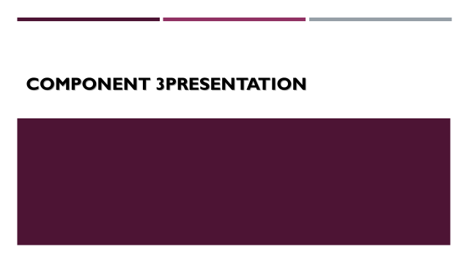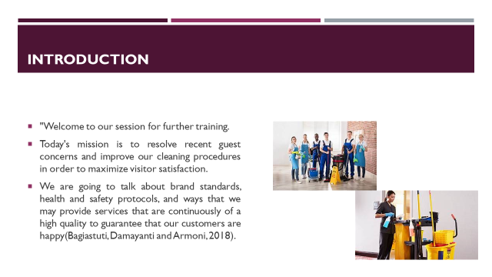

Training Notes: In light of recent comments from guests, it is crucial that we review our current standards and policies. The purpose of this meeting is to review company policies, clarify health and safety protocols, and brainstorm ways to enhance our current offerings. Since this is a group effort, your involvement and suggestions are welcome and encouraged.
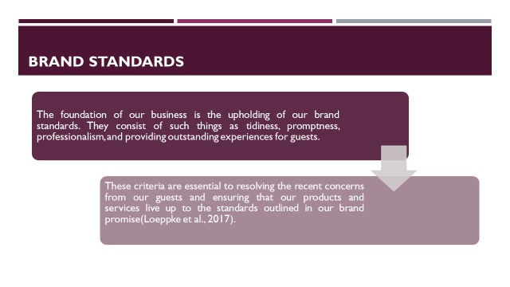

Training Notes: Maintaining brand integrity is crucial to the success of our hotel. We must maintain an exceptionally high standard of tidiness, promptness, and cordial discourse. These guidelines should serve as a touchstone for all interactions with guests, helping us constantly provide services that not only meet but exceed client expectations and speedily handle concerns.
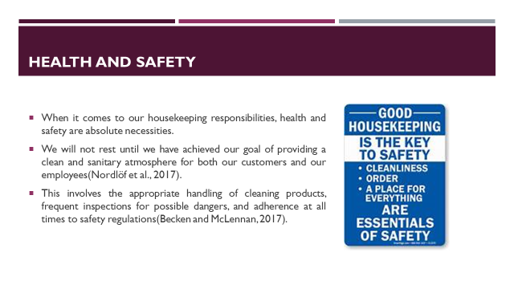

Training Notes: When it comes to keeping guests happy and cutting down on complaints, health and safety take first. Safety measures, such as the proper use of cleaning supplies, the detection and correction of dangers, and a spotless environment, have a direct bearing on the level of satisfaction of visitors. Our core value is on maintaining a clean and secure space for all of our customers.
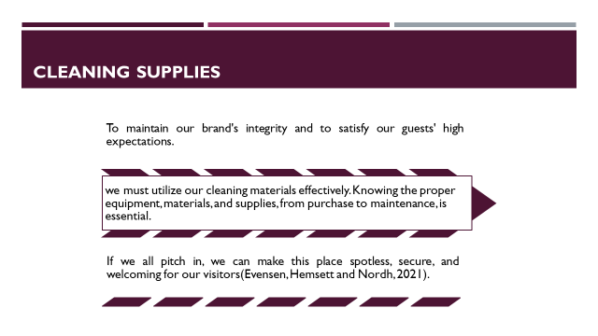

Training Notes: Maintaining a clean and secure environment relies heavily on cleaning products. Selecting the appropriate tool for the job at hand, using it properly, and stowing it away securely are all crucial steps. By perfecting them, we can respond appropriately to guest concerns about cleanliness while maintaining consistent brand standards and pleasing our clientele.
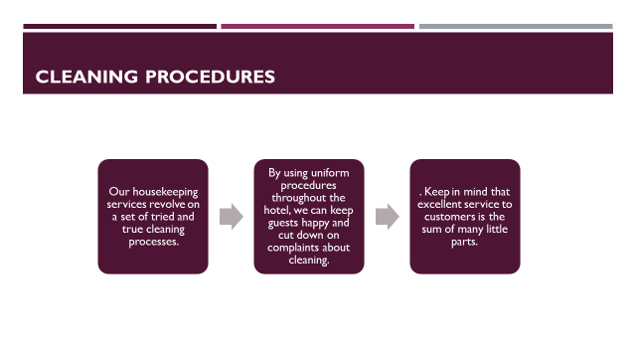

Training Notes: Cleaning practices that are standardized guarantee uniformity and consistency across the hotel, which allows for more efficient resolution of concerns related to cleanliness. These restrictions apply to all places, including the guest rooms as well as the communal areas. By adhering to these practices in a conscientious manner, we respect the values of our brand, create a clean and pleasant atmosphere, and considerably increase the happiness of our guests.

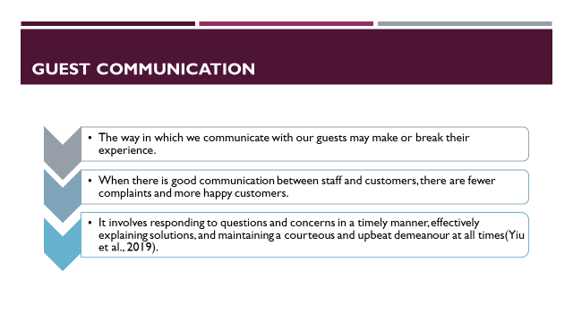

Training Notes: Effective guest communication is vital in hospitality. Responsiveness to inquiries, clarity in providing solutions, and maintaining a respectful, positive tone are essential. Through these actions, guest satisfaction can increase and complaints decrease. Every interaction is an opportunity to improve guest experience and uphold brand standards.
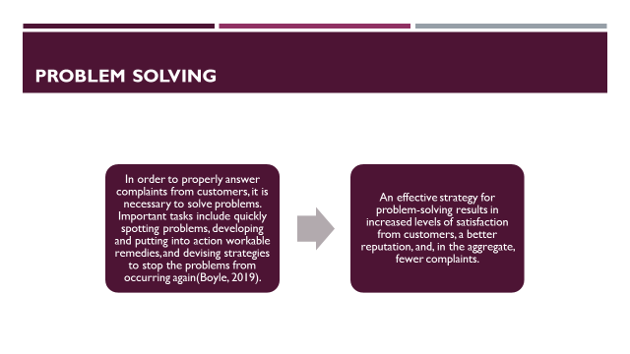
Training Notes: Effective problem-solving is a major factor in maintaining happy customers. Timely problem identification, efficient application of fixes, and avoidance of recurrence all play a part. Adopting such measures may dramatically minimize the frequency of guest complaints, which in turn strengthens brand standards and improves the property's image.
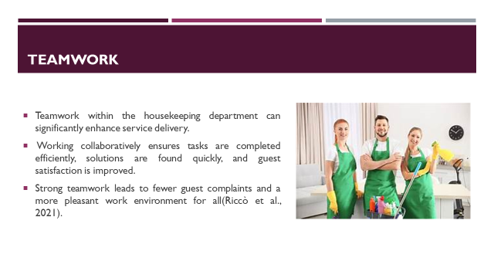

Training Notes: The success of every cleaning service depends on the strength of its teams. Working together effectively guarantees timely issue resolution and first-rate service for customers. This leads to fewer complaints from customers, consistent representation of the brand, and improved morale in the workplace.
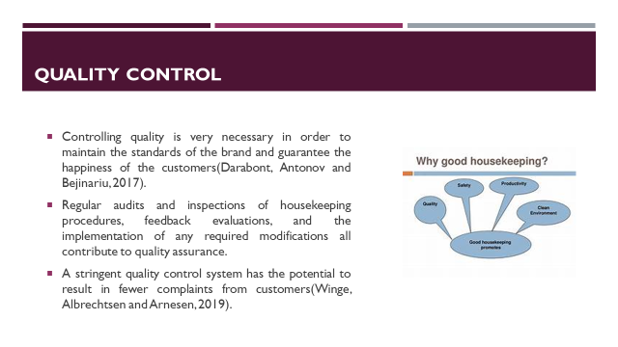

Training Notes: A high-quality control system may do wonders for the satisfaction of your guests. This entails keeping an eye on housekeeping practices, listening to what people have to say, and making adjustments as needed. Consistent quality assurance reduces visitor complaints, which is good for both the brand and the property's image.
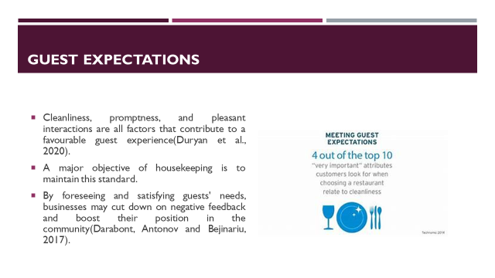
Training notes : Understanding guest expectations is a crucial part of service delivery. Expectations include a clean environment, prompt service, and respectful interactions. By meeting and exceeding these expectations, housekeeping can directly influence guest satisfaction, minimize complaints, and ensure adherence to brand standards, all contributing to the establishment's reputation.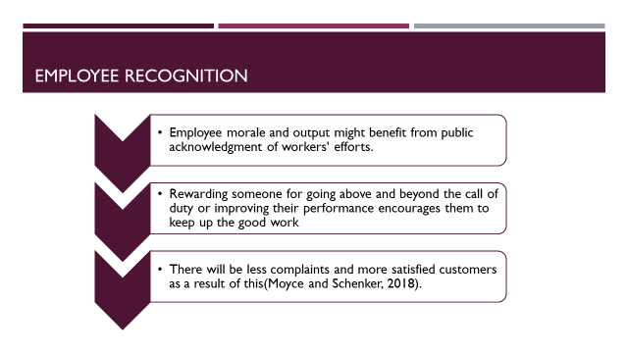

Training Notes: One of the most effective ways to motivate workers is to publicly acknowledge their efforts and successes. Motivating the team to do their best via praise for job well done is essential to their success. When employees feel valued and appreciated, they are more likely to provide excellent service to guests, which in turn reduces negative feedback and ensures the brand's integrity.

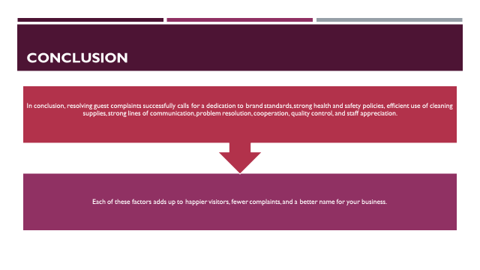

Training Notes: In conclusion, this training shed light on crucial points to concentrate on to lessen guest complaints and maintain brand values. The establishment's reputation and customer satisfaction may both benefit from adopting the aforementioned procedures. Keep in mind that your efforts in every given function are integral to the success of the whole.

References

de Kervenoael, R., Hasan, R., Schwob, A. and Goh, E. (2020). Leveraging human-robot interaction in hospitality services: Incorporating the role of perceived value, empathy, and information sharing into visitors’ intentions to use social robots. Tourism Management, [online] 78, p.104042. doi:https://doi.org/10.1016/j.tourman.2019.104042.
Dill, J.S. and Morgan, J.C. (2017). Employability among low-skill workers: Organizational expectations and practices in the US health care sector. Human Relations, 71(7), pp.1001–1022. doi:https://doi.org/10.1177/0018726717734035.
Friberg, J.H. and Midtbøen, A.H. (2017). Ethnicity as skill: immigrant employment hierarchies in Norwegian low-wage labour markets. Journal of Ethnic and Migration Studies, 44(9), pp.1463–1478. doi:https://doi.org/10.1080/1369183x.2017.1388160.
Goh, E. and Kong, S. (2017). Theft in the hotel workplace: Exploring frontline employees’ perceptions towards hotel employee theft. Tourism and Hospitality Research, 18(4), pp.442–455. doi:https://doi.org/10.1177/1467358416683770.
Hasanzadeh, S., Esmaeili, B. and Dodd, M.D. (2017). Impact of Construction Workers’ Hazard Identification Skills on Their Visual Attention. Journal of Construction Engineering and Management, 143(10), p.04017070. doi:https://doi.org/10.1061/(asce)co.1943-7862.0001373.
Hu, X., Yan, H., Casey, T. and Wu, C.H., (2020). Creating a safe haven during the crisis: How organizations can achieve deep compliance with COVID-19 safety measures in the hospitality industry. International Journal of Hospitality Management, [online] p.102662. doi:https://doi.org/10.1016/j.ijhm.2020.102662.
Jones, K., Berry, C., Rouse, J. and Whittle, R. (2019). Universal Credit and In-Work Conditionality – a productive turn? [online] e-space.mmu.ac.uk. Available at: https://e-space.mmu.ac.uk/id/eprint/624221.
Koulieris, G.-A., Bui, B., Banks, M.S. and Drettakis, G. (2017). Accommodation and comfort in head-mounted displays. ACM Transactions on Graphics, 36(4), pp.1–11. doi:https://doi.org/10.1145/3072959.3073622.
Lam, W., Lee, C., Taylor, M.S. and Zhao, H.H. (2018). Does Proactive Personality Matter in Leadership Transitions? Effects of Proactive Personality on New Leader Identification and Responses to New Leaders and their Change Agendas. Academy of Management Journal, 61(1), pp.245–263. doi:https://doi.org/10.5465/amj.2014.0503.
Lin, P.M.C., Kim, Y., Qiu, H. and Ren, L. (2017). Experiential Learning in Hospitality Education Through a Service-Learning Project. Journal of Hospitality & Tourism Education, 29(2), pp.71–81. doi:https://doi.org/10.1080/10963758.2017.1297716.
Pai, A., Manjunath, M., Kowshik, C.S.S., Ayedee, N., Malarout, N. and Naik, N. (2020). SOFT SKILLS AS A KEY COMPETENCY FOR THE FUTURE LEADERS OF THE HOSPITALITY INDUSTRY. PalArch’s Journal of Archaeology of Egypt / Egyptology, [online] 17(9), pp.4341–4355. Available at: https://archives.palarch.nl/index.php/jae/article/view/4607.
Stone, R.I. and Bryant, N.S. (2019). The Future of the Home Care Workforce: Training and Supporting Aides as Members of Home‐Based Care Teams. Journal of the American Geriatrics Society, 67(S2), pp.S444–S448. doi:https://doi.org/10.1111/jgs.15846.
Tra, T. (2020). Action plan for training new Housekeeping Employee : case: Hotel Indigo Helsinki. [online] www.theseus.fi. Available at: https://www.theseus.fi/handle/10024/343779.
Whiting, R. and Symon, G. (2020). Digi-Housekeeping: The Invisible Work of Flexibility. Work, Employment and Society, p.095001702091619. doi:https://doi.org/10.1177/0950017020916192.
Williams, J. and Multhaup, M. (2018). For Women and Minorities to Get Ahead, Managers Must Assign Work Fairly. [online] Available at: https://cacwa.org/wp-content/uploads/2022/09/ForWomenandMinoritiestoGetAheadManagersMustAssignWorkFairly-1.pdf [Accessed 12 Jun. 2023].

