A written assignment critically evaluating how Assessment for Learning can be utilised in a series of learning opportunities to aid progression across chosen areas of learning and experience.

Introduction

Assessment for learning (AFL) strategies are used in schools and learning opportunities all across the world. Assessment for learning has been defined as ‘assessing a student’s comprehension and understanding of a skill during the learning and teaching process’, employing effective AFL in class can lead to the equivalent of 8 months of extra learning. AFL is a method of “new style assessment”, which encourages teaching and learning to occur simultaneously with assessment. It is believed that using new style assessment can lead to improved attainment and achievement, as well as improved productivity and an increased sense of motivation (Hawthorne, 2018). There are four key elements to assessments for learning, these include.
- Sharing criteria with learners
- Quality of questions/Quality of talk
- Peer and Self-assessment
- Use and quality of feedback

By sharing lesson criteria with students, they can take greater control over their learning, and it can also help teachers plan for future lessons (Sheikh, N.D). Quality of talk encourages students to think for themselves. High quality talk can encourage more than just recall, it encourages children to think about how and why. It is important to then build upon this discussion rather than just receive it (University of York, 2017). During my time completing my placement in a primary school, I have utilised a lot of peer and self-assessment in my plenaries as an AFL strategy, typically through the use of ‘traffic lights’ or ‘2 glows and a grow’, which was extremely successful as it, like the University of York states, encourages students to build upon and reflect upon their work. Good quality and timely feedback are key features for enabling effective feedback according to (Crook, et al., 2011). Effective feedback will allow students to reflect on their learning and they can then adapt their work to further improve.

Second to consider, is progression in learning, this is a state of increasing difficulty and complexity in acquiring knowledge and skills (International Bureau of Education, N.D). I’ve seen how beneficial

progression in learning can be and has been incorporated effectively during my professional teaching experience (PTE). I would often have topics that would last throughout the week, beginning with introductory lessons, continually progressing until the last lesson of the topic which would be much more complicated than the first. Progression in learning allows for children to practice and develop their skills whilst building on prior knowledge (Twinkl, 2021), this belief can be linked to the cyclic curriculum model developed by D.K. Wheeler in 1967, in the way that it continuously builds upon and revisits prior knowledge.

During this written assignment, I will be using my experience during PTE to evaluate assessment for learning strategies. But first it is important to understand the context where learning occurred. My PTE occurred in a mixed year ¾ class in an English medium primary school. Since the class were mixed, a big challenge, I had to overcome was to include effective differentiation in all of my lessons, since I had such a range of ability groups in my classroom. Further contexts of my previous experience of learning opportunities can be seen during my first PTE where I was placed in a reception class, so as you can imagine both of these experiences are extremely contrasting, however PTE 1 gave me great experience in dealing with children, as well as lesson planning and being a part of the school setting. I’ve also gained invaluable experience in working with children, by working in a summer camp in the USA, as well as through coaching a Under 8’s rugby team.

During PTE I incorporated a range of learning experiences, all of which were extremely effective. These include, digital learning, using iPads and chrome books to research into different topics, taking learning outside to complete a timeline where the students had to find the dates scattered around the yard. My lessons would often fall in the morning where I would be allowed to take the whole morning to complete my lessons, and then the afternoon would be taken up by Christmas concert practice’s or my class mentor’s lessons, working this way was extremely effective and allowed me to gain the experience I needed whilst also allowing me time to continue observing lessons. Which I greatly appreciated as it allowed my own continuous learning to occur. As part of my lessons, I wanted to include a lot of information about diversity and what makes us unique, since this was the school’s theme at the time. This can be seen as I carried out lessons researching Martin Luther King jr, art around the world and even incorporated diversity into a mathematics lesson on tally charts and bar graphs.

Literature Review

Paul Black and Dylan William have been dubbed the grandfathers of AFL (Cox, 2022). Black and William were responsible for developing the theory of the ‘Black Box’, a theory which viewed the classroom as a ‘black box’. Before this, the main focus of a classroom was input and output, seen as summative assessment, however, there is much more of an emphasis on what goes on inside the classroom, formative assessment, or AFL (Teaching Expertise, 2012). The aim of formative assessment is to observe student learning and then provide continuous feedback that can be used by students to progress their learning (Eberly Center, N.D).

The use of formative assessment has produced very high growth academically, however, these gains are exponentially higher for lower ability students, and in my experiences I agree. Within my classroom, I saw my lower ability students take huge leaps academically, especially within mathematics and literacy. A second benefit is how formative assessment builds students’ actual ability to learn. This is because formative assessment includes students in the process of learning, through the use of peer and self-assessment (OECD, 2005), requiring them to analyse their own work and evaluate what they’ve produced.

We cannot consider the benefits of formative assessment without also considering the same for summative assessments. This kind of assessment can motivate students to revise outside of the classroom. Which I observed as my class mentor would carry out spelling tests, which students would revise for. Summative assessments can also help teachers find gaps in learning and therefore plan future lessons accordingly (SplashLearn, 2022). However, there are downsides to the use of summative assessments, these could include demotivating students who perhaps don’t perform well, they could also cause angst and stress for students. Thirdly, is the fact that this mode of assessment isn’t suitable for all students since some students simply don’t test well (Mezni, 2020), and their actual understanding may not be assessed.

In order to further evaluate the use of formative assessment we must also consider its limitations. One of the biggest limitations of formative assessment is actually the skill of the teachers, there is still a huge emphasis on the teacher’s ability to implement formative assessment in their classrooms. One piece of literature stated that 80% of reviewed papers claimed that teacher knowledge was the most important barrier to effectively employing formative assessments in schools. Other challenges to formative assessment included, teacher beliefs and time constraints, which was observed in 33% of the reviewed papers (Queyen & Khairani, 2017).

“Proposal 7 – Good teaching and learning means employing assessment for learning principles” – (Donaldson, 2015)

In his 2015 report Professor Graham Donaldson proposed that for effective teaching to take place then assessment for learning must be incorporated. Donaldson then goes on to explain that AFL includes regular and meaningful feedback. Black and William share this ideology as they state, “Discussions in which pupils are led to talk about their understanding in their own ways are important to increasing knowledge and improving understanding” (Black & William, 1998). Black and William then go on to discuss the issues that surround the use of summative assessments, these include the limitations of marking, and how it often fails to offer guidance, meaning students often do not use their feedback effectively. When the study was released in 1998, the pair reported that AFL practices were promoted however they were not common, thankfully, this is no longer the case since I observed AFL strategies utilised frequently.

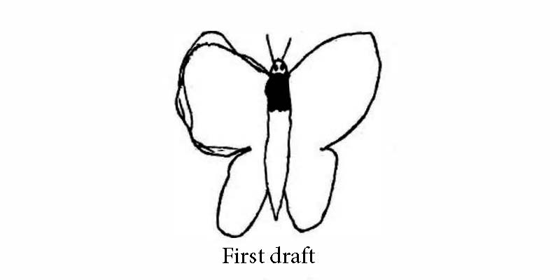
Another piece of literature that further supports the use of discussion as a form of feedback, is the case study of Austin’s butterfly. Austin was a student from Idaho, USA who had to create a scientific drawing of a butterfly. For his first draft he simply drew a butterfly from memory (See below). Then he received peer-led advice from his class, after creating 4 more drafts, he finished on an extremely impressive final draft (See below). The key to the success of peer feedback is constructive and specific feedback. Students in the video can be seen offering extremely specific feedback for example “have longer wings”, as well as “the wings need to be more like a triangle” (Berger, 2015).The study indicates how as teachers we are often unaware of the ability of our children, and may need to challenge our students further. However, one limitation of implementing this type of peer led feedback is how time consuming it could be. For this piece of work it took 6 drafts each with a critical discussion on how to improve for the next, however it is clear to see how effective it has been, by looking at the progression in the work.


- Berger, 2015

Another useful tool that teachers can use to improve the incorporation of AFL strategies in classrooms is the use of Bloom’s Taxonomy as a questioning strategy. During my time on PTE, we used a self-assessment AFL strategy, where students would have to classify and describe what skills, they had used from Bloom’s taxonomy. Blooms describes cognitive learning in six levels, these are.
  - Knowledge
  - Comprehension
  - Application
  - Analysis
  - Synthesis

It shows the accuracy of Bloom’s taxonomy that he developed the theory in 1956 and it is still used in educational settings to this day (York College, N.D.) and is still an incredibly useful resource to schools.

Dr. Richard Elmore developed the theory of the ‘instructional core’. This model helps identify the correlation between teacher, students and the content covered in lessons, the aim of the model is to ensure that student learning is continuously improving. This is achieved by increasing the level of engagement, increasing difficulty, and continually improving the skill that the teacher brings to the classroom (Department of Education and Training, N.D.).

AFL can provide opportunities to continuously progress learners, and this is achieved by analysing and recording evidence (student’s work) as it occurs. This then ensures that any evidence that can aid progression is not lost and can therefore have an impact on learning in the future. An extremely effective way that AFL strategies can be incorporated is alongside Vygotsky’s ‘zone of proximal development’ (ZPD). The zone of proximal development is the area of learning between what a student can do themselves and what they can do with assistance (Vygotsky, 1978). The teacher’s role is to foster the relationship between AFL and the ZPD, it is necessary to maintain and enhance learner’s responses and then continually monitoring students in order to optimise support or decide when to withdraw support (Martin, N.D).

Discussion of Lesson Planning Decisions

During this third section of the essay, I will be discussing and evaluating the decision-making processes leading up to the lessons I employed during my time on PTE as well as the assessment for learning strategies I used to enhance these learning opportunities. The theme of the three lesson plans were all centred around “Diversity: What makes us unique”. This was our theme as a school and we even carried out an “EPIC day: Everyone Planning in Class”, on this day students spoke about lessons that they wanted to do in their classes and then during our EPIC day, students would rotate throughout the day going to different classrooms and completing lessons all about diversity, that they chose.

Lesson 1: See Appendix 1

LO – Can I investigate a topic of my choice, then create a bar graph

This was a lesson about creating tally charts, groups would have to decide on a topic, for example “Year 3/4 ‘s favourite movies” or “How do class 3/4 get to school”. The students then would have to go around the class and discover information about their fellow students relating to the chosen topic. This lesson was focused on the mathematics and numeracy AoLE ‘, specifically looking at the What Matters Statement that states ‘the number system is used to represent and compare relationships between numbers and quantities’ (Welsh Government, 2022). In order to ensure cross-curricular responsibilities are met this lesson also placed a large emphasis on languages, literacy, and communication, since students had to communicate thoroughly in order to discuss and discover the necessary information. The purpose of this lesson was to develop the students’ ability to create and understand tally charts and bar graphs, as well as their ability to work as a group to achieve the lesson objective. A further aim was to give the learners opportunities to investigate the theme and what makes us unique and to understand our differences.

The first AFL strategy that I utilised was the ‘secret notes strategy’. This strategy gets students to write down their ideas, before folding the paper, walking around the room, and swapping their ideas with other students in the class. For the purpose of this lesson, students had to write down ideas about what they could research.

This AFL strategy worked well since it encouraged extremely high student engagement, and also allowed for great discussion to take place, since as a group students would then have to decide on which idea, they thought was best. Since we used a lot of pupil voice during this lesson it meant students completed the task extremely accurately and student engagement was high. However, this AFL strategy is not suitable for every lesson. For questions/lessons where there are definitive answers there are much more suitable and time efficient strategies, for example the use of Whiteboards. ‘Secret notes’ is instead much more effective for lessons which include ideas and discussion points.

‘Secret notes’ allows opportunities for group work to occur (Carnegie Mellon University, n.d.) which in itself has multiple benefits. Group work can improve understanding through discussion, I encouraged the students to come up with discussion points on why their idea should be chosen before allowing them to argue their points.

In the plenary of this lesson, I decided to incorporate a traffic light-based AFL strategy. The way I used this strategy is as follows, students would glue in one of our traffic lights sheets (See appendix 2) and then colour in either green, yellow or red. Green meant the students understood the task, yellow meant they needed some support and red meant they didn’t understand the task at all. By using traffic lights in this way, it can be a very effective way of showing pupil progression throughout the course of learning sessions (Thompson, n.d.), after session 1 pupils may show red or yellow hopefully after revisiting the topic hopefully, we’ll see progression to green. However, not everyone agrees on the effectiveness of traffic lights as an AFL strategy. One key downside of this AFL strategy is that students may not be completely honest when completing their traffic lights. This can be caused by a range of reasons, such as, pressure from peers, or as a means to show unfavourable behave towards the teacher (Dabell, 2019).

Lesson 2: See Appendix 3

LO – Can I research and discover key dates in Martin Luther King Jr.’s life?

This lesson was a humanities lesson centred around Martin Luther King Jr. and his life, in group’s I would take students to the library, and there they would use iPads to research key dates in his life. Clearly, the main aim of the lesson was to discover information about Martin Luther King Jr. However, I also wanted to improve the student’s capability to use digital means of education. In order to support me with my planning for this lesson I used the digital competence framework (DCF). Progression Step 2 of the DCF states “I can develop strategies for finding specific information/media using different techniques and keywords” (Welsh Government, 2016). By using technology in classrooms, it can provide new opportunities to students with low socioeconomic backgrounds, who may not have technology available to them, the use of technology can also increase student motivation (Erasmus, n.d.) since it is a different and new method to education.

This lesson had clear links to our theme of diversity since Martin Luther King Jr. was so prominent in the civil rights movement in America. As a teacher, this lesson provided some challenges such as enabling effective differentiation, which I believe I was able to successfully incorporate, completing it as groups did help with this. Secondly, it was difficult to gauge how much support each student needed since their prior experience with technology differed so much so the typical ability groups that we utilised in the classroom were almost made obsolete.

One AFL strategy that I implemented was ‘snowballing’. During this strategy students would be given time to first think individually about what they already know about MLK, then to working as pairs, then groups, before combining two groups together, before discussing it as a whole class. Group and paired work like this can promote interaction between students who do not usually work together, encouraging new ideas to be shared, as well as encouraging input from students who may be reluctant to share during whole class activities (Marr & Morgan, 2005). I can definitely agree with these findings from Marr and Morgan however, when carrying out this strategy again I would leave out the whole class discussion since I found that some students would begin to withdraw during this part of the strategy, as they didn’t know who to speak to or how to speak to their fellow classmates and became a overwhelmed. Another way to get around this could be to implement prompts on the whiteboard to help the students with what to speak about.

During the plenary of the lesson, I incorporated ‘exit cards’ AFL strategy (see appendix 4). Students would each have a piece of scrap paper and would write down something that they learnt during the lesson. This worked well as it allowed me to collect information about student ability and progression (Main, n.d.), which in turn allowed me to plan for future lessons as well as gaining an understanding as to who needed more support during my lessons. Contrarily, I found that a downside of exit cards is that sometimes the time constraints of the lesson, since it could mean that some work will go unfinished or other school responsibilities (such as assemblies and concert practices) may take priority.

Lesson 3: See Appendix 5

LO – Can I research different art styles from across the world?

This learning opportunity was based on the Expressive Arts AoLE. A key focus for me was the ‘what matter statement’ that states “Exploring the expressive arts is essential to developing artistic skills and knowledge and it enables learners to become curious and creative individuals” (Welsh Government, 2017). I was aiming to target the Welsh Government’s progression steps 2 which states:

- I can explore how and why creative work is made by asking questions and developing my own answers.
- I can explore and describe how artists and creative work communicate mood, feelings, and ideas.

In order to reach these goals, I designed a lesson that would encourage the use of the above skills. During the introduction of the lesson, I prepared a PowerPoint with a range of different artistic styles from across the world, including oil paintings, street art, manga and rangoli. As a class we then discussed the pieces, the students first attempted to describe the artwork, looking at the colour, the characteristics as well as the methods used by artists. In order to challenge the students, I then went on to prompt them on their feelings about the artwork, asking them about what they liked and disliked about it before going on to ask why, this encouraged very interesting discussion, as well as allowing for very skilled evaluations of the artwork to take place. To encourage this, and in order to receive feedback from a variety of students, I used the ‘lollipop stick’ AFL strategy.

To carry out this AFL strategy I wrote each student’s name onto a wooden lollipop stick. Next, I would ask a question, allow for think time before picking a stick and whoever’s name was on the selected stick would then answer the question. Student comfort was extremely important to me, and I thought that this may be at risk during this AFL strategy, so that’s why I made such a conscious effort to allow plenty of think time, in an effort to increase student comfort, hoping that everyone would be able to come up with an answer. By introducing this AFL strategy, it can increase engagement for all students (TheTeacherToolkit, n.d.) as well as providing opportunities for less confident students to share their ideas.

The main body of this lesson required students to discuss as a group and decide on which art style they would like to research, before analysing the information sheets and answering the prompt questions given to them. In an effort to analyse student learning I wanted to experiment with ‘hot seating’ AFL strategy, however since that usually requires student to play the role of a character, I was forced to adapt this to make it suitable for my lesson. Instead, we carried out a question-and-answer session where, similar to hot seating one student will sit in front of the class and the others will ask them questions about their chosen art style. This worked very well as it gave me brilliant feedback for the student in the chair, as well as gaining a great understand of student knowledge based on the questions the class would ask. By using Q and A sessions in lessons it maintained positive behaviour and student focus as well as developing independent and critical thinking skills (Alstad-Davies, 2015). By sharing their findings, it allowed all students to gain a deeper understanding of art from around the world, furthermore, better comprehension of our theme of diversity and what makes us unique.

Conclusion

In planning my lessons, I made sure to seek guidance from my class mentor in order to guarantee my lesson objectives were achieved in the most effective manner. Teacher collaboration has been proven to positively impact student achievement as well as encouraging creativity and new ideas (National Education Association , 2018). Something else that was a great help in my planning was being provided with opportunities to observe my class mentor conducting her lessons. This allowed me to gain greater understanding into the ability of the class and would allow me to plan and differentiate accordingly, this was especially important during the beginning of my PTE.

I ensured that all of my lessons involved some form of AFL strategy since it allowed opportunities for prior knowledge to be explored and re-covered as well as gain an understanding of pupil comprehension as the lesson was ongoing, making interventions more effective and suitable to student’s needs. To make sure I selected the appropriate AFL strategy, I used information and ideologies from university lectures, online sources, my mentor’s experiences and when necessary, by adapting existing strategies to better suite my lesson’s needs.

During my first-hand teaching experiences as well as conducting research for this written assignment and my own professional learning I have come across some incredible benefits to the use of AFL in classrooms, including but not limited to, increased attainment and achievement in learners (Hawthorne, 2022). I also observed increased confidence and participation from quieter students, especially during the use of certain strategies, such as Snowballing, Secret notes and Group Work. I found that in these strategies where there were smaller group discussions quieter students seemed much more confident and contributed more, in turn allowing me to assess their understanding more accurately.

Contrarily, more consideration has shown me that there are also limitations to the implementation of AFL, in my experience I often found it difficult to implement strategies that took place at the end of lessons, thanks to time constraints of school life. A second limitation could be the commitment and honesty students may give during AFL strategies. For example, during traffic lights I witnessed students who clearly didn’t completely understand the lesson content, self-assess themselves as ‘green’. Then making the strategy obsolete, as well as making it difficult for them to receive further guidance, and the teacher to plan future lessons.

In order to ensure the future success of AFL strategies in classrooms I would highly recommend the teacher have extremely sound understanding of AFL strategies and how to implement them effectively, since teachers have such an important role in the performance of AFL. A second recommendation I would make would be to implement AFL as part of the routine of the lesson. This was common practice in the school where I completed my PTE 2 and once students completed work, they would often ask to grab a traffic light, self-assessment, or peer-assessment sheet to complete and glue into their workbooks, before I gave them further work to complete.

4254 Words

Reference List

Alstad-Davies, C., 2015. How to Implement Question and Answer Sessions in the Classroom. s.l.:s.n.
Berger, R., 2015. EL Education. [Online]
Available at: https://modelsofexcellence.eleducation.org/resources/austins-butterfly
Black, P. & William, D., 1998. Inside the Black Box: Raising Standards Through Classroom Assessment.
Carnegie Mellon University, n.d. What are benefits of group work?. s.l.:s.n.
Cox, T., 2022. ECAD5008: Introductory Lecture. Wales: University of Wales: Trinity St. David.
Crook, A. et al., 2011. The use of video technology for providing feedback to students: Can it enhance the feedback experience for staff and students?, s.l.: s.n.
Dabell, J., 2019. eTeach. [Online]
Available at: https://www.eteach.com/blog/why-traffic-lights-gets-the-thumbs-down
Department of Education and Training, N.D.. Education.vic.gov.au. [Online]
Available at: https://www2.education.vic.gov.au/pal/school-review/guidance/4-evidence-instructional-core
Donaldson, G., 2015. Successful Futures. pp. 69-70.
Eberly Center, N.D. [Online]
Available at: https://www.cmu.edu/teaching/assessment/basics/formative-summative.html
Erasmus, n.d. Digital Competence. s.l.:s.n.
Hawthorne, H., 2018. [Online]
Available at: https://www.highspeedtraining.co.uk/hub/how-to-use-assessment-for-learning-in-schools/
Hawthorne, H., 2022. High Speed Training. [Online]
Available at: https://www.highspeedtraining.co.uk/hub/how-to-use-assessment-for-learning-in-schools/#:~:text=The%20Benefits%20of%20AFL,-The%20many%20benefits&text=Improved%20attainment%20and%20achievement.,productivity%20and%20sense%20of%20motivation.
I, n.d. s.l.: s.n.
International Bureau of Education, N.D. Learning Progression, s.l.: s.n.
Main, P., n.d. Structurallearning.com. [Online]
Available at: https://www.structural-learning.com/post/exit-tickets#:~:text=First%2C%20they%20allow%20teachers%20to,for%20both%20students%20and%20teachers.
Marr, B. & Morgan, B., 2005. Benefits of using pair and small-group activities in VET classes. s.l.:RMIT University.
Martin, P., N.D. AFL and PMLD. s.l.:Progression Matters.
Mezni, A., 2020. [Online]
Available at: https://teachingideas4u.com/2020/09/pros-cons-of-different-summative-assessments.html
National Education Association , 2018. Benefits of Collaboration. s.l.:s.n.
OECD, 2005. Formative Assessment: Improving Learning in Secondary Classrooms, s.l.: s.n.
Queyen , T. D. N. & Khairani, Z. A., 2017. Reviewing the Challenges of Implementing Formative Assessment in Asia: The Need for a Professional Development Program,. Journal of Social Science Studies, 4(1), pp. 160-177.
Quyen, N. T. D. & Khairani, A. Z., 2017. Reviewing the Challenges of Implementing Formative Assessment in Asia. pp. 160-177.
Sheikh, H. S., N.D. Effectiveness of Sharing Learning Intentions and Success Criteria with Pupils. Academia, pp. 3-4.
SplashLearn, 2022. [Online]
Available at: https://www.splashlearn.com/blog/what-makes-summative-assessment-powerful-tool-for-teachers/
Teaching Expertise, 2012. [Online]
Available at: https://www.teachingexpertise.com/articles/black-wiliam-and-assessment-for-learning/
TheTeacherToolkit, n.d. Popsicle Sticks. s.l.:s.n.
Thompson, A., n.d. What happens in the classroom when traffic lights are used as a self-assessment tool?. s.l.:North Lanarkshire Council.
Twinkl, 2021. How can Twinkl PlanIt help with planning for progression in primary education?, s.l.: s.n.
University of York, 2017. High quality classroom talk raises educational standards. [Online]
Available at: https://www.york.ac.uk/news-and-events/news/2017/research/dialogic-teaching-trial/
Vygotsky, L., 1978. Mind in society: The development of higher psychological processes. s.l.:Harvard University Press.
Welsh Government, 2016. Digital Competence Framework. s.l.:s.n.
Welsh Government, 2017. Curriculum for Wales 2022. s.l.:s.n.
Welsh Government, 2022. Curriculum for Wales 2022. s.l.:s.n.
York College, N.D.. [Online]
Available at: https://www.york.cuny.edu/president/institutional-effectiveness/institutional-assessment-1/academic-assessment/program-assessment-tools/blooms-taxonomy

Appendix

- Lesson Plan. LO – Can I investigate into a topic of my choice, and then create a bar graph?

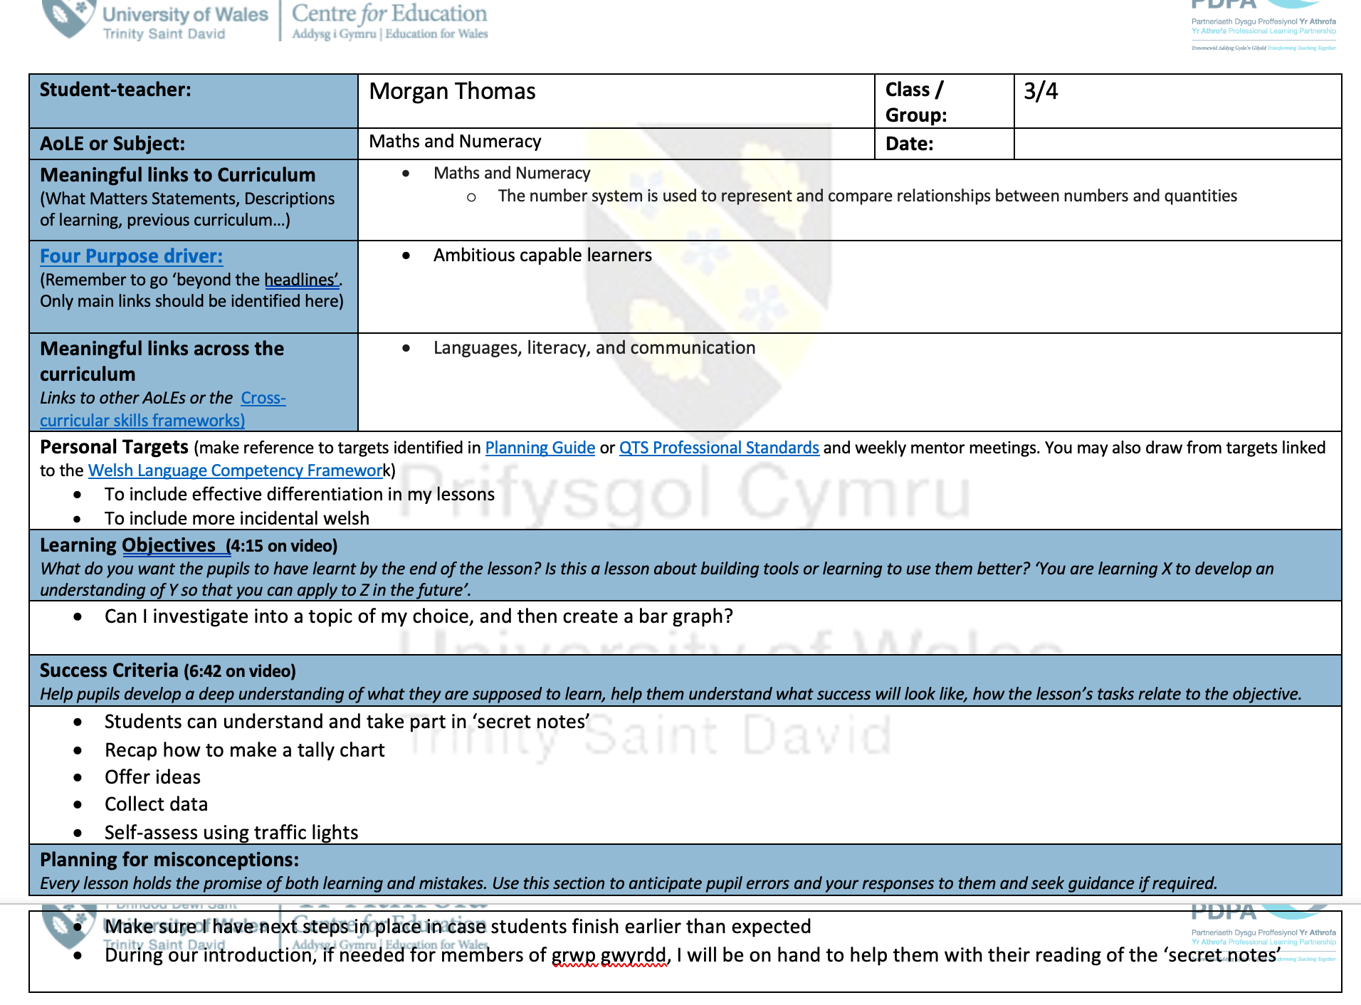

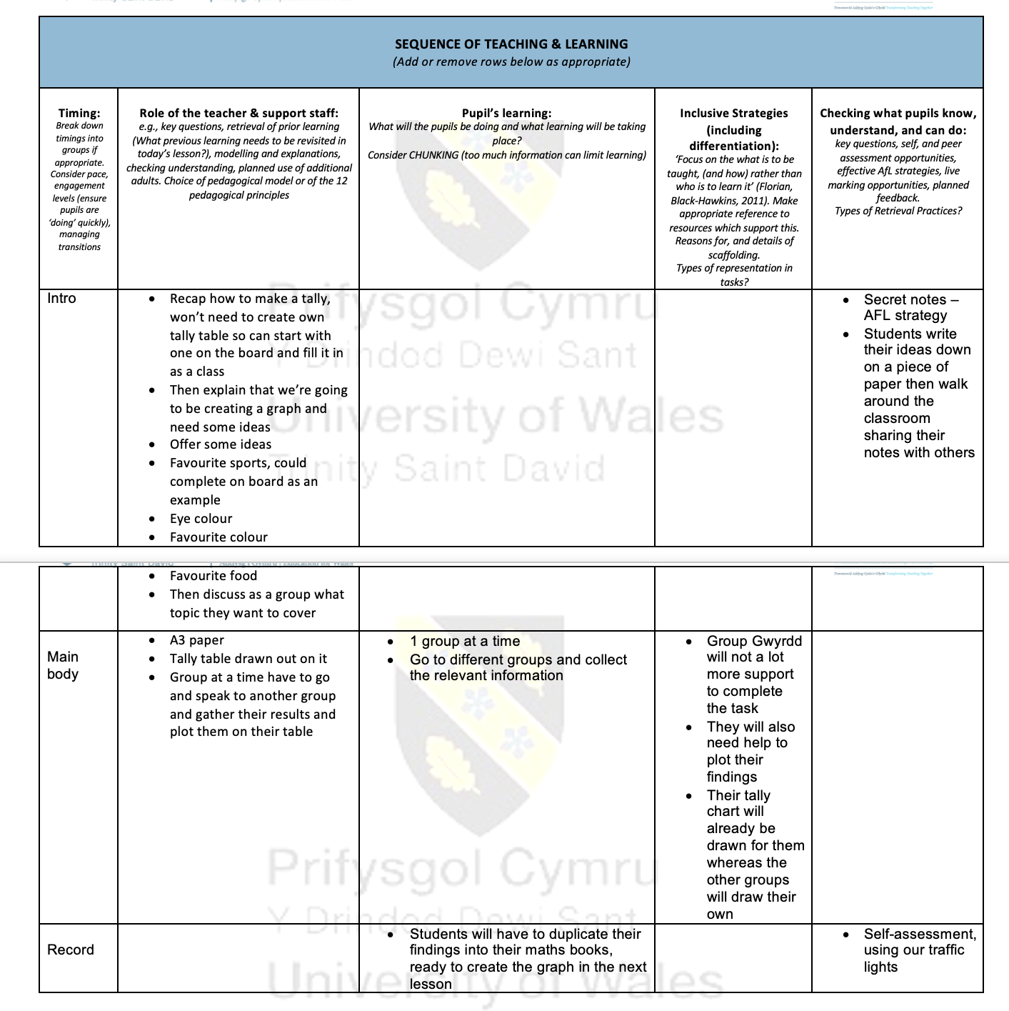

- Evidence of ‘Traffic lights’ AFL strategy

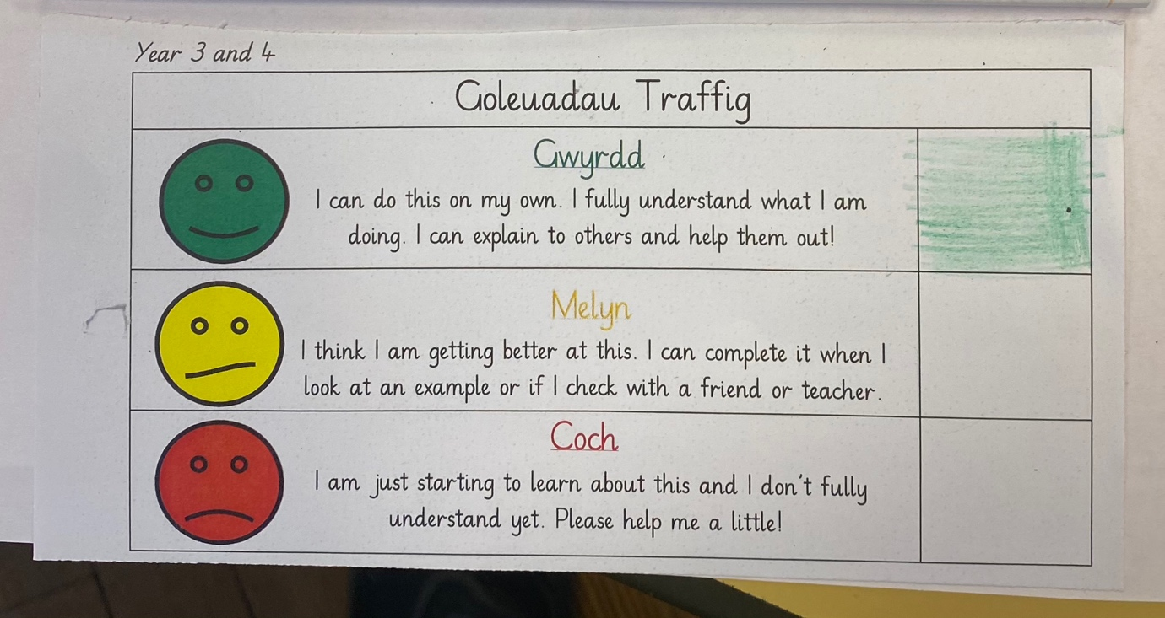

- Lesson Plan. LO – In today’s lesson I will research and discover key dates in MLK’s life
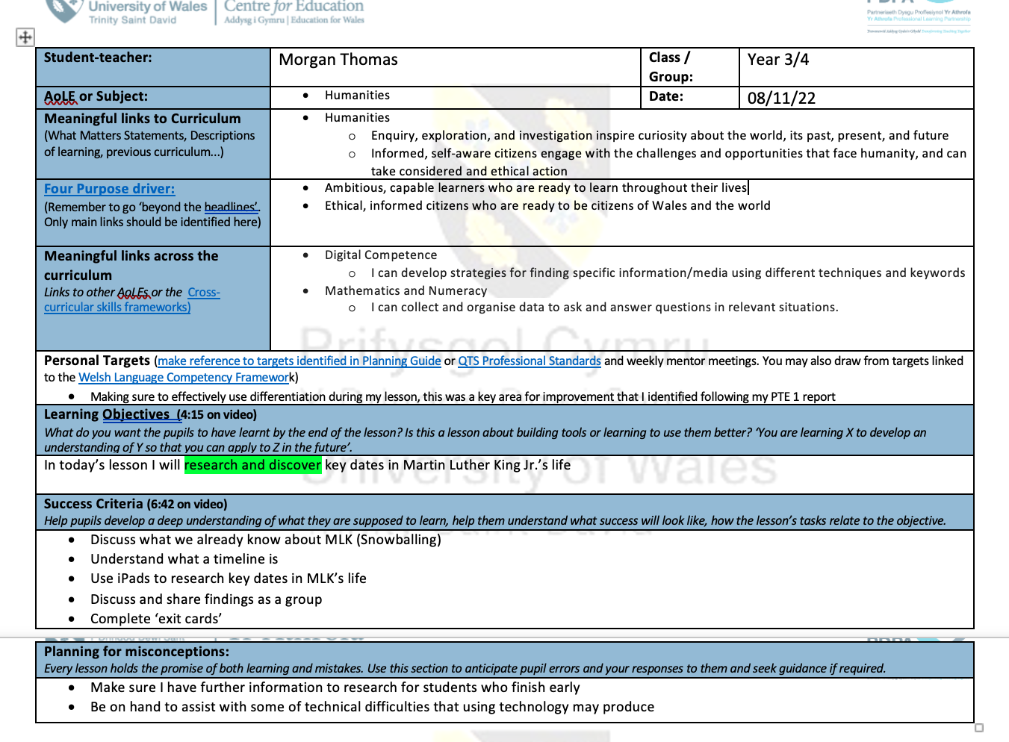

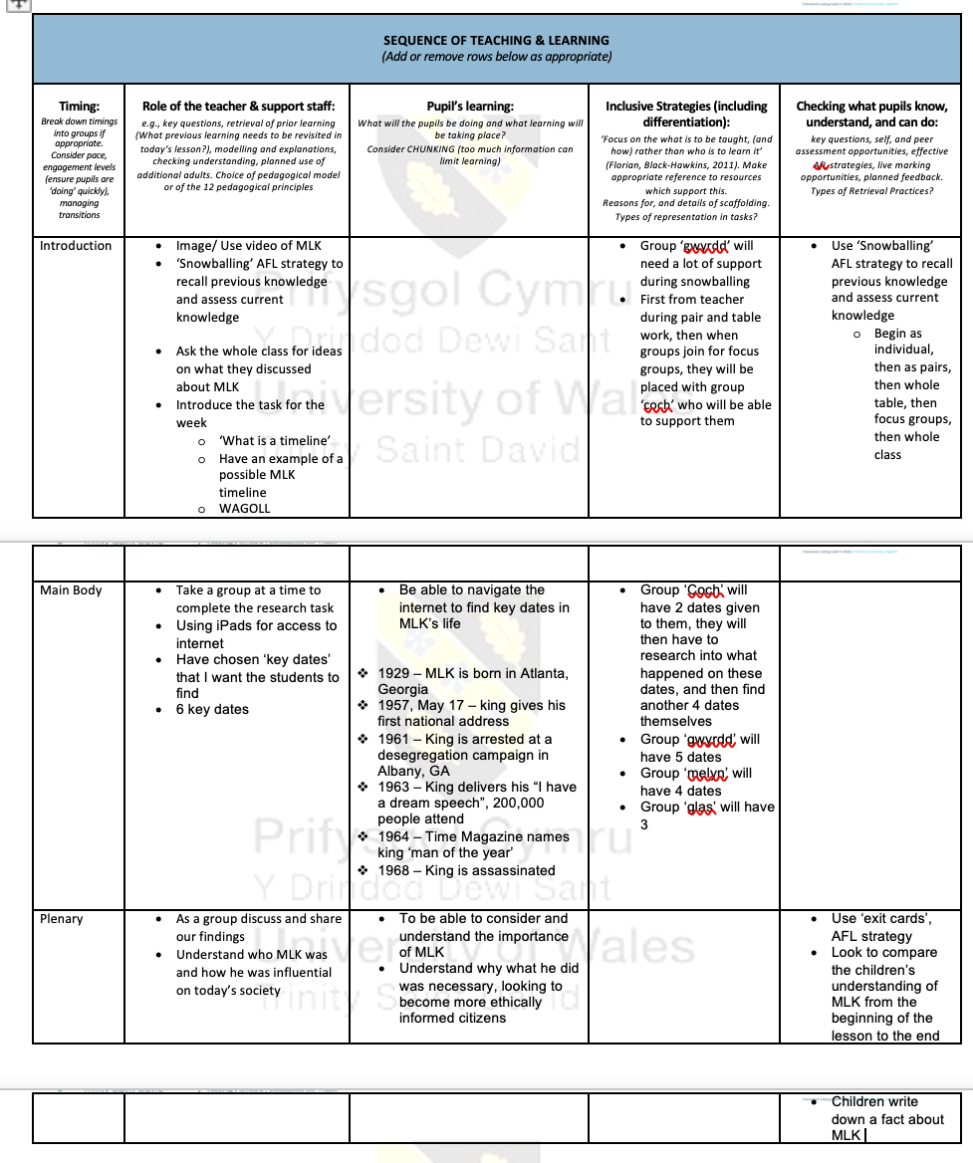

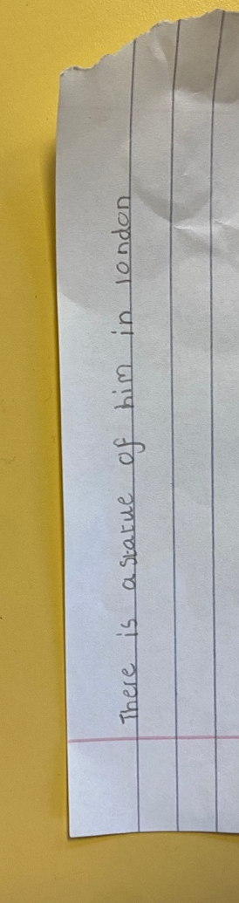
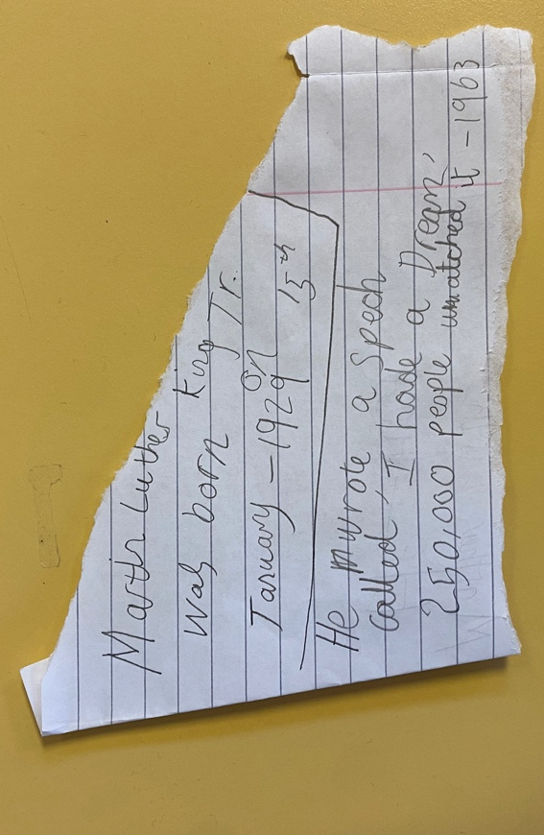
- Evidence of ‘exit cards’ AFL strategy

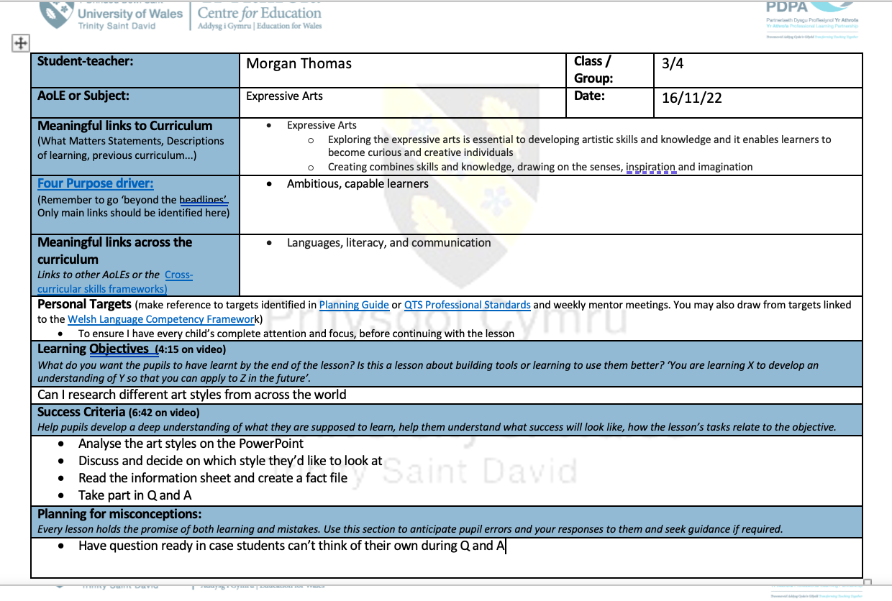
- Lesson Plan. LO - Can I research different art styles from across the world



