AHHI5017 Contesting Conflict: Representations of War, 1789–Present
Week 11: War in the 21st Century
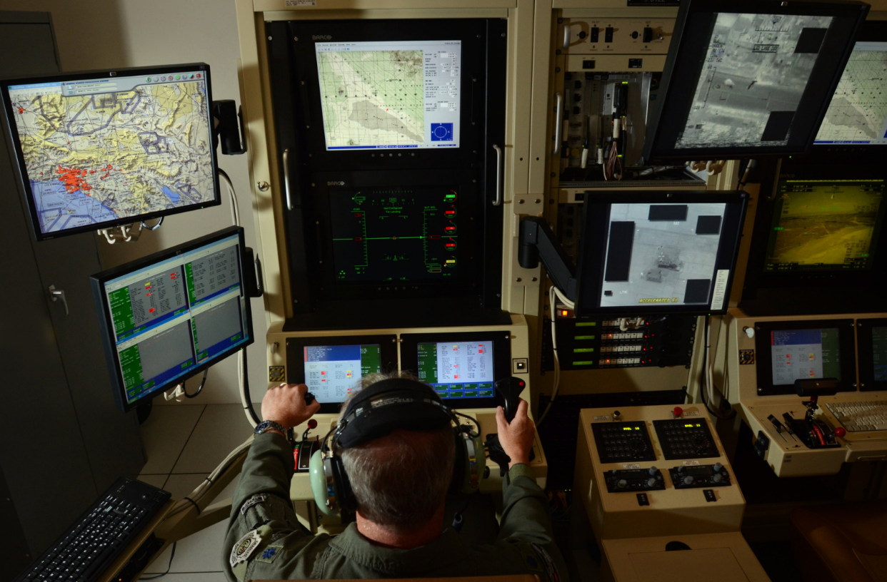
Drone pilot, Hancock Field, Syracuse, New York. Credit Heather Ainsworth for New York Times (2012)
Lectures summary:
The final week of term brings the module up to date with an examination of the different ways that war is represented in the 21st century. Teaching sessions will explore how warfare has changed in recent decades, and responses to this in different media: cinema as per previous weeks, but also video games. Particular attention is paid to representations of the series of conflicts that have taken place under the rubric of ‘the War on Terror.’ Time will also be allocated to discuss students’ planned critical analysis coursework.
Note: the lecture is rescheduled to Tuesday. The Tuesday lecture reflects on one of the module’s overarching emphases: the representation of war in cinema. We will evaluate how the terrorist attacks of September 11 2001 – and the ensuing War on Terror – have been depicted onscreen, assessing their impact on how war is represented in fil, alluding to earlier lectures on combat movies about WWII and the Vietnam War in the process. In keeping with Week 9’ discussion of Paul Virilio’s scholarship, we will also think about the ways contemporary war can itself be conceptualised as having distinctly cinematic attributes.
Friday then contextualises these ideas in relation to a different medium: computer games. The impact of games console aesthetics on representations and understandings of war will be acknowledged, with specific attention then paid to how the War on Terror has been interpreted as influencing video game franchises like Call of Duty: Modern Warfare and Medal of Honor. Students will then consider the implications of representing war, and the past, more generally in a computer game format. In doing so, several questions will be entertained: what interpretations of war are promoted by video games? how do they differ from other representations encountered on the module? do video games enhance or detract from understandings of historic and contemporary conflicts? might video games be a medium for ‘doing’ history seriously?

Preparing for the lectures:
The required reading is straightforward: one text on cinema accompanies the Monday lecture, with two articles about video games assigned for Thursday. Of the latter, Rejack’s essay is the more challenging, posing as it does questions about video games’ potentialities for presenting a nuanced, sophisticated understanding of war and history.
Students are also invited to bring personal knowledge of video games and cinematic treatments of the War on Terror to bear on lecture discussions. Insights about gaming would be particularly appreciated by the relatively uninitiated (i.e. your lecturer!).
Required reading and other preparation:
Tuesday
- Terence McSweeney, introduction and ‘Boots on the Ground: The New Millennial Combat Film as Cultural Artefact,’ The ‘War on Terror’ and American Film: 9/11 Frames Per Second (Edinburgh University: Edinburgh, 2008), pp. 1–31, 59–80.
Friday
- Brian Rejack, ‘Toward a Virtual Reenactment of History: Video Games and the Recreation of the Past,’ Rethinking History (Vol. 11, No. 3, September 2007), pp. 411–425.
- Marcus Schulzke, ‘The Virtual War on Terror: Counterterrorism Narratives in Video Games,’ New Political Science (Vol. 35, No. 4, 2013), pp. 586–603.

Suggested background reading:
- David Holloway, ‘Photography and Visual Art: “Convulsions of Empire” and ‘Adventures in Cubism’ – Visualising Republican Culture After 9/11,’ 9/11 and the War on Terror (Edinburgh University: Edinburgh, 2008), pp. 129–153.
- Frank Joseph Wetta and Martin A. Novelli, ‘“Now a Major Motion Picture”: War Films and Hollywood’s New Patriotism,’ The Journal of Military History (Vol. 67, No. 3, July 2003), pp. 861–882.
- Chris Woods, ‘Games Without Frontiers, War Without Tears,’ Geoffrey Robertson, ‘Trial by Fury,’ Michael Brooks, ‘Eyes in the Sky,’ The New Statesman, June 18 2012, pp. 22–30.
Questions to consider:
General
- Has war and conflict changed in the 21st century?
- Does contemporary warfare make distinctive use of novel combat technologies?
- Does contemporary warfare command novel modes of perception and subjectivity?
- Has contemporary warfare impacted upon distinctions between combatants and civilians?

- Has the representation of war and conflict changed in the 21st century?
- Are different media used to represent contemporary warfare, and if so, do these media represent war and conflict in a novel manner?

- What filmic representations of 9/11 and the War on Terror are you familiar with, and what are your opinions of them?

- What video game representations of war are you familiar with, and what are your opinions of them?

- Does the War on Terror pose novel and distinctive interpretive challenges for filmmakers and artists who wish to represent war and conflict?

McSweeney 9/11 Frames Per Second
- What immediate impact did the terrorist attacks of September 11 have on the Hollywood film industry?
- Did 9/11 effect films that films that were in production or scheduled for release?

- What analogies does McSweeney draw between the 2001 terrorist attacks on the World Trade Center and the narrative and cinematographic devices employed by Hollywood movies?

- How does McSweeney interpret films such as World Trade Center which directly depict the events of 9/11?

- What impacts does McSweeney suggest that 9/11 and the War on Terror had on examples of the horror and science fiction genres (and/or other Hollywood movies generally)?

- What impacts does McSweeney suggest that 9/11 and the War on Terror had on the following examples of the combat movie genre:
- Act of Valor (2012)
- The Hurt Locker (2008)
- Zero Dark Thirty (2012)
- Battle for Haditha (2007)?

- How do contemporary combat movies compare and contrast with other examples of genre encountered on AHHI5015 (i.e. Objective, Burma!, Platoon)?

Schulzke, ‘The Virtual War on Terror’
- According to Schulzke, in what ways have a) terrorism and b) counterterrorism been important themes in video games made since September 2001?

- According to Schulzke, how do video game representations of war and conflict compare and contrast from those made in other media?

- What comparisons does Schulzke draw between Call of Duty: Modern Warfare and other video game franchises such as Medal of Honor?

Brian Rejack, ‘Video Games and the Recreation of the Past’
- What existing scholarship on video games and their representation of the past does Rejack engage with in the article?

- Why does Rejack place emphasis on re-enactment as an important component of his analysis?

- What “kind of experience” does Rejack suggest video games “offer as a way to enter into history” (p. 412)?

- In what ways has gaming become “increasingly similar to re-enactment” according to Rejack (p. 413)?

- According to Rejack, how does Brothers in Arms negotiate its engagement with historical events alongside the demands of the video game medium?
  - What ‘reality effects’ and attempts at verisimilitude does Brothers in Arms deploy?

- Is Rejack optimistic about the potentialities of video games for representing war and conflict – and history in general?

