Student Name: Andrea Helen Walker
Student Number: 2308953
Module Number: LCBB5012
Lecture Name: Nassir Ibrahim

Table of Contents

Introduction | 3
The Role of Human Resource Management in Global Organisations | 4
PESTLE Analysis and Environmental Influences on HR Management | 4
Application of PESTLE Factors to Unilever | 6
Conclusion | 8
Reference List | 9

Evaluating the Impact of Environmental Factors on Human Resource Managers’ Effectiveness in Global Organisations: A Case Study of Unilever

Introduction
Human Resource Management (HRM) has developed from being mainly an administrative function into a strategic area that supports organisational success. Modern organisations depend on effective HR managers to recruit suitable employees, develop skills, improve performance and maintain positive employee relationships. In a competitive global environment, HR managers play an important role in helping organisations achieve long-term objectives by ensuring that employees have the skills, motivation and support needed to perform effectively (Armstrong and Taylor, 2023).
The role of HR managers has become more complex because organisations are affected by many internal and external environmental changes. Globalisation, technological development, changing workforce expectations, economic uncertainty and legal differences between countries all influence how HR decisions are made. Multinational organisations must manage employees from different cultural backgrounds while also following different employment regulations and responding to local market conditions.
This report examines how environmental factors influence HR managers’ effectiveness within multinational organisations. The PESTLE framework is applied to analyse political, economic, social, technological, legal and environmental influences. Unilever is used as a case study because it operates internationally and places strong importance on sustainability, innovation, employee development and diversity (Unilever, 2025). The report evaluates how these factors affect HR activities including recruitment, training, performance management and employee relations.

The Role of Human Resource Management in Global Organisations
HR managers are responsible for managing the relationship between employees and the organisation. Key HR functions include recruitment and selection, training and development, performance management and employee relations. Recruitment and selection are important because organisations need employees with the correct knowledge, skills and abilities to meet business objectives. Effective recruitment strategies help organisations attract talented employees and remain competitive (Bratton and Gold, 2022).
Training and development are also essential because workplaces continue to change due to technology and global competition. Employees require continuous learning opportunities to improve their abilities and adapt to new working methods. HR managers support this by creating development programmes and encouraging a culture of lifelong learning.
Performance management allows organisations to measure employee contribution and provide feedback for improvement. Effective performance systems help align employee goals with organisational strategy. Employee relations are equally important because positive relationships between employees and management improve engagement, reduce conflict and support organisational stability (Dessler, 2020).
However, HR effectiveness is influenced by environmental conditions. A successful HR manager must understand external pressures and adapt strategies to meet changing business needs.

PESTLE Analysis and Environmental Influences on HR Management
Figure 1: Impact of Environmental Factors on HR Effectiveness at Unilever
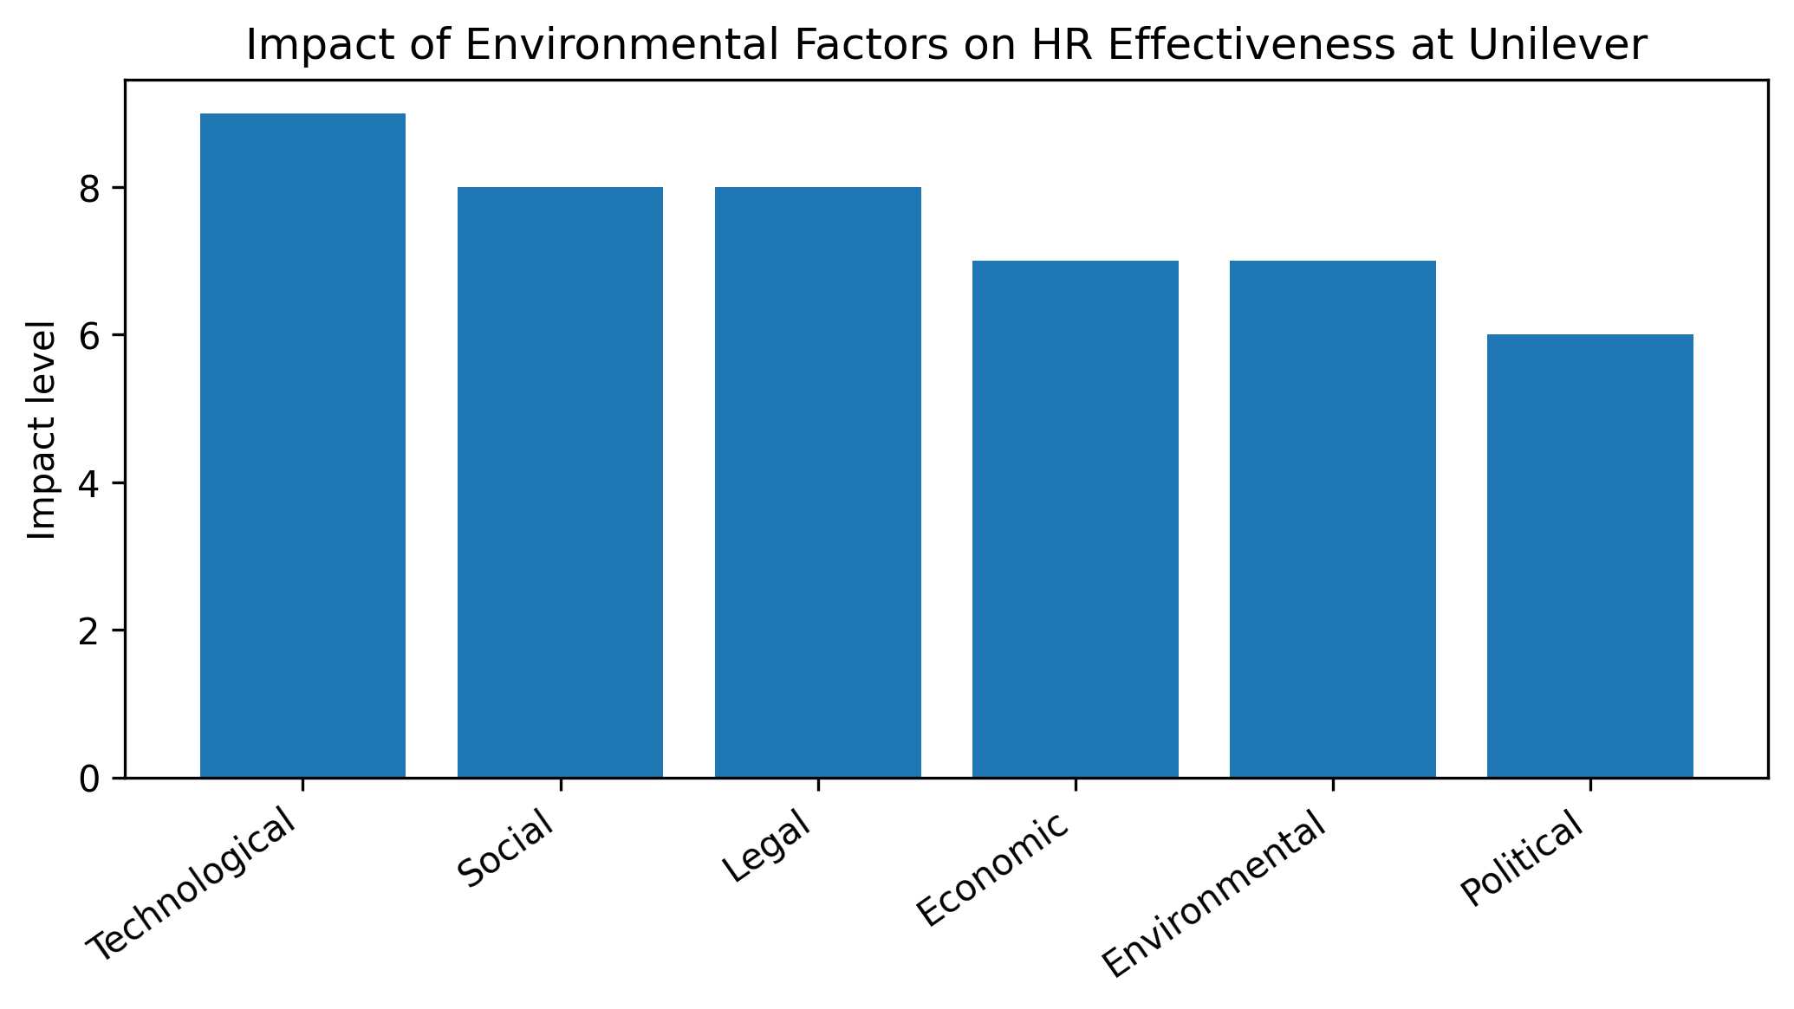
The PESTLE model is a strategic tool used to examine external factors that influence organisational decision-making. The framework includes Political, Economic, Social, Technological, Legal and Environmental factors. It is useful for multinational organisations because it helps managers understand changes in different countries and prepare appropriate responses (Johnson, Scholes and Whittington, 2020).
Political factors include government policies, political stability, taxation, trade agreements and immigration rules. These issues directly affect HR decisions because they influence workforce movement, employment opportunities and recruitment strategies. For multinational organisations, political changes can create uncertainty and require HR managers to develop flexible workforce plans.
Economic factors such as inflation, unemployment, exchange rates and labour costs also affect HR practices. During periods of economic growth, organisations may increase recruitment and investment in employee development. However, during economic difficulties, HR managers may face pressure to reduce costs through restructuring, recruitment freezes or changes to staffing levels. These decisions can affect employee motivation and organisational culture (Dessler, 2020).
Social factors relate to changes in employee expectations, demographics and cultural values. Employees increasingly expect organisations to provide flexible working options, wellbeing support, equality and opportunities for career development. HR managers must understand these expectations to attract and retain skilled employees.
Cultural differences are especially important in global organisations. Hofstede’s Cultural Dimensions Theory explains that national cultures influence communication styles, leadership expectations and employee behaviour (Hofstede, 2011). For example, employees in individualistic cultures may value personal achievement, while employees in collectivist cultures may place greater importance on teamwork and group success. HR managers must balance global consistency with local cultural differences.
Technological factors have significantly transformed HR practices. Digital recruitment systems, artificial intelligence, online training platforms and remote working technologies have improved efficiency and global communication. However, technology also creates challenges including concerns about data protection, employee monitoring and reduced personal interaction. HR managers must ensure technology is introduced ethically while maintaining employee trust.
Legal factors are another important influence. Employment laws vary between countries, and HR managers must ensure compliance with regulations relating to contracts, wages, discrimination, health and safety and employee rights. Failure to meet legal requirements can result in financial penalties and damage to organisational reputation.
Environmental factors have become increasingly important because organisations are under pressure to demonstrate sustainability. HR managers contribute by promoting environmentally responsible workplace practices, supporting ethical leadership and encouraging employees to engage with sustainability objectives (Unilever, 2025).

Application of PESTLE Factors to Unilever
Unilever is a multinational consumer goods organisation operating across many countries. The company manages a large and diverse workforce and focuses on sustainability, innovation and employee wellbeing (Unilever, 2025). Because Unilever operates internationally, its HR managers must respond to different political, economic, social, technological, legal and environmental conditions.
Political changes influence Unilever’s workforce planning and recruitment decisions. Changes in immigration policies, trade agreements and government regulations can affect the movement of employees between countries. For example, changes following Brexit created uncertainty regarding labour movement between the United Kingdom and European Union countries. HR managers needed to consider how these changes could affect recruitment and talent management strategies (CIPD, 2023).
Economic pressures also influence HR effectiveness. Rising costs, inflation and changing consumer demand can affect organisational decisions. HR managers must balance the need to control costs with the need to maintain employee motivation and retention. Poorly managed cost reductions may damage employee engagement and organisational culture.
Social factors strongly influence Unilever’s HR approach. The organisation promotes diversity and inclusion and recognises the importance of employee wellbeing. However, HR managers must adapt policies to different cultural expectations across countries. A strategy that works in one location may not be effective in another because employee values and expectations differ.
Technology has allowed Unilever to improve HR processes through digital systems and online learning. Digital tools support international collaboration and make recruitment processes more efficient. However, HR managers must consider ethical issues connected with technology, including fairness in automated decision-making and maintaining human involvement.
Legal differences between countries create additional challenges for Unilever. HR managers must ensure that employment practices meet local requirements while maintaining consistent organisational standards. Strong legal compliance protects employees and supports the organisation’s reputation.
Environmental sustainability is a key part of Unilever’s strategy. HR managers support this by developing employee awareness, sustainability training and workplace initiatives. This shows that HR is not only responsible for managing people but also supporting wider organisational values.

Conclusion
This report has evaluated how environmental factors influence HR managers’ effectiveness in multinational organisations. The analysis shows that HR managers must respond to political, economic, social, technological, legal and environmental changes to support organisational success.
The case study of Unilever demonstrates that effective global HR management requires adaptability, cultural understanding, digital knowledge and ethical decision-making. HR managers must balance global organisational goals with local employees’ needs and legal requirements.
As globalisation and technology continue to develop, the role of HR managers will become increasingly strategic. Organisations will depend on HR professionals to manage change, support employee wellbeing and create sustainable workplaces (Armstrong and Taylor, 2023).

Reference List
Armstrong, M. and Taylor, S. (2023) Armstrong’s Handbook of Human Resource Management Practice. 16th edn. London: Kogan Page.
Bratton, J. and Gold, J. (2022) Human Resource Management: Theory and Practice. 7th edn. London: Palgrave Macmillan.
CIPD (2023) Managing Brexit Implications for HR. Available at: https://www.cipd.org
CIPD (2024) People Profession Survey Report. Available at: https://www.cipd.org
Dessler, G. (2020) Human Resource Management. 16th edn. Harlow: Pearson.
Hofstede, G. (2011) Dimensional zing Cultures: The Hofstede Model in Context. Online Readings in Psychology and Culture, 2(1), pp.1–26.
Johnson, G., Scholes, K. and Whittington, R. (2020) Exploring Corporate Strategy. 12th edn. Harlow: Pearson.
Unilever (2025) Annual Report and Accounts 2025. Available at: https://www.unilever.com

Environmental factor | HR challenge | HR response
Political | Different regulations | Flexible workforce planning
Economic | Cost pressures | Retention strategies
Social | Changing employee expectations | Wellbeing and inclusion
Technology | Digital transformation | Upskilling and digital HR
Legal | Employment compliance | Strong HR policies
Environmental | Sustainability demands | Green HR practices

