Emergent Leadership Skill

in the Workplace


UNIVERSITY OF WALES TRINITY SAINTS DAVID
Student Name: Kazi Shaila Sultana Sonia
Student ID: 2013422
Module Code: BMSW 6101
Lecture’s Name: Md. Kalam
Unit Name: Emergent Leadership Skills for the Workplace
Programme Name: BA(Hons) Leadership and Management Skills for the Workplace

Executive Summary

This report aims to develop a comprehensive understanding of leadership style and the key responsibilities of leadership in the workplace and significance of developing emerging leadership skills in the face of uncertain and turbulent problems. In order to showcase this understanding, Amazon.com, one of the world's leading e-commerce platforms, has been selected to examine their leadership style, traits and skills that have adapted pre and post Covid-19 pandemic. The outcome of the critical evaluation demonstrated that, Amazon’s Transformational Leadership has been successful to communicate the visions, goals and objective to the team during uncertain business environment like Covid pandemic and boost their business. However, there are still rooms to improve their leadership model.

In the report, leadership, the traits of leadership, the skills and responsibility of an effective leader has been analysed as well as three major leadership theory has been critically analysed such as Contingency Theory, Transformational Theory and Transactional Theory of leadership. In the light of the insights, after critically analysed the theories and skills and responsibilities of an effective leader; Amazon has been recommended to adapt an emergent leadership style Situational Leadership Style and follow The Contingency Theory of Leadership to be implemented. Furthermore, recommended to use the form of Conceptualizing Leadership Questioner (Appendix) to identify the leadership style of managers as well as use the form of Leadership Skills Questioner and Emotional Quotient Inventory (EQ-I) of Bar-on to measure leadership skills and the degree of emotional and social abilities. In addition, arrange proper programme of development, training, coaching, and mentoring to improve the leadership skills; fortunately, it can be learned, practiced, and developed.

It is expected that Amazon will be able to create an emergent leadership plan and a leadership success plan following the recommendations suggested in the report which will enable them to face further challenges and being world’s best employer.

Table of Contents

1. Introduction 4
2. Critical Evaluation of Amazon’s Leadership Principles 5
2.1. Background of Amazon.com 5
2.2. Leadership Approach of Amazon.com during and post-covid time…………………………………….7
3. Leadership, Style and Key Responsibilities 10

3.1. Leadership & Traits of Leadership……....…………………………………………………………….10

3.2. The Type of Leadership style…………………...……………………………………………………..11

3.3. Key Responsibilities of the Leadership Role………………………………………………………….13

4. Critical Evaluation of Leadership Theory 14
4.1 Contingency Theory of Leadership 14
4.2 Transformational Theory of Leadeship 15
4.3 Transactional Theory of Leadeship 17
5. Recommendation……………………………………………………………………………..................19
6. Conclusion……………………………………………………………………………………………….20
7. Reference………………………………………………………………………………………………...21
8. Appendix…………………………………………………………………………………………………24

1. INTRODUCTION

We have been experiencing uncertainty and fear since the Covid-19 pandemic hit in early 2020. Not only did the disease kill 1.9 million people worldwide (WHO, 2021) but it also posed a serious threat to the world economy following the recession in 2009 (Bagchi, et al., 2021). In the post-Covid era, we confront difficulties including the Brexit issue, the war in Ukraine and Russia, and current political crises in addition to increasing inflation of 10.4%, price increases of 129%, and a 65% increase in the cost of electricity (Bank of England, 2023). In order to achieve a sustained competitive edge, e-commerce giant Amazon.com has adopted an effective leadership style in response to the challenges posed by the newly dynamic and confusing environment. In this report, Amazon and its Leadership style is being analysed in order to demonstrate the understanding of various leadership styles, the key responsibilities of the leadership role and the emergent leadership skills.

First, in section 2 of this report, the leadership approach of Amazon is being critically evaluated under the light of the pre and post Covid-19 pandemic and its strengths and weaknesses in order to find the room of improvement of Amazon’s leadership style. In section 3, leadership and its traits, the key responsibilities and the skills of an effective leader are being analysed. In section 4, the theory of leadership such as, Contingency theory, Transformational theory and transactional theory of leadership are being critically evaluated in order to suggest the appropriate one for the improvement of Amazon’s leadership management. Finally, one of the most prominent and emergent leadership style and theory has been recommended to be implemented within the workplace culture of Amazon.

The findings of the report provide a comprehensive insight of Amazon’s leadership style, skills, and responsibilities they adopted, during and post Covid-19 pandemic. Furthermore, not only sorted out the room of improvement but also recommendation provided after analysing the emergent leadership styles and models which will enable Amazon of being more customer centric company and being the world’s best employer.

Section 2- Critical Evaluation of Amazon’s Leadership Principles

Background of Amazon.com

The worldwide technology corporation Amazon was established in the US by Jeff Bezos in 1994. It has since developed into one of the biggest and most prosperous firms in the world with a concentration on e-commerce, cloud computing, digital streaming, and artificial intelligence (Taylor, 2021). One of the reasons Amazon is one of the world's top customer-focused e-commerce behemoths is because of their strong and effective leadership (Goleman, 2021). Amazon wants to be the corporation that puts its customers first. Customer focus, a love of creativity, a dedication to operational excellence, and long-term thinking are Amazon's four guiding principles. Bezos' effective management, which is based on emotional intelligence, can be partly credited for Amazon's success (Goleman, 2021).

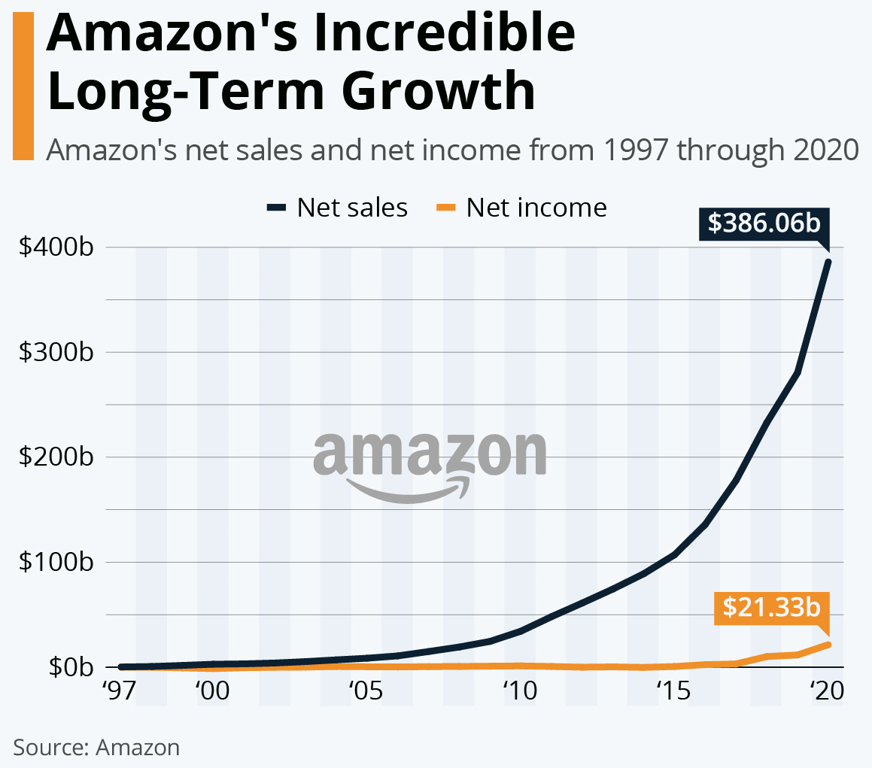

Amazon saw considerable growth during the COVID-19 pandemic, making a profit of more than 200% and adding 500,000 new employees (Amazon Annual Report, 2021). During the COVID-19 pandemic, Amazon's leadership principles and emotional intelligence skills were crucial to their effective management communication and allowed them to maintain their position as a global leader in e-commerce (Goleman, 2021).
In the post-COVID age, Amazon has strived to remain competitive, but in 2022, the company posted its first net loss in almost 10 years, a $2.7 billion loss (MarketLine, 2022). Additionally, the workforce shrank to 1,541,000, and in 2023, 10,000 jobs in business and technology will be lost (Amazon.com, 2022).
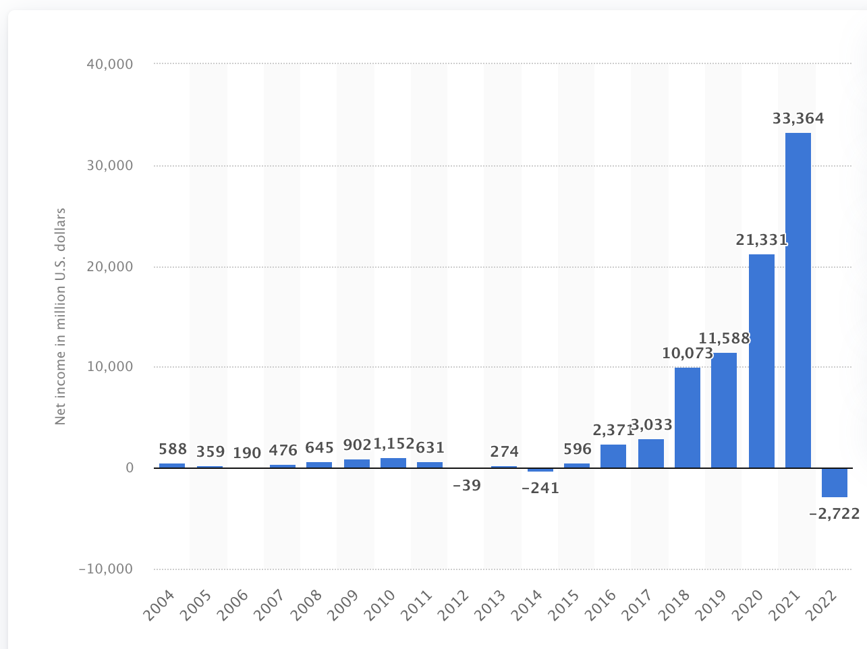

Despite all of these challenges, Amazon is continually investing in research and development, trying their best to improve their leadership approach, adding more features to their leadership tenet, and putting a strong emphasis on emotional intelligence (EI) in order to be more practical and sustainable. In fact, the annual report for 2022 lists Amazon as one of the biggest, most prosperous, and frequently searched companies in the world. (Amazon Annual report, 2022).

2.2. Leadership Approach of Amazon.com during and post-covid time

During and after the COVID-19 pandemic, every organisation in the world, including Amazon, underwent significant change and transformation (Amazon.com, 2022). One of the reasons Amazon is still one of the top customer-focused e-commerce behemoths in the world is because of its evolving leadership techniques (Goleman, 2021). Here are a few instances where Amazon shown various leadership trajectories in reaction to the Covid-19 pandemic:

Customer-Centric Focus and Customer Experience (CX): The client has always been at the centre of Amazon's leadership strategy, and this strategy became especially more crucial during and after the pandemic. (Morgan, 2021). Innovative concepts including personalised recommendations, Click & Collect Service, Same-Day Delivery, and One-Click purchases, Customer service based on Emotional Intelligence (EQ) were developed to adhere with covid retraction (Amazon Annual Report, 2021). They are creating new products and services like Amazon Pharmacy with the slogan “Save time, save money, Stay Healthy” where they deliver Insulin at the door, to build on strong customer service (Amazon Pharmacy, 2022).

Acknowledges challenges and adapt with changes: Amazon has always acknowledged that both executives and employees experience emotion. They trained more than 50,000 people across the entire firm in EI in 2021. (Goleman, 2021). Furthermore, Amazon add new Leadership principal that's called ‘Strive to be earth's best employer’ (Amazon Annual Report, 2022). The need to understand how to become more people- or human-centred is evident in this strategy, which undoubtedly reflects the trend towards more emotional intelligence. (Matthew, 2023).

Employee Safety and Well-being: Amazon adopted a number of precautions throughout the pandemic to ensure the physical and mental wellbeing of its staff members (Amazon Annual Report, 2021). Amazon is striving to play a significant role in increasing its Emotional Intelligence through leadership principles in the wake of the pandemic. Considering well-being of employee Amazon, Tilbury organised a get-together with the family members of Amazonian ‘Family at Amazon’ on August 12, 2023, and they raise the minimum wase of employees’ (Amazon.com, 2022).

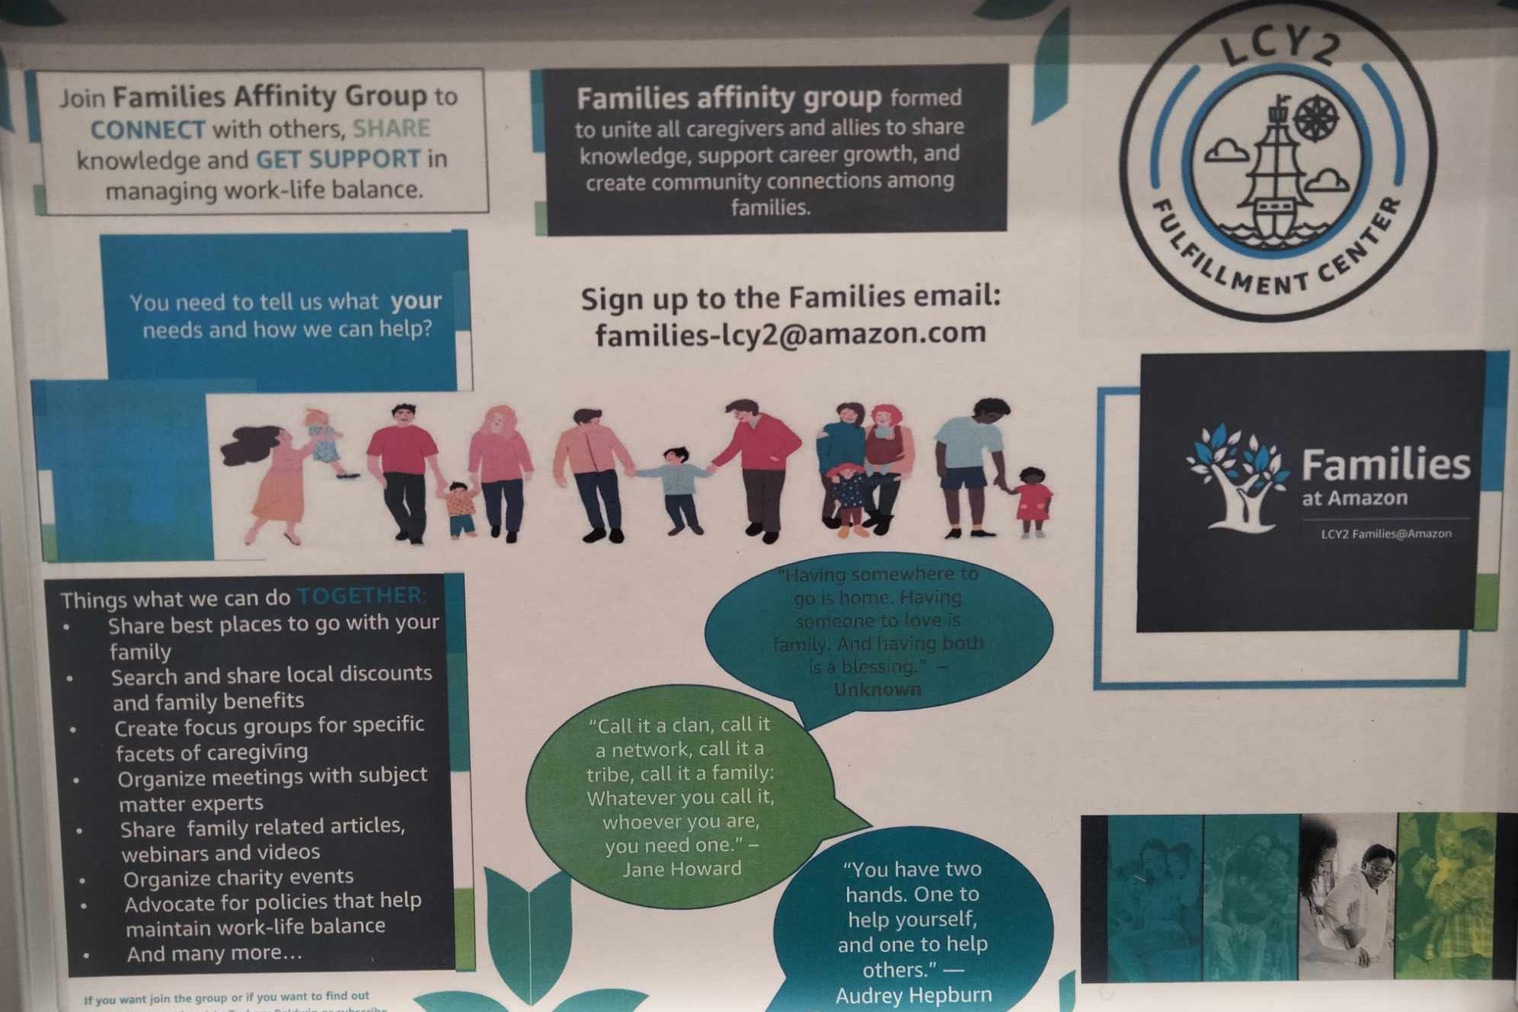
Source: Family at Amazon/Amazon.com/LCY2/Tilbury/UK

Remote Work and Virtual Collaboration: Amazon made the switch to remote work for its corporate workers, much like many other businesses.
Earn Trust: During and post pandemic, The leadership of Amazon paid great attention in order to gain the trust of the public and wished to be available to address the needs of both employees and customers. (Goleman, 2021).
Adaptation and Innovation: As a result of the epidemic, consumer behaviour changed, and more people started purchasing online. Amazon immediately modified its supply chain and logistics techniques to handle the spike in demand, adopting an emerging leadership style. (Matthew, 2023).

Communication and Transparency: Transparent communication was essential both before and after the outbreak. Regular updates on Amazon's reaction activities, safety precautions, and any potential interruptions were given to its staff, customers, and the general public. (Goleman, 2021).

Support for Communities: The business supported organisations and projects that aided those impacted by the pandemic by donating money, materials, and resources. (Amazon Annual Report, 2021).
Amazon surrounded by smarter people: Bezos knows he doesn't have all the answers, so he builds teams with individuals who are smarter or more experienced than him. (Goleman, 2021).
Hire and Develop the Best: Amazon concentrated on selecting and training the best candidate for their leadership succession strategy both during and after the pandemic. (Goleman, 2021).
Inclusive Practices: The leadership at Amazon is more open-minded and responsive to different perspectives. Amazon created a welcoming workplace that values each employee's contributions both during and after the outbreak. (Amazon.com, 2022).

In essence, Amazon's transformational leadership style has enabled it to successfully connect with and respond to all of its stakeholders during the pre- and post-Covid pandemic. However, there has been much criticism of Amazon's business practises, including a lack of trust and a high turnover rate (Allyn, 2021). Amazon should consider switching to laissez-faire leadership or situational leadership, where the leader trusts their followers and acts based on situation, gives them the freedom to manage their own workstations, and provides team support and training as necessary, in order to adopt a more effective and emergent leadership style and gain competitive advantages.

Section 3 – Leadership, Style & Key Responsibilities

3.1. Leadership & Traits of Leadership:

According to McKinsey & Company, leadership is a set of behaviours that people employ to execute strategic plans, align their collective direction, and continuously refresh an organisation. In the 21st Century, Inclusion, ethics, sustainability, and the capacity to navigate rapid change, such as globalisation, technology breakthroughs, and diverse workforces, are becoming more and more important components of leadership (Allyn, 2021). The term "leadership" refers to the aptitude for influencing, directing, and motivating people to accomplish a shared purpose or goal. It entails exercising leadership over a team of people or an organisation and making decisions and giving orders. (LearningREDDefined, 2016).

Research identifies Six key leadership traits (LearningREDDefined, 2016):

1. Intelligence: Having high verbal, perceptual, and thinking abilities are all parts of intelligence.
2. Confidence: This quality has to do with having faith in one's own abilities and success.
3. Charisma: A leader's charisma is their unique magnetic appeal and the source of their remarkable persuasion abilities.
4. Dominance: Displaying dominance from time to time is a sign of determination, particularly in circumstances where others want guidance.
5. Sociability: The ability of a leader to forge amicable social bonds is referred to as this quality.
6. Integrity: It is a quality that distinguishes leaders who are trustworthy and honest (LearningREDDefined, 2016).

3.2. Type of Leadership Style:

The basic concept of leadership styles was initially presented in 1939 by German psychologist Kurt Lewin (CFI,2022). Leadership styles are the behavioural strategies used by leaders to sway, inspire, and guide their subordinates. Lewin asserts that there are various leadership philosophies, including transactional, autocratic, democratic, laissez-faire, bureaucratic, situational, servant, and transformational (Muhammad et al., 2015). Here are some of the most prominent leadership philosophies:

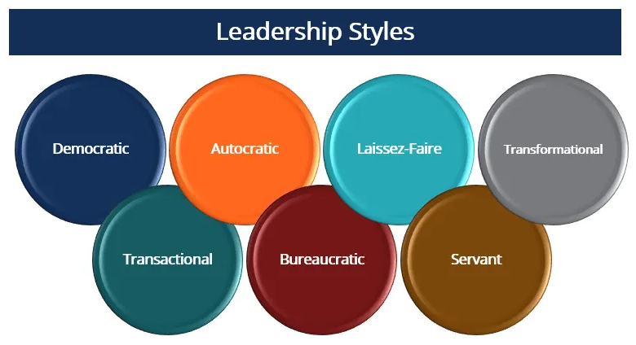

Autocratic Style of Leadership: It is one where the leader has the most discretion and control over decisions. They frequently give tasks explicit instructions and exert considerable control over decision-making. An organised system of rewards and penalties is used to create the motivational environment (McKenzie & Love, 2016). The benefits of an autocratic leadership style include good control over the structure and unhampered programme, rapid decision-making, a secure workplace, and discipline. However, throughout the past 30 years, this design has received a lot of harsh criticism. (Muhammad, et al., 2015). According to certain research, organisations with a lot of authoritarian leaders tend to have higher turnover and absenteeism than other organisations, repress the ability to criticise, undervalue the talents of their own initiative, and suffer from listlessness (Muhammad et al., 2015). But autocratic rule is not always a terrible thing. this approach may be effective when dealing with X-type individuals or untrained staff (CFI,2022).

Laissez-Faire style of Leadership: The hands-off style is another name for this one. Team members are allowed to make decisions on their own by leaders, who only provide minimum direction and control (Muhammad et al., 2015). All decision-making, goal-setting, and problem-solving are left up to the employees, who are granted complete authority. If not managed properly, this could promote independence and inventiveness while also creating confusion and a lack of focus. The benefits of this leadership style: freedom to choose and independent, the group leader hardly requires any preparation time, own social structures, the leader are popular. Adversely, less productivity, shared ownership and responsibility among team members, the holding back of weaker individuals, and a lack of innovative initiative could all happen. misuse of the organization's rules and regulations. However, this approach works best when utilising highly dependable, knowledgeable, experienced, and driven personnel. (CFI,2022).

Transformational Leadership: Creating change in both organisations and individuals is the goal of transformational leadership. Setting a vision, supporting innovation, and promoting personal development are all ways that transformational leaders inspire and drive their teams. Higher levels of staff commitment and inventiveness may result from this strategy. The creator of Amazon, Jeff Bezos, is well recognised for his Trans-formational Leadership Style, where he places a strong emphasis on high productivity and engagement through a leader-employee partnership based on shared trust and a desire for both parties to achieve personally (Al-lyn, 2021). However, transformational leaders run the danger of losing sight of team members' individual learning curves since some may not receive the proper mentoring and direction to complete difficult jobs.

Situational Leadership Style: Early in the 1970s, Paul Hersey and Kenneth Blanchard created this leadership idea. The fundamental tenet of situational leadership is that there is no one strategy that works for all leadership situations, and that leaders should be adaptable in their style to suit the requirements of their teams and the organisational environment. Four approaches are used in this style: clear instructions and close task supervision; explanations of decisions; guidance; and encouragement of two-way communication; involvement of followers in decision-making and facilitation of their contributions; and finally, autonomy and trust in followers to make decisions (Baker, 2022).

3.3. Key Responsibilities of the Leadership Role

The key responsibilities of a leader include a broad variety of activities and attitudes intended to direct, motivate, and advance organisational performance (MBM, 2022). While the precise duties can change depending on the leadership level, sector, and environment. The following are some fundamental duties of an effective leader:

- Setting and Communicating Vision
- Developing and implementing strategies to achieve the goals.
- Decision-Making: Effective decisions that support the organization's objectives.
- Team Building: Building and nurturing a high-performing team by selecting, developing, and retaining talented individuals (Baker, 2022).
- Communication & Relationship Building is must with stakeholders.
- Inspiring and motivating team members.
- Performance Management
- Conflict Resolution
- Resource Management
- Change Management
- Ethical Leadership: Demonstrate integrity, honesty, and ethical behaviour.
- Continuous Learning and Development

Leadership is a dynamic and growing function, and that duties may change depending on the demands of the organisation, the make-up of the team, and the external environment. To fulfil these obligations and guide their teams and organisations to success, effective leaders constantly adapt and improve their talents. (MBM, 2022).

Section 4 - Critical Evaluation of Leadership Theory

To comprehend leadership theories' benefits, drawbacks, and suitability for different situations, it is crucial to critically evaluate them. Frameworks for comprehending the emergence, behaviour, and influence of leaders are provided by leadership theories. The following three significant leadership theories are being critically analysed:

4.1. Contingency Theory of Leadership

The Contingency Theory of Leadership also known as The Situational Leadership Theory, was created by Fred Fiedler and Paul Hersey in 1960 and contends that there is no one-size-fits-all method of leadership. Instead, the most appropriate leadership style should rely on the particular circumstances at hand because effective leadership depends on a variety of situational aspects (Fiedler, 1964). The following are essential elements of the contingency theory of leadership:

Leadership Styles: According to the notion, there are many different leadership philosophies, including autocratic, democratic, transformational, and transactional leadership. Depending on the circumstance, several approaches may be successful.

Situational factors: According to contingency theory, a leader's efficacy is dependent on the circumstances.

Finding the Right Leadership Style for the Situation: The main concept is to find the right leadership style for the situational context. For instance, a participative and democratic leadership style might be most effective in a highly structured job with positive member-leader relationships.

Flexibility: The theory emphasises how crucial it is for leaders to be adaptable and flexible.

Efficacy: The results attained in a specific context serve as a gauge of a leadership style's efficacy.

Critic of Contingency Theory: Critics claimed that the theory oversimplified the intricate relationships between leaders, followers, and circumstances and that it might not adequately take into account the complex dynamics that can affect a leader's effectiveness (Miles, 2022). Depending on their leadership style and the favourableness of the scenario, a leader can either fix a crisis or replace themself.

Despite these criticisms, the theory is still a helpful resource for leaders in organisations given the uncertain, complex, and volatile environment we have been in since the Covid-19 pandemic and the diverse nature of leadership style (Miles, 2022). It promotes a leader's capacity for self-awareness and self-reflection, enabling them to assess the effectiveness of their leadership (McKenzie & Love, 2016). It offers a simple method for deciding when and how one's skills fit a scenario, with an emphasis on the current circumstances.

4.2. Transformational Theory of Leadership

James MacGregor Burns created the Transformational Theory of Leadership in 1978 while conducting a descriptive study on political leaders. According to Burns, transforming leadership is a process in which leaders and followers support one another in reaching higher levels of motivation and morale. Using this strategy, people's lives and organisations are significantly changed. It alters employee expectations and goals within the workplace culture as well as attitudes and values (Pielstick, 1998). The philosophy places emphasis on the following major ideas:
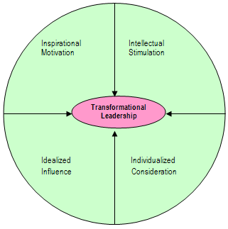
Model Of Transformational Leadership

Inspirational Motivation: The dissemination of a constant vision, mission, and set of values to the members is the cornerstone of transformative leadership. They strive to promote a culture of commitment and teamwork with enthusiasm and optimism (Pielstick, 1998).

Intellectual Stimulation: A transformational leader inspires innovation and creativity in their people.

Influence that is idealised: The leaders serve as examples for followers to follow.

Individualised Consideration: Leaders serve as mentors to their teams and give them incentives for being inventive and creative (Pelstick, 1998).

Criticisms of Transformational Leadership Theory: Despite being widely accepted and well-liked, the theory of transformational leadership has drawn criticism, including that it is very challenging to teach because it combines a number of leadership theories, followers may be duped by leaders, and transformational leadership utilises impression management. (Management Study Guide, 2021).

However, a leader must be able to motivate organisational members to go above and beyond their tasks because developing high-performance workforce has become more crucial in the current uncertain climate (Pielstick, 1998). Transformative leadership has become one of the most well-known notions for organisations as a result.

4.3. Transactional Theory of Leadership

The Transactional Leadership Style was first defined by German sociologist Max Weber as the exercise of control based on knowledge (St. Thomas University, 2023). The Transactional Theory emphasises on the more practical and task-oriented components of leadership and emphasises the trade or transaction between leaders and followers. The Theory of Leadership's main ideas are as follows:

Transactional Leaders: Leaders who interact in a transactional manner with their followers. They put a lot of emphasis on defining positions, outlining expectations, and employing rewards and penalties to encourage followers to do assigned tasks.

Contingent Rewards: ontingent rewards are given to followers in response to their accomplishment of predefined objectives or certain performance standards. (St. Thomas University, 2023).

Management by Exception: Monitoring follower performance and taking action when standards are not met is management by exception.

Laissez-Faire Leadership: In this style of leadership, the leader abstains from making decisions or offering advice in favour of letting their followers handle things on their own.

Routine Tasks: Transactional leadership works well when there are routine duties to complete. (St. Thomas University, 2023).

Advantages of transactional leadership: In organisations where structure is vital, transactional leadership excels. gives enormous organisations, systems requiring repetitive operations, and infinitely reproducible environments a clear framework. Quickly completes short-term objectives. For employees, rewards and sanctions are clearly laid out (Shen, Syed, & Tayyabe, 2018).

Disadvantages of transactional leadership: In organisations where initiative is valued, transactional leadership is inappropriate. Rewarding the employee purely in terms of utility. Due to the predetermined objectives and goals, there is little room for creativity. Confusion and decreased productivity could result from this fashion. (Shen, Syed, & Tayyabe, 2018).

To wrap up, The Transactional Theory of Leadership places a strong emphasis on the leader's responsibility for directing and inspiring followers through a system of incentives and consequences. Maintaining the status quo and completing predetermined objectives are more important than motivating people to reach their full potential (St. Thomas University, 2023). The efficacy of both transformational and transactional leadership styles often depends on the particular organisational setting and the tasks or difficulties at hand. Each style has its own advantages and disadvantages.

5.Recommendation
The pre- and post-Covid-19 pandemic periods have seen significant upheaval and transformation at every organisation in the world, including Amazon. (Amazon.com, 2022). Amazon’s emergent leadership approaches is one of the reasons why Amazon is still one of the top customer centric e-commerce businesses in the world (Goleman, 2021). Despite of all excellence, Amazon's Transformational Leadership Style has been criticised loudly because of its Work Hard/Pay Hard work environment and ‘Tough Guy Macho Culture’. Although, they demonstrated an Emergent Leadership style, adding new principle ‘Strive to be earth's best employer’ (Amazon Annual Report, 2022), and emphasize on soft skills like Empathy and Emotional Intelligence (Morgan, 2021).
Amazon is recommended to adapt Situational Leadership Style instead of following Transformational Leadership Style as well as follow The Contingency Theory of Leadership, also known as the Situational Leadership Theory. The most suitable leadership style should depend on the particular conditions at hand because effective leadership depends on a variety of situational aspects. (Fiedler, 1964). In a volatile current circumstance, it is essential to be more emergent, flexible, and proactive to leverage the resource available and make decision to respond the challenges. Situational leadership emphasizes the importance of adapting leadership style to the specific needs of employees and teams. Situational leadership style is effective for both the leader and organization. Amazon leadership will have all skills and approached needed adapting Situational Leadership Style along with The Contingency Theory of Leadership.

Amazon is highly recommended to use the form of Conceptualizing Leadership Questioner (Appendix) to identify the leadership style of managers as well as use the form of Leadership Skills Questioner to measure leadership skills. Furthermore, Emotional Quotient Inventory (EQ-I) of Bar-on can be applied to measure the emotional and social abilities. Based on the score, it is possible to identify the level of leadership skills, traits, and degree of EQ of being an effective leader in an ambiguous environment. And arrange proper programme of development, training, coaching, and mentoring to improve the leadership skills; fortunately, it can be learned and developed.

6.Conclusion

In order to demonstrate the understanding of leadership style and the key responsibilities of leadership in the workplace, the platform of e-commerce giant Amazon and its leadership style, skills, and responsibilities they adopted, during and post Covid-19 pandemic, has been discussed comprehensively. Amazon had been successful following its Transformational Leadership approach, but it has been criticised and there were still room to improve their CRM process, workplace culture, employees’ well-being and CSR and Sustainability. However, Contingency theory, Transformational theory and transactional theory of leadership have been critically evaluated as well as the traits and skills of an effective leader has been illustrated in the report. Based on the outcome, Amazon has recommended to adapt an emergent leadership style Situational Leadership Style and follow The Contingency Theory of Leadership to be implemented. Furthermore, recommended to use some form to measure the skills, traits and EI level and leader’s strengths and weaknesses and lunched a programme of development. It is expected that Amazon will be able to face all further challenges by their emergent leadership plan.

7.References

- Adair, J. (2013) Develop Your Leadership Skills. 2nd edn. London: Kogan Page.

- Allyn, B. (2021) Jeff Bezos Built Amazon 27 Years Ago: He Now Steps Down As CEO At Critical Time. [Online] Available at: https://www.npr.org/2021/07/05/1013166252/jeff-bezos-built-amazon-27-years-ago-he-now-steps-down-as-ceo-at-critical-time (Accessed: 25 August 2023).

- Amazon Annual Report (2022) Annual reports, proxies and shareholder letters. USA: Amazon.com.

Amazon Pharmacy (2022) Get to know your Amazon pharmacy. [Online] Available at: https://pharmacy.amazon.com/how-it-works#:~:text=Contact%20your%20prescriber%20and%20ask,up%20to%20fill%20future%20prescriptions (Accessed: 29 August 2023).
- Amazon.com (2022) Amazon reportedly planning to shed 10,000 corporate and technology jobs [Online] https://www.theguardian.com/technology/2022/nov/14/amazon-job-cuts-jeff-bezos-recession (Accessed: 28 April 2023).

Amazon.com (2023) Financial Report of Amazon 2022: Amazon announces fourth quarter results [Online]. Available at: https://ir.aboutamazon.com/news-release/news-release-details/2023/Amazon.com-Announces-Fourth-Quarter-Results/default.aspx (Accessed : 26 August 2023).
- Armstrong, M. (2016) Armstrong's handbook of management and leadership for HR: developing effective people skills for better leadership and management. 4th edn. London: Kogan Page.
- Bagchi, B., Chatterjee, S., Ghosh, R. & Dandapat, D. (2021) Impact of COVID-19 on Global Economy. International Journal of Environmental Research and Public Health, 18(5), pp. 247-355
- Baker.C (2022) What Is Situational Leadership, and How Do You Practice It? [Online]. Available at: https://leaders.com/articles/leadership/situational-leadership/ (Accessed :22 August 2023).
- Bank of England (2023) Monitory Policy Report- February 2023. [Online] Available at:https://www.bankofengland.co.uk/monetary-policy-report/2023/february-2023#:~:text=The%20Bank%20of%20England's%20Monetary,percentage%20p04%25 (Accessed: 26 August 2023).

CFI (2022) Leadership style [Online]. Available at: https://corporatefinanceinstitute.com/resources/management/leadership-styles/ (Accessed : 26 August 2023)
- Fiedler, F, E. (1964). A Contingency Model of Leadership Effectiveness. Advancement in Experimental Social Psychology on SinceDirect,1 (1) pp. 149-190.
- Goleman, D. (2021) The Power of Emotional Intelligence at Amazon. [Online] Available at: https://www.linkedin.com/pulse/power-emotional-intelligence-amazon-daniel-goleman/ (Accessed: 25 August 2023).
- Gibbs, G. (1988) Learning by Doing: A guide to teaching and learning methods.
- Kumar, S. R. (2018). Literature Review on Leadership, Leadership Theories, Style And Leadership Development. International Journal of Research in Business Management, 6 (6) pp. 13-24.

LearningREDDefined (2016) How to Be a Leader - The 7 Great Leadership Traits [Online]. Available at: https://www.youtube.com/watch?v=2lEp4TVpxgA (Accessed :25 August 2023).
- Management Study Guide (2021) Transformational Leadership Theory [Online]. Available at: https://managementstudyguide.com/transformational-leadership.htm (Accessed: 26 August 2023).
- Marketing Business Matter (2022) Leadership Responsibilities: How to Effectively Enact Your Duties [Online] Available at: https://www.makingbusinessmatter.co.uk/leadership-responsbilities/ (Accessed: 28 August 2023).
- MarketLine (2022) Amazon’s external environmental analysis. [Online] Available at: https://www.marketline.com/blog/tag/amazon/ (Accessed: 18 August 2023).

Matthew, L. (2023) Rich Hua - EI growth at Amazon and the Tech Industry. [Online] Available at: https://www.youtube.com/watch?v=YIqVo4jvBHc/ (Accessed: 22 August 2023).
- McKenzie, L. & Love, K. (2016) “Contingency Theory of Leadership” in Organization. UK: Editor Oakleaf.
- McKinsey & Company (2022) What Is Leadership? [Online]. Available at: https://www.mckinsey.com/featured-insights/mckinsey-explainers/what-is-leadership (Accessed :22 August 2023).
- Mewton, L., Ware, J & Grantham, C. (2009). A question of leadership: Which skills and competencies will be most critical for leaders as the workplace continues to evolve? International Journal of Research in Leadership Management, 29 (5) pp. 12-13.

- Miles, M. (2022) Understanding the contingency theory of leadership [Online]. Available at: https://www.betterup.com/blog/contingency-theory-of-leadership#:~:text=The%20contingency%20theory%20of%20leadership%20tells%20us%20that%20effective%20leadership,respond%20differently%20in%20certain%20situations. (Accessed :27 August 2023).

Morgan, B. (2021) Amazon CEO Andy Jassy’s Strategy for Post-Pandemic CX. [Online] Available at: https://www.forbes.com/sites/blakemorgan/2021/09/27/amazon-ceo-andy-jassys-strategy-for-post-pandemic-cx/ (Accessed: 29 August 2023).
- Muhammad, S, K., Khan, I., Qureshi, Q. A., Islam, H. M., Hamid, R. L., & Muhammad, T. (2015). The Styles of Leadership: A Critical Review. Public Policy and Administration Research, 5 (3) pp. 87-92.
- Pielstick, C.D. (1998) The transforming leader: A meta-ethnographic analysis. Community College Review, 26(3), 15-34.

Richter, F. (2021) Amazon's Incredible Long-Term Growth [Online]
Available at: https://www.statista.com/chart/4298/amazons-long-term-growth / (Accessed :27 August 2023).
- Shen, L., Syed, T.H & Tayyabe, A. (2018) Kurt Lewin's change model: A critical review of the role of leadership and employee involvement in organizational change. Journal of Innovation and Knowledge, 3 (3) pp. 123-127.

St. Thomas University (2023) What is Transactional Leadership? How Structure Leads to Results [Online]. Available at: https://online.stu.edu/degrees/education/what-is-transactional-leadership/ (Accessed :27 August 2023).

Sudmann, L. (2016) Great leadership starts with self-leadership [Online]. Available at: https://www.youtube.com/watch?v=vlpKyLklDDY&t=515s (Accessed :26 August 2023).

Taylor, S. (2021) Amazon now employs nearly 1.3 million people worldwide [Online]. Available at: https://www.geekwire.com/2021/amazon-now-employs-nearly-1-3-million-people-worldwide-adding-500000-workers-2020// (Accessed :28 August 2023).
- UK Parliament (2023) Raising cost of living in the UK. [Online] Available at: https://commonslibrary.parliament.uk/research-briefings/cbp-9428/#:~:text=Both%20the%20OBR%20and%20Ba. (Accessed: 17 August 2023).

William, O. (2022) Why Amazon is raising the price of Prime in a cost-of-living crisis [Online]. Available at: https://www.newstatesman.com/business/2022/09/amazon-raising-price-prime-cost-of-living-crisis (Accessed : 26 August 2023)
- World Health Organization (2021) the impact of Covid-19 on global health goal. [Online] Available at: https://www.who.int/news-room/spotlight/the-impact-of-covid-19-on-global-health-goals (Accessed: 26 August 2023).

7.APPENDIX

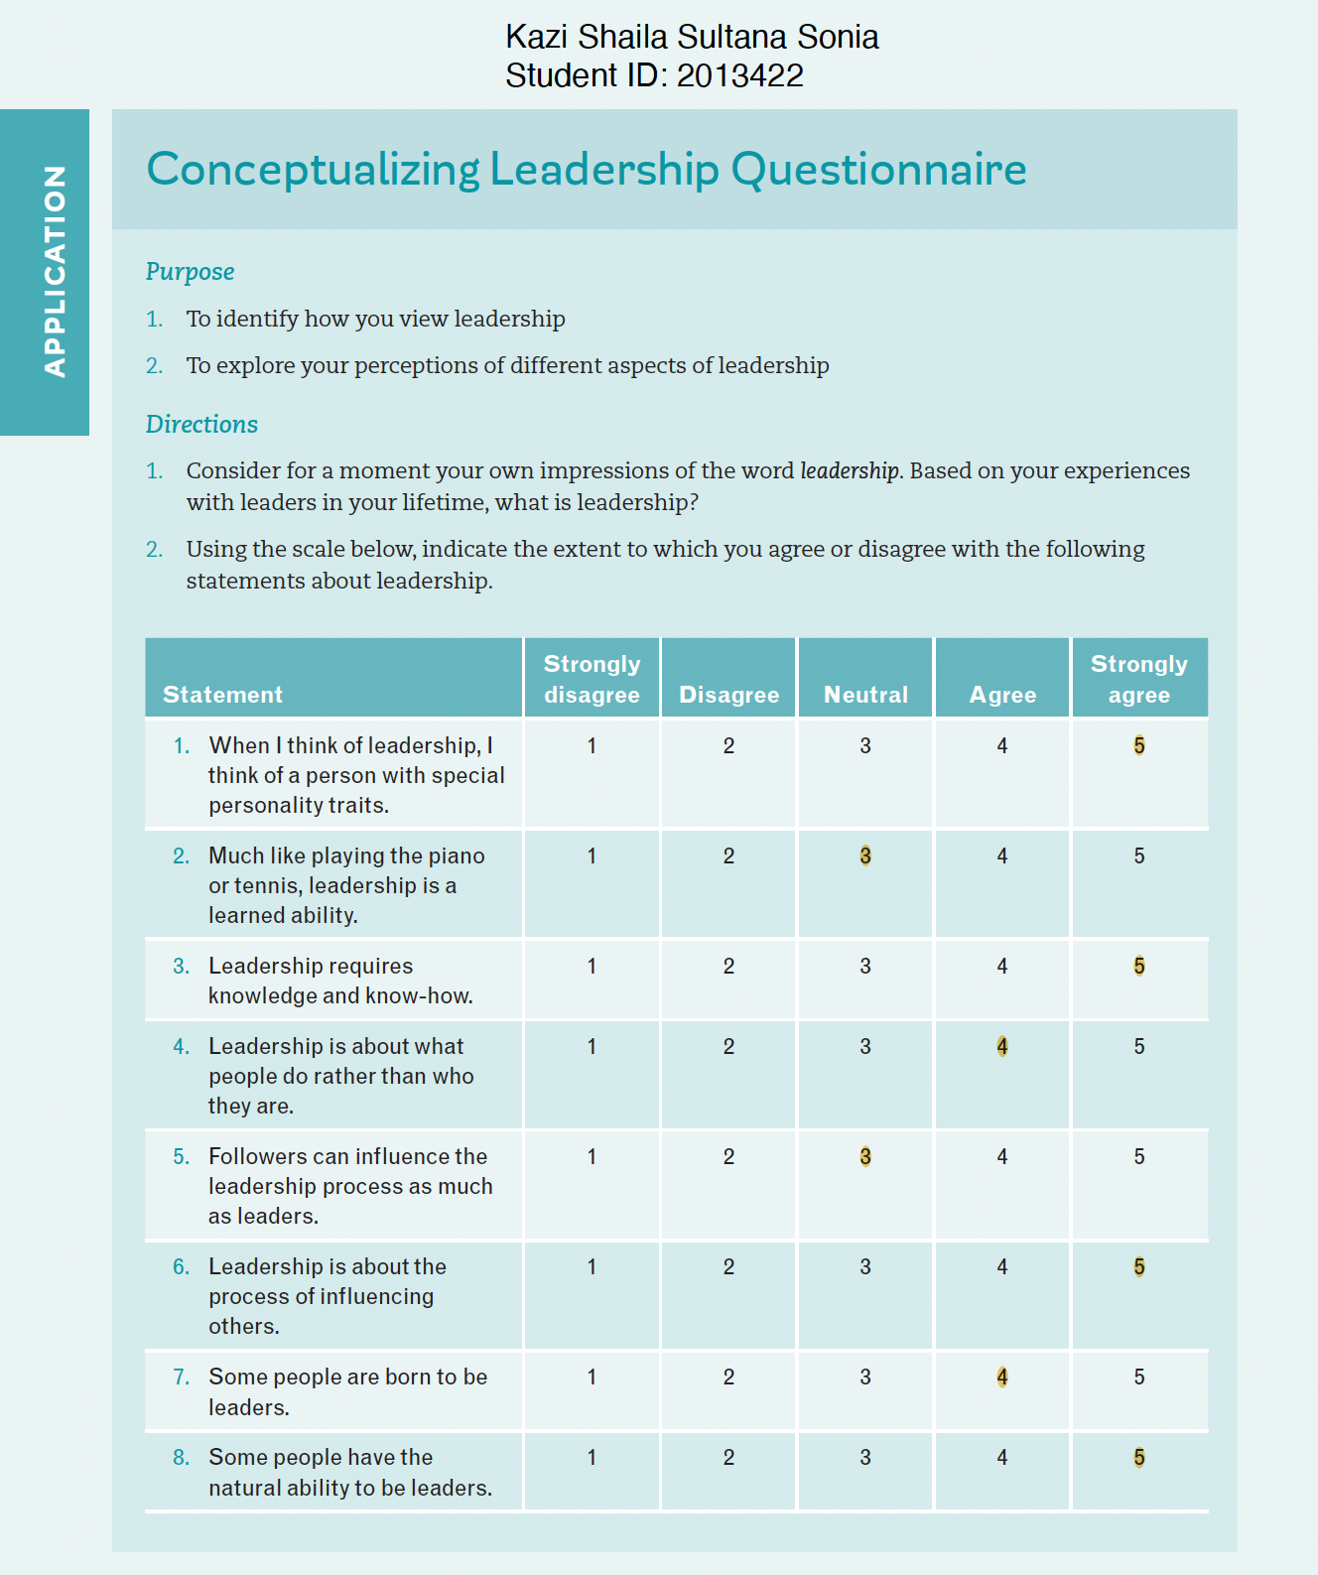

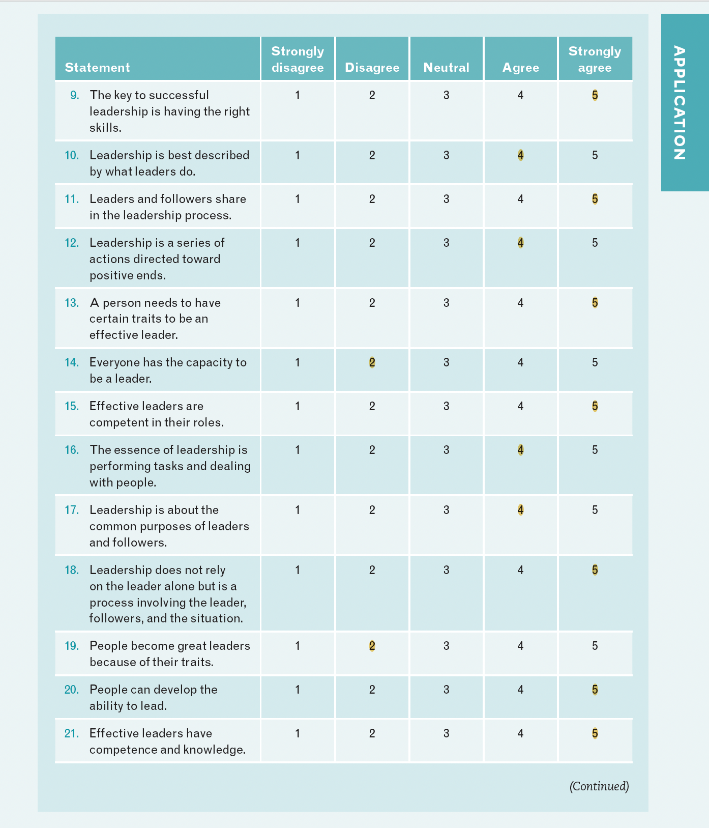

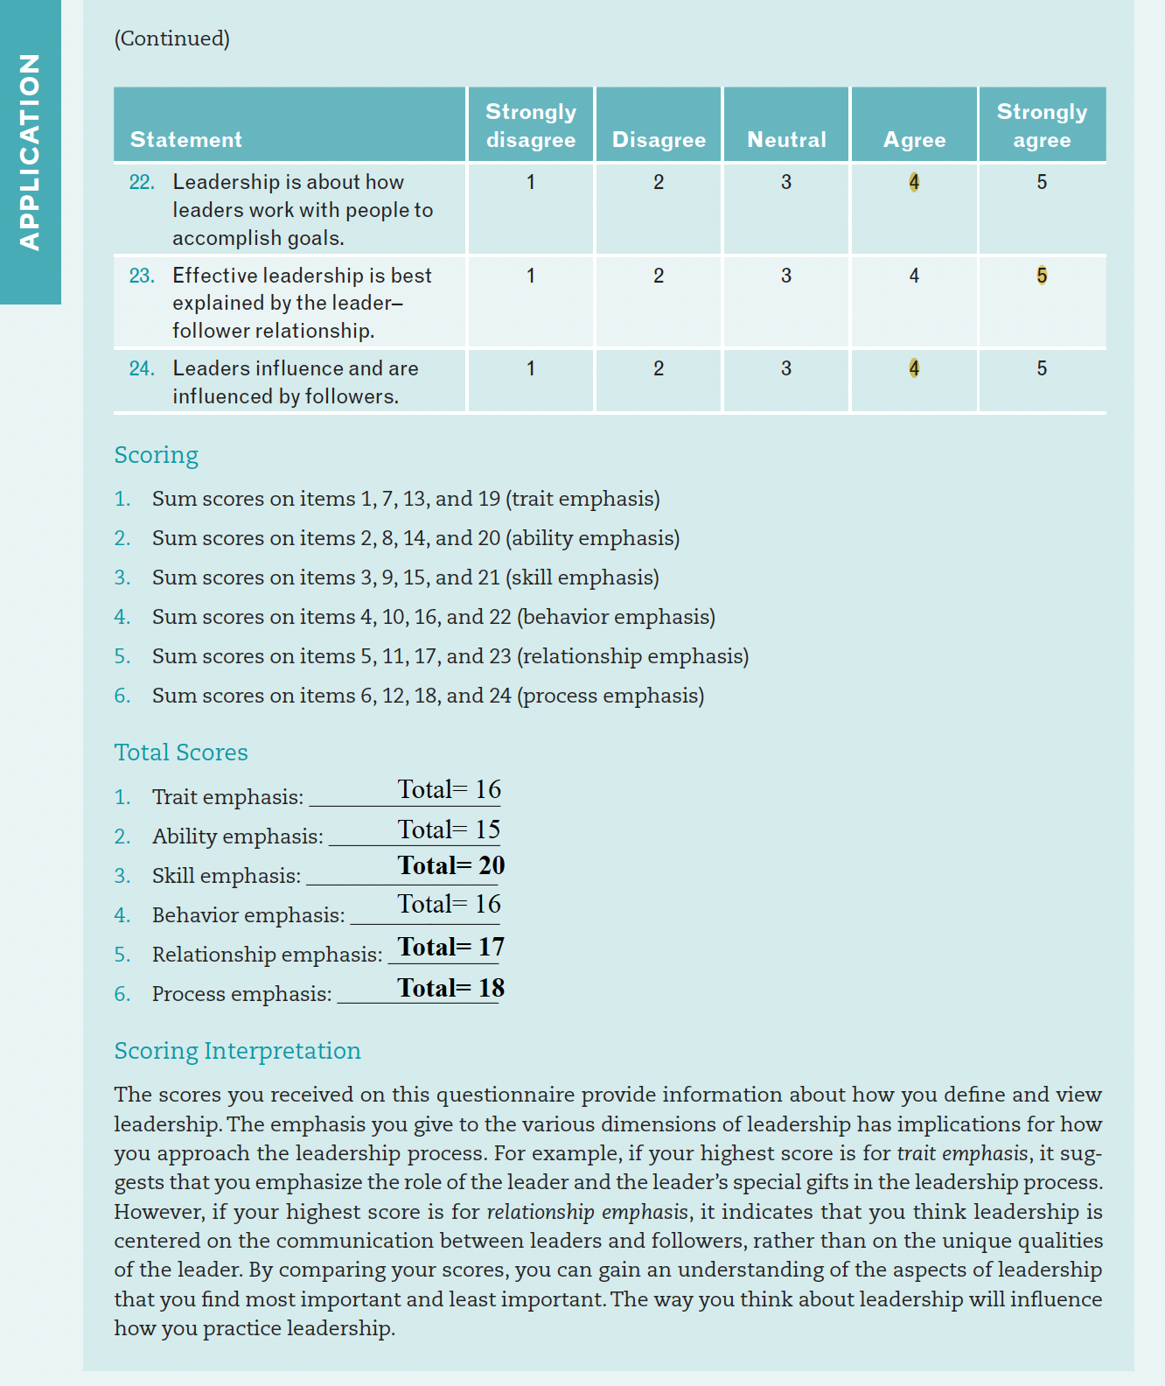

Task – 2

Individual Reflection Essay



The Summary of the learning and acquired skills from the module
‘Emergent Leadership Skills for the Workplace’

Introduction

This essay, which is a personal written reflection, aims to outline the learning and acquired skills from the module and demonstrate my abilities to convert my academic skills into employability skills and my ability to make decisions by comprehending the internal and external business environment at my workplace. I will use the widely used Gibbs Reflective Cycle, which has six steps and enables the reflector to think through every component of an activity or event (Gibbs, 1998).

Personal Reflection (Gibbs’ Reflective Cycle)

This module focuses on critically assessing one's capacity to carry out the major duties of the leadership role within the context of the workplace and making plans for the leadership of change or emerging leadership style. Since the first week of the module, I learned the evolution of leadership, examine the different perspectives on leadership and understand the impact of culture on leader effectiveness. And I deepen my understanding, watching TEDx video of Lars Sudmann ‘Great Leadership Starts with Self-leadership’ where he suggests that if one want to lead, need to invest 40% of time in leading oneself and there are three strategies of self-leading: self-awareness/ tool: character traits check, self-reflection/ tool: 2 to 5 minutes to reflect each day and self-regulation/tool: re-framing. Then I did a case study of Danny Hill’s task and relationship behaviours in his leadership style. Then I knew about six key leadership traits, and I filled a form of Conceptualizing Leadership Questionnaire where my score for skill: 20, relationship: 17 and process: 18, observing these scores I got an understanding of my leadership aspects. I came to know about Theory X, Theory Y, and Theory Z of leadership in week 3, and read an article on a critical review of leadership style and effectiveness. Following week, I filled a form for identifying own style of leadership and watch TEDx video of Roselinde Torres ‘What it takes to be a great leader’ and I came to know that Leadership is a choice, and it can be learned and practiced. Furthermore, I filled a questionnaire to measure my task-oriented (score:45) and relationship-oriented (score:55) leadership behaviour. Then we did a group activity, reading articles on importance of building relationship in the workplace. I came to know about important of developing administrative skills for being an effective leader along with interpersonal and conceptual skills.

In week six, I learned about various model of leadership like Contingency theory, transactional and Transformational leadership theory. Vision is a mental model of an ideal future state. I knew what vision is, the role of vision in leadership and the challenges in developing a vision. Following weeks, I learned Beer’s Model and Hennan-Freeman’s Theory of organizational performance, I studied about Ethical Leadership and its importance; Hence, the leader’s ethics establish the ethical climate for an organization. At the end, I learned Edwin Locke’s Goal-setting Theory where goals need to be specific, Challenging, must be accepted and Feedback. Goals are more effective when they are used to evaluate the performance.

I feel confident because I have a good understanding of leadership style and the key responsibilities of leadership in the workplace, and I know how importance of emergent leadership skills to face volatile and ambiguous challenges which we have been facing since 2020. I feel self-motivated as I know now my strengths and weaknesses evaluating the score of various questioners want to do to overcome the weaknesses. I feel I am ready to be a manager as I have knowledges, tools, and frameworks to justify the environment and making the decision applying my own leadership traits and approaches.

In hindsight, the experience I gained throughout this module, almost everything is good and positive. I learned how to critically analyse the skills, traits, and style of an effective leadership and the importance of having a plan of leadership for uncertain business environment or Emergent leadership style. This experience enables me to go forward with my dream to be a successful manager. To mention the bad side of the experience, I would say the time is very limited. The module is full of information, and all are very pragmatic and applicable in workplace. Only 10 weeks and its does not help us to dive into deep into the knowledge. The class environment could be more organised with IT equipment like computer, large TV, soundbox.

I think, although, I was juggling to balance my work-family-university life, I did concentrate fully on the discussion lectured had and the materials provided for lesions. I think, this module provides me all tools to be a successful leader, in addition, being ready with emergent leadership skills to face unpredicted challenges. However, I should have done more study and research and spend some time for extra book reading and teamwork.

During the module lesion, I gain clear understanding of leadership style, skills, traits, and approaches. I tried to fill the questioners to evaluate my skills, traits, and behaviours. Some score was not satisfactory, but I did not prioritize them. I could have discussed with my lecturer and ask his valuable suggestions. The module is full of reading materials like journal, books, articles. I could have invested more time for module session, reading and TEDx.

In the future, I want to apply all my learning knowledge into my workplace. For being a leader no need any position so I can be a leader without holding a managerial position as well. Anyway, I will ask my manage to give me an opportunity to gain some managerial experience as a Shadow worker. I know my strengths, weakness and traits (appendix), and I will put myself in action to improve myself. I will try to be balance with task and relationship approach of leadership style. Additionally, I will change how I interact with my team members by using different forms of communication, such as active listening and positive body language. I'll keep doing professional reflection on a regular basis using the Gibbs Reflective Model (Gibbs, 1988) as well as I will fill in Conceptualizing Leadership Questionnaire, skills and traits questionnaire to revaluate my strengths and weaknesses. I will read some book ‘Develop Your Leadership Skills’ by John Adair in 2007, ‘Emotional Intelligence’ by Daniel Goleman in 1995. I will undergo a coaching and mentoring session if needed. I will observe influential public figures, and watch TEDx Talks, YouTube videos provided in the module lesions, that I could not watch during the session.

Conclusion

The reflection on the outcome of the module is effective and worthful. I gathered a comprehensive understanding of leadership style and the key responsibilities of leadership in the workplace and the importance of emergent leadership skills to face volatile and ambiguous challenges like per and post Covid-19. I have all tools and techniques which I will be able to apply in my workplace, moreover, I know my strengths and weaknesses and I already make an action plan to improve myself as an effective leader who is ready to face ambiguous challenges like Covid-19 pandemic with an emergent leadership plan.

