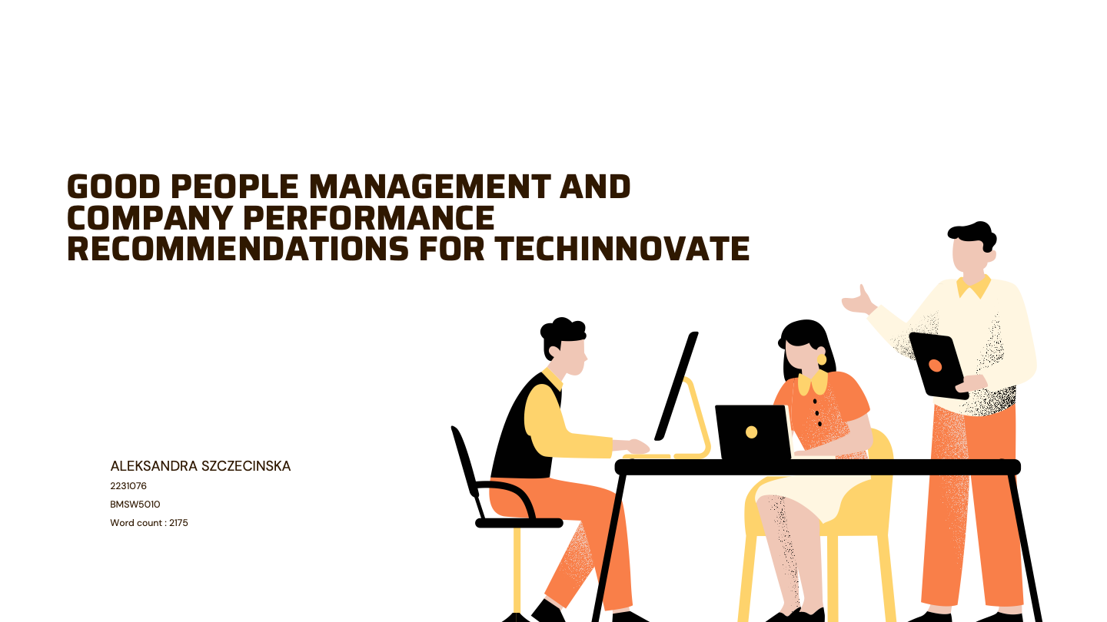

Table of Contents
1. Executive Summary 3
2. Introduction 4
3.0 Main Findings 4
3.1 Human Resources 4
3.2 TechLnnovate 6
4. Conclusion 11
5. References 12

Executive Summary

The report examined TechInnovate and offered suggestions. The report covered the history and terminology of human resources as well as the theories and frameworks that are relevant. It was also demonstrated that although HR has the resources, knowledge management is the responsibility of the employee.

Analysis revealed that the leader will play the primary role in creating a good work environment. It was acknowledged that this individual is and will oversee preventing turnover and increasing retention. To help both new and seasoned managers bridge the gaps in qualifications and acquire new ones, a training program was offered.

The purpose of performance reviews was to increase employee satisfaction and engagement. High turnover and decreased team productivity have resulted from the lack of a formal performance review system.

The research also revealed that a lack of recognition methods has resulted in a decline in employee motivation. To increase morale and productivity, it was suggested to create a reward system with features like incentives, "Employee of the Month" programs, and packages for mental health care.

Employee loyalty has decreased, and conflicts have arisen because of a lack of emphasis on diversity and inclusion. In this instance, it was suggested that diversity and inclusion policies be strengthened through objective recruiting procedures, training courses that tackle workplace prejudices, and projects that provide workers a feeling of community.

Employee disengagement, poor communication, and uncertainty have all been caused by a weak corporate culture. Promoting a culture based on open communication, common ideals, and respect for one another was suggested. To motivate staff members and preserve a positive work-life balance, leaders should set a good example.

Introduction
The recommendations that Aleksandra Szczecinska prepared were for the beginning and analysis of TechInovate oversight. The author analysed recruiting and retention companies and explained why it is crucial.

Human resource management (HRM) transforms from a support function to a strategic partner in accomplishing organisational goals as businesses expand. Good HR procedures are essential for creating a welcoming and inclusive workplace and matching workforce capabilities with corporate objectives.

The experience of TechInnovate emphasises how crucial it is to have a strong HR framework that strikes a balance between organisational expansion and worker welfare.

The main HR issues facing TechInnovate are examined in this report, with a focus on the necessity of diversity and inclusion programs, structured performance reviews, recognition of staff members, and effective leadership development. It also describes methods for developing a vibrant, driven, and efficient employees that supports the strategic objectives of the business. To prepare the report, credible sources such as books , journals and websites were used .

Main Findings

American mechanic, productivity specialist, as well as leadership consultant Frederick W. Taylor is regarded as the founder of scientific management. He outlined the approach of conducting scientific research to improve worker and organisational efficiency in his landmark book, The Principles of Scientific Management, which was released in 1911. Task specialisation, assembly line production methods, job evaluation, job layout, rewards systems, and goal setting and control are only a few of the management techniques that were influenced by the ideas that underpinned his theory during the twentieth century. (Giannantonio, Hurley-Hanson,2011).

3.1 Human Resources

In business texts, the emphasis is on the creation of a system for "HR planning" and "HR development" that would entry, promote, and manage people's shared assets and guide them towards achieving company goals. (Inkson ,2008). Indeed, HR planning and development offer well-defined paths for both organisational success and personnel advancement. If the framework isn't counterbalanced with an approach that prioritises people, it might harm employee liberty, creativity, and job satisfaction.

As businesses work to make the HR function more tactical and thinner, current HRM models indicate that expectations for positions in human resources are evolving. (Francis, Keegan,2006). The modification is indicative of a larger movement in which HR is seen as a strategic partner in attaining organisational success rather than only a support function.

Below model called 5-p which was created by Randall Schuler in 1992. As Schuller and Jackson (1992) stated: “many activities within the five "P” (HR Philosophy, Policies, Programs, Practices, and Processes) can be strategic”. The 5Ps Model is still a useful framework for coordinating HR operations with corporate strategy. Its strategic emphasis and comprehensive strategy are its strongest points. However, its flaws include a lack of enforcement and flexibility guidelines.

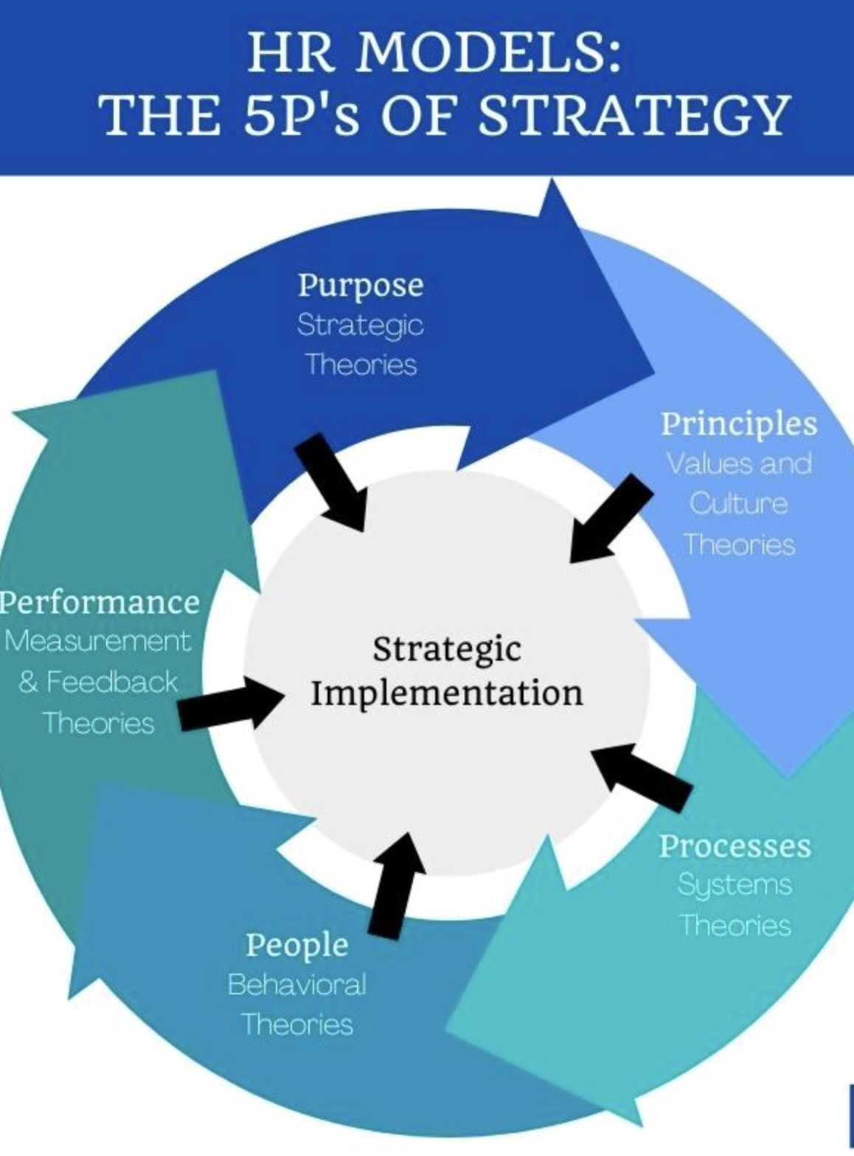 Hans (2024).

The concept is in line with more general strategic HR frameworks that highlight how crucial HR is to the success of businesses. The "Above the Line" and "Below the Line" distinctions are more of a conceptual framework used in modern HR to show how HR can contribute at different levels throughout the company.
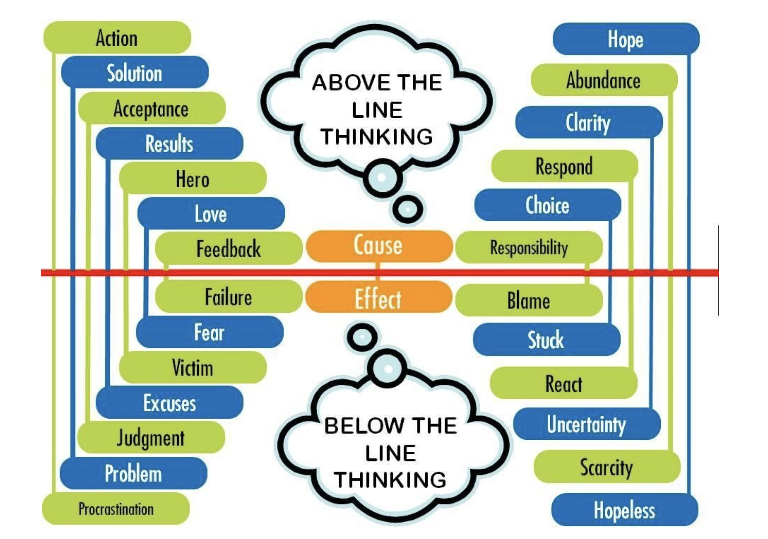 Lowina(2020).

We see ourselves as victims and refuse to accept accountability for our acts when we are below the line. The below-the-line behaviours of disputing, accusing, and dismissing are then manifestations of this mindset.

Above-the-line actions show vulnerability, self-assurance, and accepting individual responsibility. A person who operates above the line interprets life through a "through me" perspective, seeing it through the eyes of a creator who can influence and learn from their surroundings. They are receptive, inquisitive, and dedicated to education.

The function of HR in business is shown in the structure above. It demonstrates that HR's overarching goal is to develop leaders' strong, self-assured minds. Although human resources can carry out the training and strategy, leaders and staff must focus on improving their conduct and abilities.

3.2 TechLnnovate

The environment and relationships inside the organisation are immediately impacted by the leadership style, which also indirectly influences the team's output and efficiency. (Kan,2024). Whether the business will continue in accordance with the norms and culture, as well as whether people will want to follow himself, depends on this individual. Managers are required to encourage teams, give clear instructions, and assist individuals in reaching their own and the organization's objectives. They are also in charge of establishing a harmonious team atmosphere that encourages cooperation.

To cultivate the abilities that propel performance and sustained corporate success, an organisation can:

- Management Training Program - Formal training that covers subjects including hiring and firing, coaching, identifying training requirements, inclusive workforce, and dispute resolution. Enhancing executive skills has a direct correlation with increased productivity and staff retention.

“Coaching is a training process that can develop self-confidence, self-efficacy, and contribute to actions that create results”. (Karlsen, Berg,2012).

Managers must comprehend the company's technological stack, the core product, and the technical difficulties that their teams encounter in a technical setting like TechInnovate. Unfortunately, a lack of leadership abilities results in poorer business sales or higher employee turnover in numerous companies. Eliminating skills gaps cannot be accomplished with a method that is universal that works for all business sizes and industries. (Lindorff,2011). This is true, but to prevent this, businesses need to train leaders and make sure they have people in the right place at the right time.

Thomas Carlyle, who advocated for the Great Man Theory of Leadership model, held that we are born with the capacity to lead; we cannot learn it.
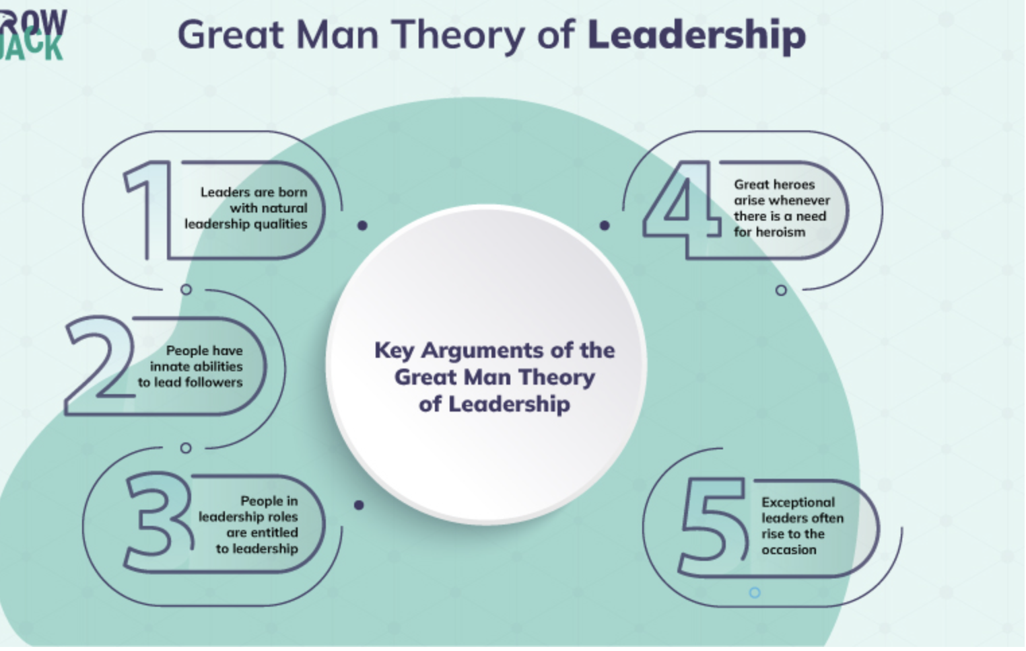 Miller (2022).

Despite the model's contentious sound, the issue is widespread. Many workers who perform exceptionally well are promoted to managers or leaders. Unfortunately, promoting employees to leadership positions requires more than just their excellent efficiency. Insufficient credentials and training frequently result in the team's dissolution.

A professional growth framework known as the 70-20-10 Learning Model places a strong emphasis on the value of education, experience, and engagement.

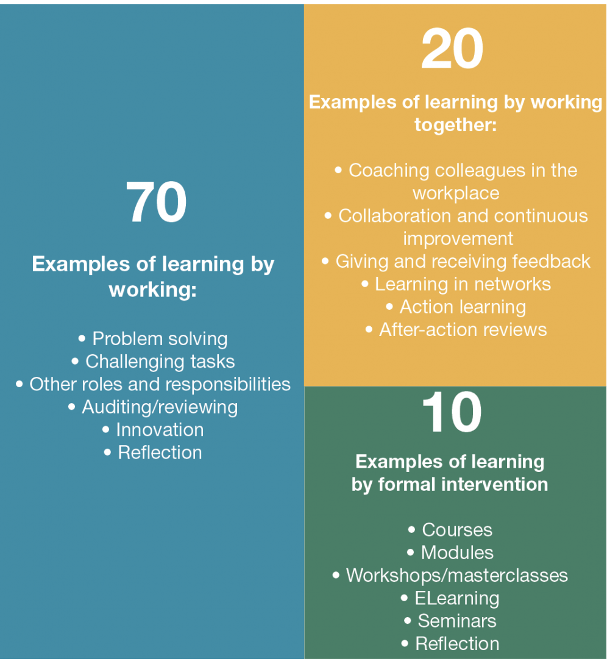702010 Institute (2024).

Nevertheless, a brief examination at the 70-20-10 model indicates that the formula's 70% represents the largest opportunity area. (Mclagan,2017). People often say that they learn by doing. If they are unable to put their newly acquired information and skills into practice, it will not always be enough. The managers at TechInnovate will find this model very helpful since they may improve their management abilities through a combination of formal training programs, learning from others, and practical leadership activities. The model may also face challenges. One of them is that learning through practices will necessitate a great deal of leadership support, which may result in an abrupt drop in the organization's output. The industry position will not always be compatible with the model.

“An open mind and a willingness to learn are also staples of strong leadership”. (Dorner,2022).

High levels of employee engagement, satisfaction, and performance are ensured by effective people management. There is no official performance review procedure in place at TechInnovate. To guarantee that workers are regularly assessed, given helpful criticism, and inspired to achieve company objectives, this needs to be handled.

One of the most important aspects of performance management is performance evaluation, which should be important, relevant, and consistent with the development of the company. It evaluates what is most important for the company and its employees. (Kis,Tudoran,2023). Goal and objectives must be presented through the SMART framework.

By enhancing job performance, facilitating the identification of strengths and shortcomings, and assessing eligibility for advancement, appraisals can be valuable to employees as well as employers. The appraisal is a chance to reflect on the accomplishments of the reporting period, agree on goals for the following one, and take a broad picture of the amount of work, amount, and subject matter of the job.

TechInnovate must establish a systematic system of staff rewards that encourages productive behaviour, reduces resignation, and inspires employees. Maslow made a distinction between the coping and expressive types of human motivation. (Hansen F. et al,2008, Smith et al,2008 , Hansen R. et al,2008).

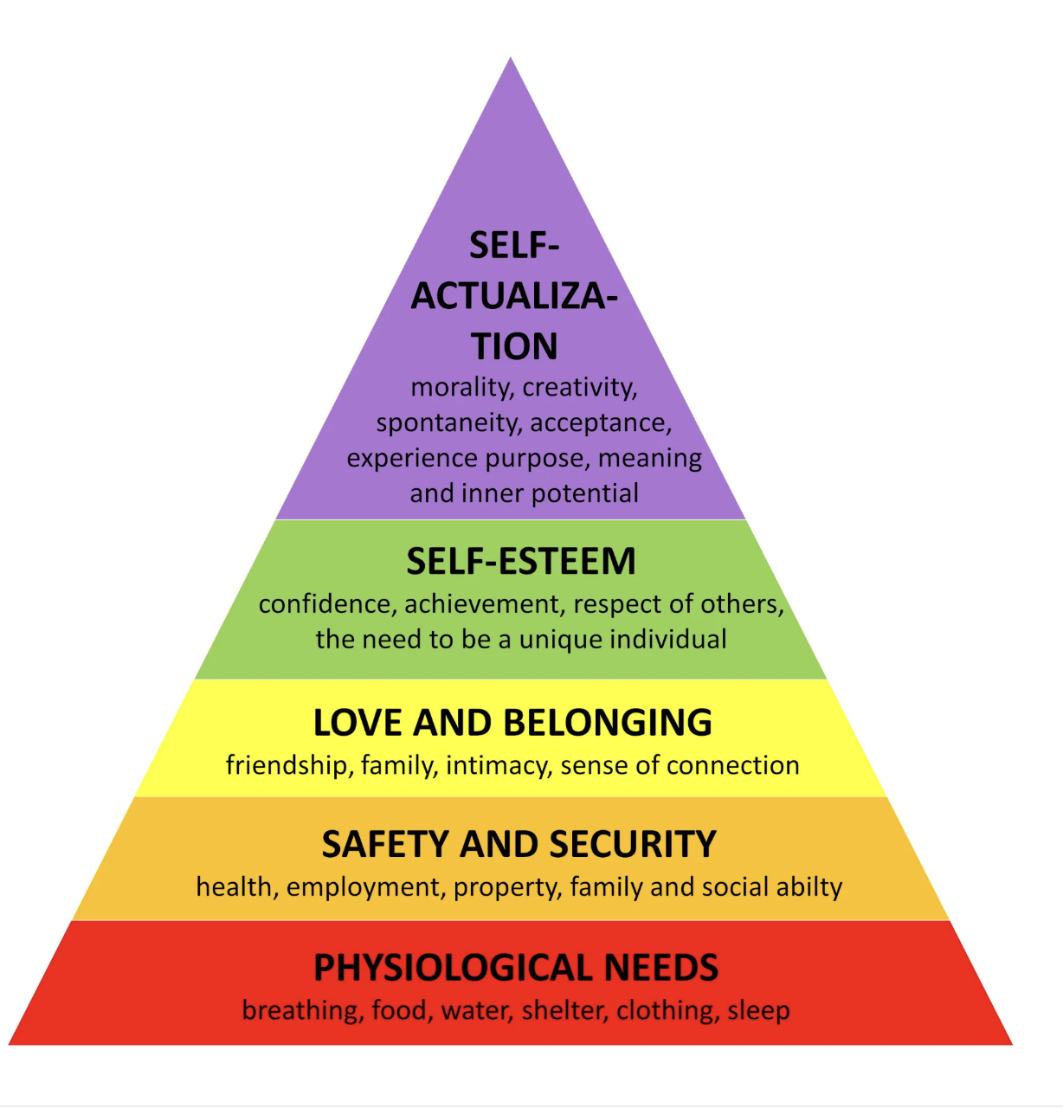 Mcleod(2024).

According to this theory, when people believe they have adequately met the previous demand, higher needs in the hierarchy arise.

Motivation and achievement among workers can be enhanced by rewards and recognition. Rewards and recognition have the potential to improve employee happiness and foster a positive work environment when handled properly. TechInnovate must implement a reward system, and these may be:

- When an employee is chosen as the employee of the month and given a bonus, it will feel valued and honoured, which will improve output. Creating KPIs and evaluating or rewarding employees in this way will be a unique experience that will help the business grow.

- Mental Health First is providing a manager and employee package that includes a free psychological consultation. For those who become overwhelmed and unsure of how to handle it, work has a significant influence on their personal lives in the twenty-first century. Maintaining a healthy work-life balance is crucial.

Employee motivation is a significant problem since it lays the groundwork for high performance levels and reduced periods of inactivity. (Smither, Walker,2000). Employee productivity declines when there is a lack of commitment and motivation. As a result of self-preservation, the team becomes less dedicated, and the corporate culture deteriorates. The above behaviours will impact all stakeholders in the company.

Inclusion and diversity are not well-known in the workforce. However, management must genuinely embrace diversity and then foster it with inclusiveness if they want to reap all its advantages. (Ferdman et al,2021, Prime et al,2021, Riggio et al,2021). Diversity is the state of having a variety of distinct elements in the company including:

- Gender
- Colour
- Religion
- Culture
- Age
- Skills
- Education
- Physical characteristics, and disabilities

While inclusion refers to the strategies that foster diversity, diversity itself is an idea. When team members experience safety, acceptance, and inclusion at work, they are successful. Employees have a sense of inclusion when they have access to information, systems, assets, and protection that allows them to have an impact on choices and feel like they belong to a group or organisation. (Jeronimo et al,2022, Henriques et al,2022, Carvalho et al,2022).

It is advised that businesses enhance their diversity and inclusion policies by:

- To improve the company's reputation, highlight in the job posting that the organisation values and prioritises diversity and inclusion. More varied job candidates result from not limiting hiring to specific societies, ethnic groups.
- Curriculum for training can encourage respectful and constructive relationships at work and assist in recognising and addressing biases.
- Policies in place strive to educate staff members on appropriate and inappropriate behaviour as well as how possible problems are handled.

Lack of diversity and inclusion in the workplace affects staff loyalty, business achievement, and retention.

The company culture and all the suggestions must complement one another. Because it affects employee behaviour, the work environment, and an organization's overall success, company culture is extremely significant. Uncertainty, lack of interaction, and irregularity are caused by a negative company culture. (Mansour,2024).

The foundation of a strong workplace culture consists of honest communication, significant employment, and fundamental principles. From the top, workplace culture begins. Leaders may actively empower staff members to perform at their highest level by emphasising work-life balance, a positive outlook, and respect for one another. The underlying values of the company may be reflected in culture, or they may be betrayed. A company practices, workflow management, team dynamics, and customer service all contribute to an experience that should reflect the organization's identity and views on how a firm should be operated. To put it succinctly, company's culture is the culmination of its values.

Conclusion

Since the start of its rapid expansion, TechInnovate has encountered numerous difficulties. Numerous mistakes have been made by undertrained employees that must be fixed.

Businesses can develop a motivated, high-performing workforce by coordinating HR operations with organisational objectives, for example, through performance management, reward systems, and organised leadership training.

Employing competent managers and providing training for current managers will be the company's top priorities. The corporation employed management without qualifications in response to the significant rise in orders, which decreased team productivity. Present managers lack the skills necessary to lead a diverse and inclusive team, manage an inclusive workforce, or train employees.

The organisation experienced turnover because of the absence of performance requirements. Performance management is the key to good communication with the employee. By setting goals and measuring them, it brings many benefits to the employee and the company.

Additionally, Techinnovate suggested putting in place a program for staff rewards. According to the findings, it boosts employee potential, happiness, and the target team's atmosphere.

Diversity was important to the business as well. In its absence, the team experienced conflict, a lack of acceptance, and a diminished sense of security. Its deployment was thought to decrease retention, corporate success, and employee loyalty.

In the end, for businesses to succeed, leadership needs to take the initiative to build both individual skills and the company culture. A dynamic, driven workforce that is in line with the company's vision and capable of making a significant contribution to its expansion is the outcome of HR policies that place a high priority on people in addition to organisational goals.

References

702010 Institute.. (2024). What is the 70:20:10 model?. [Online]. Jos Arets. Available at https://702010institute.com/702010-model/. [Accessed 27 November 2024].

Bernardo M Ferdman, Jeanine Prime, Ronald E Riggio. (2021). Inclusive Leadership: Transforming Diverse Lives, Workplaces, and Societies. London: Routledge. p.60.

Frederick Hansen;Michelle Smith;Ries Hansen. (2002). Rewards and recognition in employee motivation. Compensation and Benefits Review. 34(5), pp.64-72.

Guinevere L. Smithers, Derek H.T. Walker. (2000). The effect of the workplace on motivation and demotivation of construction professionals. Construction management and economics. 18(7), pp.833-841.

Helen Francis, Anne Keegan. (2006). The changing face of HRM: in search of balance. Human resource management journal. 16(3), pp.231-249.

Helena Mateus Jerónimo, Paulo Lopes Henriques, Sara Isabel Carvalho. (2022). Being Inclusive Boosts Impact of Diversity Practices on Employee Engagement. Management research. 20(2), pp.129-147.

Ishvani Hans. (2024). Top 10 HR Models Every Human Resources Professional Should Know. [Online]. Select‍Software Reviews. Available at https://www.selectsoftwarereviews.com/blog/top-10-hr-models. [Accessed 27 November 2024].

Jan Terje Karlsen , Morten Emil Berg. (2012). An evaluation of management training and coaching. The journal of workplace learning. 24(3), pp.177-199.

Jiajun Kan. (2024). Research on the relationship between leadership style and team dynamics in high-performance teams. SHS web of conferences. 200(1), p.2031.

Judith Kis, Diana Tudoran. (2023). Integrating Employee Feedback into the Continuous Improvement of Performance Management. Revista de Management Comparat International. 24(5), pp.760-772.

Kerr Inkson. (2008). Are humans resources? Career development international. 13(3), pp.270-279.

Kiara Miller.. (2022). A Comprehensive Guide on The Great Man Theory of Leadership. [Online]. Crow Jack. Available at https://crowjack.com/blog/strategy/leadership-theories/great-man-theory. [Accessed 27 November 2024].

Lowina. (2020). Above the line Below the Line Thinking Pattern: Which side are you? [Online]. Money Phlow. Available at https://lowinablackman.com.au/above-the-line-below-the-line-thinking-pattern-which-side-are-you/. [Accessed 27 November 2024].

M. Giannantonio, Amy E. Hurley-Hanson. (2011). Frederick Winslow Taylor: Reflections on the Relevance of The Principles of Scientific Management 100 Years Later. Journal of Business and Management. 17(1), pp.7-10.

Margaret Lindorff. (2011). Skills gaps in Australian firms. Journal of vocational education & training. 63(2), pp.247-259.

Marwa Mansour. (2024). The Impact of Organizational Culture on Employee Engagement and Performance. Journal of Business Studies Quarterly. 13(3), pp.8-14.

Pat Mclagan. (2017). Unleashing the Unstoppable Learner. Talent Development. 71(7), pp.44-49.

Randall S. Schuler , Susan E. Jackson. (1992). Strategic human resources management: Linking the people with the strategic needs of the business. Organizational dynamics. 21(1), pp.18-32.

Saul McLeod. (2024). Maslow’s Hierarchy of Needs. [Online]. Simply Psychology. Available at https://www.simplypsychology.org/maslow.html. [Accessed 27 November 2024].

Udi Dorner. (2022). What Makes A Great Leader? Best Practices When Discovering Your Management Style. [Online]. Forbes. Last Updated: 15 February 2022. Available at: https://www.forbes.com/councils/forbesbusinesscouncil/2022/02/15/what-makes-a-great-leader-best-prac [Accessed 28 November 2024].

