

Digital Forensics
(ACCA7031)

End of Semester Assignment

By
Talwinder Kaur (2227879)

January, 2023

Contents
ABSTRACT 3
1. INTRODUCTION 4
TASK 1 5
2. CURRENT STATE OF THE FIELD 5
2.1 The Intersection of Digital Forensics and Cybersecurity 6
2.2 CHALLENGES 7
2.4. Emerging Trends 7
2.5. National and International Job Market 9
TASK 2 10
3. The current state of digital forensic tools, their features, and capabilities 10
3.1 Forensics Tools 10
3.2 Open-source tools and Commercial forensics tools 12
4. TASK 3: HARD DISK 13
HDD GROUP REPORT 13
4.1. Scenario: corporate crime 13
4.2. DATA EXTRACTION 14
4.3. Evidence from Image 21
4.4. ANALYSIS REPORT BASED ON EVIDENCE ANALYSED 22
4.5 Challenges 24
TASK 4: MOBILE FORENSICS 25
5. Executive Summary 25
5.1 Background 25
5.2 Scope 25
5.3 Key Findings 25
5.4 Case Information 25
5.5 Methodology 26
5.6 Data Acquisition 26
5.6.1 Device Identification 26
5.6.2 Data Extraction 26
5.6.3 Data Preservation 27
5.7. Data Analysis 28
5.7.1 Overview 28
5.7.2 SUMMARY OF ANALYSIS 34
5.7.3. Recovered Data 35
5.7.4 Deleted Data 35
5.8. Forensic Artifacts 35
5.8.1 Artifacts Overview 35
5.8.2 Notable Findings 36
5.9. Conclusions 36
5.9.1 . Recommendations 36
5.9.2 Limitations 37
5.9.3 Acknowledgments 37
CONCLUSION 38
REFERENCES 39

Figure 1 screenshot of HDD properties 16
Figure 2 powershell commands 16
Figure 3 Evidence of recovered files and folders 17
Figure 4 Recovered files 18
Figure 5 Screenshots of recovered personal details 19
Figure 6 screenshot Veracrypt 20
Figure 7 screenshot mysql DB 23
Figure 8 screenshot mail 24
Figure 9 screenshot Database 24
Figure 10 screenshot bank statement 25
Figure 11 Screenshot suspect list 26
Figure 12 extraction summary 29

Table 1 Evaluation of open-source and commercial forensics tools [10] 14
Table 2 Given evidence 23

ABSTRACT

Digital forensics plays a pivotal role in modern investigations, addressing the challenges presented by the pervasive use of digital technologies. This work provides an overview of the current state of digital forensics, with emphasis on the complexities faced by investigators in a rapidly evolving technological landscape. Challenges include the encryption of data, volatile memory analysis, and the sheer volume of digital evidence generated daily. The paper also examines the tools employed in digital forensics, ranging from traditional forensic software to advanced data recovery techniques and machine learning applications.

INTRODUCTION

Digital forensics is now a fast-evolving discipline. As part of cybersecurity and criminal investigations, it is dedicated to uncovering and analyzing digital evidence to support legal proceedings. As our society becomes increasingly reliant on digital technologies, the importance of digital forensics has grown exponentially. This field encompasses a wide range of activities, from recovering data from electronic devices to analyzing network traffic and identifying cyber threats. Understanding the current state of digital forensics involves exploring the challenges faced by investigators, the tools at their disposal, and the emerging trends shaping the future of the field.

TASK 1

CURRENT STATE OF THE FIELD
Digital forensics is focused on finding, collecting, analyzing, and storing digital evidence, or reconstructing crime scenes to discover how the suspects or offenders and the victim perpetrated the crime.
In order not to damage the evidence, Special techniques and methods must be adopted to carefully extract information from digital devices. If the information is currently extracted, the motivation behind the crime can be revealed by the analyst.
The field's current state shows that there's been a big advancement in the field between 2018 and now.
As of 2018, there were fewer papers written on the topic, of digital forensics. According to research conducted by [2], it is observed that the current digital forensic investigation (DFI) models are mainly designed to support the investigator and the procedures involved in the investigation, not many tools are available to drive the analysis phase.
This means intensive research must be conducted in this area.
To further discuss the current state of this field, the following key points will aid in the discussion
- Advancement in Technology
- Cybersecurity Challenges
- Artificial Intelligence and
- Machine Learning
- Legal and Ethical Challenges
- International Collaboration
- Education and Certification

2.1 The Intersection of Digital Forensics and Cybersecurity
The intersection of digital forensics and cybersecurity plays a great role in ensuring the security of digital assets and responding to cyber threat incidents. It is more like a symbiotic relationship where proactive measures are put in place to handle cybersecurity incidents and reactive methods and techniques are adopted during digital forensics investigations.
Digital forensics and cybersecurity aim to achieve a common goal, which is to protect an organization's digital assets, but they adopt different approaches and techniques in doing this [3].
Some key points to further explain the intersection between these two fields are discussed below:

1. Continuous Improvement
2. Adaptive Cybersecurity Strategies
3. Proactive Cybersecurity Measures
4. Collaboration and Sharing of Information
5. Reactive Digital Forensics Investigations

The collaboration between these two dynamic fields is essential for enabling a more robust and adaptive cybersecurity ecosystem amidst increasing cyber threats.

2.2 CHALLENGES
Due to the complexity of this field, new technological models and solutions must be developed to tackle the evolving challenges in digital forensics [3].
More challenges are discussed below [3]:
- Insufficient and readily available free forensic tools to conduct an investigation: Most available tools are not open source and not everyone can afford to purchase the licensed copy.
- Readiness of forensic expertise and management is lacking: There is not enough expertise and a proper management system in this field.
- Managing data fragmentation is a major setback during investigations.
- Jurisdiction for confidential data is lacking: currently, there are no proper guidelines on data confidentiality because of differences in jurisdiction.
- Cross-border investigation is lagging due to the different jurisdictions and laws of each Nation.
- Interoperability and training are lagging between the court and forensic investigators: no sufficient professional training is readily available.
- Unethical practices in digital forensics (Anti-forensics): so many anti-forensics practices are affecting the outcome of investigations.
- The lack of sufficient experts in the field is also a setback: due to how complex and sensitive this field is, a lot of people are scared of going into the field.

2.4. Emerging Trends
As more users are embracing technological devices and more devices are connected online, the chances of cyber-attacks are also increasing, making digital forensics an ever-evolving field. New trends are emerging but new challenges are also evolving, which means forensic investigators must also expand their expertise to meet up with current trends [1]..
Some of the recent trends will be discussed based on the following key points:

Deepfake Detection and Analysis: the level of deep fake technology advancement is on the rise, and posing serious security issues for users of technology. Digital forensics professionals are developing new models and techniques to bridge this gap [1].
Memory Forensics: Most high-profile cases rely on evidence data from mobile devices to establish a case. New mobile devices are now created with sophisticated embedded operating systems, chips, volatile memory, encryption, etc. Experts in this field must stay up to date with these trends [1].
Cross-disciplinary collaboration: this aspect is currently under research. More attention will be given to cross-border collaboration in digital forensics.
Machine Learning and Artificial Intelligence: With the integration of AI and machine techniques, larger amounts of data can be easily sifted through to find hidden patterns and evidence [1].
Internet of Things (IoT) Forensics: a lot of smart devices and machines are not connected to the Internet, and they share and store data, however extracting and analyzing these data can be a great deal to investigators, but tools like encase and OSForensics has been designed for this [1]..
Remote Forensics: remote forensics was made possible during the Covid-19 pandemic era, in 2020. Cybercrime was on the rise during that period, and since experts couldn't access their laps, remote access to forensics lap and tools was the way out. However, this technology is still under research, as maintaining evidence integrity and confidentiality is a challenge [1].

2.5. National and International Job Market

The "Global Digital Forensics Market 2018 - 2025" report projects that by 2025, the digital forensics job market will grow to an astounding $7 billion. Compared to the estimated $3 billion that was disclosed in 2017, this amount is higher. As businesses and consumers alike depend more and more on connected devices, the likelihood of falling victim to cybercrime has escalated. According to the same study, about half of all people on Earth communicate with digital devices daily. Cybercrime will unavoidably rise as the population grows and technology gets more affordable and accessible, posing new difficulties for security professionals. This means there are going to be more job opportunities in digital forensics by 2025. Thankfully, several cutting-edge technologies that will support digital forensic investigators are starting to take shape [11].

TASK 2

The current state of digital forensic tools, their features, and capabilities

Digital forensics is playing a major role in combating cybercrime and other digital-related crimes. The current state of digital forensics tools shows that the struggle investigators once had, in trying to extract and analyze data is gradually not becoming a challenge as new and sophisticated forensics tools are been developed to tackle this issue. Crimes like Cyber-bullying, Terrorism, financial fraud, Cryptocurrency, Identity theft, etc can easily to investigated with the help of forensics tools. These tools can extract data from any device without corrupting or altering the evidence. Metadata indicating the timestamp, dates, locations, and source of files, can be analyzed, and the culprits brought to face the law [9].
With the current adoption of AI and machine learning technologies in digital forensics, investigators can now conduct investigations on complex cases and obtain clear evidence [10]. Forensic software like ADF Solutions' software is gradually revolutionizing the way investigators carry out investigations. ADF can collect and analyze evidence faster and more accurately than other existing tools. It also supports collaboration among other investigators [9].

3.1 Forensics Tools
Below are lists of forensics tools with their features and capabilities 14.

Digital Forensics Tools | Features | Capabilities
Sleuth Kit (Autopsy): an open-source digital forensics tool. | Disk image, file analysis, keyword search, timeline analysis | Ability to analyze file systems, timeline analysis, and data carving  uses command-line commands to analyze disk volumes, extraction of disk drives and volume, and the analysis of evidence data.
Encase forensics:  A proprietary forensics tool with more advanced functionalities, mostly used for complex investigations | Disk imaging, keyword search, file analysis, and evidence collection. | Ability to perform Cryptographic hash calculations,  Ability to carry out EXIT meta-data extraction,  Can conduct memory dump analysis,  Automatic data extraction,  Static and Live investigations analysis.
Volatility: it is a free forensic tool used for memory analysis like. E.g RAM | Memory acquisition, process identifier, | Ability to extract data from volatile memory, identify active processes, and analyze network connections.
Wireshark: an open-source tool that analyzes network packets | Live capture and offline analysis, network filters  runs on multiple operating systems. | Ability to capture and analyze network traffic, identify untrusted packets, and inspect multiple data packets at a time.
X-Ways forensics: a commercial tool for disk and file analysis. | Disk imager, metadata analyzer, and file carving | Capable of reading data from either an image, a disk, volume, or partitions, extracting huge data from a source, ability to produce tangible information of files and directories.
Magnet AXIOM: a commercial mobile and computer forensics platform. | Memory analyzer, mobile device analyzer, supports cloud forensics. | Has the capability to acquire and analyze data, and generate reliable reports after analysis.
Splunk: a commercial tool used for analysis logs. | Data extractor, log analyzer, threat detector, and events correlation. | Ability to generate logs for security information, useful for event management systems.
Cellebrite UFED: a commercial tool for mobile forensics. | Supports physical and logical extraction, decrypts keychain items and raw disk images, Visual events timeline, customizable reports, and advanced decoding feature. | Ability to extract data from mobile devices, and analyze extracted data to generate reports.

3.2 Open-source tools and Commercial forensics tools
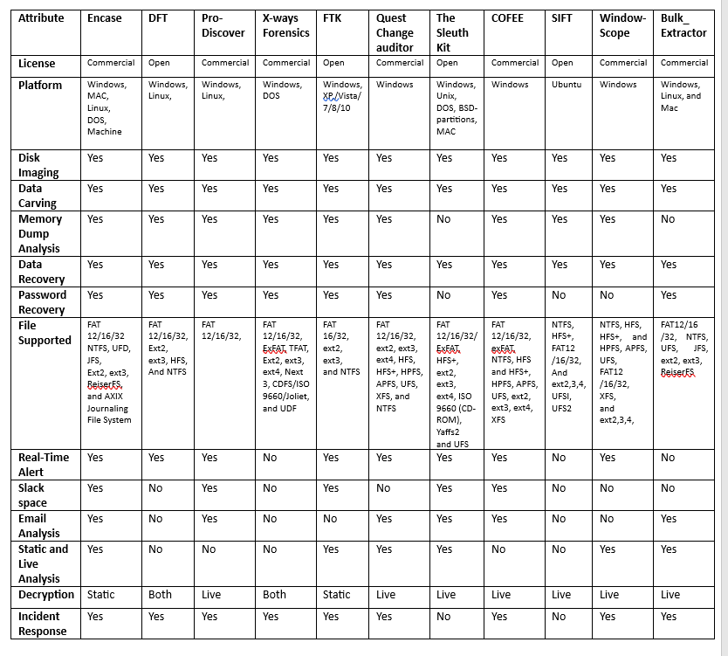
Open-source forensics tools are free tools developed by a community of developers for use by anyone who needs them. It usually has no license renewal restrictions, whereas the commercial tools are not free for use, but are only available to those who purchase its license. I will evaluate these two types of forensics tools using the following attributes; Imaging, carving, memory dump, platform, data recovering, etc [10].

Table 1 Evaluation of open-source and commercial forensics tools [10]

TASK 3: HARD DISK

HDD GROUP REPORT

4.1. Scenario: corporate crime
“An online dating company called Red Hot Passion has received veiled threats that confidential information such as (Payment information, Names, Addresses, Job positions, and Photographs) stored in database documentation and other communications via text messages emails, and videos could be leaked by unknown sources.
This information is more so sensitive due to the nature of the website which provides a platform for married members to engage in infidelity. This is an invasion of the user’s privacy who trusted that website would confidentially retain their information. A lot of the users of the website work in high positions of importance such as at Fortune 500 companies and in high-end managerial positions and could be under pressure of firing if this information was leaked as well as affecting the security of their marriages.
It is believed that several employees/employees of administration staff could have potentially had access to this sensitive information and have left the company recently. These employees could have potentially been disgruntled and could have had reasons to want to take revenge against the company due to previous payment disputes”.

DATA EXTRACTION
SIZE OF HDD: 250GB
DISKPART> detail disk

JMicron Generic SCSI Disk Device

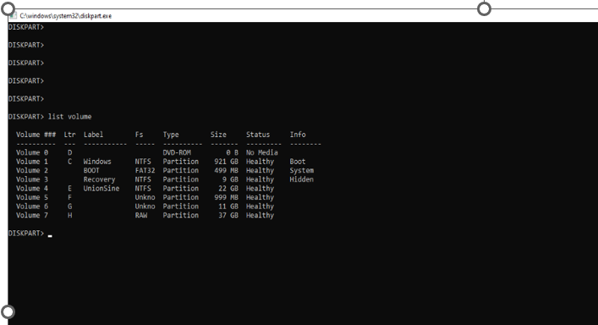

Figure 1 screenshot of HDD properties

The HDD came with about 4 different partitions, lettered E, F, G, and H. Part. F and G have BitLocker password encryption without a password given.
We tried to disable the BitLocker using a PowerShell command “disable-BitLocker”, but it didn’t work. Except we use the system that was used to add the BitLocker on the HDD.
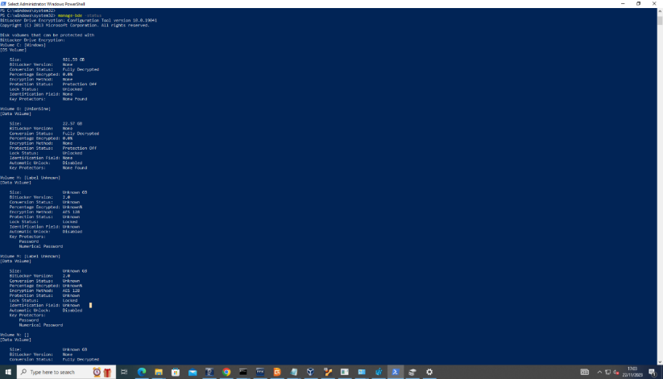
The screenshots below are proof of the PowerShell command.

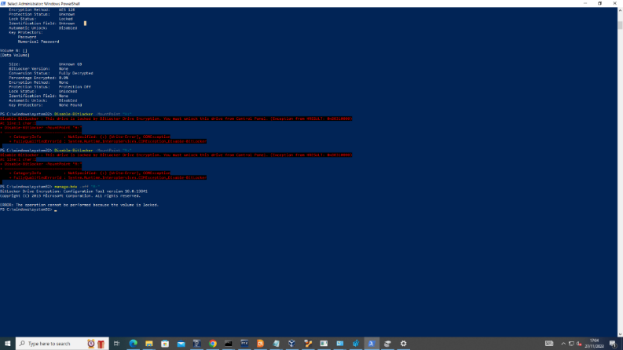
Figure 2 powershell commands

After several attempts to unlock the BitLocker drives, we reached out to Team A concerning the difficulties we encountered trying to unlock the BitLocker, we were informed that the BitLocker drives don’t contain any files and that we should ignore it.

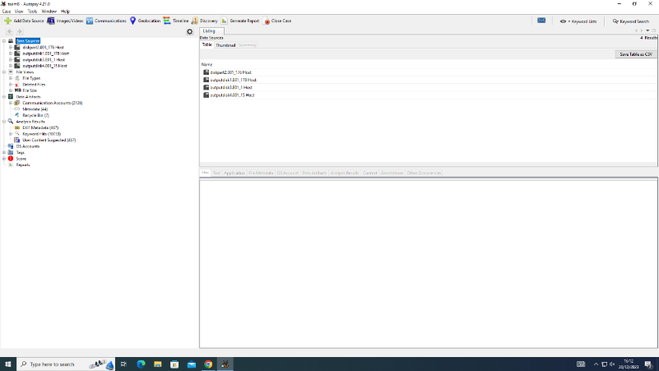
We took an Image of all visible partitions on the HDD using FTKImager, we tried to analyze the image using the Autopsy tool, and we could recover previously stored and deleted files from the HDD.
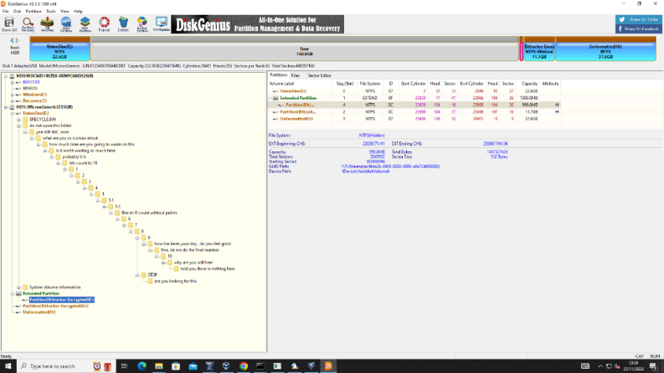
Below are screenshots of those files recovered.
Screenshot showing all four partitions
Screenshot showing root folders present in the HDD
Screenshot showing each drive and storage capacity
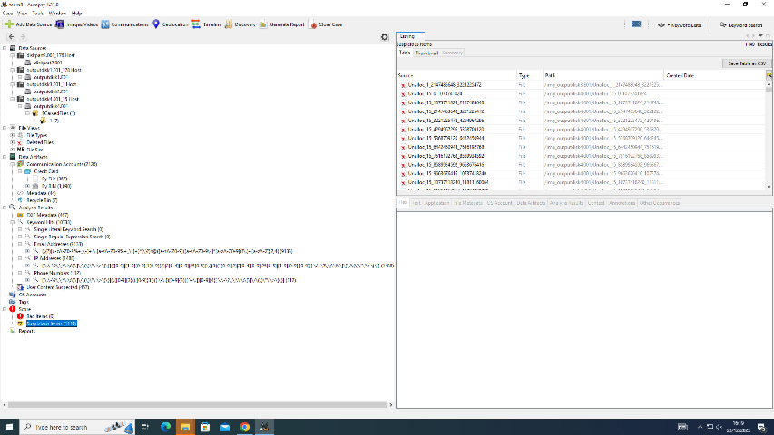
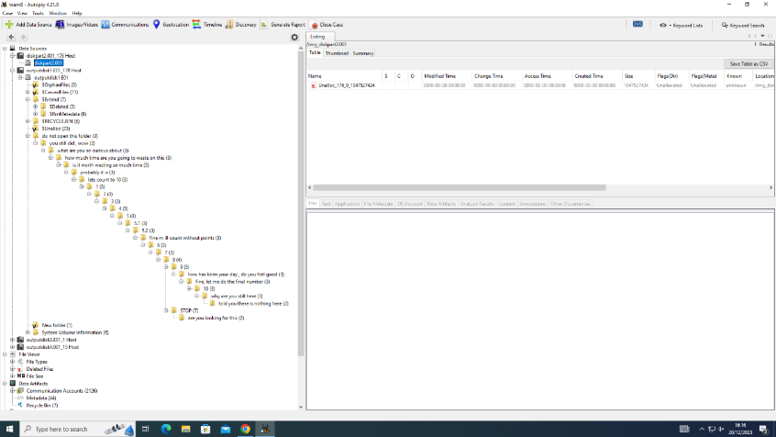
Screenshot showing root folders present in the HDD
Figure 3 Evidence of recovered files and folders

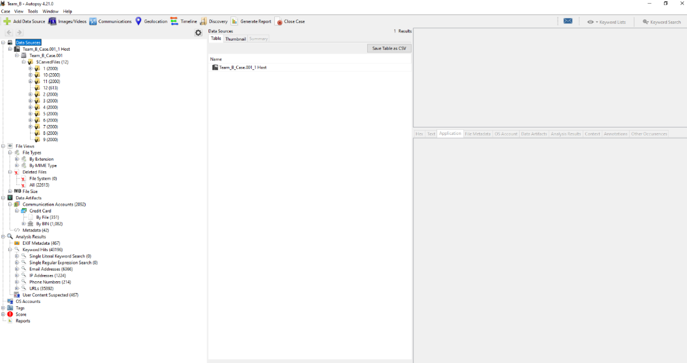

Evidence of Credit card details recovered from the HDD.

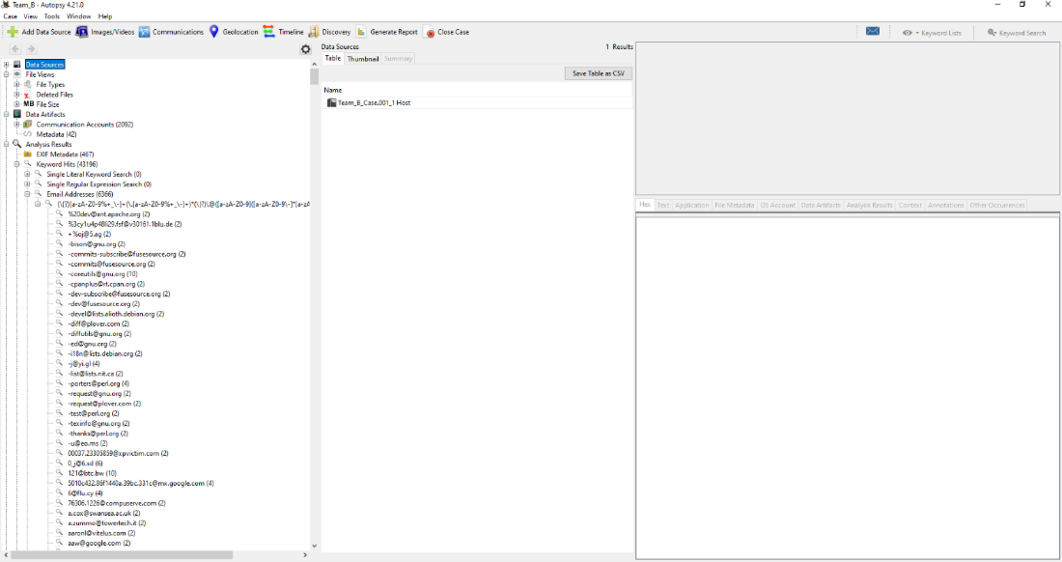

Evidence of email accounts recovered.

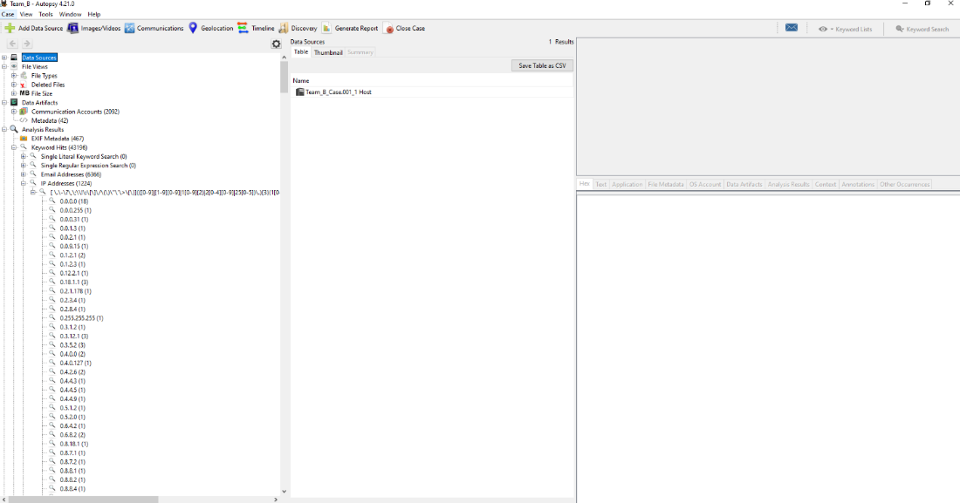

Evidence of IP addresses.

Figure 4 Recovered files

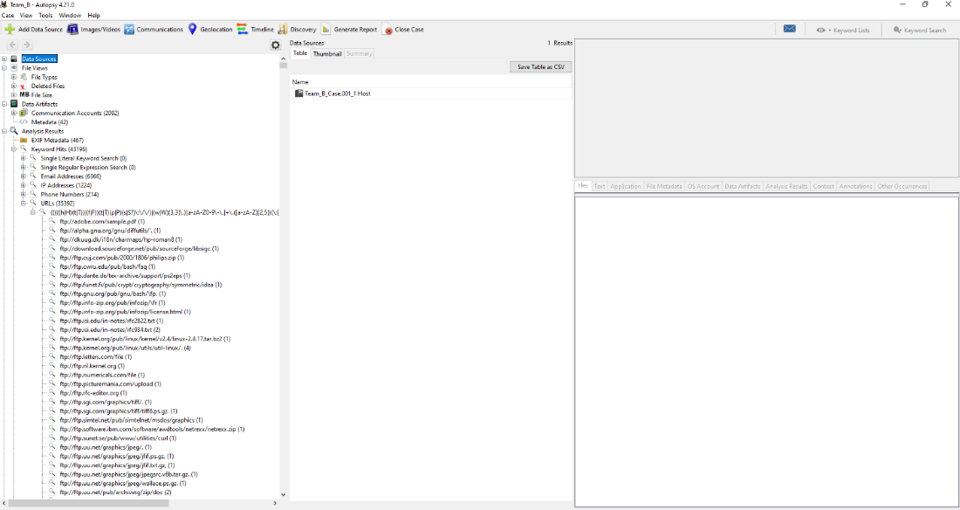

Evidence of different URLs.
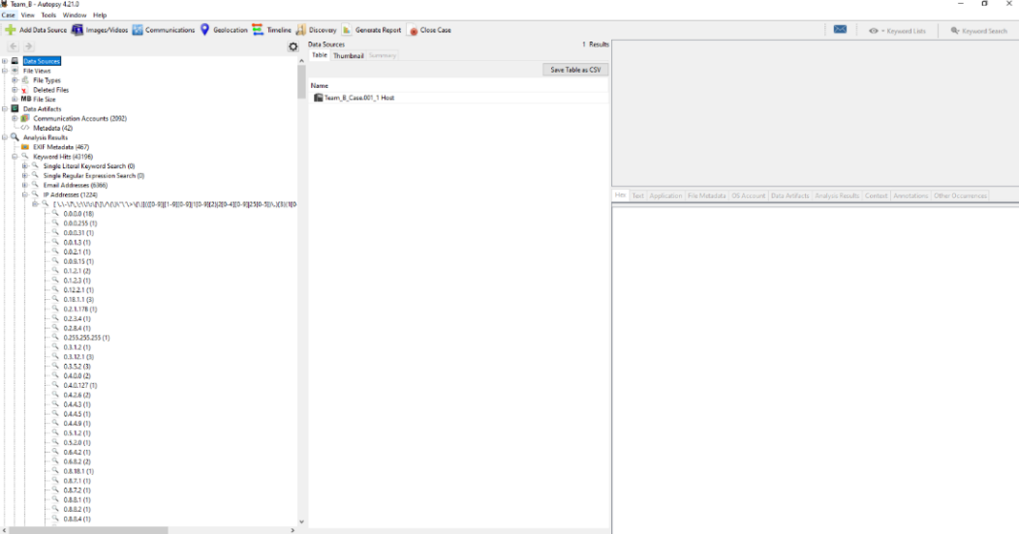

Evidence of Phone numbers recovered
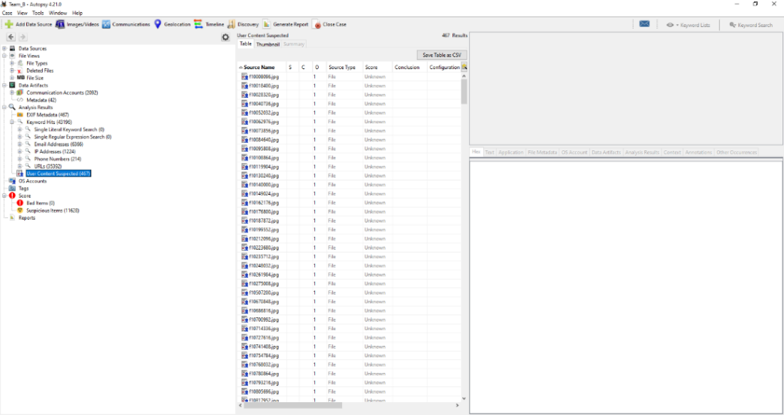

Figure 5 Screenshots of recovered personal details

After recovering all these files, we started analyzing the files one after another, and we noticed that the evidence didn’t corollate with the given scenario, so we had to reach out to the team to confirm if the files we recovered were the actual evidence they copied into the HDD, they confirm it wasn’t their files.
Team A informed us that there was a hidden drive partition on the HDD, and their actual evidence files are likely saved on that hidden drive partition.
After several attempts in trying to find the hidden partitions failed, we did some research and found a tool called VeraCrypt, this tool was used to encrypt the drive
This is the drives partitions that were visible before we used the VeraCrypt

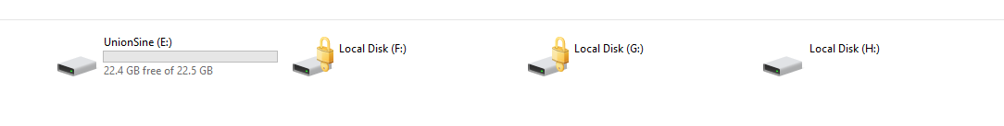

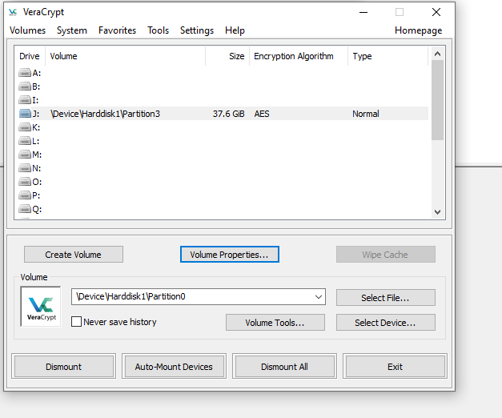
We used the VeraCrypt to dismount all drives in the HDD after which we mounted a new drive with a different drive letter, it requested for a password, which we collected from Team A.

Figure 6 screenshot Veracrypt

The next shot below shows the new mounted drive, lettered “J”

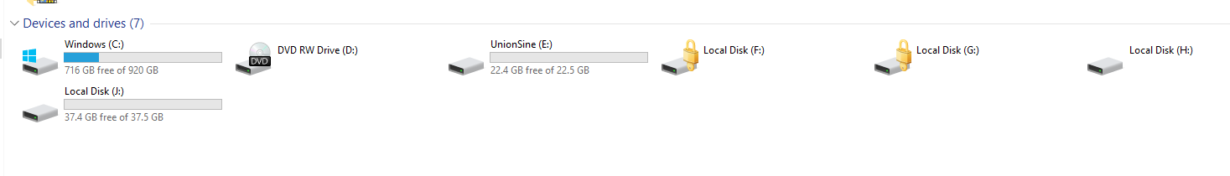
We now have a new drive partition. Drive J is the hidden drive which contains evidence files from Team A.

We took a new image of the un-hidden drive partition (drive J)

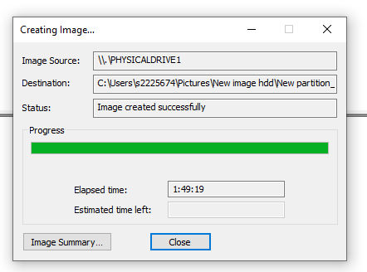

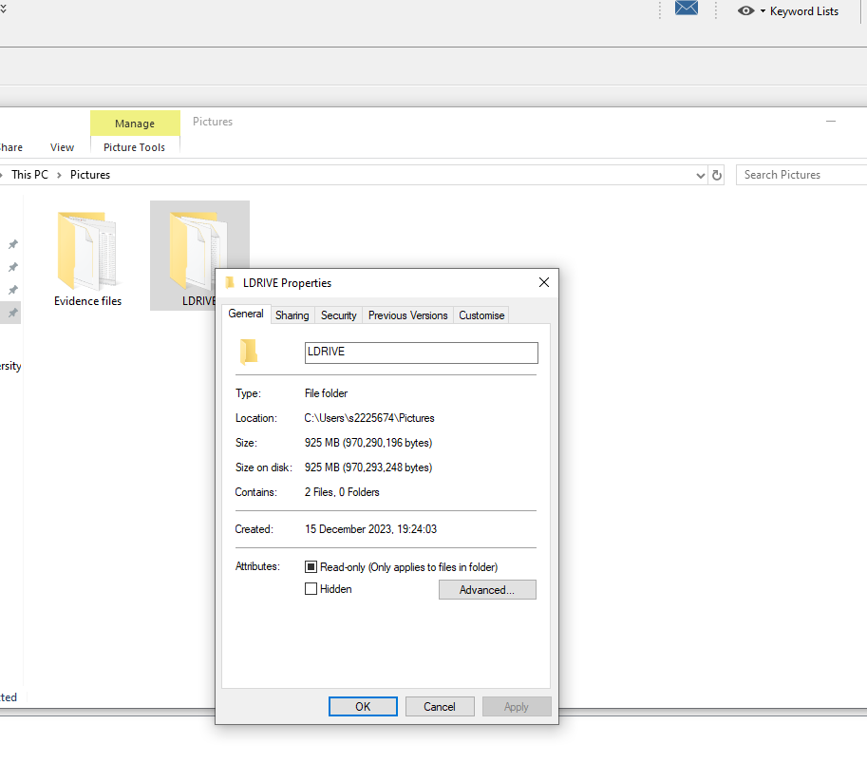
Size of Data: The total size of an image taken of Local disk J is 925MB

Evidence of unallocated spaces
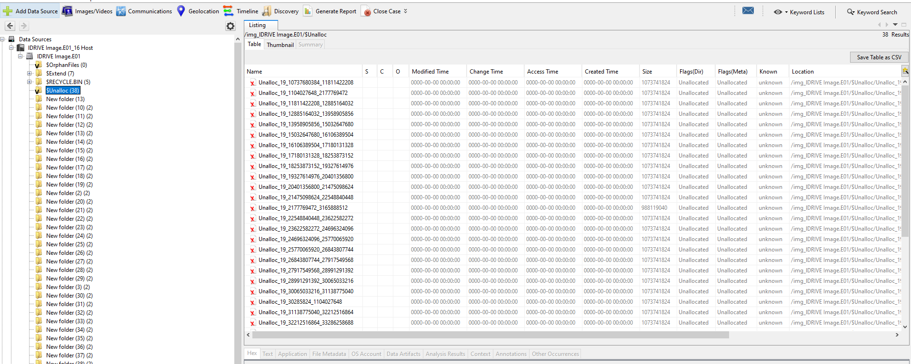

Evidence Location of files with Metadata from the new image
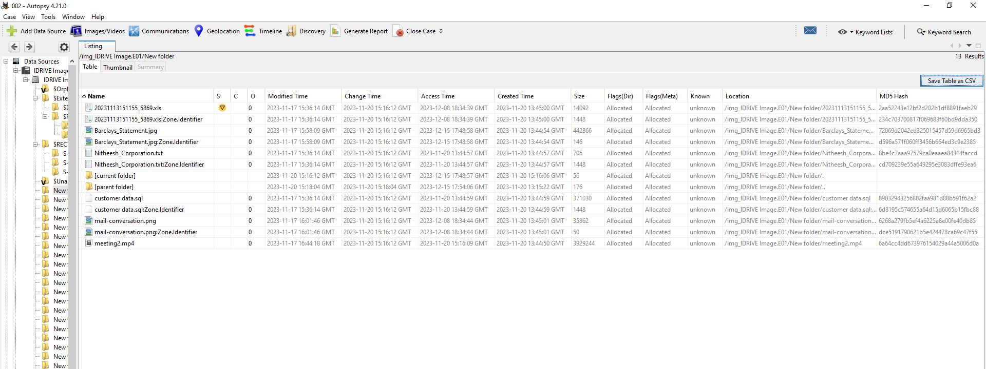

Evidence from Image

The following are files found in the new image of drive J.
Evidence Title | Format | Extension
- 20231113151155_5869 | Excel sheet document | XLS
- Barclays_Statement | Image | jpeg
- customer data | Mysql Database | Sql
- mail-conversation | Image screenshot | Jpeg
- Nitheesh_Corporation | Notepad text file | txt
- meeting2 | Video | Mp4

Table 2 Given evidence

ANALYSIS REPORT BASED ON EVIDENCE ANALYSED

- From the given scenario above, the customer database of a dating company (Red Hot Passion), with patronizes who are top executives at a 500 Fortune company was hacked and their user details were leaked, exposing names of different customers including top employees with managerial roles at (Nitheesh Corporation).

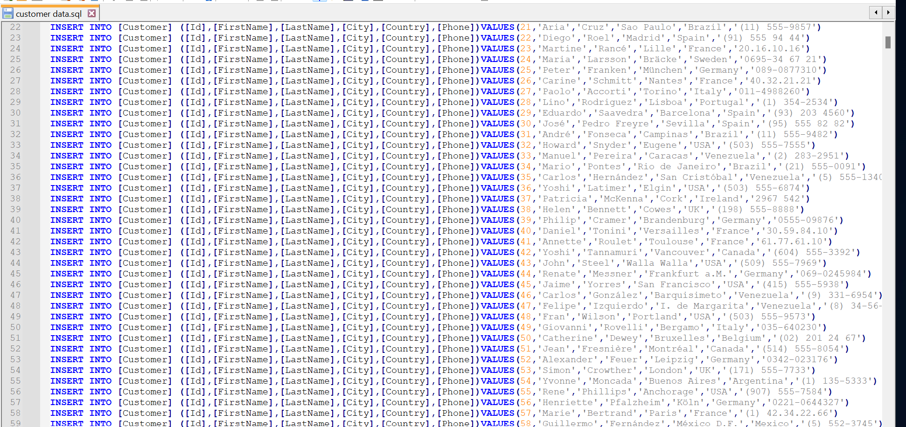

Figure 7 screenshot mysql DB

- A sender known as Josh sends a mail to Nitheesh's email (nithesh@gmail.com), but we can't tell who Josh is because there's no record of him in the database that was leaked, or why is he sending a mail to Nitheesh, asking him to verify his bank details. Nitheesh cooperation is possibly owned by Nitheesh. The sender of this email could be a hacker who is claiming the identity of someone very close to Nitheesh. He sends a verification form, for Nitheesh to verify his account details. But why?
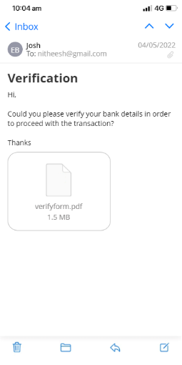

Figure 8 screenshot mail

- Database containing confidential details and bank card details of employees' of Nitheesh's cooperation, possibly leaked by former staff of Nithesh corporation, who left the company due to issues. As administrative staff, these employees had access to almost every record and data of the cooperation, it is also possible that they leaked the bank card details of the employees.
The reason is they want to take revenge against the company due to previous payment disputes.
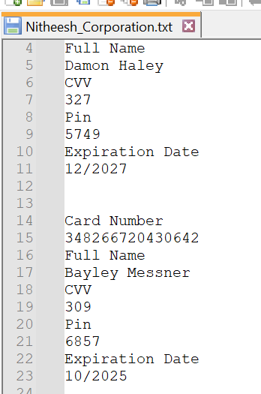
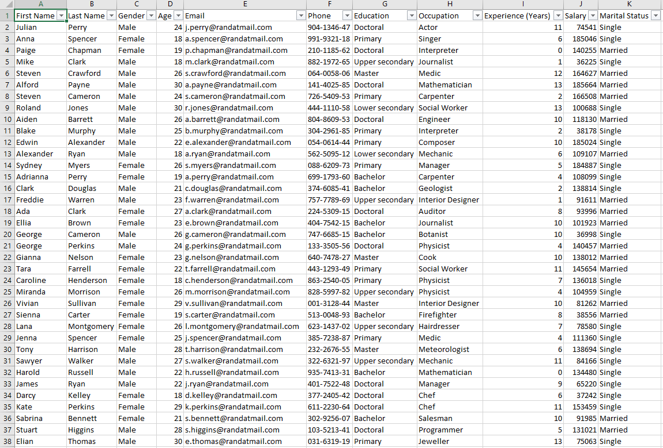

Figure 9 screenshot Database
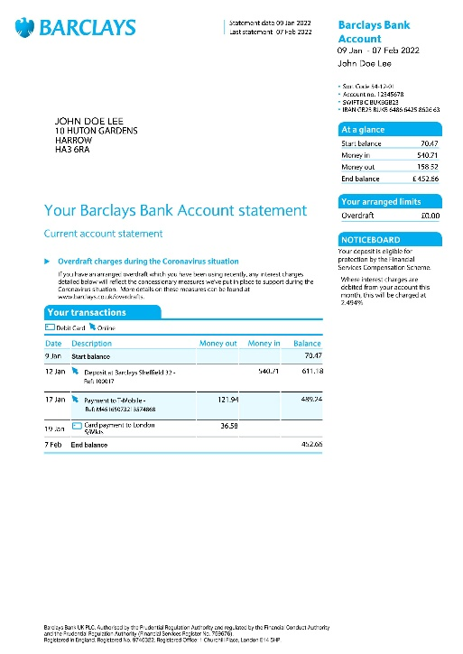
- An account statement having the name John Doe Lee, there's no record of John Doe among the list of either customer data of Red-Hot Passion or the database of Nitheesh Corporation. He may be the hacker, who was paid by the suspects who leaked confidential data of Nitheesh's cooperation. From his bank statement, there was a deposit of £540 into John Doe's account on 12 Jan. On 19 Jan. he paid £39 for transport to London.

Figure 10 screenshot bank statement

Who are these culprits? we can't say for sure, but from the bank statement, John Doe made a card payment to London on 19 Jan. 2022. From the SQL database, about seven names appeared to live in London, I suspect that John could've possibly traveled to meet with these people. Those names have been highlighted below from the SQL file.
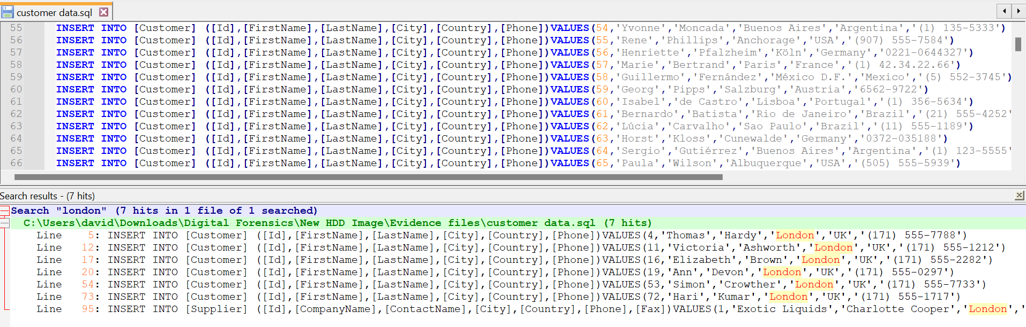 Figure 11 Screenshot suspect list

4.5 Challenges

Not able to ascertain the actual size of HDD and size data on the HDD, because it contained hidden partitions and unallocated spaces.
2. HDD contains 2 BitLocker encryption partitions, and no password was given.
3. The HDD Contains malware, that automatically displays multiple windows, which causes a disruption of operations on the PC.
4. In trying to recover hidden partitions using autopsy tools, the autopsy tools recovered previously deleted files on the HDD, these files amount to over 160GB. Below is a screenshot of the files recovered.

Video link: https://shorturl.at/bsx03

TASK 4: MOBILE FORENSICS

Executive Summary

5.1 Background
Our client is a car manufacturing company working on a new model of AI self-driving cars.
They have competitors in several Countries, and they want to maintain the privacy of this project. However, they suspect that one of their technical officers might be selling the research data to their competitors.

5.2 Scope

The company wants us to investigate the veracity of the allegations by analyzing the suspect mobile phone. To achieve this, we will use Cellebrite tool kits to analyze the phone. We will perform both logical and physical analysis of the phone.

5.3 Key Findings

From the analysis, we discovered over 64 images taken with the suspect's mobile phone camera,
23 audio recordings, Phone logs, SMS, and 7 video files. A summary of the evidence discovered is included in this report.

5.4 Case Information
2.1 Case Details
Case ID: MP-0140124
Date of Request:18/12/2023
Requesting Authority: Team B
Case Investigator: Team B
Device Information: ulefone
Manufacturer: China
Model: Note 14 (16)
Serial Number: S/N:3102SH1010027469
IMEI/MEID: IMEI-1:355617730545789

5.5 Methodology

The mobile phone was handed to us by the company, and every authorization process was sorted by the company. We ensured to maintain a chain of custody after receiving it
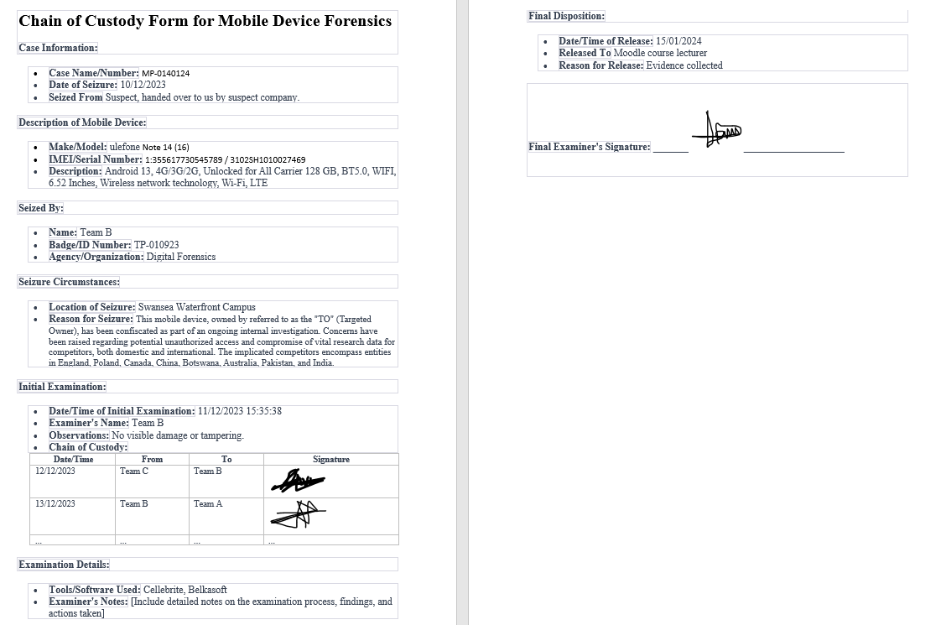

5.6 Data Acquisition

5.6.1 Device Identification
The phone was handed to us by the company where the suspect works, due to an ongoing investigation involving a breach of data. Every verification was done by the company before the phone was handed to us.

5.6.2 Data Extraction
We extracted a logical filesystem using the Cellebrite forensics toolkit. Due to the model of the phone, we could not perform a physical extraction.
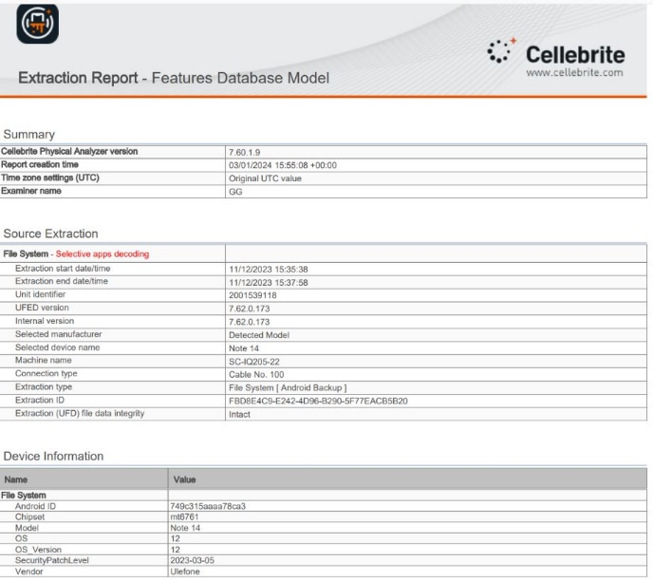

Figure 12 extraction summary

5.6.3 Data Preservation
To maintain data integrity, we set up a forensics lab in the Cisco lab, using virtual machines with operating systems installed on them. All digital extraction and analysis took place in this environment. Every piece of evidence collected and analyzed was stored on OneDrive.

5.7. Data Analysis

5.7.1 Overview
We used the Cellebrite Physical analyzer and Belkasoft forensics tool in analyzing the data.
The analyzed data contain images of different locations and places the suspect visited; we trailed his journey based on the position of images extracted from his device. We found audio recordings with details of events happening within the suspect. Some of the audio was not audible enough, but we were able to transcribe the audio to the best of our ability.

Below are screenshots of the evidence, with timestamps, location, and details about each piece of evidence discovered.
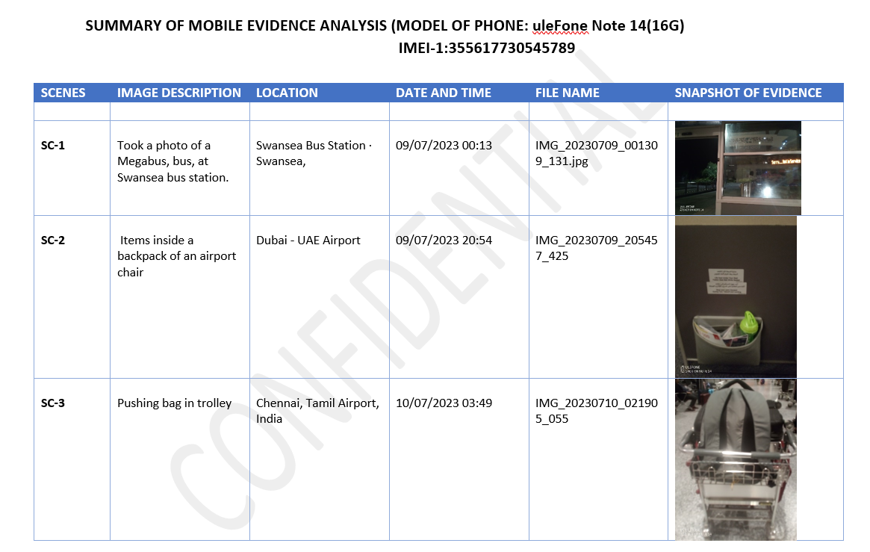

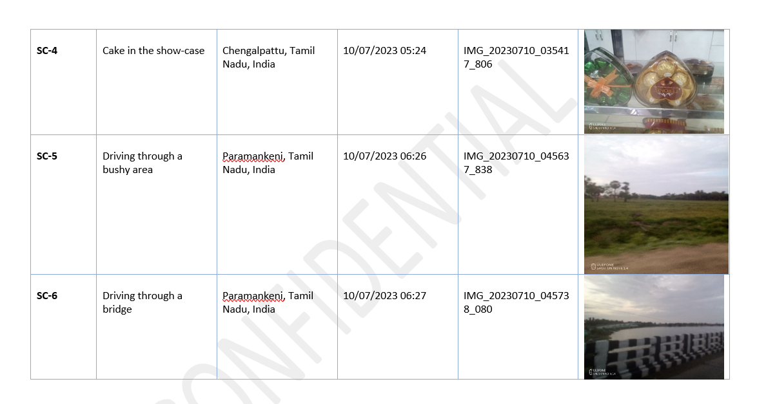
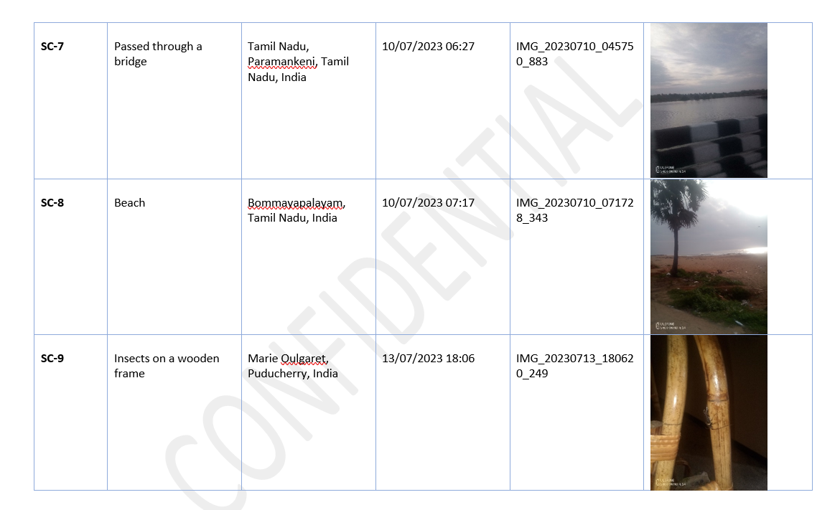

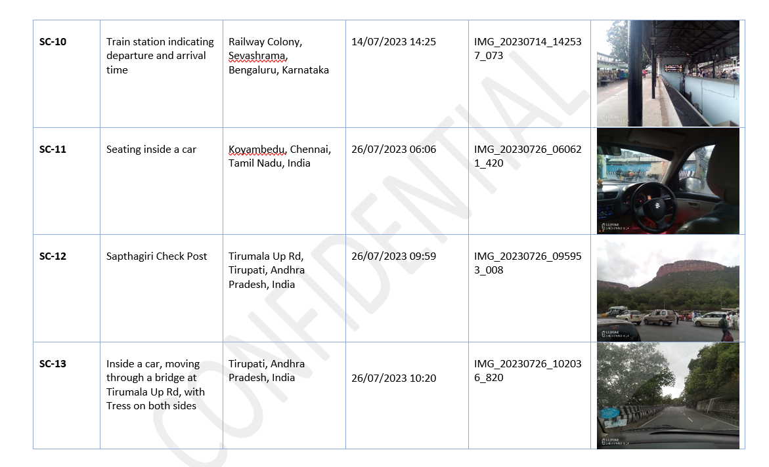
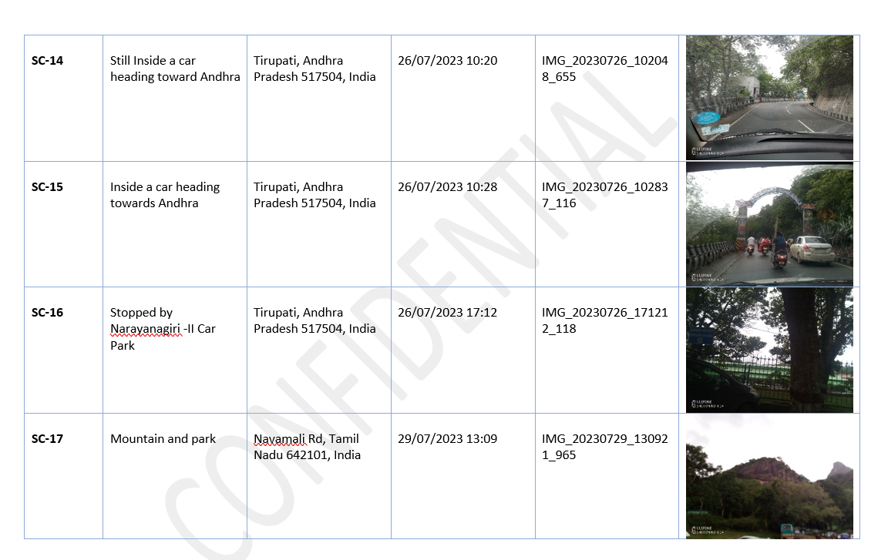

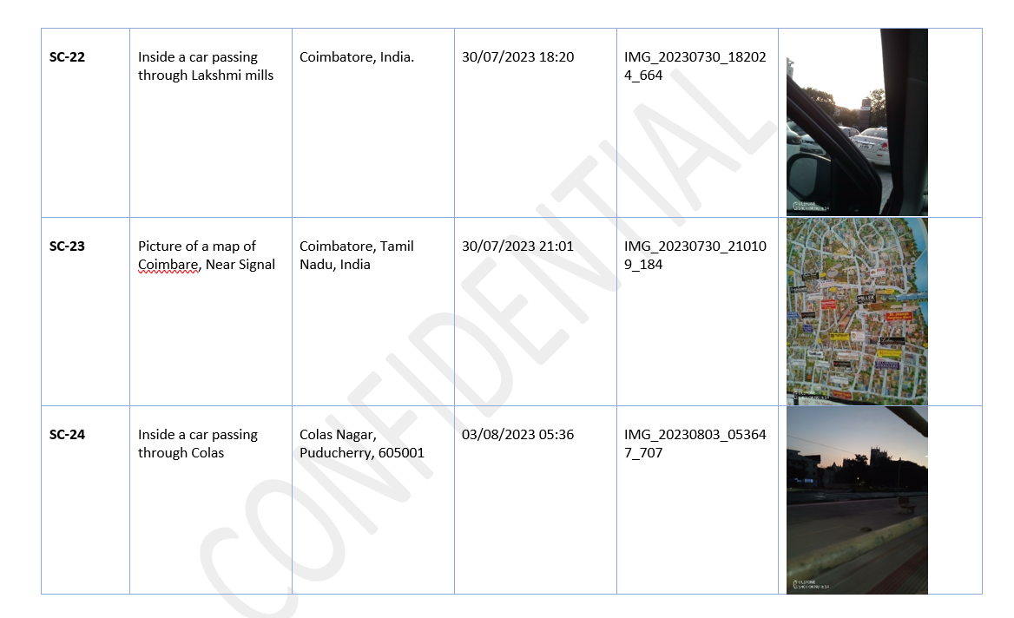
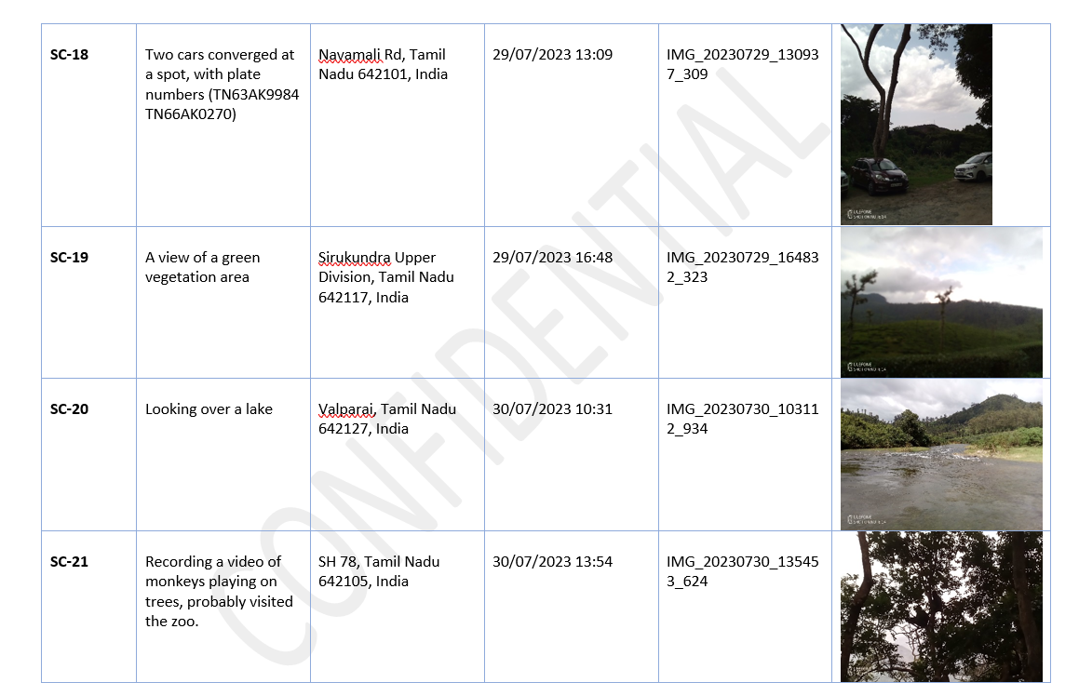

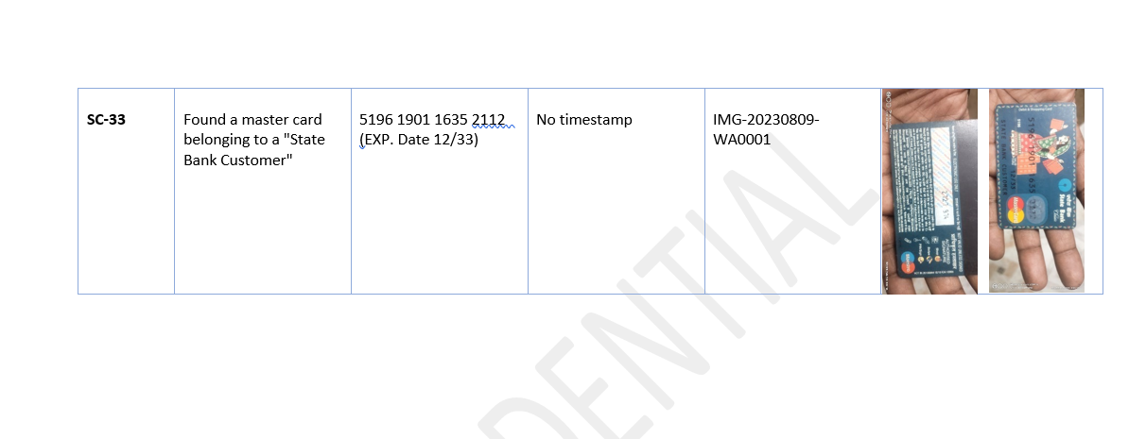
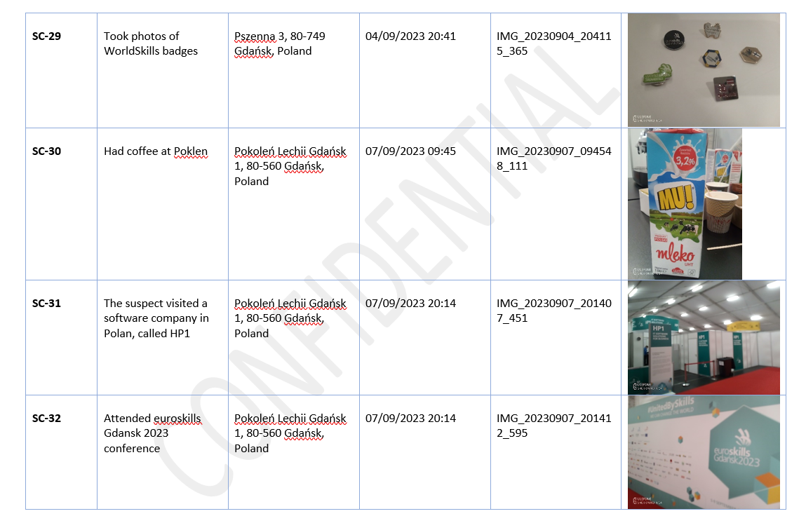
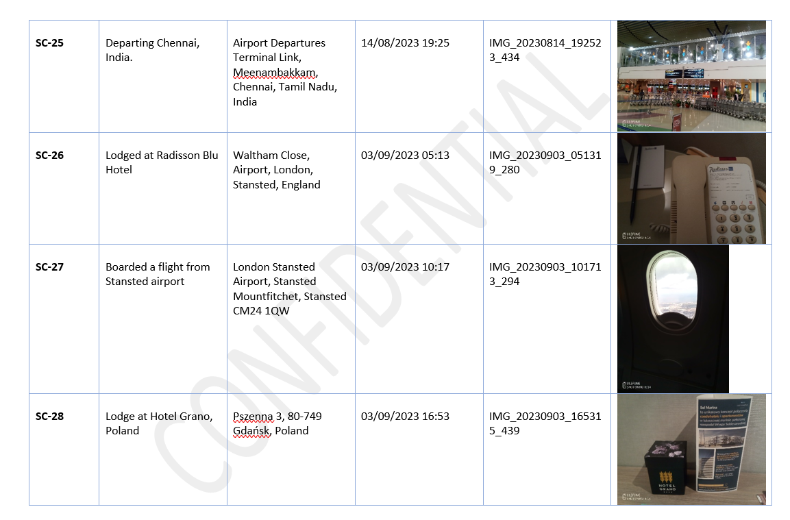
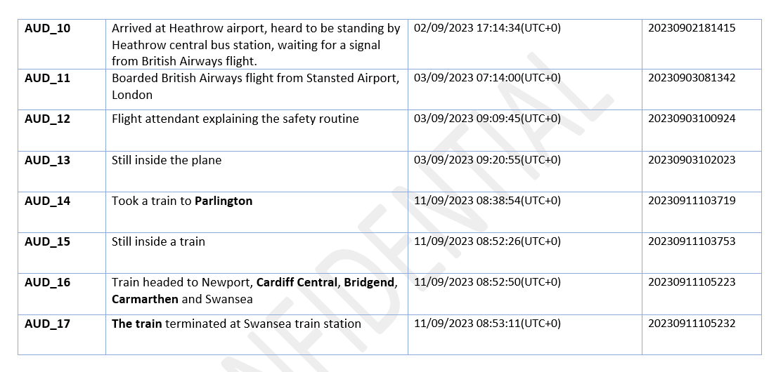
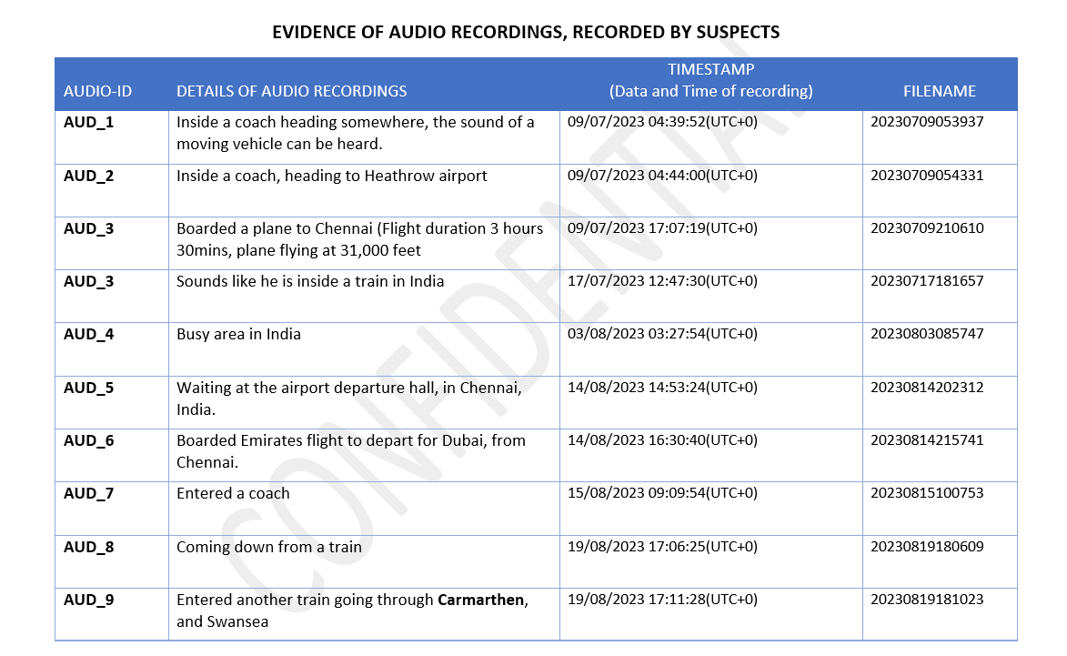

5.7.2 SUMMARY OF ANALYSIS

The evidence provided contains a detailed analysis of the suspect's activities and locations throughout his journey.
The suspect embarked on two different trips.
- He began his first trip from Swansea to London, where he boarded a flight from Heathrow Airport, stopped at Dubai Airport, and took a reconnecting flight to Chennai, India, as indicated in Sc-1 and Sc-3.
- While in India, he met with an unknown person, as seen in SC-18, two vehicles are seen to converge in Navamali Road, Tamil, Nadu. One of the vehicles was probably used in transporting the suspect. The plate numbers of these vehicles have been captured for further investigation.
- He was in India for about 35 days starting from 10/07/2023 to 14/08/2023, Sc-1 to sc-25, AUD_1 to AUD_9.
- His first trip ended when he returned to Swansea on 19/08/2023.
His second trip started on 02/09/2023, as indicated in AUD_10.
- He arrived at Heathrow Airport and waited for a flight signal from British Airways.
- He was next spotted at the Radisson Blu Hotel, Stansted Airport, England on 03/09/2023,
Sc-26.
He boarded a flight that same day to Poland, at about 10:17, SC-27, AUD_11 to AUD_13.
- At about 16:53 of that same day, he lodged at Hotel Grano, Gdansk, Poland, Sc-28.
- While in Poland, he visited an IT company called HP1, located at Pokenlen Lechoo, Gdansk 1, Sc-31.
- He also attended euroskill Gdansk 2023 Conference, Sc-32. A payment card was also found in the suspect phone, but we can't confirm who the owner is, Sc-33.
- He returned to the UK on the 11/09/2023, AUD_14 to AUD_17.
- He spent about 8 days in Poland, and about 4 days in the UK.

5.7.3. Recovered Data

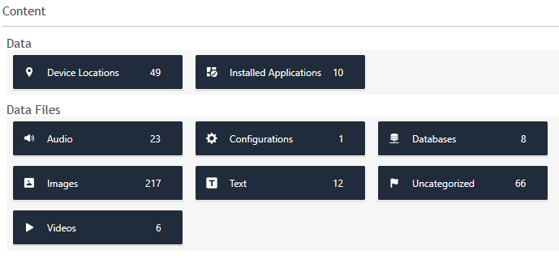

5.7.4 Deleted Data
We didn't recover any deleted data.

5.8. Forensic Artifacts

5.8.1 Artifacts Overview
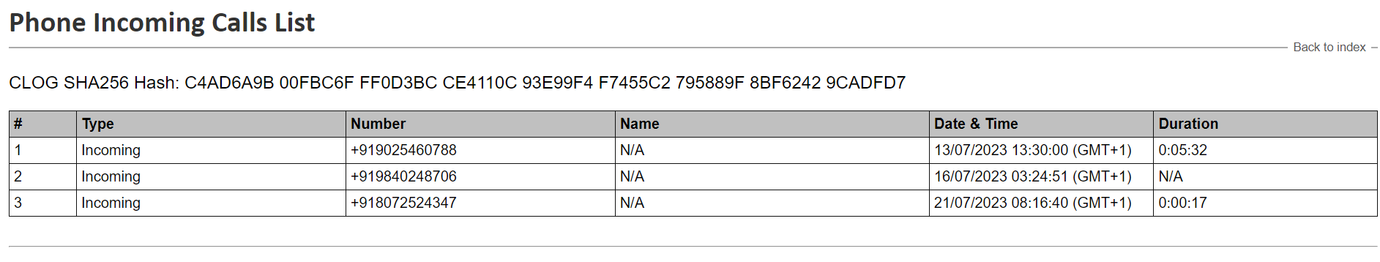
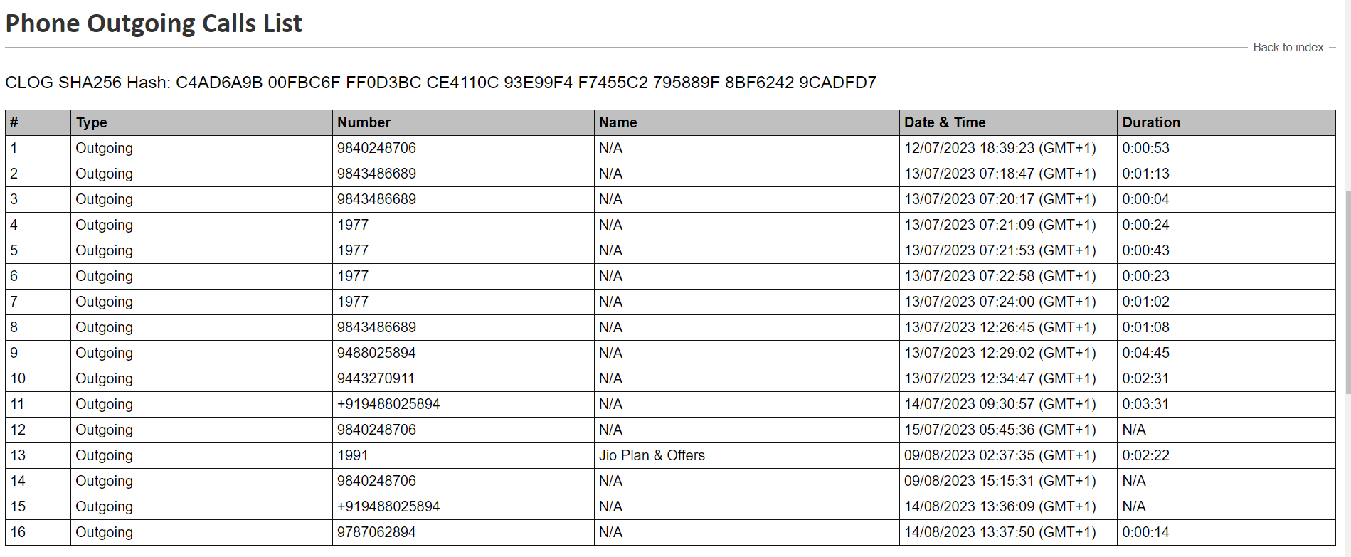
Below is the file system structure of the mobile device and the data structure contained in the phone.
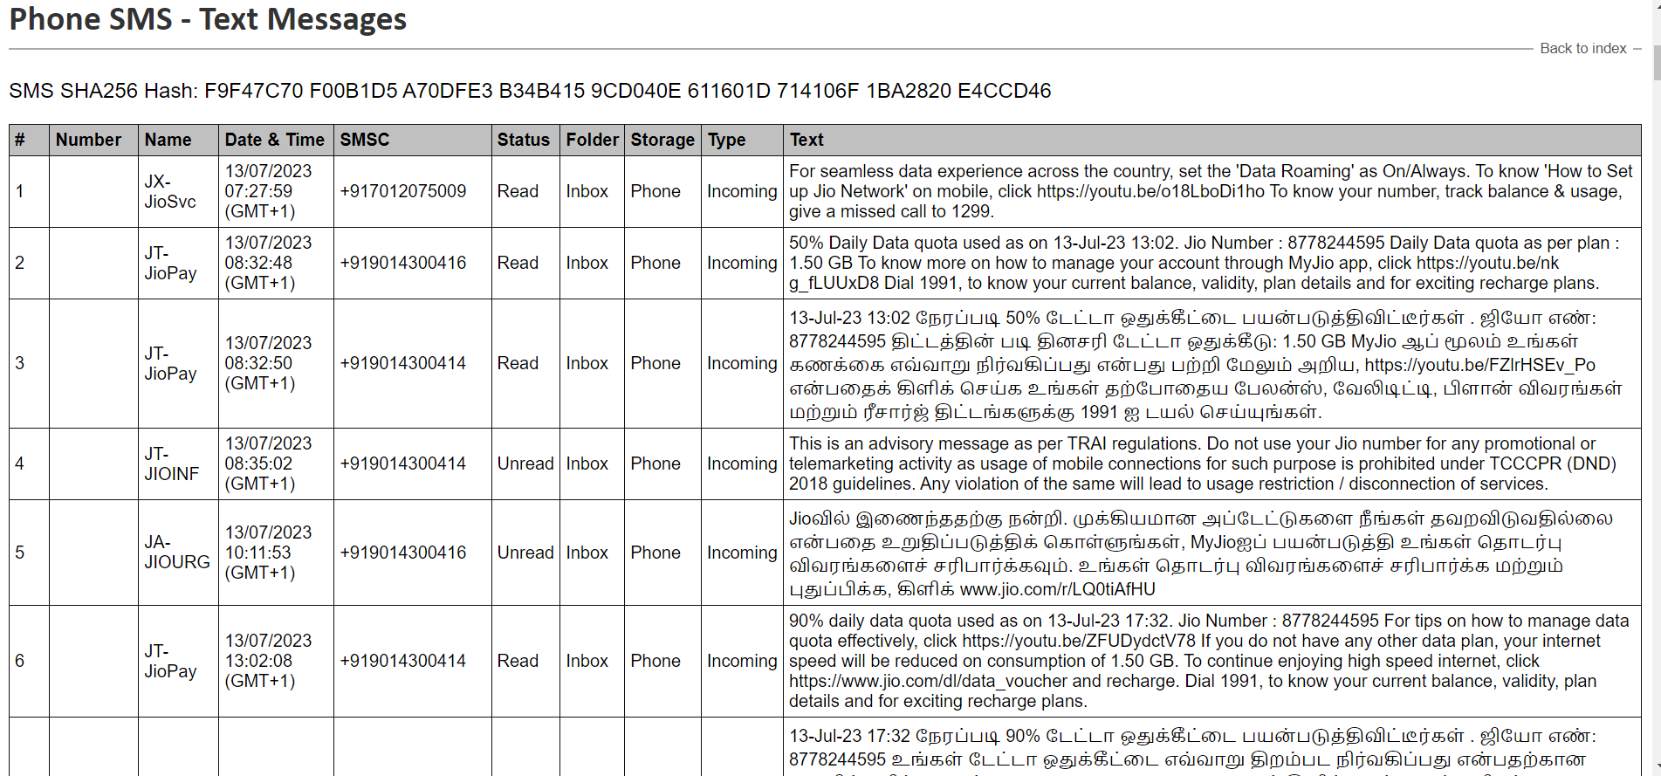
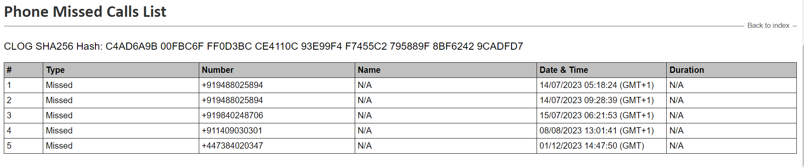
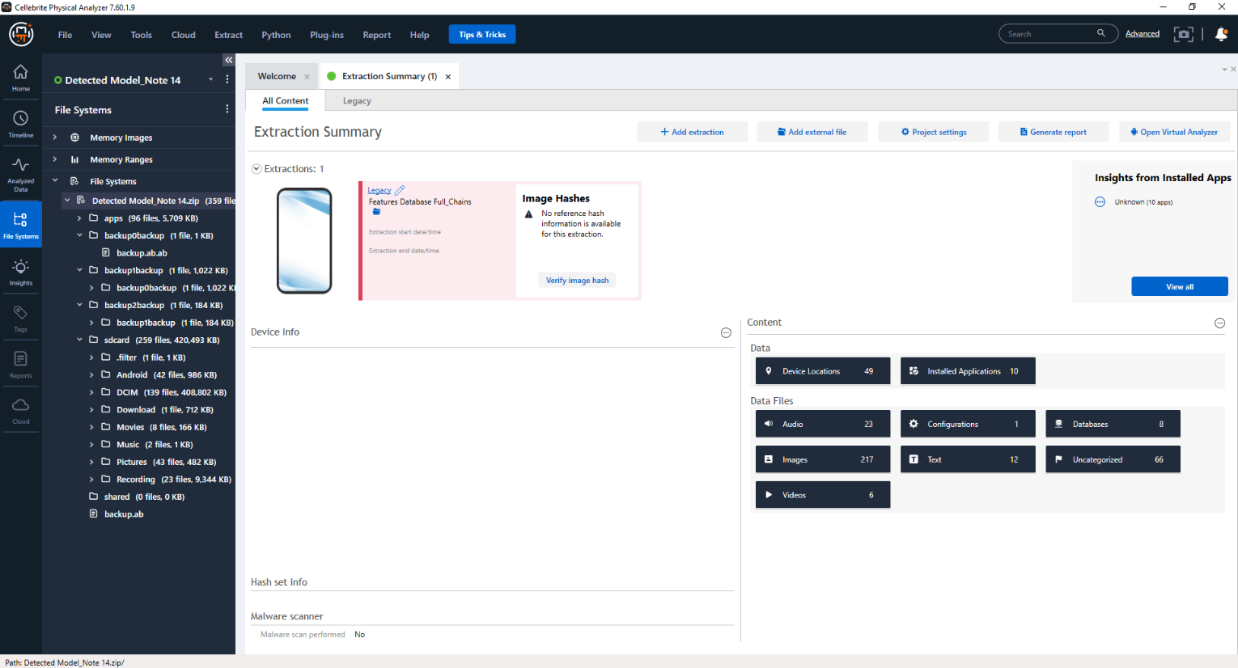
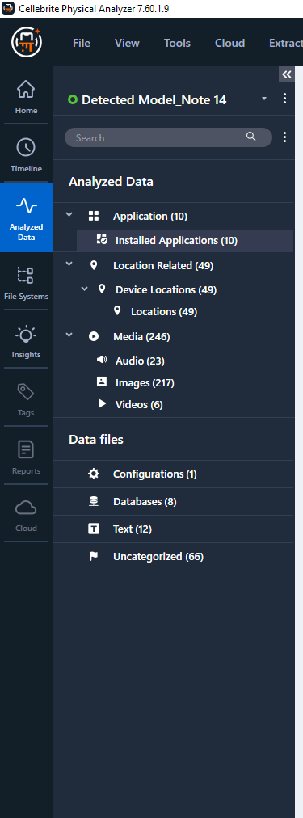

5.8.2 Notable Findings
From our analysis, we discovered that the suspects:
- Visited 4 different Countries, the United Kingdom, United Arab Emirates, India, and Poland.
- Spent more time in India than the other 3 Countries.
- Met with someone in India.
- Visited an IT company in Poland.
- Was careful not to leave any trace of the leaked research data on his mobile device.

5.9. Conclusions
From our analysis, we have been able to point out key convincing points to prove that the suspects visited some of the Countries. He visited 3 Countries from the list of suspected Countries (England, Poland, Canada, China, Botswana, Australia, Pakistan, and India).
This is proof that he compromised the research data of his company.

5.9.1. Recommendations
We recommend that further investigations be conducted to discover who he met with in India, based on the car plate numbers captured.
The IT company he visited should also be investigated to confirm this claim.

5.9.2 Limitations
Not enough evidence to establish a convincing case of stolen research data. There was no chat, text, or email of any conversation between the suspect and his accomplice.
Some features on the Cellebrite UFED and Physical analyzer didn’t effectively. If we had more sophisticated proprietary forensic tools

5.9.3 Acknowledgments
The report is based on a group discussion. Each team member played a different role in ensuring the integrity of every evidence and analysis performed. Every fact and assumptions made were based on the team agreement.

CONCLUSION

In the near future, new trends are driving a revolutionary change in the field of digital forensics. Artificial intelligence integration offers increased productivity by identifying patterns and anomalies, and cloud forensics and the proliferation of Internet of Things (IoT) devices open up new areas of inquiry. Because of the convergence of these themes, digital forensic practitioners' methodology and skill sets need to continuously evolve.
As we move forward, collaboration between industry, academia, and law enforcement becomes increasingly crucial to staying ahead of cyber threats. The constant adaptation to technological advancements, coupled with a commitment to research and development, will empower digital forensics experts to navigate the evolving landscape of digital crime successfully. In conclusion, the future of digital forensics hinges on innovation, collaboration, and a relentless pursuit of knowledge to ensure the integrity of investigations and the protection of digital ecosystems.

REFERENCES
- A. Thakar, K. Kumar and B. Patel, "Next Generation Digital Forensic Investigation Model (NGDFIM) – Enhanced Time Reducing and Comprehensive Framework", Journal of Physics: Conference Series, 2021.
- Amandeep Kaur, Ravneet Kaur. “Digital Forensics.” International Journal of Computer Applications (0975 – 8887) Volume 50 – No.5, July 2012.
- F. Casino et al., "Research Trends, Challenges, and Emerging Topics in Digital Forensics: A Review of Reviews," in IEEE Access, vol. 10, pp. 25464-25493, 2022, doi: 10.1109/ACCESS.2022.3154059.
- Gary L Palmer. (2001). A Road Map for DigitalForensic Research. Technical Report DTR-T0010-01, DFRWS. Report for the First Digital ForensicResearch Workshop (DFRWS).
- International Journal of Computer Applications (0975 – 8887)Volume 50 – No.5, July 2012
- K. Ghazinour, D. M. Vakharia, K. C. Kannaji and R. Satyakumar, "A study on digital forensic tools," 2017 IEEE International Conference on Power, Control, Signals and Instrumentation Engineering (ICPCSI), Chennai, India, 2017, pp. 3136-3142, doi: 10.1109/ICPCSI.2017.8392304.
- K. Strandberg, N. Nowdehi and T. Olovsson, "A Systematic Literature Review on Automotive Digital Forensics: Challenges, Technical Solutions and Data Collection," in IEEE Transactions on Intelligent Vehicles, vol. 8, no. 2, pp. 1350-1367, Feb. 2023, doi: 10.1109/TIV.2022.3188340.
- M. Ivanova and S. Stefanov, "Digital Forensics Investigation Models: Current State and Analysis," 2023 8th International Conference on Smart and Sustainable Technologies (SpliTech), Split/Bol, Croatia, 2023, pp. 1-4, doi: 10.23919/SpliTech58164.2023.10193176.
- Patterson, Tom, et al. "Enhancing National Cybersecurity: The Current and Future States of Cybersecurity in the Digital Economy." Amerika Birlesik Devletleri Resmi Gazetesi (2017).
- R. S. Khalaf and A. Varol, "Digital Forensics: Focusing on Image Forensics," 2019 7th International Symposium on Digital Forensics and Security (ISDFS), Barcelos, Portugal, 2019, pp. 1-5, doi: 10.1109/ISDFS.2019.8757557.
- “Axxera 4N6 Manager.” Www.fulcrum.net.au, www.fulcrum.net.au/product/axxera-4n6-manager. Accessed 31 Dec. 2023.
- “Digital Forensics Market.” Www.futuremarketinsights.com, www.futuremarketinsights.com/reports/digital-forensics-market.
- Ghazinour, Kambiz, et al. “A Study on Digital Forensic Tools.” 2017 IEEE International Conference on Power, Control, Signals and Instrumentation Engineering (ICPCSI), Sept. 2017, https://doi.org/10.1109/icpcsi.2017.8392304. Accessed 19 Apr. 2021.

