ECED7006 - Assignment 1

How meritocracy propels university admissions cheating - with case studies in the US and Vietnam

In many countries and territories worldwide nowadays, especially in the West, it is believed that individuals can move up in the social ladder and be successful thanks to their own talent and efforts (Tašner and Gaber, 2022). However, more people are asserting that belief could be a fallacy and reproduce social inequalities. This paper will look into situations when meritocracy may propel cheating and unfairness when money and power are in the game. It will highlight the key words and cite relevant case studies to prove that meritocracy does not guarantee social mobility.
“Meritocracy” was coined by British sociologist Michael Young with a negative connotation in his political fiction book in 1958 that warns ‘about consequences of assigning social status based on formal educational qualifications’ (Online Etymology Dictionary, 2020; Guinier, 2015; Carvalho, 2022; Poocharoen and Brillantes, 2013). The concept, morally logical as it holds talents and hard work in high regard rather than birth or aristocracy (Clifton, 2020; Poocharoen and Brillantes, 2013), seems to be a fruit of the ‘enlightenment tradition’ (Tašner and Gaber, 2022; Carvalho, 2022). It also brought to life ‘social democratic institutions developed over the 20th century’, particularly ‘the expansion of public education and public sector employment’ (Carvalho, 2022). As a result, it is highly welcomed as a form of social promotion in comparison to ‘nepotism and clientelism’ (Tašner and Gaber, 2022; Poocharoen and Brillantes, 2013).

China is believed to be the origin of ‘meritocratic principles’ (Duong, 2023; Poocharoen and Brillantes, 2013) given the ‘Confucian concept of meritocracy’ which takes roots from the sixth century (Carvalho, 2022). The concept attached importance to ‘intelligence and education’, as well as ‘virtue’. It was to encourage individuals possessing those traits to succeed in the ‘the system of Imperial civil service examination’ and become worthy ‘government officials’ (Carvalho, 2022; Poocharoen and Brillantes, 20130). Carvalho (2022) pointed out at the time of its birth, ‘the notion of meritocracy’ was in tandem with ‘education and bureaucracy, and moral significance’. Since its inception, the concept has been a leading principle in education and recruitment. It gives birth to an array of examinations (Bell, 2020), which are considered optimal and fair tools to measure merit (Tašner and Gaber, 2022). The entrance examination was also adopted in other East Asian countries (Poocharoen and Brillantes, 2013) and ‘by the British in India’ prior to arriving in Europe and the US (Poocharoen and Brillantes, 2013; Hobson, 2004). Poocharoen and Brillantes (2013) held that although Max Weber did not refer to the exact term, he ‘promoted this concept in his writings on bureaucracy’. The researchers (2013) cited Weber (1946) that impartial and capable individuals are the right ones for public offices.

In the West, the principles were applied starting late 19th century to replace ‘political patronage in civil service management’ (Duong, 2023; So, 2015). Meritocracy has been among the most prominent social ideals (Clifton, 2020). And merit-based assessment seems to have become crucial and ‘rarely be questioned’ as most members of the society, especially influential figures in a person’s lifetime like parents and teachers, and politicians, endorse it (Tašner and Gaber, 2022; Clifton, 2020; Endleman et al, 2022). Poocharoen and Brillantes (2013) emphasised:
It is a system that values the principles of competition, open selection, careful evaluation of qualities, and of having a set of qualification standards and an established recruitment process.

On that note, Sabic-El-Rayess (2016) defined ‘social mobility refers to an individual’s movement upward within institutional and social hierarchies’. Carvalho (2022) cited Chetty et al (2014)’s finding that mobility has been on the decline ‘in segregation and inequality’, but rising ‘in social capital, family stability, and school quality’. On the other hand, the concept could be perceived by a group of privileged individuals who fail to satisfy their desired goals, as “taken spots”, drag others down and “cut in line” (Byrd, 2019).

Tašner and Gaber (2022) noted that Young, who rejected that meritocracy would lead to a ‘more just society’, was among ‘the first critics of the concept’. For it is ‘conceptualised in neoliberal fashion’, meritocracy is hardly associated with ‘solidarity and the common good’ (Tašner and Gaber, 2022). Sabic-El-Rayess (2016) cited Turner (1960) who held that sponsorship by the power holders is an alternative pathway to obtaining elite status, not just ‘merit-based contest’ as many have assumed. Carvalho (2022) held that social divisions triggered by meritocracy could exaggerate inequality (Bénabou and Tirole, 2006). Echoing these views, in his book, Markovits (2019) dismissed meritocracy as a major barrier to equality in the US context, rather than a pathway to social mobility (Bell, 2020). Carvalho (2022) observed that what has come under criticism is not the concept of merit, but the negative sides of the meritocracy system, which renders ‘screened out individuals’ seemingly ‘invisible’, (Goodhart, 2020; Markovits, 2020; Sandel, 2020). The regime operates in a setting that only people with outstanding academic achievements ‘are qualified for elite positions’.

Graph 1: Negative sides of the current meritocracy system
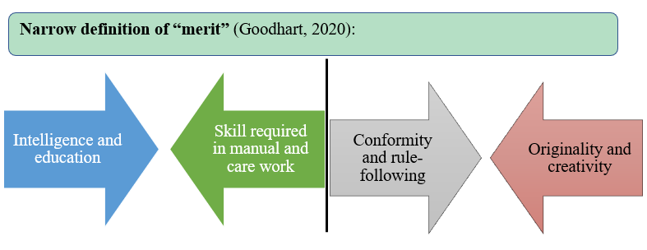
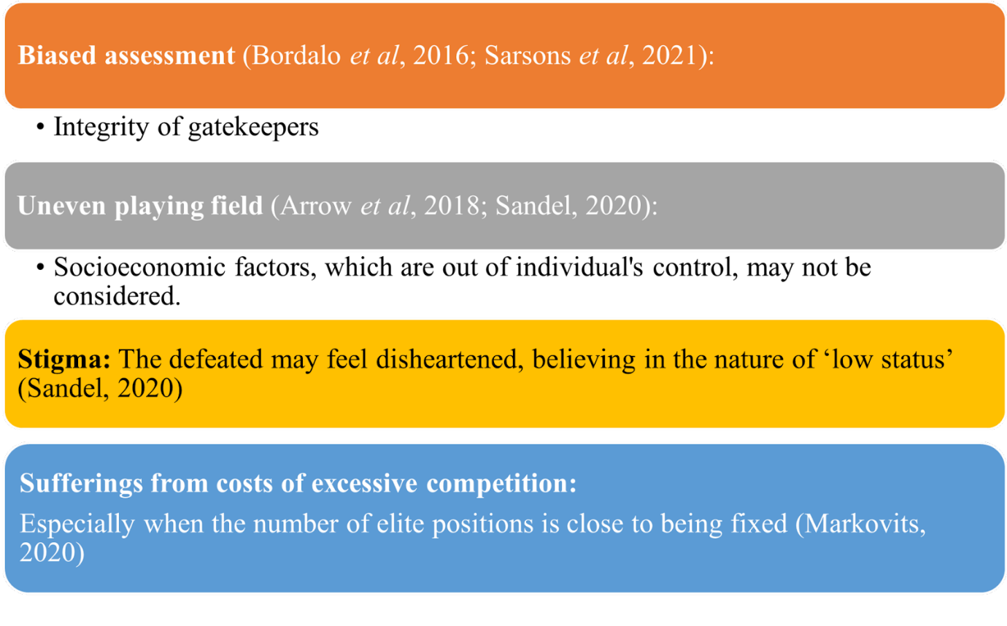
(Carvalho, 2022)
Additionally, meritocracy tends to disregard obstacles that individuals have been facing and label negative results as ‘personal failure’ (Bell, 2020). Clifton (2020) emphasised the ‘tenuous and indirect’ connection between merit and results. Bell (2020) warned populists may take advantage of the dissatisfaction and hypocritically criticise ‘meritocratic elites’ to serve their own purposes.

Tašner and Gaber (2022) reiterated that the problems of meritocracy emerged first-hand in education, the same field in which it has greatly contributed to accelerating ‘equal opportunities for all’. In the US in the 1960s, ‘children from socially privileged strata’ were more likely to obtain ‘higher and most prestigious educational degrees’ (Tašner and Gaber, 2022). The researchers cited a description by Bourdieu and Passeron (1990, p. 84) that the concept creates ‘an illusion behind which social reproduction continues’. Similarly, some other researchers rejected the credibility of ‘decisions based on merit’ and concluded that it is “an inevitable myth” (Tašner and Gaber, 2022). Tomusk (2000, p. 240) also observed that ‘‘power is legitimising itself through the educational systems’’. He explained that the elites are capable of ‘controlling social mobility opportunities’ and therefore ‘award individual success as they see fit’. The argument was strengthened as Sabic-El-Rayess (2016) named some corrupt behaviours, such as gaining ‘full or partial educational credentials and having access to ensuing benefits’ through ‘bribes and favour reciprocations’. Due to meritocracy belief, bribes can be but not limited to ‘favour exchange’, which enables individuals to have an advantage over others in social mobility but based on a ‘non-merit’ foundation (Sabic-El-Rayess, 2016).

“Favour reciprocation” is among the most common types of ‘non-pecuniary corruption in higher education’ (Sabic-El-Rayess, 2012). The researcher clarified that it can be perpetuated when students with special connections receive high grades not based on their abilities, with ‘expectation that such favours will be reciprocated in the future’. Difficulty in detection, verification and report makes it more dangerous. Therefore, the supposed ‘merit-based opportunities’ for those who are without connections will be minimised, and maybe even down to none (Sabic-El-Rayess, 2016). The researcher also emphasised that this does not only affect the reliability of ‘meritocracy’ in the educational environment, but also ‘social standing’ consequently. Hermanowicz (2019) cited Slaughter and Rhoades (2004, p. 298)’s argument comparing the relationship between universities/colleges and students nowadays as service providers and “consumers”, respectively. “The college experience” discourse has depreciated ‘learning and being educated’ and Grigsby (2009) warned against the emergence of ‘an attitude of earning a degree with as little effort as possible’ (Hermanowicz, 2019).

Although the US is described as ‘the land of opportunity, the place where potential awaits’ (McGlinn, 2004), recent incidents have come to light to challenge that belief, notably in regard to fairness. Hermanowicz (2019) noted that in this country, ‘high school grades’ and ‘letters of recommendation’, for a long time, have been ‘principal means to provide testimony about the merit of applicants to college’. Then if these are tampered or overstated, they no longer serve the expected merit-based purpose. ‘Peer networks and socio-economic backgrounds’ are also among decisive factors for college admission (Hermanowicz, 2019; McDonough, 1997). Financial contributions by students’ families to the institutions may be involved, Hermanowicz (2019) underlined.

In 2019, a group comprising more than 50 parents and college personnel in the US were accused of attempting bribery to have children enrolled into some famous universities (Pascus, 2019). Their tactics included being an invigilator for their child’s exam and correcting the answers afterwards, together with feigning ‘sport team recruit’. Bodovski (2020) stated that this ‘college admissions scandal’ speaks volume ‘about parenting than the institution of higher education’, and stresses the correlation ‘between parenting, education, and social class’. The researcher affirmed that parents’ motive lies in their knowledge and experience in the benefits of enrolment in prestigious schools, including ‘social and professional opportunities’. In their mind, it is a sure-fire way to maintain the children’s status and ‘ensure their social mobility’ (Bodovski, 2020). She cited Calarco (2018) who stated even “mundanely privileged families” may strive to make use of every chance they afford, for the sake of their children. However, the social reproduction of inequalities results in parents who have received education gain the better advantage in knowing how educational establishments operate than their counterparts who have not.

Hermanowicz (2019) borrowed from Merton (1968) who elaborated that people tend to resort to underhanded methods to fulfil their targets when conventional ones fail to do so. The use of money to ‘secure the end legal means’ have been reported in tertiary enrolment (Hermanowicz, 2019). Byrd (2019) observed wealthy parents may refuse to attribute their children’s poor academic performance that make them unqualified for prestigious institutions to ‘indulgence, indolence or incompetence’, but ‘perception’. Accordingly, they could spend a humongous fortune in falsifying the children’s scores and accomplishments in sports or competitions. This projects the significance and influence of parents’ viewpoints and decisions in the current meritocratic system. Markovits (2019) pointed out that the current ‘parenting and educational system’ are to make sure ‘their offspring's human capital’, which he argued will attain ‘more significant dividends than property or assets’. Holding similar views, Bevia and Corchon (2017) proved their hypothesis stating ‘human capital can be accumulated without bound and without diminishing returns in the production of capital’. Paradoxically, Mijs and Hoy’s research in 2022 indicated that most people in the US believe ‘there is more upward social mobility than there really is’ (Alesina et al, 2018; Kraus and Tan, 2015). They held that news media is a source of misinformation on meritocracy, adding that researchers also find popular media affect the audience’s viewpoints on inequality (Larsen, 2016). For example, the “rags-to-riches” theme has been ‘a staple of young adult novels in modern times’, boosting the ‘American Dream’ belief among viewers (Mijs and Hoy, 2022; McGlinn, 2004). Most importantly, those works highlight characters’ perseverance and hard work will eventually ‘pay off’. To help people better understand ‘income distribution and social mobility rates’, Mijs and Hoy (2022) suggested that ‘new and accurate information’ may contribute to adjusting their viewpoints (Hauser and Norton 2017; McCall et al 2017).

Although there are differences between the meritocratic views and systems in the US, the UK and Asia, including Vietnam (Duong, 2023), they are all subjected to criticisms (Mijs and Hoy, 2022) and more debates. A similar cheating scandal was reported in three provinces in Vietnam in 2017-18 (VietnamPlus, 2020). Some high-ranking examination officials of the respective provincial education departments were found guilty of their involvement in test score manipulation by altering hundreds of multiple-choice test’s answer sheets’. In a single province, the students whose scores were raised so that they could graduate high school and enrol in universities or colleges, could receive more than 20 marks higher than they should have (Viet Nam News, 2020). Result of the examination is to determine whether a student is qualified to ‘graduate from high school and get into their dream university’ (Viet Nam News, 2020). It is considered an important stage of life by many. Çırak’s research in 2016 gave an insight into students’ common perceptions and anxiety brought by the university entrance exam. It is worthy of note that the exams are viewed by some students as a serious issue of make or break, and a ‘door’ expected to deliver a self-reliant future with careers (Çırak, 2016). In addition, the fear of being disoriented in life, and unable to reciprocate for all the family expectations and support in case of failure, greatly contributes to their perturbation.

Phan et al (2021) noted that young people have been under pressure to prove themselves in a more fast-paced world, and academic perfectionism can be one problem among an array of them all. More dangerously, as talent and effort are deemed top priority in meritocratic principles, individuals may be trapped in ‘a cycle of setting higher and more unrealistic standards’ after fulfilling one (Endleman et al, 2022; Shafran et al, 2002). This will worsen if they have demanding and controlling parents who encourage unrealistically high expectations (Endleman et al, 2022).

Examinees in Vietnam are given ‘written examinations’, similar to Japanese students in the past (Rappleye and Komatsu, 2018). Research by Rappleye and Komatsu (2018) analysed reasons for the pressure among Japanese students in the 1980s, which bear some similarities in the Vietnamese current context.

Graph 2: Pressure facing Japanese students in the 1980s
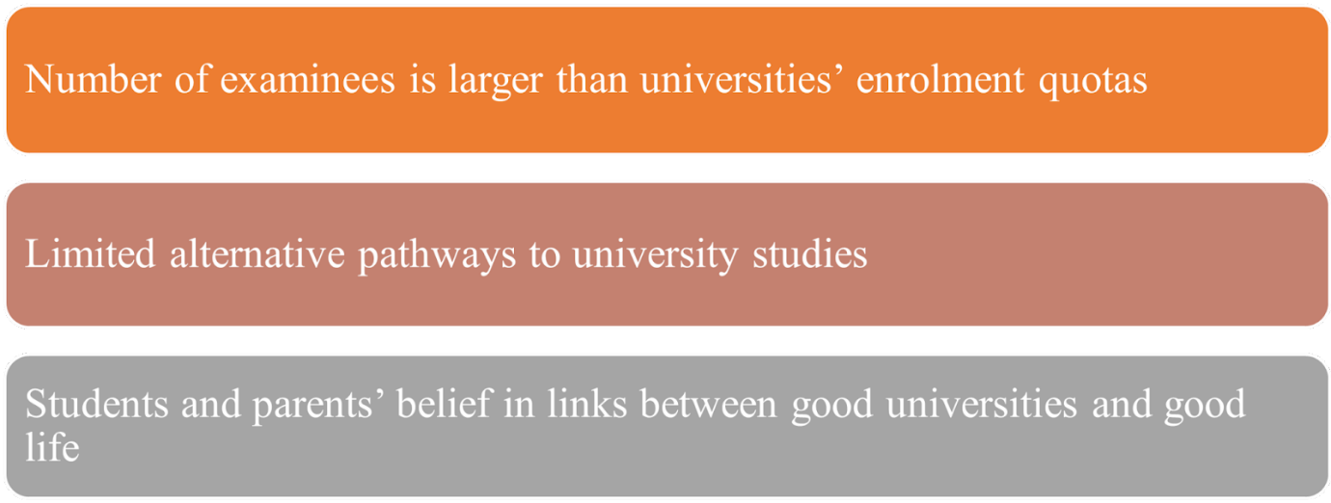
(Rappleye and Komatsu, 2018)

Poocharoen and Brillantes’s research (2013) revealed that Asian countries have attached more importance on exams and qualifications in recruitment. Meritocracy is hoped to select the most brilliant individuals, as well as find ways to remove patronage and counter corruption. In Vietnam, the country’s ruling Communist Party has reiterated the essentiality of ‘both morality and talent’ in its development strategy since 1997 (Duong, 2023). Policymakers in the country henceforth have devised incentives for those who possess such qualities. At the same time, ‘nepotism, patronage, and corruption in recruitment and promotion’ persist in Asia and Vietnam in particular, Poocharoen and Brillantes (2013) found. Meanwhile, international organisations, including the World Bank (WB) and the United Nations Development Programme (UNDP) in Vietnam, for example, encourage recruitment processes of fairness, openness, and competency (Duong, 2023; World Bank, 1997; UNDP, 2015).

Furthermore, researchers have observed that the Southeast Asian nation is greatly influenced by lessons from Confucius connecting merit with ‘relationship, social hierarchy, and a high priority for education’ (Burns, 2007; Zhang, 2015). Duong (2023) introduced an example in the workplace as payment and bonus would not only be in accordance with ‘professional performance’, but also work ethic, virtues, and ‘seniority’. Likewise, ‘rankings and positions’ may have an important role to play in facilitating merit-driven cheating among school and examination management staff. For example, they might get involved in misconduct to do a favour for their social connection or carry out an order by their superiors. Nevertheless, Sabic-El-Rayess (2016) discovered that students can have little faith in ‘merit-based mobility’ as well as transparency when they are in school, in particular with low-satisfying teaching. If that mentality continues when they enter the society, young people may have little or no motivation or prone to commit non-merit tactics, for they believe otherwise it will be in vain. As more people condone the act, it is likely to repeat in other cases and for generations.

Poocharoen and Brillantes’s work in 2013 held that some countries possess ‘well-designed and strong merit-protection’ systems, while pointing out most Asian nations still lack ‘whistleblower protection laws’ and awareness about their necessity. In addition, training in relations to ‘ethics and merit’, which the researchers believed may be key to ‘ensuring meritocracy’, stays modest (Poocharoen and Brillantes, 2013). The duo affirmed that only having entrance exams, like in Vietnam at present, remains ‘insufficient’ to ensure an efficient and credible ‘merit-protection’ system. However, they observed that in some Asian nations, the promulgation and ‘actual enforcement’ of the law are not always consistent, together with the possibilities of loopholes (Poocharoen and Brillantes, 2013).

Rappleye and Komatsu (2018) observed that in Japan, the assumption stating good universities promise good companies and a good life was discredited from the 1990s onwards, following the country’s economic stagnation. It served as a wake-up call for parents and students as external factors beyond individuals’ control, rendered corporations unable to guarantee ‘a high salary and lifetime employment’. Afterwards, Japanese authorities adopted and fostered policies to make the admissions process less competitive, namely ‘diversifying admissions’ and offering more slots (Rappleye and Komatsu, 2018). This experience could be valuable for Vietnam to reduce stress levels for exam takers as well as university admissions cheating in any form.

Bell (2020) quoted Markovits (2019)’s argument regarding a dilemma facing many university admission and job recruitment officers. They highly value merit, whereas at the same time they understand that it is not totally equitable. In response, Markovits (2019) called for efforts to ‘make the education system fairer’, with it being more inclusive (Bell, 2020). He advocated an economic agenda in which middle-skilled jobs requiring education and training but less than a college degree (Modestino, 2016), will receive more recognition (Markovits, 2019). Those jobs may be in the field of construction, mechanical maintenance, and health care, among others (Modestino, 2016). Carvalho (2022) recommended that in the wake of the development of artificial intelligence, students should receive support to brace for tasks requiring creativity (Acemoglu and Restrepo, 2019). At the same time, the internet may contribute to changing the traditional assessment method that is heavily biassed towards ‘elite education’ (Carvalho, 2022). Hermanowicz (2019) argued that students, for their part, must show their passion for education but also righteousness to be supportive of a healthy competitive environment.

Conclusion

Regardless of ‘all the necessary criticism’, meritocracy is still good for growth but not necessarily for optimality (Bevia and Corchon (2017). It can boost ‘justice and fairness’ and may even be the sole hope for social mobility for many people (Tašner and Gaber, 2022; Sabic-El-Rayess, 2016). Tašner and Gaber (2022) hypothesised the maintenance of the setting and suggested the inception and ‘practice of a new meritocracy’ in keeping with ongoing ‘economic and social changes’. Carvalho (2022) underlined that ‘populist movements’ and reversion to ‘a caste-based society’ must be avoided as efforts in changing the current system.

Tašner and Gaber (2022) affirmed that meritocracy facilitates socialisation which aims towards ‘collective well‐being for all’ (Brown et al, 2018), as well as helps consolidate education ‘as a norm’. As a result, rather than only ‘by the lottery of birth’ (Clifton, 2020), education has become a prerequisite for various ‘occupations and socio-political positions of power’ (Tašner and Gaber, 2022). Along the lines, instead of being a lair for corrupted favour reciprocation, educational institutions should serve as a place enabling individuals to ‘prove/demonstrate knowledge, skills, and abilities’ to earn rightful qualifications together with deserving social standing (Tašner and Gaber, 2022). They also underlined the importance of striving for ‘greater equality and justice’ and rejected the idea of stopping children from going to schools.

Meanwhile, Sabic-El-Rayess (2016) held against ‘the sponsorship model’ and the elites that aspire to exert their control over the academic institutions. Although people in the US and Vietnam may have different social-economic context and views on meritocracy, case studies in this essay highlight the similar significance and influence of their perceptions and actions, which turn the negative sides of the current meritocratic system into cheating and plutocracy in disguise. Given the difficulty to detect and report these incidents, talents and hard work alone will hardly lead to social mobility./.

