Why should business be ethical? March 2023

In some ways this might seem to be a strange question.
Some think the term ‘business ethics’ is an OXYMORON.
Collins (1994) Gives an idealistic view of what business is about. “The traditional view of the management role, to maximize profits, clashes with ethics, but it ignores the interdependent nature of the business environment. Ethical theory suggests that the role of management is to create social value and build trust.”
Dawson (2020) with a video looks at different types of moral responses to challenges (muteness, myopia, etc.) https://www.mccombs.utexas.edu/Communications/Placeholder/business-ethics-not-oxymoron
A University of York view on BE importance. https://online.york.ac.uk/what-are-business-ethics-and-why-do-they-matter/
Therefore, it depends on what you think business objectives are and how they can achieve them.
- There are those who think business is immoral or amoral. In this case the oxymoron is appropriate.

- There are those who think that business wants to be ethical and is trying to do its best, being influenced by being in society.

- There are those who think that simply doing what it does naturally makes a valuable contribution to society

Greed is good?
https://www.youtube.com/watch?v=6Da1tDKFfno

Good ethics, is Good business”?

See my brainstorm on why business should be ethical.

Many arguments in favour of adopting ethics can revolve around protecting the organisation in the long run (a precautionary motive). In other words, do obey the law, do not cause scandals, don’t be untrustworthy…

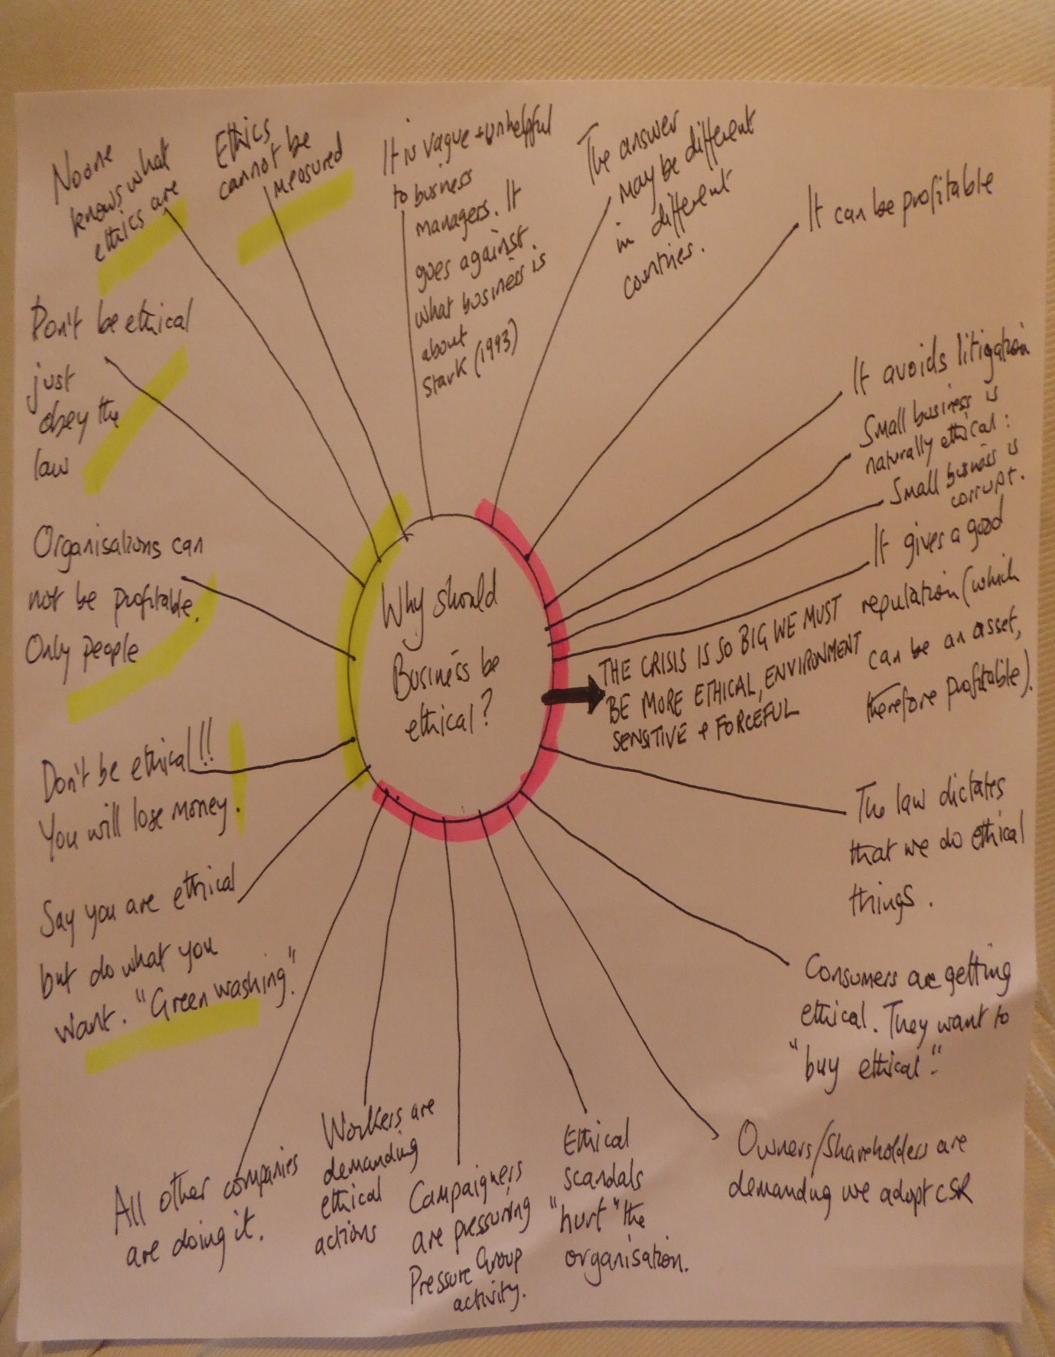

Beware the “Machiavellian organisation”. They will say the right things but not do them. http://ianchadwick.com/machiavelli/chapters-15-21/chapter-18-the-subtle-art-of-lying/

Pictures from BBC (2015) https://www.bbc.co.uk/news/magazine-34912959

The Italian diplomat and philosopher Niccolo Machiavelli wrote in The Prince, a founding bible of modern political science, that for the statesman, "occasionally words must serve to veil the facts".

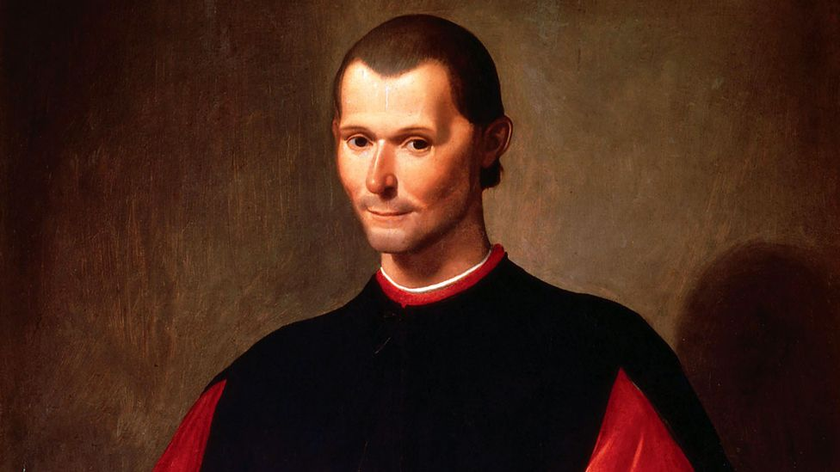

“Everyone sees what you appear to be, few experience what you really are.”
― Niccolò Machiavelli, The Prince

“…he who seeks to deceive will always find someone who will allow himself to be deceived.”
― Machiavelli Niccolo, The Prince

“Of mankind we may say in general they are fickle, hypocritical, and greedy of gain.”
― Niccolò Machiavelli, The Prince

Is lying the same as “mistruth”, “obscuration”, “terminological inexactitude”, “misleading”, not telling the full truth and many other terms?

Can lying ever be ethical?

Can the truth be damaging?

Do we have to tell the whole truth?

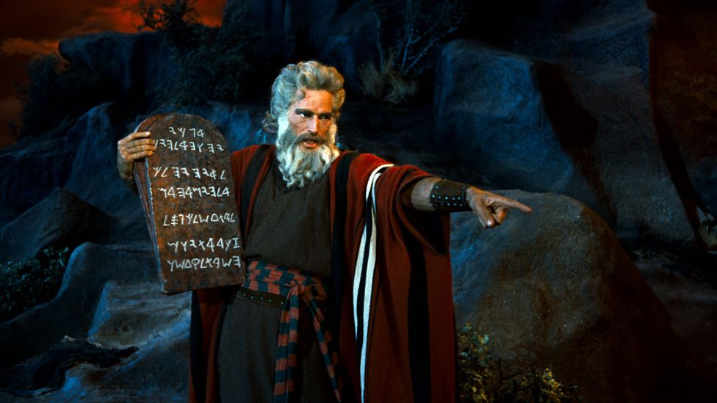

The idea that deception is wrong can probably be dated to the Bible, and the ninth commandment: "Thou shalt not bear false witness against thy neighbour".

Motives for being ethical ARE the drivers.

- Objectives: Stockholder (Milton Friedman) Narrow v Stakeholder (R.E. Freeman) Broad

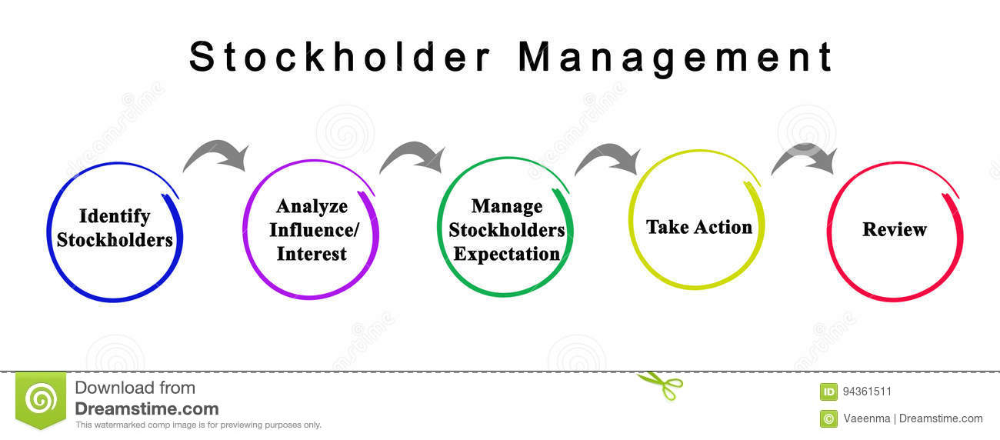

Obvious criticisms?

- Owners /shareholder/ stockholder are the ones that matter. Who are they? How do they make their views known? Managerial Capitalism? Resurgence of the stockholders? Enron haunts us all.

Gordon Gekko in Wall Street https://www.youtube.com/watch?v=VVxYOQS6ggk

- What about us non owners who are affected by the organisation?

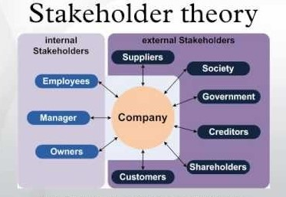

https://www.youtube.com/watch?v=4lEjv0vE6VY

Obvious criticisms?

Who are your stakeholders?

Pragmatic Objections:

- We can’t agree what it is.

- If we could, we can’t measure it.

- If we knew what it was and how we want to put it in action, it wouldn’t make any difference.

What about PUBLIC SECTOR and NOT FOR PROFIT SECTORS?

- The Law and ethics

Verne E. Henderson (1982) The Ethical Side of Enterprise, Sloan Management Review, Spring, 42.

 | Legal | Illegal
Ethical | 1. | 2.
Unethical | 3. | 4.

Can you think of examples to put into the boxes?
Answers?

 | Legal | Illegal
Ethical | 1. Giving company donations to Charities (Corporate Philanthropy) | 2. Positive Action/Discrimination in favour of groups who were discriminated against in the past to ensure diversity in the workforce
Unethical | 3. Targeting selling lifesaving drugs only to rich people. | 4. Selling marijuana

Can we move examples from one box to the other? Why might this be good to do?
Box 1 might be criticised by Milton Friedman. He might move it to Box 3. Why?
Box 2, might move if the case of Article 153 of the Constitution of Malaysia was considered. It safeguards the special position of the Malays (the BUMIPUTERA). It goes on to specify ways to do this, such as establishing quotas for entry into the civil service, public scholarships and public education. This works to the disadvantage of Malaysian Chinese and Indian communities. The Malays would say it needs to be in Box 1.
- What about international laws?
- What about regulations? Are they the same?
- What about future laws?

- Profit/Business objectives?

Profitable v Ethical Classification of Actions (modification of the “Enlightenment Matrix” in Cannon, 1996)
Tom Cannon (1996) Corporate Social Responsibility, London, Pitman

 | Profitable | Unprofitable
Ethical | 1. | 2.
Unethical | 3. | 4.

Can you think of examples to put into the boxes?

Answers?

 | Profitable | Unprofitable
Ethical | 1. Making plastic toys but………. | 2. Telling customers about all the side effects and defects of our product…the whole truth
Unethical | 3. Selling illegal drugs but……….. | 4. Insulting Asian people potential customers or suppliers by calling them racist names

Henderson and Cannon’s matrices can interact. They offer a quick way to clear heads on what could or should be done.
- Is there a hierarchy of responsibilities?

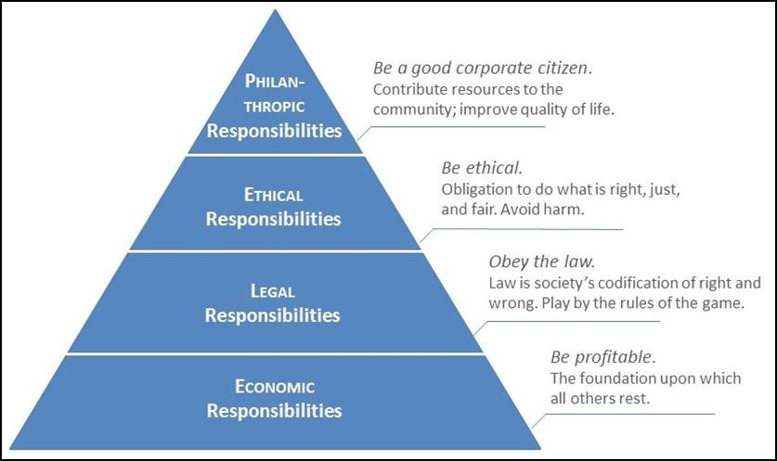

Carroll’s Pyramid of social responsibility.

Is it a hierarchy?

Can we dip in and out?

- How wide should we go with CSR?

- See the old article Stark (1993). If we go too wide no one will listen to us.

- Crane & Matten (2022) Their view of Corporate Citizenship (CC)

Coined by practitioners, sees the corporation’s place in society, with other “citizens” with whom the corporation forms a community. “Citizenship ..focuses on rights and responsibilities of all members of the community, who are mutually interlinked and dependent on each other.” P62

- Limited View of CC- equates with corporate philanthropy
- Equivalent view of CC- equates with CSR
- Extended View of CC- acknowledges the extended political role of the corporation in society.

Corporate Shared Value (CSV)-

https://hbr.org/2011/01/the-big-idea-creating-shared-value

A big part of the problem lies with companies themselves, which remain trapped in an outdated, narrow approach to value creation. Focused on optimizing short-term financial performance, they overlook the greatest unmet needs in the market as well as broader influences on their long-term success. Why else would companies ignore the well-being of their customers, the depletion of natural resources vital to their businesses, the viability of suppliers, and the economic distress of the communities in which they produce and sell?
It doesn’t have to be this way, say Porter, of Harvard Business School, and Kramer, the managing director of the social impact advisory firm FSG. Companies could bring business and society back together if they redefined their purpose as creating “shared value”—generating economic value in a way that
also produces value for society by addressing its challenges. A shared value approach reconnects company success with social progress.

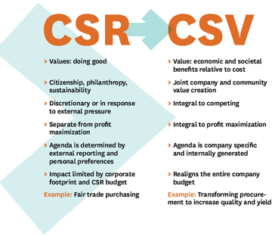

- Corporate Social Responsiveness “the capacity of the corporation to respond to social pressures”.

What options are there?

- Reaction- denial
- Defence- fight the case, PR management.
- Accommodation- complies with interest groups.
- Proaction- goes beyond industry norms anticipates future expectation.

- The emergency is so great we have no choice. Sustainability must be the goal.

APOCALYPSE NOW…..TOMORROW……IN 2099….WHO CARES?

Sustainability is DIFFERENT from ethics although they are related.

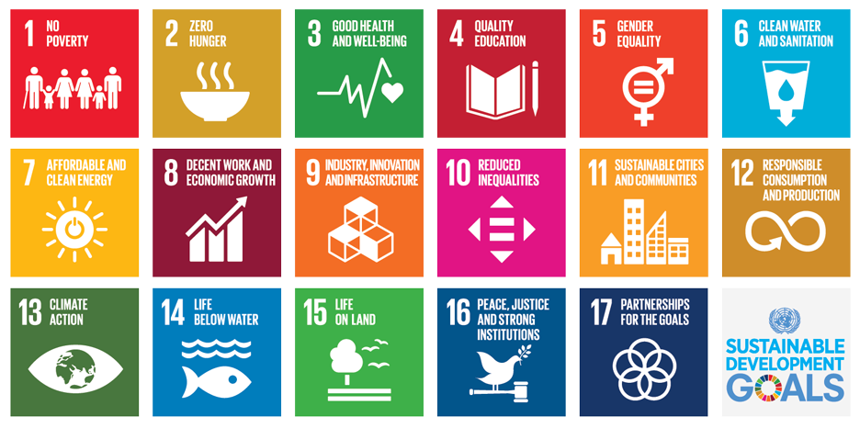

History

The 2030 Agenda for Sustainable Development, adopted by all United Nations Member States in 2015, provides a shared blueprint for peace and prosperity for people and the planet, now and into the future. At its heart are the 17 Sustainable Development Goals (SDGs), which are an urgent call for action by all countries - developed and developing - in a global partnership. They recognize that ending poverty and other deprivations must go hand-in-hand with strategies that improve health and education, reduce inequality, and spur economic growth – all while tackling climate change and working to preserve our oceans and forests.
The SDGs build on decades of work by countries and the UN, including the UN Department of Economic and Social Affairs

Bibliography:

Cannon, T. (1996) Corporate Social Responsibility, London, Pitman.

Carroll, A.B. (2004) Managing Ethically with Global Stakeholders: A Present and Future Challenge, Academy of Management Executive, Vol.18 No.2, pp.114-20.
Collins, John W. "Is business ethics an oxymoron?" Business Horizons, vol. 37, no. 5, Sept.-Oct. 1994, pp. 1+. Gale Academic OneFile, link.gale.com/apps/doc/A15859236/AONE?u=anon~b383eaca&sid=googleScholar&xid=e17631af. Accessed 7 Dec. 2021.
Crane, A. & Matten, D. (2022) Business Ethics, Managing Corporate Citizenship and Sustainability in the Age of Globalization, Oxford, OUP

Freeman, R.E. (1994) The Politics of Stakeholder Theory, Business Ethics Quarterly, Vol. 4, pp. 409-21.
Freeman, E.R., Wicks, A.C. and Parmar, B. (2004) Stakeholder Theory and ‘The Corporate Objective Revisited’, Organization Science, Vol.15 No.3, pp. 364-69.
Friedman, M. (1962) Capitalism and Freedom, University of Chicago Press, Chicago.
Friedman, M. (1970) The social responsibility of business is to increase profits, The New York Times Magazine, 13 September, Vol. 13, No. 32-33, pp. 122-126.

Porter, M.E. and Kramer, M.R. ( 2011) Creating Shared Value, How to reinvent capitalism—and unleash a wave of innovation and growth. Harvard Business Review Magazine, January-February. https://hbr.org/2011/01/the-big-idea-creating-shared-value (Accessed 12-02-11).

Stark, A. (1993) What’s the Matter with Business Ethics? HBR Magazine (May–June 1993).

United Nations (2021) 17 Goals, https://sdgs.un.org/goals

Verne E. Henderson (1982) The Ethical Side of Enterprise, Sloan Management Review, Spring, 42.

Weblinks:
https://www.investopedia.com/ask/answers/040815/why-are-business-ethics-important.asp
https://www.redlands.edu/study/schools-and-centers/business/sbblog/2019/may-2019/3-reasons-why-business-ethics-important/
https://www.chartercollege.edu/news-hub/why-are-good-ethics-so-important-businesses
Quite nice on why scandals are bad https://www.wgu.edu/blog/ethical-dilemmas-how-scandals-damage-companies1909.html#close

