

Soil Mechanics PRACTICAL

By Shahram Sharifi Sarab Shah Hosseini
Student number: 1705246

Geology and Soil Mechanics
Allan Nantel
University of Wales Trinity Saint David
Swansea, UK
2018-2019

Contents
Introduction 3
Sieves Analysis: 3
experiment process 3
Results and Analysis 5
Conclusions 7
recommendation 7
Atterberg Limits: 8
Liquid limit 8
experiment process 8
Results and Analysis 9
Plastic limit 10
experiment process 10
Results and Analysis 12
Conclusions 14
Recommedation 14
References 14

Introduction
Using soil experiments can predict deformations, or movements in natural or artificial structures constructed of soil or underground soil. For achieving a strong construction, the greatest bearing capacity that can achieved by greatest density compaction.so having information about moisture of soil is very necessary.in between two experiments can be helpful:
1-sieves analysis
2- Atterberg Limits

Sieves Analysis:
The purpose of this experiment is to find the extent of the particles in the soil that show as a percentage of dry soil. This test plays a very important role in the classification of soils. Because the soil classification cans show the particle size of the soil. Because its help full for predict the soil behaviour. So, it is a way for understanding the necessary changing in soil for make it good for civil engineering purpose.

experiment process
The materials were used in this experiment on due to British standard:
- Vibration machine (BS 1377-2: 1990: 9.3.2.9)
- Weighting scale (BS 1377-2: 1990: 9.3.2.2)
- scoop (BS 1377-2: 1990: 9.3.2.7)
- metal tray (BS 1377-2: 1990: 9.3.2.6)
- bowl (BS 1377-2: 1990: 9.3.2.4)
- brush (BS 1377-2: 1990: 9.3.2.8)
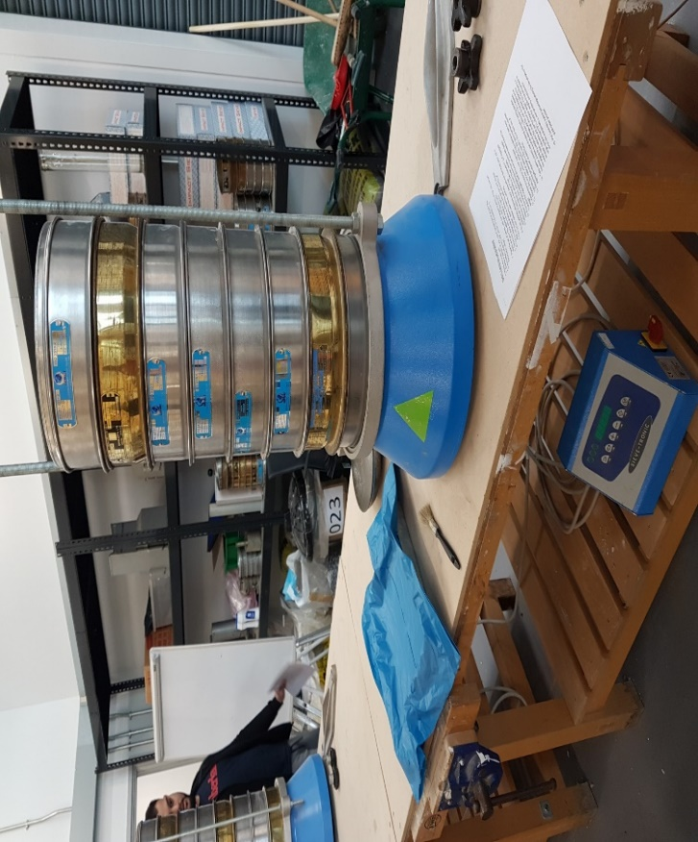
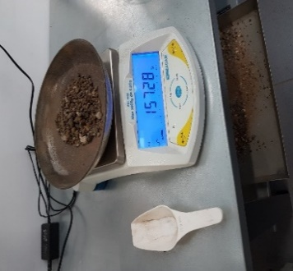
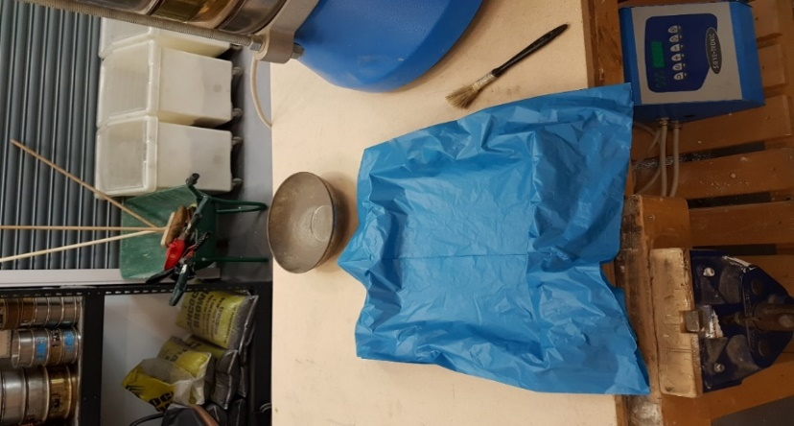
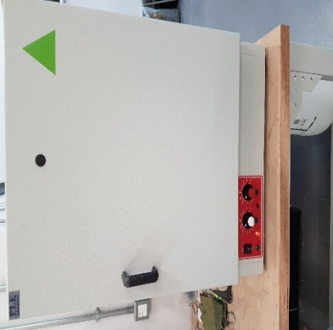
- oven (BS 1377-2: 1990: 9.3.2.5)
1
2
4
7
3
5
6
Figure 1: The materials were used in sieves analysis

For this experiment, a special sieve it used, the bottom of which is steel wire, and the holes in the foam of the sieve are all correct and distinct.
sieves have put together a set of sockets, with a larger hole at the top and lower sieve at the bottom (BS 1377-2: 1990: 9.3.4.2).in this case the sieves are used with 7 sizes that are shown in figure 2.

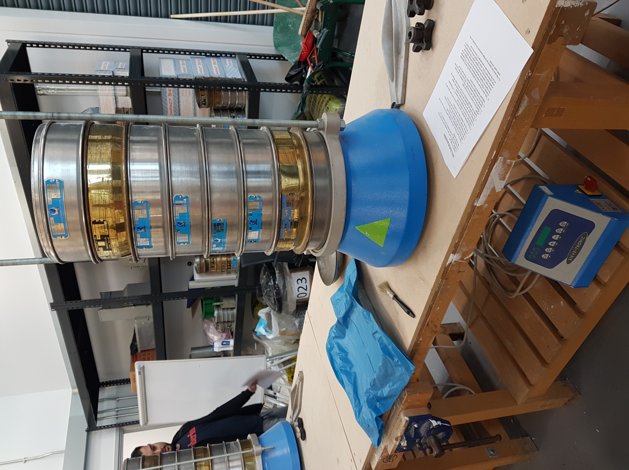
Figure 2: the size of sieves
4.00 MM
2.00 MM
1.00 MM
500 UM
250 UM
125 UM
63 MIC
PAN

After placing the sieves in coarse order, we placed those on the vibration machine; underneath the smallest sieve, a tray should be placed so that the smallest grain passing through the last sieve is deposited in that tray. First the equipment should be nicely clean as shown in figure 1.
In this case Place 1061.82 kilograms of sample soil on the largest sieve and the all fastened should be tightened. Then the vibrator machine should be turn on for 2 mins (On base (BS 1377-2: 1990: 9.3.4.5) the minimum period of shaking should be 10 min). After that very carefully the soil weight should be determined in each sieve.

Results and Analysis

in this case the result is shown in figure 3 and 4.

Sieve size(mm) | Mass(g) | % on sieve | % passing
4.00 mm | 157.28 | 14.810 | 85.19
2.00 mm | 164.58 | 15.5 | 69.69
1.00 mm | 139.32 | 13.12 | 56.57
500 um | 116.44 | 10.97 | 45.6
250 um | 180.49 | 16.99 | 28.61
125 um | 196.28 | 18.49 | 10.12
63 mic | 40.48 | 3.81 | 6.31
pan | 64.55 | 6.08 | 0.23
total | 1059.35  Figure 3: table of recorded for sieves analysis | 99.77

Figure 4: diagram of recorded for percentage of soil on sieves
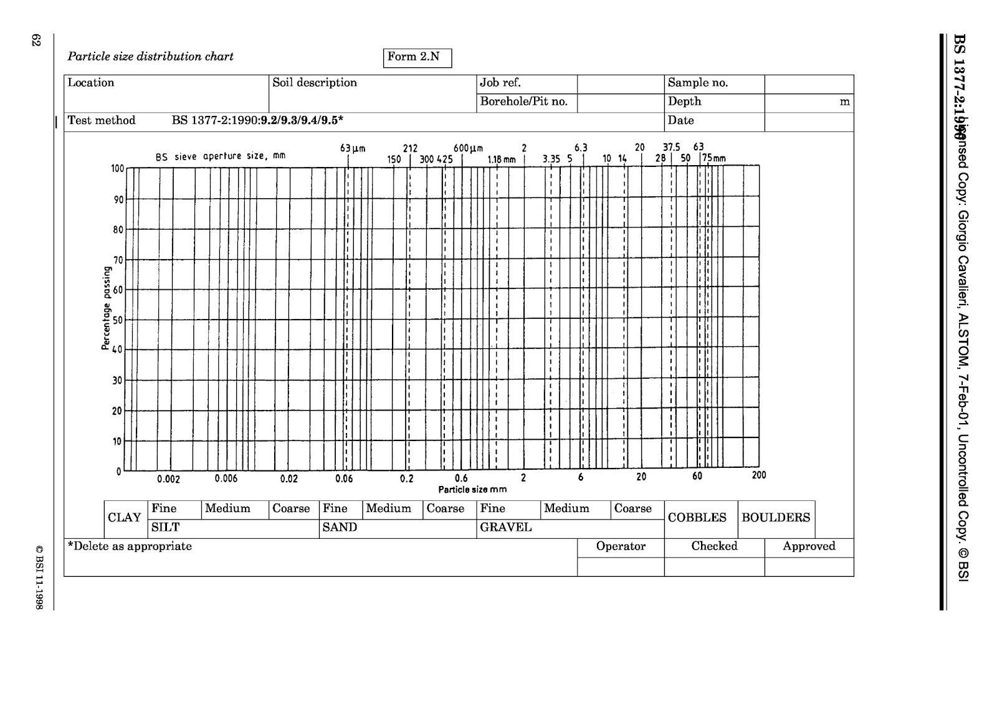
The information in figure 3 is used for drawing the diagram 5 that can give some overview of what kind of sizes include the soil.
5.31%
63.15%
30.31%
Figure 5: diagram of particle sizes of soil
1.00%

Sieve size(mm) |  | Mass(g) |  | % on sieve |  | % passing
sand | 1.00 mm | 673.01 | 139.32 | 91.24% | 18.89 | 8.76 | 81.11
sand | 500 um | 673.01 | 116.44 | 91.24% | 15.79 | 8.76 | 65.32
sand | 250 um | 673.01 | 180.49 | 91.24% | 24.47 | 8.76 | 40.85
sand | 125 um | 673.01 | 196.28 | 91.24% | 26.61 | 8.76 | 14.24
sand | 63 mic | 673.01 | 40.48 | 91.24% | 5.49 | 8.76 | 8.75
silt | 0.002 um | 54.32 | 54.32 | 7.36% | 7.36 | 1.4 | 1.4
clay | pan | 10.23 | 10.23 | 1.4% | 8.75 | 0 | 0
total |  | 737.56 | 737.56 | 100 | 100

Figure 6: the table on base of sand, silt and clay for triangle soil texture

As regards usually for triangle soil texture, the materials are recorded that are in sand, silt and clay area. So, all material we could record for triangle soil texture is 737.56 g so for triangle soil texture the table could be as figure 6 on base the figures 3 & 5.

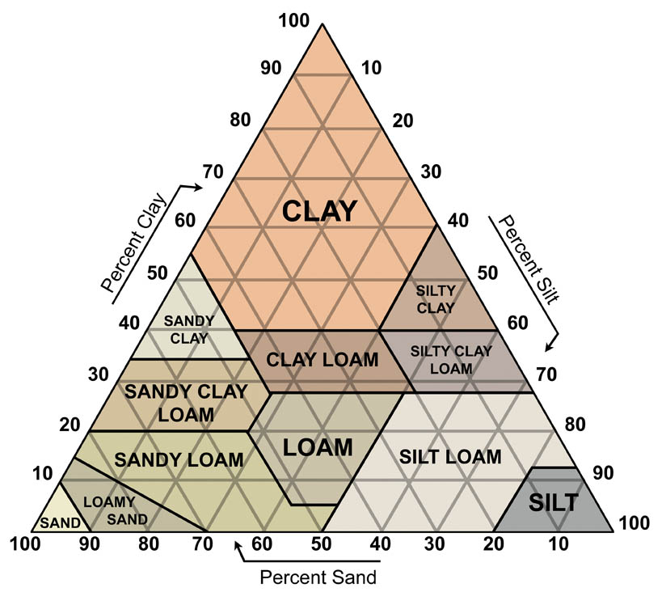
Now for completing the triangle soil texture. The data at column “% on sieve” should be considered. By arrows guide on the triangle soil texture the cross point is found it (figure 7).
Figure 7: triangle soil texture

Conclusions
As result in figure 7 the soil is in sand and because it has a good representation of all sizes of sands group and as figure five the soil includes: 30.31% gravel, 65.15% sand, 5.31% silt, and clay 1% is classified therefore as: a well-graded gravelly sand. This type of soil is gritty to touch and dry and because it has large pores, its holding moisture is not good but drains easily. If it is used for foundation, it will be compact but it is necessarily known when it is wet it can be wash away that can cause a gap beneath the foundation.

recommendation
* This method is logical for coarse grains, but it is not suitable for very fine grains because the very fine grains of the soil stick together and thus the sieve method will not give proper answers. If the amount of fine grain is high, first have to pass water through the soil and rough grains, and after washing larger particles and destroying clods, we begin to sift.

Atterberg Limits:

It is a fundamental measure of soil moisture content. Based on this criterion, three limits are defined for moisture content in water:

- Shrinkage limit
- Liquid limit
- Plastic limit

Liquid limit
“The liquid limit is defined as the minimum water content at which a pat of soil cut by a groove of the standard dimension will flow together for a distance of 12 mm (1/2 inch) under an impact of 25 blows in the device.” (Kaliakin,2017)

experiment process

The materials were used in this experiment on due to British standard:
1.Spatula (BS 1377-2: 1990: 4.5.2.2)
2.liquid limit device (BS 1377-2: 1990: 4.5.2.3)
3.grooving tool (BS 1377-2: 1990: 4.5.2.4)
4.container (BS 1377-2: 1990: 4.5.2.7)
5.bowl (BS 1377-2: 1990: 4.5.2.5)
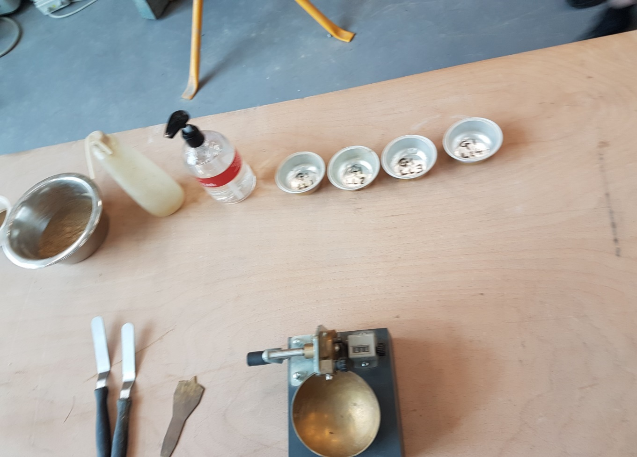
1
3
2
4
5
Figure 8: The materials were used in Liquid limit experiment
First of all, 300g (BS 1377-2: 1990: 4.5.4.1) the soil sample thoroughly mixed in a bowl and took initial amount of water about 1-2ml until reached to a clay consistency that required 30-35 drops of the Liquid Limit Device for reaching to 12 mm gap closure between two segments (BS 1377-2: 1990: 4.5.4). Then squeezed some of the sample in the brass cup of Liquid Limit Device that known as “Casagrande. “The thin of the sample on cup was about 8mm. In the next step divided the soil in two segments by using the standard grooving tool for do this the grooving tool moved from back to front. Started to rotate the with 2 revolutions in second until the two-segment met each other about 12 mm (1/2 inch). Recorded the number of drops required. The sample was taken and placed in a container.in the next step it weighted for the moisture content determination. Finally, for drying, the sample was put in the oven for 24 hours. The experiments repeated 4 time and any time gradually added some water for increasing the moisture that caused the reduce the number of dropping in Casagrande for reaching to goal gap closure (they were between 35-15) (BS 1377-2: 1990: 4.5.4.5).
result is brought in figure9

Results and Analysis
The result is shown in below table.

 | 1 | 2 | 3 | 4
Type of test | LL | LL | LL | LL
Container number | 1 | 2 | 3 | 4
Wt of wet soil + cont. | 13.44 | 13.70 | 15.07 | 14.63
Wt of dry soil +cont. | 11.16 | 11.26 | 12.67 | 12.11
Wt of container | 4.73 | 4.70 | 4.72 | 4.75
Wt of moisture | 2.28 | 2.44 | 2.4 | 2.52
Wt of dry soil | 6.43 | 6.56 | 7.95 | 7.36
Moisture content* | 35.46% | 37.19% | 30.19% | 34.24%
Number of blows | 26 | 16 | 88 | 31
Figure 9: table of recorded for Liquid limit experiment
*MOISTURE CONTANT= (WEIGHT OF MOISTURE / WEIGHT OF DRY SOIL) * 100

35.635
25
25
36.6
Figure 10: graph for Liquid limit experiment

LIQUID LIMIT= -0.0894*25 + 37.87= 35.635 it is found on graph also

Plastic limit
The plastic limit (PL) is the water content, in percent, at which a soil can no longer be deformed by rolling into 3 mm (1/8 in.) diameter threads without crumbling. (Smith, 2016)

experiment process

The materials were used in this experiment on due to British standard:
1.weighting scale (BS 1377-2: 1990: 5.3.2.4)
2.three containers (BS 1377-2: 1990: 5.3.2.1)
3.a rod with 3 mm diameter (BS 1377-2: 1990: 5.3.2.5)
4.a glass plate (BS 1377-2: 1990: 5.3.2.2)
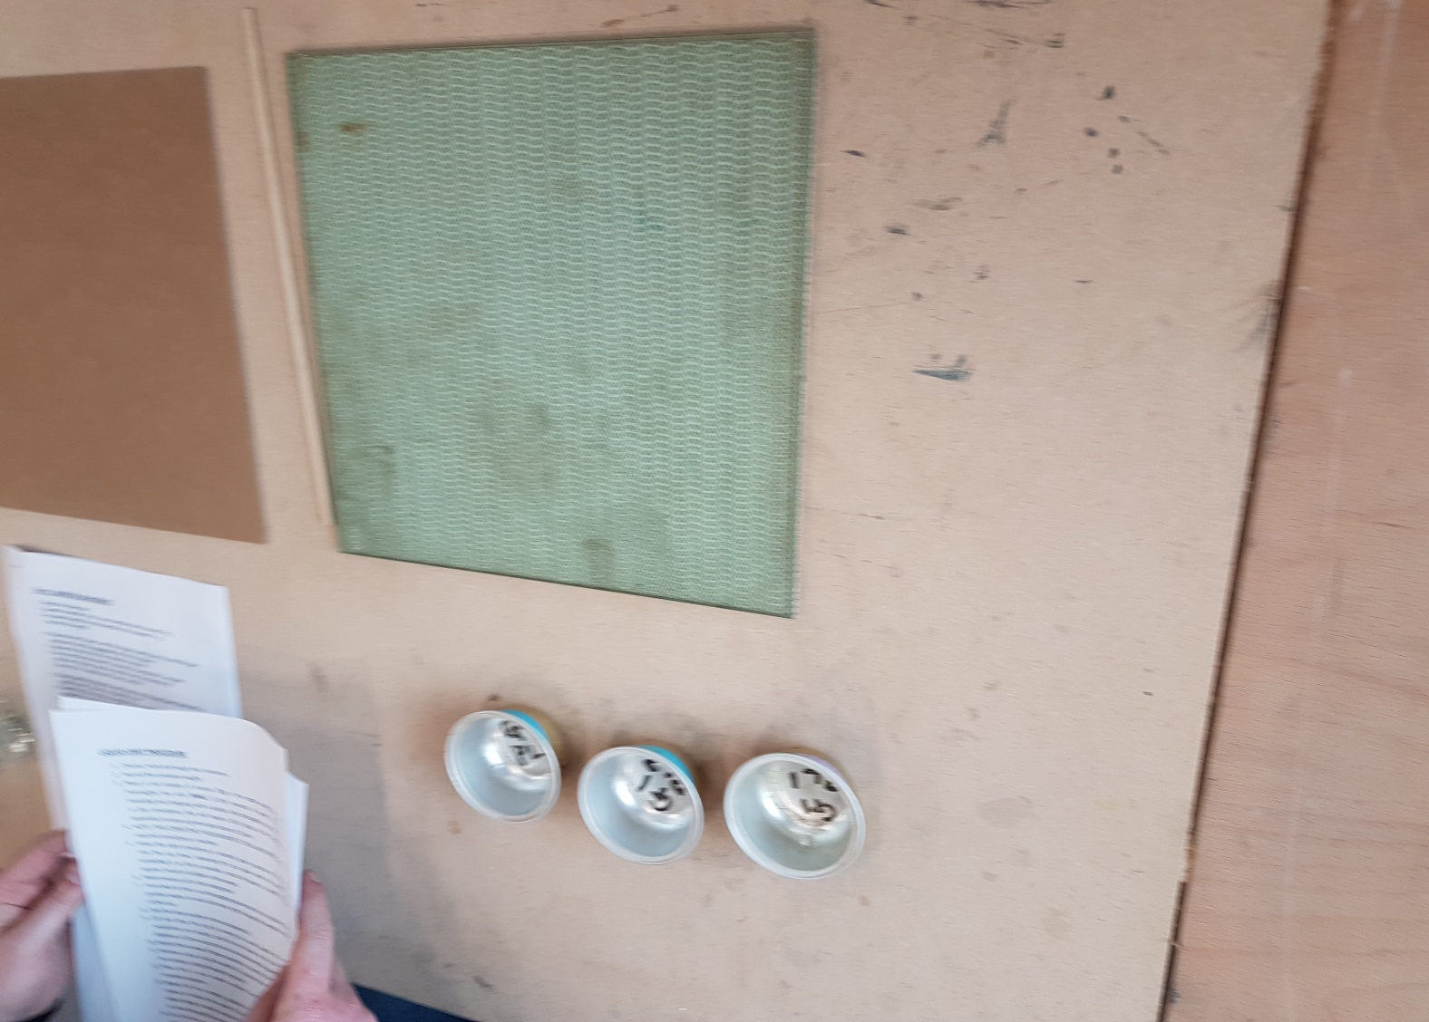
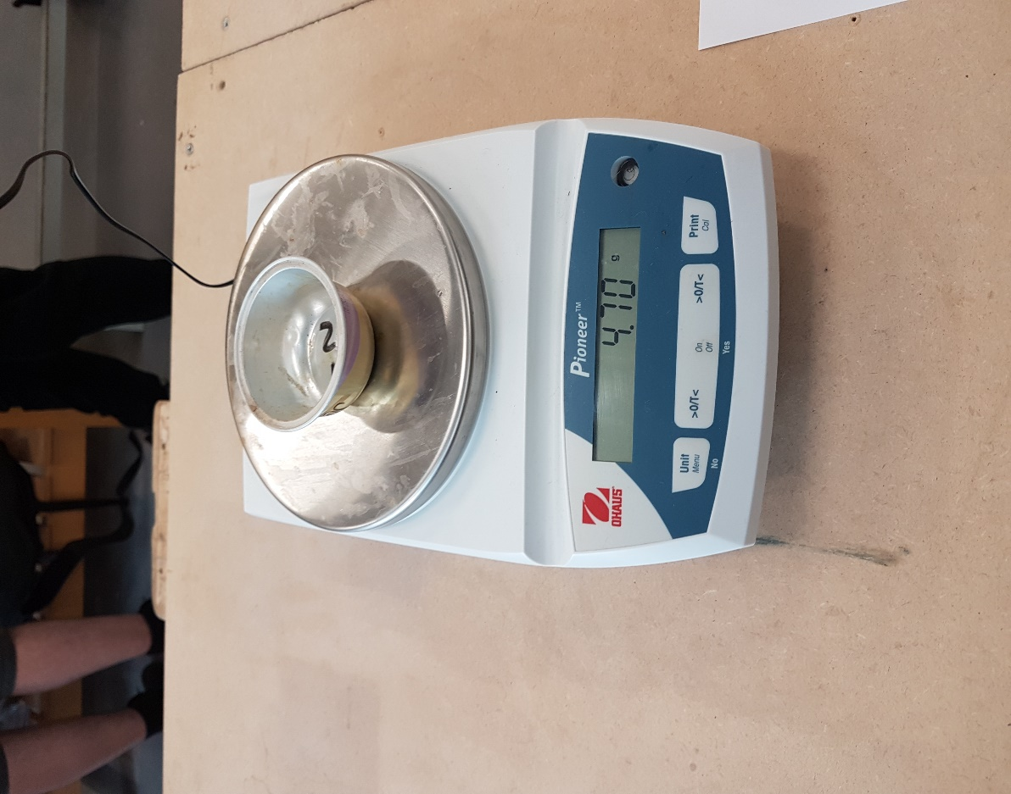
2
4
3
1
Figure 11: The materials were used in Plastic limit experiment

In this experiment, three containers were chosen. First of all, the weight of containers recorded. Slowly kneaded the sample until reached to the required moisture. Then a rolled a ball of mould by palms of hands (this process takes some of the moisture out of the sample soil.) until the cracks appeared. After that it was divided to 3 parts that about 10g were any of parts.
Next applied pressure to taper until would be 3mm diameter.in the first time the soil thread crumbled before it can be rolled to 3mm diameter so some water was added to sample and the process was repeated. Second time it could be rolled to 3mm.keep pressure when the 3 mm dimeter roll is made until the thread start to crumble.(it was important the pressure was same in all of the experiment and didn’t use any external force.).Finally the rolled sample placed in the container and it put in the oven to be dry. The experiment was repeated for 3 times. The result is brought in figure 12 (BS 1377-2: 1990: 5.3.3).

Results and Analysis

The result is shown in below table.

 | 1 | 2 | 3
Type of test | PL | PL | PL
Container number | 1 | 2 | 3
Wt of wet soil + cont. | 7.30 | 7.29 | 6.58
Wt of dry soil +cont. | 6.72 | 6.80 | 6.19
Wt of container | 4.70 | 4.76 | 4.76
Wt of moisture | 0.58 | 0.48 | 0.39
Wt of dry soil | 2.02 | 2.06 | 1.43
Moisture content* | 28.71% | 23.23% | 27.27%
Figure 12: table of recorded for Plastic limit experiment

*MOISTURE CONTANT= (WEIGHT OF MOISTURE / WEIGHT OF DRY SOIL) * 100

On base the table in figure 12 and this point that average the moisture contents of the tests is the plastic limit of soil. the plastic limit can be calculated:

PLASTIC LIMIT= AVREAGE THE MOISTURE CONTANTS OF THE TESTS
PLASTIC LIMIT= (28.71+23.23+27.27) / 3 = 26.40
The result of calculate is shown in a graph for more understanding (figure 13)
PLASTIC LIMIT
MOISTURE CONTANT
Figure 13: graph for Plastic limit experiment

Finally, for classification of soil sample, it is necessary to calculate the
Plasticity index that can be found by use the below formula:

Plasticity Index = Liquid Limit – Plastic Limit
Plasticity Index = 35.635 – 26.40 = 9.235

Due to the plasticity index and liquid limit the plasticity chart can be draw. (figure 14).as the shown in figure 14 the type of soil is silt with intermediate plasticity.
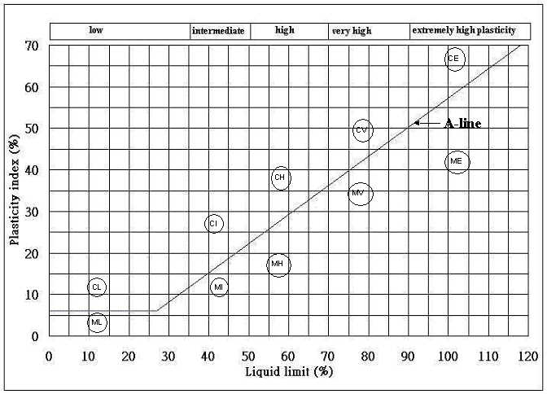
Figure 14: plasticity chart

Conclusions
In all experiments are done. The results are definitive. As the tables shown in the first part of experiment liquid limit was 35.635 and second part shown plastic limit that was 26.40. With two data the plasticity index calculated that was 9.235.
This plasticity index is low that is mean the soil has the tent to be silt and possibility soil has high organic matter. This plasticity index is low that is mean the soil has the tent to be silt and possibility soil has high organic matter. this soil has medium capability for compressibility and it is not very strong for heavy construction.it is told soil is silt with intermediate plasticity and medium compressibility also.
Silt has small particles that cause keep water for long time but drains poorly. This is a reason it’s not ideal for foundations because this Expansion and contraction can push the foundation and damage to it.
Plasticity limit is 26.40 which is low and it is cause the cohesiveness of soil will be very low.The liquid limit was 35.635 that mean it is low so soil has the tendency to destroy the cohesion with other particle of soil. If add a little extra moisture it will be muddy.

Recommedation
Unfortunately, in the liquid limit experience, number of blows in second test is 88. This number should be between 35 and 15.So It is recommended the second test of liquid limit should be repeated.

References
- British Standards Institution (1990). Methods of test for soils for civil engineering purposes. BS 1377, London.
- Brown R.B, professor emeritus, Soil and Water Science Department, Florida Cooperative Extension Service, Institute of Food and Agricultural Sciences, University of Florida, Gainesville, FL 32611-0510
- Kaliakin, V.I.C.T.O.R (2017). Soil Mechanics. [Online]. Newark: University of Delaware. [18 April 2019]. Available from: https://www.sciencedirect.com/science/article/pii/B9780128044919000021
- royal civil. (2015). LIQUID LIMIT OF SOIL – WHAT, WHY & HOW?. [Online]. [15April 2019]. Available from:
http://royalcivilmvr.weebly.com/blog/liquid-limit-of-soil-what-why-how
- Smith, W.I.L.L. 2016. www.coursehero.com. [Online]. [15April 2019]. Available from: https://www.coursehero.com/file/p2b9ase/7-What-is-the-importance-of-liquid-limit-and-plastic-limit-in-soil/https://civilblog.org/2015/03/07/liquid-limit-of-soil-what-why-how/

