Part 1:

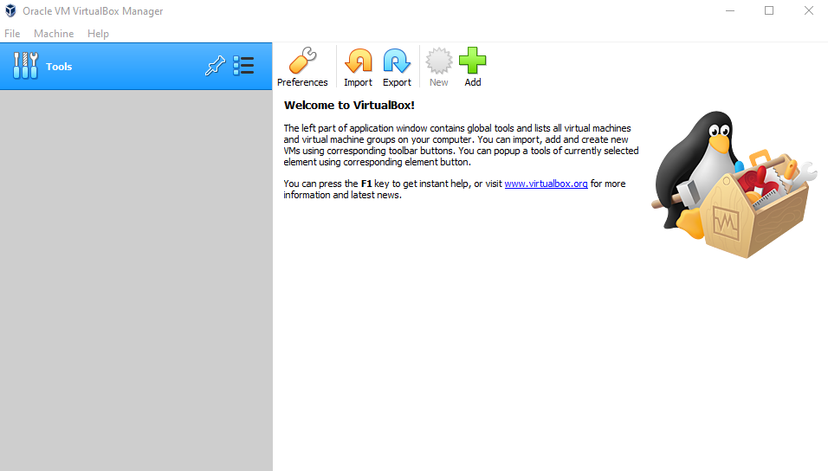
Firstly, I will be choosing my virtualization software which will be VirtualBox this virtualization software will be the host for my virtual machine.

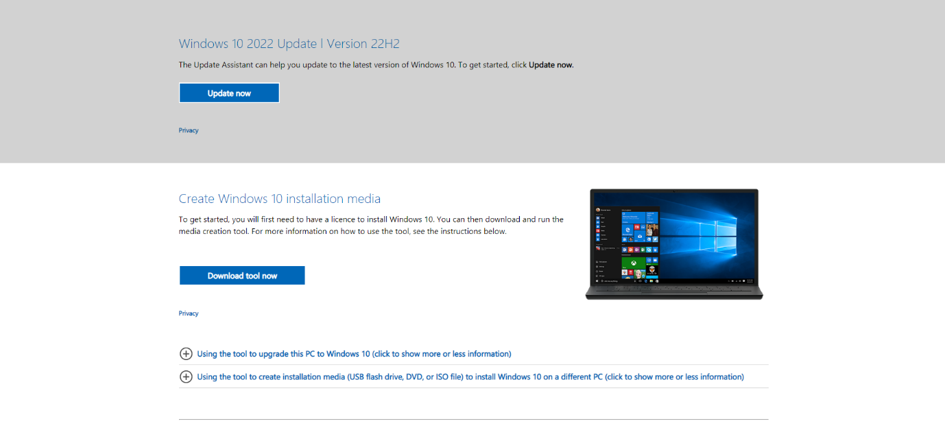
Next, I will be installing the windows 10 ISO from the Microsoft website this will be the operating system I will be installing on the virtual machine.

Next I will be creating my virtual machine through virtual box.
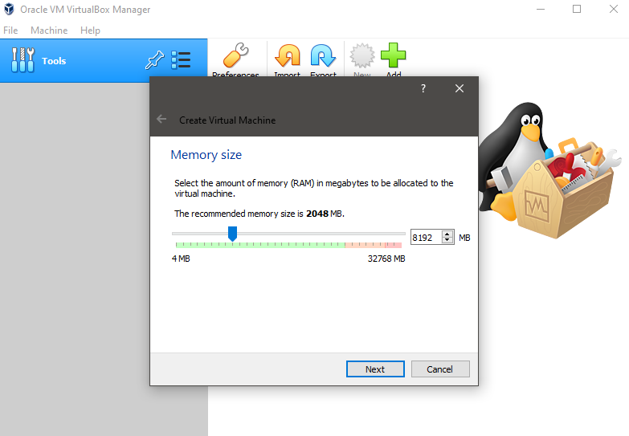
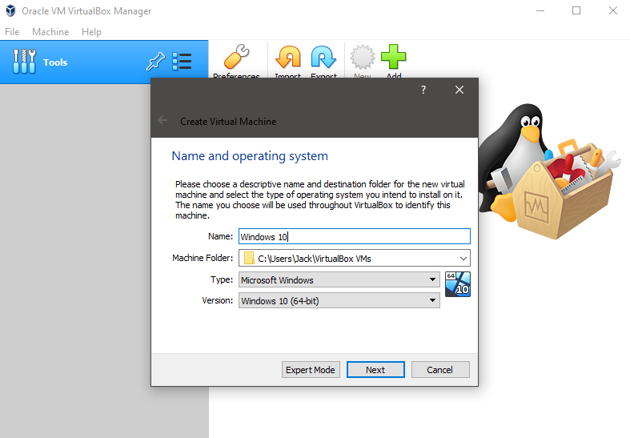
then I will receive prompts to set the memory size (RAM) in megabytes for the purposes of this demonstration we will be using 8GBs of ram but this will all depend on the limits of your machine.
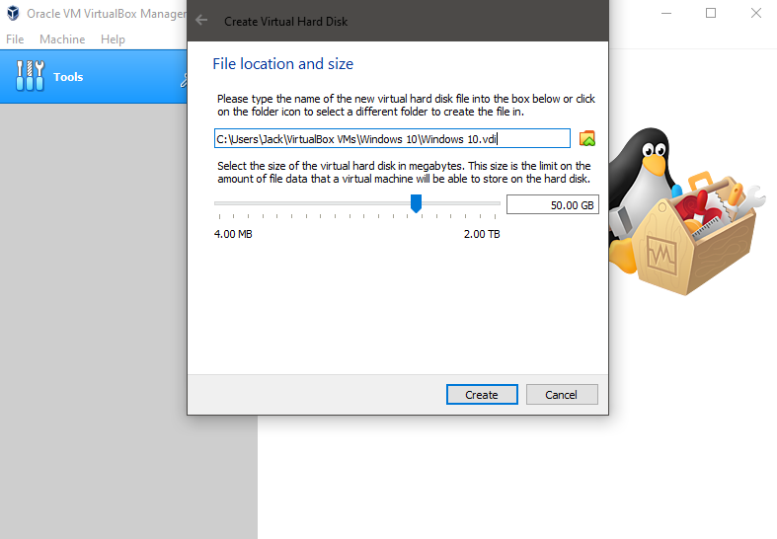
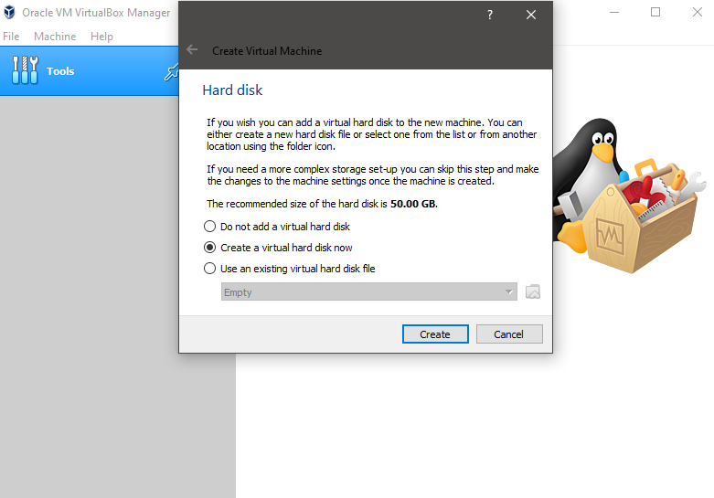
Secondly it will ask you to create a virtual hard disk which will be set at 50GBs

Once all of the virtual box steps have been completed, I can then launch the virtual machine and begin installing Windows 10 these steps take little time to process and are as follows:
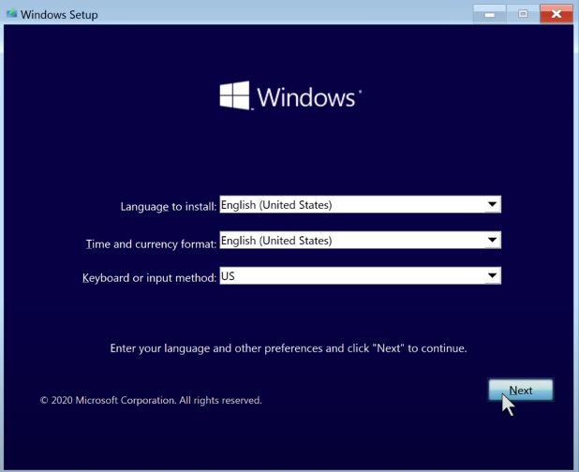

Firstly, you will be prompted with options to select your Time zone Language and Keyboard layout.
You should select these as needed.
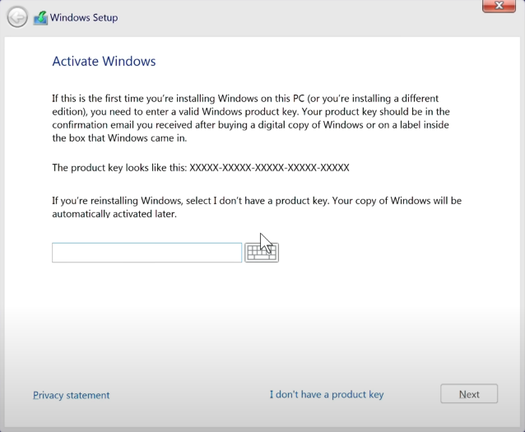

Once those options have been selected we will be faced with a product key tab if you have a windows product key you should enter it here if not then select the “I don’t have a product key”
Which will then take you to another tab which will allow you to select your version install of windows. For the purposes of this install I will be selecting The Windows 10 Home

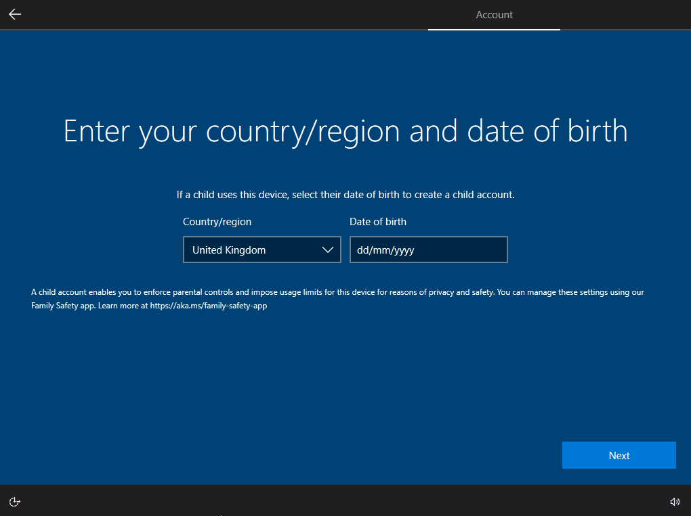
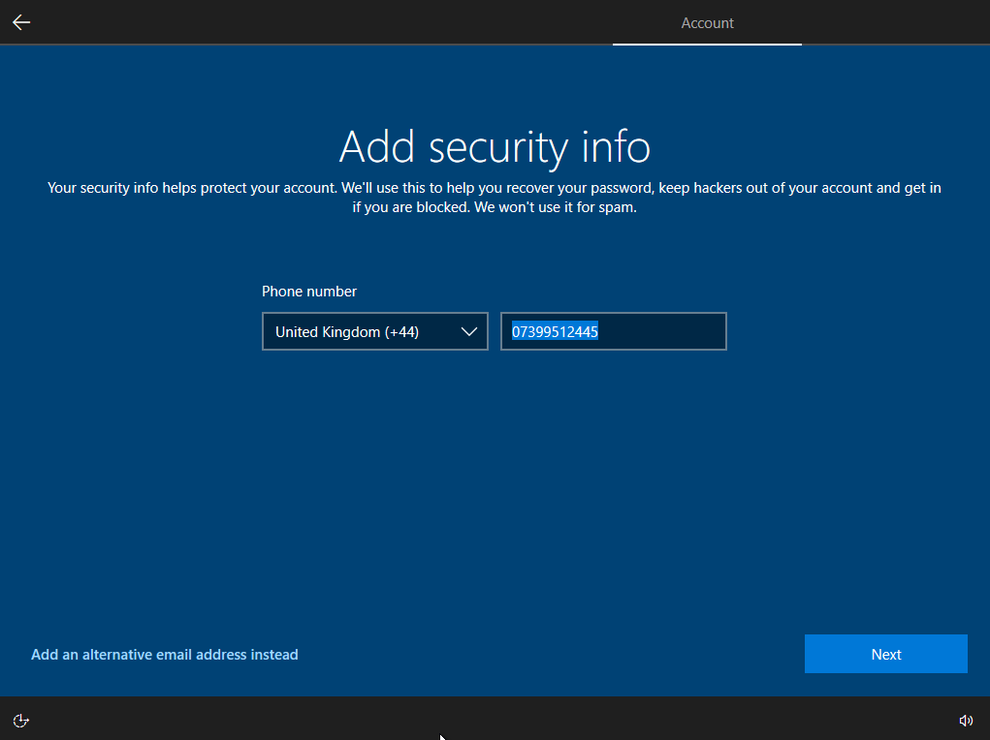
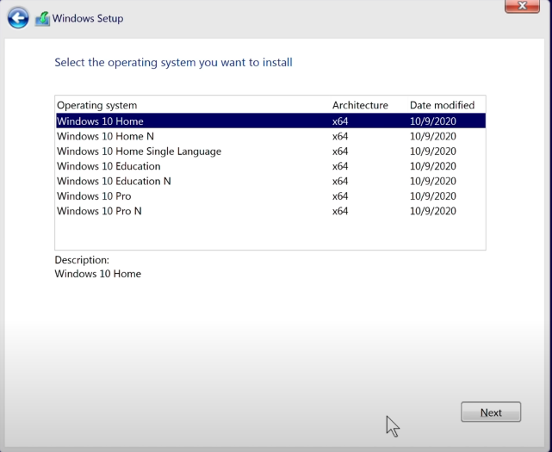Once you have selected this option you will be asked where you’d like to install windows 10 we will then select the storage device we created earlier in the VirtualBox setup then windows will begin to install on your Machine. Once the installation has finished you will then be taken through some windows 10 setup pages.

Firstly a simple Country/Date of birth tab appears once this is filled in you will also be presented with a tab to add a phone number for extra security. Then you can create your new Microsoft account to go with your windows install this can be done a number of ways you can either create a new email address or use an existing one you have or alternatively you can use a mobile phone number
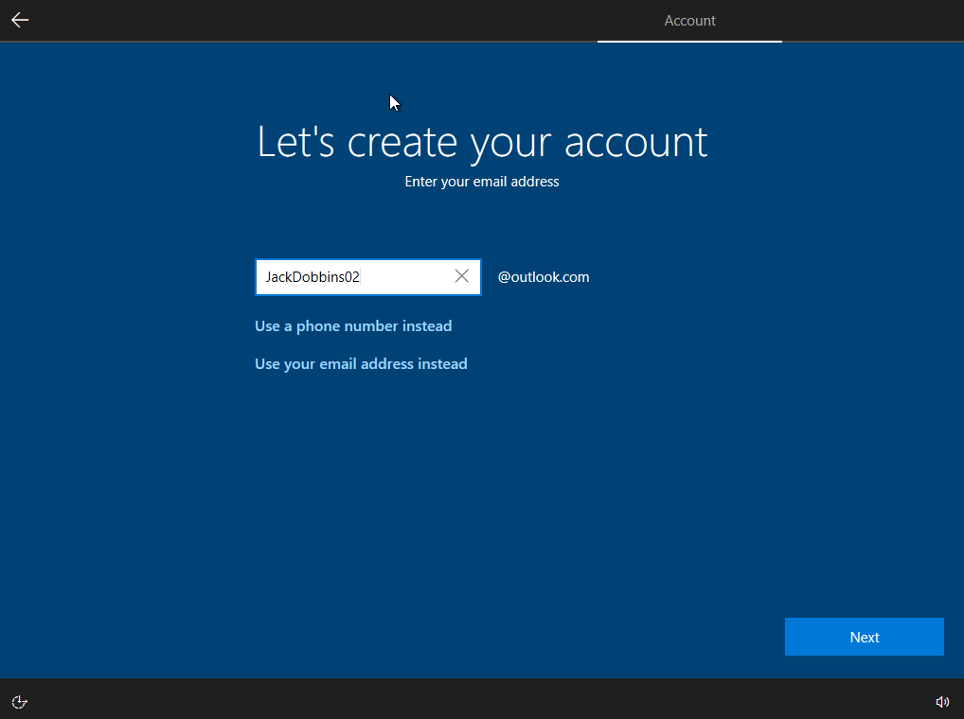

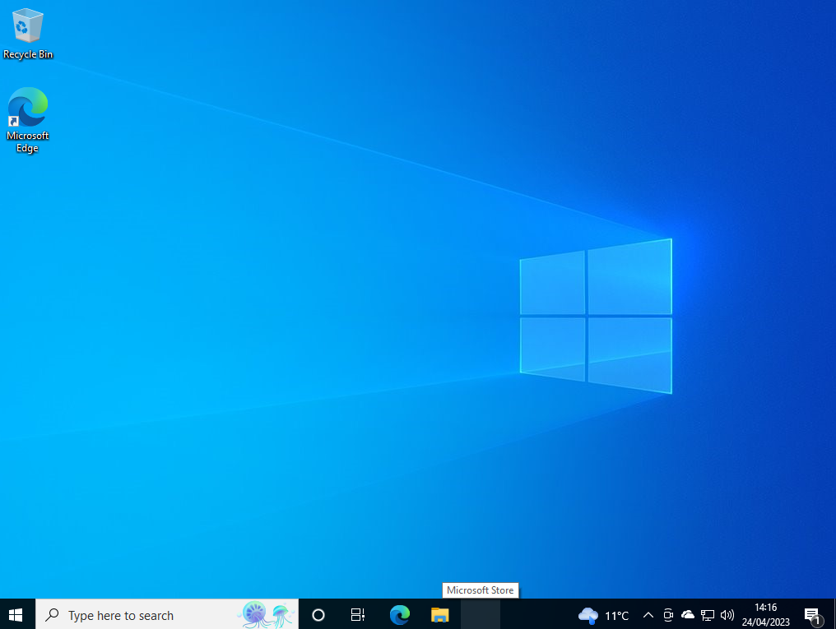
Once you have gone through all of the settings above and successfully created your account your windows installation will be complete and you will be shown the windows home screen which should look something like this. If you are seeing this screen then you have successfully installed windows 10 to yo

Part 2: Report

Introduction: Computer networking Principles are set guidelines we use in computer networks. These principles ensure efficient data transferring across multiple networks.

Network Architecture:
Network Architecture is the layout of a computer network essentially the computers and servers etc themselves and is also the way these devices are connected there are various types of network architectures such as LANs which stands for local area networks, wide area networks (WANs) Metropolitan area networks (MANs). LAN networks are used in homes offices or even schools and universities. WANs are for your large area connectivity connecting remote areas to a main network and MANs are used to connect numerous LANs together in large areas.
Network Communication Standards:

Network Communication Standards are rules set to make sure that devices can communicate with each other in a network some of the standards we use today are Ethernet, Bluetooth, and Wi-Fi
Ethernet is used via wiring in LAN networks and provides a relatively fast and secure connection.
Wi-Fi is the wireless equivalent of Ethernet also used on LANs and provides connectivity without wiring.
Bluetooth is a small area connectivity method to allow connection between phones headphones and mouse and keyboards.

Network Protocols:

Network protocols are rules that dictate how your data is sent across networks. They ensure that your data is sent safely to other networks.

There are various types of protocols these include TCP/IP transmission Control Protocol/Internet Protocol, File Transfer Protocol FTP, Simple Mail Transfer Protocol.
TCP is the most popular protocol and provides secure ways to send data over the web. FTP is a way to send files through networks. SMTP is a way to send emails over networks.

Network Security:

Network Security is the methods we have used to protect our networks from unwanted visitors and data leaks. Some of the ways we can protect networks are firewalls, IDS intrusion detection systems
And VPNs Virtual private networks.

Firewalls are hardware or even software that scan incoming and outgoing traffic and identifies malicious traffic and blocks this malicious traffic from disrupting the network.
IDS Is similar to Firewalls in that it detects unwanted activity and it alerts the network admins of threats that it detects.
VPNs provide security when connecting to networks through the internet they conceal data that is then communicated between networks or devices to prevent any unwanted access.

Network Topologies:

Network Topologies are the layout of a network. There are multiple types of topologies such as Bus,Star,Ring

Bus network. In the bus network topology, every node is connected in series along a single cable. This arrangement is found today primarily in cable broadband distribution networks.
Star network. In the star network topology, a central device connects to all other nodes through a central hub. Switched local area networks based on Ethernet switches and most wired home and office networks have a physical star topology.
Ring network. In the ring network topology, the nodes are connected in a closed-loop configuration. Some rings pass data in one direction only, while others are capable of transmission in both directions. These bidirectional ring networks are more resilient than bus networks since traffic can reach a node by moving in either direction. Metro networks based on Synchronous Optical Network technology are the primary example of ring networks. [1]
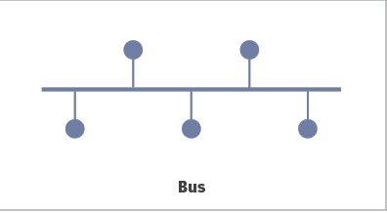
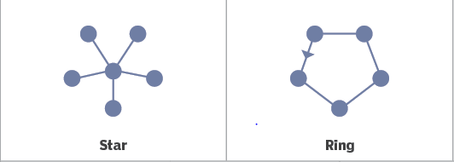
[1]

Conclusion:

So in conclusion these Computer networking principles are very critical in the way our data is han
dled and processed through networks and even in our own networks. They all combine together to generate a safe and dependable network these core principles are crucial for anyone who is associated with the management utilization and design of networking.

Bibliography

[1] | A. S. Gillis, “Network Topology,” TechTarget, 14 05 2023. [Online]. Available: https://www.techtarget.com/searchnetworking/definition/network-topology#:~:text=What%20is%20a%20network%20topology,often%20represented%20as%20a%20graph.. [Accessed 14 05 2023].

ur virtual machine.

