
Module Assignment Submission
Student Name: | Jemma Rees
Student Number: | 2008032
Module Code: | BMSK 5002
Module Title: | Developing Relationships and Workplace Achievement

Statement of Confirmation of Authenticity
By the act of making this submission, the student declares that this is the work of the student named above. The work has not, in whole or in part, been knowingly presented elsewhere for assessment, or where assessment has been built on a previous assessment, this has been identified. Where materials have been used from other sources it has been properly acknowledged. If this statement is untrue, the student acknowledges that an assessment offence has been committed.
Attention is drawn to the plagiarism and unfair practice policies of the University.

Contents
1.0 Introduction 3
2.0 Employee development is critical to organisational and personal success 3
2.1 Return on investment 3
2.2 Development opportunities and staff retention 4
2.3 Targeted development 4
2.4 Data manipulation 4
2.5 Professional and personal success 5
3.0 Employee development impacts organisational reputation 6
3.1 Proficiency increases organisational reputation 6
3.2 Proud employees promote the organisation 7
3.3 Reputation is more important than salary 7
3.4 No objections 8
3.5 Crisis management and reputational impact 8
4.0 Managing employee expectations enable effective learning and development 9
4.1 Employee development and managing expectations within the workplace 9
4.1.1 What is employee development 9
4.1.2 What is managing expectation 9
4.2 Motivation is contagious 9
4.3 Learning and Development systems in the ONS correctly manage expectations 10
4.4 How personal development plans improve performance 10
4.5 Are performance reviews outdated bureaucracy? 10
4.6 Does management create a barrier to performance improvement 11
5.0 Performance reviews and appraisals should be tailored 12
5.1 70:20:10 learning and development model 12
5.2 Accurate and Fair 13
5.3 Poor Performance Impact 13
5.4 It only works because you believe in it - The Tinkerbell Effect (Durgin, 2002) 13
5.5 Management by Objectives (MBO) 14
6.0 Conclusion 15
7.0 References 16
8.0 Appendices 24
8.1 Appendix 1 24
8.2 Appendix 2 25
8.3 Appendix 3 26
8.4 Appendix 4 27
8.5 Appendix 5 28
8.6 Appendix 6 29
8.7 Appendix 7 30
8.8 Appendix 8 31
8.9 Appendix 9 32
8.10 Appendix 10 33
8.11 Appendix 11 34
8.11.1 Appendix 11.1 35
8.11.2 Appendix 11.2 36
8.12 Appendix 12 41
8.13 Appendix 13 42
8.14 Appendix 14 43
8.15 Appendix 15 44
8.16 Appendix 16 45
8.17 Appendix 17 46
8.18 Appendix 18 47

1.0 Introduction

The following report will critically assess the potential benefits of facilitating learning and development to the organisation and the employee whilst managing employee expectations. The report will critically evaluate performance review processes whilst providing insight into the 70:20:10, management by objectives (MBO) and 360° feedback method. The report will not seek to suggest the correctness of these methods, only to provide analysis and information.

2.0 Employee development is critical to organisational and personal success

2.1 Return on investment

Research suggests that employee skills and knowledge directly impact an organisation's net income and overall success (Podsakoff & MacKenzie, 1997). The Harvard Business Review (2022) substantiates this in their recent study, comparing the cost of employee learning and development against the return on investment (ROI). It was found that the ROI over five years would reach 30%, and the ROI over ten years would exceed 80%. (Appendix 1). Although this is an indicative figure, it clearly shows that investing in employee development is substantially financially beneficial to an organisation.
Many factors relate to employee development; some tangible factors include formal qualifications and the correct tools to carry out daily tasks. Equally important are intangible factors such as increased confidence, improved self-esteem and happiness. A recent study by Forrester Consulting on behalf of Indeed (2021) reports that 72% of employees cite happiness as a workplace priority.
Furthermore, employee development leads to job satisfaction, directly influencing happiness. When employees feel valued and competent in carrying out their duties, they are more likely to feel a sense of accomplishment (Career Insights, Program Insights, 2020).

2.2 Development opportunities and staff retention

The CIPD Good Work Index (CIPD, 2022) publishes an annual survey reporting against '7 dimensions of job quality (Appendix 2). The 2022 survey states that 34% of employees aged between 25-34 and 35% of employees aged between 45-54 were dissatisfied with their careers and cited this as the main reason for seeking alternative employment. Surji (2014) asserts that staff turnover is the highest cost to an organisation, costing 50 to 100 times an employee's salary to recruit a new employee. Furthermore, Surji reports a strong correlation between employee development opportunities and staff retention.

2.3 Targeted development

Employees' attributes, such as attitudes and values, knowledge and practical skills, are the workforce's foundations. Introducing targeted learning and development is where organisations gain a competitive advantage and create a robust and competent workforce. A recent report by Bîrca (2022) supports this and explains how supporting employee development facilitates competitive advantage whilst recognising this remains challenging to quantify. Additionally, Bîrca (2022) describes how, in general, organisations are aware of how upskilling employees impacts the business's overall success. Nevertheless, despite this, they fail to understand how value is added.
Similarly, Moreira et al. (2022) assert that organisations can increase their employees' perceptions of their internal employability by implementing procedures that support the development of specific competencies in their workforce. Additionally, employees' perceived external employability rises when the development of generic abilities is encouraged. Although, when an organisation recognises that losing its most valuable employees is a risk, perceived internal employability must be monitored.
However, a study conducted by Benson (2006; as cited in Moreira et al. 2022) reported that employees were less likely to consider leaving an organisation that invests in developing their abilities; the study also shows how this development nurtures organisational commitment, reinforcing loyalty and generating a more significant ROI.

2.4 Data manipulation

Although there are clear advantages, as mentioned above, to both the organisation and the employee, in developing the workforce, Gaille (2016) addresses the negative financial implications, stating that the cost of training could potentially account for 50% of the employee's salary in the first year and that there are likely to be ongoing training costs, dependent on the business need and employees role.
Furthermore, Becker (1964/1993) asserts that highly educated and skilled employees are more likely to be well paid; this is true of developed and undeveloped countries alike; as evidenced by Hanushek & Woessmann (2007), whose research proves that countries and organisations who invest in 'human capital' achieve sustained economic growth. Furthermore, Becker's (1964/1993) research shows an undeniable link between low wages and poor education, supporting the economic value of investing in employee development.
However, the benefit of economic value from employee investment has come into question from those who disagree. Some contend that the reported increase in ROI is due to targeted reporting, focusing on the most advantageous groups, such as white-collar employees, and omitting other demographics. For Example, Birnir et al. (2018; Museus & Kiang, 2009; Tindall & Sha, 2011) report that biased data is commonly used to make assumptions about demographic proclivities. (Appendix 3). Suggesting the actual correlation is extremely weak, making it a poor indicator and of little assistance to those investing in development. (Becker, 1964/1993)
Additionally, employees may have specific learning preferences and needs that some training providers may not be familiar with; Dunn & Honigsfeld (2013) assert that training success increases when teaching strategies accommodate biological and developmental learning style traits. Thus presenting the risk that initial training may not be successful if these factors are recognised too late, the training may be ineffective, and the organisation would need to fund another course, leading to a poor ROI.

2.5 Professional and personal success

Colarelli and Montei (1996, Becker 1993; cited in Jehanzeb & Bashir 2013) argue that training is an instrument that benefits employee retention. Furthermore, the report recognises that identifying employees' learning and development needs is complicated and challenging to implement; but it can dramatically impact the success of an organisation (Jehanzeb & Bashir, 2013). Research from IBM Corporation (2014; as cited in Jay, 2021) substantiates the above claims, reporting that top earning organisations meet 84% of employees' training needs, whereas the lowest earning only satisfied 19% of employees' needs (appendix 4). Jay (2021) suggests using the 'Kirkpatrick Model' (Kirkpatrick, 1959; as cited in Jay, 2021) to accurately measure the effectiveness of training and ROI. (Appendix 5)
In general, most employees want to succeed in their role; underachievement leads to demoralised and frustrated employees, who are more likely to produce poor outputs and are more likely to seek alternative employment; it is necessary to assess the current competencies of the employees and then identify potential skill gaps. Once these have been determined, the employer can work with the employee to create a suitably tailored development plan to address these gaps, thus ensuring the overall success of employees and the organisation's ultimate success (Career Insights, Program Insights, 2020).

3.0 Employee development impacts organisational reputation

Reputation may be the most influential factor when employing new staff and retaining existing staff; benefits to the organisation and employees are demonstrated in increased performance and job satisfaction, leading to a profitable and desirable business. (Chozz & Tedjob, 2003; as cited in Ibrahim, 2019). For instance, a recent study conducted by Glassdoor (2021) found that 92% of employees would contemplate leaving their current employer if approached by an organisation with an excellent reputation.

3.1 Proficiency increases organisational reputation

Das et al. (2022) assert that employee performance increases organisational reputation; their recent study collected statistics from 225 technology companies to investigate if the agility of employees impacted organisational reputation. Data analysed shows that organisations that invest in and manage workforce development produce more proficient employees; this proficiency is directly responsible for the correlation between high workforce performance and high reputation.
Whereas underperforming, underachieving employees negatively impact the organisation's reputation (Pusey, 2021; Choi & Park, 2001). Clardy (2005) reports six possible reasons why inadequate or poorly trained employees can harm an organisation's reputation (Appendix 6). One Example of inadequate training led to fatal consequences and extreme reputational damage. The Ocean Ranger oil rig capsized during a storm in 1982, losing 100 million dollars and all crew members. The investigation concluded that the staff were inadequately trained in the ballast operations, a critical component to enable the rig to remain stable in volatile weather conditions. Chiles (2001, p. 28; as cited in Clardy, 2005)
A good reputation is a powerful asset; reputable businesses can target and successfully attract the customers and employees they desire, with the ability to charge a premium for their services (Eccles et al., 2007)

3.2 Proud employees promote the organisation

Helm (2011) hypothesised that perceived corporate reputation positively impacts employees' self-esteem and fortifies a positive association with the organisation. According to Fombrun et al. 2000 cited in Helm (2011), employees provide the most reputational leverage.
Employees proud of their workplace are 6 times more likely to promote their reputation and are twice as likely to remain with the same company (Hastwell, 2022). More importantly, these employees can influence the decisions of others either in conversation or through a leading site such as Indeed (2022), where employees can publish honest reviews of their employer; however, it is essential to bear in mind the possible bias in these reviews. Despite this, 86% of people trust these reviews and use them to aid in their decision when applying for a job (Glassdoor. Inc, 2021).
Helm (2011) asserts that the social identity theory (Turner & Tajfel, 1979) (Appendix 7) is responsible for this driving force; as humans seek acceptance and belonging, reputable organisations provide this enabling a reciprocal relationship.
Collins (2018) suggests that employee skills develop and emerge for several reasons: organisational culture, sharing information, and being included in decision-making; this undoubtedly contributes to emotional intelligence, which is reported to be a leading predictor of success both personally and professionally.

3.3 Reputation is more important than salary

Organisational reputation is the same as a first impression, 82% of job seekers consider reputation before applying (David, 2021), and 50% would not work for an organisation with a bad reputation, even if they were offered a pay increase. Additionally, employers with a good reputation can reduce hiring costs by up to 50%, whereas a poor reputation can cost a company up to 10% more in wages per hire (Glassdoor. Inc, 2021).
Band (1991; as cited in Clardy, 2005) researched how employees affected by negative experiences damage reputations; the report concludes that unsatisfied employees are more likely to share their thoughts with nine other people, thus demonstrating how quickly reputations can be damaged.
Furthermore, Cable and Turban (2000; as cited in Clardy, 2005) positively and negatively engineered organisational reputation, recruitment campaigns and wages in an experiment; their findings conclusively show, job seekers are more likely to apply for work in an organisation with a strong reputation and would be willing to accept a lower wage than their competitor with a poor reputation.

3.4 No objections

A thorough investigation into academic work concludes there are no objections to the claim that 'employee performance increases organisational reputation'. A considerable amount of literature has been published on performance and organisational reputation (Walker, 2010; Langham, 2018/2019; Cooper, 2011/2012; Hannington, 2016; Graca & Arnaldo, 2016).
The above sources present varying theories regarding the correlation between performance and its effect on reputation; however, they all confirm that performance impacts organisational reputation either negatively or positively, with suggestions of how to prevent or repair reputational damage.

3.5 Crisis management and reputational impact

Timothy Coombs & Holladay (2006) researched 'crisis management' of organisational reputation; the paper focused on the impact of a crisis on reputation and if maintaining a solid reputation before adversity safeguards an organisation's reputation, referred to in the paper as the 'halo effect'. The study found that although no benefit was found to an organisation that maintained a positive or neutral reputation, there was significant damage to a reputation with an already poor reputation.
Coombs and Holladay (2002; as cited in Timothy Coombs & Holladay, 2006) dubbed this the 'velcro effect', stating that poor reputation entices further reputational damage. Further experiments conducted by Klein and Dawar (2004, p. 215; as cited in Timothy Coombs & Holladay, 2006) assert that a negative reputation could be a significant liability for an organisation facing disaster; however, a neutral or positive reputation may offer equal protection. Moreover, the research found that stakeholders believe human error is more likely to occur and is more common than mechanical errors; this is important as mechanical errors are viewed as unexpected or unpreventable and outside the immediate organisations' control and responsibility. In contrast, human error is seen as a result of poor decision making, inferior training, preventable and ultimately the organisation's responsibility, thus reflecting poorly upon the organisation in question.
In conclusion, the paper states, "given that people weigh negative information more strongly than positive, one set of messages might be enough to create a velcro effect but not a halo effect" Timothy Coombs & Holladay (2006). Reasoning that creating a robust organisational reputation can prevent significant damage should a negative situation occur. However, regardless of the organisation's current reputation, it should expect a significant reputational impact should human error be found to be the cause. Coombs and Holladay (2002; as cited in Timothy Coombs & Holladay, 2006)

4.0 Managing employee expectations enable effective learning and development

Performance management is defined as a process which enables establishing a shared understanding between employees and their supervisors (and often peers) about what is to be achieved and how it is to be achieved, and that, as an extension of this, it is a critical part of the managing expectations process. What matters about this definition is that any process which enables this to occur is, in fact, performance management. (Blackman et al., 2017)

4.1 Employee development and managing expectations within the workplace

4.1.1 What is employee development

Employee development can be defined as; the development and improvement of an employee's knowledge and skills, usually aligned with the organisation's objectives (Armstrong, 1994/2014, pp. 211–225). Additionally, most professional memberships, such as Axelos (2022), require a commitment to continuous learning; membership relies upon this condition to renew membership.

4.1.2 What is managing expectation

"Employees' expectations are defined as the anticipation of the way an employee thinks a manager will reward them in the future concerning their job performance" (Furlich, 2016, p. 18).
Furlich (2016) asserts that expectation can impact motivation; if the expectations of the employer and employee are not correctly aligned, the employee may become demotivated and lose interest in the task. For instance, if an employee is expecting to receive a financial reward for completing a set task and the employer is expecting to verbally reward the employee, the employee is likely to feel disappointed when they are rewarded, despite the employee completing the task to the requirement and satisfaction of the employer. Therefore, the employee's expectations must be managed effectively.

4.2 Motivation is contagious

Barber, 2004 (cited in Aguinis & Kraiger, 2009) conducted a study demonstrating that employee development creates innovative skills and tacit knowledge. Furthermore, another study carried out by Dvir et al. (2002, as cited in Aguinis & Kraiger, 2009) proves that employees who are responsible for goal setting and are empowered to achieve these goals benefit significantly in personal development. Interestingly, employees who share this experience with colleagues positively influence their co-worker's attitudes, instilling the same motivational interest, boosting team morale and encouraging them to achieve their learning and development goals.

4.3 Learning and Development systems in the ONS correctly manage expectations

The Office for National Statistics (ONS) (2021) encourages all employees to participate in learning and development. 'The Project Delivery Capability Framework' (PDCF) (Government Project Delivery Profession, 2018); provides a clearly defined career pathway and an in-depth look at the available job roles, the required competencies and further development opportunities specific to each role.
Additionally, the PDCF enables employees to understand each role's required capabilities and behaviours and what skills and experience are necessary to progress into a higher position; generally, a higher position will require more skills and experience than a lower position.
Moreover, the PDCF states that the information provided is to be used as a guidance tool and that achieving each behaviour and competency does not automatically entitle an employee to progress but will provide the necessary skills to prepare them for the desired role and interview process. Providing such a comprehensive document ensures that the employees' expectations are correctly addressed in advance of the learning and development process, thus negating the potential for miscommunication. (Furlich, 2016)

4.4 How personal development plans improve performance

Employees within the ONS (2021) must create a personal development plan (PDP) to align with their chosen career path as defined in the PDCF (Appendix 8). A PDP provides structured focus enabling the achievement of goals and objectives and can be utilised for personal or professional use (Putter, 2021).

4.5 Are performance reviews outdated bureaucracy?

Netflix CEO Reed Hastings and Patty McCord, the chief talent officer from 1998 to 2012 (as cited in McCord, 2014), created a presentation rewriting Netflix's approach to hiring and managing employees; it removed formalised and sporadic employee reviews and replaced them with 360° reviews (Appendix 9). Claiming that performance is apparent in most business areas, and that analytics such as key performance indicators (KPIs) (Appendix 10) can provide useful information without needing a bureaucratic system that provides little benefit.
Additionally, where employees' skills were no longer needed, rather than retraining employees, an attractive redundancy package was offered. Furthermore, according to McCord (2014), conventional performance reviews are conducted to provide an auditable process to prevent the threat of legal proceedings triggered by grievances. The overarching ethos of Netflix is 'to provide a clear expectation of responsible behaviour' and 'to regularly talk frankly and truthfully with employees regarding their performance'.
Where learning and development targets have not been achieved, Blackman et al. (2017) provide possible explanations, such as managers not adhering to the agreed timeframe for conducting reviews and lack of guidance from managers to employees when completing process documents such as a PDP.
Therefore, implying a lack of management interest in the process, leaving employees perplexed about how the process would benefit them and the organisation and an overall confusion around expectations. Additionally, when processes have not been tailored to employees' specific needs and goals, or as the business needs have evolved, the learning and development have not been updated or adapted.

4.6 Does management create a barrier to performance improvement

Additionally, (Blackman et al., 2017) assert that performance management and goal setting are imperative in managing employee expectations, and it is critical to ensure the expectations of an employee are explicitly clear. According to Kerr, 1995; Schmidt & Dolls (2009; as cited in Blackman et al., 2017), expecting employees to achieve goals and behave as desired is unreasonable if this has not been clearly communicated.
Furthermore, the efficiency of these processes is at risk should a manager lack dedication or interest, if the targets are poorly aligned with corporate goals or if there is a lack of goal revision when business needs change. However, the ultimate success of an employee is only possible when they comprehend the organisation's purpose and role within it (Armstrong & Murlis, 2004; Marrelli, 2011; as cited in Blackman et al., 2017).
Blackman et al. (2017) conclude; that managing employees' expectations and creating meaningful learning and development plans to inform the performance review process can only be successful if organisations are prepared to instil the importance of these processes throughout the organisation's management structure and recognise that it is unlikely to be a process that fails the employee but rather the lack of capacity and ability of the manager.

5.0 Performance reviews and appraisals should be tailored

Human Resource Management (2016) defines performance reviews and appraisals as terms used to describe how an employee's performance is measured and rewarded (if applicable). Stating, these are formal planned processes providing documentation that can support the employee in seeking professional advancement or the employer in identifying poor performance.
Typically, these processes should document the employees' performance against agreed responsibilities, such as a job description, goals, and behaviours over an agreed period; this could be anything from 1 month – 12 months and is usually individual to the organisation. Examples of how the ONS manage and record employee development, progress and outcome are provided in appendix 11 for reference.

5.1 70:20:10 learning and development model

The ONS (2021) employ the 70:20:10 learning and development model (Appendix 12) to support all employees in achieving their professional goals; the model provides a structured approach to learning, advising that the majority of employee learning (70%) is carried out alongside their daily duties by seeking out tasks outside of their comfort zone to stretch their current abilities.
20% of employees' time is to be allocated to working with colleagues to learn from their experience and knowledge; learning platforms are also provided, such as Percipio (Skillsoft, 2021), to support continuous professional development (CPD) (Appendix 13).
The ONS supports and finances the final 10% of learning through professional qualifications, such as the Association of Project Management (2022) APM and PRINCE2® Project Management Certifications (Axelos, 2022). However, the professional qualifications available will depend on the employee's current role and area of work to ensure that learning and development remain relevant and targeted to the individual (Government Project Delivery Profession, 2018).
The above learning and development model provides the tool to formally monitor the employee's progress, facilitating conversations around performance and goal setting. These conversations are usually conducted monthly; however, these can be carried out more frequently if required. The ONS (2021) does not prescribe any one way to assess performance but advocates using the 360° feedback method (Marshall Goldsmith, 1949; as cited in Vincent van Vliet, 2022).
Ward (1997; as cited in Armstrong, 1994/2017, pp. 106–117) later described the 360° feedback method, which can be interpreted as a way for peers to methodically gather performance feedback on an individual. (Previously noted in appendix 9)

5.2 Accurate and Fair

Jacobs et al. (1980; as cited in Iqbal et al., 2014) suggested using two specific categories for measurement criteria, accuracy and fairness. Accuracy to reflect goals, specific and targeted feedback and eliminating errors when using a scoring system, such as the Likert scale (Likert et al., 1934) (Appendix 14). Fairness ensures that the review is unbiased and follows corporate rules and best practices.
CIPD (2020) states that reviewing and evaluating employee performance can be difficult and, depending on the chosen method, biased; for instance, if conducting a feedback questionnaire (Appendix 15), an employer may have a personal like or dislike of the employee, or the employee may rate themselves higher than their actual ability.
Furthermore, an article by Pillai (2021) asserts that fairness instils confidence in employees, which can improve the overall work atmosphere; additionally, confidence enables employees to enter into the feedback process without concerns of reprisal, allowing the employee to provide feedback concerning the organisation, which is crucial to ensuring long-term organisational sustainability.

5.3 Poor Performance Impact

Managing poor performance is critical as it can be detrimental to the organisation and employees. Poor performance can impact all areas of an organisation; employees may become disengaged, unmotivated and indignant. Causing low productivity, absenteeism, and a decline in sales; in some cases, it could damage the organisation's reputation (Pusey, 2021).

5.4 It only works because you believe in it - The Tinkerbell Effect (Durgin, 2002)

Several scholars have argued that performance reviews and appraisals only work when employees believe they do. Giles and mossholder (1990); Keeping and Levy (2000); Levy and Williams (2004); Roberson and Stewart (2006); Walsh and Fisher (2005); as cited in Iqbal et al. (2014). Moreover, research has shown that these reviews only motivate approximately 14% of employees (Evans-Reber, 2022).
Kluger and DeNisi (1996; as cited in Erik van Vulpen, 2019a) conducted a meta-analysis of 600 papers relating to the use of the 360° feedback method, and the results found that approximately 33% of performance reviewers reported an increase in employee performance, 67% reported no change or a detrimental impact as a result of the 360° feedback method.
Erik van Vulpen (2019a) suggests possible explanations for these results; it could be the amount of time and resources needed to conduct this type of performance review or that once the initial feedback has been shared, it is not pursued further.
Bracken et al. (2016) support this stance, reporting that the data resulting from a 360° feedback review should be shared with managers, thus creating accountability for the employee and reviewer. Should sharing be discouraged, it could be viewed that no action has been taken or that the review itself was unnecessary and time-wasting; this can have a negative impact, leaving the employee disheartened and producing undesirable behaviour from the employee and their peers.

5.5 Management by Objectives (MBO)

91% of organisations conduct some form of performance review or appraisal (Evans-Reber, 2022). An article written by Zenger (2016) featured in Forbes (2022) supports this claim stating, "More than 85% of all the Fortune 500 companies use the 360° feedback process as a cornerstone of their overall leadership development process". (Zenger, 2016)
However, there are numerous performance management methods and tools available to employers; as organisations are individual in their management approach, culture and objectives, it is vital that all potential methods are individually reviewed for suitability.
A recently favoured method is Management by Objectives (MBO), occasionally referred to as management by planning, created by Peter Drucker (1954; as cited in Hayes, 2022). (Appendix 16) MBO modifies the organisation's objectives (usually in a mission or vision statement) to become meaningful objectives for an employee, ensuring that the employee and the organisation's objectives are aligned. The method empowers employees to realise their own objectives, creating SMART (specific, measurable, acceptable, realistic, time-bound goals) (Doran, 1981) (Appendix 17) and motivating employees to achieve them.
However, the MBO method requires a review at the end of the agreed time set for achieving these goals and objectives, and the employee is then assessed on whether they have passed or failed; this can cause undue stress and anxiety. Should the employed be deemed to have succeeded, the reward could be a promotion or pay increase, although if they are considered to have failed, the employee may be transferred or required to undertake further training. Additionally, this method does not consider soft or transferable skills such as communication, problem-solving and leadership skills (National Careers Service, 2022) (Appendix 18)

6.0 Conclusion

In conclusion, the above research provides evidence proving organisations' tangible benefits when investing in staff development; this is apparent in ROI and organisational reputation. Interestingly, the research suggests performance reviews and appraisals are widely utilised in organisations, although a significant proportion of organisations and employees do not see any added value or purpose to these ritualistic reports.
However, this report has only focused on a few very complex corporate and social behavioural areas. Further specific research into these areas is needed to understand the behaviours and motivations to draw a full conclusion.

7.0 References

Aguinis, H., & Kraiger, K. (2009). Benefits of Training and Development for Individuals and Teams, Organizations, and Society. Annual Review of Psychology, 60(1), 451–474. https://doi.org/10.1146/annurev.psych.60.110707.163505
Ali, D. (2018, June 24). How to Choose the Right 360-Degree Feedback Tool: A Detailed Guide. Mettl. https://blog.mettl.com/360-degree-feedback-tool-system/
Andrei Kurtuy. (2021, August 17). Top Soft Skills for 2022 [90+ Examples for Your Resume]. Novorésumé; Novorésumé ApS. https://novoresume.com/career-blog/soft-skills
Armstrong, M. (2014). Armstrong's handbook of performance management : an evidence-based guide to delivering high performance (5th ed., pp. 211–225). Koganpage. (Original work published 1994)
Armstrong, M. (2017). Armstrong's handbook of performance management an evidence-based guide to delivering high performance (5th ed., pp. 106–117). Kogan Page. (Original work published 1994)
Association of Project Management. (2022). APM - the chartered body for the project profession. Apm.org.uk. https://www.apm.org.uk/
Axelos. (2022). About Axelos | Axelos. Axelos.com. https://www.axelos.com/about-axelos
Barak, M. E. M. (2008). Social Psychological Perspectives of Workforce Diversity and Inclusion in National and Global Contexts. Researchgate. https://www.researchgate.net/publication/239609885_Social_Psychological_Perspectives_of_Workforce_Diversity_and_Inclusion_in_National_and_Global_Contexts/stats
Becker, G. S. (1993). Human Capital : a Theoretical and Empirical Analysis, with Special Reference to Education (3rd ed.). University of Chicago Press. https://scholar.google.co.uk/scholar_url?url=https://www.academia.edu/download/58822050/BECKER_HumanCapital_Cp1_3.pdf&hl=en&sa=X&ei=wCcSY8urJq2Vy9YPgKORuAM&scisig=AAGBfm3KAwr7mSRzLeim4X_ToOeg0KZoKw&oi=scholarr (Original work published 1964)
Bîrca, A. (2022). Investments in Human Resource Development - A Growing Concern for Organizations - ProQuest Central - ProQuest. Proquest.com, 23(1), 21–36. ProQuest Central. https://doi.org/10.24818/RMCI.2022.1.21
Birnir, J. K., Laitin, D. D., Wilkenfeld, J., Waguespack, D. M., Hultquist, A. S., & Gurr, T. R. (2018). Introducing the AMAR (All Minorities at Risk) Data. Journal of Conflict Resolution, 62(1), 203–226. Sage Journals. https://doi.org/https://doi.org/10.1177%2F0022002717719974
Blackman, D. A., Buick, F., O'Flynn, J., O'Donnell, M., & West, D. (2017). Managing Expectations to Create High Performance Government. Review of Public Personnel Administration, 39(2), 185–208. Researchgate. https://doi.org/10.1177/0734371x17701544
Bounthavong, M. (2019, May 17). Mark Bounthavong. Mark Bounthavong. https://mbounthavong.com/blog/2019/5/16/communicating-data-effectively-with-data-visualization-part-15-divergent-stacked-bar-chart-for-likert-scales
Bracken, D. W., Rose, D. S., & Church, A. H. (2016). The Evolution and Devolution of 360° Feedback. Industrial and Organizational Psychology, 9(4), 761–794. https://doi.org/10.1017/iop.2016.93
British Library. (2022). British Library. Www.bl.uk. https://www.bl.uk/business-and-ip-centre/articles/what-is-swot-analysis#:~:text=The%20SWOT%20framework%20is%20credit,the%201960s%20and%20early%201970s.
Buglione, S. (2012). Non-traditional approaches with non-traditional students: Experiences of learning, service and identity development. ResearchGate; ResearchGate. https://www.researchgate.net/publication/254694171_Nontraditional_Approaches_with_Nontraditional_Students_Experiences_of_Learning_Service_and_Identity_Development
Career Insights, Program Insights. (2020, December 17). 6 reasons you need to invest in employee development now. Post University. https://post.edu/blog/heres-investing-employee-development/
Choi, S., & Park, S. (2001). Exploring performance paradox in public organizations: Analyzing the predictors of distortive behaviors in performance measurement. International Review of Administrative Sciences, 1–18. Sage Journals. https://doi.org/10.1177/00208523211054876Sungjoo Choi, Soonae Parkhttps://doi.org/10.1177/00208523211054876
CIPD. (2020). Performance Reviews | Factsheets | CIPD. CIPD. https://www.cipd.co.uk/knowledge/fundamentals/people/performance/appraisals-factsheet#87785
CIPD. (2022). Survey report: CIPD Good Work Index. Chartered Institute of Personnel and Development (CIPD). https://www.cipd.co.uk/Images/good-work-index-survey-report-2022_tcm18-109896.pdf
Clardy, A. (2005). Reputation, Goodwill, and Loss: Entering the Employee Training Audit Equation. Human Resource Development Review, 4(3), 279–304. Sage Jounals. https://doi.org/10.1177/1534484305278243
Collins, J. (2018). Developing Future Leaders. HR Management in the Forensic Science Laboratory, 477–490. ScienceDirect. https://doi.org/10.1016/b978-0-12-801237-6.00027-0
Cooper, C. L. (2012). Corporate Reputation: Managing Opportunities and Threats. (M. G. Martin, P. S. C. Cooper, & P. R. J. Burke, Eds.; 1st ed.). Ashgate Publishing Limited. (Original work published 2011)
CPD. (2022). RSS; Royal Statistical Society. https://rss.org.uk/membership/professional-development/professional-statistician-s-network/cpd/
Das, K. P., Mukhopadhyay, S., & Suar, D. (2022). Enablers of workforce agility, firm performance, and corporate reputation. Asia Pacific Management Review. ScienceDirect. https://doi.org/10.1016/j.apmrv.2022.01.006
David, T. (2021, March 3). Future of Recruiting Study - CareerArc social recruiting. CareerArc Social Recruiting. https://www.careerarc.com/blog/future-of-recruiting-study-expanded-results/
Doran, G. T. (1981). There's a S.M.A.R.T. Way to Write Management's Goals and Objectives. Management Review, 70, 35–36.
Dunn †, R., & Honigsfeld, A. (2013). Learning Styles: What We Know and What We Need. The Educational Forum, 77(2), 225–232. https://doi.org/10.1080/00131725.2013.765328
Durgin, F. H. (2002). The tinkerbell effect. Journal of Consciousness Studies, 9(5-6), 88–101. Academia. https://www.academia.edu/download/40712523/JoCS_Durgin2002.pdf
Eccles, R. G., Newquist, S. C., & Schatz, R. (2007, February). Reputation and Its Risks. Harvard Business Review. https://hbr.org/2007/02/reputation-and-its-risks
Erik van Vulpen. (2019a, August 21). 360 Degree Feedback: A Full Guide - AIHR. AIHR. https://www.aihr.com/blog/360-degree-feedback/
Erik van Vulpen. (2019b, August 28). The One Employee Performance Review Template to Rule Them All. AIHR. https://www.aihr.com/blog/employee-performance-review-template/
Evans-Reber, K. (2022, April 14). Council Post: Here's What Can Happen When Companies Get Rid Of Performance Reviews. Forbes. https://www.forbes.com/sites/forbeshumanresourcescouncil/2020/02/19/heres-what-can-happen-when-companies-get-rid-of-performance-reviews/?sh=4078b03f5451
Forbes. (2022). Forbes. https://www.forbes.com/?sh=17c7b27e2254
Furlich, S. A. (2016). Understanding employee motivation through managerial communication using expectancy-valence theory. Journal of Integrated Social Sciences, 6(1), 17–37. www.JISS.org. https://www.jiss.org/documents/volume_6/JISS%202016%206(1)%2017-37%20Employee%20Motivation.pdf
Gaille, B. (2016, November 29). 10 Pros and Cons of Training Employees. BrandonGaille.com. https://brandongaille.com/10-pros-and-cons-of-training-employees/
Glassdoor.Inc. (2021, June 11). 40+ Stats For Companies to Keep In Mind for 2021. US | Glassdoor for Employers. https://www.glassdoor.com/employers/resources/hr-and-recruiting-stats/
Gov.uk. (2018). Project Delivery Capability Framework For Project Delivery Professionals in Government November 2018 (Version 2) Government Project Delivery Profession is part of Infrastructure and Projects Authority. https://assets.publishing.service.gov.uk/government/uploads/system/uploads/attachment_data/file/755783/PDCF.pdf
Government Project Delivery Profession. (2018). Project Delivery Capability Framework (PDCF). 2. Infrastructure and Projects Authority.
Graca, C. A. M., & Arnaldo, C. (2016). The role of corporate reputation on co-operants behavior and organizational performance. Journal of Management Development, 35(1), 17–37. https://doi.org/10.1108/jmd-08-2014-0079
Hannington, T. (2016). How to Measure and Manage Your Corporate Reputation. Routledge.
Hanushek, E. A., & Woessmann, L. (2007). The Role of Education Quality for Economic Growth. In Ssrn.com (p. 76). World Bank Policy Research Working Paper No. 4122. https://papers.ssrn.com/sol3/papers.cfm?abstract_id=960379
Harvard Business Review. (2022, March 22). Research: How Employee Experience Impacts Your Bottom Line. Harvard Business Review. https://hbr.org/2022/03/research-how-employee-experience-impacts-your-bottom-line
Hastwell, C. (2022). The High Value of Building Pride in the Workplace. Great Place to Work®. https://www.greatplacetowork.com/resources/blog/the-value-of-building-pride-in-the-workplace#:~:text=Pride%20is%20more%20than%20just,endorse%20their%20workplace%20to%20others
Hayes, A. (2022). Management by Objectives (MBO) (A. Drury & P. Rathburn, Eds.). Investopedia. https://www.investopedia.com/terms/m/management-by-objectives.asp
Helm, S. (2011). Employees' awareness of their impact on corporate reputation. Journal of Business Research, 64(7), 657–663. Elsevier. https://doi.org/10.1016/j.jbusres.2010.09.001
Human Resource Management. (2016, March 22). Umn.edu; University of Minnesota Libraries Publishing edition, 2016. This edition adapted from a work originally produced in 2011 by a publisher who has requested that it not receive attribution. https://open.lib.umn.edu/humanresourcemanagement/front-matter/publisher-information/
IBM Corporation. (2014). The Value of Training; IBM Training building skills for a smarter planet. In IBM Corporation (p. 6). https://www.ibm.com/training/pdfs/IBMTraining-TheValueofTraining.pdf
Ibrahim, M. H. (2019). Corporate Reputation as a Key Driver of Employee Retention (M. Stadler, Ed.). Ligsuniversity.com. https://ligsuniversity.com/blog/corporate-reputation-as-a-key-driver-of-employee-retention
Indeed. (2021). Work Happiness Score. Indeed.com. https://uk.indeed.com/employers/work-happiness
Indeed. (2022). Working at Office for National Statistics: 174 Office for National Statistics Reviews | Indeed.com. Indeed.com. https://uk.indeed.com/cmp/Office-For-National-Statistics/reviews
Iqbal, M. Z., Akbar, S., & Budhwar, P. (2014). Effectiveness of Performance Appraisal: An Integrated Framework. International Journal of Management Reviews, 17(4), 510–533. Wiley. https://doi.org/10.1111/ijmr.12050
Jay, S. (2021, February 16). Measuring Training Effectiveness: A Practical Guide - AIHR. AIHR. https://www.aihr.com/blog/measuring-training-effectiveness/
Jehanzeb, K., & Bashir, N. A. (2013). Training and development program and its benefits to employee and organization: A conceptual study. European Journal of Business and Management, 5(2). Researchgate. https://www.researchgate.net/profile/Nadeem-Bashir-3/publication/274703936_Training_and_Development_Program_and_Its_Benefits_to_Employee_and_Organization_An_Conceptual_Study/links/5c650d59299bf1d14cc4d35b/Training-and-Development-Program-and-Its-Benefits-to-Employee-and-Organization-An-Conceptual-Study.pdf
Kissflow. (2022, March 28). 6 Performance Appraisal Methods that Boosts Employee Performance. Kissflow.com; Kissflow. https://kissflow.com/hr/performance-management/employee-performance-appraisal-method/
Langham, T. (2019). Reputation management : the future of corporate communications and public relations. Emerald Publishing. (Original work published 2018)
Likert, R., Roslow, S., & Murphy, G. (1934). A Simple and Reliable Method of Scoring the Thurstone Attitude Scales. The Journal of Social Psychology, 5(2), 228–238. https://doi.org/10.1080/00224545.1934.9919450
McCord, P. (2014). How Netflix Reinvented HR. Harvard Business Review. https://hbr.org/2014/01/how-netflix-reinvented-hr
Moreira, A., Sousa, M. J., & Cesário, F. (2022). Competencies Development: The Role of Organizational Commitment and the Perception of Employability. Social Sciences, 11(3), 125. https://doi.org/10.3390/socsci11030125
Museus, S. D., & Kiang, P. N. (2009). Deconstructing the model minority myth and how it contributes to the invisible minority reality in higher education research. New Directions for Institutional Research, 2009(142), 5–15. Academia. https://doi.org/10.1002/ir.292
National Careers Service. (2022). Develop your soft skills. Service.gov.uk. https://nationalcareers.service.gov.uk/careers-advice/how-to-develop-your-soft-skills
Office for National Statistics. (2021). Careers - Office for National Statistics. Ons.gov.uk. https://www.ons.gov.uk/aboutus/careers
Pillai, G. (2021, November 18). Implementing fair performance appraisals is an essential component of a successful business. Employers may... Linkedin.com; LinkedIn. https://www.linkedin.com/pulse/how-implement-fair-performance-appraisals-better-employee-pillai?trk=public_profile_article_view
Podsakoff, P. M., & MacKenzie, S. B. (1997). Impact of Organizational Citizenship Behavior on Organizational Performance: A Review and Suggestion for Future Research. Human Performance, 10(2), 133–151. Taylor and Francis Online. https://doi.org/10.1207/s15327043hup1002_5
Post University. (2020, December 17). 6 Reasons You Need to Invest in Employee Development Now. Post University. https://post.edu/blog/heres-investing-employee-development/
PRINCE2 Certification | Qualifications and Exams | Axelos. (2022). Axelos.com. https://www.axelos.com/certifications/propath/prince2-project-management
Prins, N. (2022, June 9). How to Create Meaningful SMART Goals. Launch Space; Launch Space. https://launchspace.net/blog/smart-goals/
Prisha, A. (2020, December 25). What are Key Performance Indicators (KPIs)? Definition & Examples. Projectcubicle. https://www.projectcubicle.com/what-are-key-performance-indicators-kpis-definition-examples/
Pusey, S. (2021, January 6). The Real Cost Of Not Managing Poor Performance In Your Business. The Curve Group - Recruitment & HR Specialists. https://www.thecurvegroup.co.uk/the-real-cost-of-not-managing-poor-performance-in-your-business/
Putter, M. (2021, June). What is a personal development plan? CPD Online College. https://cpdonline.co.uk/knowledge-base/business/what-are-personal-development-plans/
Skillsoft. (2021). Percipio - Immersive Learning Platform. Skillsoft. https://www.skillsoft.com/meet-skillsoft-percipio
Surji, K. (2014). The Negative Effect and Consequences of Employee Turnover and Retention on the Organization and Its Staff. European Journal of Business and Management, 5(25). ResearchGate. https://doi.org/10.7176/ejbm/5-25-2013-01
Timothy Coombs, W., & Holladay, S. J. (2006). Unpacking the halo effect: reputation and crisis management. Journal of Communication Management, 10(2), 123–137. Emerald Group Publishing Limited. https://doi.org/10.1108/13632540610664698
Tindall, N. T. J., & Sha, B.-L. (2011). The Missing Minorities: Problems for Research and Professionalism in Public Relations. Public Relations Society of America Educators Academy, 101–113. Researchgate. https://scholar.google.com/citations?view_op=view_citation&hl=en&user=sB-CM-cAAAAJ&cstart=20&pagesize=80&citation_for_view=sB-CM-cAAAAJ:KlAtU1dfN6UC
Turner, J. C., & Tajfel, H. (1979). Social comparison and group interest in ingroup favouritism. European Journal of Social Psychology, 9(2), 187–204. European Journal of Social Psychology. https://doi.org/10.1002/ejsp.2420090207
U.S Bureau of Labor Statistics. (2015, April 2). Bureau of Labor Statistics, U.S. Department of Labor. The Economics Daily, Occupational employment and wages in 2014. U.S. Bureau of Labor Statistics. https://www.bls.gov/opub/ted/2015/occupational-employment-wages-2014.htm
Vincent van Vliet. (2022, February 28). Marshall Goldsmith. Toolshero. https://www.toolshero.com/toolsheroes/marshall-goldsmith/#:~:text=Marshall%20Goldsmith%20(1949)%20is%20a,great%20employee’s%20performance%20analyze%20tool.
Walker, K. (2010). A Systematic Review of the Corporate Reputation Literature: Definition, Measurement, and Theory. Corporate Reputation Review, 12(4), 357–387. https://doi.org/10.1057/crr.2009.26
Zenger, J. (2016, March 10). How Effective Are Your 360-Degree Feedback Assessments? Forbes. https://www.forbes.com/sites/jackzenger/2016/03/10/how-effective-are-your-360-degree-feedback-assessments/?sh=68a388fba690

8.0 Appendices

8.1 Appendix 1
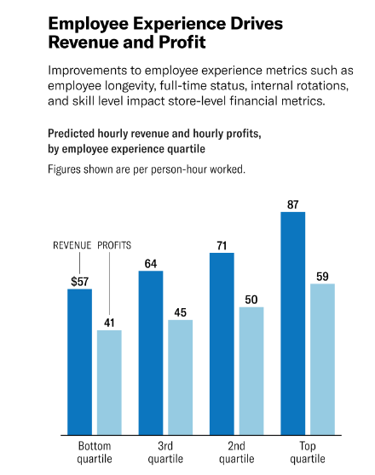
Harvard Business Review, 2022

8.2 Appendix 2
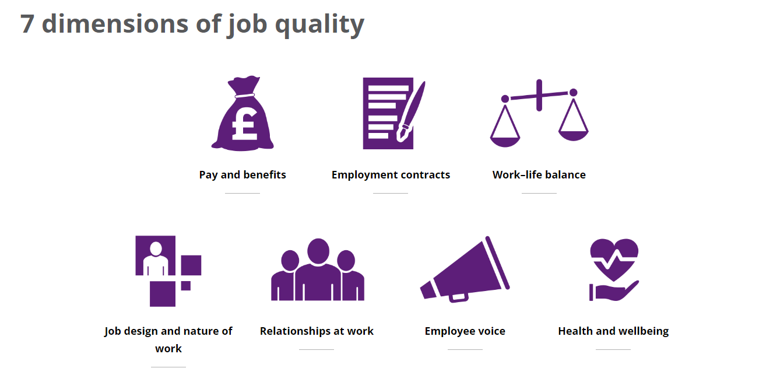
(CIPD, 2022)

8.3 Appendix 3

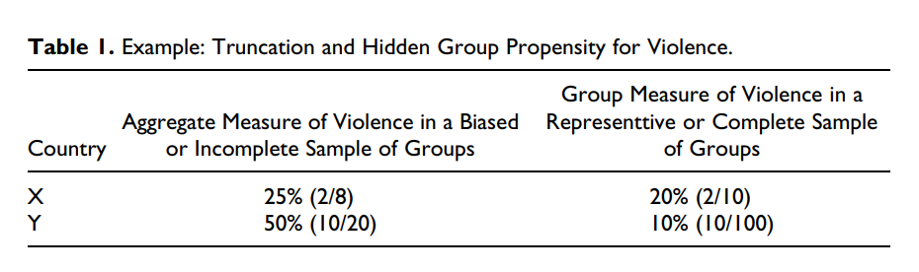
Birnir et al. (2018)

8.4 Appendix 4
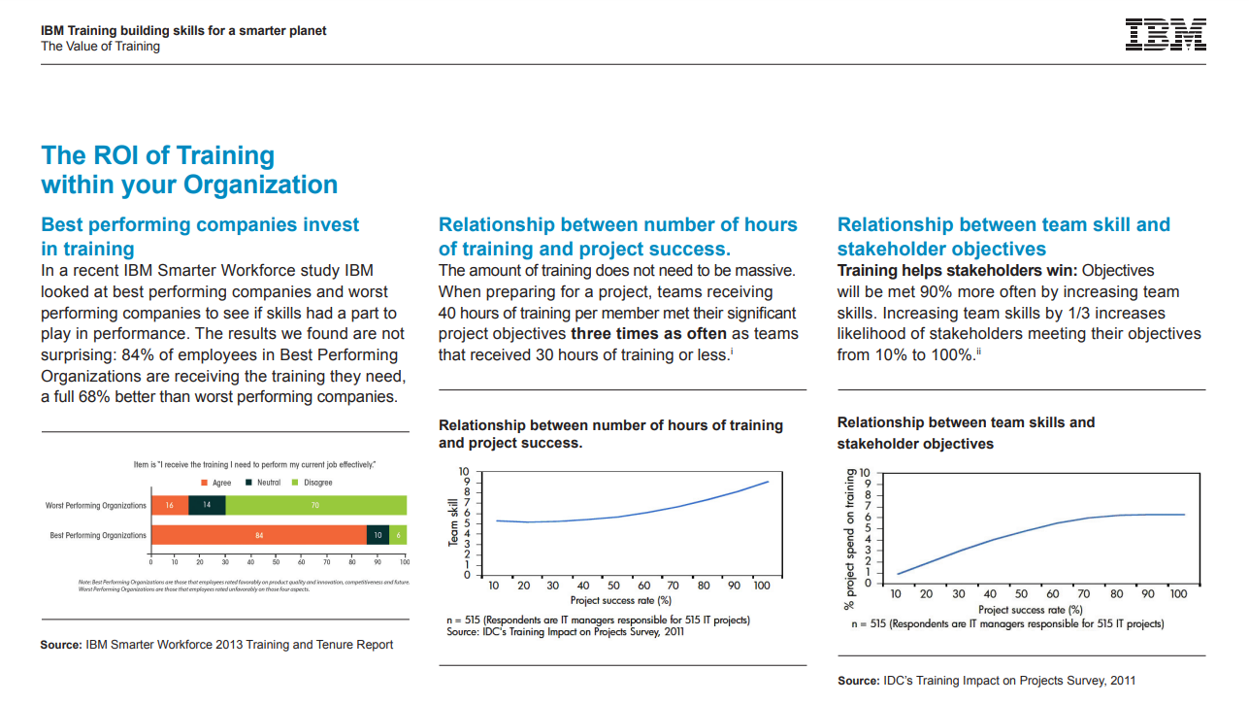
(IBM Corporation, 2014; as cited in Jay, 2021)

8.5 Appendix 5

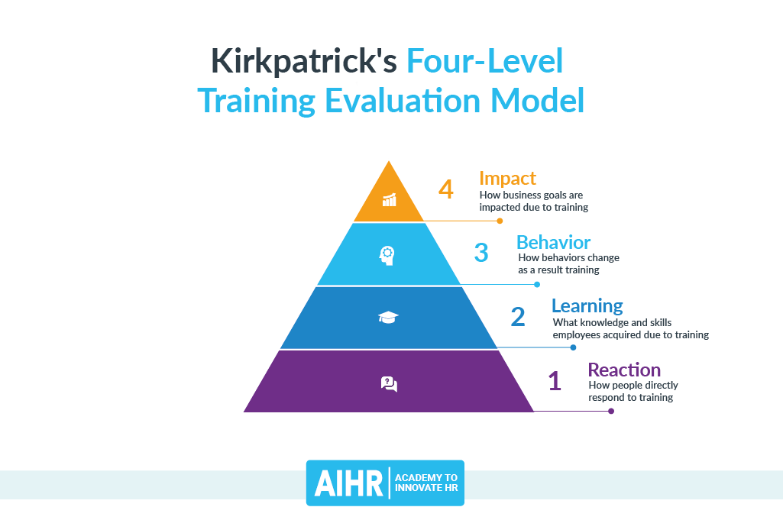
(Jay, 2021)

8.6 Appendix 6
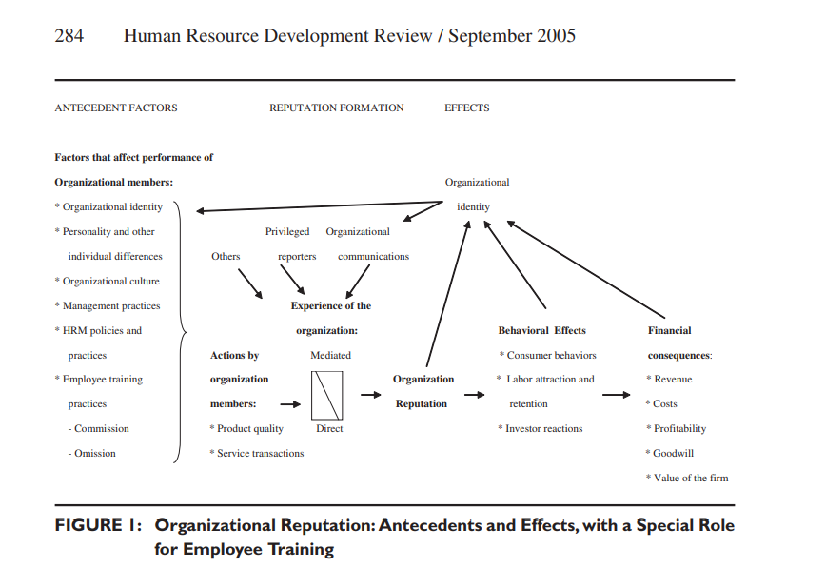
1. Appropriate training required for skilled system positions is not provided.
2. Training is provided but teaches skills that are illegal and/or unethical.
3. Training may use questionable, if not harmful principles and practices.
4. The proper training is provided but the training is done poorly
5. Loss of skill is not compensated for by retraining.
6. Inadequate training for responding to organizational failures or crises.

Clardy (2005)

8.7 Appendix 7

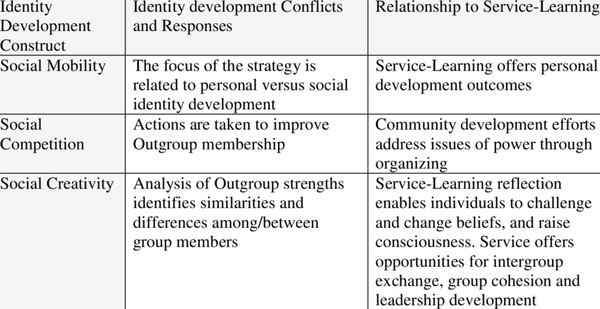
Social Identity Theory Constructs (Tajfel & Turner, 1986; as cited in Buglione, 2012)
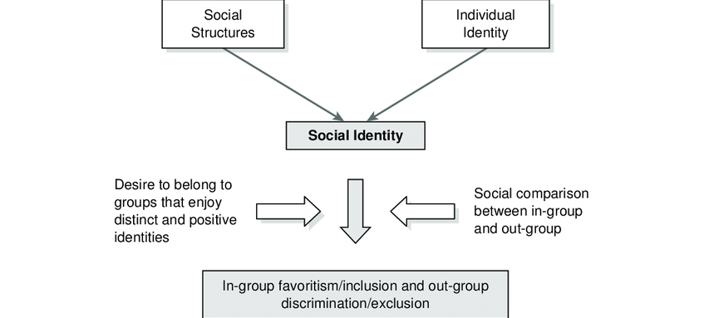
A Schematic Diagram of Social Identity Theory's Basic Principles (Barak, 2008)

8.8 Appendix 8
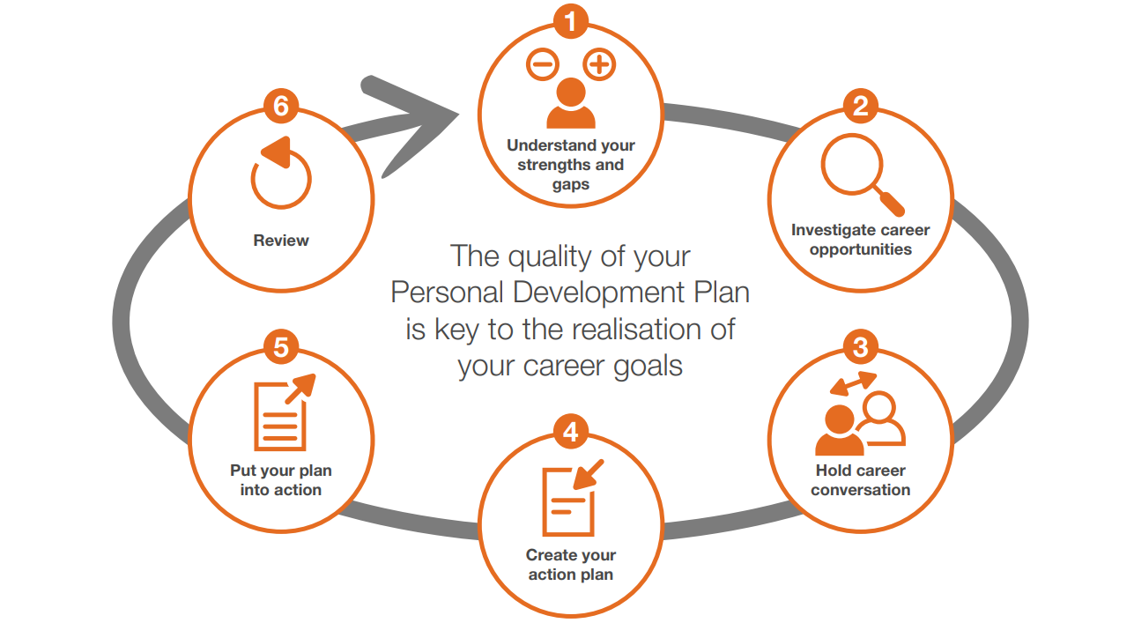

(Project Delivery Capability Framework for Project Delivery Professionals in Government November 2018 (Version 2) Government Project Delivery Profession Is Part of Infrastructure and Projects Authority, n.d.)

8.9 Appendix 9
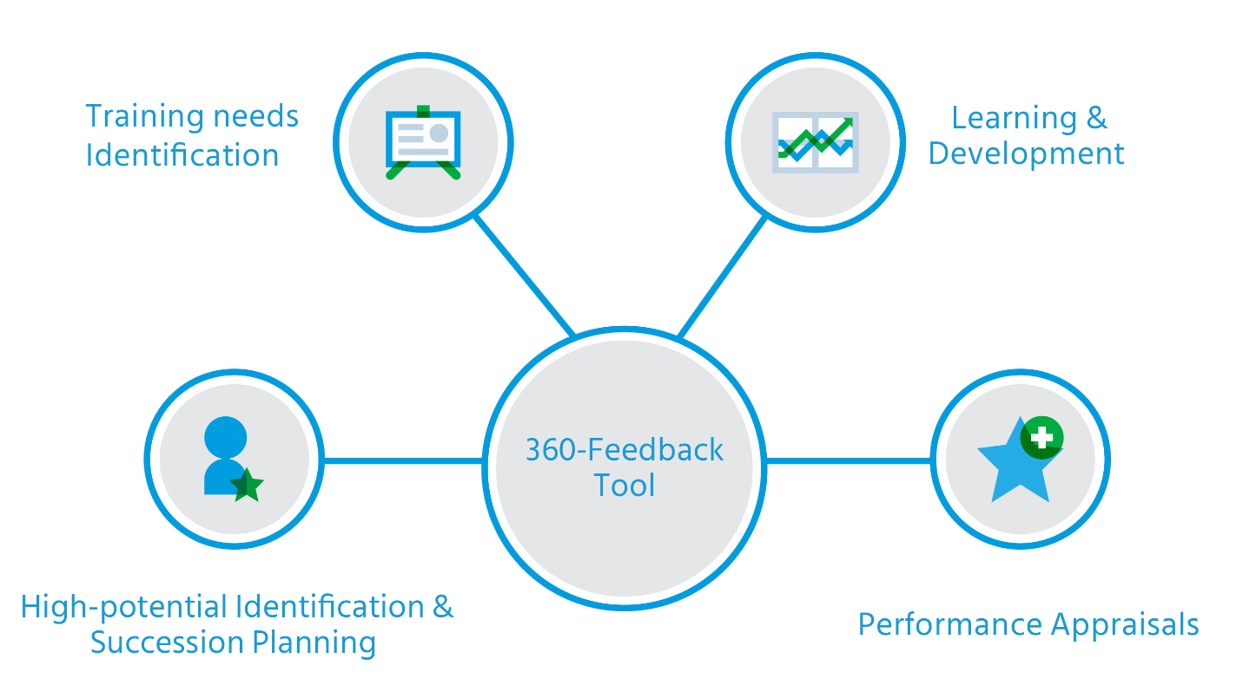
(Ali, 2018)

8.10 Appendix 10

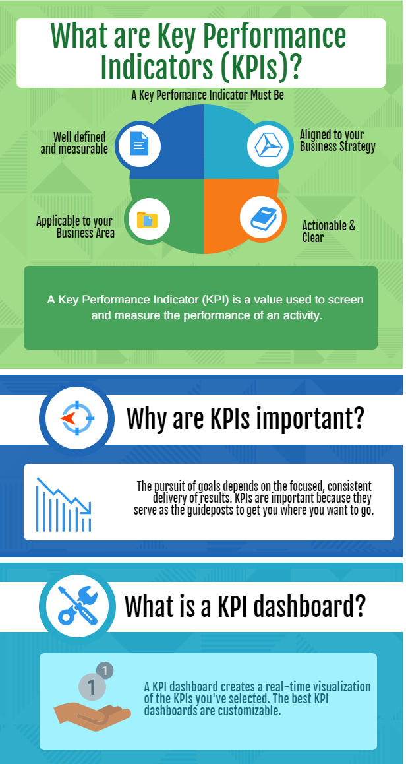
(Prisha, 2020)

8.11 Appendix 11

Example of how learning and development are approached within the ONS and how employee expectations are managed.
To protect identity and confidentiality, the employee provided in the example below shall be referred to as 'John'.
Employee background | The ONS recruited John via a government initiative, providing employment opportunities to disadvantaged youths. After completing a beauty course at college, John, aged 18, decided an office career would be more suitable.  John started with the organisation with limited skills in computer literacy and no experience of an office environment or the associated etiquette.
Job role | John was assigned an entry-level role as an administrative support officer, required to create reporting documents, Minute taking at meetings, and support any other business areas as required.
Learning and development identification | Weekly one 2 one conversations and daily check-in meetings assisted in the identification of skill gaps over the course of the first month of employment. Additionally, John was assigned simple office tasks and discussed at the daily check-in meetings to monitor his performance and abilities. All meetings were followed up by email to reiterate the expectation of assigned tasks and areas for improvement.  All one 2 one conversations were formally documented on a people management system, allowing a record of performance and process to be documented. John created a SWOT analysis (A. Humphrey 1960; as cited in British Library, 2022) (Appendix 11.1) to identify skill gaps and development needs further.  Once skill gaps were identified, a PDP was created with John (Appendix 11.2) using SMART goals (Doran, 1981) to provide a focused plan for development. Further monthly one 2 one meetings were scheduled to monitor progression, with the agreement that a formal review takes place after five months; these monthly meetings also provided open discussion for any areas of concern or recognition of improvement.
Outcome | A formal review meeting was conducted as agreed after five months. The review meeting concluded that good progress had been made against the documented PDP goals; he improved in all areas identified in the SWOT. John was allowed to provide feedback on the process, support and management; further development goals were identified and documented, and the process re-started.

8.11.1 Appendix 11.1

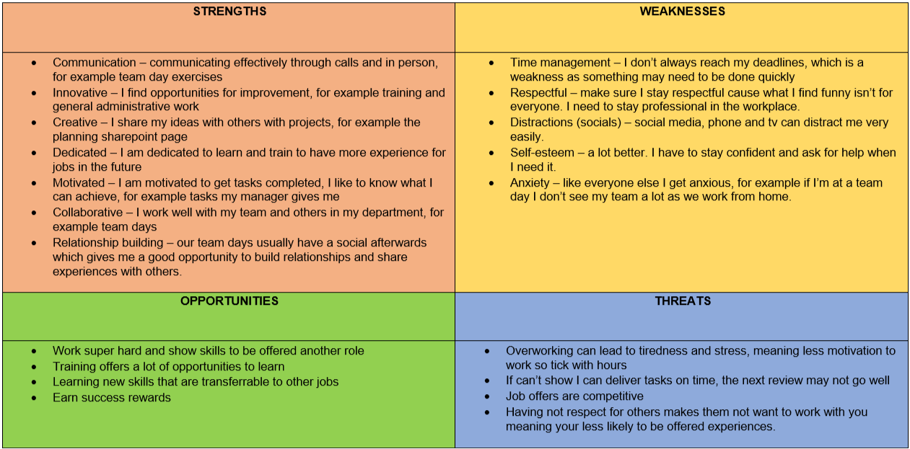
SWOT analysis created by John for a 5 month review

8.11.2 Appendix 11.2

Personal development plan (PDP) created by John and reviewed with his line manager

Name: John
Job Title/Business Area: AO Administration Support - PMO

What do I need to know/Do? | How will I learn it? |  | What will be different as a result? | What is the business benefit? | What resources will I need? | Time scale
Time management | 70% | To improve my productivity, I will dedicate an hour of my day to tasks marked as important. I will turn off all distractions during these hours and focus on important tasks. I will implement this practice starting August and make it into a habit by the end of the year. To ensure this is achieved I will book an hour in my diary for focus time every day. | This will help manage what tasks I need to do in a certain time limit at work. I will be more effective in my role and be able to deliver what is expected of me on time, instead of leaving it till the last Minute or even forgetting about the task I have been asked to do. | My time will be wasted less, meaning I have more time to do what I need to do. It Also means I will not slow anything down and I will be more reliable to the business. By teaching myself That time matters, it will help me manage my day better and complete daily tasks as well as work. | Use my diary to plan my day out. | April 2023
Time management | 20% | Find a mentor inside the organisation who has experience in this field. Ask for input from co-workers on my ability. |  |  | Speak to work colleagues with good experience, and Support from work coach | April 2023
Time management | 10% | Attend online courses on managing time usefully. |  |  | Online classes to identify tools | April 2023
Interpersonal skills | 70% | Over the next month, I will dedicate half an hour a day to researching self-help and communication and interpersonal skills to identify my flaws in this area and find ways to improve them. I will give myself 2 months to see a change in my interpersonal skills. | This will help me with my awareness and collaborating with people in my workplace. It will also help me with being shy at times and I can get clear feedback from my colleagues. It will also be a good trait for future careers. | Providing clear and effective communication will make people want to talk to me more and will build my social awareness of others around me. | Speak to colleagues in person about communication skills and learn from other people's experiences. | April 2023
Interpersonal skills | 20% | For Example, ask my manager for training on how to communicate properly and professionally. |  |  | Support from my manager | April 2023
Interpersonal skills | 10% | Read about interpersonal skills or train on Percipio and learning hub. |  |  | Learning with Percipio and Learning Hub | April 2023
Patience | 70% | I will Identify triggers that make me impatient as I hate not being able to do something. I will give myself a month to change these triggers. I will also watch videos and online blogs on how to deal with Patience. I will give myself 2 months to work on my patience. | This will help me understand the importance of having patience and help me maintain my focus on long term goals and training at work and outside of work. | Practicing patience will help me show my competence and help with the chance of professional growth. This will require accepting challenges. I will teach myself to take viewpoints and criticism from my manager and colleagues. | See if there are any courses on Patience and tell people how you feel. Be mindful and remain calm when facing difficult situations. | April 2023
Patience | 20% | Find a mentor inside the organisation who has experience in this field.  Ask friends and co-workers what they think are my strengths and weaknesses are around patience. |  |  | Support from my manager and immediate team. Support from a mentor. | April 2023
Patience | 10% | Find courses on how to deal with impatience. |  |  | ONS and Paula to find suitable courses. | April 2023
Gain a qualification in Microsoft Office | 70% | I will use my training log (Excel), the POAP (PowerPoint & Microsoft Project), Minute taking (Word), Management of the IDP Inbox (Outlook), Task management (OneNote) | By learning Microsoft Office, I will be more organised, I will increase my transferable skills. I will be productive. | This will benefit the business as I will complete tasks quicker and more efficiently. | Support will be given in my daily check in with my manager | April 2023
 | 20% | Watch online how to videos and shadow colleagues whilst they are using Microsoft and ask questions. |  |  | Support will be given in my daily check in with my manager, who will help to arrange shadow sessions | April 2023
 | 10% | Seek out formal training qualification for Microsoft Office. |  |  | I will find external courses which I think are suitable and my line manager will look for internal courses. | April 2023

8.12 Appendix 12

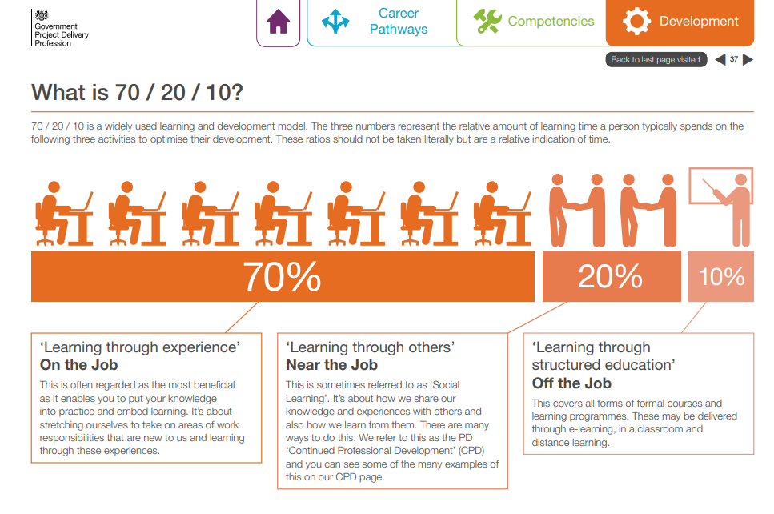
(Gov.uk, 2018)

8.13 Appendix 13

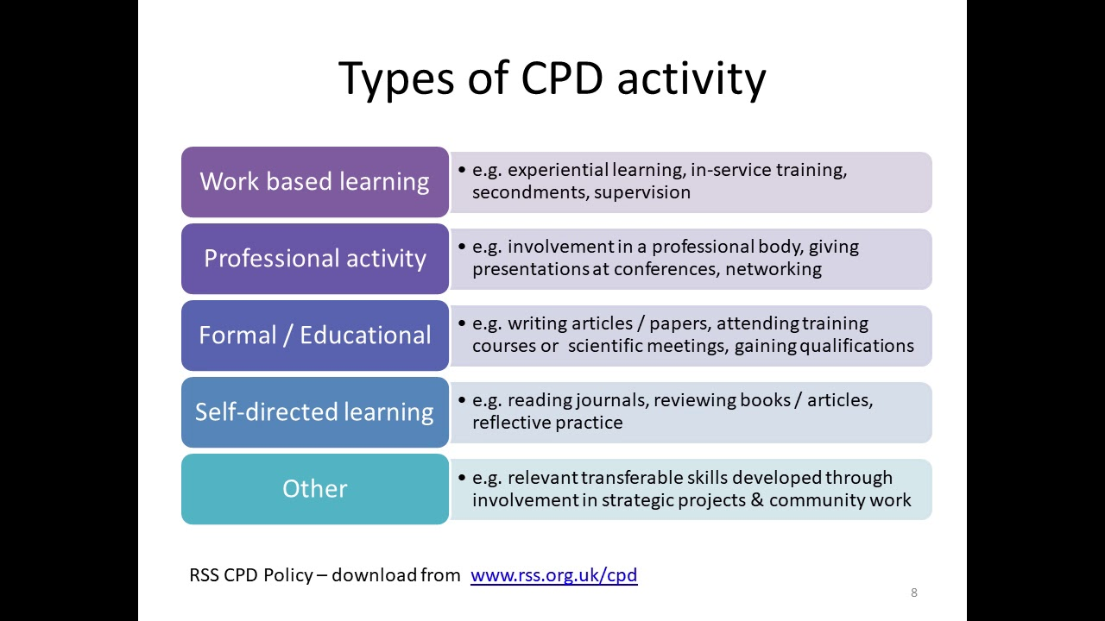
(CPD, 2022)

8.14 Appendix 14

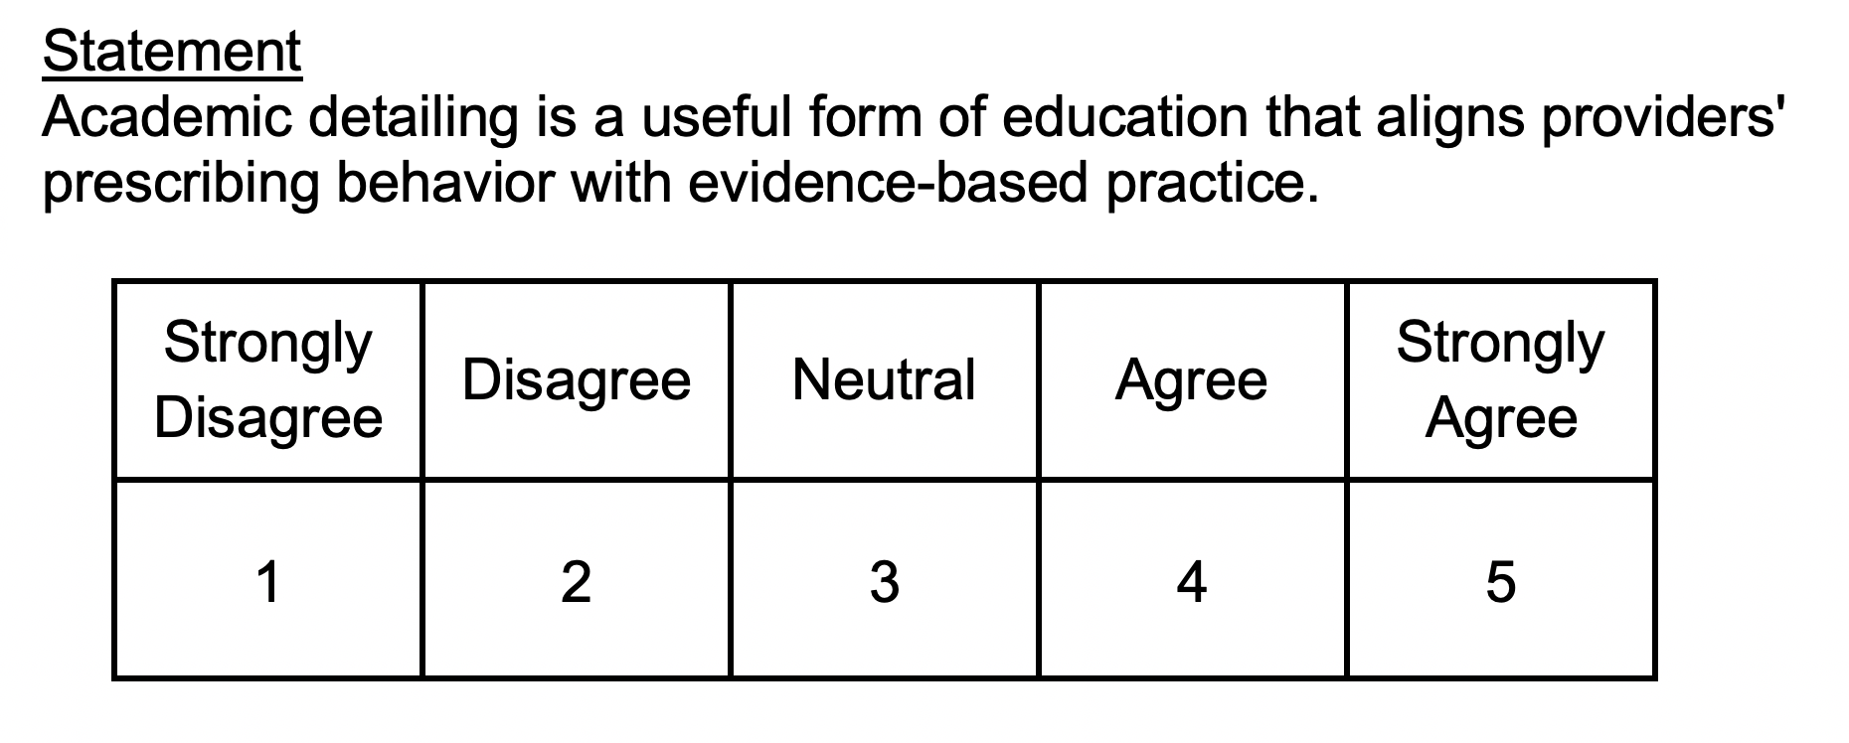 Example of the Likert scale (Likert et al., 1934) picture source; Bounthavong (2019)

8.15 Appendix 15

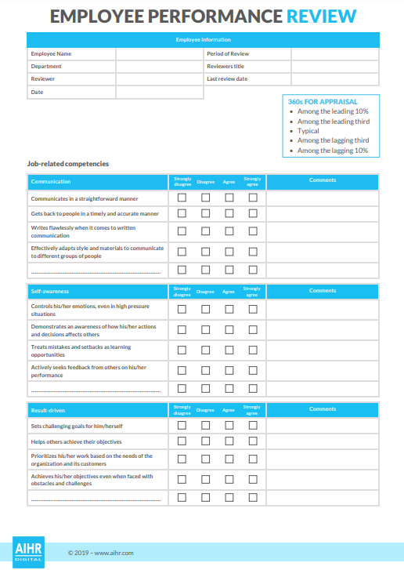
(Erik van Vulpen, 2019b)

8.16 Appendix 16

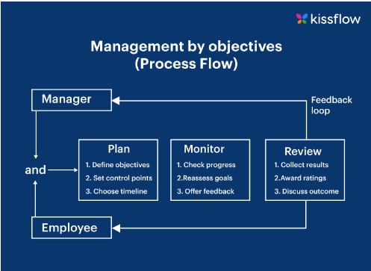
Kissflow, 2022

8.17 Appendix 17

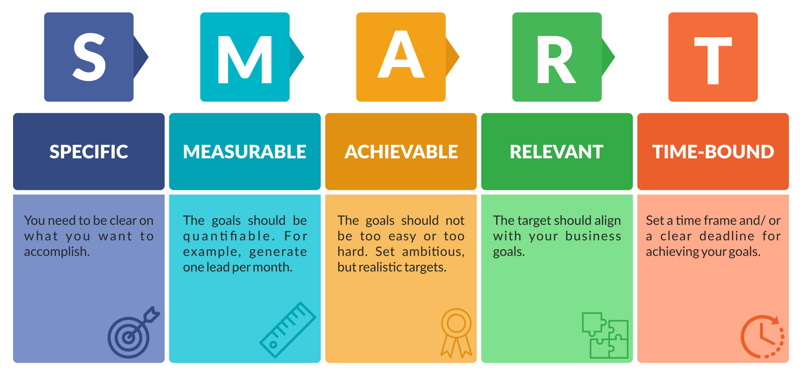
(Prins, 2022)

8.18 Appendix 18

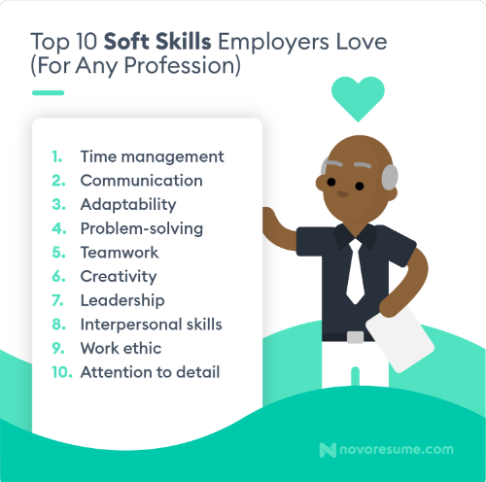
(Andrei Kurtuy, 2021)

