  - BSc/HND Automotive and Motorsport Engineering

Vehicle System
Subith Joseph || 1902458

Table of Contents
Introduction 3
Aim: 3
Research 4
Chassis 4
Ladder Frame chassis 5
Monocoque Chassis 6
Carbon Fibre Monocoque chassis 7
Tubular space frame chassis 7
Suspension 9
Camber 9
Caster 10
King Pin Inclination 10
Tracking (front toe) 11
Thrust angle (rear toe) 11
Results 12
Analysis 14
List of Figures 15
Bibliography 18

Introduction

Aim:
The Aim of the report, to compare and contrast vehicle chassis and suspension design features which achieve specific vehicle behavioural characteristics. This report will be split up into three sections; Research, Excel Graphs and spreadsheet, Analysis.

Research

For this section you are to research what effects the handling and comfort of a vehicle and discuss the set-up choices that can influence these. Consider how the handling and comfort balance of a race vehicle, supercar and road vehicle may differ and why this would be acceptable in each case?

Chassis
Chassis are the main component of a vehicle. Each chassis design has different purposes for example for a utility vehicle a ladder chassis would be the most appropriate due to its stiffness, durability and that is it cost affective and convenient to repair if damaged.

Ladder Frame chassis
https://images.cdn.circlesix.co/image/1/700/0/uploads/posts/2018/11/850fc56d20b55c9e041ab3af5c94583c.jpg
Ladder frame chassis are common on vehicle which are designed to carrying heavy load and even off-road capable vehicle. Due to its material choice mainly steel they are heavy but also having this the vehicle will be very strong and durable. For comfort the ladder chassis is not the most comfortable, due to its stiffness all forces and vibration are transferred across the whole vehicle. For handling the Ladder chassis is great when it comes to off road or when used for utility purposes for example heavy goods. Ladder Chassis are commonly used in various vehicle for an example Range rover line ups, this is due to is simplicity and also its structure rigidity and also the cost

Monocoque Chassis

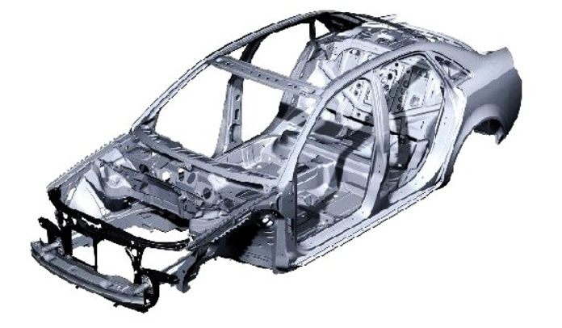

https://3.bp.blogspot.com/-xQLNBjihDlg/UafFXGvHfXI/AAAAAAAAIvA/swBEPvSfR9c/s1600/Monocoque-Chassis.jpg
Monocoque Chassis is the most commonly used chassis design on a modern vehicle, this is due to its fast manufacturing process as almost everything is done by robots. Monocoque chassis are the standard when it comes to modern vehicle, this is due to its excellent crash rating. when developing an monocoque chassis it can be expensive due to everything being developed in CAD (computer Aided Design). The handling characteristic on a monocoque chassis are very impressive as the chassis are designed to meet regulations which needs to meet up to certain standard. the problems with this the monocoque design are that it is not suitable for small batch production since the development cost are high and also setting up the infostructure can be very expensive.

Carbon Fibre Monocoque chassis

Carbon fibre monocoque design is widely used in super/ exotic vehicles, they are extremely rigid and also strong, they are widely used for vehicle used for motorsports applications due to the lightweights. Examples of vehicles that use carbon fibre monocoque are various modern Lamborghini.

Tubular space frame chassis
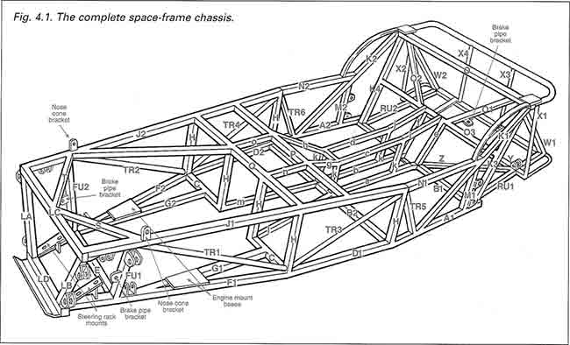
https://www.buildyourownracecar.com/wp-content/uploads/Chassis_SpaceframeDiagram.jpg
(n/a, 2020)
The tubular space frame chassis is a commonly used frame for a race application vehicle, this is due to its very strong structure from its complex design, tubular chassis can be made of out varies types of metal since any types of metal that can be welded and would keep its structural integrity. The Advantage of a tubular chassis are they can be very lightweight but also extremely strong.

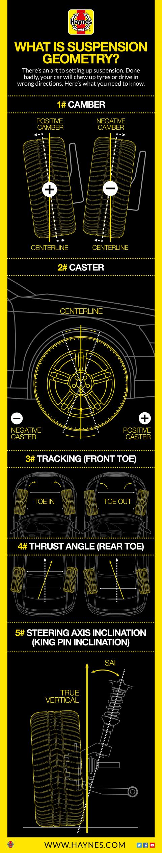
Suspension

The suspension is in charge of hold the sprung mass (mass which is held by the shock absorbers), dealing with bumps on the road and the weight transfer of the vehicle and also in charge of how the wheel reacts to bumps and control the tyre contact patch.

Camber
‘Camber is the inclination of the wheel on the vertical in relation to the ground. It can be measured as positive or negative. In the case of positive camber, the top of the wheel would tuck into the car. In the case of negative camber, the top would pull out from the top of the car.
The amount of camber can drastically change the way a car drives. If you have a lot of positive camber, the car would be more stable in a straight line, but awful in the corners, as the force of cornering would push more weight over the wheel, which would already be at an adverse angle to the road.
If you have negative camber, you get the opposite result. When cornering, the wheel is pushed straight in relation to the vertical, and as more load is put on it, more of the tyre can touch the road, so more grip.
As such, a nettle bit of negative camber is never a bad thing. But even so, setting it up is something best left to the professionals.’
(Understanding your car’s suspension geometry, 2020) https://d32ptomnhiuevv.cloudfront.net/en-gb/sites/default/files/styles/haynes_medium/public/info_Suspension%20geometry.jpg?itok=GH_yGQbF&timestamp=1528194258

Caster
‘This is the backward or forward inclination of the suspension. Positive caster would be to swing the suspension forward, while negative would be to pull it back into the car.
Positive caster is the way to go, as you’ll get greater steering feel, improved turn-in response and greater stability when at speed.
By having too much negative caster, you’re already pulling the suspension back into the car, so when the car is moving, the forces are amplified, and the suspension/tyres are put under much more strain.
You’ll also lose a lot of the car’s handling ability as the wheels will in effect tilting into the ground when you steer.’ (Understanding your car’s suspension geometry, 2020)

King Pin Inclination

‘King pin inclination, or KPI, is the angle determined by looking at the angle of the steering axis perpendicular to the ground, or in the case of a car, the contact patch of the tyre.
The more positive the KIP, the further into the car the uppermost point of the steering axis/steering arm is, the more negative the KPI, the further out the steering axis is pushed.
The benefit in having a greater positive KPI is the you’re get more steering feel and feedback, and provided you don’t go mad, you’ll get better stability, too.
But you have to be careful, as the KPI can alter the camber and caster, throwing out any good their respective setting may have offered.’

Tracking (front toe)
‘This is the most common suspension term, and it’s probably something you have had altered on your own car at some point. It’s measured by toe-in and toe-out. And the best way to think if it is to indeed use your toes.
Imagine your feet are your front wheels. Now keep your heels together and twist your toes away from each other. That’s toe-in. Needless to say, the opposite, with your toes touching and your heels apart, is toe out.
This is something that can need altering after you clip a curb or hit a particularly unforgiving pothole.
Thankfully, unlike Caster and Camber, you adjust the tracking on even the most basic of cars by winding the track rod ends in or out. ‘ (Understanding your car’s suspension geometry, 2020)

Thrust angle (rear toe)
‘This is like tracking, but for the back wheels. The trust angle is determined by the toe-in and toe-out of the rear wheels. However, unlike the front wheels, which you can steer, the rear wheels are fixes, so if the suspension adjustment is out, you can be thrust in the wrong direction. Hence the name.’ (Understanding your car’s suspension geometry, 2020)

Results
Table 1 Vehicle information
Mass | 628 | kg
Wheelbase | 2.8 | m
Centre of Gravity Height | 0.36 | m
Static Weight Distribution (Front) | 0.47 | % Front |  | 0.53 | % Rear
Static Weight Distribution (Left) | 0.51 | % Left |  | 0.49 | % Right
Cl | -0.62
A | 1.2 | m²
Air Density | 1.22 | kg/m³
Centre of Pressure | 0.42 | % Front
Average Track | 1.62 | m
Maximum G | 1.5 | G

 | Front Static loads | VALUE | UNIT |  | Rear Static loads | Value | Unit
 | Front Left | 1476.714996 | N |  | Rear Left | 1665.231804 | N
 | Front Right | 1418.804604 | N |  | Rear Right | 1599.928596 | N
Table 2 vehicle measurement

Analysis
- What do the initial graphs show about how load transfers around a vehicle undergoing acceleration?
The graph shows the higher longitudinal (acceleration forces) the higher the weight transfer. This shows that under acceleration the vehicle weight shifts to the rear, this can be seen by looking at the weight of the vehicle comparing from front to back as the rear become heavier while the front becomes lighter
- What type of effect is the aerodynamic load having on the vehicle?
As the vehicle speeds up the aerodynamic forces that are acting on the vehicle is much greater, this is due to the flow of air flow increased speed also varying the air density
- Explain why 1.5G can’t be achieved in both the longitudinal and lateral directions at the same time?
The vehicle cannot achieve 1.5G in both longitudinal and lateral due to the tyres having a limit to its frictional coefficient.
- How do chassis and suspension changes affect vehicle characteristics?
From different suspension designs, you can change how progressive the wheel is when reacting to bumps, while the vehicle changes its height, the wheel geometry changes. The chassis can dramatically change the vehicle characteristic as some chassis can flex and also be heavy when other can be rigid and lightweight.

List of Figures
Table 1 Vehicle information 11
Table 2 vehicle measurement 12

Bibliography
n/a. (2020, March 18). Chassis Space Frame Diagram. Retrieved from Build your own race car: https://www.buildyourownracecar.com/wp-content/uploads/Chassis_SpaceframeDiagram.jpg
Understanding your car’s suspension geometry. (2020, march 18). Retrieved from Haynes: https://haynes.com/en-gb/tips-tutorials/understanding-your-car-s-suspension-geometry

