

Marketing Management

LCMB7024

Assessment 2: Portfolio: Brand Extension

Tesla VoltRide

Student ID: 2427831
Student Name: Adeeb Mohammed
Lecturer name: Laila maazouz
Word count: 3196
Submission date: 26-04-2025

Table of Contents
1. Introduction & Rationale for Brand Extension 3
2. Market Analysis 4
3. Segmentation, Targeting, and Positioning (STP) 7
4. Customer Persona Development 11
5. Marketing Mix (7Ps Framework) 12
6. Critical Evaluation of Strategic Fit & Challenges 16
7. Conclusion and Recommendations 16
References 17

1. Introduction & Rationale for Brand Extension
Tesla’s Current Brand Image and Market Position
Tesla is a global innovator and market leader in electric mobility (Tesla, 2025). Known for its cutting-edge technology, autonomous driving capabilities, and sleek design, Tesla has cultivated a strong brand image synonymous with sustainability, premium quality, and performance. In 2023, Tesla was ranked among the top fifteen most valuable global brands, further reinforcing its influence in the industry (Carlier, 2023). The company achieved record-breaking vehicle deliveries, reaching 1.8 million units globally, demonstrating robust market demand and operational scale.
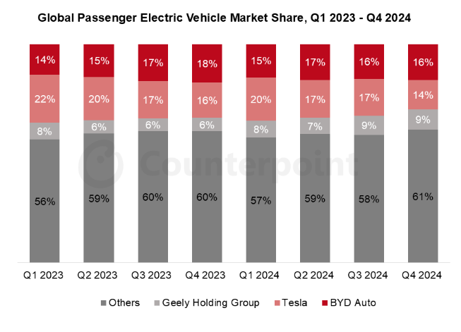
Figure 1: Global Market Share EV
Source: (Counterpoint, 2024)
Despite its dominance, Tesla is facing intensified competition, particularly from Chinese EV manufacturers such as BYD Auto. According to Counterpoint (2024), Tesla’s global EV market share declined from 22% in Q1 2023 to 14% in Q4 2024, whereas BYD increased from 14% to 16% over the same period. These figures indicate that Tesla must diversify and evolve to maintain its leadership position amid rising global competition.
Strategic Rationale for E-Bike Brand Extension
Extending into the e-bike segment aligns strategically with Tesla’s commitment to innovation and sustainability. The United Kingdom presents an ideal target market, with its e-bike sector projected to grow from USD 554.1 million in 2025 to USD 832.9 million by 2029, driven by urban mobility challenges and government-supported green commuting initiatives (Mordor Intelligence, 2024). The proposed Tesla VoltRide leverages Tesla’s strengths in smart tech, battery innovation, and ecosystem integration. It supports the shift toward micro-mobility, offering urban commuters a premium, clean-energy alternative (Razmjo et al., 2022). This extension enhances Tesla’s brand lifestyle synergy and broadens its portfolio, reinforcing its position as a forward-thinking, sustainable mobility provider.

2. Market Analysis
The PESTLE analysis evaluates the macro-environmental factors—Political, Economic, Social, Technological, Legal, and Environmental that influence industry trends and business decisions (Zindros and Anagnostopoulou, 2024). This framework is especially relevant for analysing the UK e-bike market and Tesla’s potential entry.
Political
The UK government supports e-bike adoption through initiatives like the Cycle to Work Scheme and extensive cycling infrastructure, with 5,830 km of dedicated lanes built by 2022. Public-private partnerships, such as Sustrans and Bosch’s charging stations, further promote usage, contributing to a market penetration rate of 8.05% (Mordor Intelligence, 2024).
Economic
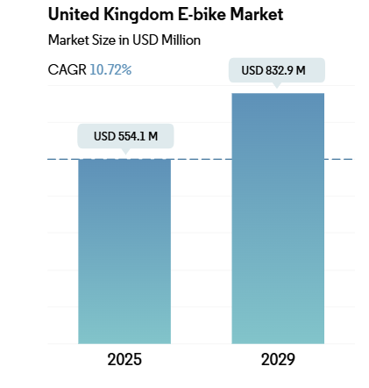
Figure 2: E-Bike Market Growth in the UK
Source: (Mordor Intelligence, 2024)
The UK e-bike market is estimated at USD 554.1 million in 2025, with a projected CAGR of 10.72% through 2029 (Mordor Intelligence, 2024). This economic growth is fuelled by rising urbanisation, inflation-affected fuel prices, and cost-effective commuting solutions. E-bikes are seen as economical alternatives to cars, especially in congested city areas.
Social
E-bike adoption has risen from 30,000 units in 2015 to 181,000 in 2023, supported by changing consumer behaviour (Statista, 2025). Urban dwellers seek healthier lifestyles, flexible transport, and eco-conscious solutions (Chatziathanasiou et al., 2024). The growing popularity of connected and smart e-bikes aligns well with Tesla’s tech-forward image.
Technological
The market is rapidly advancing with IoT-enabled e-bikes, real-time geolocation, and C-V2X (Vehicle-to-Everything) communication for cyclist safety. Tesla can leverage its Lithium-ion battery expertise—including NCA, NCM, and LFP chemistries to deliver superior battery performance and connectivity via the Tesla app (Find My Electric, 2025).
Legal
UK regulations mandate that e-bikes must have pedal assistance, a motor output not exceeding 250 watts, and a power cut-off beyond 15.5 mph (Cross, 2025). Tesla will need to ensure compliance with these standards while maintaining performance and innovation.
Environmental
E-bikes align with the UK’s Net Zero carbon goals and growing demand for sustainable transport (Manifold et al., 2024). Tesla VoltRide’s integration with solar charging would strengthen its appeal among eco-conscious consumers.

3. Segmentation, Targeting, and Positioning (STP)
The STP model—Segmentation, Targeting, and Positioning—provides a structured approach for businesses to identify key market segments, select suitable target audiences, and position their offerings in a way that resonates with those groups (Luthfiandana et al., 2024). For Tesla VoltRide, applying this model is crucial in penetrating the UK’s emerging e-bike market.
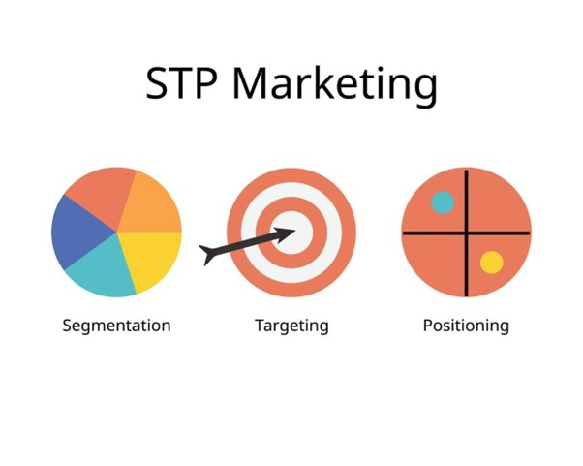
Figure 3: STP in Marketing
Source: (Luthfiandana et al., 2024)
a. Segmentation
Segmentation divides the market into distinct groups with shared characteristics:
- Demographic: Young professionals aged 25–40, typically in dual-income households (DINKS), urban dwellers with a household income above £40,000.
- Psychographic: Tech-savvy, health-conscious, and sustainability-driven individuals who seek smart mobility solutions and identify with innovative brands.
- Behavioural: Regular short-distance commuters, early adopters of technology, and users who value seamless smartphone integration and app-based functionality (Wang, et al., 2024).
- Geographic: Focused on major UK urban centres such as London, Manchester, and Birmingham, where cycling infrastructure and congestion pricing incentivise e-bike commuting.
b. Targeting Strategy
The company will adopt a differentiated targeting strategy, focusing on eco-conscious urban professionals and tech adopters (Ogunmola and Kumar, 2024). These individuals are inclined toward innovation, sustainability, and premium mobility experiences. According to Statista (2025), in 2022 and 2023, nearly six in 10 UK consumers stated they would be more likely to adopt sustainable lifestyles if the options were more affordable. Although this dropped slightly to 53% in 2024, it remains the leading barrier to eco-adoption, highlighting both demand and a price sensitivity to address.
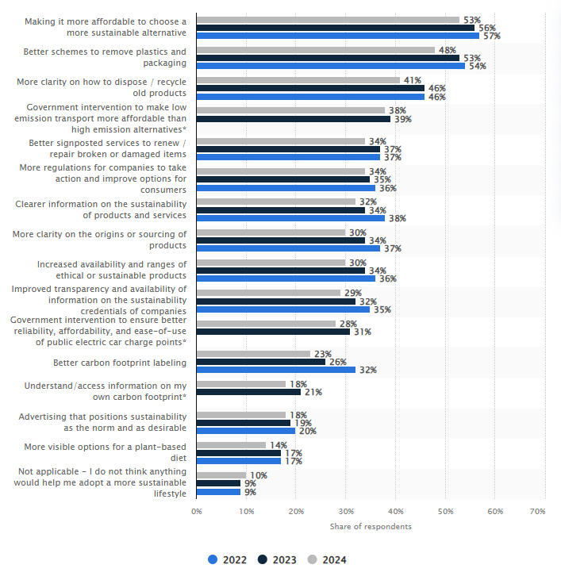
Figure 4: Sustainable Choices of Consumers in the UK
Source: (Statista, 2025)
This segment aligns with Tesla’s core identity and allows for meaningful customer engagement through digital ecosystems and lifestyle branding.
c. Positioning
Tesla VoltRide will be positioned as a premium, smart, and sustainable e-bike that integrates advanced Tesla battery technology, solar charging, and mobile connectivity (Find my Electric, 2025). Unlike mass-market brands, VoltRide offers a futuristic commuting solution that enhances mobility while aligning with eco-conscious values.
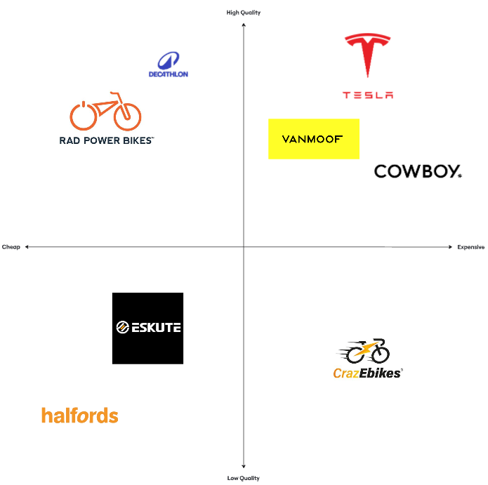
Figure 5: Positioning of VoltRide
Source: (Self-made)
A perceptual map is a visual representation used in marketing to show how consumers perceive different brands relative to each other based on key attributes (Alzate et al., 2022). The perceptual map above positions Tesla VoltRide in the high-quality and expensive quadrant, alongside other premium brands like VanMoof and Cowboy, which reflects its strong emphasis on technological innovation and sleek design. This differentiates it from mid-market value brands like Rad Power Bikes and Decathlon, which offer reliability at a more accessible price point. On the opposite end, Eskute, Halfords, and CrazEbike occupy lower tiers in terms of perceived quality or technological innovation, appealing to more price-sensitive customers.
Positioning Statement
For urban professionals seeking a smarter commute, Tesla VoltRide is the premium electric bike that delivers innovation, sustainability, and Tesla-level performance—because your journey should be as advanced as your destination.

4. Customer Persona Development
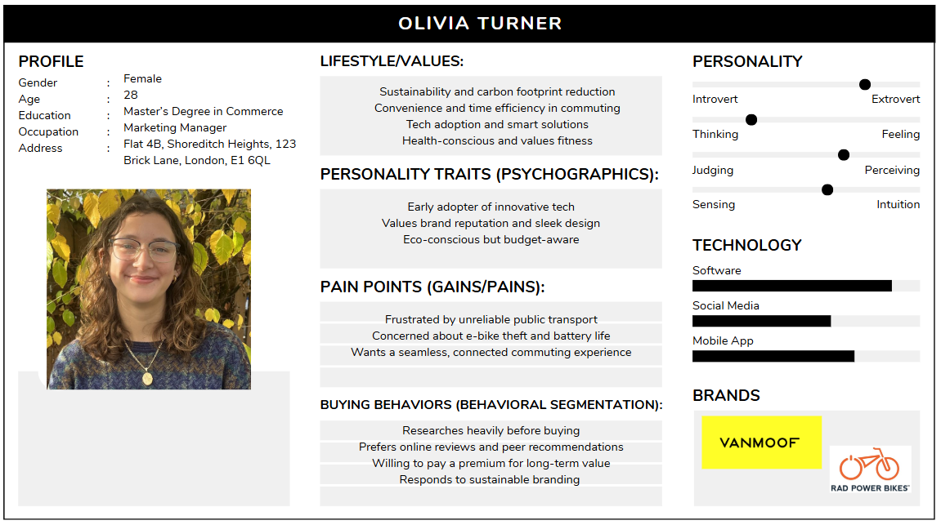
Figure 6: Consumer Persona
Source: (Self-made)
The consumer persona of Olivia Turner, a 28-year-old marketing manager living in London, represents the "Tech-Savvy Urban Commuter" segment. She is eco-conscious, convenience-driven, and values innovation, aligning with modern consumer behaviour trends that prioritise sustainability, time efficiency, and smart technology (Velaoras et al., 2025). Her purchasing decisions are shaped by thorough research, peer reviews, and brand reputation. This reflects high involvement behaviour where consumers invest time and effort before making a choice (Cheung et al., 2021). Psycho-graphically, Olivia is an early adopter who seeks sleek design and seamless connectivity in products, suggesting a preference for premium, sustainable brands like VanMoof and Rad Power Bikes. Her behavioural traits, such as being budget-aware yet willing to pay for long-term value, indicate a rational, utility-maximising buyer profile. She experiences pain points typical of urban dwellers—unreliable transport and concerns over e-bike theft or battery life—driving her toward smart, secure commute solutions.
Overall, Olivia embodies the shift in consumer behaviour toward ethical consumption, tech integration, and personalised brand engagement in modern urban lifestyles.

5. Marketing Mix (7Ps Framework)
The 7Ps Framework is a strategic marketing model that helps businesses develop a comprehensive and cohesive marketing strategy (Jain et al., 2022). It focuses on Product, Price, Place, Promotion, People, Process, and Physical Evidence.
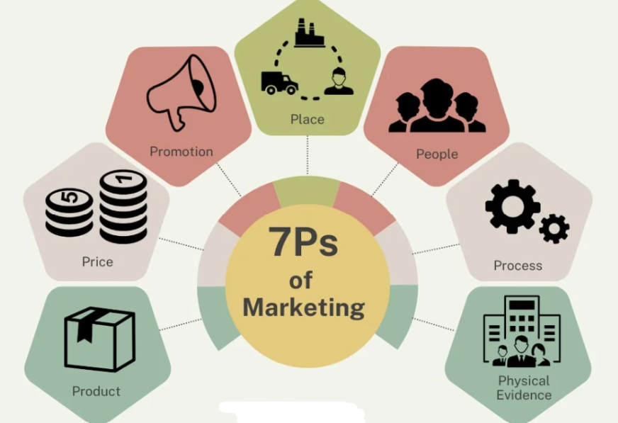
Figure 7: 7Ps of Marketing
Source: (Jain et al., 2022)
a. Product
The Tesla VoltRide is a premium electric bicycle designed for urban commuting. It integrates cutting-edge AI technology, solar charging capabilities, and regenerative braking, offering a sustainable and efficient transportation solution. This is relevant for tech-savvy, eco-conscious individuals. The bike will have a sleek, minimalist design, reflecting Tesla's brand identity.
- Key Features:
  - AI Integration: The bike will feature adaptive power assistance based on rider behaviour and terrain.
  - Solar Charging: A solar-powered charging system will allow users to extend range without needing to plug into external outlets.
  - Regenerative Braking: Tesla's regenerative braking will recover energy when braking and store it in the bike’s battery (Tesla, 2025).
  - Tesla Ecosystem Integration: The VoltRide will sync with the Tesla mobile app, allowing users to track performance, lock the bike remotely, and access diagnostics, creating a seamless connection for current Tesla vehicle owners.
This product is designed to cater to consumers who prioritise innovation, sustainability, and premium design.
b. Price
Tesla VoltRide will adopt a premium pricing strategy, placing it above mid-market competitors like Raleigh or CUBE but in line with VanMoof or Cowboy, both of which target high-income, tech-savvy consumers.
- Price Point: The VoltRide is expected to be priced at £2,500 to £3,000. This price reflects the bike's superior features, such as AI integration, solar charging, and advanced battery technology.
- Price Skimming: Initially, Tesla may use a price skimming strategy, setting a higher price for early adopters and tech enthusiasts who are willing to pay a premium for the first batch of products (Lotfi et al., 2024). Over time, the price may be adjusted to attract a broader market segment.
- Literature Justification: According to Kotler and Monroe (2001), premium pricing works when the product offers unique value and perceived quality, which Tesla VoltRide certainly delivers.
c. Place
Tesla VoltRide will be distributed through direct-to-consumer channels, similar to Tesla's vehicle sales model. Key distribution methods include:
- Online Sales: The VoltRide will be available for purchase on Tesla’s website, where customers can customise the bike, choose colours, and complete the buying process (Tesla, 2025).
- Tesla Showrooms: VoltRide will be featured in Tesla showrooms across major cities like London, Manchester, and Birmingham, offering potential customers the opportunity to see, feel, and test ride the bike.
- Pop-up Stores: Temporary pop-up locations in high-traffic urban areas will allow for live demonstrations and test rides (Boustani, 2025).
- Tesla App Integration: VoltRide will be integrated with the Tesla mobile app, allowing customers to manage and track their bike in real time.
This distribution strategy aligns with Tesla’s direct-to-consumer sales model, ensuring a streamlined, controlled customer experience.
d. Promotion
Tesla VoltRide will primarily rely on organic marketing and word-of-mouth promotion, capitalising on Tesla’s established brand equity. However, there will be additional promotional strategies:
- Social Media Influencers: The company will partner with eco-conscious influencers and urban cycling advocates to showcase the premium features and sustainability benefits on platforms like Instagram and YouTube (Hristova and Lieberoth, 2021).
- Content Marketing: Tesla will create and share content highlighting the environmental impact of e-bikes, their convenience, and Tesla’s commitment to sustainable urban mobility. This content will appear on Tesla’s website, blog, and social media channels.
- Experiential Marketing: Tesla will organise test-ride events and pop-up stores in key cities, allowing potential customers to experience the VoltRide firsthand. Demonstrations will be available, showcasing the bike's features.
- Integrated Marketing Communications (IMC): IMC will ensure consistent messaging across digital ads, social media, and showroom experiences, reinforcing the product’s image as a premium, eco-friendly, tech-driven product (Rehman et al., 2022).
e. People
The success of the VoltRide depends on the people representing the brand:
- Staff Training: Employees in Tesla showrooms and service centres will receive comprehensive training on the VoltRide’s features, ensuring they can offer detailed demonstrations and assist with any customer inquiries or concerns.
- Brand Ambassadors: Tesla will leverage brand ambassadors who embody the brand’s values of innovation, sustainability, and tech-forward living. These ambassadors will engage with consumers via social media, customer forums, and real-world events, fostering a community of Tesla enthusiasts.
- Customer Engagement: The company will build a loyal customer base through ongoing engagement, providing exclusive promotions, events, and content for product owners (Nkegbe and Abor, 2023).
f. Process
Tesla VoltRide’s purchase and ownership process will be seamless and customer-centric:
- Online Ordering: Customers can purchase the product online through Tesla’s website, customising their bikes to suit their preferences (Tesla, 2025).
- Real-Time Tracking: Once purchased, customers can track the delivery status of their VoltRide through the Tesla app, offering a transparent and convenient customer experience.
- Integration with Tesla Accounts: For Tesla vehicle owners, the VoltRide will integrate with their Tesla accounts, allowing them to manage both their vehicle and bike in one place, streamlining the ownership experience.
This smooth process ensures customer satisfaction from purchase to ownership.
g. Physical Evidence
To enhance the customer experience, physical evidence will emphasise the VoltRide’s premium positioning:
- Branded Packaging: The VoltRide will be delivered in eco-friendly, high-quality packaging, ensuring that the unboxing experience reflects the product’s premium value (Ghorbani and Westermann, 2025).
- Tesla Showroom Aesthetics: Showrooms will feature sleek, minimalist designs, with VoltRide prominently displayed to create a high-end, immersive experience for customers.
- Augmented Reality (AR): Tesla will offer AR previews in the app and online, allowing potential customers to visualise the VoltRide in their environment before making a purchase decision.

6. Critical Evaluation of Strategic Fit & Challenges
The Tesla VoltRide aligns seamlessly with Tesla’s mission to “accelerate the world’s transition to sustainable energy” by extending its clean energy solutions to the urban mobility segment. The VoltRide promotes sustainable commuting and leverages Tesla’s battery technology and app integration to reinforce its eco-innovative brand identity. However, risks such as brand dilution (by entering a non-automotive market), cannibalisation (among current Tesla users opting for e-bikes over cars), and operational challenges (in manufacturing, logistics, and servicing) must be considered (Tesla, 2025). According to Kapferer’s Brand Identity Prism, a strong brand must maintain coherence across its physique, personality, culture, and self-image (Zwakala and Steenkamp, 2023). VoltRide preserves this coherence through design consistency, premium positioning, and eco-conscious technology.

7. Conclusion and Recommendations
This report proposed the Tesla VoltRide, a premium AI-powered e-bike, as a strategic brand extension that aligns with Tesla’s mission to “accelerate the world’s transition to sustainable energy.” The analysis identified the UK market as an ideal entry point due to its infrastructure investment and rising eco-conscious consumer base. Through the STP model, tech-savvy urban commuters emerged as the optimal target audience, with VoltRide positioned as a high-quality, smart mobility solution. The 7Ps marketing mix demonstrated how Tesla can leverage its strengths in innovation, direct distribution, and branding. To ensure successful market entry and long-term impact, it is recommended that Tesla initially launch in high-cycling urban areas, collaborate with sustainability-focused brand ambassadors, and fully integrate VoltRide into the Tesla digital ecosystem to enhance brand coherence and mitigate cannibalisation risks.

References
Alzate, M., Arce-Urriza, M. and Cebollada, J. (2022). ‘Mining the text of online consumer reviews to analyse brand image and brand positioning’, Journal of Retailing and Consumer Services, 67, p.102989.
Boustani, G. (2025). Understanding pop-up stores through passion and practice. Taylor & Francis.
Carlier, M. (2023). Tesla - statistics & facts. Statista. Available at: https://www.statista.com/topics/2086/tesla/ (Accessed: 16 April 2025).
Chatziathanasiou, M., Botzoris, G., Morfoulaki, M. and Kotoula, K.M. (2024) ‘A lifestyle-based perspective on the mobility choices and preferences of urban travellers’, Applied Sciences, 14(24), p.11542.
Cheung, M.L., Pires, G.D., Rosenberger, P.J., Leung, W.K. and Sharipudin, M.N.S. (2021). ‘The role of consumer-consumer interaction and consumer-brand interaction in driving consumer-brand engagement and behavioural intentions’, Journal of Retailing and Consumer Services, 61, p.102574.
Counterpoint (2024). Global Electric Vehicle Market Share: Quarterly. Counterpoint Research. Available at: https://www.counterpointresearch.com/insight/global-electric-vehicle-market-share-quarterly (Accessed: 16 April 2025).
Cross, A. (2025). UK e-bike laws and regulations | Paul’s Cycles. Paul’s Cycles Blog. Available at: https://www.paulscycles.co.uk/blog/uk-e-bike-laws-and-regulations/ (Accessed: 16 April 2025).
Davies, K. (2025). Requirements for sustainable living UK 2022. Statista. Available at: https://www.statista.com/statistics/1325318/prerequisites-for-living-a-more-sustainable-lifestyle-uk/ (Accessed: 16 April 2025).
Find my Electric (2025) Tesla Batteries: What Kind of Battery Does My Tesla Have? Find My Electric. Available at: https://www.findmyelectric.com/blog/what-kind-of-battery-does-my-tesla-have/ (Accessed: 16 April 2025).
Ghorbani, M. and Westermann, A. (2025) ‘Exploring the role of packaging in the formation of brand images: A mixed methods investigation of consumer perspectives’, Journal of Product & Brand Management, 34(2), pp.186–202.
Hristova, D. and Lieberoth, A. (2021). ‘How socially sustainable is social media gamification? A look into Snapchat, Facebook, Twitter and Instagram, in Transforming Society and Organisations through Gamification: From the Sustainable Development Goals to Inclusive Workplaces. Cham: Springer International Publishing, pp.225–245.
Jain, R., Jain, S. and Jain, S. (2022). ‘Analysing and exploring the effectiveness of each element of 7Ps of marketing mix’, International Journal of All Research Education and Scientific Methods (IJARESM), 10(1), pp.2455–6211.
Lotfi, A., Naoum-Sawaya, J., Lotfi, A. and Jiang, Z. (2024). ‘To skim or not to skim: Studying the optimal pricing strategy for technology products’, Omega, 127, p.103079.
Luthfiandana, R., Barus, G.A., Nuraeni, N., Yanthy, S. and Pujiati, H. (2024). ‘Marketing strategy: Segmenting, targeting, and positioning for digital business (literature review)’, Siber International Journal of Digital Business (SIJDB), 1(4), pp.11–22.
Manifold, J., Renukappa, S., Suresh, S., Georgakis, P. and Perera, G.R. (2024). ‘Dual transition of net zero carbon and digital transformation: Case study of UK transportation sector’, Sustainability, 16(17), p.7852.
Mordor Intelligence (2024). United Kingdom E-Bike Market - Growth, Trends and Forecasts (2021 - 2026). Available at: https://www.mordorintelligence.com/industry-reports/united-kingdom-e-bike-market (Accessed: 16 April 2025).
Nkegbe, F. and Abor, Y. (2023). ‘The role of social media in enhancing customer engagement and brand loyalty’, Journal of Policy Options, 6(3), pp.26–34.
Ogunmola, G.A. and Kumar, V. (2024). ‘A strategic model for attracting and retaining environmentally conscious customers in e-retail’, International Journal of Information Management Data Insights, 4(2), p.100274.
Razmjoo, A., Gandomi, A.H., Pazhoohesh, M., Mirjalili, S. and Rezaei, M. (2022). ‘The key role of clean energy and technology in smart cities development’, Energy Strategy Reviews, 44, p.100943.
Rehman, S.U., Gulzar, R. and Aslam, W. (2022). ‘Developing the integrated marketing communication (IMC) through social media (SM): The modern marketing communication approach’, SAGE Open, 12(2), p.21582440221099936.
Statista (2025). United Kingdom: E-bike market share 2023. Statista. Available at: https://www.statista.com/statistics/1475070/e-bike-market-share-united-kingdom/ (Accessed: 16 April 2025).
Tesla (2025). About Tesla. Tesla. Available at: https://www.tesla.com/about (Accessed: 16 April 2025).
Ulojijefepa, T.J. (2024). Bright Future of E-Bike Technology: Trends and Impacts. Velcro. Available at: https://velco.tech/en/ebike-technology-innovation-and-trends/ (Accessed: 16 April 2025).
Velaoras, K., Menegaki, A.N., Polyzos, S. and Gotzamani, K. (2025). ‘The role of environmental certification in the hospitality industry: Assessing sustainability, consumer preferences, and the economic impact’, Sustainability, 17(2), p.650.
Wang, R.S.M., Liao, Y.C., Feng, T.H., Srisung, N., Chang, C.Y. and Lung, C.H. (2024). ‘Speculative design for sustainable urban mobility: E-bike futures and data-driven innovation’, in International Symposium on Grids and Clouds (ISGC2024), 24, p.29.
Zindros, S. and Anagnostopoulou, A. (2024). ‘Assessing the macro-environmental factors affecting innovative last-mile delivery solutions’, Transport and Telecommunication, 25(1), pp.1–10.
Zwakala, K.M. and Steenkamp, P. (2023). ‘Brand identity-image fit in professional services in South Africa: Is brand co-creation a panacea?’, Journal of Contemporary Management, 20(1), pp.444–473.

