Section 1 – Challenges of Implementing the Foundation Phase
A curriculum is a framework that aims to guide teaching and learning and methods of assessment. UNESCO (2025) states that a curriculum is a structured plan that outlines learning objectives, content, methods and assessment, to best support children’s development. However, Young (2014) sees curriculum as a social system placing emphasis on it is both a constraint and an enabler as it can set limits on learning and can also provide learning opportunities. UNESCO (2025) highlights that curriculum is important because it supports fairness and accessibility, promotes high quality learning experiences and provides children with lifelong skills contributing to their overall development.
A play-based curriculum uses play as the main way of learning. Wainwright et al, (2016) emphasises this and suggests that play based approaches supports children’s learning and development through exploration and meaningful experiences.
This assignment will explore key aspects of play and learning within the early year’s curricula. Section one will critically analyze the implementation of the Foundation Phase Framework and the challenges faced in practice. Section two will critically evaluate assessment methods and approaches used to track children’s progress within early years. Finally, the third section will present a blog exploring the benefits of risky play and how it contributes to children’s holistic development.

The Foundation Phase was an early year’s curriculum used in educational settings between the years 2004 to 2014 for children aged three to seven. It was designed to transition away from traditional classroom structures and instead take a play-based approach to learning, focusing on seven key areas of learning (Siraj-Blatchford et al., 2007). The curriculums pilot phase began in 2004 and was then eventually used widely across Wales. It recognized the need to shift away from formal subject based teaching and focus more on active and experiential learning. However, whilst these educational needs were identified, it still came with its challenges, one of the key challenges to implementing this play based curricula was balancing play based pedagogy with academic pressures and measurable outcomes (Maynard et al, 2013). Donaldson (2014) highlighted many positives of the curriculum but did identify a need for a reform, suggesting that some areas of the curriculum were not fit for purpose.
Siraj-Blatchford et al (2007) argues that the Foundation Phase was built around the fact that children learn best through hands on experiences and opportunities for exploration and play. Similarly, Donaldson (2014) highlights that learning beyond the classroom is an important learning experience for children. However, Maynard et al (2013) suggests that adult directed approaches are needed to ensure the children are successful later on in life and support those children from more disadvantaged backgrounds who may be struggling developmentally. This complicates the implementation of the curriculum. Welsh Government (2014) found that due to external pressures, educators were teaching children for the outcomes rather than allowing the children to lead their own learning. Maynard et al (2013) highlights that children do not have enough opportunities to follow their own interests as activities are often structured and adult led to achieve pre-determined outcomes. According to Maynard et al (2013) there were various key aims of the Foundation Phase curriculum, many of these aims were qualitative and difficult to measure, however one of the key aims was to raise standards of achievement, which was able to be measured drawing practitioners away from play based approaches and their attention was more focused on literacy and numeracy results. Donaldson (2014) report highlighted that practitioners themselves actually wanted to teach interesting and engaging lessons and not just focus on teaching to achieve a certain outcome. However, teachers may feel unable to teach engaging lessons as Maynard et al (2013) further states that many of the aims of the curriculum are not easily measurable, therefore practitioners may resort to worksheets or structured tasks in order to visibly meet specific targets. This could be a contradictory way of implementing the curriculum as it takes away an element of child led play which is what the curriculum is built on. Thomas and Lewis (2016) argue that there needs to be a balance between child led and adult led activities but does consider that carrying out tests can negatively impact the curriculum play based approach as practitioners may start to see play and learning as two opposing things.
Waters (2016) emphasized that there were challenges in practitioners understanding of how beneficial learning through play is. Siraj-Blatchford et al suggests that if practitioners do not have a clear understanding of how beneficial implementing this play based curricula is they may revert back to outcome driven practices. Similarly, Waters (2016) argues that staff who are trained to a higher standard are able to implement the curriculum more efficiently, this raises concerns as to whether there are differences in practitioners’ understanding and capabilities to take a play based approach. However, Baldwin and Beauchamp (2014) found that the foundation phase improved teachers’ confidence because it set out clear expectations on how to deliver the curriculum. In contrast to this the Welsh Government (2014a) report found that practitioners felt uncertain and even anxious about moving away from formal teaching methods due to the expectations of performing well. This highlights a reluctance to embrace and implement a play based curriculum. Thomas and Lewis (2016) support this argument and also found practitioners to be apprehensive and inconsistent when implementing the curriculum. Estyn (2011) report suggests that children’s literacy skills were not developing enough due to a lack of understanding and how practitioners have interpreted the foundation phase. This could also highlight the pressures practitioners and children feel, leading them to revert back to formal teaching methods in order to show progress. Taylor, Rhys and Waldron (2016) suggest that that the Foundation Phase Curriculum still includes formal teaching even though children may not be ready for this.
Implementing a play based curricula and presenting a certain level of achievement puts pressure on practitioners, which can be heightened by having reduced members of staff. Being able to focus on the children learning through play whilst also observing and gathering evidence of progress can be difficult when there is a lack of staff. Welsh Government (2015) highlights that due to lack of funding ratios of staff to children recommendations may not be met. Welsh Government (2014b) found that this happened more often in Reception and Nursery compared to Year 1 and Year 2. As a result of this, practitioners may find it easier to collect evidence and show progress through adult led activities, which does not always truly reflect a play based curricula. Welsh Government (2014) also found that even when ratios were met it meant less qualified staff were employed who had not had any training on implementing the curriculum, decreasing the quality in which it is delivered. This raises the challenge of practitioners being able to effectively implement the Foundation Phase Curriculum.
Practitioners are constantly under pressure to collect evidence and produce results which could mean their attention is more focused on meeting targets rather than responding to the children’s genuine needs. Welsh Government (2014) further emphasizes this suggesting that the high demands to maintain a certain standard meant practitioners were often led to revert back to older and more formal practices, reducing the children’s opportunities for hands on and meaningful experiences. This also contradicts one of the initial reasons the foundation phase was introduced to move away from formal teaching approaches (Taylor, Rhys and Waldron, 2016).
In conclusion, the implementation of foundation phase is seen to have various challenges. It aims to produce a play based curriculum with the approach of promoting children’s learning through play, exploration and hands on experiences. Despite these intensions academic pressures often undermined this alongside practitioners’ confidence and understanding, and pressure to produce evidence, limiting children’s opportunities for meaningful child led learning. Overall, from the findings it is clear to implement the curriculum effectively, it heavily relies on a balance between the understanding of play based learning and its importance and how to meet external standards and expectations.
Section 2 – Concept of the ‘Unique Child’ and assessment methods
The concept of the ‘unique child’ recognizes that every child is unique and learns in different ways and develops at their own rate which is individual to them (Department for Education, 2025). The Early Years Coalition (2021) emphasizes that progress is not linear and how important it is that practitioners always consider progress to each individual child whilst adhering to their strengths, following their interest and supporting their needs, as this is often more effective. Welsh Government (2020) agrees and states that each child should be supported and challenged whilst also taking into consideration any barriers they may have towards their learning.
According to Welsh Government (2021), the term assessment means the progress children have made, what are next steps needed and how practitioners can support them in taking those next steps. Donaldson (2014) states that assessments should encourage children to take responsibility of their own learning. Assessment plays a significant role within early years education as it supports the children’s learning. Assessments enable practitioners to identify areas where children’s strengths lay, their interests and any areas where they could support them to develop further (Welsh Government, 2019).
It is important to consider the concept of the ‘unique child’ in assessment as different methods of assessment may need to be adapted to accurately reflect their progress. Welsh Government (2019) highlights that the aim should always be to move forward in their learning according to their own individual needs. For example, if a child is bilingual or has additional learning needs a different approach may need to be taken in order to move forward and show progress.

The Foundation Phase curriculum’s progress was assessed using summative assessments at the end of the Foundation Phase against the Foundation Phase Outcomes, which used a scoring method (Welsh Government, 2015a; Welsh Government 2015b). This provided a clear way of showing how the child was progressing in each area of learning. Welsh Government (2015a) supports that using these outcomes is a measurable way of showing the expected standard children should be performing at and therefore with the evidence produced practitioners can clearly see how to support them in their next steps. Alongside the scoring method was a list of the ages of development and aligned next to them was the score or outcome of where they were expected to be (Welsh Government, 2015b).
Welsh Government (2015c) report highlights that most teachers had generally positive views on the end of Foundation Phase Outcomes Assessment. Donaldson (2014) highlighted that using larger scale assessments highlights areas where the setting may need to improve. One strength of using Foundation Phase Outcomes was that it provided practitioners with a clear and structured method of tracking each child’s progress and where they might need support (Welsh Government, 2015b). This could be seen as a benefit as children who may be struggling will be able to get support at an earlier stage of education (Welsh Government, 2022a). It also means that if concerns are raised sharing these with parents, carers and multi agencies is more evident as how that child is progressing is shown in a clear and visible way through this form of assessment.

However, whilst this assessment method does clearly outline progress, it does raise concerns as to whether using age related expectations against the Foundation Phase outcomes supports the concept of the ‘unique child’. Welsh Government (2014a) highlights that this approach is often seen as linear which does not support each individual. Welsh Government (2014) suggests that in order to meet children’s individual needs assessments should be carried out based on the stage they are currently at rather than following age expected outcomes. As previously mentioned, children develop in different ways and at different rates, therefore using a scoring system alongside their age may inaccurately represent their progress. Welsh Government (2022) agrees and argues that assessment needs to be individual, suggesting that age related expectations are not always in the child’s best interest. Similarly, Taylor, Rhys and Waldron (2016) also state that there are expectations placed on children to reach certain outcomes by a certain age, which is not reflective of the ‘unique child’. This may lead to children who do not score well against these expectations could be perceived as falling below the standard level. Although they may have made individual progress that is not being shown in these assessments, therefore Foundation Phase Outcomes may not accommodate to the diverse needs of all children which goes against the concept of the ‘unique child’ (Taylor, Rhys and Waldron, 2016). Welsh Government (2022a) supports this argument further and describes the assessment as a tick box exercise that does not provide enough flexibility to support each child’s unique development.
This could raise concern for children with additional learning needs. For example, children with autism or ADHD may show different ways of learning and development compared to mainstream standards. Foundation Phase Outcomes assessment is useful for identifying areas where children might need additional support as a starting point (Welsh Government, 2022a). Although it could be argued that it highlights more what children can not do rather than what they can do taking away from individual strengths and successes. Donaldson (2014) highlights that children need to see their achievements as positive and they should use language like ‘I can’ or ‘I have’, really focusing on what they can do.This is supported by strength based approaches that reinforce the approach of celebrating children’s achievements rather than highlighting areas where they do not meet certain standards (Early Years Coalition, 2021; National Council of Teachers of English, no date; Brightwheel, 2025). Thomas and Lewis (2016) also highlight that assessments are carried out in the language of the setting which raises concerns where they might have English as an additional language or children that have moved from an English setting to a Welsh setting as their progress to the practitioner may not be clear. Tierney (2013) also states that assessments can become unfair for children who have English as an additional language and children who have additional learning needs, they go on to say it is best practice to ensure assessments are individualised. The Additional Learning Needs Code for Wales highlights the importance of person centred practice which supports the concept of the ‘unique child’, therefore using standardized outcomes to assess children with additional learning needs may not be effective (Welsh Government, 2021a). Furthermore, this opposes the concept of the ‘unique child’ as assessment then becomes more concerned with whether progress aligns with the pre-determined outcomes.
In conclusion, using summative assessment against Foundation Phase Outcomes does support the concept of the ‘unique child’ to some extent as it enables practitioners to measure and assess progress and supports them in recognizing any needs. However, using age related expectations and predetermined outcomes does not support the ‘unique child’ as outcomes are already standardized and not all children will progress in the same way. Overall, from the research it seems that formal assessment methods that already place academic expectations on children are often deemed as unfair especially for children with English as an additional language and children with additional learning needs. Therefore, it could be argued that other methods of assessment that are individualized such as written observations or learning stories would be more effective in supporting the concept of the ‘unique child’.
Section 3 – Blog: Why are we so afraid of risky play?
Throughout my time working in the early years sector, I have often found that implementing risky play is approached inconsistently across various settings. Visser, Van Aalst and Meijer (2024) found that the opportunities for risky play have decreased. More times than most I have found that adults intervene and stop children from engaging in activities that appear to be risky, which could explain the decrease in this type of play. I often find myself asking the question are we protecting children from harm or missing opportunities for valuable learning?
The aim of Curriculum for Wales is for children to become ambitious, capable learners; enterprising, creative contributors; ethically informed citizens and healthy confident individuals, within this framework it is clearly stated that children need to have opportunities to learn to take and manage risks (Welsh Government, 2022). Welsh Government (2024) emphasizes the importance of taking risks and says it is an essential skill and valuable part of play. Similarly Welsh Government (2023) highlights that taking risks is a natural part of learning, particularly for exploration and physical development. This is supported by Sandseter, Kleppe and Sando (2021) study that found the majority of children engaged in some form of risky play. Therefore, it could be argued that risky play is beneficial in supporting the aims of the Curriculum for Wales.
Risky Play contributes to children developing essential life skills (Early Years Blog, 2025). Care Learning (no date) highlights one of the benefits of taking risks is children improve their problem-solving skills as they need to navigate what they might need to do to reach the outcome they desire. This also benefits their emotional development as using different methods helps them learn how to handle decision making. Science Insights (2026) and Sandseter, Kleppe and Sando (2021) found risky play to be beneficial for physical development as it meant children had higher levels in physical activity leading to stronger gross and fine motor skills. Kvalnes and Sandseter (2023) further support this and state that when children challenge themselves with something they were initially afraid of, it has a positive impact on their physical and mental health. Similarly, Sando, Kleppe and Sandseter, (2021) highlight that risky play positively contributes to children’s well-being.
Sandseter, Kleppe and Sando (2021) identified eight categories of play. The image below shows a few of them an how they might be presented in play.
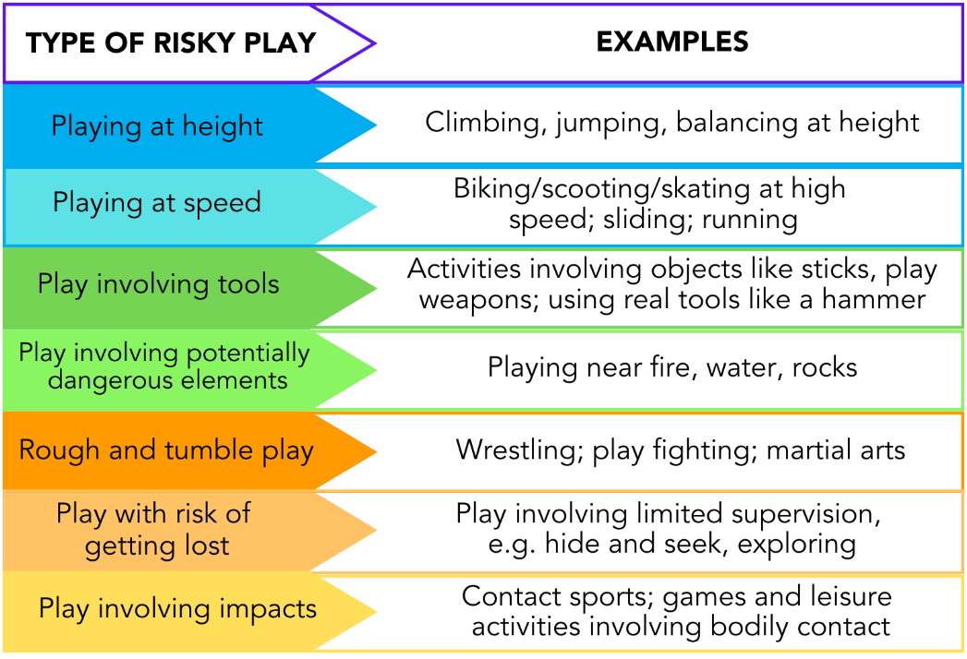
Figure 1. Types of risky play and examples of them.
(BAMBI, 2025)
The non-maintained curriculum encourages children to take calculated risks and indicates that experiencing different play types is essential to their learning and development, with one of those being risky play (Welsh Government, 2022b). Furthermore, the Curriculum for Wales highlights that being able to take risks is an important skill for children to succeed in all six areas of learning within the curriculum and to become resilient individuals later on in life (Welsh Government, 2019).
However, adults are often reluctant and overly concerned about the safety of the children and judgement from others, which can reduce opportunities for risky play. According to Brussoni, Olsen, Pike and Sleet (2012) imposing so many restrictions to prevent potential injuries, negatively impacts childrens development. Visser, Van Aalst and Meijer (2024) also support this argument and found that parents often restricted risky play as they feared judgement that they would be deemed irresponsible or a bad parent and professionals limited risky play because they were fearful that blame would be place on them if an injury did occur. Similarly Play Wales (2024) does take into consideration that adults have a responsibility to keep children safe but that they also need to be challenged, therefore completely eliminating risk does not challenge them or encourage further development.
According to the World Playground Research Institute (2025) parents and professionals can use a risk reframing approach to see risky play as beneficial to their learning rather than dangerous. This is similar to using a risk benefit approach where they can assess and balance whether the benefits children get from the experience outweigh the potential risks of injury (Play Wales, 2024). Both approaches focus on what the children can gain from engaging in risky play rather than the possibility of them getting hurt.
The role of the adults is to minimize risks rather than remove the risks entirely. Therefore it is important to ensure they carry out risk assessments, to allow the children to freely explore and manage and take risks within their play (Welsh Government, 2024) Brussoni et al (2021) found that interventions can effectively promote risky play by helping parents and practitioners to understand and develop a positive attitude towards risky play, helping to feel more confident supporting children with these experiences.
It is also important to understand that risk play is mainly about the child being challenged and moving forward in their development. Play Wales (2024) highlights that risky play does not always mean that it is a high risk activity, it could simply be that the child is challenging themselves, for example, a child jumping from a low height such as the first step or playground equipment.
Risky play also supports children’s rights. Article 31 of the United Nations Convention on the Rights of the Child (1989) clearly states that children have a right to play. Therefore, if we are restricting children from certain play opportunities, we are hindering their right to play freely. Additionally, Article 12 also states children have the right to be listened to, therefore children should be able to freely express the types of play they find meaningful (United Nations Convention on the Rights of the Child, 1989).
The Froebelian approach strongly suggests risky play activities such as climbing trees or building dens supports children connecting with the natural world around them (Tovey, 2020). This indicates that risky play is important when it comes to understanding themselves and the environment they are surrounded by.
The next time a child asks to climb a tree, jump from a height or play with the elements, we should take a moment to ask ourselves whether this is actually a valuable learning opportunity before immediately saying no. To reach the aims of the Curriculum for Wales we need to allow children to take measured risks, shaping them into ambitious, confident and resilient individuals.

