Module: Information Engineering

Student: Shaun Fox 1150748
Title: Practical test Analysis of Systems Requirements

Lecturer: B Holland

Module Code: ACCB4013

Context Diagram

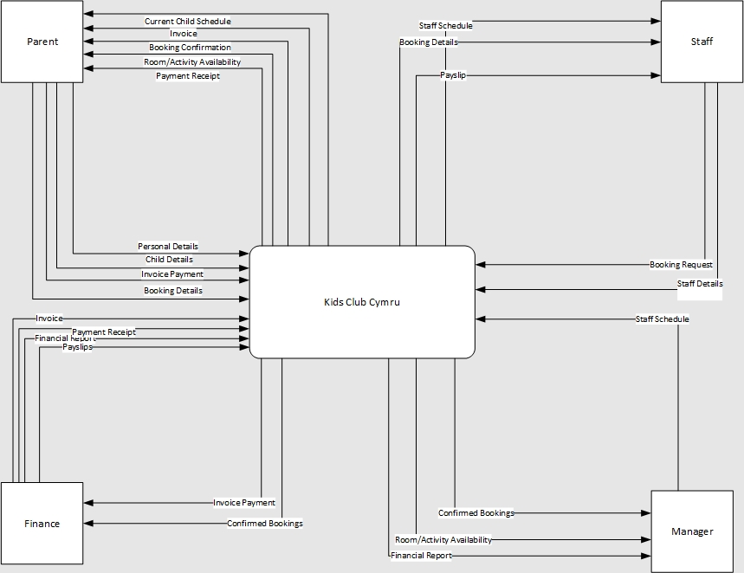

DFD 0 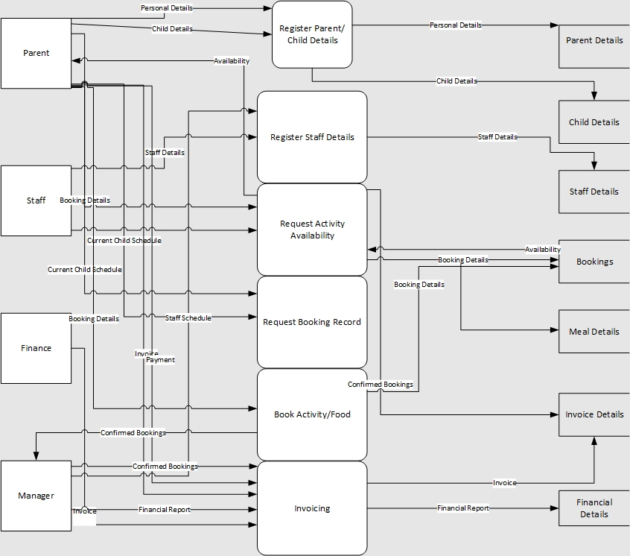

DFD 1
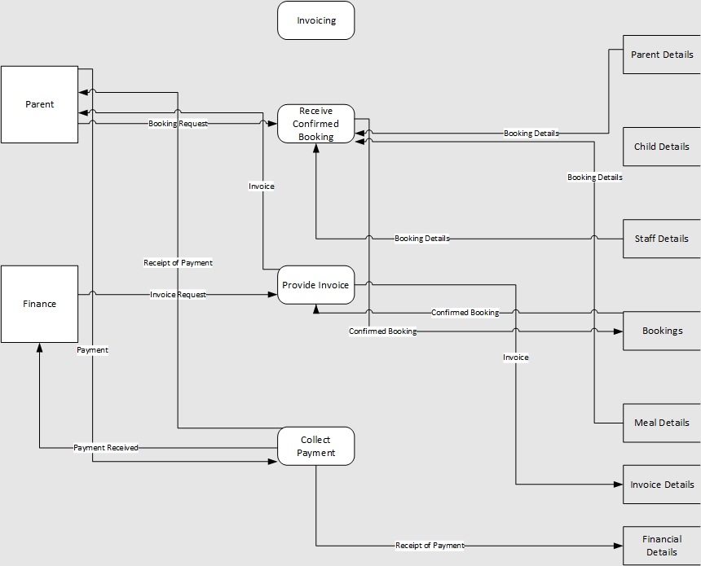

Entity Relationship Diagram


