
PLC’s and Control
Student Name: Joshua Smith
Student ID: SMI16836261
Lecture: Lintao Zhang

Table of Contents

Table of Contents 2
Task 1 (A) 3
Task 1 (B) 4
Task 2 5
Task 3 7
Task 4 8
Task 5 9
Bode plots 9
Nichols Charts 10
References 11

Task 1 (A)
The fundamental idea of a PID controller is that it is a feedback control loop mechanism that will continuously calculate the; proportional, integral and differential terms individually. The input is subjected to a correction factor that is computed based on the variation of these values. An example of this is if the thermostat senses the room temperature is below the set temperature the heating will turn on. PID control systems are one of the most important parts of a PLC system for this reason. (figure 1) shows the PID in a block diagram format.
(Engineering, How does a PID controller work? 2023)

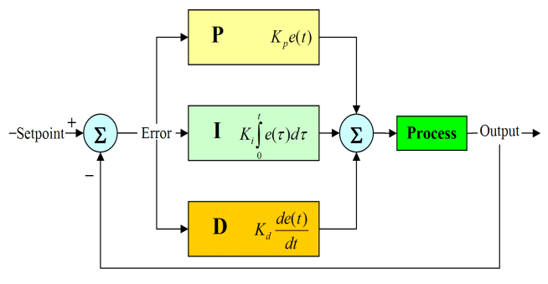
(Figure 1) (B. Patel, Block diagram of a system with PID controller. 2017)

Each of the three terms have different effects and benefits.

Proportional - The difference between the process variable and the set point is the single factor that determines the proportional component. The ratio of the output response to the error signal is determined by the proportional gain (kc) a benefit of this term is that it will improve the systems stability by reducing the steady state error

Integral - the error term is added up over time by the integral component. As a result the integral part will gradually expand even with a tiny error term. The result is to drive the steady-state error down to zero because the integral response will keep on increasing unless the error is zero. The final discrepancy between the process variable and the set point is known as the steady state error. One of the main benefits of the integral component is that it helps eliminate the Steady-state error and ensures accurate control

Differential - If the process variable increases quickly, the derivative component makes the output fall, the derivative response varies in proportion to the process variable's rate of change. A higher derivative time (Td) parameter will result in a faster overall control system reaction and a stronger response from the control system to changes in the error term Due to the Derivative Response's extreme sensitivity to noise in the process variable signal, the majority of real-world control systems employ very small derivative times (Td). The derivative response may cause the control system to become unstable if the sensor feedback signal is noisy or if the pace of the control loop is excessively slow. The benefits of the differential component is
(Emerson , The PID Controller & Theory explained 2023)

Task 1 (B)
Tuning is the process of determining the best gains for P, I, and D to provide the best response possible from a control system. The Ziegler Nichols method is one of these tuning techniques.

A PID controller's gains can be found through trial and error. Upon comprehending the importance of every gain parameter, an engineer may handle this procedure with reasonable ease. This method involves setting the I and D terms to zero first, then increasing the proportional gain until the loop's output oscillates. The system speeds up when the proportional gain is increased, but caution must be used to avoid making the system unstable. The oscillations are stopped by increasing the integral term once P has been adjusted to get the required quick response. While increasing overshoot, the integral term lowers the steady state error. A rapid system must always have a certain level of overshoot in order to react quickly to changes.

To attain the least amount of steady state error, the integral term is adjusted. The derivative term is increased until the loop reaches its fixed point at a pace that is acceptable after the P and I have been adjusted to obtain the intended fast control system with the least amount of steady state error. Raising the derivative term makes the system more noise-sensitive while reducing overshoot and producing larger gains with stability. To better satisfy their needs, engineers frequently have to compromise on one control system feature for another.

A method of PID tuning is the zeigler-Nichols method, which seeks to generate optimal settings for the three gain parameters:
- (Kp) gain of the controller path
- (Ti) integrator time constant for the controller
- (Td) is the derivative time constant of the controller
given two measured feedback loop parameters that are obtained from measurements
- (Tu) the conciliation frequency at the stability limit
- (Td) time derivative

(Emerson , The PID Controller & Theory explained 2023)
(Trammell, 2023)

Task 2
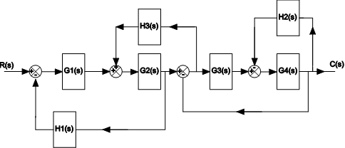
Figure 2
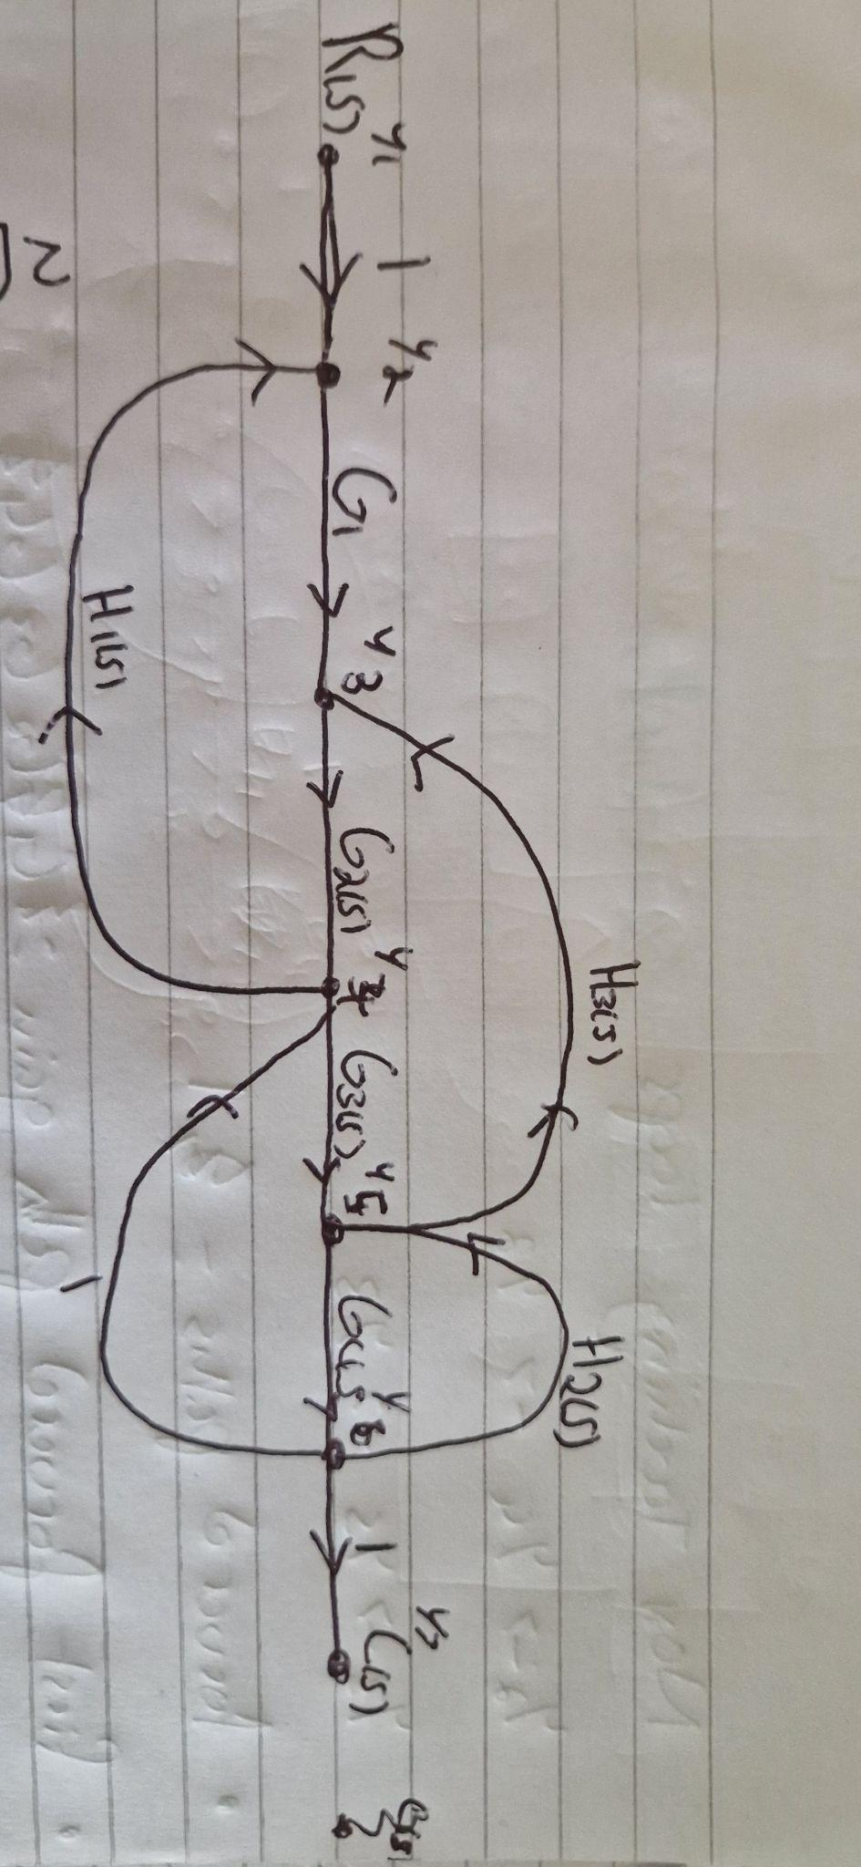
Figure 3

The first thing I did is change the block diagram shown in (figure 2) I was given and change it into a signal flow diagram changing any of the summing points and branches into nodes and labelling them y1- y5 as shown in (figure 3) putting all of the gains that were in the blocks and placing them between the nodes. This will help me with the next step of changing this into a transfer function using mason's gain formula

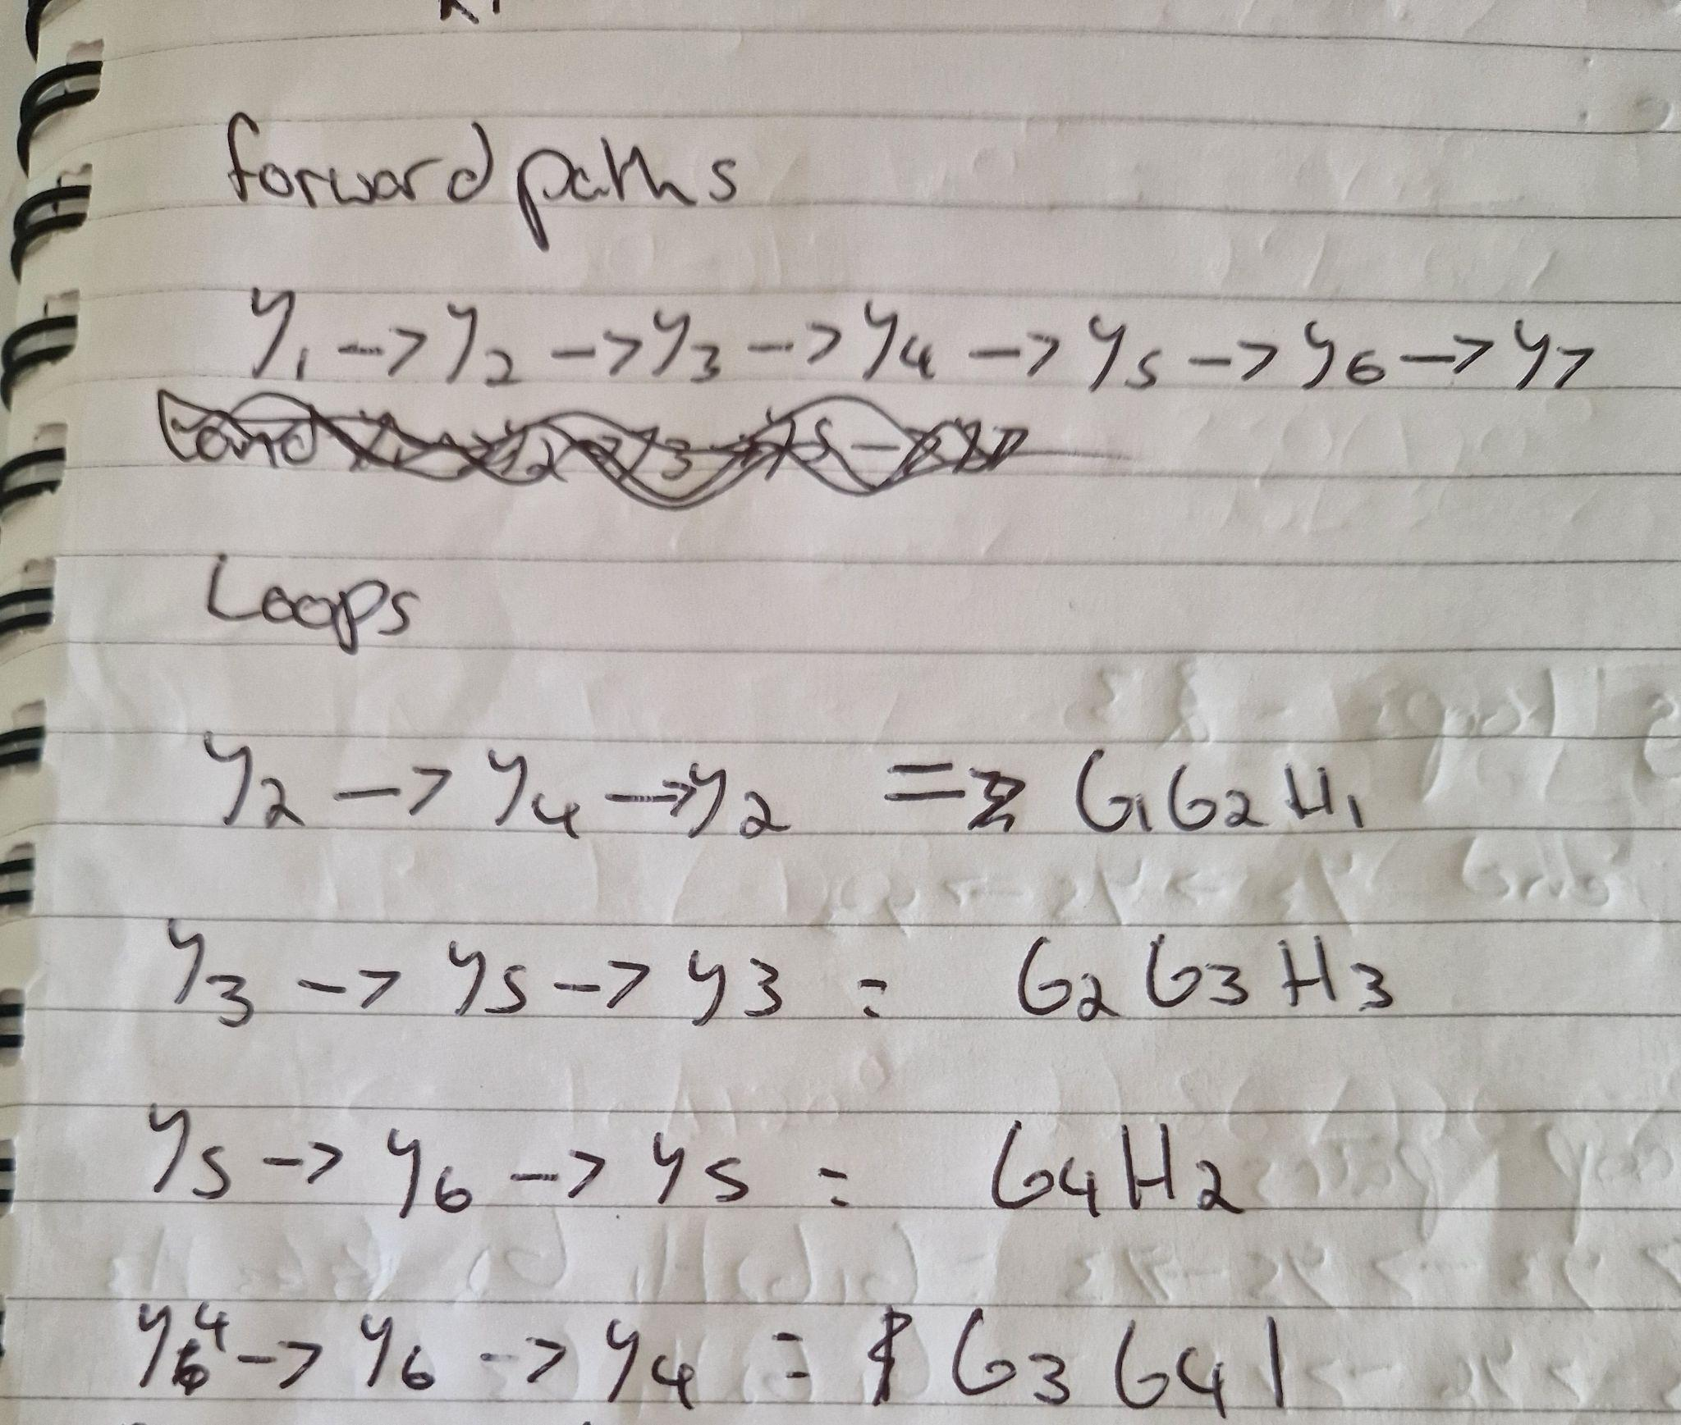
Then from that signal flow diagram I found all the forward paths and loops that are in the system, making sure the gains for each loop are place next to the nodes as shown in (figure 4)

Figure 4
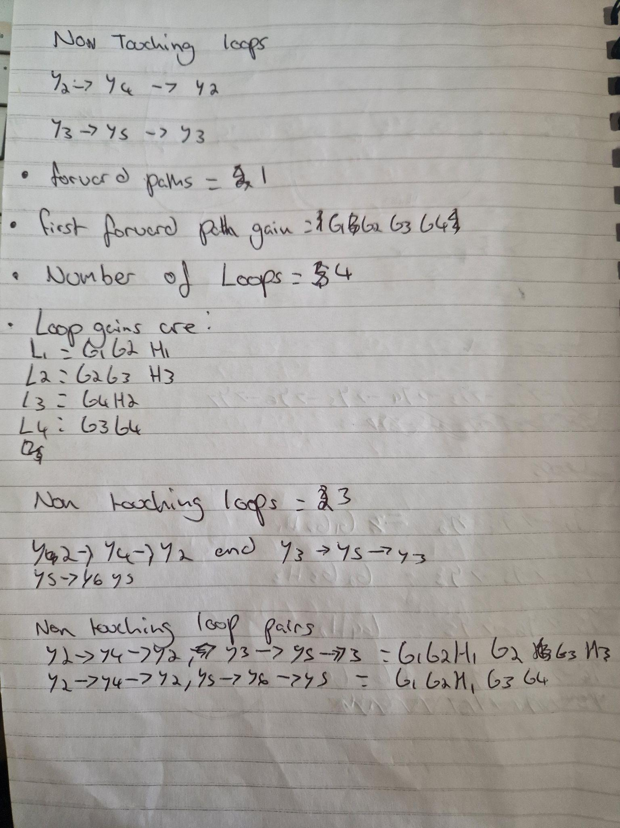
Next I found all the non-touching loops that are in the circuit, counted the amount of forward paths there were and wrote the gain of that path, stated the amount of loops that there are and stated the gains and found the non touching loops, paired them and calculated the gains all this is shown in (figure 5)

Figure 5
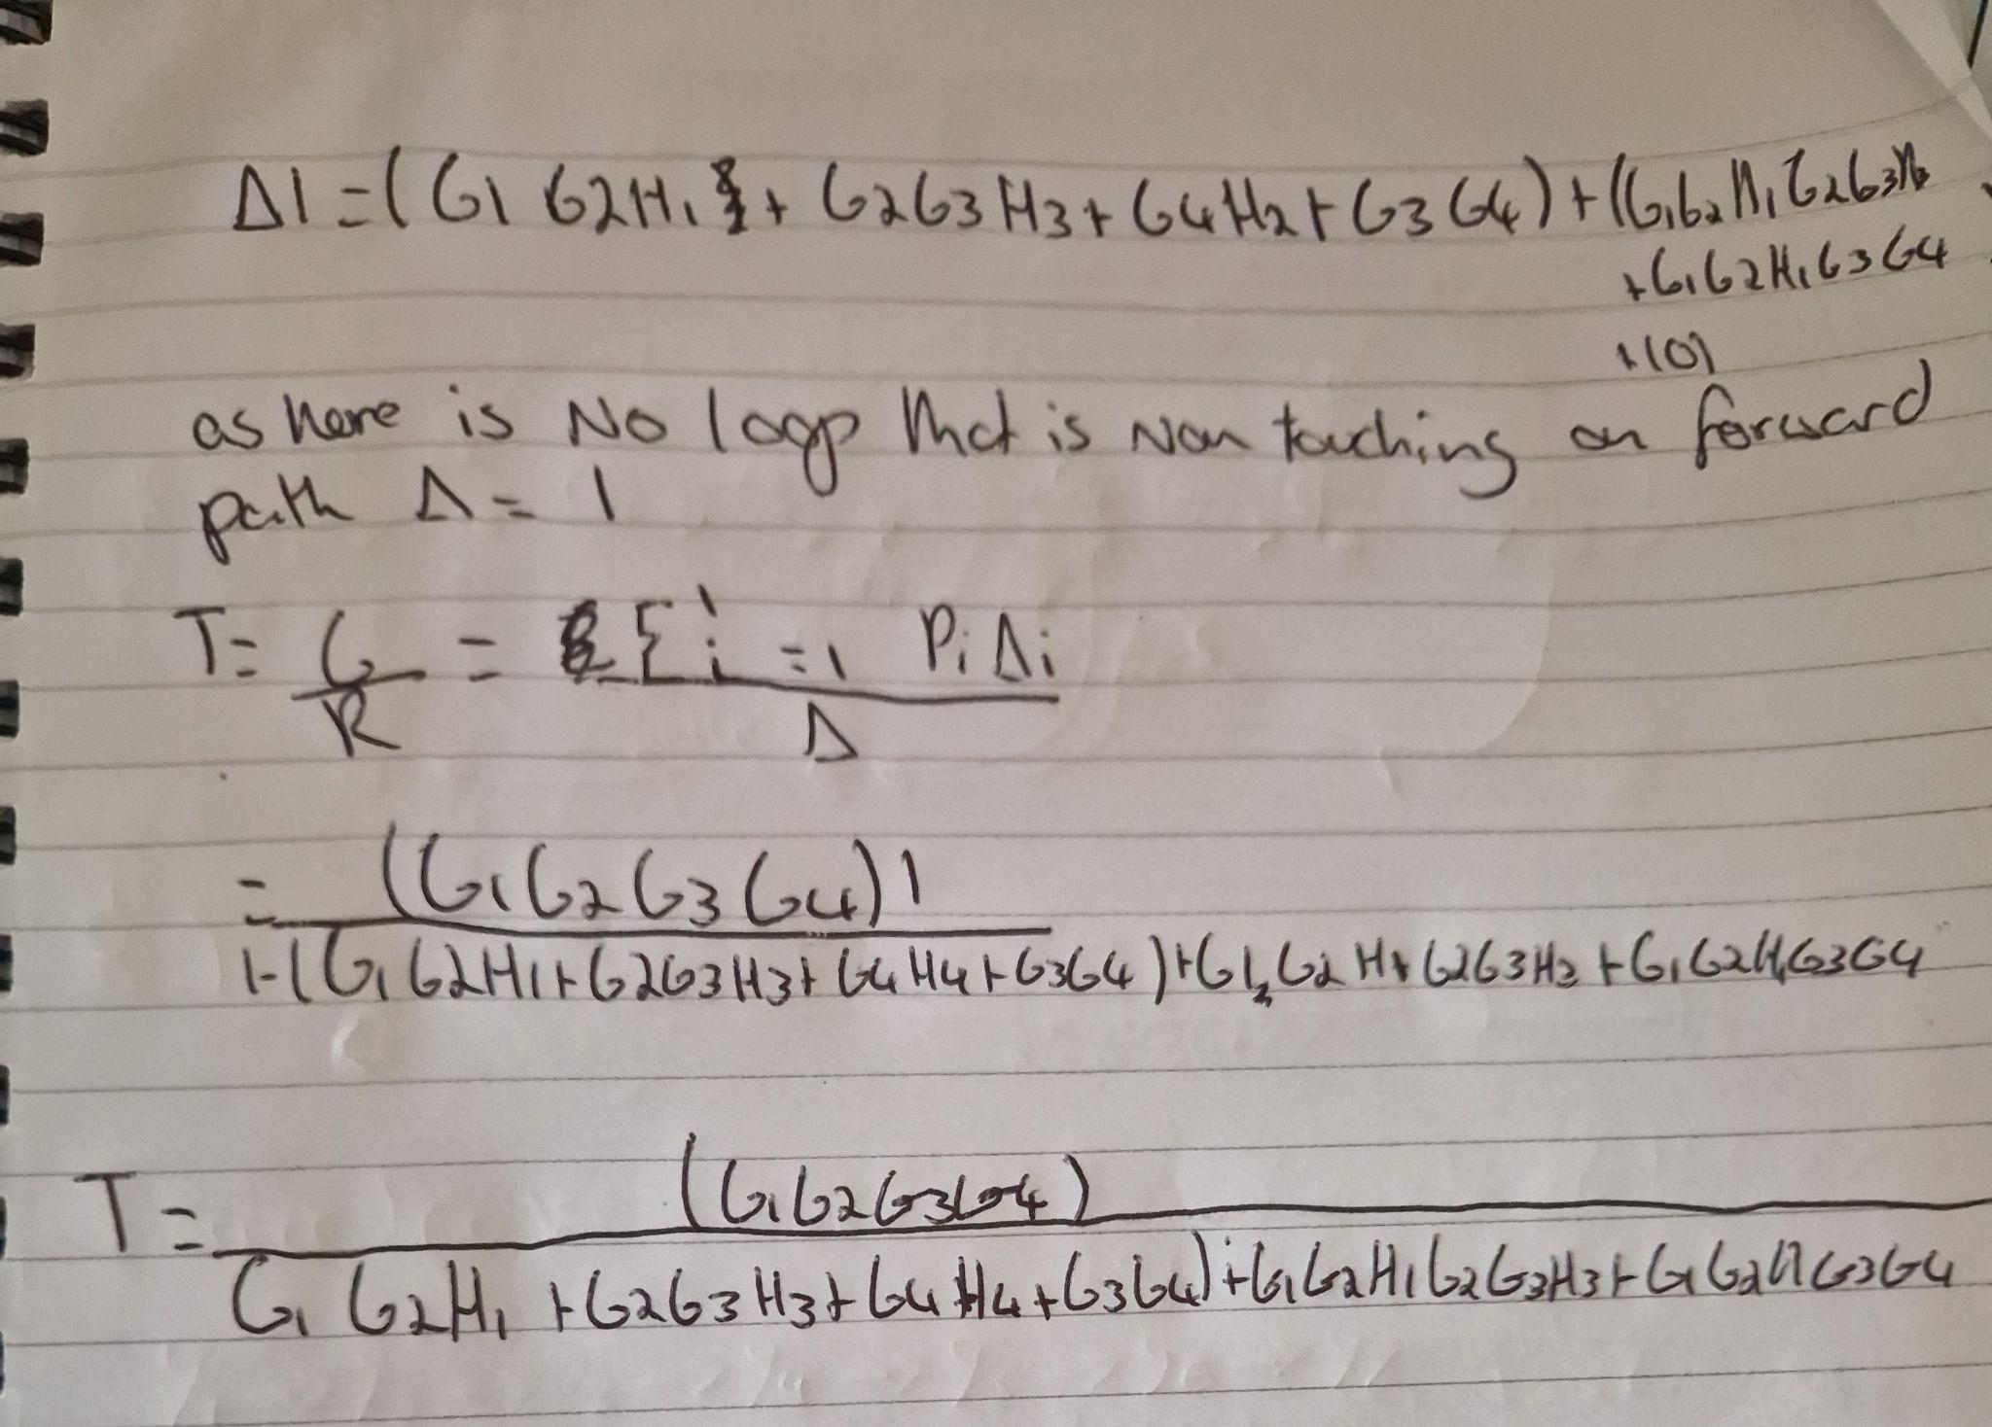
Next I put all the loop gains and non touching loop gains to see if delta was equal to 1, as there were no loop that was non touching on the forward path delta was equal to 1. Then i put everything into the transfer function which is the gain of the forward paths over the gain of the loops and non-touching loops. The final transfer function can be shown in (figure 6.)

Figure 6

Task 3
A state space model is a set of inputs, output and state variables connected by first order differential equations that represents a physical system mathematically. The output variables' values are defined by the state variables. SISO or MIMO state-space models in continuous time or discrete time can be represented using the ss model object.
(Matlab , State space model 2019)
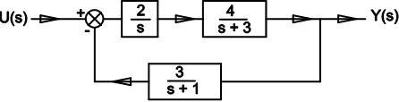
Included on the images below are the calculations for task 3(b) and task 3 (c). The working that are on the left hand side are the workings out for part (b) and the calculations on the right hand side are for part (c)

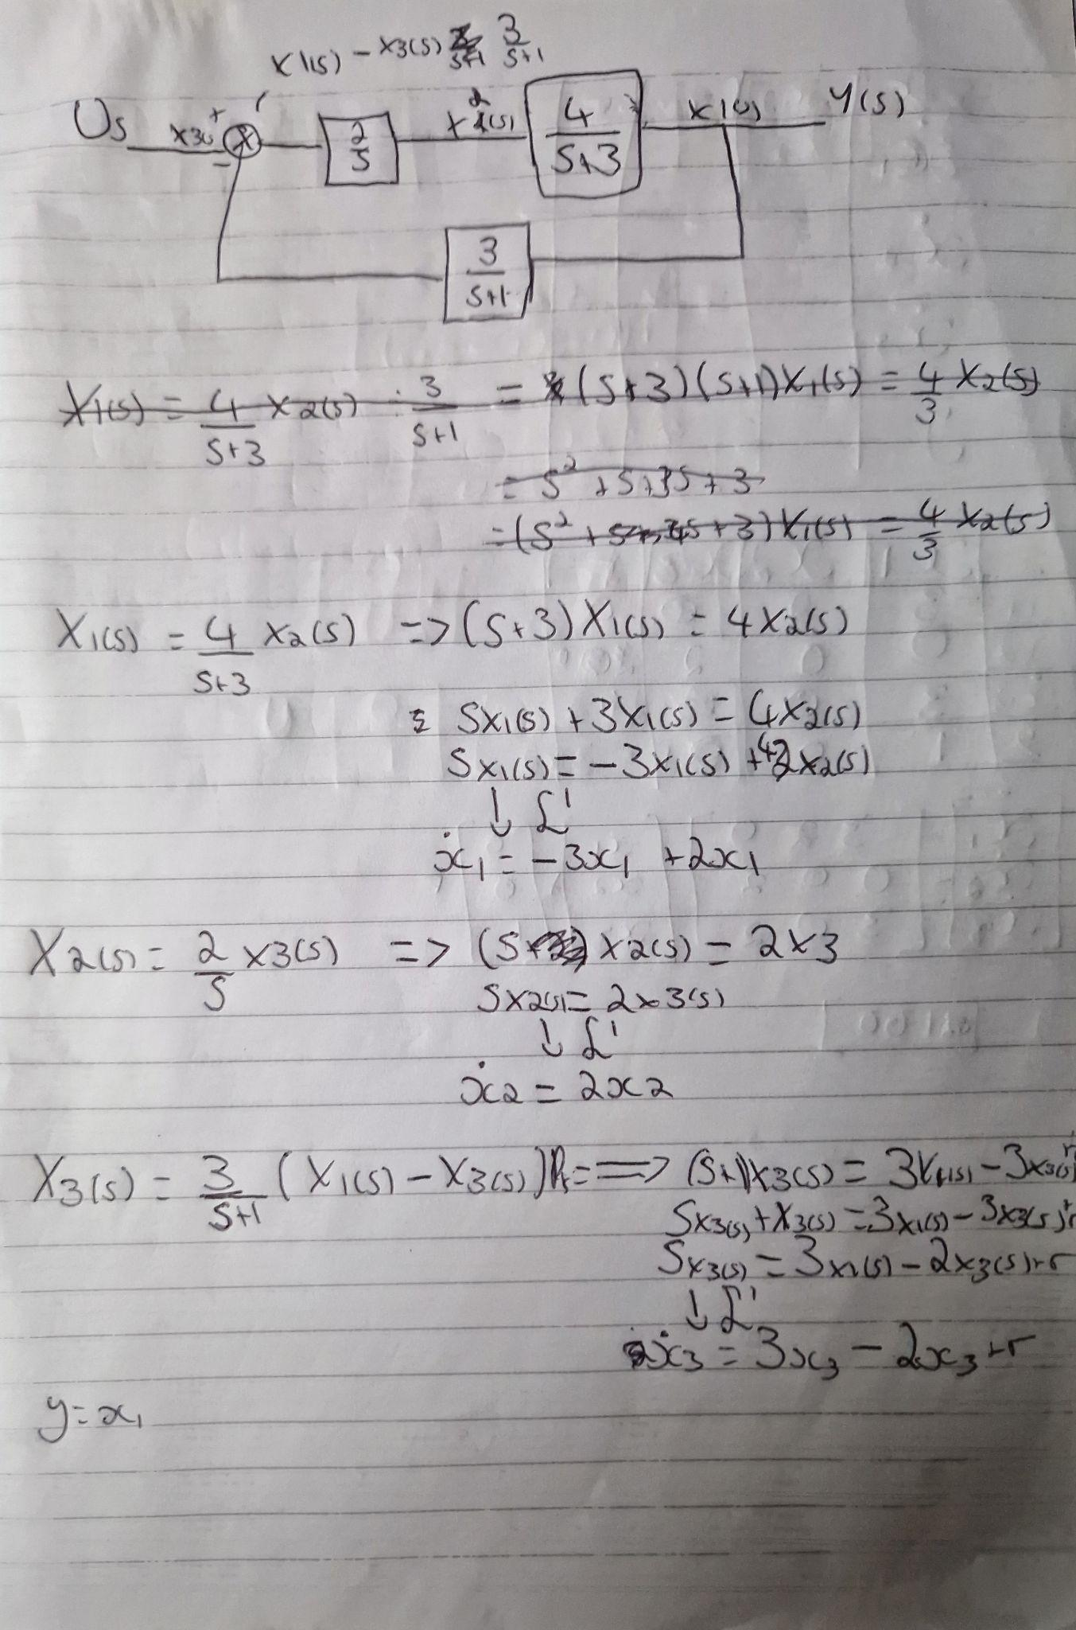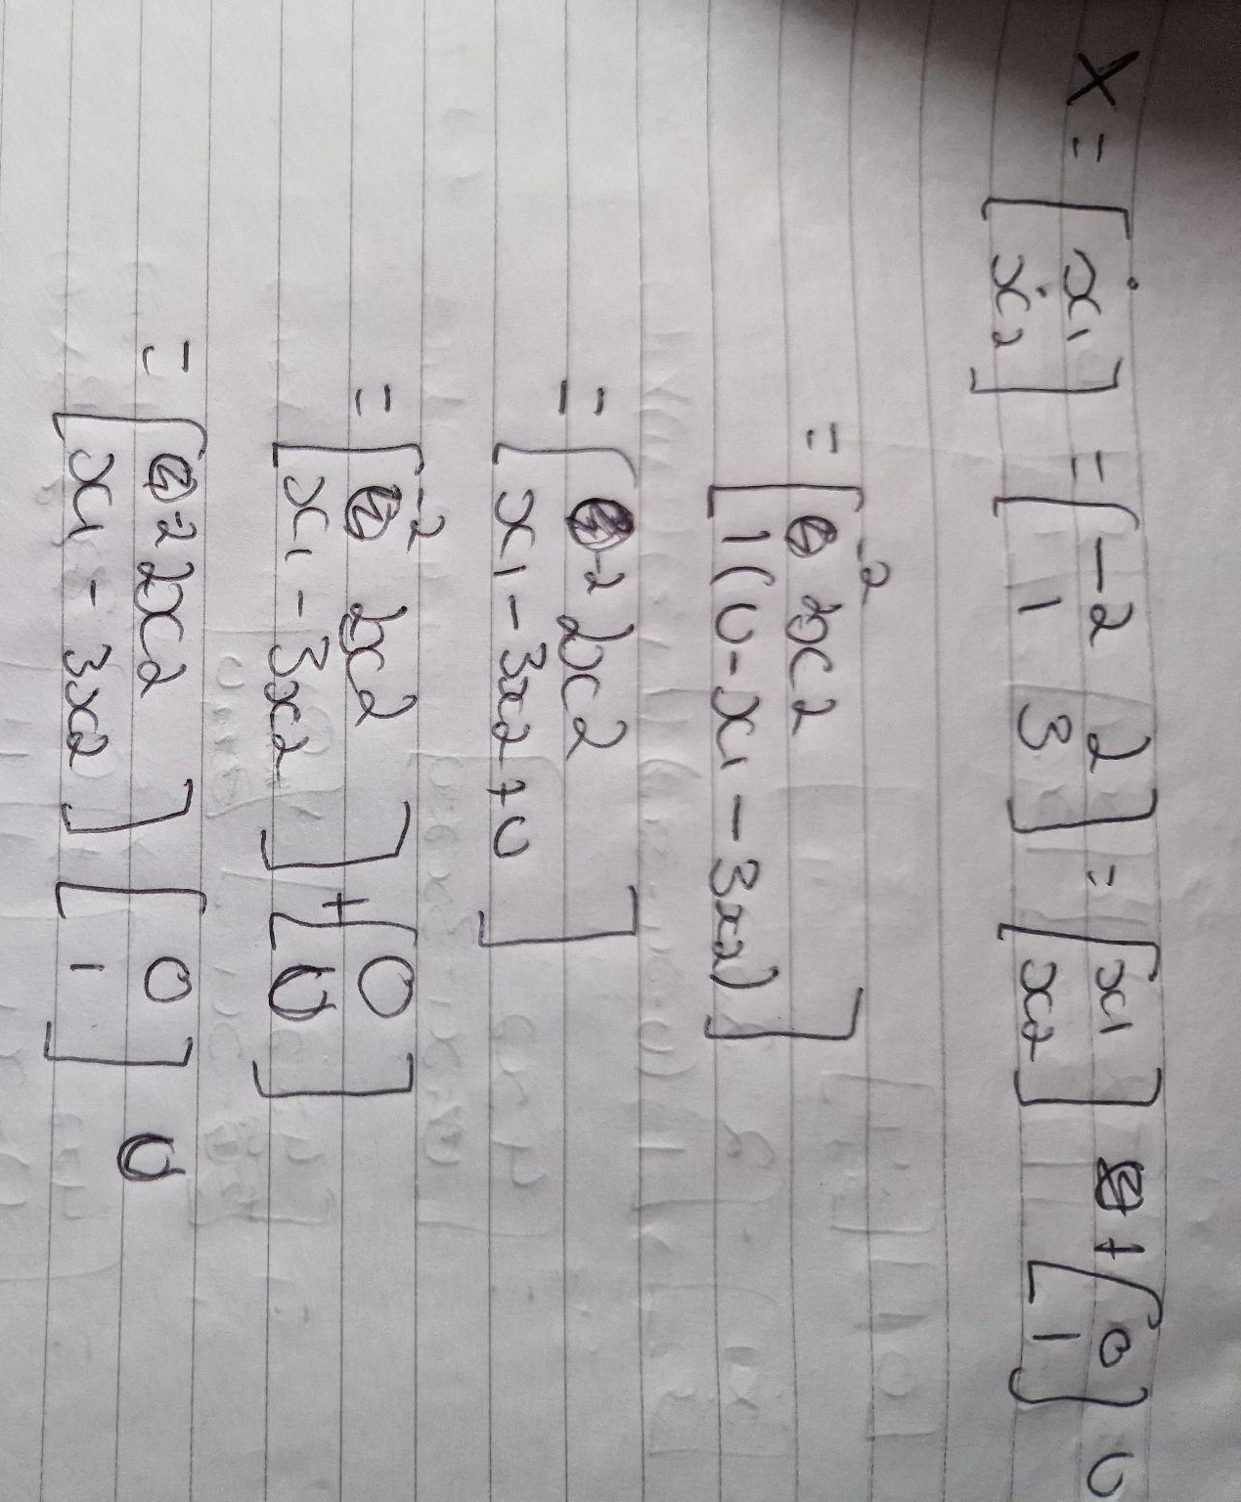
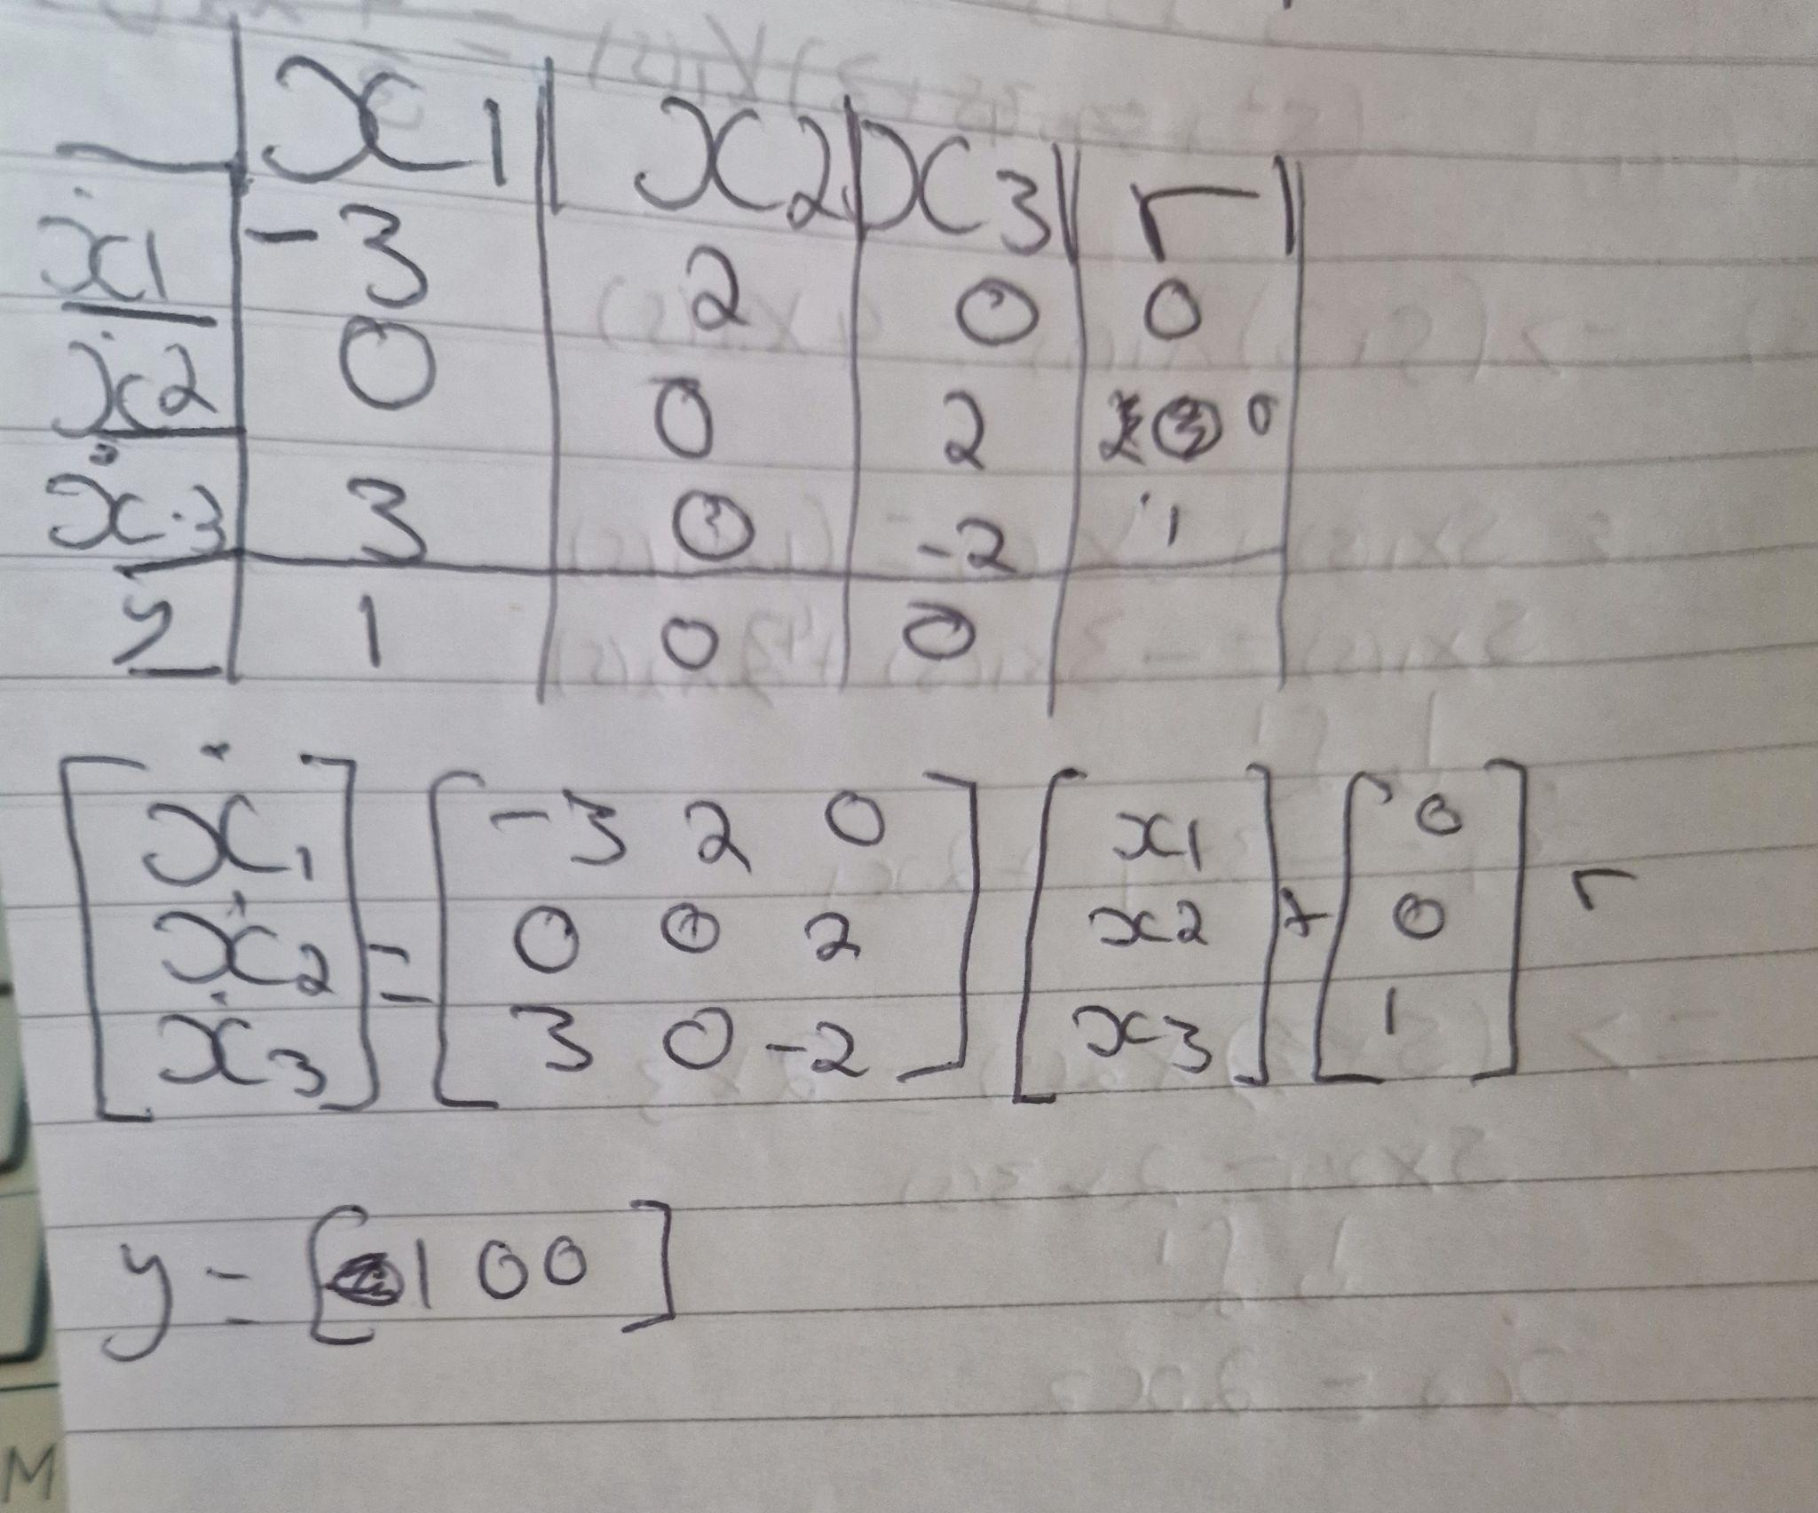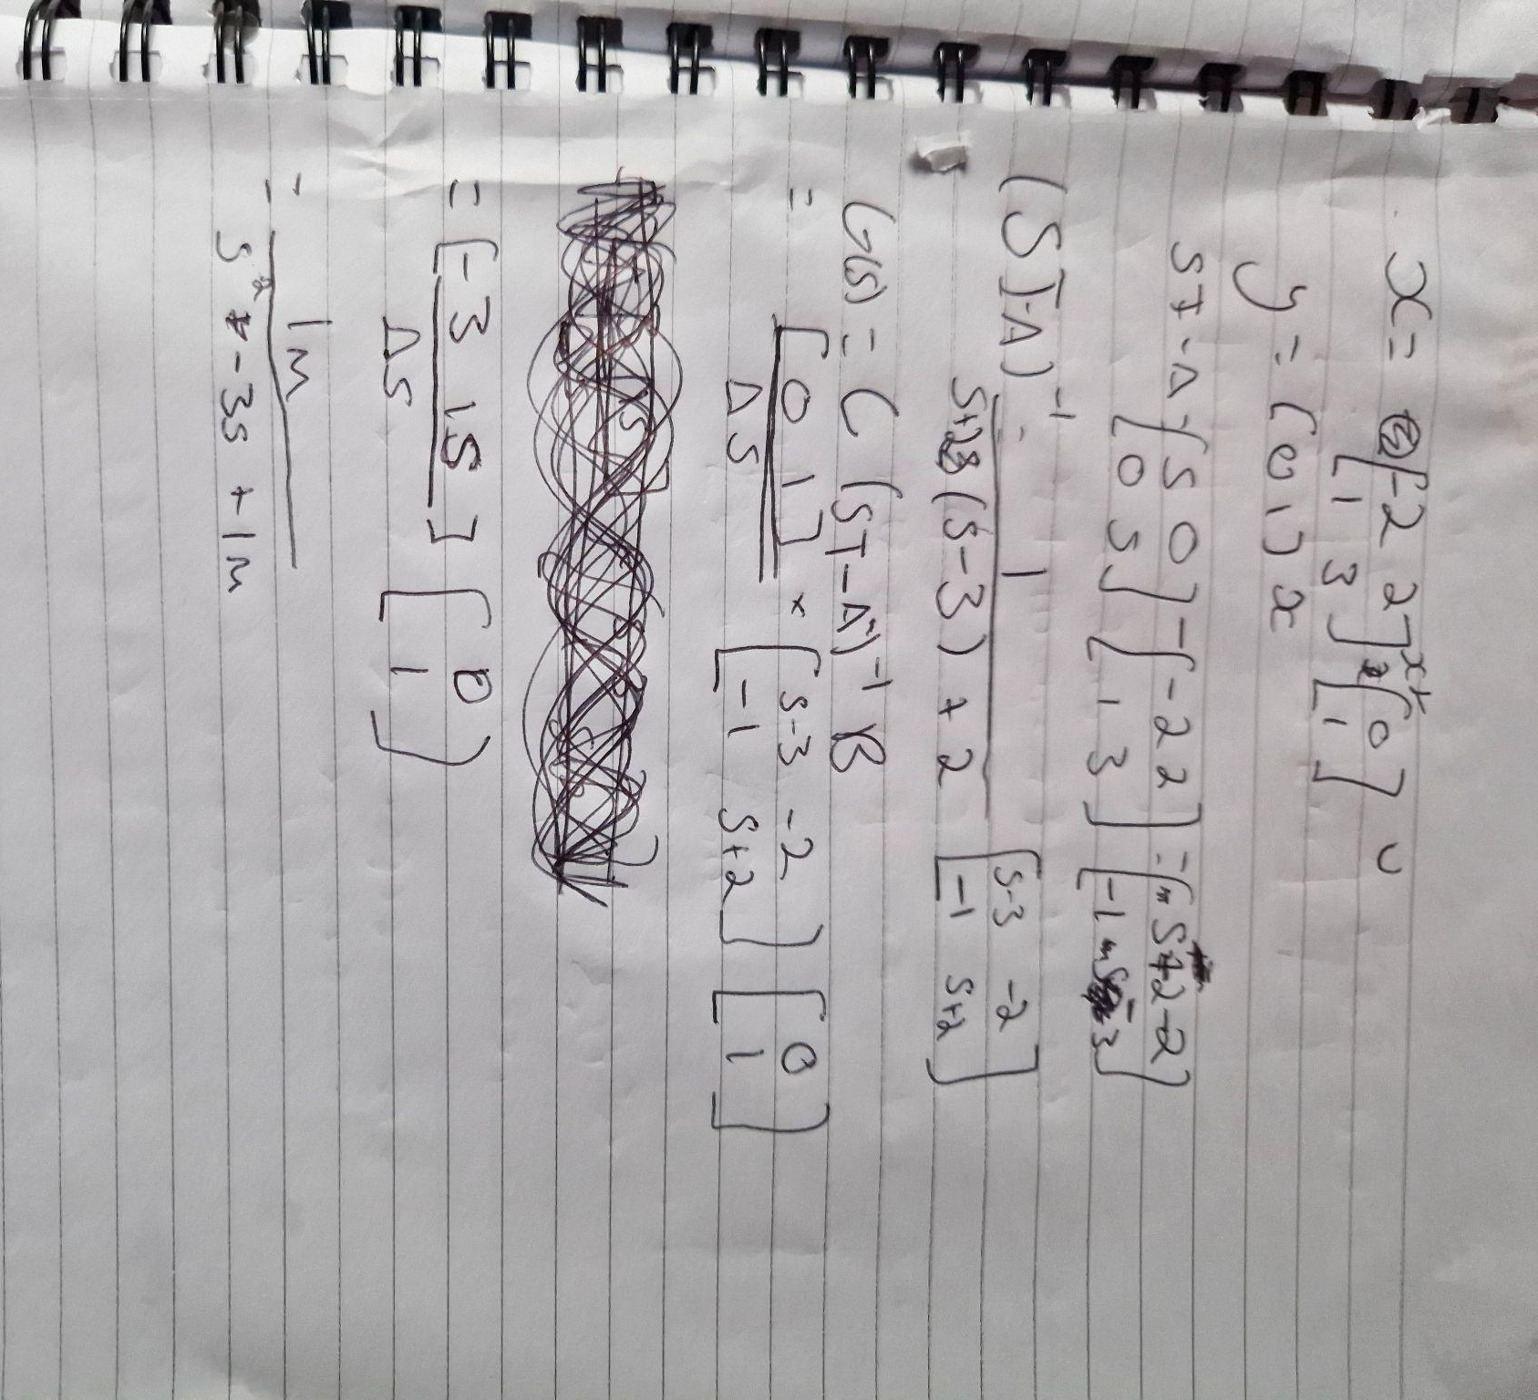

Task 4
The roots of the system's characteristic equation, or the Laplacian, are displayed in root locus plots in relation to control variables like Kc. The stability of various control variable values can be ascertained by looking at these graphs. The formula for a typical transfer function is G(s)=Y(s)/U(s).
following factorization, the roots of the denominators are the poles, and the roots of the numerator are the zeros. All that determines stability is the poles' values. When the real part of each pole value is smaller than zero, the system is stable for all values of the control variables.The poles for the control variable(s) values from zero to infinity on a complex coordinate system are shown by the lines of a Root locus graphic. There will always be a line of symmetry in these maps at i=0.
(Libretexts, 10.6: Root locus plots - effect of tuning 2023)
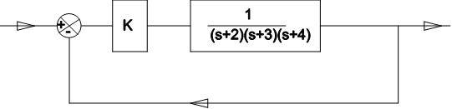
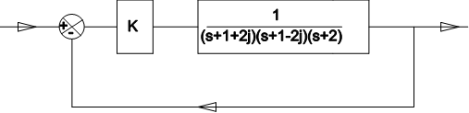

Task 5

Bode plots
What are Bode plots?
Dr. Henrik Wayne Bode created the Bode plots in the 1930s while he was employed by Bell Laboratories. The most common application for them is in the analysis of control system stability, such as in the design and analysis of power supply feedback loops. Bode plots have the benefit of being a simple and widely used method for characterising a linear time invariant system's frequency response.
Bode graphs display the variations in phase and magnitude as a function of frequency, or the frequency response. Two plots with semi-log scales are used for this. Usually, the magnitude, or "gain," is plotted at the top in dB. Phase is plotted at the bottom, usually expressed in degrees.
( Schwarz, 2024)
Phase and gain margin
The stability of the system increases with the Gain Margin (GM). The amount of gain that can be changed without the system becoming unstable is known as the gain margin. Typically, it is given as a magnitude in decibels (dB).
Generally, the Bode plot (as seen in the above diagram) allows us to interpret the gain margin immediately. To do this, find the vertical distance at the frequency where the Bode phase plot = 180° between the x-axis and the magnitude curve on the Bode magnitude plot. The phase crossover frequency is the name given to this location.
(Electrical4U, Bode plot, gain margin and phase margin (plus diagrams) 2024)
Frequency Response
frequency response describes how our system will alter in response to a specific input frequency. We shall refer to this group of notes as ω our input frequency.
Usually, a bode plot consists of two graphs. We'll refer to one as the phase angle plot and the other as the magnitude plot.
(scribd, 5.1 bode plots and Nichols Charts 2023
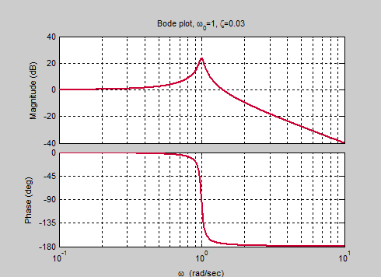
Tuning a Control system
Bode plots consist of two graphs: a phase vs. frequency graph and a gain vs. frequency graph. Performance and stability metrics may be found by merging the two graphs.

(Cheever, Bode plots overview 2022)

Nichols Charts
What are Nichols Charts ?
A highly helpful method for figuring out a feedback system's stability and closed-loop frequency response is the Nichols chart. Plotting the open-loop gain against phase characteristics yields the stability. Concurrently, the gain-phase plot is overlaid with contours representing continuous closed-loop amplitude and phase shift to ascertain the system's closed-loop frequency response.
Nichols charts provide both open-loop and continuous closed-loop gain curves. The system is stable if the closed-loop gain crosses the open-loop point (0 dB, -180 degrees) to the right.
(Electrical4U, Nichols chart: What is it? (control systems) 2024)
(scribd, 5.1 bode plots and Nichols Charts 2023)
How does a Nichols Chart work
The M-circles (constant magnitude loci) and N-circles (constant phase angle loci) are the basic elements of the Nichols chart.
The constant M and N circles in the G (jω) plane are essential for control system analysis and design.
But since these plots provide information with less modification, the constant M and constant N circles in the gain phase plane are ready for system design and analysis.
The graph with the phase angle along the abscissa (horizontal axis) and the gain in dB along the ordinate (vertical axis) is known as the gain phase plane.
(Shinners , 1999)
Frequency Response
The gain-phase plot is overlaid with contours representing the constant closed-loop amplitude and phase shift to establish the system's frequency response.
where the phase component of the transfer function is denoted by α(ω) and the amplitude component by M(ω). The highest value of C(jω)/R(jω) is represented by Mp, and the radian frequency at which it occurs is known as the system's resonant frequency, or ωp.
(Di Gennaro, Nichols plot 2023)
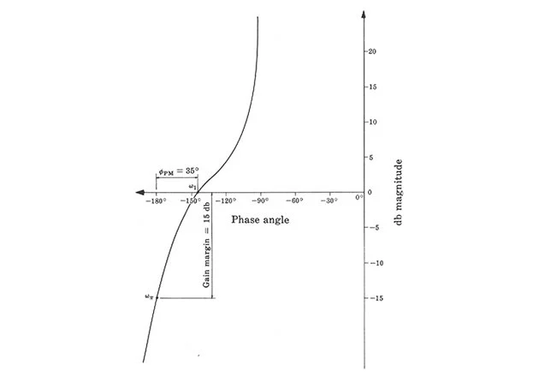

(The Nichols chart the practical tool for design and test - technical articles 2023)

References
& Schwarz, R. (2024) Understanding bode plots, Rohde & Schwarz Understanding Bode plots. Available at: https://www.rohde-schwarz.com/uk/products/test-and-measurement/essentials-test-equipment/digital-oscilloscopes/understanding-bode-plots_254514.html#:~:text=Bode%20plots%20show%20the%20frequency,phase%2C%20most%20commonly%20in%20degrees (Accessed: 21 April 2024).
B. Patel, S. (2017) Block diagram of a system with PID controller. , lock diagram of a system with PID controller. Available at: https://www.researchgate.net/figure/Block-diagram-of-a-system-with-PID-controller_fig1_268802558 (Accessed: 21 April 2024).
Cheever, E. (2022) Bode plots overview, Bode Plots Overview - Erik Cheever. Available at: https://lpsa.swarthmore.edu/Bode/Bode.html (Accessed: 21 April 2024).
Di Gennaro, S. (2023) Nichols plot, Nichols Plot - an overview | ScienceDirect Topics. Available at: https://www.sciencedirect.com/topics/engineering/nichols-plot (Accessed: 21 May 2024).
Electrical4U (2024a) Bode plot, gain margin and phase margin (plus diagrams), Electrical4U. Available at: https://www.electrical4u.com/bode-plot-gain-margin-phase-margin/ (Accessed: 21 April 2024).
Electrical4U (2024b) Nichols chart: What is it? (control systems), Electrical4U. Available at: https://www.electrical4u.com/nichols-plot/ (Accessed: 20 May 2024).
Emerson (2023) The PID Controller & Theory explained, NI. Available at: https://www.ni.com/en/shop/labview/pid-theory-explained.html#:~:text=As%20the%20name%20suggests%2C%20PID,are%20discussed%20in%20this%20paper. (Accessed: 21 April 2024).
Engineering, O. (2023) How does a PID controller work?, https://www.omega.com/en-us/. Available at: https://www.omega.com/en-us/resources/how-does-a-pid-controller-work#:~:text=The%20working%20principle%20behind%20a,and%20applied%20to%20the%20input. (Accessed: 21 April 2024).
Libretexts (2023) 10.6: Root locus plots - effect of tuning, Engineering LibreTexts. Available at: https://eng.libretexts.org/Bookshelves/Industrial_and_Systems_Engineering/Chemical_Process_Dynamics_and_Controls_(Woolf)/10%3A_Dynamical_Systems_Analysis/10.06%3A_Root_locus_plots-_effect_of_tuning#:~:text=Root%20locus%20plots%20show%20the,)%2FU(s). (Accessed: 21 April 2024).
Matlab (2019) State space model , State-space model . Available at: https://www.mathworks.com/help/control/ref/ss.html (Accessed: 21 April 2024).
scribd (2023) 5.1 bode plots and Nichols Charts, Scribd. Available at: https://www.scribd.com/document/616870314/5-1-Bode-Plots-and-Nichols-Charts (Accessed: 21 May 2024).
Shinners , S.M. (1999) Modern Control System Theory and Design, 2nd edition, O’Reilly Online Learning. Available at: https://www.oreilly.com/library/view/modern-control-system/9780471249061/sec6-10.html#:~:text=The%20Nichols%20chart%20%5B21%5D%20is,loop%20gain%20versus%20phase%20characteristics. (Accessed: 21 April 2024).
Trammell, L. (2023) Ziegler-Nichols tuning rules for PID. Available at: https://www.mstarlabs.com/control/znrule.html (Accessed: 21 April 2024).
EEPower (2023) The Nichols chart the practical tool for design and test - technical articles, EEPower. Available at: https://eepower.com/technical-articles/the-nichols-chart-the-practical-tool-for-design-and-test/ (Accessed: 21 April 2024).

