
Master of Business Administration
International Business

Module Name: Marketing Management
Module Code: LCMB7024
Lecturer Name: Dr. Laila Maazouz
Student Name: Prasanna Panthee
Student ID: 2541875
Word Count: 2500
Submission date: 7/24/2026

Marketing Environment Analysis and Strategic Growth Positioning of Tata Steel: Navigating the Transition Towards a Lower-Carbon Business Model

Table of Contents
Introduction 4
1. Marketing Environment Analysis 1
1.1 Company and analytical context 1
1.2 Natural environment 1
1.3 Governmental and regulatory publics 2
2. Strategic Growth and Competitive Positioning 3
2.1 Recommended Ansoff Strategy 3
2.2 Proposed Offer: Optemis Verified Circular Steel 5
2.3 Focused Differentiation and Demand Creation 5
2.4 Implementation, Control and Risk 6
3. Critical Reflection on AI Usage 7
3.1 Tool disclosure and contribution 7
3.2 Verification and correction 7
3.3 Ethical and professional reflection 8
Conclusion 8
References: 9

Introduction
The report critically examines the marketing environment and positioning of Tata Steel when it comes to becoming a low carbon company. It scrutinizes the environment, regulations, it looks at the growth potential following Ansoff's matrix and proposes a differentiated circular steel strategy with a supporting verification, innovation and transparency. The analysis was focused on sustainable value and its impact to gain the competitive advantage.

1. Marketing Environment Analysis

1.1 Company and analytical context
The marketing environment comprises external actors and forces that affect an organisation’s capacity to create, communicate and deliver value (Philip Kotler, Armstrong and Balasubramanian, 2023). The substance of this Report is the case of Tata Steel with a focus on Tata's business in the UK and the Port Talbot transition. Tata Steel has an integrated report which has been published for FY25-26 and has reported the group carbon intensity of 2.22 tonnes of CO₂ per tonne of crude steel, while the company has become net zero by 2045. The strategic focus is on an electric arc furnace (EAF) at Port Talbot, which will target the end of coal-based blast furnace technology (Tata, 2025). Two external and most influential actors are the natural environment and government-regulatory publics. They exist in parallel, and the ecological constraint makes decarbonisation necessary, while public policy makes it commercially viable, credible, distinctive, and salient to the market.

1.2 Natural environment
The natural environment is not just a corporate social responsibility issue, but in fact affects connected areas of Tata Steel's costs, product design and customer proposition. Energy-based CO₂ emissions are about 7% of those from iron and steel production, and scrap material used for EAF is significantly lower energy than using ore in any route (IEA, 2020). This means that Port Talbot's EAF is able to lower its emissions as it operates and turn the locally available scrap into a marketable lower-carbon product. This opens up possibilities for companies in the automotive, construction and packaging industries who have value-chain targets to meet themselves.
But a reduction of carbon loss does not automatically lead to sustainability in the environment. Climate change is now exacerbating related damage and disruption caused by heat, floods and water, placing infrastructure of industrial sites, transport, and raw-material supply at risk of physical damage (IPCC, 2023). Technological shifts and investor expectations and purchasing preferences also present transition risks for metal and mining companies (IPCC, 2023). Tata Steel's plans for the new furnace will therefore need to account for harsh weather, as well as mitigate for these impacts beyond direct emissions, while ensuring that secure, reliable, low-carbon electricity has been sourced.
Material-technical trade-offs exist in the EAF route also. There are limitations with high-grade scrap as it is finite, may be contaminated with copper and other materials, and may not conform to all demanding tolerances. Direct-reduced iron using hydrogen could also contribute to reducing steel emissions from virgin steel production and to supplement the use of scrap iron, but the competitiveness will depend on the costs of electrolysers and the utilisation of renewable electricity. Hydrogen efficiency can be enhanced with hybrid direct-reduction and hydrogen-plasma processes, but scaling these would require a substantial supply of true-green hydrogen (Filho et al., 2022). Furthermore, in some cases, recycled content can be misleading where a producer is eclectic with their scrap, making no great contribution to the overall decarbonisation of the system. The Steel Decarbonisation Scale tackles this by measuring emissions alongside scrap share, thereby introducing a more comparable approach to product claims (ResponsibleSteel, 2025). Therefore, Tata Steel need to communicate “verified carbon” performance by product and production route, not an unqualified “green steel” label.
Another marketing dilemma is which value to use. Different environmental and local groups can focus on absolute emissions, pollution and jobs; while the purchasers can focus on the product-level footprints, consistency and price. The benefit of Tata Steel's blast-furnace closure is that national emissions are cut, but it comes at a high local cost of adjustment due to loss of primary ironmaking. This means that stakeholder communication needs to recognise loss as well as gains. Claims should distinguish between the things that were avoided and the actual operational emissions, between the residual electricity and alloying and upstream impacts and specify the boundary of the calculation. This transparency can build trust in the environmental performance and selective claims can lead to an allegation that the environmental impact is transferred to the outside.The natural environment affects the segmentation, positioning, and corporate legitimacy, in addition to production technology.

1.3 Governmental and regulatory publics
Government is also a financier, regulator and big buyer. The UK has funded the Port Talbot project to the amount of £500 million out of the £1.25 billion total; the UK Government and the company estimate that this will reduce onsite emissions by around 90%, and safeguard around 5,000 jobs in the business (GOV.UK, 2025). This support reduces capital risk, but also raises accountability, and the capital in this way is maintained locally. The Subsidy Advice Unit evaluated the grant in line with the principles of competition for subsidies, and noted the need for a strong counterfactual, proportionality, and evidence of market impacts (Subsidy Advice Unit, 2024). No source of funding for public use is available, however, unless milestones, emissions results and broader economic gains can be demonstrated, which provides an added boost to Tata Steel.
A protected lead market can be created with European policy. The EU Steel and Metals Action Plan include targets for low-carbon materials such as affordable clean energy, circularity and trade defence (REGNIER and MICCOLI, 2025). Authorised importers will be forced to report embedded emissions and surrender certificates with the definitive Carbon Border Adjustment Mechanism, narrowing the gap between carbon-intensive imports from January 2026 (CBAM, 2026). However, regulatory measures can't cure the lack of demand or international overcapacity. The OECD also notes that excess production and lower orders and profitability are still present and could deter customers from paying a premium that is durable (OECD, 2026).
The natural environment determines an inevitable strategic need, and policy translates part of the strategic need into investable demand. Tata Steel's chance is realistic, bankable low-carbon steel; its problem is becoming independent of subsidy and fluctuating power and regulation. Thus, a winning proposition must be based on something more than carbon - quality, circularity, supply security, and auditable data.

2. Strategic Growth and Competitive Positioning

2.1 Recommended Ansoff Strategy
The strategic area recommended for Tata Steel is Product Development: the production of new products within the steel family to decarbonise and circularise existing customer markets in the UK and Europe. Ansoff's Matrix indicates product development strategy can be used to grow by producing new products for current customers based on existing market knowledge and relationships (Hako, 1972).
This has been an appropriate move since Tata Steel's own shift towards lower-carbon production addresses the growing demand of customers for sustainable products. The automotive, construction and engineering sectors are becoming more interested in finding suppliers with solid verified emissions disclosures, and those who can help them achieve decarbonisation targets. So, Tata Steel can design a value proposition by differentiating the Customer Value by involving Sustainability requirements to create a competitive advantage.
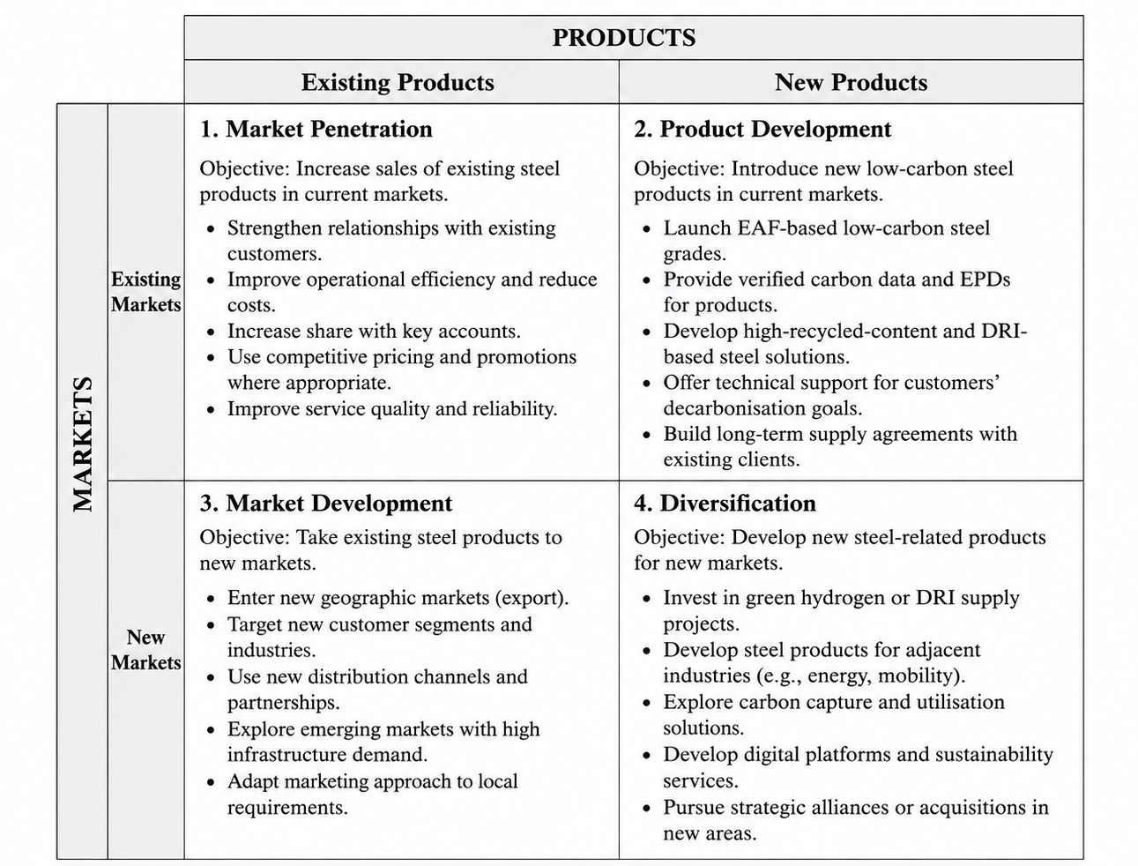
Figure 1: Ansoff Matrix - Tata Steel Strategic Growth Options for Low-Carbon Transition
As shown in Figure 1, there are four strategic options that are available for Tata Steel. While Market penetration and Market development & diversification would be opportunities for the future, Product Development is the most suitable option in the immediate future, as it would combine growth potential with risk being kept to a minimum.
Market penetration would involve greater sales of current steel products, but this would offer much less benefit, not addressing the demand for reduced carbon products adequately. Market development would include entering new markets but could heighten uncertainty while Tata Steel's low-carbon competencies are still building. Diversification introduces the highest risk since it is a case of requiring new products and new markets at the same time (Xue et al., 2025). Because of its unique nature, Product Development offers the best connection between Tata Steel's environmental investment and its commercial development.

2.2 Proposed Offer: Optemis Verified Circular Steel
Tata Steel must build on the current Optemis platform with Optemis Verified Circular Steel that helps its customers switch to low-carbon steel grades backed by environmental product declarations, carbon information and independent verification. Reduced-carbon solutions are already part of the language used for existing Optemis Carbon Lite solutions (SUCURI, 2026).
The offering should be in significantly 3 Phases. In the transition period, Tata Steel must start to deliver lower-emissions certified products. Secondly, after the introduction of the electric arc furnace (EAF) production, the firm needs to grow the physically produced low-carbon steel grades. Third, it should delve into high-quality recycled scrap and low-emission direct reduced iron, and advanced circular steel solutions.
The catalogue of products should include digital product passports with emissions intensity, production methods, recycled content and energy sources. This would enable customers to show progress towards their own sustainability goals. Tata Steel should also develop closed-loop recycling agreements with automotive and construction companies, which help them increase their availability of scrap and deliver good customer relationships.
In this manner, Tata Steel could break away from being seen as a traditional steelmaker and become a supplier of sustainable material solutions that are certified as such. This can benefit customer loyalty and develop more durable and binding commercial relationships.

2.3 Focused Differentiation and Demand Creation
Tata Steel should strategically strive for differentiation instead of cost leadership. According to Porter (1985), a benefit to others that may not be easily copied is a source of competitive advantage (Porter and Daniel, 1985). Because of the global overcapacity of steel and energy costs, Tata Steel may not be able to hold a sustainable advantage by competing on prices.
Rather, it should be using carbon performance proven through independently verified LEED v credit systems, as well as supply reliability, technical know-how and sustainability transparency to competitively battle for contracts. Priority customer segments should include automotive manufacturers, renewable-energy infrastructure providers, public construction projects and premium engineering businesses.
But Tata Steel also needs to be aware of the fact that customers don't always pay a lot for low-carbon steel. Research indicates a growing demand for sustainable materials, which, however, differs by sector depending on levels of credibility, regulations and customer preferences (McKinsey, 2024). Instead, Tata Steel should enter long-term supply deals and NOT just higher prices.
Public procurement can also be used to drive demand for the use of lower carbon materials, which supports market development. Tata Steel should engage with infrastructure organisations to develop embodied carbon, traceability and lifecycle performance requirements. This would contribute to developing market faith as well as proving the practical utility of low-carbon steel.
Different solutions for steel decarbonisation may be needed; therefore, the company should strive to keep technological flexibility. Mission Possible Partnership (2022) cites industry research that sees EAF production, hydrogen-based direct reduction and carbon capture as complementary pathways (Worldsteel, 2026). The adoption of hydrogen-based technologies, however, demands careful consideration due to cost, the availability of renewable energy, and market conditions influencing the feasibility (OECD, 2025).

2.4 Implementation, Control and Risk
They should be gradually implemented, and they should be implemented uniformly. The focus for Tata Steel in 2026-27 should really be on customer engagement, carbon measurement systems, renewable electricity sourcing and scrap partnerships. The firm will further ramp up the production of low-carbon products made from EAFs and achieve long-term contract agreements with customers between 2028 and 2030.
One of the main challenges will be adequate supply of high quality and competitiveness of scrap because the adoption of EAFs increases in Europe (Lee et al., 2026). Tata Steel should thus test out scrap supply reliability, emissions reduction and customer retention.
Key risks are technological late deliveries, energy price fluctuations, reluctance of customers to pay and potential greenwashing issues. Greenwashing often occurs because of unclear standards and information gaps between organisations and stakeholders (Delmas and Burbano, 2011). Instead, Tata Steel should be based upon open reporting, independent verification and truthful environmental claims.
These mean that Tata Steel has the best possible strategic way forward through Product Development backed by focused differentiation on an overall basis. It will help the company overcome the forces of its environment and gain advantage and sustainable health by keeping customers' confidence.

3. Critical Reflection on AI Usage

3.1 Tool disclosure and contribution
The use of ChatGPT was wide-ranging to create a first draft, develop keywords, summarise texts, refine academic vocabulary and to test out different readings. It also helped to organise the Harvard reference list and to determine if the argument correlated with the Ansoff recommendation. The AI was therefore used in the nature of a drafting and an analytical-support tool and not as an evidential source. I was responsible for the selection of Tata Steel as the second actor in the process (government-regulatory publics), and for the recommendation of product development with focused differentiation.

3.2 Verification and correction
Generative models can generate fluent but fabricated references, incorrect figures and overconfident claims (Kasneci et al., 2023). For each statistic, date, and policy statement that was carried forward, verification was done against the corporate report or government publication, a regulatory webpage, or a journal article. Author names, year/doi-location and assertions not supported by the original source have been checked. I also called into question the fact that the model automatically considers EAF steel as “green” at the beginning. Results on electricity intensity, the quality of the scrap, and the system boundaries and employment impacts yielded a less extreme conclusion. Logical consistency was assessed based on the question of whether Task 2 directly referred to the risks identified in Task 1.

3.3 Ethical and professional reflection
Ethical concerns were primarily on the subject of authorship, transparency, bias, confidentiality and accountability. In accordance with UNESCO's AI ethics guideline, which highlights the importance of human oversight, fairness and transparency, a responsibility cannot be outsourced to a language model (UNESCO, 2026). The use of AI should also align with the standards of assessment and expectations regarding academic integrity; as such, disclosure is strictly required (QAA, 2024). No private company or personal information was input. There were issues of scepticism about suggestions; training data can be used to reward corporate narratives or mask uncertainty.
In the drafting phase, AI can aid in streamlining research comparisons, copy-pasting source material, and initial editing, which may lead to overreliance on the AI and result in a lack of critical thinking in the original fabrication of language and greenwashing. My part was estimating opposing types of evidence, determining which aspects were strategic trade-offs, and what things to omit. So, the Report is an AI-assisted, human-accountable report. This acknowledgment should match the actions taken before submitting with actions taken any step where verification was not personally done should not be claimed.

Conclusion
Lastly, Tata Steel's ability to bring its decarbonisation and strategic value differentiation towards its customers will be its competitiveness enablers in the future. The suggested product development process can help reduce the market expectations and environmental pressures and discover solutions for circularity of steel. Two words that will play important roles in the quality partnerships en route to the sustainable growth at Tata Steel are: transparency and innovation.

References:
CBAM (2026) “Carbon Border Adjustment Mechanism.” Available at: https://taxation-customs.ec.europa.eu/carbon-border-adjustment-mechanism_en.
Delmas, M.A. and Burbano, V.C. (2011) “The Drivers of Greenwashing,” California Management Review, 54(1), pp. 64–87. Available at: https://journals.sagepub.com/doi/10.1525/cmr.2011.54.1.64.
Filho, I.R.S. et al. (2022) “Green steel at its crossroads: Hybrid hydrogen-based reduction of iron ores.” Available at: https://www.sciencedirect.com/science/article/abs/pii/S0959652622004437?via%3Dihub.
GOV.UK (2025) 5,000 jobs secured as construction starts on Port Talbot green steel project. Available at: https://www.gov.uk/government/news/5000-jobs-secured-as-construction-starts-on-port-talbot-green-steel-project.
Hako, B. (1972) “Strategies for diversification,” Long Range Planning, 5(2), pp. 65–69. Available at: https://ia803104.us.archive.org/32/items/strategiesfordiversificationansoff1957hbr/Strategies for Diversification-Ansoff1957-HBR.pdf.
IEA (2020) Iron and Steel Technology Roadmap. Available at: https://www.iea.org/reports/iron-and-steel-technology-roadmap.
IPCC (2023) “Climate Change 2023 Synthesis Report.” Available at: https://www.ipcc.ch/report/ar6/syr/downloads/report/IPCC_AR6_SYR_LongerReport.pdf.
Kasneci, E. et al. (2023) “ChatGPT for good? On opportunities and challenges of large language models for education,” Learning and Individual Differences, 103, p. 102274. Available at: https://www.sciencedirect.com/science/article/abs/pii/S1041608023000195?via%3Dihub.
Lee, D. et al. (2026) “Circular transformation of the European steel industry renders scrap metal a strategic resource,” Resources, Conservation & Recycling Advances, 30, p. 200323. Available at: https://www.sciencedirect.com/science/article/pii/S266737892600012X?via%3Dihub.
McKinsey (2024) “Materials ‘green’ premia: Trends and outlook to 2030.” Available at: https://www.mckinsey.com/industries/metals-and-mining/our-insights/materials-green-premia-trends-and-outlook-to-2030.
OECD (2025) “Hydrogen in Steel: Addressing Emissions and Dealing With Overcapacity. OECD Science, Technology and Industry,” (174). Available at: https://www.oecd.org/content/dam/oecd/en/publications/reports/2025/03/hydrogen-in-steel_f4d15f8d/7e2edc69-en.pdf.
OECD (2026) OECD Steel Outlook 2026. Available at: https://www.oecd.org/content/dam/oecd/en/publications/reports/2026/06/oecd-steel-outlook-2026_a79fb861/99ab9b0c-en.pdf.
Philip Kotler, Armstrong, G. and Balasubramanian, S. (2023) Principles of Marketing, Global Edition, 19th edition. Available at: https://www.pearson.com/en-gb/subject-catalog/p/principles-of-marketing-global-edition/P200000010013/9781292449401.
Porter, M.E. and Daniel, J.S. (1985) “Competitive Advantage: Creating and Sustaining Superior Performance,” in. Available at: https://books.google.com.np/books/about/Competitive_Advantage.html?id=_Fu1AAAAIAAJ&redir_esc=y.
QAA (2024) “Quality Compass.” Available at: https://www.qaa.ac.uk/docs/qaa/news/quality-compass-navigating-the-complexities-of-the-artificial-intelligence-era-in-higher-education.pdf.
REGNIER, T. and MICCOLI, F. (2025) Commission’s Action Plan to secure a competitive and decarbonised steel and metals industry in Europe. Available at: https://ec.europa.eu/commission/presscorner/detail/en/ip_25_805.
ResponsibleSteel (2025) The Steel Decarbonisation Scale. Available at: https://www.responsiblesteel.org/resources/the-steel-decarbonisation-scale.
Subsidy Advice Unit (2024) “Subsidy Advice Unit Report on a proposed Subsidy to Tata Steel UK,” (February). Available at: https://assets.publishing.service.gov.uk/media/65c13941704282000d752283/Final_report_4.pdf.
SUCURI (2026) Access Denied - Sucuri Website Firewall. Available at: https://eurometal.net/tata-steel-uk-says-has-started-low-carbon-steel-sales/.
Tata, J.N. (2025) “Year Integrated Report and Annual Accounts 2025-26.” Available at: https://www.tatasteel.com/media/25904/tatasteel-iar-2025-26.pdf.
UNESCO (2026) “Recommendation on the Ethics of Artificial Intelligence.” Available at: https://www.unesco.org/en/artificial-intelligence/recommendation-ethics.
Worldsteel (2026) “Making net-zero steel possible.” Available at: https://worldsteel.org/wp-content/uploads/2b.-Pathway-to-Paris-Mission-Possible-Partnership-net-zero-steel-sector-transition-strategy.pdf.
Xue, F. et al. (2025) “Impact of Carbon Transfer and Low Carbon Preferences on Firm Decision Making Under Two Power Structures,” Sustainability, 17(11), p. 4956. Available at: https://www.mdpi.com/2071-1050/17/11/4956.

