
Current trends of business intelligence

student name: Irinel-georgian Gheorghe
student Id: 2030513

TABLE OF CONTENTS

INTRODUCTION 3
CURRENT TRENDS OF BUSINESS INTELLIGENCE 4
Data Visualization 4
Data Mining 5
Data Manipulation 6
Data Warehousing 7
SaaS and Cloud Adoption 8
CONCLUSION 9
REFERENCES 10

TABLE OF FIGURES

Figure 1 Business Intelligence: A Complete Overview [1] 3
Figure 2 Data Visualization [2] 5
Figure 3 Data Mining Architecture [3] 6
Figure 4 Data Manipulation [4] 7
Figure 5 Data Warehousing [5] 8
Figure 6 SaaS Cloud Adoption [6] 9

INTRODUCTION

In the last 10 years, business intelligence (BI) has undergone a revolution as a result of the enormous growth and rise in data that has made the cloud accessible to everybody. Spreadsheets were finally surpassed by interactive corporate dashboards with insightful and actionable data visualizations Self-service analytics have liberalized the data supply chain by enabling all users, not just analysts, to access complicated analyses.
The business analytics industry had enormous growth in the decade 2021, but the game has been played today with the latest trends to monitor as the BI environment changes. In 2022, BI methods and tools will become increasingly specialized (Golfarelli, 2005).
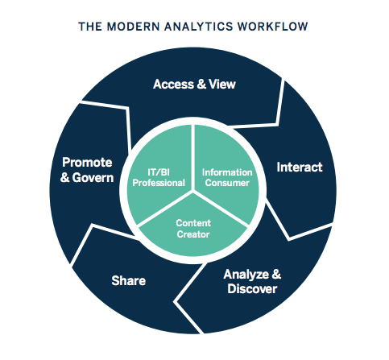
Figure 1 Business Intelligence: A Complete Overview [1]

Modern BI dashboard software allows firms to focus on communicating each data narrative effectively rather than discussing whether data visuals improve analysis. In 2022, the emphasis will be on information discovery and data security, which combines clear, safe data with understandable visualization. It will also be a decade of cooperative business intelligence and artificial intelligence. In this article, we'll talk about some contemporary business intelligence trends that might be beneficial for handling data in a variety of ways.

CURRENT TRENDS OF BUSINESS INTELLIGENCE

Data Visualization

Data visualisation may help enterprise customers make sense of their vast data collections. They benefit from their ability to identify odd patterns and data errors. The users can go forward by concentrating on areas that cause alarm by extrapolating any relevance from these trends. The strategy finally leads to the firm's advancement.
Data visualization aids comprehension by giving the data a visual perspective via mapping or charts. Mirchandani & Gaur (2019) contend that since aware people can more easily understand the data, it is easier to identify trends, patterns, and anomalies in large data sets.
It is the ability to show data visually. For instance, we make our young students learn everything using data visualization—pictures that are incorporated within books—when we train them.
Data visualization tools:
1) Tableau
2) Power BI
3) Microsoft Excel

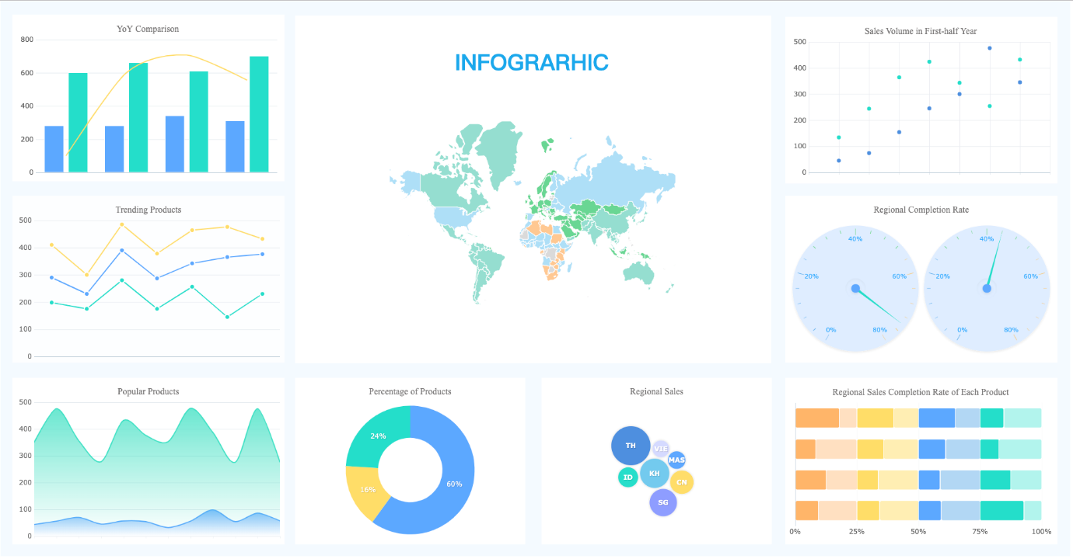
Figure 2 Data Visualization [2]

Data Mining

Data mining is a method used by companies and industries to turn flawed information into insightful findings. They utilise this programme to look for trends among a big quantity of data in order to understand further about their clientele.
Data mining is critical to business as it is used to turn raw data into knowledge that can be applied to making decisions. Data engineers utilize software to uncover patterns that aid in their analysis of customer behavior (Boland et.al, 2015).
It is the process of looking for patterns and connections in data to help businesses make more informed business decisions. Data mining could be used to accurately predict customer satisfaction, uncover sales trends, and develop more successful advertising campaigns.

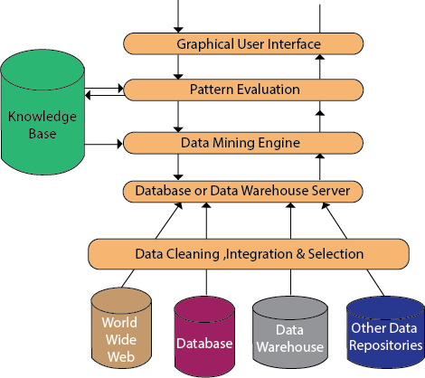
Figure 3 Data Mining Architecture [3]

Because of changing client demands and tastes in a more saturated market, there is a fiercer global rivalry.
To supply the appropriate information structure, data mining is a sort of algorithm that makes use of strategic marketing. The prototype system may be made to operate using data mining techniques.

Data Manipulation

Data manipulation is a crucial responsibility for the operation and optimization of enterprises. To successfully use the information and turn it into actionable insights, including by analyzing financial data, consumer behavior, and trend analysis, you must be able to engage with it in the way you need to.

Information presented consistently makes it easier to organize, understand, and comprehend the material (Harrison et.al, 2015). When combining data from many sources, you might not have a clear picture, but you can use processes and data manipulation to make sure the data is properly formatted and saved.

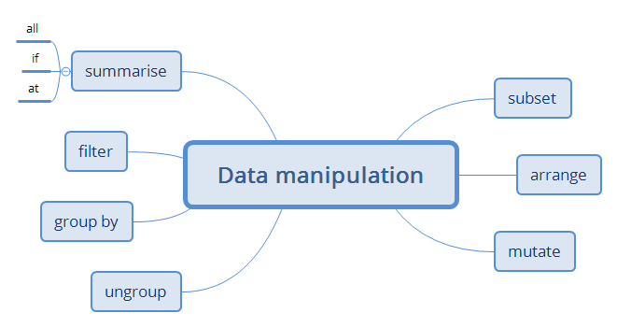
Figure 4 Data Manipulation [4]

Modeling, data manipulation, data cleaning, modeling, and controlling reporting are some of the processes used in business intelligence. The most current improvements in BI data manipulation do not support sticking with the older approaches.

Data Warehousing

A data warehouse is a system that stores data from numerous sources. Business executives may more easily evaluate data over a given period with the use of data warehouse platforms, which differ from database systems in that they incorporate historical data.
The most important BI, analytics, and data trends for 2022, according to Kabakchieva (2013). Data quality and master information management have been identified as the most important trends for five years running. This is in line with prior BARC survey findings, which repeatedly show that firms suffer from poor data quality.

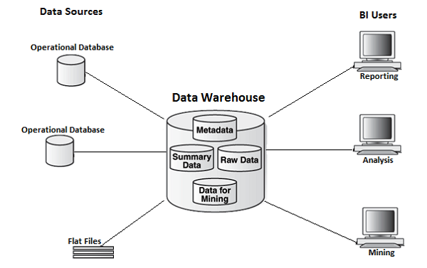

Figure 5 Data Warehousing [5]

SaaS and Cloud Adoption

Businesses are using cloud-based services like online file storage, repositories, and customer relationship management (CRM) software (Salesforce) more and more frequently (Dropbox, Box). Businesses will be helped by business intelligence and SaaS to handle issues related to cost-efficiency and the newest software, which strains resources and reduces competitiveness (Vanani & Jalali, 2017).

Applications for cloud BI are easy to use, much like other cloud services. Their implementation was quick and simple because they didn't require any hardware or software installs. The number of cloud applications is rapidly growing as corporate users increase.

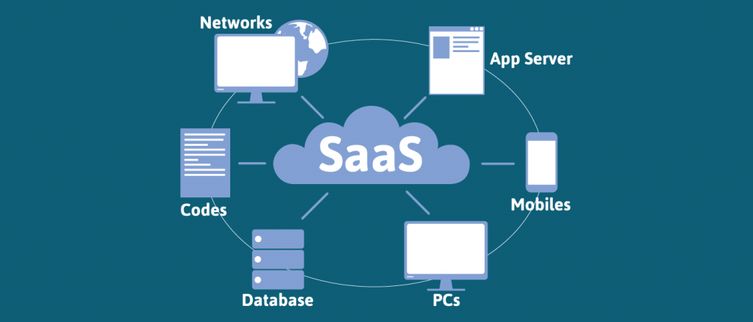
Figure 6 SaaS Cloud Adoption [6]

SaaS is a method for delivering software that gives companies a lot of flexibility and financial efficiency, making it a viable option for many business types and sectors (Obeidat et.al, 2015). It is also well-liked by businesses due to its simplicity of use, user availability, security, and wide connection.

CONCLUSION

In general, it may be argued that business intelligence is a kind of technology that helps make data easier to understand and more visually appealing.
This method evaluates and manages raw data in addition to making the business smarter. There are various benefits for the BI, including increased customer satisfaction and simplified decision-making. Furthermore, Microsoft Excel is preferred over the Power BI application. One of the business intelligence trends that is discussed in many places is the methods for managing data and a safe way to preserve it.

REFERENCES

- Boland, G.W., Thrall, J.H. and Duszak, R., 2015. Business intelligence, data mining, and future trends. Journal of the American College of Radiology, 12(1), pp.9-11.

- Golfarelli, M., 2005. New trends in Business Intelligence. In miproBIS (pp. 15-20).

- Harrison, R., Parker, A., Brosas, G., Chiong, R. and Tian, X., 2015. The role of technology in the management and exploitation of internal business intelligence. Journal of Systems and Information Technology.

- Kabakchieva, D., Stefanova, K. and Yordanova, S., 2013. Latest Trends in Business Intelligence System Development. In Proceedings of International Conference on Application of Information and Communication Technology and Statistics in Economy and Education (ICAICTSEE) (p. 212). International Conference on Application of Information and Communication Technology and Statistics and Economy and Education (ICAICTSEE).

- Mirchandani, A. and Gaur, B., 2019. Current trends & future prospects of social media analytics in business intelligence practices. Journal of Content, Community and Communication, 5(9), pp.123-130.

- Obeidat, M., North, M., Richardson, R. and Rattanak, V., 2015. Business intelligence technology, applications, and trends.

- Vanani, I.R. and Jalali, S.M.J., 2017. Analytical evaluation of emerging scientific trends in business intelligence through the utilisation of burst detection algorithm. International Journal of Bibliometrics in Business and Management, 1(1), pp.70-79.

[1] https://www.tableau.com/learn/articles/business-intelligence
[2] https://www.finereport.com/en/data-visualization/data-visualization-2.html
[3] https://www.javatpoint.com/data-mining-architecture
[4] https://xmind.app/m/d42D/
[5] https://www.tutorialspoint.com/cognos/data_warehouse_overview.htm
[6] https://www.fingent.com/blog/cloud-service-models-saas-iaas-paas-choose-the-right-one-for-your-business/

