Critical analysis of decision support

Introduction

Micro carers
There is currently a national care crisis whereby there are not enough hours of care available to support those in need (Glasby et al., 2021). In trying to create capacity within this market local authorities are considering different models by which care might be delivered.
Micro carers are a relatively new option for people requiring care and support in Monmouthshire. Previously, care and support were available via the local authority’s in-house care and support teams, through external care and support agencies, or by becoming an employer and employing someone to support you directly via a direct payment.
Whilst these options offer a range of ways in which to receive care, they did not allow for people in receipt of a direct payment to employ someone directly without the additional responsibilities of becoming an employer. This is where micro carers come in. Micro carers are self-employed carers able to take on clients usually within a small geographic area. Micro carers take responsibility for their own DBS, insurance, NI, tax, sick pay, and pension and can be paid for via self-funding or a direct payment.
Micro carers within Monmouthshire have signed up to the micro carer code of practice and have had their training, DBS, insurance and HMRC registration checked by the Monmouthshire Council micro carer team.
Currently people can find out about micro carers in their area via the micro carer directory on the Dewis website. The filter function on this directory allows people to find micro carers within a county and to narrow this down to within a number of miles of their home. It does not, however, allow the person to filter the results by need or availability. This means the person seeking care has to scroll through each micro carer’s page to see what services they provide and whether they are available.
An enhancement of the current directory would allow a more detailed filtering function to better inform a person’s choice of care provider. This would save the person time by returning only those people who are willing to support them with the type of care they need and only those carers who currently have availability.
This type of decision support will allow people to make better decisions regarding who amongst the micro carers is best placed to support them with their particular needs. It should also allow people to carry this out with minimal effort.
Use of the decision support tool by people in need of care would enable notification of the micro carer team when there is an unmet need regarding micro care in a geographical area. This would allow targeted recruitment to expand the pool of micro carers available.

Outcomes sought in this intervention can be seen in figure 1.

Figure 1: Outcomes of an improvement to the decision aid in place to search and find micro carers.

Decision Support Systems
A decision support system provides a user with information to inform and thus aid their decision making. This can be in the form of guidelines, Artificial Intelligence from a data set, information regarding options available to them etc.
Decision support systems have been of particular interest in a clinical setting to try and narrow the gap between scientific research and its application in healthcare. It would be impossible for clinicians to be aware of, and be able to process, all research to date or indeed all information for a complex patient (Sittig et al, 2008). Decision support systems can use patient data to provide clinicians with relevant information to assist in their decision making.
Such an approach is key in the development of evidence-based medicine and what is described as a learning health system. A learning health system can be described as “a system that seeks to continuously generate and apply evidence, innovation, quality, and value in health care” (Platt, Raj, & Wienroth, 2020). The increased availability of data from sources ranging from public health data to electronic health records to personalised wearables and the ability to process this data should be able to inform the learning cycle. It is hoped that a learning health system will improve the quality, safety, and efficiency of healthcare whilst reducing unnecessary variation and increasing the personalisation of provision (Nwaru et al., 2017). Figure 2 depicts a representation of the elements of a learning health system.

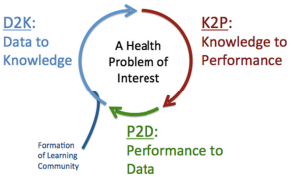
Figure 2: Framework of a learning health system (Nwaru et al., 2017)
Clinical decision support will be a pillar of this learning health system within the Knowledge to Performance step in figure 1 by providing clinicians with knowledge gleaned from data to inform practice. Clinical decisions are often complex and affected by myriad factors which is why these systems are referred to as decision support as they could not replace the clinician’s ability to evaluate these various factors in a given context.
While the aims of decision support are aligned to the learning health system (improving quality, efficiency, and safety, reducing variation), not all decision support systems will focus on all these areas. The improvement suggested above for the micro carer system will primarily focus on improving the quality and efficiency of someone finding support. Enhancing their ability to find an appropriate, available carer with minimal effort.
In addition, maintenance of information in the database will allow necessary qualifications to be kept up to date alongside encouraging timely renewal of DBS checks which may impact safety.
Reducing variation would not necessarily be a consideration of this decision support as there is by nature variation in people’s care needs. Growing the pool of micro carers may, however, reduce the variation in availability of micro carers seen in different areas which would be a positive reduction in variation currently experienced by the residents of Monmouthshire.
Decision support systems can broadly be split into two categories knowledge based and non-knowledge based. Types of knowledge can be defined in a number of ways. It can refer to knowing how (ability), knowing of (acquaintance), or knowing that (propositional). Generally, the knowledge provided by decision support systems is propositional knowledge. However, were a decision support tool created to inform methods this would be an example of supporting the “ability” type of knowledge (knowing how).
Knowledge based decision support systems use rules to elicit specific data from an information source. Non-knowledge based decision support retrieves information generated by Artificial Intelligence or machine learning to inform the decision.
For a decision support system to be able to interact with the knowledge it needs to be computable. For this to be the case it must first be structured. The different levels of structure of knowledge can be seen below.

Figure 3: Different levels of knowledge structure relevant to decision support systems. (Michaels, 2019)
If knowledge is simple and contained within e.g. a structured database achieving this can be relatively straightforward. This, however, is not the case when moving from research within a journal and translating this through the various levels until the knowledge is computable. In this instance the information sought will sit in a structured format within a database.
Decision support systems can also be split into those which present information unprompted when certain criteria are met, a so-called push model, and those which present information when asked, a so-called pull model (Savory and Fortune, 2015). The proposed intervention is an example of a pull model of decision support.
Decision support systems have three fundamental component parts to them. These are the user interface, the software made up of the rules / algorithms in place to generate the correct data, and the database from which this information is drawn. Figure 4 demonstrates the interaction between these elements.
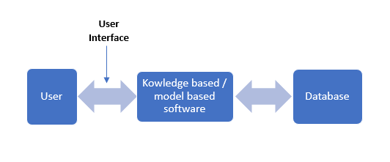
Figure 4: Components of a decision support system

A further aspiration of decision support is the concept of the five rights seen in figure 5.

Figure 5 – Five rights for clinical decision support systems (Osheroff et al, 2012)

These rights are specifically related to clinical decision support systems so not all elements are applicable in this case. Less applicable are the right intervention format as this refers to how the information is presented to the clinician. Those results which meet the person’s needs will be returned as a list, although in future consideration could be given to the order in which the results are returned especially as it has been shown that results appearing at the top of the list are more likely to be chosen (Jeziorski & Segal, 2009).
The right time in the workflow is not a consideration in this case either as this decision support is not part of a workflow.

Evidence Review
To ascertain how decision support has been used within the area of interest, namely in supporting choice of care, a literature search of the University of Wales Trinity St. David databases was conducted. The search terms and the resulting literature can be seen in figure 6.
Search terms | Results | Number discounted using title | Number relevant following abstract? review
“decision support” and “care choice” | 28 | 28 | 0
“decision support and homecare” | 33 | 33 | 0
“decision support” and “care at home” | 10 | 10 | 0
"choosing care" and " decision support" | 0 | 0 | 0
"choosing a carer" and " decision support" | 0 | 0 | 0
Figure 6: Results of literature searches relating to carer choice and decision support.

The relevance of papers was assessed using the following inclusion and exclusion criteria.
Inclusion criteria: patient/person decision support, related to the choice of the person regarding something which affects them, adults.
Exclusion criteria: clinician / professional decision support, shared decision making decision support surrounding treatment of health conditions, related to behaviour change on the part of the person e.g. smoking cessation, not Artificial Intelligence or Machine Learning, not relating to children, not related to planning of rotas or routing for home care.
As can be seen from figure 6 following inspection of the titles with respect to the inclusion and exclusion criteria, there was nothing which credited further inspection or was relevant or applicable to the decision support under consideration.
As a result, an alternative, comparable setting was used for the literature search. The analogous context was that of hotel booking decision support within online travel agencies whereby users filter options by elements such as geographical location, availability, and a number of other services / features to narrow down the field to the most appropriate options (Denizci, Mattila, and Gao, 2020). Depending on the technology behind these decision support tools these options may then be ranked according to their proximity to an “ideal solution”.
This is essentially what the person seeking care is doing only in relation to a care provider rather than a hotel. The search terms used and resulting literature can be seen in figure 7.

Search terms | Results | Number discounted using title | Number relevant following abstract review
"decision support" and holiday | 54 | 54 | 0
"decision support" and booking | 90 | 89 | 0
filtering hotel choice | 13 | 4 | 2
Figure 7: Search terms and resulting literature relating to hotel selection

The inclusion and exclusion criteria applied to the results can be seen below.

Inclusion criteria: decision support directed at the guest’s decision.
Exclusion criteria: research relating to filtering by type of traveller, research relating to filtering based on reviews, research relating to social media recommendations.
Further filters were placed upon the results limiting them to those post 2000 as this was when the first online travel agencies to allow the booking of hotels (hotwire.com and tripadvisor.com) were launched (May, K., 2014).
Most papers related to the development of decision support featuring more complex filtering algorithms based on traveller type (as different types of traveller have been shown to prioritise different aspects of a hotel stay (Wang and Wang et al., 2020)), customer reviews (Eshkevari et al., 2022), or social media recommendations. None of these would be relevant to the micro carer decision support system. If the database and availability of micro carers were to grow considerably, consideration of reviews may become relevant but for the time being this is a more complex filtering system than is necessary.
As a result of this, the additional search term of filtering hotel choice without including decision support with the post 2000 date filter was used. This returned 13 results, 9 of which were scrutinised at abstract level. Two of these warranted further reading. One of the papers once read in full turned out to relate to the impact of filtering on information sets of different sizes and as such wasn’t relevant. The second paper considered was more relevant as it related to the impact of the filtering decision aids on the quality of decision making and effort of searching.
The paper was extremely detailed and thorough. At times it wasn’t especially clear but this will be in large part due to the lack of expertise of the reader in the field being discussed making it difficult to assess. Other times the paper lacked clarity through translation. Overall, the paper demonstrated that the existence of filtering decision aids enabled better quality decisions to be made. It further made the point that a lack of transparency around how the results were returned and what led to the order in which they were displayed might have further decreased search time for an individual (Chen and Yao, 2017).
The references within the first paper were then assessed for further possible literature which resulted in an additional paper by Haubl and Trifts (2000) being considered. This studied two different types of decision aids and the impact they had on online shopping choices. Whilst not the exact same context as carer choice, the study similarly involves filtering options based on preferences before making a decision.
The paper was extremely clear with context, background, and rationale for research well explained. The different decision aids described are a consumer matrix allowing different products to be compared and a recommendation agent whereby a user selects certain attributes of importance to them to narrow down their search. This latter decision aid is more relevant to the micro carer decision aid which also involves filtering to provide a narrower option pool for further consideration. The hypotheses for both types of decision aid were clear and well-reasoned.
The experimental design is described in a level of detail that should allow for replication. The aspect of the paper referring to modelling would require greater expertise to assess. Aspects of the study were piloted first to ensure they worked prior to the main study. The sample size was reasonable at 249 participants, although the sample lacked diversity as they were all business students in one institution.
The impact of the different decision aids was checked with questions relating to ease of finding products relevant to personal preference and ease of comparing products. Additionally, quality of decision making was measured by asking about confidence in a decision and offering opportunities to switch products at a later time.
The results and statistical information suggest that decision aids definitely improve the ability of individuals to make better quality decisions in relation to their personal preferences whilst expending less effort.
Filtering as a way of narrowing down choices in order to ease decision making is a part of everyday life (Haubl and Trifts, 2000). The irony of the method used to find and consider the literature discussed above is not lost. In this instance it involved information retrieval of unstructured data in relation to the search terms and Boolean operators used (this is mostly about which information is extracted) followed by filtering structured data elements for e.g. dates, source type etc. (this is mostly about what is left after removing information) (Belkin and Croft, 1992).
These findings suggest that an intervention involving improved search and filtering functionality should benefit those using it to more efficiently find appropriate care and support.
Limitations in relation to this evidence review arise in the form of search terms missing relevant papers.

Implementation issues
Implementation of various decision support systems hasn’t been without issue (Sutton et al., 2020) and consideration would need to be given to possible barriers. One risk lies in the fact that the service is so new there are only a limited number of micro carers. This might lead to the system returning nil results which has the potential to erode faith in the system impacting its usage.
Mitigation for this could be in the form of waiting until there is greater coverage of micro carers. Alternatively, the system could return possible options nearby and automate an email to the micro carers team to allow for targeted recruitment advertising of the scheme in these areas. The system could also manage expectation in the initial stages by explaining to the person looking for care that the pool of micro carers is being built, this would possibly minimise frustration if there is no one available in the area. It is further possible that where a nil result is returned, users are given the option of providing their details with a view to being notified when a micro carer registers in that area.
Maintaining up to date information within a decision support system is key to its usefulness with incorrect information causing frustration (Ash et al., 2007). The information in this system which will need to be maintained is that regarding the micro carer, their availability, and the tasks with which they are willing to assist. This would be managed by the micro carer and it is in their interest to do this. To assist, the system could be set up to send a periodic email to the micro carer with a summary of their current information and a link to the database should they need to modify it.
Unlike clinical decision support (CDS) systems which are designed to assist clinicians in the delivery of healthcare, the risks and potential safety consequences associated with this system are very low. One area to be considered in the name of safety would be the maintenance of any relevant qualifications / training along with legal requirements such as current DBS certificates. Including these as part of the system would enable alerts to be sent to the carer and the local authority team supporting them when they were due for renewal.
CDS systems need to fit seamlessly into a clinician’s workflow and have been shown to suffer from issues such as causing “alert fatigue” whereby the system creates too many alerts resulting in clinicians ignoring them (Campbell et al., 2006). As this system isn’t part of a workplace and will be something sought out by those wanting information it won’t suffer from these negative consequences.
A further possible barrier to the successful implementation of the system is its visibility and how people will find it. Strategies to overcome this could include search engine optimisation of the specific area of the Dewis site alongside links through from the Monmouthshire Council website. In addition, promotion of the system amongst the integrated teams, primary and secondary care, and third sector would be undertaken.
There is a chance that necessary digital literacy of both the person and the micro carer could present an issue (Leslie et al., 2006). Involving end users in the development and design of healthcare innovations has been recognised as an important factor in successful implementation (Savory, 2010, Kawamoto et al., 2005). This engagement would allow the public and carers to feedback to developers to ensure the user experience makes sense for them.
Various factors influence the user experience, these can be seen in figure 8. Of these, desirability is least influential in this example as seeking care and support is more akin to a necessity rather than a desirable product.
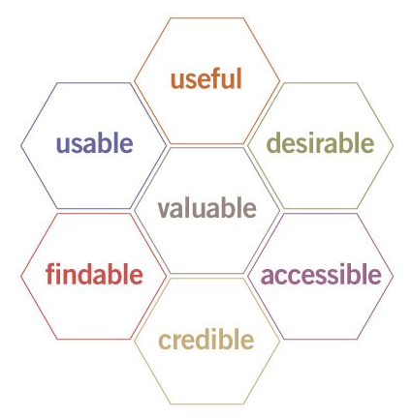
Figure 8 – The User Experience Honeycomb (Morville, 2004)
Continuous and iterative design of solutions has also been shown as preferable in the implementation of decision support tools (Van de Velde et al., 2018) and the above approach involving users would allow for this.
Whilst the user experience should be such that training isn’t necessary, training has been shown to facilitate decision support implementation (Lai et al, 2006) and could be delivered to the carer by the micro care team upon starting, or alternatively in the form of a web tutorial for any user.
Wu, Davis, & Bell (2012) conducted a systematic review which also suggested that system design, continual improvement, and training were key to successful implementations. Whilst the iterative approach allows for continual improvement during the design process it does not allow for this post implementation. As such a feedback button should be included as part of the implementation to allow for the continued evolution of the platform.

Evaluation
To understand the success or otherwise of any digital implementation a relevant evaluation framework should be established. Figure 9 shows the desired outcomes of the intervention with associated measures.

Figure 9 – Desired outcomes of the intervention with measures beneath.

User Experience
The factors affecting user experience have previously been seen in figure 8. As mentioned, most of these, excluding desirability, would be applicable to this system. To evaluate the user-experience a standardised user-experience survey will be deployed.
A standardised survey has undergone psychometric validation, within it everyone is asked the same questions, and has the same options as answers. Their standardised nature improves reliability, sensitivity to differences of opinion, and how well it measures what it is trying to. They also enable systems across different studies to be compared (Sauro, 2012).
User experience of the system will be measured by people looking for care completing the Standardized User Experience Percentile Rank Questionnaire (SUPR-Q) survey. This was developed by Jeff Sauro to assess user perception regarding different elements of a website. These include usability, credibility, appearance, and loyalty (Sauro, 2015). The SUPR-Q will be carried out before and after the implementation to understand the difference made by the implementation.
The SUPR-Q is made up of 8 questions including a net promoter score. The answers to these are scored from 1 for Strongly Disagree to 5 for Strongly Agree. The last question is a net promoter score scored from 1-10 from Not at all likely to Extremely likely. The score is calculated by the formula for the average below:

$$=(Q1+Q2+Q3+Q4+Q5+Q6+Q7+\left(net promoter score*0.5\right))/8$$

The Usability factor of user experience can be gleaned by looking at ease of use and navigation (1 & 2). Usefulness is probably best measured by the usability and credibility questions (1, 2, 3 & 4). Credibility is assessed by the credibility and reliability questions (3 & 4). Accessibility can be elucidated from the ease of use and navigation questions alongside whether it was easy to find and clear and simple (1, 2, 6 & 8). As previously mentioned, desirability is not a relevant measure in this instance. Whether or not the website is valuable is another part of the user experience. This will be evaluated using the question involving reliable information, whether they’d return to the site or recommend it to a friend (4, 7 & 9).
One element of the user experience factors not expressly explored by the SUPR-Q is how findable the website is. As such, an additional question has been added to the Likert scale regarding how readily people were able to find the website but as this was not part of the original standardised questionnaire it will not be included in the scoring and only used to assess findability.
The SUPR-Q questions and possible answers can be seen in figure 10.
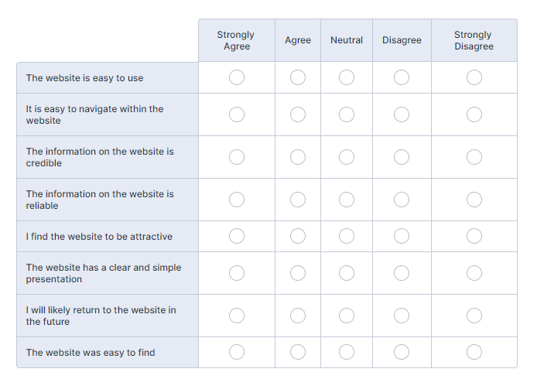
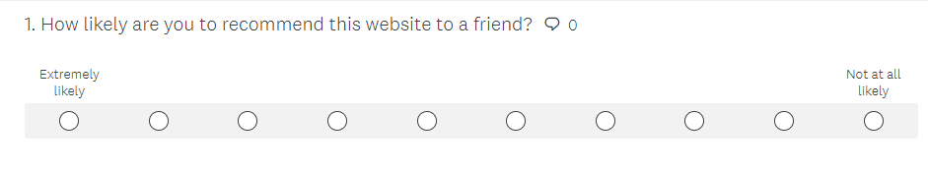
Figure 10: questions on the SUPR-Q with one addition

Understanding the user experience of the website is one element of this system but it is also necessary to ensure we understand the micro carer experience using the back end of the system as they are responsible for keeping the system content up to date such that the resource is a useful one for the cared for person.
To assess the usability of the database element of the system we will ask micro carers to complete the standardised usability survey (SUS) developed by John Brooke in 1986.
The SUS itself is made up of ten standard statements regarding usability of a system - five positive and five negative. These sit alongside a Likert scale ranging from Strongly Disagree to Strongly Agree. The statements included as part of the SUS can be seen in figure 11. As the changes to the system will not fundamentally change how a micro carer interacts with it, this measure will not need to be taken before and after and will simply look at how usable carers find the system. If the scores for this are low, it is possible that a further intervention may be needed to improve usability and enable carers to provide those seeking care with the most up to date and relevant information.
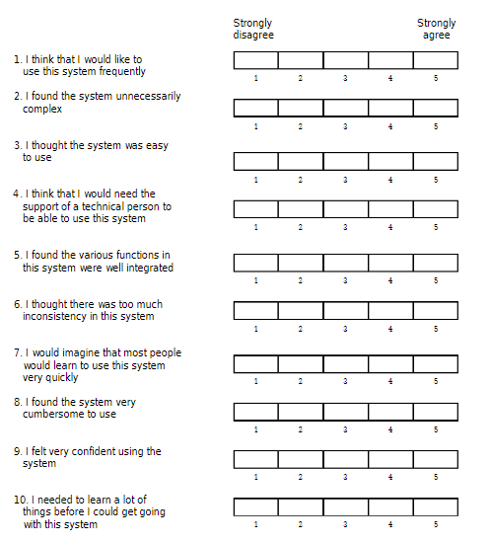
Figure 11: the System Usability Scale questions (Brooke, 1995) © Digital Equipment Corporation, 1986

It is possible that not all these questions would be appropriate for the way in which a micro carer would use the system. It is not anticipated, for example, that they will be using it particularly frequently. Whilst it is not recommended that standardised questionnaires are changed, it has been shown that the removal of one question in the SUS did not have a big enough effect on reliability of the test as to make a significant difference (Sauro, 2011) and as such the first question could be removed.
As one of the outcomes is improved information, we will look to add two questions regarding the appropriateness of request from people contacting the micro carer.
People contact me for services when I have availability.
People contact me for services I am able to provide.
Other factors may affect the responses to these two questions such as people contacting carers showing as unavailable on the site or those who don’t offer the services required on the off chance. It is also possible that the information provided on the website isn’t up to date. As such an additional question regarding maintaining their information will be included.
I keep my information and availability up to date on the site.
Responses to this question can be considered alongside the SUPR-Q question regarding the reliability of the information on the site to create a picture of what is happening.

Effectiveness
The overall effectiveness of the intervention can be measured using the outcome measures shown in figure 9. Broadly, the system is looking to improve the ability to find appropriate support whilst also improving the landscape of micro carer provision. As such, those measures regarding these elements would be indicators of success or otherwise.
An increase in micro care provision and a decrease in areas not served by micro carers would indicate a positive outcome. This could also be evidenced by measuring the number of nil results returned by the site over time.
Additionally, an improvement in the ability to find micro carers would be a mark of success. In relation to this element, whilst the additional findability question included in the SUPR-Q will provide some information, this survey would only be completed by those using the site. Site traffic data, whilst important to understand if people are being correctly signposted, will also only tell part of the story. It would be interesting to know more broadly how people are finding micro carers.
To achieve this a brief survey for all those commencing employment of a micro carer would be deployed. The questions for this would be open text to allow for maximum understanding of the situation. The questions are below:
How did you hear about micro carers?
How did you find your micro carer?
Were there any difficulties in the process?
Responses to these will be thematically analysed to create a greater understanding of peoples’ micro carer journey.

Safety
The risk to safety with this intervention is low as compared with clinical decision support systems which make suggestions based on a patient record and research information. Clinical decision support systems have the potential to impact the health of an individual by influencing clinicians and their decisions. This system is looking to improve access to appropriate support which, whilst key to wellbeing, carries far fewer inherent safety issues.
One area where the intervention could improve safety regards the training of micro carers and the maintenance of relevant legal requirements. The system will alert the micro carer and the micro carer team when their various compulsory training is due for renewal, alongside notifications regarding renewing their DBS at the appropriate times.

Efficiency
Some aspects of the outcome measures relate directly to efficiency, namely reduced time for care to be in place for people with a direct payment and reduced time spent on the site assessing potential carers.
It should be noted that the latter of these would need to involve evidence of activity on the site such that the figures aren’t skewed should someone simply remain on the site whilst no longer actively considering their options. A further measure could involve the number of times someone returns to the site.
Whilst a decrease in time taken for a direct payment to be implemented would show increased efficiency in this area, there are various factors (such as the financial set up) which could affect the time taken for the direct payment itself to be in place. This is why the measure accounts for time from the direct payment being in place to care being in place.
However, this period too could be influenced by availability of carers in an area. To account for this, data regarding nil returns for an area would need to be considered alongside any direct payment data over time.
It is worth noting that a limiting factor of the evaluation of the implementation in the first instance will be the small sample size whilst the micro carer pool and awareness of its existence grow. It will be interesting to see how these develop and the evaluation should provide valuable information which may identify further areas of improvement in keeping with the iterative approach recommended for such an implementation (Van de Velde et al. 2018).
In future, this type of decision support could be expanded such that it assisted navigation of the care ecosystem more broadly and not simply to enhance decisions relating to which micro carer can best support someone.

References
Glasby, J., Zhang, Y., Bennett, M., & Hall, P. (2021). A lost decade? A renewed case for adult social care reform in England. Journal of Social Policy, 50(2), pp. 406-437. Available at: doi:10.1017/S0047279420000288n
Sittig, D.F., Wright, A., Osheroff, J.A., Middleton, B., Teich, J.M., Ash, J.S., Campbell, E. and Bates, D.W., (2008). Grand challenges in clinical decision support. Journal of Biomedical Informatics, 41(2), pp. 387-392.
Platt. J.E., Raj, M., Wienroth, M. (2020). An Analysis of the Learning Health System in Its First Decade in Practice: Scoping Review. J Med Internet Res. 22(3):e17026. doi: 10.2196/17026.
Nwaru, B.I., Friedman, C., Halamka, J., and Sheikh, A.. (2017) Can learning health systems help organisations deliver personalised care? BMC Med 15 (1) pp.177
Michaels (2019) Knowledge Levels with Examples, U.S. Centers for Disease Control and Prevention. Accessible at: http://hl7.org/fhir/uv/cpg/documentation-approach-06-01-levels-of-knowledge-representation.html (Accessed: 20.02.2023)
Savory, C. and Fortune, J., (2015). From Translational Research to Open Technology Innovation Systems. Journal of Health Organization and Management, 29(2), Pp. 200-220.
Osheroff, J.A., Teich, J.A., D. Levick et al. (2012) Improving Outcomes with Clinical Decision Support: An Implementer’s Guide. 2nd Edition. Chicago, IL: HIMSS, p. 15.
Jeziorski, P. and Segal, I. (2012) What Makes Them Click: Empirical Analysis of Consumer Demand for Search Advertising. SSRN Available at: https://ssrn.com/abstract=1417625 or http://dx.doi.org/10.2139/ssrn.1417625
Denizci Guillet, B., Mattila, A. and Gao, L. (2020). The Effects of Choice Set Size and Information Filtering Mechanisms On Online Hotel Booking. International Journal of Hospitality Management, 87, pp. 102-379.

May, K. (2014) How 25 years of the Web inspired the travel revolution. Available at: https://www.theguardian.com/travel/2014/mar/12/how-25-years-of-the-web-inspired-travel-revolution (Accessed: 21.02.2023)

Eshkevari, Jahangoshai Rezaee, M., Saberi, M., & Hussain, O. K. (2022). An end-to-end ranking system based on customers reviews: Integrating semantic mining and MCDM techniques. Expert Systems with Applications, 209, pp.118-294. Available at: https://doi.org/10.1016/j.eswa.2022.118294
Chen, Y. and Yao, S. (2017) Sequential Search with Refinement: Model and Application with Click-Stream Data Management Science 63 (12) pp.4345-4365.

Haubl, G. and Trifts, V. (2000) Consumer Decision Making in Online Shopping Environments: The Effects of Interactive Decision Aids. Marketing Science 19 (1) pp. 4-21.

Sutton, R.T., Pincock, D., Baumgart, D.C. et al. (2020). An overview of clinical decision support systems: benefits, risks, and strategies for success. npj Digit. Med. 3(17). Available at: https://doi.org/10.1038/s41746-020-0221-y
Ash, J. S., Sittig, D. F., Campbell, E. M., Guappone, K. P., & Dykstra, R. H. (2007). Some unintended consequences of clinical decision support systems. AMIA ... Annual Symposium proceedings. AMIA Symposium, 2007, 26–30.
Campbell, E., Sittig, D., Ash, J., Guappone, K., Dykstra, R., (2006) Types of Unintended Consequences Related to Computerized Provider Order Entry, Journal of the American Medical Informatics Association, 13 (5), pp. 547–556. Available at: https://doi.org/10.1197/jamia.M2042
Savory, C., (2010). Patient and public involvement in translative healthcare research. Clinical Governance, 15(3), pp. 191-199.
Kawamoto, K. et al. (2005) ‘Improving clinical practice using clinical decision support systems: a systematic review of trials to identify features critical to success’, BMJ, 330(7494), pp. 765–768. Available at: https://doi.org/10.1136/bmj.38398.500764.8F.
Morville, P. (2004) User Experience Design. Available at: http://semanticstudios.com/user_experience_design/, (Accessed: 21.02.2023)
Van De Velde, S., Kunnamo, I., Roshanov, P., Kortteisto, T., Aertgeerts, B., Vandvik, P.O. and Flottorp, S., (2018). The GUIDES checklist: development of a tool to improve the successful use of guideline-based computerised clinical decision support. Implementation Science, 13.
Lai, F., Macmillan, J., Daudelin, D. H., & Kent, D. M. (2006). The Potential of Training to Increase Acceptance and Use of Computerized Decision Support Systems for Medical Diagnosis. Human Factors, 48(1), 95–108. Available at: https://doi.org/10.1518/001872006776412306
Wu, H.W., Davis, P.K. & Bell, D.S. (2012). Advancing clinical decision support using lessons from outside of healthcare: an interdisciplinary systematic review. BMC Med Inform Decis Mak 12, 90. Available at: https://doi.org/10.1186/1472-6947-12-90
Sauro, J. (2012) Advantages of Standardized Usability Questionnaires. Available at: https://measuringu.com/standardized-usability/ (Accessed: 23.02.23)
Sauro, J. (2015). SUPR-Q: A Comprehensive Measure of the Quality of the Website User Experience. Journal of Usability Studies, 10(2), pp. 68-86.
Sauro, J., (2011). A practical guide to the system usability scale: Background, benchmarks & best practices. Measuring Usability LLC.
Wang, L., Wang, X., Peng, J. and Wang, J., 2020. The differences in hotel selection among various types of travellers: A comparative analysis with a useful bounded rationality behavioural decision support model. Tourism Management, 76, pp. 103961.
Belkin, N.J. and Croft, W.B., (1992). Information Filtering and Information Retrieval: Two Sides. Communications of the ACM, 35(12), pp. 29.

