Student name: Syeda Ambia Khatun
Student Number: 1814005
Module No: BMSK4003_LON
Module Name: Digital skills and Research Methods
Lecturer: Joy Botu

Topic:
The Effects of Social Media on People’s Social Life

Introduction:
The concept chosen for this survey is social media, in order to find out if it is affecting people’s social life and social activities. To make the readers understand the advantages and disadvantages of the use of social media. This concept was chosen because at the present time everything resolves around social media and every where you go you see people in all ages using them in homes, workplace, schools, trains etc. Understanding it is needed in so many ways, there are advantages and disadvantages. For children these days, they are losing their childhood because of this, they are less active, less interest in toys, don’t want to go out and play and becoming very lazy in general. Advantages I would say there’s a lot you can do by just sitting at home like avoiding queues, online banking, online shopping, online bookings etc. Here is a couple of questions to ask the public in what they think about this.
Social media:
What is Social media? There are so many types, and still there are so many new ways of are coming out. Social media is the collective of online communications channels dedicated to community-based input, interaction, content-sharing and collaboration (Margaret Rouse, February 2019).
Some examples of social media:
Facebook is one of the most popular free social networking websites where you can connect with your friends, family and colleagues. You can upload photos, do facetime from around the world.
Twitter is where registered members send short posts which is called tweets. It’s a free microblogging service where twitters can send tweets and track other users’ tweets by using several stages and procedures.
LinkedIn is a social networking site intended for the business society. The aim of the site is to allow registered members to set up and keep a record of people they know and trust skilfully.
Reddit is a social news website and forum where stories are socially curated and promoted by site members. The site is composed of hundreds of sub-communities, known as "subreddits." Each subreddit has a specific topic such as technology, politics or music. Reddit site members, also known as, "redditors," submit content which is then voted upon by other members. The goal is to send well-regarded stories to the top of the site's main thread page.
Pinterest is a social curation website for sharing and categorizing images found online. Pinterest requires brief descriptions, but the focus of the site is visual. Clicking on an image will take you to the original source. For example, clicking on a picture of a pair of shoes might redirect users to a purchasing site and an image of blueberry pancakes might redirect to the recipe. (Margaret Rouse, February 2019).
Instagram is a photo and video-sharing social networking service owned by Facebook, Inc. It was created by Kevin Systrom and Mike Krieger and launched in October 2010 exclusively on iOS. The app allows users to upload photos and videos to the service, which can be edited with various filters, and organized with tags and location information. An account's posts can be shared publicly or with pre-approved followers. Users can browse other users' content by tags and locations, and view trending content. Users can "like" photos and follow other users to add their content to a feed. (Kevin Systrom, Mike Krieger, 09 Apr 2012).
There are many more you can find and still a lot of new type of social networking apps are coming out.
Aim of the research:
The aim of this research is to find out, is it effecting people’s social life, is social media taking over people’s social activities and are children getting effected by this. This survey was done on only women who are mothers to see what they thought of this and why. The result that came out of it, wasn’t surprising at all, knowing from the start, this is what was expected.
Methodology:
For this survey there has been twenty women selected for the questions, in order to find out what do these mothers feel about the effect of social media. The age group of these mothers where 25 – 45. The question was asked to them personally, one to one conversation. They all have been asked to come to a meeting point and was given the written question paper to answer.
The data collected was all primary source, the experience gained was astonishing. Some gave answers in an ease, where others got a bit emotional because it was affecting their social life and they think its too late to change.
Here you can see that the questions used was very simple and straight forward. Two with a simple yes or no answer and one with timing given to choose from. Yet there was some conversation that bought out other questions to this survey.
For collecting the data, the chosen method used was a structured interview, each person was asked in the same format and asked the same questions in the same order, here is a brief statement explaining a structured interview.
A structured interview (also known as a standardized interview or a researcher-administered survey) is a quantitative research method commonly employed in survey research. The aim of this approach is to ensure that each interview is presented with the same questions in the same order. This ensures that answers can be reliably aggregated and that comparisons can be made with confidence between sample subgroups or between different survey periods (26 August 2019).

Results
Question one:

- How many hours in a day do you think you use social media?
Less than 2hrs/ 2-4hrs/ 4-6hrs/ 6-8hrs/ 8-10hr/ More than 10hrs

From the information gathered from this pie chart you can see that these women are using long hours of social media. These are average homemaker women who are mothers who are using social media for watching movies, playing games, searching for recipes and even online shopping. Some multitasking while preparing a meal for the family, by using WhatsApp. All still had the say if they could reduce the time and give more time to their family probably would be better. It shows how these mothers clearly want to give time to their family can’t because they are glued to this style of living with social media. People are so addictive to the social networking that they don’t even realise until someone opens their eyes.
Some mothers had said they even put their kids with tablets, so they just sit in one place and be quiet. Who are we kidding? Why aren’t we interacting with our children! Where is the family time going? playing physical activities together, going out to the local park, reading a book together.
One even stated that the relationship with their partner wasn’t much, partner goes work early, but when his back has his dinner then is on the phone until he has fallen asleep, so no communication between the two, this happens nearly every day, Why?!!

Results
Question two:

- Do you feel it is affecting your everyday life?
Yes/No
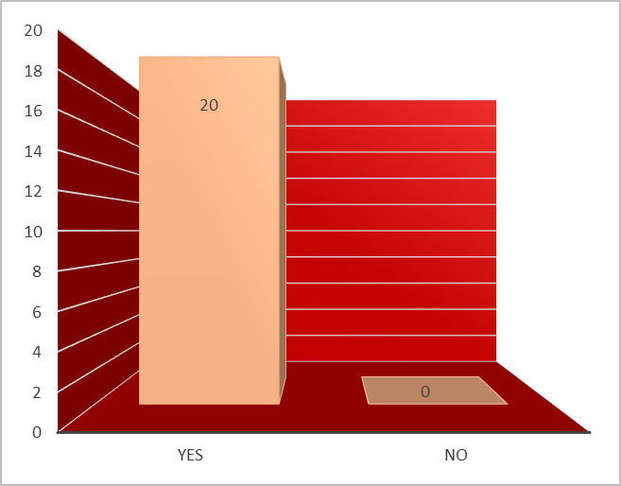

This bar chart shows that these mothers do want to change their lifestyle. While asking this question, and several long conversations, another question came up, why is it becoming a problem? Well...
One had to say that during school days when kids are in school, both partners have the time to go out shopping or just for a stroll, but what they end up doing is, all day on the phone, watching a movie or the partner playing games on it. They both don’t even communicate with each other much.
Another mother had to say, she only communicates with her teenage kids by phone, whether they are outside, home or even upstairs, hardly interacting with her kids and seeing them, even after they are living under the same roof.
This third one’s answer was surprising. she had three boys, all under the age of ten. she mentioned her house is so quite all the time, that nobody would know she had three boys, all because they are on the tablet nonstop, she feels guilty, but she feels that no one is bothering no one else, Really!!...

Results
Question three:

- Would you consider in limiting the time short?
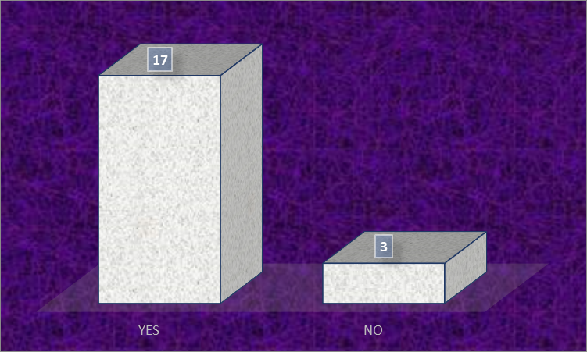 Yes/No

This question you can see seventeen said yes and three said no. By now it’s clear why these mothers said yes from the previous answers. Why three said no is,
One: “Too addicted, can’t live without it”
Two: “Need it for my recipes and movie time when kids are in bed”
Three: “I always stay contact with my friends and love Facebook”
It’s clearly addiction that is making this happen. Knowingly and knowingly this is still taking place, and everyone is affected by it. Will change happen? Will there be a breakthrough and find the solution?
Discussion:
From the busy life these women maintain, they gave the time to sit down and answer these questions for this survey, it has been well appreciated and a pleasure. It was time consuming, yet astonishing finding out the result. Questions asked where simple and kept short and was handed out personally, so the results came straight away. Using primary source was an advantage, you control the design and the question asked, you get exactly the information you want.
There has been two type of charts used, pie chart the first question where there were hours related and bar chart where there was only yes and no answers. There has been Ethical Consideration used for this survey, Ethic meaning: to do good, not to do harm. Privacy was ensured, when the interview took place. They had given their consent to ask the questions, and where respectfully treated for their opinion. They were told that this survey was for University of Wales Trinity Saint David and the purpose of it.

Conclusion:
From the survey the findings that was found is that these people weren’t so happy with the lifestyle they were living. They want to make a change, some realising what impact it had in their life, they’re goal now is to change the time spent with social media, to spending a lot more time with their family. Some realising what they are doing is affecting their children and feel that their children will lose out a lot in life if they don’t act up now, it has been said that if they are doing it their children will follow what they are seeing. These mothers have realised their children are getting very lazy, less active and don’t want to go out and play. Some mothers and their partners have so less sleep because they are up all night and aren’t getting enough sleep, so they feel less active in the morning and grumpy all day.
Many more complaints and thoughts were mentioned all related to one. Hoping there will be hope and understanding for these mothers and for all the future children, for more communication, relation, and brighter future.
Reference:
Available at :https://www.bing.com.socialmedia.instagram (Accessed: 30th August 2019).
Available at: https://en.wikipedia.org/wiki/Structured_interview last edited on 26 August 2019. (Accessed: 29th August 2019).
Available at: https://whatis.techtarget.com/definition/social-media (Accessed: 29th August 2019).

