

Student name:MODUPEOLA OYENAME AWODESU
Student ID: 2442429
Module name: INTRODUCTION TO PHYSIOLOGY
Module code: BMHP5023
Lecturer name: DR SOBAN SADIQ

CASE STUDY 1:
DIABETES BLOOD GLUCOSE CONTROL AND LIFESTYLE MANAGEMENT
Introduction
Diabetes is a condition that affects the body's ability to keep the amount of glucose in the blood within a healthy range. Glucose comes mainly from the food we eat and is needed by cells to produce energy. The pancreas produces insulin, which helps the body use glucose. When insulin is missing or does not work effectively, glucose can build up in the bloodstream and lead to hyperglycaemia (NHS, 2025a).
Type 1 and Type 2 are the main forms of diabetes. Type 1 develops when the immune system damages the pancreatic cells responsible for producing insulin. In Type 2 diabetes, the body becomes less responsive to insulin. This is known as insulin resistance and is a major feature of the condition. Type 2 diabetes is the most common form in the UK (Diabetes UK, 2024).
A person's chance of developing Type 2 diabetes can be influenced by factors such as age, family history, excess weight, limited physical activity, diet and smoking. High blood pressure is another factor associated with an increased risk (NHS, 2025a).
For patients attending a GP practice, understanding these factors can make it easier to take an active role in managing diabetes. This report considers how the body regulates glucose, how glucose and oxygen are involved in energy production, the value of monitoring blood glucose, and the lifestyle measures that can support people living with Type 2 diabetes.
How the Body Controls Blood Glucose
The body needs to keep blood glucose within a safe range. This process is known as homeostasis, which means keeping the body's internal conditions stable. Food is one of the main sources of glucose. When a person eats carbohydrates, the digestive system breaks them down into glucose, which then enters the bloodstream. The pancreas plays an important role in controlling blood glucose by producing hormones such as insulin and glucagon (NHS, 2025a).
After eating, blood glucose levels rise. The pancreas responds by releasing insulin. Insulin helps glucose move from the blood into the body's cells, where it can be used to produce energy. It also helps the liver and muscles store extra glucose for later use. As glucose moves from the bloodstream into the cells, the blood glucose level falls towards a healthier range (NICE, 2026a). The body also needs to prevent blood glucose from becoming too low. When glucose levels fall, the pancreas releases glucagon. This hormone signals the liver to release stored glucose into the bloodstream, helping to raise blood glucose when necessary. Therefore, insulin and glucagon work together to help maintain a balanced blood glucose level (NHS, 2025a; NICE, 2026a).
In Type 2 diabetes, this system does not work properly. The body's cells become resistant to insulin. This means insulin does not work as well as it should. At first, the pancreas may make more insulin to try to overcome this problem. However, over time, the pancreas may not be able to make enough insulin. As a result, too much glucose stays in the blood (NICE, 2026a). Having high blood glucose for a long time can damage the body. It can damage blood vessels and nerves and increase the risk of heart disease, stroke, kidney disease, eye problems and problems with the feet (NHS, 2025b).
This is why it is important for people with Type 2 diabetes to manage their blood glucose carefully. However, blood glucose targets are not exactly the same for everyone. Healthcare professionals should consider the person's age, medicines, other health conditions and risk of low blood glucose when agreeing an appropriate target (NICE, 2026a).
How Glucose and Oxygen Produce Energy
Every cell in the body needs energy to carry out important activities such as movement, growth, repair and keeping the body working normally. Glucose is an important source of energy, while oxygen helps the body release energy from glucose through aerobic respiration (Open University, 2021).The process can be shown simply as: Glucose + Oxygen → Carbon dioxide + Water + Energy.
The energy produced is stored in a molecule called adenosine triphosphate (ATP). Cells use ATP as an available source of energy for their activities. The first stage of breaking down glucose is called glycolysis. This takes place inside the cell and produces a small amount of ATP. When oxygen is available, the process continues in the mitochondria, where further reactions occur and most ATP is produced (Open University, 2021).
This process is important in Type 2 diabetes because glucose is an important fuel for the body's cells. When insulin does not work effectively, glucose may remain in the bloodstream instead of moving into cells properly. This can contribute to high blood glucose levels, showing why good diabetes management is important. Oxygen enters the body when a person breathes in. It travels to the lungs and then passes into the blood. The blood carries oxygen around the body to the cells. At the same time, carbon dioxide is produced as a waste product of energy production. The blood carries carbon dioxide back to the lungs, where it is breathed out (NHS, 2024).
This shows how the respiratory system, blood and cells work together. The body needs both glucose and oxygen to produce energy effectively. This process is important when thinking about Type 2 diabetes. A person may have a high amount of glucose in their blood, but this does not mean that their cells are using the glucose properly. Because of insulin resistance, glucose may not move into the cells as effectively as it should. Therefore, controlling blood glucose is important for the whole body and not just for getting a good blood test result.

Why Recording Blood Glucose is Important
Recording and tracking blood glucose can help some people with Type 2 diabetes understand how their blood glucose changes. However, it is important to understand that not every person with Type 2 diabetes needs to test their blood glucose every day. NICE recommends blood glucose self-monitoring for some people depending on their treatment and circumstances. It may be useful for people who take insulin, people who are at risk of low blood glucose, and people taking certain medicines that can cause hypoglycaemia (NICE, 2026b).
For patients who have been advised to test their blood glucose, recording the results can help them see patterns. For example, a patient may notice that their blood glucose becomes higher after eating certain foods. They may also notice that their glucose improves after walking or doing other physical activity. This information can be discussed with the practice nurse, GP or diabetes team. It can help the patient and healthcare professional understand what may be affecting their diabetes.
Monitoring can also encourage patients to take more responsibility for their health. When patients can see the effect of their food and exercise on their blood glucose, they may be more motivated to make healthy changes. However, patients need to understand what their readings mean. They should know how to use their blood glucose meter correctly and what they should do if their readings are too high or too low.
Another important test is HbA1c. HbA1c is different from a normal finger-prick blood glucose test. A finger-prick test shows the person's glucose level at that particular time. HbA1c gives an indication of the person's average blood glucose over the previous two to three months (NHS, 2025b). Some patients may also use continuous glucose monitoring (CGM). A CGM device measures glucose regularly and can show whether glucose levels are rising or falling. NICE recommends CGM for certain people where it is clinically appropriate (NICE, 2022).
Therefore, monitoring should not just be about writing down numbers. Patients should understand what the results mean and how the information can help them manage their condition safely.
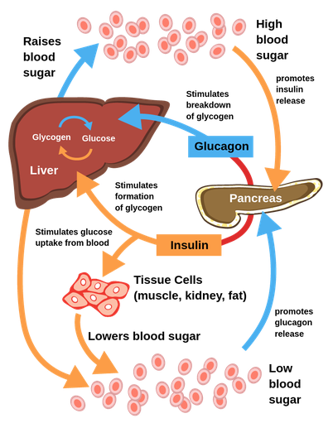
Figure 1 above: Regulation of Blood Glucose
Lifestyle Changes That Can Help Manage Diabetes
Healthy Eating
Healthy eating is one of the most important lifestyle changes for people with Type 2 diabetes. Food affects blood glucose, weight, cholesterol and heart health. People with diabetes should try to eat a balanced diet. This can include vegetables, fruit, wholegrains, beans, pulses, lean sources of protein and healthier fats. Foods and drinks that contain large amounts of added sugar should be limited. This includes sugary drinks, sweets and some highly processed foods. Eating too many foods high in saturated fat can also increase the risk of heart disease (Diabetes UK, 2024).
People with Type 2 diabetes do not necessarily need to stop eating carbohydrates. Instead, they should think about the amount and type of carbohydrate they eat. Foods such as vegetables, beans, pulses and wholegrains can provide useful fibre.
Portion size is also important. Eating large amounts of food can lead to weight gain, even when some of the foods are healthy. Healthy eating advice should be suitable for the individual. NICE recommends that healthcare professionals consider a person's preferences, culture, beliefs and willingness to make changes (NICE, 2026c).
For example, a practice nurse should not simply tell a patient to stop eating foods that are important to their culture. Instead, the nurse can discuss healthier cooking methods, smaller portions and healthier alternatives. This can make the advice easier for the patient to follow.
Exercise and Physical Activity
Regular exercise can help people with Type 2 diabetes. Physical activity helps the muscles use glucose and can improve the way the body responds to insulin. Exercise can also help with weight control and improve heart health. UK guidance recommends that adults should aim for at least 150 minutes of moderate physical activity each week. This could include activities such as brisk walking, cycling or swimming. Adults should also do activities that strengthen their muscles on at least two days each week (Department of Health and Social Care, 2026).
Exercise does not have to mean going to a gym. Walking, gardening, dancing, cycling and taking the stairs can all help increase physical activity. People should also try to avoid sitting for very long periods. Getting up regularly and moving around can be beneficial. Patients who take insulin or certain diabetes medicines may need additional advice before exercising because physical activity can sometimes cause blood glucose to become too low. Exercise should therefore be suitable for the individual's health and treatment.
Stopping Smoking
Smoking is harmful to everyone, but it is particularly important for people with diabetes to stop smoking. Diabetes already increases the risk of heart and blood vessel disease. Smoking can increase this risk further. The practice nurse should ask patients about smoking in a supportive way. Patients who smoke should be offered information about NHS smoking cessation services and other appropriate support (NHS, 2025c). Stopping smoking can be difficult. Some people may make several attempts before they are successful. Patients should therefore be supported rather than judged. Helping a patient stop smoking can be an important part of diabetes care because it can improve their overall health and reduce future health risks.
Weight Management
Weight management can also help people with Type 2 diabetes. Being overweight can make insulin resistance worse. Losing weight can help the body respond better to insulin and can improve blood glucose control. NHS England's Type 2 Diabetes Path to Remission Programme shows that significant weight loss can improve Type 2 diabetes for some people. The programme provides structured support involving a low-calorie diet followed by help with maintaining healthier eating habits. NHS England reported that around one-third of people who completed the programme and had the required measurements were in remission after one year (NHS England, 2024a).
However, very low-calorie diets are not suitable for everyone. People should not attempt these diets without appropriate professional advice. For many patients, smaller changes may be easier to maintain. These could include eating smaller portions, reducing sugary drinks, eating more vegetables and becoming more physically active. The NHS Diabetes Prevention Programme also provides support with healthy eating, weight management and physical activity. This shows the importance of structured lifestyle support in reducing the risk of Type 2 diabetes (NHS England, 2024b).
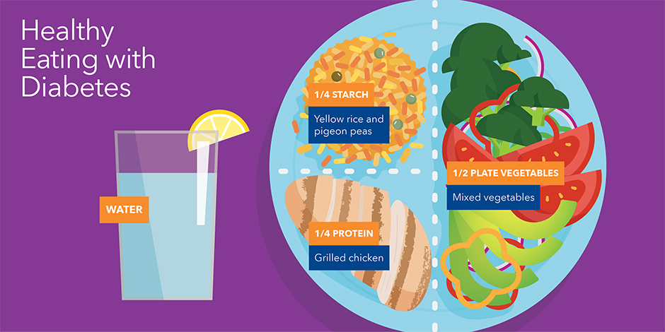
Figure 2 above - Healthy Eating with Diabetes (Building Your Best Plate)
Conclusion
Diabetes is a long-term condition that affects how the body controls blood glucose. In Type 2 diabetes, the body does not use insulin properly, which can cause blood glucose to become too high and increase the risk of health problems.
Monitoring blood glucose and HbA1c can help patients understand and manage their condition. It can also help them see how food, exercise and medication affect their blood glucose levels. However, not everyone with Type 2 diabetes needs to check their blood glucose every day. Healthy eating, regular exercise, stopping smoking and maintaining a healthy weight can help improve blood glucose control and reduce the risk of complications. The practice nurse has an important role in giving patients clear information and helping them make realistic lifestyle changes.
Overall, good diabetes management involves more than taking medication. With the right knowledge, support and lifestyle changes, patients can take a more active role in managing their diabetes and improve their long-term health and quality of life.

Harvard Reference List
Department of Health and Social Care (2026) UK Chief Medical Officers' physical activity guidelines. Available at: GOV.UK – UK Chief Medical Officers' Physical Activity Guidelines (Accessed: 20 July 2026).
Diabetes UK (2024) Eating well with diabetes. Available at: Diabetes UK – Eating well with diabetes (Accessed: 20 July 2026).
NHS (2024) How your body gets energy from food. Available at: NHS – Healthy eating and energy (Accessed: 21 July 2026).
NHS (2025a) Type 2 diabetes. Available at: NHS – Type 2 diabetes (Accessed: 21 July 2026).
NHS (2025b) Treatment for type 2 diabetes. Available at: NHS – Treatment for Type 2 diabetes (Accessed: 22 July 2026).
NHS (2025c) Quit smoking. Available at: NHS – Quit smoking (Accessed: 22 July 2026).
NHS England (2024a) NHS Type 2 Diabetes Path to Remission Programme. Available at: NHS England – Diabetes remission (Accessed: 24 July 2026).
NHS England (2024b) Healthier You NHS Diabetes Prevention Programme. Available at: NHS England – Diabetes Prevention Programme (Accessed: 24 July 2026).
NICE (2022) Type 2 diabetes in adults: management. NICE guideline NG28. Available at: NICE – Type 2 diabetes in adults: management (Accessed: 25 July 2026).
NICE (2026a) Type 2 diabetes in adults: management – Blood glucose management. NICE guideline NG28. Available at: NICE – Blood glucose management (Accessed: 25 July 2026).
NICE (2026b) Type 2 diabetes in adults: management – Self-monitoring of blood glucose. NICE guideline NG28. Available at: NICE – Type 2 diabetes management (Accessed: 26 July 2026).
NICE (2026c) Type 2 diabetes in adults: management – Dietary advice and interventions. NICE guideline NG28. Available at: NICE – Dietary advice and interventions (Accessed: 26 July 2026).
Open University (2021) Oxygen, blood and the body. OpenLearn. Available at: Open University – Oxygen, blood and the body (Accessed: 26 July 2026).

