Security Analysis Report
HealthPlus Analytics (HPA)



Prepared by:
Stephen Jones - 2440121

Abstract
Cybersecurity is a vital part of modern business. With more information of many forms stored on computers, servers and online, we must learn to be vigilant to the threat of cybercrimes. This report details some of the more well-known threats to cybersecurity, as well as some of the mitigation methods to help protect us from them. There is also information on monitoring these issues and the ways in which staff can be taught to deal with threats as they arise. As the world becomes more digital, the opportunity for online based crimes evolves with it. This report will serve as a strong introduction on how to protect HealthPlus Analytics and ensure trust in the company going forward.

Contents
Abstract 2
Introduction 4
Identification of Modern Threats 4
Ransomware 4
Phishing/Vishing 4
Man in the Middle Attacks 5
Denial of Service Attacks 5
Insider Threats 5
Modern Security Policies 5
Access Control 5
Risk Management 5
Acceptable Use 5
Data Backup/Recovery 5
Technical Mitigation Measures 6
Training 6
Multi-Factor Authorisation 6
Vulnerability Patching 6
Network Segmentation 6
Firewalls 6
Proactive Monitoring and Incident Response 6
Continuous Training and Awareness 8
Conclusion 8
References 9
Presentation 12

Introduction
With the amount of data stored online, from saved passwords to global financial records, cybersecurity is essential for any user with an online presence, no matter how small or large. Cyberattacks have proven to be very viable threats, with countless amounts of personal and restricted data being leaked online and sold on the dark web, effecting businesses and lives. Threats, both internal and external, need to be addressed so we can be prepared to prevent these ever-growing security concerns.

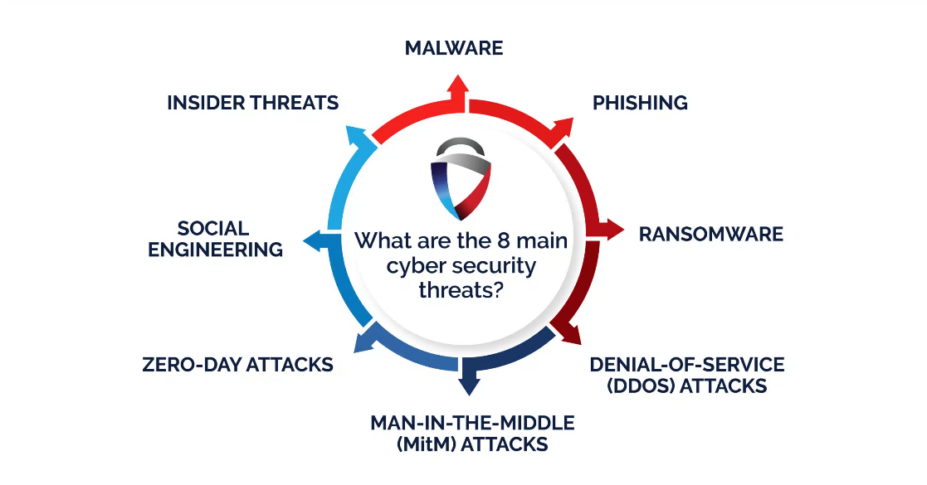
Figure 1: Common cybersecurity threats

Identification of Modern Threats
Before these threats can be prevented, they must first be understood. The following section details common cybersecurity threats faced today.

Ransomware
Ransomware is when the attackers encrypt important or personal files or restrict access to a system in order to get the user to pay a ransom to regain access or prevent the attacker leaking private information [1].

Phishing/Vishing
Phishing involves convincing users to share sensitive information through various methods of deception [2]. These methods include fake emails and websites that seem genuine, convincing the user to click malicious links or share personal details. Vishing is very similar but uses voice communication such as phone calls to achieve the same results [3]. These types of attacks are known as Social Engineering [4].
Social engineering is assisted with the advancements in artificial intelligence (AI) [5] and it’s ability to create more believable phishing content.

Man in the Middle Attacks
A considerable threat to wireless networks, man in the middle (MitM) attacks allow the attacker to interrupt communication between locations and interfere with the data being sent [6]. The data can be viewed, as well as altered before being sent on to its end location.

Denial of Service Attacks
Denial of service, or distributed denial of service (DDoS) attacks involve using a network of bots, known as a botnet, to continuously flood a server or website with requests [7]. This kind of attack interrupts the server traffic and slows down or stops access.

Insider Threats
Not all security threats come from outside sources. Current and former employees can also pose a threat to cybersecurity [8]. If an employee has access to sensitive information, they also have the ability to remove and share the information if motivated to. These motives can come from anywhere, such as blackmail, unhappiness with employers or simple greed.

Modern Security Policies
There are certain policies that staff can follow to ensure the data is protected in the best way possible. It’s important to build these cybersecurity policies around the principal of Zero Trust. An essential security principal, zero trust [9] means that every user or device that accesses the system must be verified every time they request access. This would prevent any user being able to access a system they don’t have clearance for and stealing information with the use of an external device.

Access Control
By restricting access to certain areas and systems to only the employees that need it [10], we can play a large part in preventing insider threats and system misuse.

Risk Management
It’s important to research and assess any risks to security, the likeliness of them occurring and the consequences that could follow [10]. After risk assessment is done, we can then take steps to prevent these threats from happening, or lessen the impact is they do.

Acceptable Use
Setting rules on how IT systems can be used [12], such as restricting Email usage to work only and not allowing casual web browsing will all but eliminate social engineering threats and system misuse.

Data Backup/Recovery
Creating backup files of stored data prevents any issues if any data is somehow lost or its integrity is compromised [13]. This is a valuable policy for any business that stores large amounts of information.

Technical Mitigation Measures
This section details some of the methods that can be used to protect systems and prevent cyber-attacks [14]. This report merely scratches the surface of the number of different mitigation techniques available to us.

Training
It is of vital importance that staff are trained to identify and mitigate threats themselves [15]. Cybersecurity requires more than just software and hardware integration. The users must also have awareness of the threats both online and around them.

Multi-Factor Authorisation
Login details can be easily stolen using modern social engineering tactics, but multi-factor authorisation (MFA) makes logging into an account or system less risky. MFA [16] requires the user to use other forms of identification that change retroactively such as one-time codes, or some may request user specific biometrics such as fingerprints. These methods prevent lost or stolen login data causing as much of an issue as it once did.

Vulnerability Patching
If the software you’re using has security flaws, fixing them is essential. Patching software [17] regularly keeps it as safe as possible from cyber-threats.

Network Segmentation
Network segmentation refers to breaking the network into smaller sections, each with their own security requirements [18]. This prevents attackers attacking the network as a whole, therefore improving security.

Firewalls
The firewall [19] is a basic, but essential security tool. The job of the firewall is to act like a security guard for the system. It monitors everything incoming and outgoing and flags potential security concerns. If the firewall flags something as suspicious or dangerous, it works to stop it from entering the system.

Proactive Monitoring and Incident Response
Cybersecurity is something that must be constantly monitored. It’s very important that we can identify threats at the earliest opportunity and take the steps to remedy any problems that arise. This involves developing a plan to monitor and regularly audit networks and systems, respond quickly and eliminate the threats [20].
[21] details the importance of monitoring for different types of attack, including DDoS and Brute Force Attacks. It’s also very important to monitor for Zero Day Attacks [22] since it’s almost impossible to be prepared for a ZD attack because they exploit vulnerabilities not commonly known with the software. Security auditing and monitoring can be done with the help of an analysis and management platform such as Splunk [23]

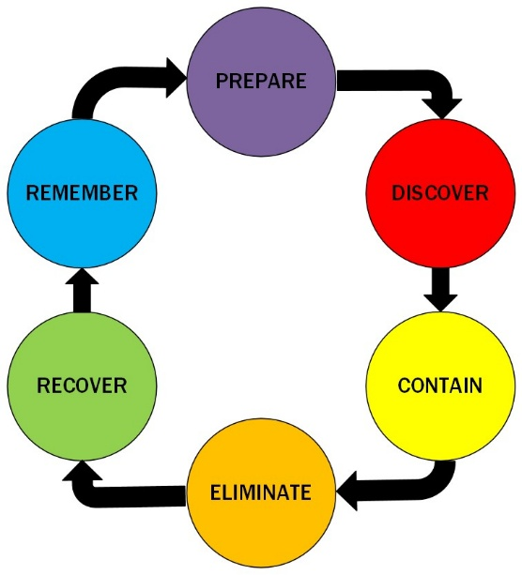
Figure 2: Incident Response Cycle

Figure 2 shows a response cycle for cybersecurity incident response. I will break it down.

Prepare
Train staff to provide knowledge of threats and mitigation measures. Install necessary security software.

Discover
Monitor and audit networks regularly until a threat is detected.

Contain
Once a threat is discovered, take steps to stop it from proceeding further while you learn how to remove it.

Eliminate
Remove the threat from the network/system.

Recover
Make sure everything is working normally, use backups to restore data if necessary.

Remember
Log the threat and the steps taken to remove it and patch vulnerabilities so the same threat can be prevented in the future.

Continuous Training and Awareness
Training staff on threats, mitigation methods and security procedures plays a valuable role in cybersecurity. If the users know what to be aware of and how to counter it, alongside hardware and software countermeasures then cybersecurity will be at its best.
This section will detail some training methods [24] to help raise staff awareness and prepare them for potential cyberthreats going forward.
Presentations and Videos
These methods are usually seminars, classes or video presentations, in which viewers will listen to a professional discussing the subject
Game-Based Training
This method involves using games that teach the players about a subject [25]. This is a more hands-on approach, making the trainees use the skills they’d need to progress the game. This helps by making people not only learn, but to put the skills into practice.
Simulations
Much like the game-based method detailed above, simulations, such as fake, but accurately structured phishing emails van test users’ ability to identify threats, and if they fail, teach them what they missed. This method could also be repeated with variations on the simulations to best prepare trainees for the real thing.
Discussions
Discussions can prove very useful as people can talk about the knowledge and experience they have and put their thoughts and ideas together to fully flesh out a subject. Group discussions also promote teamwork and improve working relationships

Conclusion
Cybercrime is an ever-expanding problem. It is more important than ever that we learn what threats there are to IT security and what steps can be taken to avoid it. There will always be new threats, but there will always be new countermeasures too, and proactive training and awareness is the only way everyone can stay in the loop and protect themselves and/or their company from these growing issues.

References

[1] S. Razaulla et al., “The Age of Ransomware: A Survey on the Evolution, Taxonomy, and Research Directions,” IEEE Access, vol. 11, pp. 40698–40723, Apr. 2023, doi: https://doi.org/10.1109/ACCESS.2023.3268535.

[2] G. Varshney, R. Kumawat, V. Varadharajan, U. Tupakula, and C. Gupta, “Anti-phishing: A comprehensive perspective,” Expert Systems with Applications, vol. 238, p. 122199, Mar. 2024, doi: https://doi.org/10.1016/j.eswa.2023.122199.

[3] S. Ashfaq, Pankaj Chandre, S. Pathan, U. Mande, Madhukar Nimbalkar, and Parikshit Mahalle, “Defending Against Vishing Attacks: A Comprehensive Review for Prevention and Mitigation Techniques,” Lecture notes in networks and systems, pp. 411–422, Jan. 2024, doi: https://doi.org/10.1007/978-981-99-9811-1_33.

[4] W. Syafitri, Z. Shukur, U. A. Mokhtar, R. Sulaiman, and M. A. Ibrahim, “Social Engineering Attacks Prevention: A Systematic Literature Review,” IEEE Access, vol. 10, no. 1, pp. 39325–39343, 2022, doi: https://doi.org/10.1109/ACCESS.2022.3162594.

[5] M. Schmitt and I. Flechais, “Digital deception: generative artificial intelligence in social engineering and phishing,” Artificial Intelligence Review, vol. 57, no. 12, Oct. 2024, doi: https://doi.org/10.1007/s10462-024-10973-2.

[6] M. Thankappan, H. Rifà-Pous, and C. Garrigues, “Multi-Channel Man-in-the-Middle Attacks Against Protected Wi-Fi Networks: A State of the Art Review,” Expert Systems with Applications, vol. 210, p. 118401, Aug. 2022, doi: https://doi.org/10.1016/j.eswa.2022.118401.

[7] K. B. Adedeji, A. M. Abu-Mahfouz, and A. M. Kurien, “DDoS Attack and Detection Methods in Internet-Enabled Networks: Concept, Research Perspectives, and Challenges,” Journal of Sensor and Actuator Networks, vol. 12, no. 4, p. 51, Aug. 2023, doi: https://doi.org/10.3390/jsan12040051.

[8] S. Prabhu and N. Thompson, “A primer on insider threats in cybersecurity,” Information Security Journal: A Global Perspective, vol. 31, no. 5, pp. 1–10, Sep. 2021, doi: https://doi.org/10.1080/19393555.2021.1971802.

[9] W. Yeoh, M. Liu, M. Shore, and F. Jiang, “Zero trust cybersecurity: Critical success factors and A maturity assessment framework,” Computers & Security, vol. 133, no. 1, p. 103412, Oct. 2023, doi: https://doi.org/10.1016/j.cose.2023.103412.

[10] E. Humphreys, Implementing the ISO/IEC 27001 Information Security Management System Standard. Third Edition. Artech House Publishers, 2025.

[11] J. Parsola, “Cybersecurity Risk Assessment and Management for Organizational Security,” NeuroQuantology, vol. 20, no. 5, Jun. 2023, doi: https://doi.org/10.48047/nq.2022.20.5.nq22815.

[12] D. Kostadinov, “Understanding Acceptable Use Policy: A Comprehensive Guide | Infosec,” www.infosecinstitute.com, Sep. 23, 2014. https://www.infosecinstitute.com/resources/management-compliance-auditing/essentials-acceptable-use-policy/

[13] A. Mishra, Y. I. Alzoubi, A. Q. Gill, and M. J. Anwar, “Cybersecurity Enterprises Policies: a Comparative Study,” Sensors, vol. 22, no. 2, p. 538, Jan. 2022, doi: https://doi.org/10.3390/s22020538.

[14] T. Rains, CYBERSECURITY THREATS, MALWARE TRENDS, AND STRATEGIES : mitigate exploits, malware,... phishing, and other social engineering attacks. S.L.: Packt Publishing Limited, 2020.

[15] D. Tolossa, “IMPORTANCE OF CYBERSECURITY AWARENESS TRAINING FOR EMPLOYEES IN BUSINESS,” Vidya - A Journal of Gujarat University, vol. 2, no. 2, pp. 104–107, 2023, doi: https://doi.org/10.47413/vidya.v2i2.206.

[16] R. Mahmood Saqib et al., “Analysis and Intellectual Structure of the Multi-Factor Authentication in Information Security,” Intelligent Automation & Soft Computing, vol. 32, no. 3, pp. 1633–1647, 2022, doi: https://doi.org/10.32604/iasc.2022.021786.

[17] Y. Nong, et al., "{APPATCH}: Automated adaptive prompting large language models for {Real-World} software vulnerability patching", 34th USENIX Security Symposium (USENIX Security 25), pp. 4481–4500.

[18] Vishnu Vardhan Baligodugula, Ashutosh Ghimire, and Fathi Amsaad, “An Overview of Secure Network Segmentation in Connected IIoT Environments,” Computing & AI Connect, vol. 1, Aug. 2024, doi: https://doi.org/10.69709/caic.2024.193182.

[19] J. Liang and Y. Kim, “Evolution of Firewalls: Toward Securer Network Using Next Generation Firewall,” IEEE Xplore, Jan. 01, 2022. https://ieeexplore.ieee.org/stamp/stamp.jsp?tp=&arnumber=9720435

[20] E. Blessing and K. Hubert, “Security Auditing and Monitoring: Incident response and management,” Hal.science, 2024, doi: https://doi.org/10.5281/zenodo.14926029.

[21] Palvi Shelke and T. Hamalainen, “Analysing Multidimensional Strategies for Cyber Threat Detection in Security Monitoring,” Proceedings of the ... European conference on information warfare and security, vol. 23, no. 1, pp. 780–787, Jun. 2024, doi: https://doi.org/10.34190/eccws.23.1.2123.

[22] C. A. Teodorescu, "Perspectives and reviews in the development and evolution of the zero-day attacks," vol. 26, no. 2, pp.46–56, 2022,

[23] P. Shelke and T. Frantti, “Exploring the Possibilities of Splunk Enterprise Security in Advanced Cyber Threat Detection,” International Conference on Cyber Warfare and Security, vol. 20, no. 1, pp. 605–613, Mar. 2025, doi: https://doi.org/10.34190/iccws.20.1.3326.

[24] J. Prümmer, T. van Steen, and B. van den Berg, “A systematic review of current cybersecurity training methods,” Computers & Security, vol. 136, no. 103585, Jan. 2024, doi: https://doi.org/10.1016/j.cose.2023.103585.

[25] G. N. Angafor, I. Yevseyeva, and Y. He, “Game‐based learning: A review of tabletop exercises for cybersecurity incident response training,” Security and Privacy, vol. 3, no. 6, Jul. 2020, doi: https://doi.org/10.1002/spy2.126.

Presentation



