Sound and Moving Image
CREATIVE RESEARCH (MX501599)
2018-2019
Name: Jacob Berridge
Student number: 1702730
MUSIC TECHNOLOGY BA HONOURS DEGREE
Word count: 2224 Words
Tutor: Rob Jones
Assignment Brief: write a 2,000-word essay, choosing one of the following questions:
- Compare and contrast the creative strategies of two sound designers/composers when designing solutions for film/game/animation within a given genre. Provide examples to support your discussion.

Sound and Moving Image
CREATIVE RESEARCH (MX501599)
2018-2019
Introduction

For This Assignment, I’ve been asked to compare and contrast two sound designers/composers. Analyzing their creative strategies for a film or game.

Part 1 – Halo 2 & Martin O’Donnell

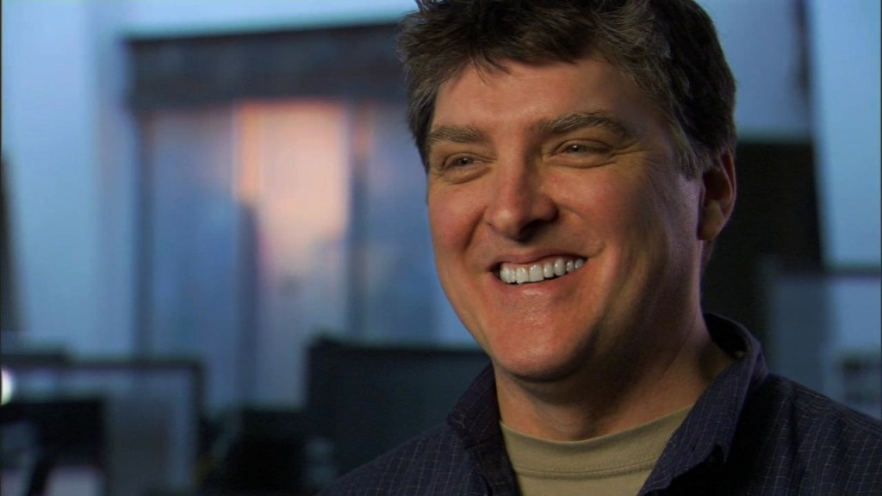 The First Composer I will look at is Martin O’Donnell. O’Donnell was born on May 1st, 1955. He first started his composing career by writing jingles for radio stations. He then began to use his composing skills for videos games in the late nineties. He worked on sound design for Riven in 1997 and then went on to producing music for myth 2. Later the growing and improving games company, Bungie hired O’Donnell to work on their highly anticipated games project that would soon to be called, Halo: Combat Evolved. Bungie was then bought by Multimillion company, Microsoft which is where O’Donnell would work for all their projects. The Project we’re going to look at is Halo 2 and a little bit of Halo Combat Evolved and Halo 3.

Halo 2 is FPS (First Person Shooter), released in 2004. Halo 2’s Campaign broke records around the world. The plot was a sequel to Halo: Combat Evolved. The UNSC (United Nations Space Command) had from fled Halo after a huge war emerged leading Halo (also known as a power weapon to clear all living species off the face of the galaxy) to self-detonate in a controlled process without harming any life outside the ring in order to protect the remaining civilizations of humanity. The UNSC fleet was ordered to protect earth and to wipe out the Covenant fleet sent to completely destroy humanity as part of their religious journey to activate all the halo rings. In short, the rest of the halo story consists of humanity chasing the Covenant into a slip space rupture and stopping them to activate another Halo. The plot of Halo 2 brings out Courage, Bravery, Desperation, Hope, Loss, Fear and Reflection.

Throughout Halo 2, O’Donnell along with his partner, Michael Salvatori, managed to compose music pieces that manages to capture the listeners imagination and really drag them into the halo world. It makes the listener gain a sense of semantic listening, which means they seek the meaning of what their listening too. O’Donnell did this perfectly by using a whole orchestra and a respectable sized mixed choir of 80. This means they capture the sound and mood perfectly, whether it’s to capture a courageous part of the game or to capture a reflective, thoughtful part of the story. For instance, in the final cutscene of the Halo 2 story, UNSC manage to stop the covenant from activating the super weapon. O’Donnell uses various string, woodwind and voice instruments to bring out a sense of mystery when the UNSC learn that the war isn’t over and their chase to stop the covenant continues. Then it leads into a more dynamic piece as the screen blackens out, this is where O’Donnell wanted the player to feel unaccomplished and adrenalized and to add a sense of added mystery to the story. O’Donnell brings in more strings and brass to layer up the piece and also brings in drums to build tension in to making the player question how the journey throughout halo pans out. He does this really well by using the shepherd’s tone to continue build tension. A shepherd’s tone is a sound made up of sine waves which are split up by octaves. This creates the audio illusion when the bass moves up or down in pitch. This is used in a lot at the end of some cutscenes in the first halo trilogy. Where there is drama in the story O’Donnell likes to emphasize these tense moments in the games.

At the start of the halo 2 mission – Delta Halo. The strings are introduced along with the choir following. This is playing in the back ground where they learn that there is another halo. This introduces the superweapon with superiority, the choir sings the main halo theme when this scene plays, O’Donnell clearly thought of a tune to relate to the halo ring. O’Donnell wanted to create a tune that will stick in players’ heads. Clearly this tune and method was effective because to this day it is arguably up the ranking list as one of the most nostalgic and rememberable pieces of music to be used in gaming. Even if O’Donnell doesn’t use the whole same song he sometimes uses the first few notes, and the player will always recognize it is halo. Moving on from the introduction to the second Halo ring, the choir and strings fade out and O’Donnell completely changes the mood of this cutscene. Various percussive instruments and a deep bass is used to create a sparkplug like mood, everything comes into action, where the player is queued to act and feel like the cool, heroic, inflamer character that the player plays as. The deep bass of the track resembles the UNSC fleet ship over powering the covenants small scout groups. The drums add the mood and texture of this piece to give a very attacking sound. In my opinion the drums resemble war, where the it mimics the sound of explosions and the sheer power of the army’s fleet. Later on, in the mission, the player is rallied up with more special forces and heavy armor to reach their destination which is protected by many enemy checkpoints along the way. As you roll through each checkpoint, a marching band plays a very dynamic and fast paced piece with the choir singing in the background. O’Donnell composed the marching band to give the player a feel of power and sheer courage, as the mood of the music perfectly matches the resemblance of the tank, matching its power with the dynamic of the music, and the destruction with the pace of the piece, the fast tempo creates that panic from the enemies point of the view. The choir give that lighter mood to the piece. It creates that thought of hope of saving humanity and courage of the UNSC. O’Donnell says in a documentary “you have these whole series of self-doubts, then there comes a point where you get over the hump, where I put in an instrument or a play some melody and then it’s like oh oh, oh that’s what’s it meant to be.” In the same documentary, the team comment on O’Donnell’s work and they say he’s been into this project more than ever and he makes everything seem 2, 3 times better than what they should be. This also tells me that O’Donnell hasn’t just created this piece without any deep meaning to them. He wants every detail and every object on screen and every plot to have its own very way of sounding. Which O’Donnell in that way is a genius in making everything sound unique and giving its own dynamic sound to it. And giving it own scene and map atmosphere its desired meaning.

Part 2 – Halo 4 & Neil Davidge

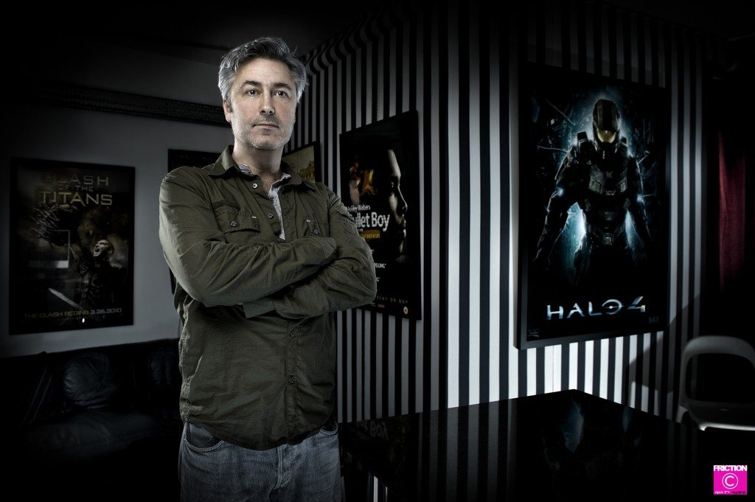 The alternative composer I am going to compare to Martin O’Donnell is Neil Davidge. Davidge was born in 1962 in Bristol, UK. He’s most famously well known for the production of Massive Attack’s album, ‘Heligoland’ and ‘Collected’. Davidge also composed the score for Clash of the titans in 2010. Davidge was contracted by
343 industries. 343 are a selected group of individuals who worked with Bungie and the Halo trilogy along with Halo: ODST. Since Bungie stopped development on Halo, Martin O’Donnell was fired from composing music scores for Halo, 343 Industries were looking for a different, more evolved electronic sound to fit along with Halo 4’s direction in the series.

Halo 4 follows the character of Spartan 117 or John (his given name) as he finds himself in an unknown part of space. He establishes contact with a UNSC fleet in distress and need of assistance. After helping the fleet to get back on their feet. They search for clues on their new contact with an unknown lifeform and seek their purpose. Along the way we get introduce to many new villains and allies. This whole campaign exposes secrets and the players learn a whole new halo universe and the stories behind it. Davidge composed the pieces to exploit this whole new world, these whole new mysteries. To open up a new era of the Halo universe. Davidge uses new methods of sound design to help evolve the Halo franchise from a classic orchestral soundtrack, to a more complex futuristic meaningful piece.

343 released a music documentary, in it, Davidge said he wants to bring something fresh to the game. This already tell me that every score to the first part of the new trilogy is going to be different. Halo 4 introduces a new threat and this this where the story expands and goes deep into its origins even before the first Halo. There are a lot more details to think about and pay attention too. Davidge stated in the documentary that he was playing halo since 2001 so he’s very much intrigued by the series and he’s very much well aware of Martin O’Donnell’s work. Halo 4 introduces a lot of new weapons, enemies and environments. This means that Davidge has to offer a whole different integrity of music to match the integrity of detail with the rest of the game. With working with Massive attack and he was at the cutting edge with beats, electronic sounds and sound textures and how he manipulates sound. it’s a sort of evolution form the classic Halo score, not a revolution.

A classic example of a Davidge score from halo 4 is its final mission soundtrack where there is still huge similarities to Martin O’Donnell’s tracks in the previous Halo’s. However, you can instantly recognize that the musical score has in fact been evolved. There is a huge improvement to sound quality obviously due to technology improving. But the drums and percussion have been recorded acoustically however Davidge wanted to twist up the music score for Halo by manipulating the percussive sounds and this is why 343 Hired Davidge, his ideas of what he wants halo to sound like is more evolved in terms of more futuristic and inputs a lot of depth into what he truly wants in the new trilogy. He wants to evolve the music at the same rate as the whole story is evolving. Davidge usually would record all the sounds as they are then his skills and methods in sound design plays a huge part where he would reverse the audio or play the sounds through a guitar amp and adding multiple effects to make the acoustic sound have that futuristic twist to it, adding in more depth, dynamic, variety. The strings play a huge part in this track and in both of O’Donnell’s and Davidge’s composition the strings emphasize the courage of the main character and drama to the mood. At 6:11 into the music piece, you hear the brass play exactly the same motif as the warthog run music in Halo 3, which O’Donnell composed. It only lasts 15 seconds but the fact Davidge added that into his composition and manage to involve that around his piece does back up the evidence he wanted to evolve the music score and not entirely change it.

Links to the songs I mentioned in the paragraph above;

https://www.youtube.com/watch?v=Czc9SQeOjFk – Halo 4 Final mission music soundtrack – Neil Davidge

https://www.youtube.com/watch?v=q_pAa9252Uo – Halo 3 Final mission music soundtrack – Martin O’Donnell

Part 3 – Conclusion

In conclusion, Halo always comes out with amazing sound tracks. Both O’Donnell and Davidge produced amazing, emotional and intricate soundtracks. O’Donnell created the foundation soundtrack for other great composers to follow and build up on. O’Donnell’s techniques required thought, feelings, and genius to create such a intricate sound track. He wanted to pain an image with music and give everything from, objects to events to characters a different soundtrack so that players will be able to remember each little detail from the piece of his music. O’Donnell like to create tension and build it up till the next big event happened in the story. He used a lot of techniques from the shepherd’s tone, to non-diegetic sounds. Providing a perfect contrast between sound, image and the story background.

Davidge on the other hand did a very good job Evolving the Halo soundtrack by using his ideas and skills he’s used in the past and applied them to the halo sound track. From he applied many effects to raw and acoustic recordings. Something O’Donnell didn’t do. Davidge applied more emotion in his soundtrack, providing and automating more textures, dynamic, mood and color to his scores. His idea was to try and keep the halo sound track as close to the original scores as possible but to add his twist on the music. He wanted the player to feel like it was still a halo game.

Both Halo trilogies explore the story of Spartan 117 or John and the UNSC, they both focus on the survival for humanity and race to seize new planets while stopping the covenant and freelancers from destroying the halo rings which will end all life. But the 2 trilogies. Both have their own uniqueness and both O’Donnell and Davidge manage to use their ideas to create their music with meaning and a story behind each event.

References

Designed, b. (2018). Halo 4 | Neil Davidge. [online] Neildavidge.com. Available at: https://www.neildavidge.com/additional/halo-4.html [Accessed 12 Dec. 2018].

YouTube. (2018). Halo 2 DVD -Voices of Halo 2 and Music. [online] Available at: https://www.youtube.com/watch?v=1mGYPj7nh6Y [Accessed 12 Dec. 2018].

Halowaypoint.com. (2018). Music | Channel | Halo - Official Site. [online] Available at: https://www.halowaypoint.com/en-us/halo-channel/channels/music [Accessed 12 Dec. 2018].

YouTube. (2018). Making Halo 4: Composing Worlds. [online] Available at: https://www.youtube.com/watch?v=ZmfGsuOacMA [Accessed 12 Dec. 2018].

Friction Collective. (2018). Promotions for Neil Davidge; Composer, Producer, Arranger, Songwriter, Musician - Friction Collective. [online] Available at: https://www.frictioncollective.com/promotions-for-neil-davidge-music-producer-and-musician/ [Accessed 12 Dec. 2018].

YouTube. (2018). The Halo 3 Warthog Run: The Complete Extended Version. [online] Available at: https://www.youtube.com/watch?v=q_pAa9252Uo [Accessed 12 Dec. 2018].

YouTube. (2018). Halo 4 - Final Mission&Ending Soundtrack OST - 117. [online] Available at: https://www.youtube.com/watch?v=Czc9SQeOjFk [Accessed 12 Dec. 2018].

