

ACCA4023

Introduction to Web and Database Concepts

Design and Implementation of a Relational Database System

Student ID – 2511138
Student Name –akram ahmad fakhredin

Table of Contents
List of figures 2
1. Introduction 4
2. Scenario Analysis (Entities and Attributes) 5
3. Entity-Relationship Diagram (ERD) 6
4. Data Structure Development 6
5. Normalisation Compliance 10
6. Sample Data Population 11
7. Query Development 14
8. Validation and Testing 23
9. System Evaluation and Reflection 23
10. Conclusion 25
References 26

List of figures
Figure 1: Required ERD 6
Figure 2: MedicineCatalog table creation 7
Figure 3: Vendors Table creation 7
Figure 4: Pateints Table creation 8
Figure 5: DoctorOrders Table creation 8
Figure 6: OrderMedications Table creation 9
Figure 7: Transactions Table creation 9
Figure 8: TransactionDetails Table creation 10
Figure 9: MedicineCatalog Table 11
Figure 10: Patient Table 12
Figure 11: DoctorOrders Table 12
Figure 12: OrderMedications Table 13
Figure 13: Transactions Table 13
Figure 14: TransactionDetails Table 13
Figure 15: Query for Medicines Requiring Special Storage 14
Figure 16: Results of Medicines Requiring Special Storage 14
Figure 17: Query for Pending Doctor Orders 15
Figure 18: Results of Pending Doctor Orders 16
Figure 19: Query for Pending Doctor Orders 16
Figure 20: Results of Pending Doctor Orders 17
Figure 21: Query for Top Selling Medicines 17
Figure 22: Results of Top Selling Medicines 18
Figure 23: Query for Patients with pending orders 18
Figure 24: Results of Patients with pending orders 19
Figure 25: Query for Total Sales by Payment Type 19
Figure 26: Results of Total Sales by Payment Type 20
Figure 27: Query for Medicines Near Expiry 20
Figure 28: Results of Medicines Near Expiry 21
Figure 29: Query for Total Sales per Patient 21
Figure 30: Results of Total Sales per Patient 22
Figure 31: Query for Orders with Multiple Medicines 22
Figure 32: Result of Orders with Multiple Medicines 23

1. Introduction
A UK-based community pharmacy, MediLink Pharmacy, is a growing company that currently implements its customer prescription, sales, and management of medicines manually. The CEO has realised that such a system is likely to commit errors, duplicate information and inefficiencies that adversely affect stock management, prescription tracking, and service delivery in general. A manual system is also incapable of providing a timely management report, tracking sales trends and also protecting adherence to the regulatory requirements.
The project aims to design and create a relational database in Microsoft Access that would automate major pharmacy operations. The database contains information about medicines, suppliers, prescriptions of patients and sales in detail and supports queries and reports to help in decision-making. The system is tailored through UK sample records so as to portray real-life operating plans and to avoid duplication. The solution will also assist in enhancing accuracy, easing of the working process, and proving the educational part of the learning database management concepts in a medical setting.

2. Scenario Analysis (Entities and Attributes)
The MediLink Pharmacy is the database that will be used to manage the medicines, suppliers, patients, prescription and sales of medicine effectively. All the entities were well chosen to mirror the operational requirements of a pharmacy that is based in the United Kingdom and retain the originality in structure and workflow.
- MedicineCatalog
  - Purpose: Monitors medicines that are in the pharmacy.
  - Key Attributes: MedID, BrandName, GenericName, MedicineType, DosageForm, StorageCondition, BatchNumber, ExpiryDate, PricePerUnit, QuantityAvailable, and MinimumStockLevel.
  - Requirements: Batch and expiry tracking, and storage conditions are also needed to achieve realistic inventory management.
- Vendors
  - Purpose: Records of the store supplier.
  - Key Attributes: VendorID, CompanyName, ContactPerson, PhoneNumber, EmailAddress, Region
- Patients
  - Purpose: Maintains customer information.
  - Key Attributes: PatientID, FullName, Gender, DateOfBirth, PhoneNumber, EmailAddress, Address, RegistrationDate, InsuranceProvider
- DoctorOrders / OrderMedications
  - Help keep a record of patient prescriptions; junction table sorts many-to-many with medicines.
- Transactions / TransactionDetails
  - Registers the purchase of patients; the junction table records details of each medicine per transaction and discounts.
This design is not the same as other examples, as it adds special storage, discounts and workflow tracking to guarantee that the prescriptions and sales are uniquely associated and that the operations of pharmacies in the United Kingdom are realistic.

3. Entity-Relationship Diagram (ERD)
An Entity-Relationship Diagram (ERD) represents the structure and the database relationships of the MediLink Pharmacy database [1]. Tables are well defined, having primary keys that are used to identify the records within the table and foreign keys that are used to establish referential integrity between the related tables. There are some one-to-many Vendors to MedicineCatalog and Patients to DoctorOrders and Transactions, as one supplier can sell several medicines, and a patient can have several prescriptions and purchases. The junction tables are used to resolve many-to-many relationships: OrderMedications is a relationship between DoctorOrders and MedicineCatalog, and Transactions and MedicineCatalogs are related together by the TransactionDetails. Through these junction tables, a single prescription or sale can be linked to several medications, yet the consistency of data in these children and adolescent cases of the retail pharmacy remains unchanged and allows an increase in the accuracy of tracking the activities of the pharmacy.
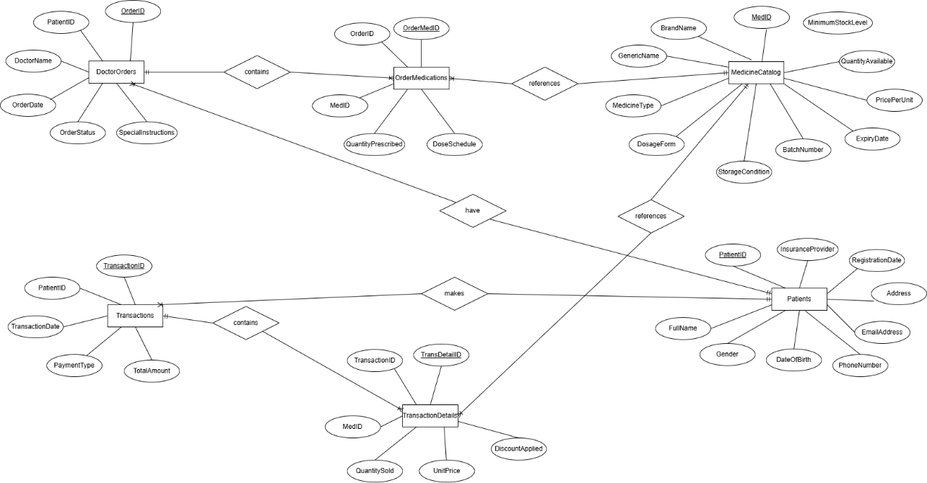
Figure 1: Required ERD
Source: (Author, 2026)

4. Data Structure Development
The database of MediLink pharmacy was introduced in Microsoft Access with the help of seven primary tables to handle medicines, suppliers, patients, prescriptions, and sales. The tables were designed with care to ensure that the data would be well-structured and would provide realism in the pharmacy operations.
- MedicineCatalog
  - Primary Key: MedID
  - Field Types: Text (BrandName, GenericName), Number (QuantityAvailable, MinimumStockLevel), Currency (PricePerUnit), Date/Time (ExpiryDate)
  - Constraints: Required fields for BrandName, GenericName, and QuantityAvailable; referential integrity for VendorID
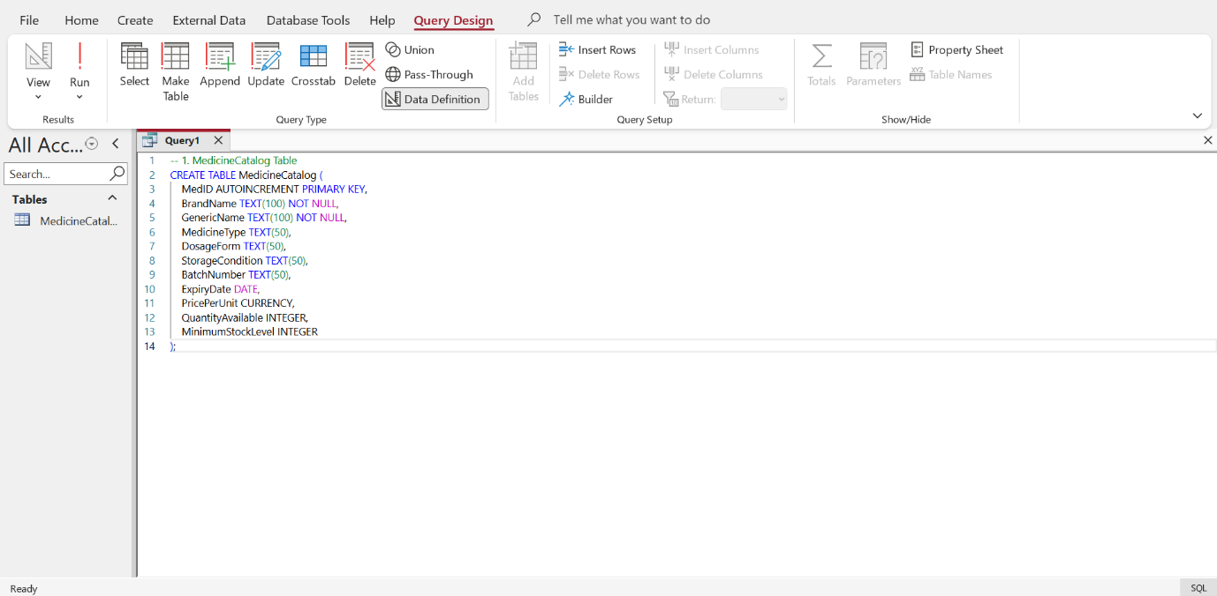
Figure 2: MedicineCatalog table creation
Source: (Author, 2026)
- Vendors
  - Primary Key: VendorID
  - Field Types: Text for names, contacts, and region
  - Constraints: Required CompanyName
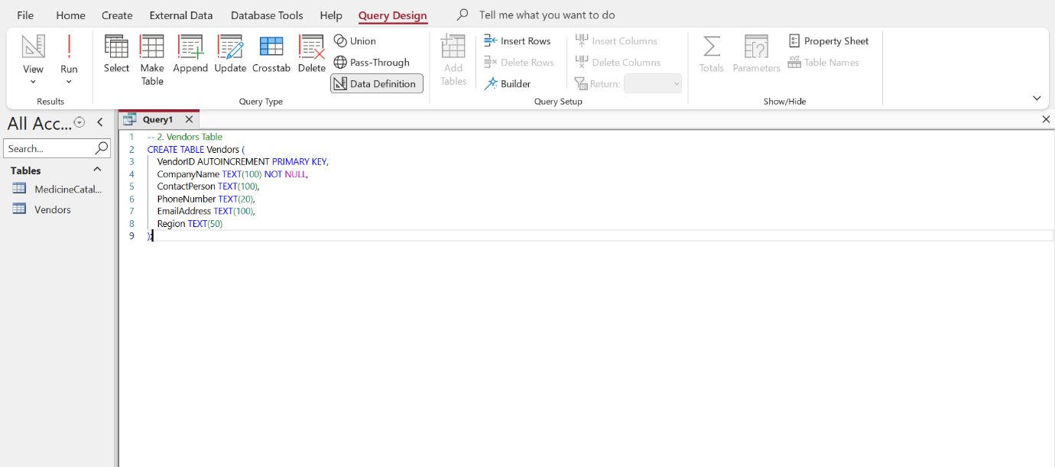
Figure 3: Vendors Table creation
Source: (Author, 2026)
- Patients
  - Primary Key: PatientID
  - Field Types: Text, Date/Time for DOB and RegistrationDate
  - Constraints: Required FullName
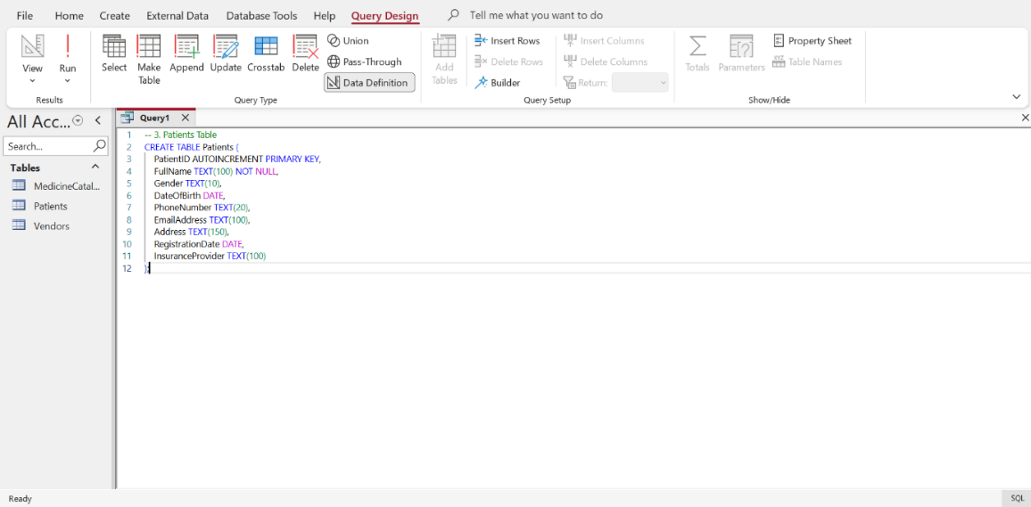
Figure 4: Patients Table creation
Source: (Author, 2026)
- DoctorOrders & OrderMedications, Transactions & TransactionDetails
  - The many-to-many relationships are solved through the use of junction tables.
  - Foreign keys are enforced on the connections of the patients, orders, transactions, and medicines [2].
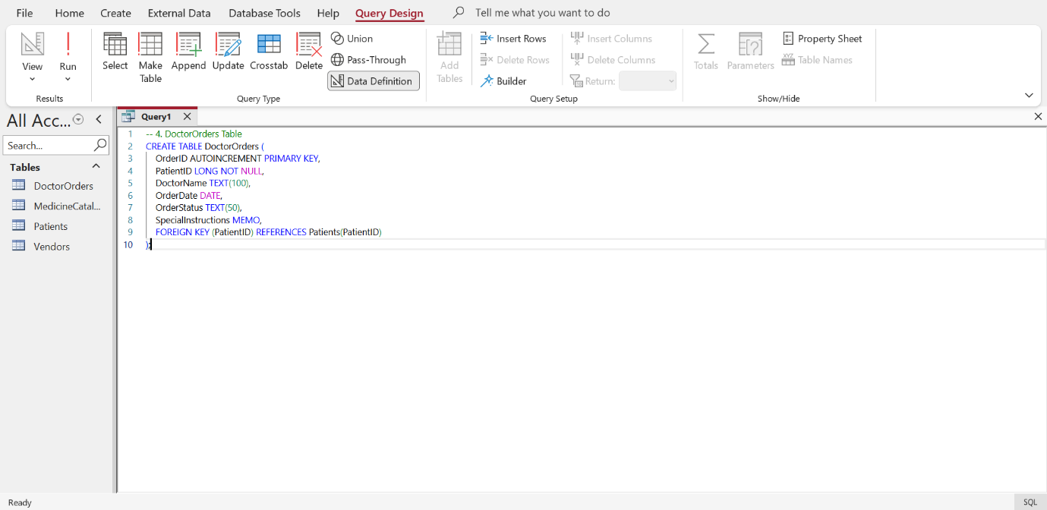
Figure 5: DoctorOrders Table creation
Source: (Author, 2026)
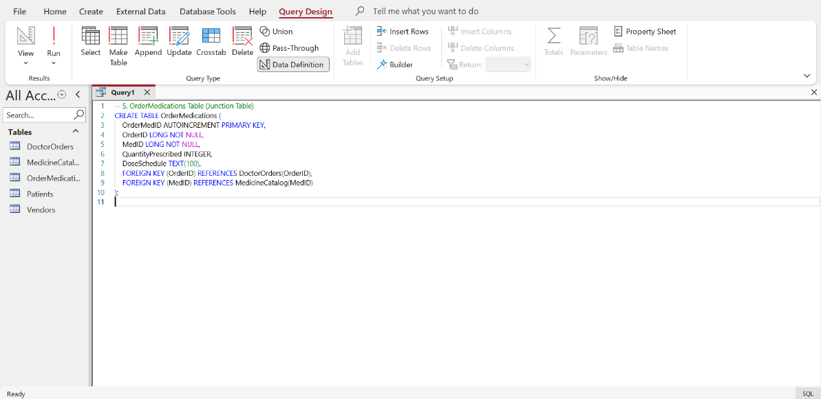
Figure 6: OrderMedications Table creation
Source: (Author, 2026)
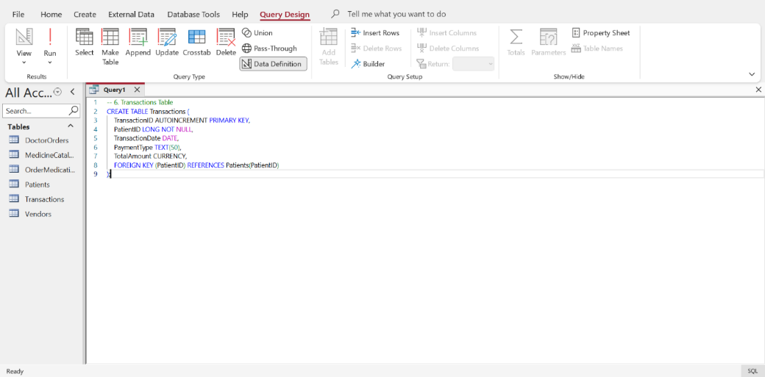
Figure 7: Transactions Table creation
Source: (Author, 2026)
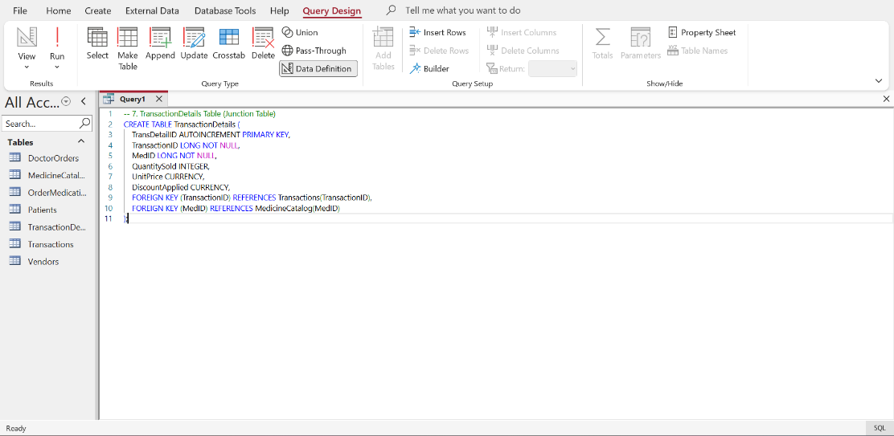
Figure 8: TransactionDetails Table creation
Source: (Author, 2026)
Referential integrity was applied to all the tables and required fields that could ensure accuracy, avoiding repetition of child records and constant entry of records.

5. Normalisation Compliance
The MediLink Pharmacy database has undergone normalisation to three normal forms (3NF) to achieve data integrity, redundancy minimisation, and effective data queries.
- First Normal Form (1NF):
  - The attributes have no group repetition and reportedly have no groups [3].
  - Details Each medicine record in MedicineCatalog contains one row of batch, expiry and quantity.
- Second Normal Form (2NF):
  - All the non-key attributes are entirely dependent on the primary one [3].
  - Example: DoctorOrders. When changing such fields as SpecialInstructions, OrderDate, etc., to rely on PatientID, they can only exist given OrderID.
- Third Normal Form (3NF):
  - None of the attributes are transitive, and all the non-key attributes are based on the primary key [4].
  - Examples: At OrderMedications, many-many relationships are resolved between DoctorOrders and MedicineCatalog, and in this circumstance, the issue lies in the fact that more than one medication can be written on a prescription; however, this information cannot be repeated.
  - Similarly, several medicines will also be resolved using a transaction and will be uniform across sales records with the use of TransactionDetails.
This structure provides a strong, scaled and sustainable database structure.

6. Sample Data Population
The MediLink Pharmacy database was filled with sample data, which was realistic and included UK-specific data, to demonstrate the real pharmacy operations. A minimum of 5 rows are contained in each table, which covers the daily operations of stock management, filling medication prescriptions and making sales.
- MedicineCatalog: It contains medicine of various types with different storage conditions, like Room Temperature or Fridge, with the batch numbers and expiry dates to replicate the reality of inventory monitoring.
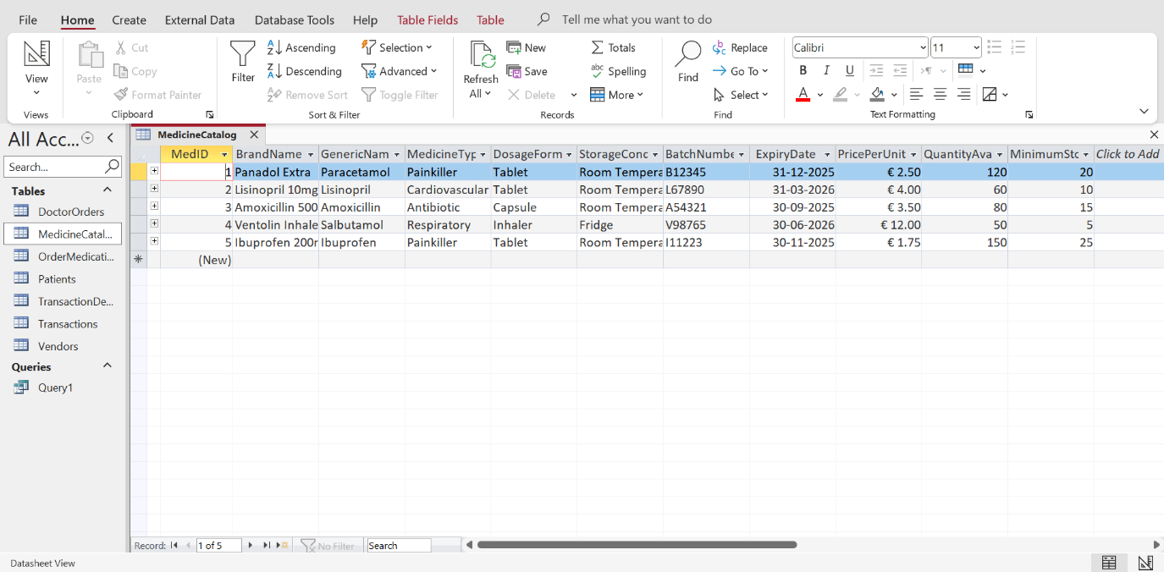
Figure 9: MedicineCatalog Table
Source: (Author, 2026)
- Patients: Addresses of the UK and insurance companies are given in records, and some patients are entitled to several prescriptions to check the functionality of the junction table.
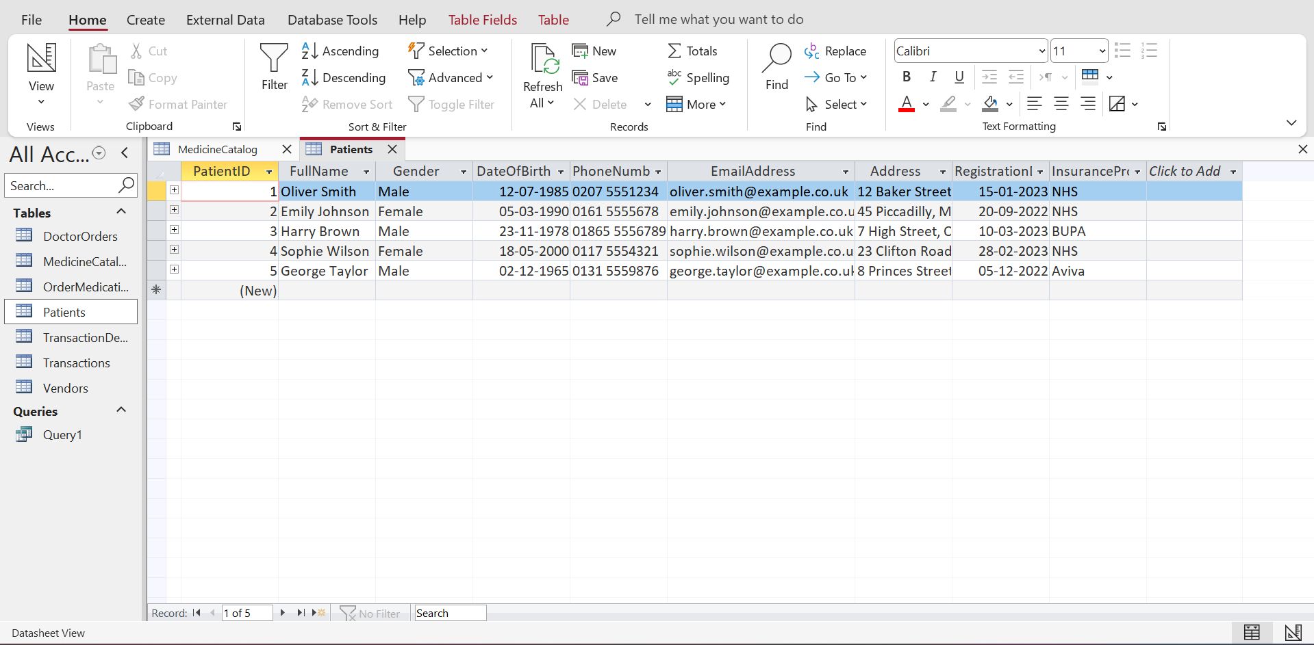
Figure 10: Patient Table
Source: (Author, 2026)
- DoctorOrders & OrderMedications: Show various medicines per prescription, dosage plans of each patient.
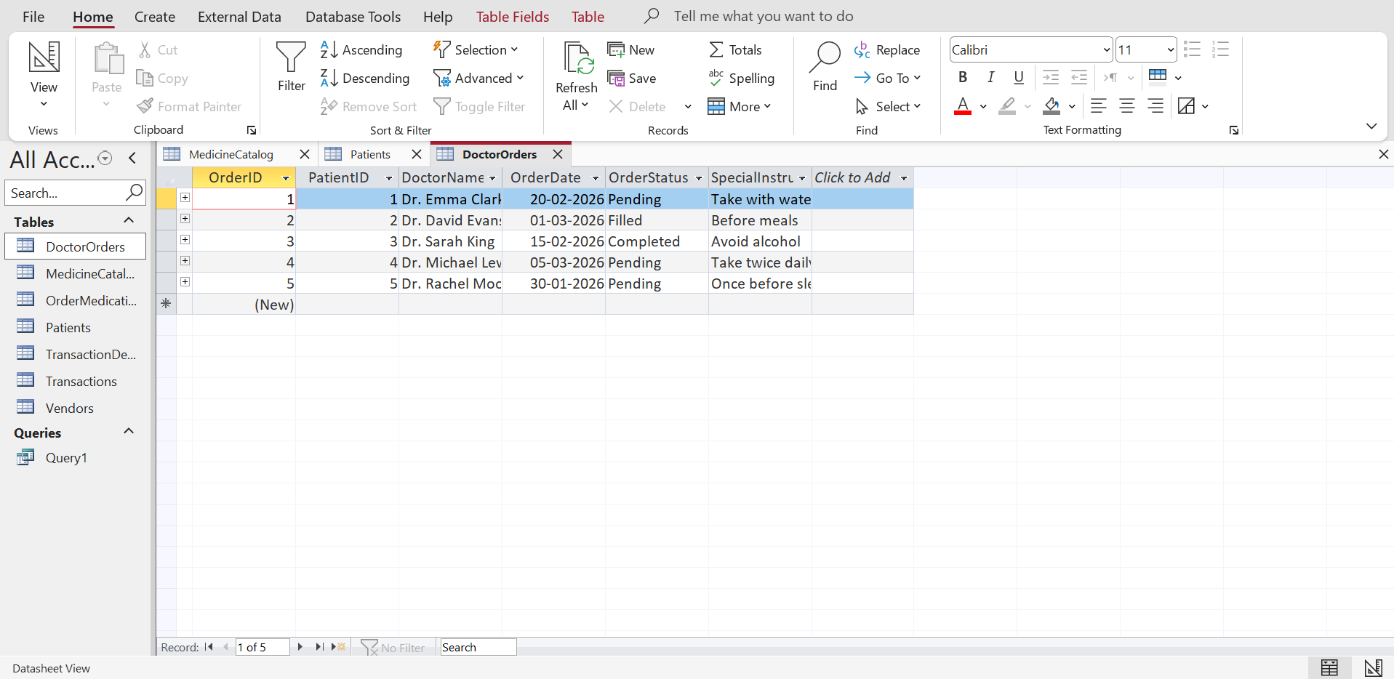
Figure 11: DoctorOrders Table
Source: (Author, 2026)
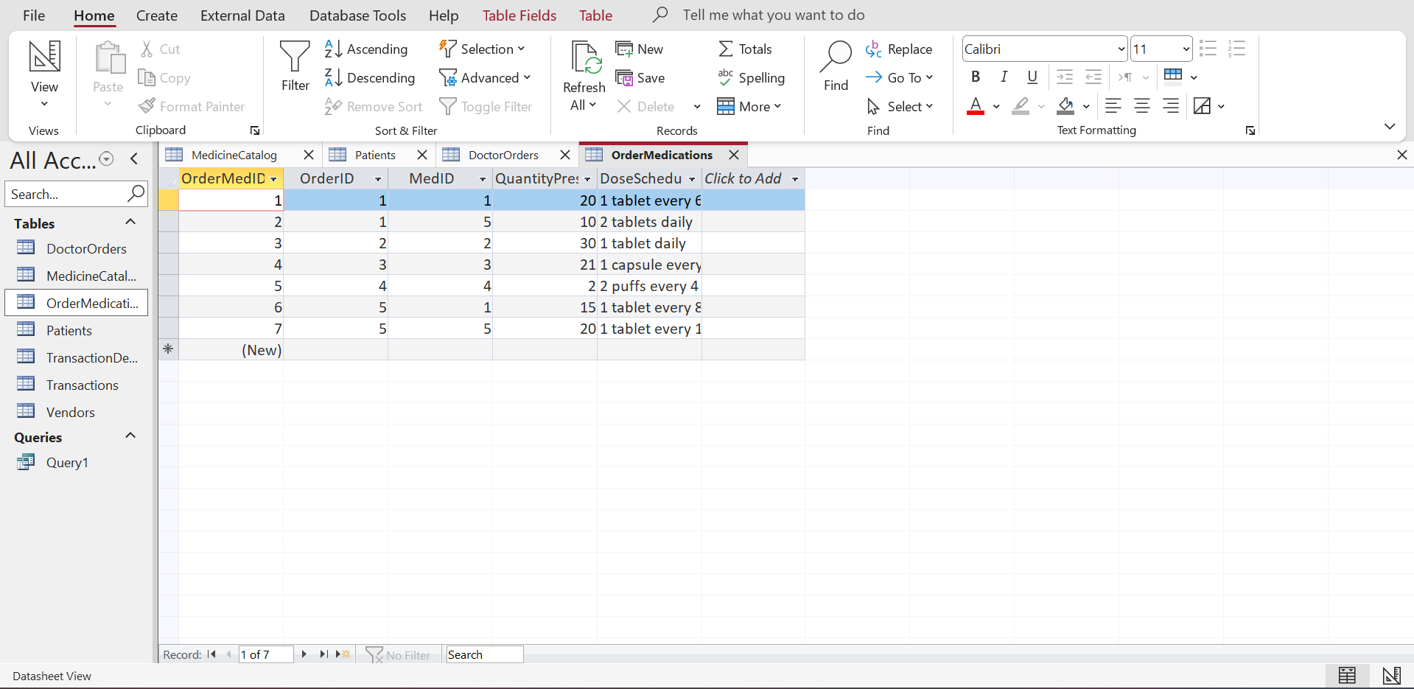
Figure 12: OrderMedications Table
Source: (Author, 2026)
- Transactions & TransactionDetails: Sales with various payments (Card, Cash, and Insurance) and various discounts are present and it is premised on the actual transactions of the pharmacy.
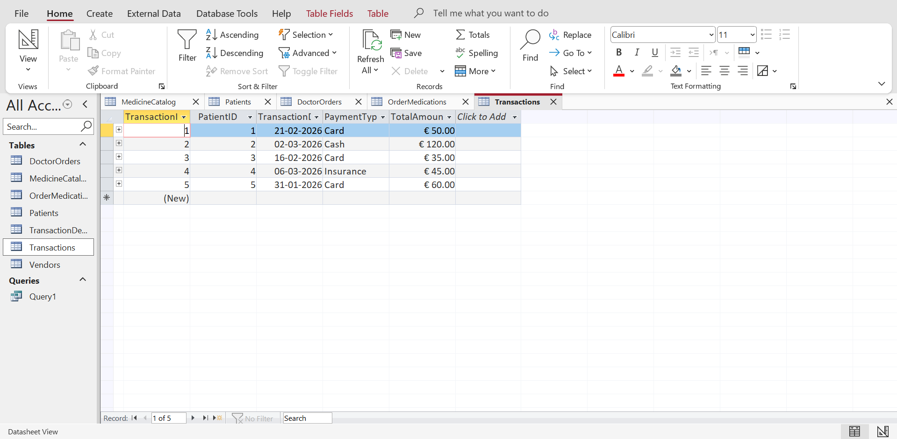
Figure 13: Transactions Table
Source: (Author, 2026)
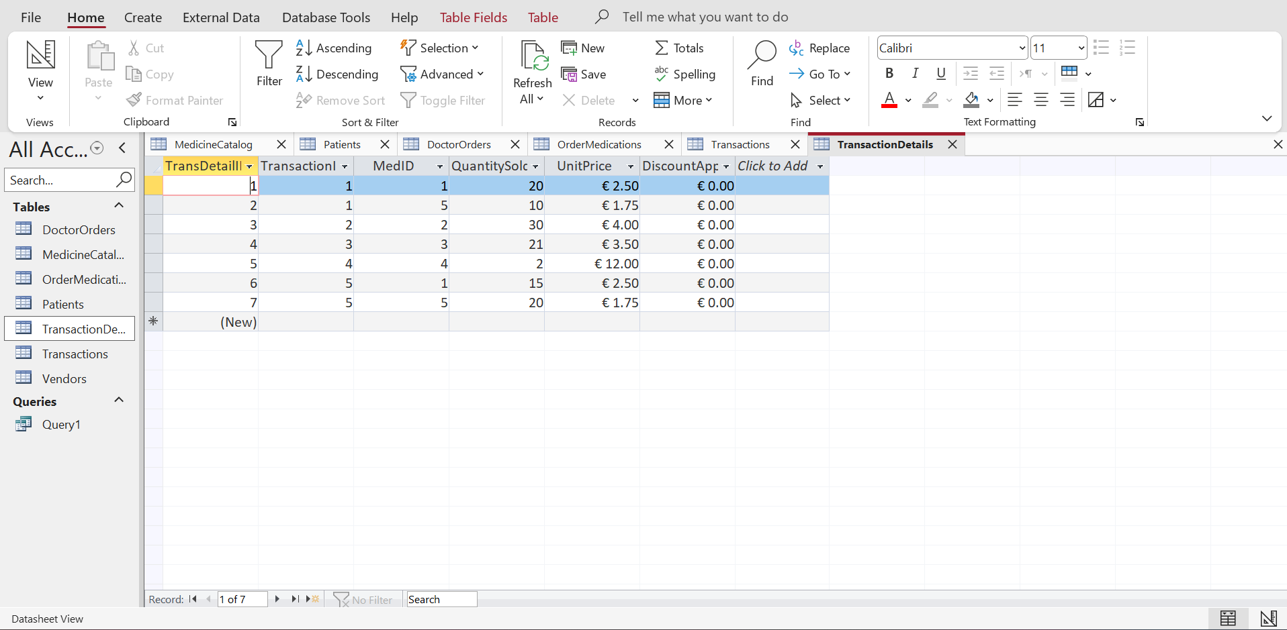
Figure 14: TransactionDetails Table
Source: (Author, 2026)
- Vendors: This section would have UK-based suppliers and the region-specific information needed to facilitate reporting.
This data set can ensure that queries and reports have a useful output and are not similar to other assignments, and present workflow testing with a realistic educational environment.

7. Query Development
- Medicines Requiring Special Storage
This query is used to determine medicines that require special storage, e.g., refrigeration, to avoid spoilage. It assists the pharmacy staff in tracking stock position, and safe storage measures can be maintained to support inventory and compliance.
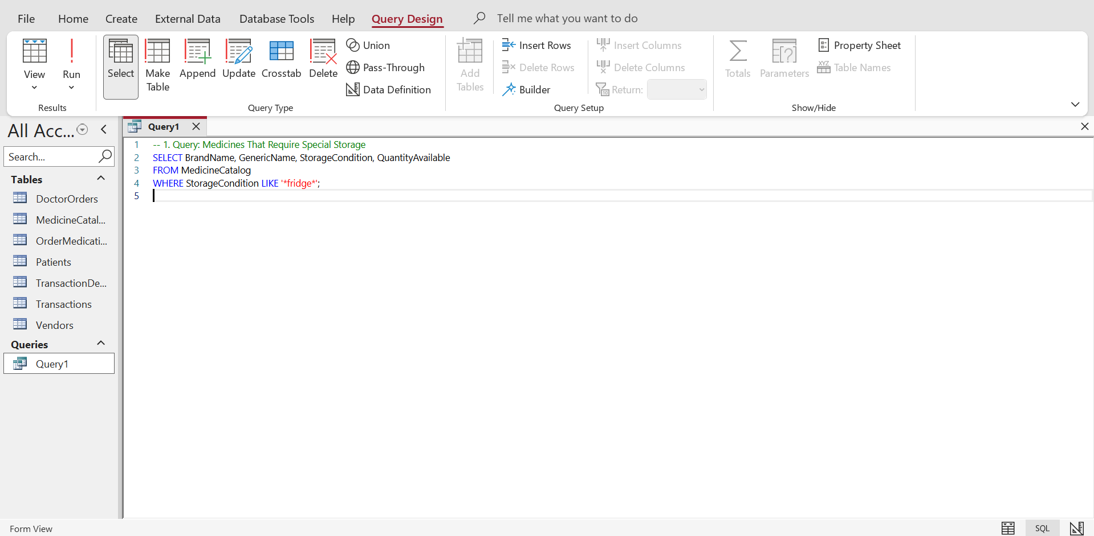
Figure 15: Query for Medicines Requiring Special Storage
Source: (Author, 2026)
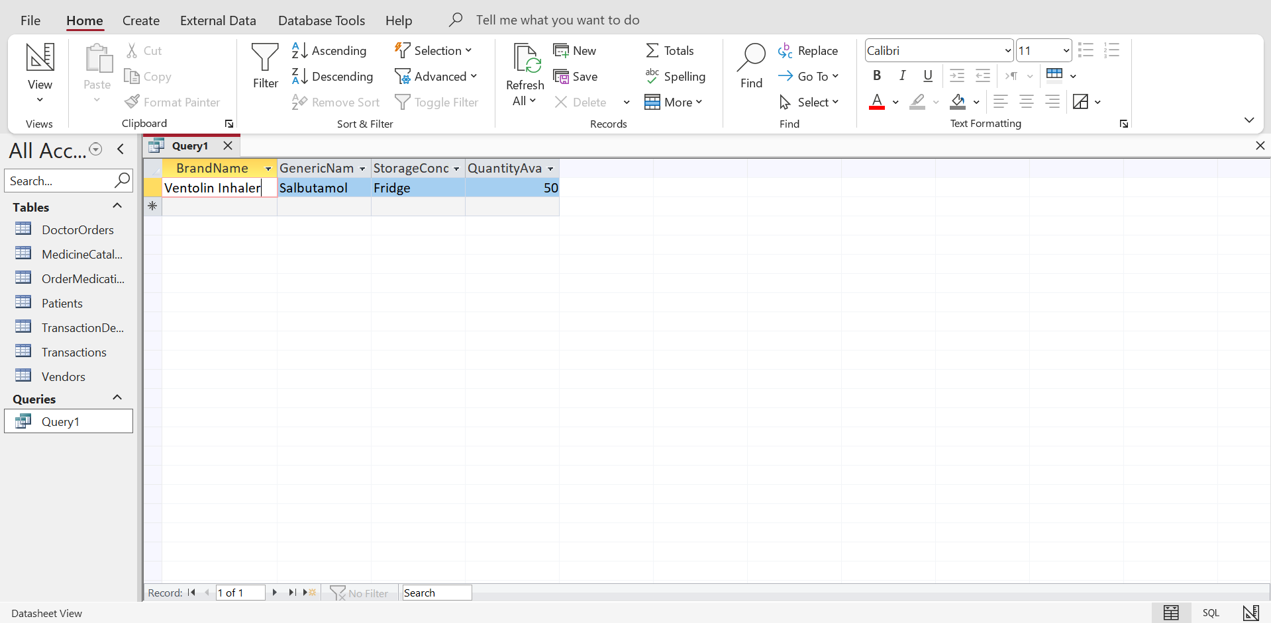
Figure 16: Results of Medicines Requiring Special Storage
Source: (Author, 2026)
- Pending Doctor Orders
This query generates all the unfilled prescriptions, and this allows the staff to prioritise the workflow. It shows the order tracking of patients and the dispensing of medicines on time.
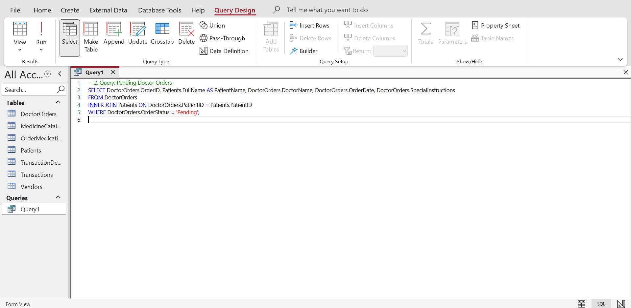
Figure 17: Query for Pending Doctor Orders
Source: (Author, 2026)
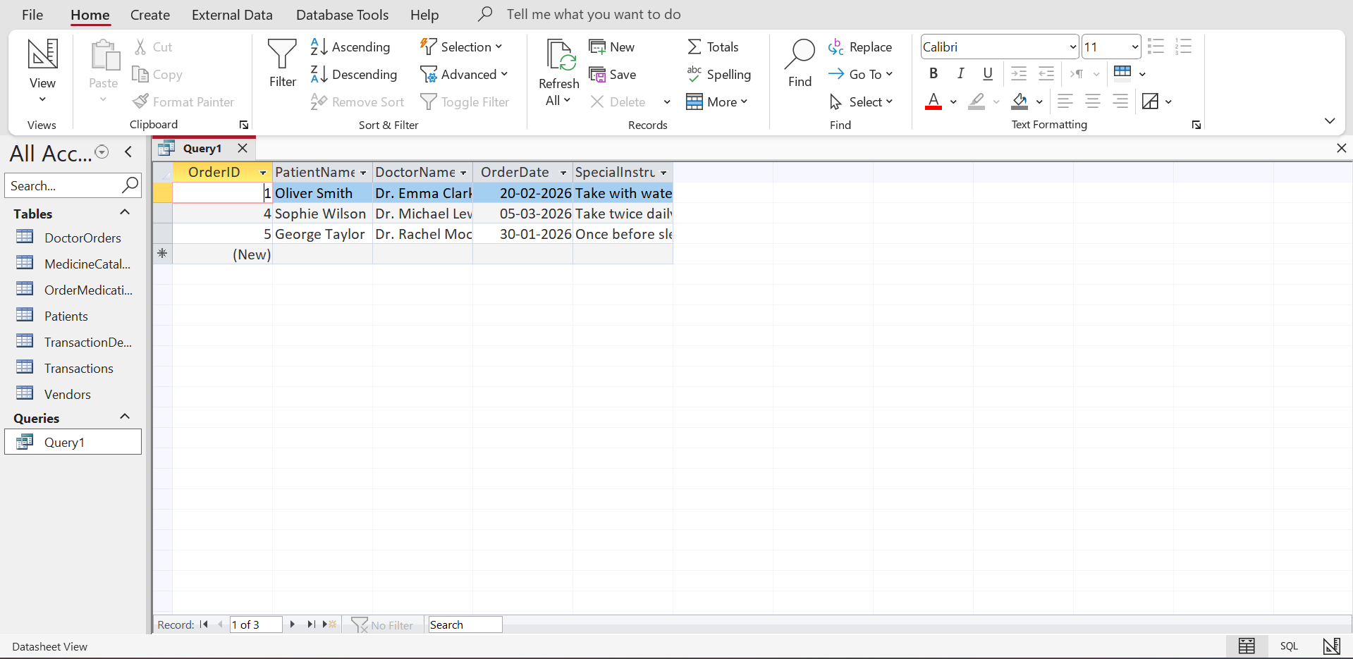
Figure 18: Results of Pending Doctor Orders
Source: (Author, 2026)
- Total Medicines Prescribed per Patient
This query involves the summation of all the medicines issued to a certain patient. It helps determine the needs of individual patients, assists in planning of stock, and ensures that the prescription of specific drugs is properly followed.
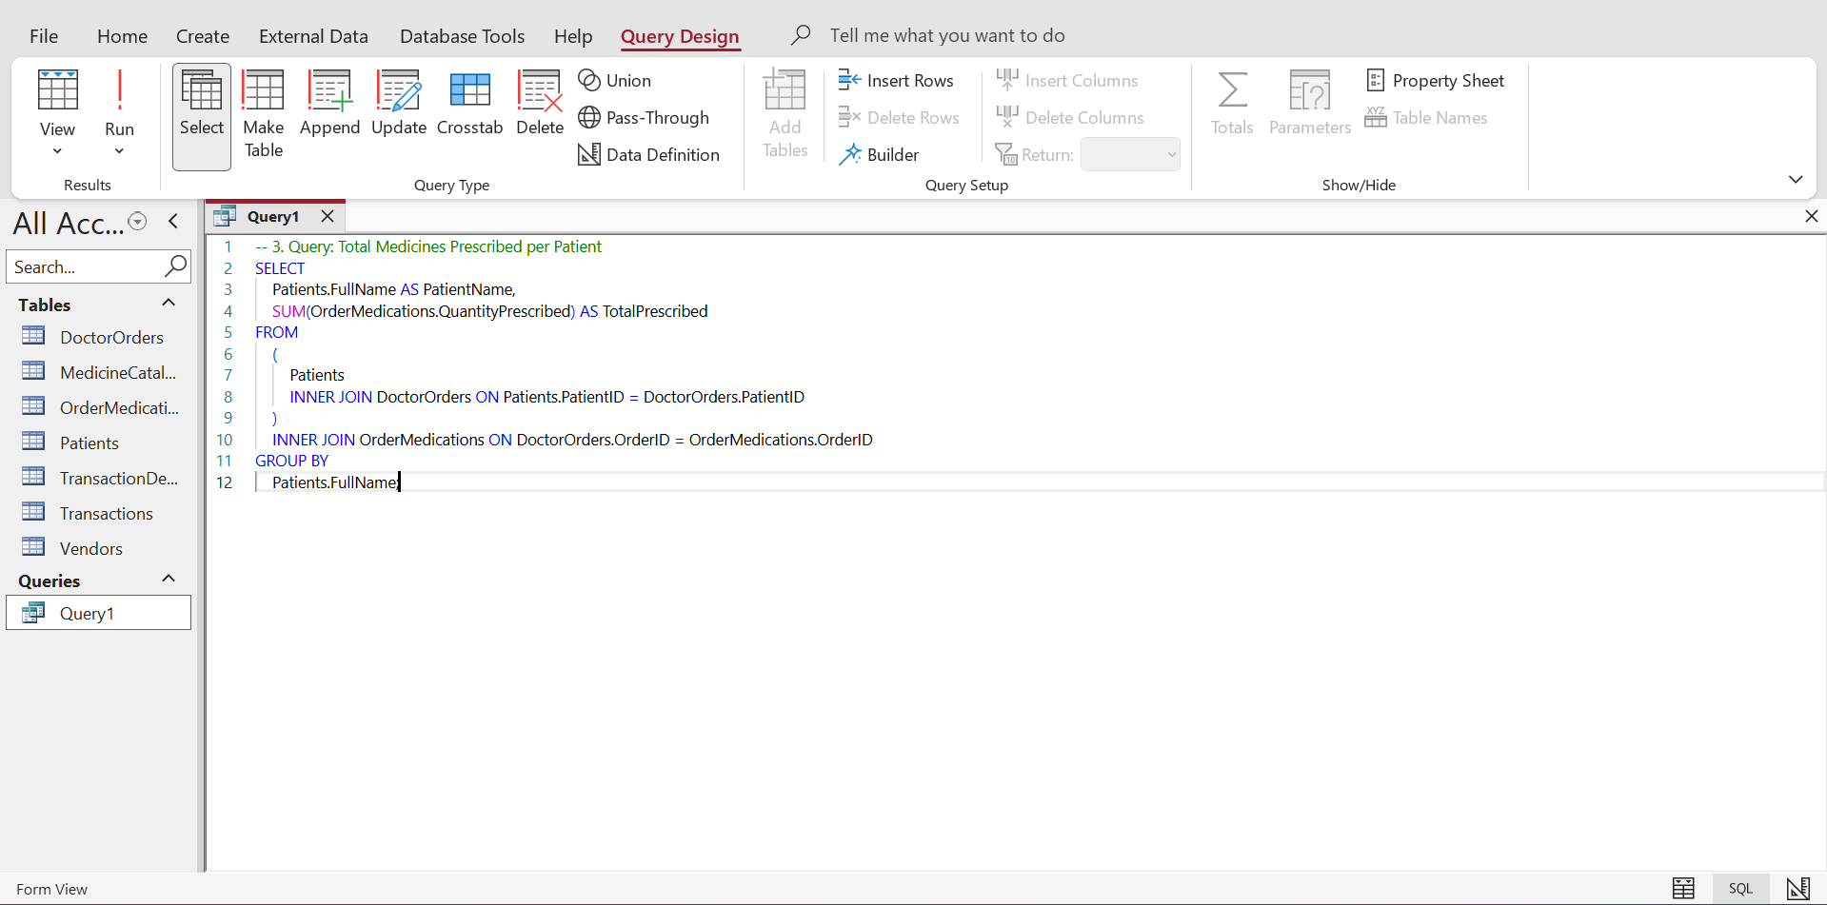
Figure 19: Query for Pending Doctor Orders
Source: (Author, 2026)
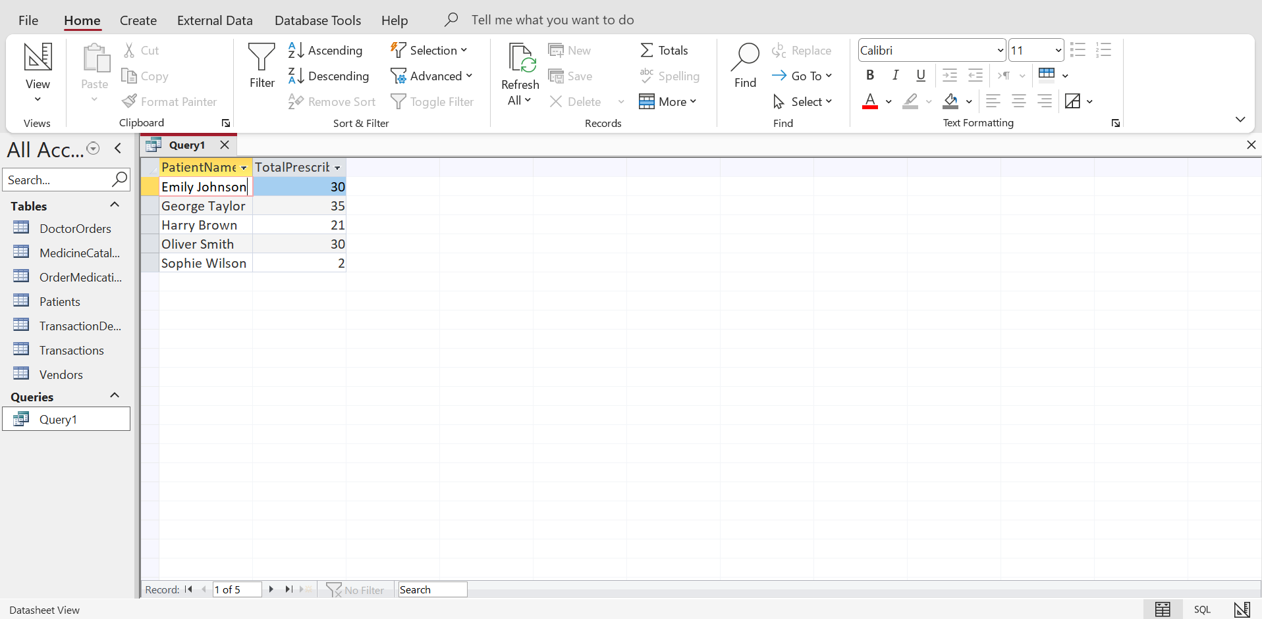
Figure 20: Results of Pending Doctor Orders
Source: (Author, 2026)
- Top-Selling Medicines
The query also determines medicines that are sold in the most number, and which are used to replenish the stocks and which are more popular. It helps to analyse the sales and make decisions on inventory management.
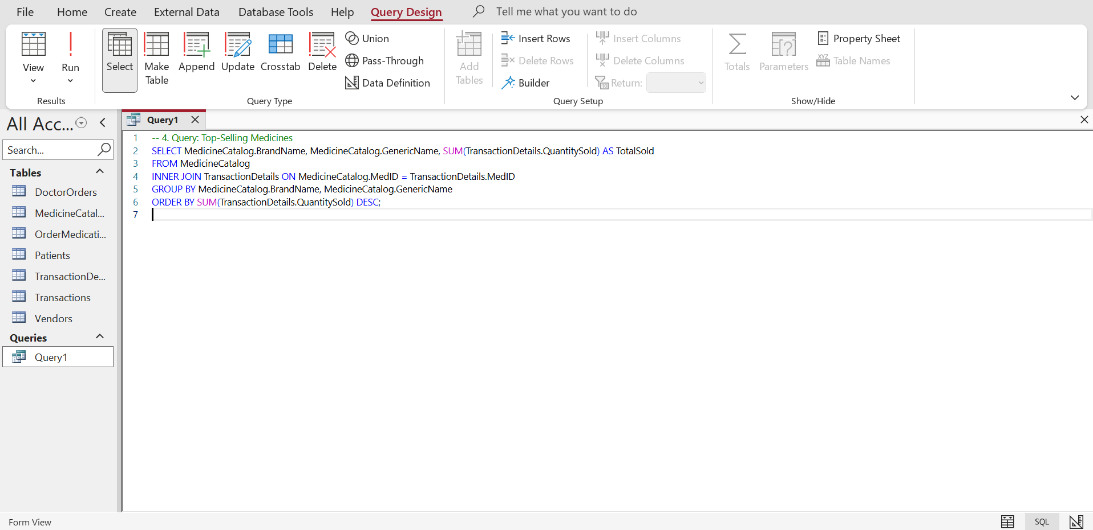
Figure 21: Query for Top Selling Medicines
Source: (Author, 2026)
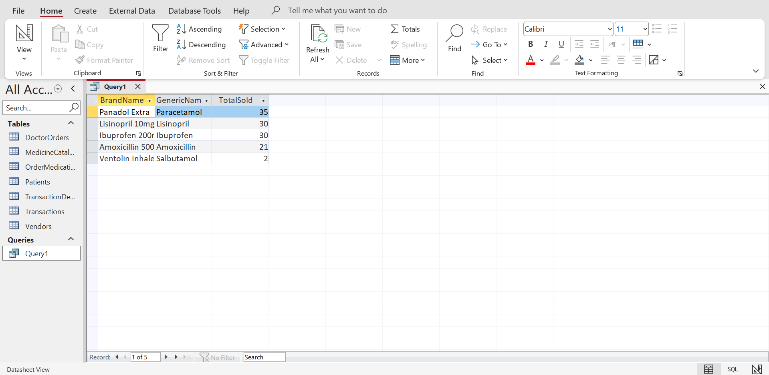
Figure 22: Results of Top Selling Medicines
Source: (Author, 2026)
- Patients with Pending Orders
This query will give all the patients whose prescription is pending. It shows tracking of workflow and assists in working out pending orders effectively to diminish delays and mistakes.
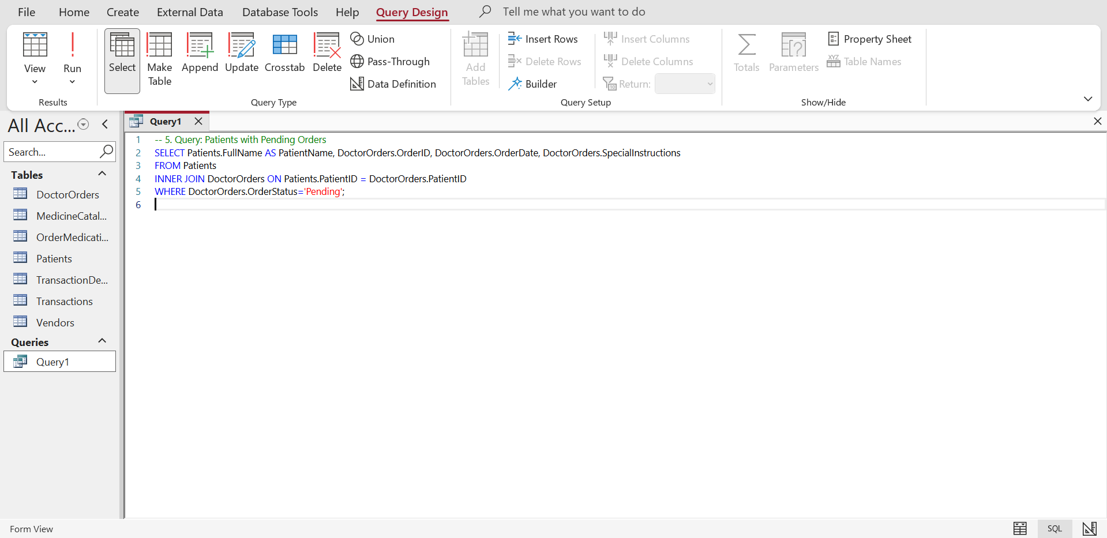
Figure 23: Query for Patients with pending orders
Source: (Author, 2026)
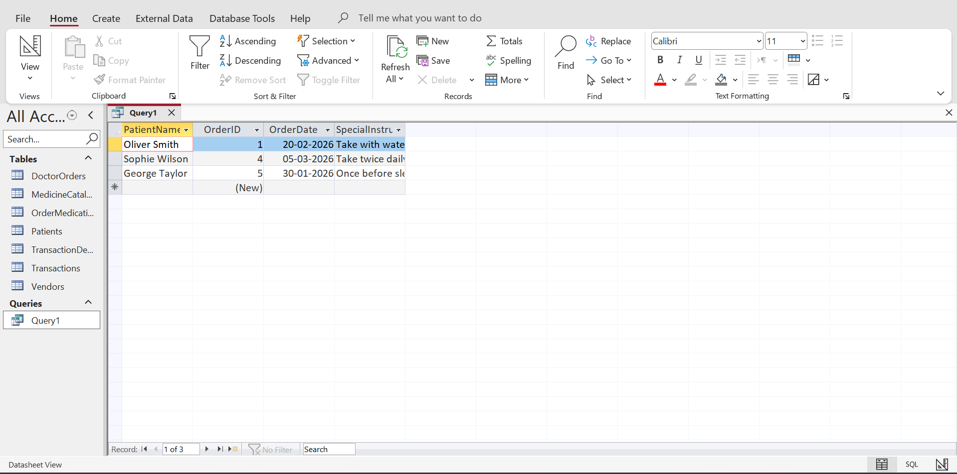
Figure 24: Results of Patients with pending orders
Source: (Author, 2026)
- Total Sales by Payment Type
In this query, the sales are summarised by the method of payment, such as Card, Cash or Insurance. It aids in the reporting, as well as decision-making in finance, as it displays revenue allocation.
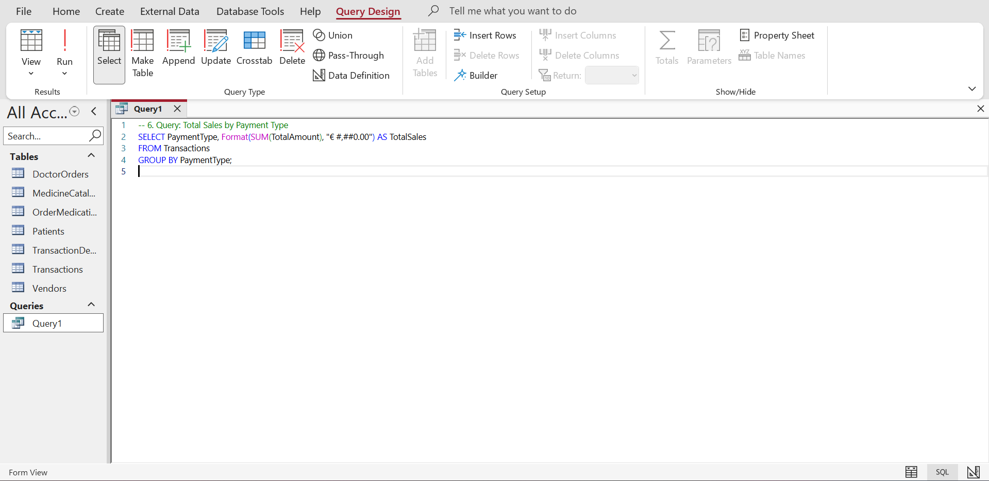
Figure 25: Query for Total Sales by Payment Type
Source: (Author, 2026)
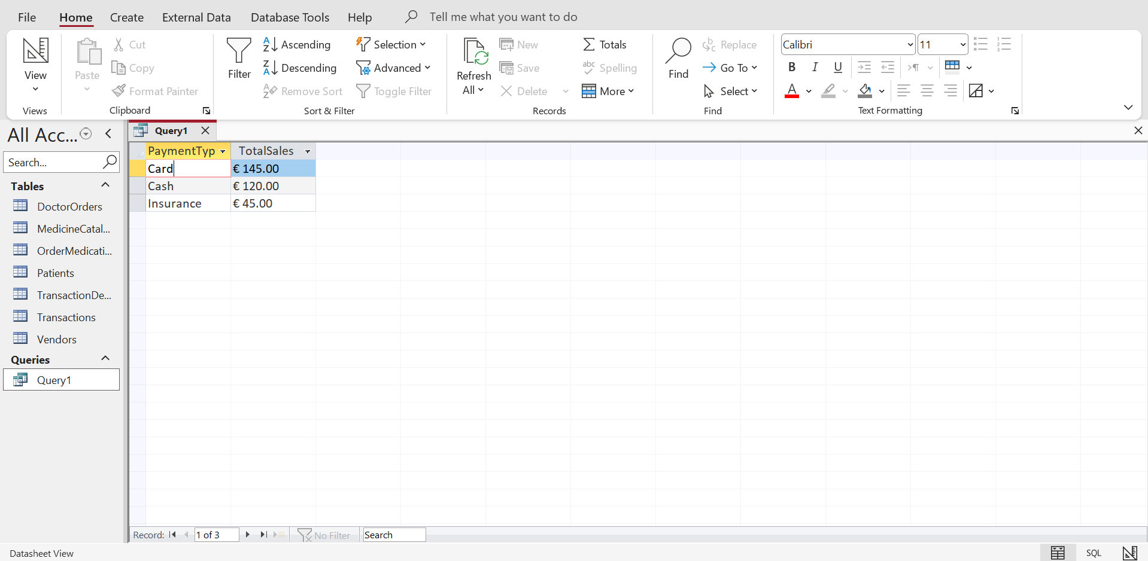
Figure 26: Results of Total Sales by Payment Type
Source: (Author, 2026)
- Medicines Near Expiry
This request presents drugs that are nearing expiry. It will help in rotating stocks and minimise waste, and enhance patient safety, as an expired product will not be sold.
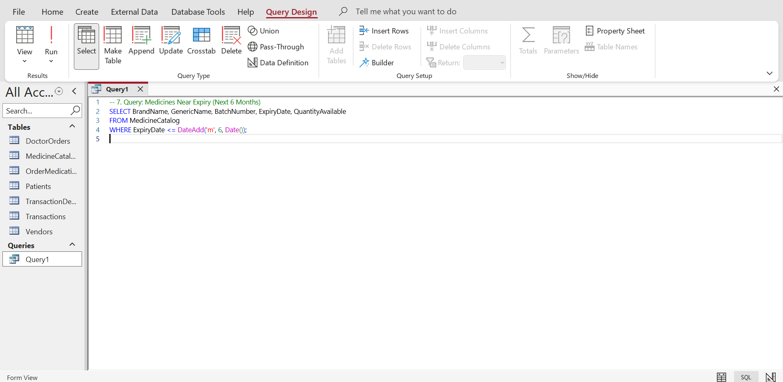
Figure 27: Query for Medicines Near Expiry
Source: (Author, 2026)
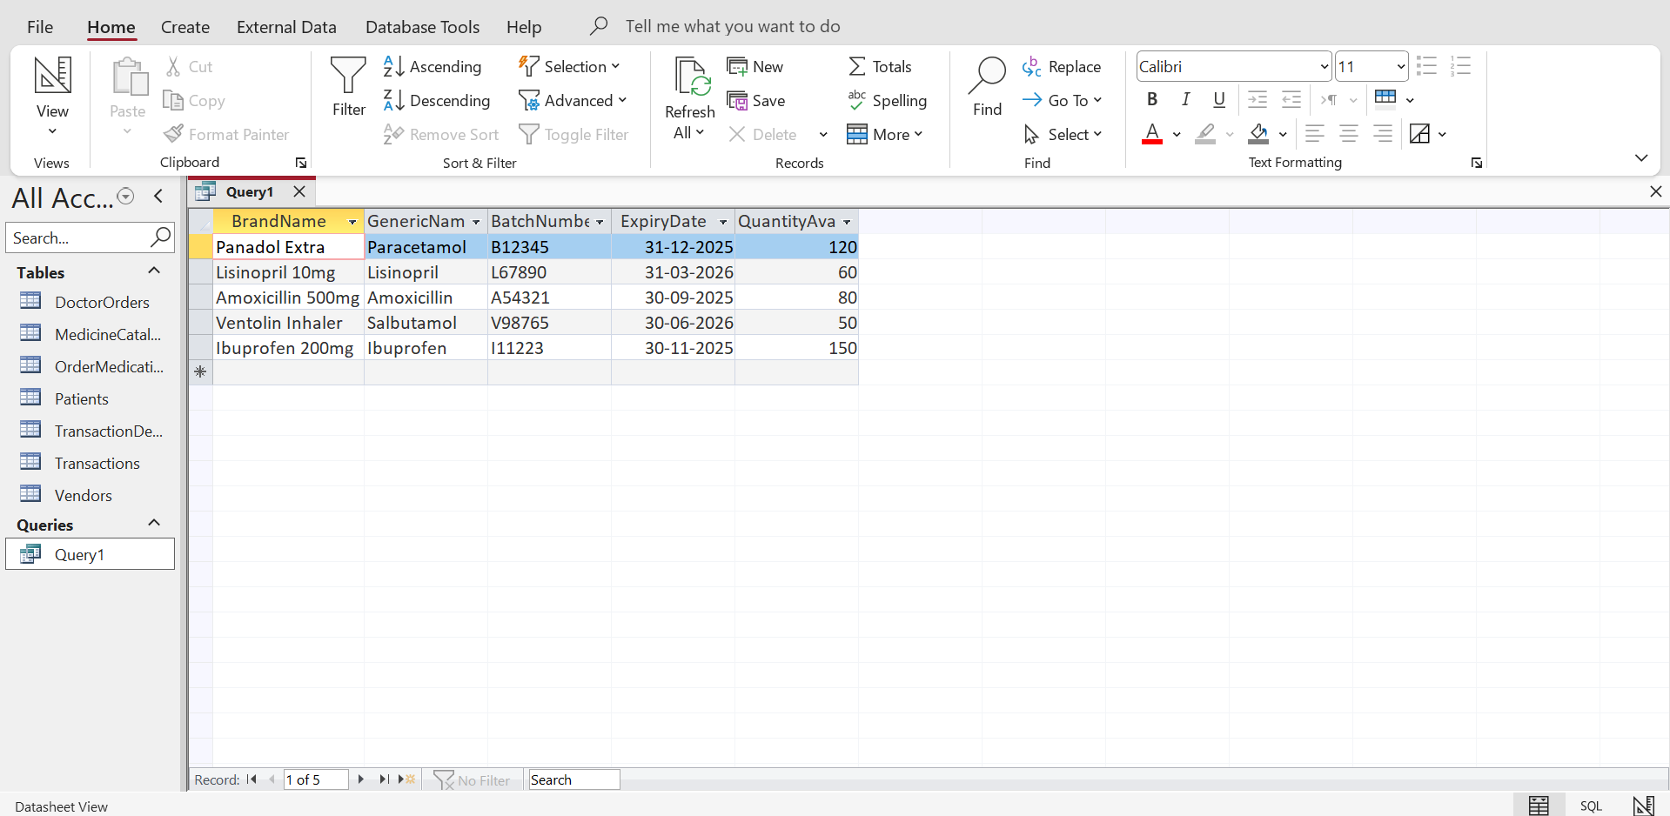
Figure 28: Results of Medicines Near Expiry
Source: (Author, 2026)
- Total Sales per Patient
This question determines the amount of money that a patient has spent. It enables tracking the activity of customers, loyalty analysis, and making marketing or service decisions.
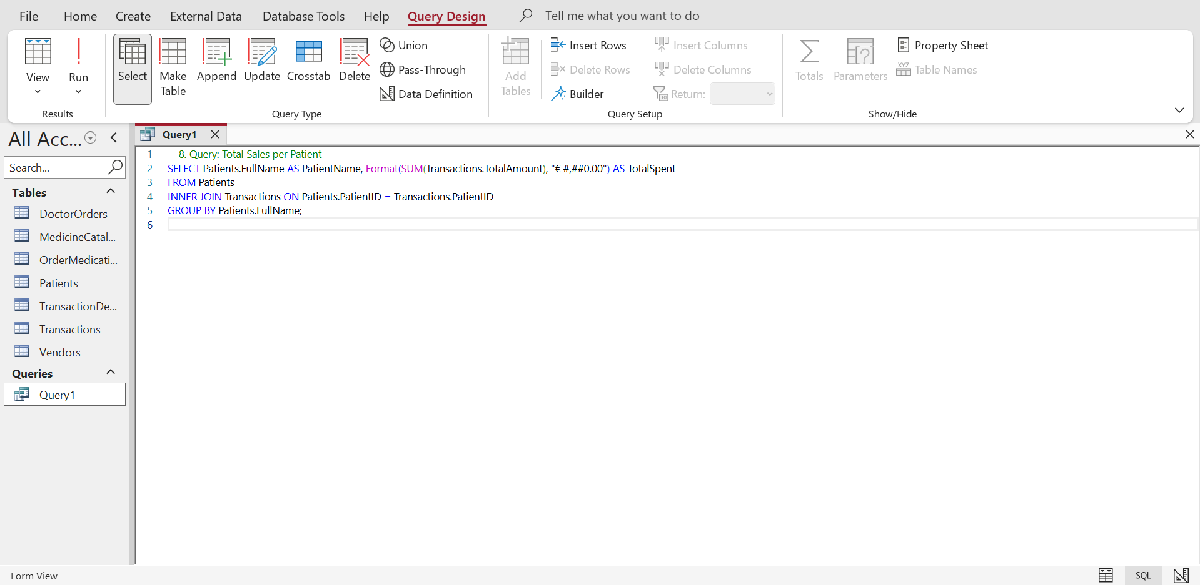
Figure 29: Query for Total Sales per Patient
Source: (Author, 2026)
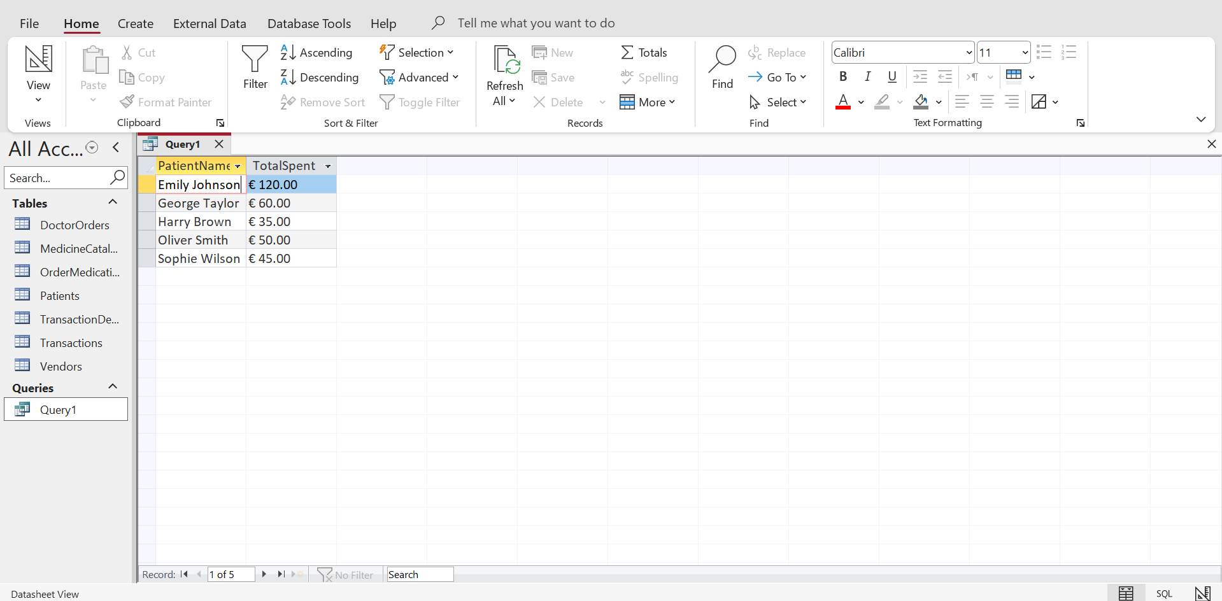
Figure 30: Results of Total Sales per Patient
Source: (Author, 2026)
- Orders with Multiple Medicines
It is a query that will pinpoint prescriptions that have over one medication. It illustrates how jurisdiction tables are used, aids in the tracking of prescriptions and proper dispensing of any necessary drug.
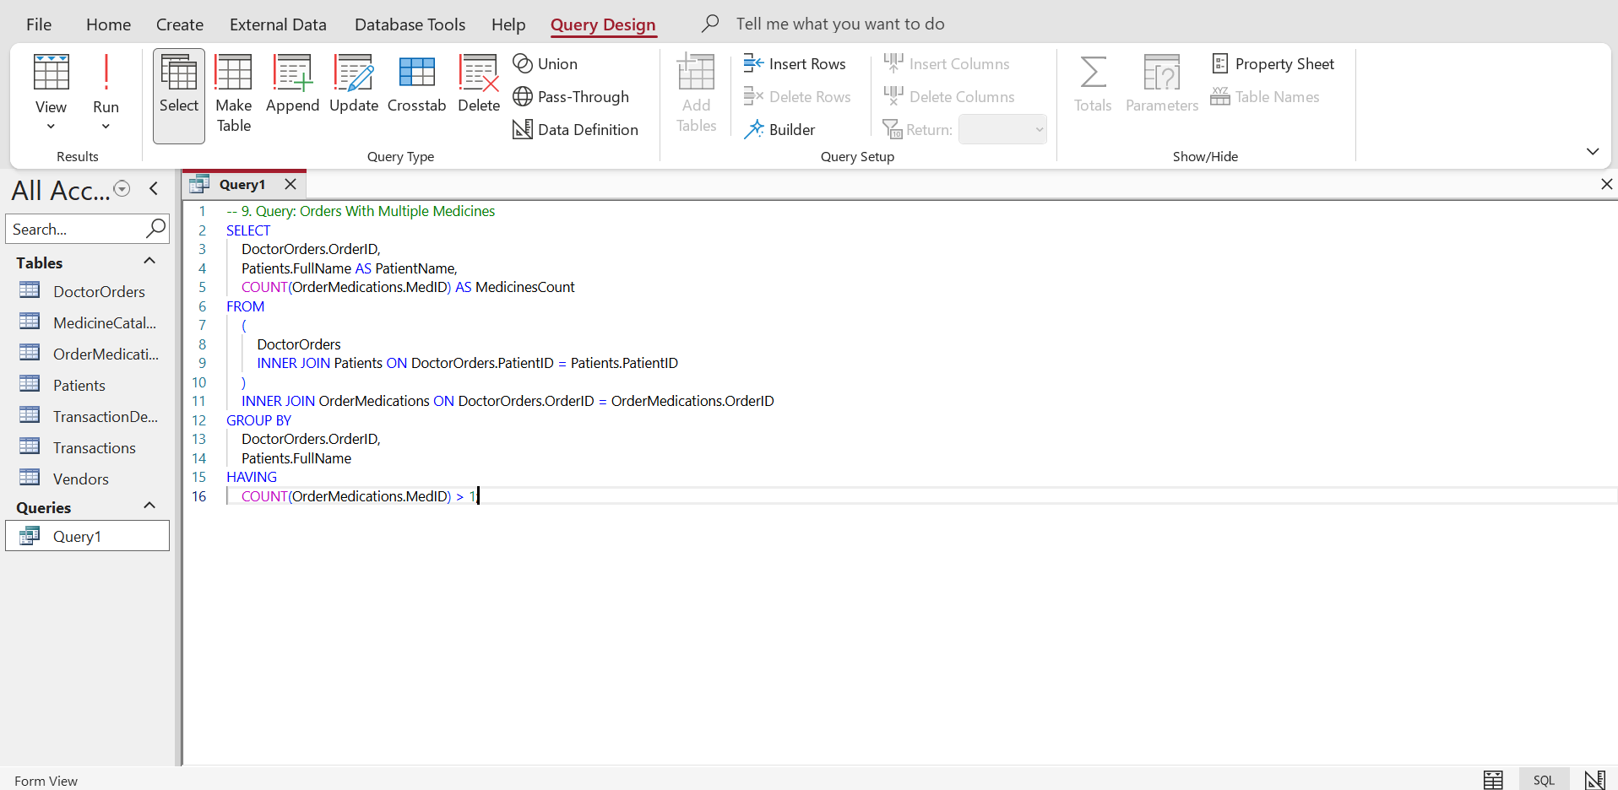
Figure 31: Query for Orders with Multiple Medicines
Source: (Author, 2026)
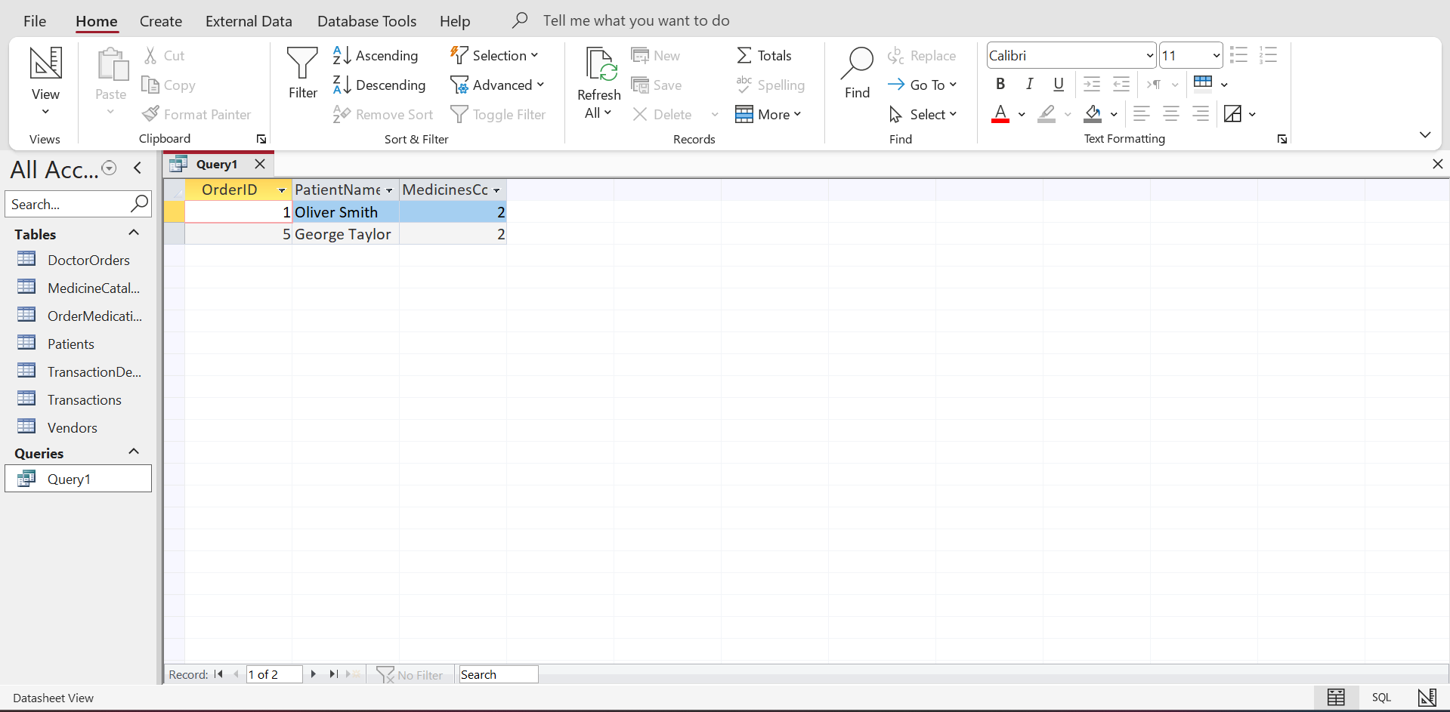
Figure 32: Result of Orders with Multiple Medicines
Source: (Author, 2026)

8. Validation and Testing
The MediLink Pharmacy database was strictly tested to comply with the requirements of functionality and data integrity. There were the following testing procedures:
- Adding Records: Records that concern medicines, patients, prescriptions and transactions were added to ensure that the required fields were properly entered and the required data was input.
- Running Queries: The designed queries were all executed to make sure that they yielded desired and correct results which included pending orders, bestselling medicines and medicines that were about to expire [5].
- Checking the Foreign Key Constraints: The constraints were utilised to verify relationship between the tables and that the junction tables avoided the orphan records and maintained referential integrity [6].
- Checking of Totals and Counts: Aggregate queries, e.g. sum of sales per patient, sum of medicines prescribed, etc., were verified on sample data as to their correctness [7].
These were small problems that were detected during the testing level: inconsistency when entering sample data and not adding dosage directions to certain prescription. This was rectified by revising records to get full and consistent records. Scenes with test results make him sure that everything is working as it should and the result is always the same.

9. System Evaluation and Reflection
Medilink Pharmacy database portrays several strengths. It is completely normalised to 3NF, and referential integrity is supported in all the tables and junctions to avoid the duplication of data, hence consistency [8]. Its design is a true-to-life representation of real-life pharmacy, such as inventory, prescriptions, and sales. Queries also have valuable outputs that can be applied in management decisions, including determining medicines that must be under special storage, tracking pending prescription and analysing sales trends.
There are several development problems that were faced. When building a complex query with many joins, parentheses and table relationships, attention is to be paid to avoid mistakes. It was necessary to plan the sample data to make it realistic and to ensure that it was strictly based in the UK. Moreover, the entire process of ensuring uniformity in dose command and batch information in two tables meant the same thing as verifying them again.
The suggested solutions might involve having automated forms to enter the order and transaction data to minimise errors in case of manual inputs, having warning messages about low stock or imminent expiry of specific medicines, and having more efficient reporting dashboards to have an overview of main metrics, which can aid in effective management of the pharmacy.

10. Conclusion
MediLink Pharmacy database is a full-scale system of databases, which is planned in Microsoft Access and has the ability to cope with the medicines, patient prescriptions, and sales transactions. It shows complete stock monitoring, prescriptions, and sales management, in addition to maintaining realistic pharmacy processes. The design is normalised in its entirety, possesses referential integrity and good utilisation of junction tables in order to support many to many relationship. There is the implementation of special queries, which include pending prescriptions, top selling medicine and, sold medicines, and medicines near expiration, to help in decision-making and reporting [9]. In general, the database has fulfilled all the functional requirements listed in the assignment brief and presented a very powerful, UK-based, and real-world solution to the pharmacy operations.

References
[1] N.M.A.M. Bohari, H. Rahmalan, N.A. Arbain, S. Mohtar & F.N.B.M. Leza, “AN AI-DRIVEN COLLABORATIVE ENGAGEMENT (CE) APPROACH FOR TEACHING AND LEARNING ENTITY–RELATIONSHIP DIAGRAM (ERD) DESIGN” Chief Editor, pp.1-639, 2025. https://www.researchgate.net/profile/Ker-Yuek-Li/publication/399854423_AI_Meets_Heritage_A_Concept_Paper_of_Co-Creating_YaoZhou_Kiln_Learning_in_the_Digital_Classroom/links/696b3f465cc49c35ce7f3a15/AI-Meets-Heritage-A-Concept-Paper-of-Co-Creating-YaoZhou-Kiln-Learning-in-the-Digital-Classroom.pdf#page=600
[2] W. Dong, J. Fang, K. Yi, Y. Tao, & A. Machanavajjhala, “R2t: Instance-optimal truncation for differentially private query evaluation with foreign keys,” Proceedings of the 2022 International Conference on Management of Data, pp. 759-772, June 2022. https://dl.acm.org/doi/pdf/10.1145/3514221.3517844
[3] N.A.R. Amato, “Mastering database normalization: A comprehensive exploration of normal forms,” Researchgate, pp.1-14, 2023. https://www.researchgate.net/profile/Nicola-Antonio-Roberto-Amato/publication/374509386_Mastering_database_normalization_A_comprehensive_exploration_of_normal_forms/links/652106cffc5c2a0c3bbe361d/Mastering-database-normalization-A-comprehensive-exploration-of-normal-forms.pdf
[4] Z. Zhang & S. Link, “Synthesizing third normal form schemata that minimize integrity maintenance and update overheads: parameterizing 3nf by the numbers of minimal keys and functional dependencies,” Proceedings of the ACM on Management of Data, vol. 3, no. 3, pp.1-25, 2025. https://dl.acm.org/doi/pdf/10.1145/3725362
[5] T. Taipalus & H. Grahn, “Framework for SQL error message design: A data-driven approach,” ACM Transactions on Software Engineering and Methodology, vol. 33, no. 1, pp.1-50, 2023. https://dl.acm.org/doi/pdf/10.1145/3607180
[6] T.R. Braide & I.C. George, “ENHANCING DATABASE RELIABILITY THROUGH PARTIAL REFERENTIAL INTEGRITY ENFORCEMENT,” Ayden Journal of Intelligent System and Computing, vol. 13, no. 2, pp.13-19, 2025. https://aydenjournals.com/index.php/AJISC/article/download/1070/1066
[7] B. Shah, P.M. Jat & K. Sashidhar, “Performance study of time series databases,” arXiv preprint arXiv:2208.13982, pp.1-14, 2022. https://arxiv.org/pdf/2208.13982
[8] M. Hardini, V. Agarwal, D. Apriani, I.A. Widjaya, E. Setiawaty & N. Nurasiah, “Application of database normalization in increasing data storage efficiency,” International Transactions on Artificial Intelligence, vol. 3, no. 2, pp.201-211, 2025. https://journal.pandawan.id/italic/article/download/799/592
[9] S. Abdy & S. Ramadhany, “Relational Database Design Principles: Normalization, Denormalization, and Query Optimization for Database Management Systems,” International Journal of Economics Management and Social Science, vol. 9, no.1, pp.180-192, 2026. https://journal.salewangang.net/ijemss/article/download/43/40

