ENTREPRENEURIAL
EDUCATION
P146061

Content Page

Portfolio…………………………………………………….......…………………….......3
- Introduction
- The Educational Entrepreneurial Opportunity
- Target group
- Content
- Resources
- Rationale
- Links to the curriculum
- The learning aims and objectives
- Skills developing within the learners
- How will you assess and evaluate it?
- Conclusion

Reference List…….………………………..……………………...……………………...13

Appendix A…………………………...…..……………………...………………….…….14

Appendix B……………………………….……………………...………………….…….15

Appendix C………………………………….…………………....………………….……16

Appendix D………………………………….…………………....………………….……18

Appendix E………………………………….…………………....………………….……19

Appendix F………………………………….…………………....………………….……20

Portfolio – Entrepreneurial Education

Introduction
Entrepreneurial Education is defined as the process of ‘developing students in a manner that provides them with an enhanced capacity’ for learners to be able to ‘generate ideas, behaviours, attributes and skills’ (QAA, 2018, p. 9) Thea Visser also supports the definition of entrepreneurial education stating that entrepreneurial education aims to ‘develop behaviours, skills and attributes’ for learners (Visser, 2016, p. 23). The main concept behind entrepreneurial education is to provide learners with an increased educational gain by participating in entrepreneurial education. Partaking in entrepreneurial education allows learners to receive many advantages such as developing employability skills, entrepreneurial skills and other key transferable skills such as critical thinking and creativity.

This portfolio will talk about an entrepreneurial education opportunity which will take place in primary schools in Swansea and how the opportunity enhances creativity and critical thinking skills. The aims of this portfolio are to also find out how entrepreneurial skills from the ‘ACRO Model’ are developed by this opportunity and how this opportunity is relevant to 21st century learning.

The Educational Entrepreneurial Opportunity
To support healthy eating week, the educational entrepreneurial opportunity that will be conducted will be a smoothie making competition which will take course at the end of the four-week process. This competition will take place in primary schools in Swansea. The idea behind this competition is to teach young learners more about healthy eating in a more entrepreneurial approach. This means this process will allow young learners to receive and increase many transferable skills such as critical thinking, creativity as well as developing entrepreneurial skills shown in (Appendix A). (Appendix A) shows the skills and behaviours of the ‘ACRO Model’, the ‘ACRO Model’ is identified as a template of what skills and abilities an entrepreneur should possess to be successful. The skills that the young learners will benefit from this process are crucial to success within 21st century learning. The ability to understand digital skills, become more creative and better at problem solving is emphasised massively during this four-week process.

This educational entrepreneurial opportunity will be begin four weeks prior to healthy eating week and the smoothie making competition will take place on the week of healthy eating week. Healthy eating week is emphasised greatly in schools whether it is primary or secondary. Healthy eating week focuses on getting learners to learn more about healthy eating, being more active, making healthy meals and understanding more about different foods. Studies show that ‘introducing simple competition’ to young learners is a great way to get learners to show their ‘competitive streak’ and be more active with their learning (Kershaw, 2014). Kershaw also states that ‘competition could be the key to healthy eating’ (Kershaw, 2014). This is the main idea behind this concept, to get more young learners actively involved in their learning and by doing that, they will receive many benefits within such as achieving multiple skills and more extensive knowledge on healthy eating. This competition also is promoted and involved with the ‘The Healthy Eating in Schools (Wales) Measure 2009’ which emphasises that schools should provide ‘appropriate action to promote healthy eating and drinking’. Schools should also ‘encourage’ young learners to ‘enjoy healthy options’ (Welsh Government, 2014, p. 4). The Healthy Eating in Schools (Wales) Measure 2009’ is a fundamental reason why this competition is conducted. In the school environment, learners need to be constantly updated and always informed more about healthy eating, so they can adapt healthy eating in their life.

Target group
This competition is aimed at young learners aged from six to seven years old. This is targeted at year groups of year one and year two. The competition is targeted at all pupils, male and females as it is promoting healthy eating which is suitable for all learners. The idea is mainly targeted at foundation phase but only year one and year two as the learners grow to become more active, responsive and have grown to become more independent in their learning at that age. The idea of developing great transferable skills at a young age could lead to great success for the young learner within education and the business world.

Content
Each two-hour session will be conducted in the classroom. There will be four classes involved, two classes of year one and two classes of year two. If you look at the scheme of work in (Appendix B), you can see that each session will last two hours which is plenty of time to allow learners to partake in the activity of each session and complete the work. In the lesson plan in (Appendix C), you will see that each class should be around 20 pupils with three learning support assistants (LSA) and the teacher which would mean each teacher will have a group of five each. If there are more pupils, teachers can adapt and add more pupils into their group. The scheme of work (Appendix B) shows a plan of how the four sessions will be delivered week by week. Whereas (Appendix C) the lesson plan, has a more in-depth description of how session three out of the four will be conducted.

In session one, the main goal will be to express the aims and objectives of this opportunity to the young learners as stated in the scheme of work (Appendix B). Explaining the aims and objectives will allow learners to know and be informed with what they need to achieve and how they will achieve it. There will be group discussions for learners if they have a questions or concerns. In session one, there will also be poster making to advertise competition to post around the school to get more attention from other pupils, teachers and parents.

Session two will be similar to session one but the instead of poster making, the young learners will have to make leaflets to hand out. These sessions are made to be easy and understandable for the young learners but also for them to be capable of completing the work. Along with the leaflet making, once completed, teachers will conduct a feedback sheet with each individual which will be documented and used as a tool to recognise improvement and progress of the young learners. The feedback sheet will be conducted at the end of each session in session two, three and four as stated in the scheme of work (Appendix B).

The third session is poster making but with a twist that involves more of an independent approach to it. As you can see in the lesson plan (Appendix C) which is a more in-depth description of session three. The young learners are expected to make a recipe for their entry of their own smoothie recipe idea which will be handed to the teacher. The teacher will choose only one of the 20 pupils recipe idea in each class. Amongst the four classrooms, there will be four final recipe ideas from each class.

The final session will be conducted on the week of healthy eating week. Learners will be out of the classroom for this session and will be in the school hall for the competition. Each class will have to produce their final smoothie, put it in plastic cups ready to sell. The team that sells the most smoothies are ultimately the winner of the competition and will receive incentives for participation.

The positives with the activities involved in these four sessions are that they aim to develop creative skills by the poster making and leaflet making. As well as developing the ACRO Model skills in (Appendix A) throughout the four sessions such as innovation, teamwork, leadership and problem solving. This competition aims to enhance and develop various skills, as well as key skills that are relevant to 21st century learning. These 21st century skills (Trilling, 2009, p. 48) states are such as ‘information, media and technology skills’. Fundamental skills such as ‘life and career skills’; as well as ‘innovation skills’ and ‘critical thinking skills’. The other benefits of this process are that it allows learners to gain more than just skills, it allows learners to learn more about their own health and wellbeing and key employability skills for the future. The negatives can be that there may not be just 20 pupils in each class, there may be more which means teachers would need to adapt and take more pupils in their group. Small adjustments like these could influence many opportunities for others. Some learners may benefit more, and some learners may learn less. The main idea is to provide equal opportunities for all the learners, so all the learners have the same advantage.

Resources
The key attraction to this form of competition is that it is low cost and based in school which saves money. This competition is targeted to be easy to partake in for schools around Swansea and so that schools can heavily rely on the school budget to fund this competition. The learning sessions will take place in the classroom and the competition on the final day will take place in the school main hall. Every resources needs and role are explained in the scheme of work (Appendix B).

The resources that will already be in schools and will not need to be bought are:
- Paper
- Pencils/Coloured Pencils
- Computer
- Microsoft PowerPoint
- Electronic Whiteboard
- Tables
- Chairs
- Cello tape

The resources that will need to be bought and paid for from the school budget will be:
- Blender
- Fruits
- Plastic Cups

Every item that needs to be bought is fairly low cost and will be reasonably affordable with the school budget. The average cost for a low budget blender roughly comes to a price of £10. As there are four classes who will need one blender each, that will result in £40. Fruits prices are based on weight and can fluctuate but on average, one kg worth of any mixed fruit costs £3. Each class will need about five kg worth of fruit for the competition day which will serve up to 80 small cups of smoothies. This adds up to £15 per classroom totalling up £60 for the four classes. The final resource which is ultimately the cheapest is plastic cups which can be bought at £1 for 80 cups. Each class will need 80 small cups each which totals £4.

- Four Low Budget Blenders = £40
- 20kg Mixed Fruit = £60
- 4x80 Small Plastic Cups = £4
- Total cost adds up to £104

This competition will be free to enter. The main positives of the entrepreneurial opportunity are the fact that all the proceeds made from the sales of the smoothies from each class will go back to the school budget. As the school will be funding the competition, the school will receive the money back from all the sales of the smoothies. The amount of money made is not really the main aim of this opportunity, the main aim and objective is for the young learners to enhance and develop skills to become better learners.

Rationale
Healthy eating is emphasised greatly in schools around the UK. Whether it is secondary or primary, healthy eating is always promoted and made clear to learners to understand. If you look at the obesity rates in Wales for four to five-year olds in (Appendix D), it states that ’82.5%’ of the children who are obese at four and five remain obese at the age of eight to nine years old. If you think about those ages in year groups, the ages four and five is the year group of reception. When you look at the year group of ages eight to nine years old, it is year three and four when the learners leave foundation phase and go on to juniors. The idea behind this competition and targeting this opportunity at the learners of ages six to seven which is in between those ages stated in (Appendix D), it allows the participants to have a better and thorough understanding of the importance of healthy eating so these percentages can change and begin to decrease. There are many educational advantages with this entrepreneurial opportunity as well developing vitals skills and improving health and well-being.

Links to the curriculum
This four-week entrepreneurial opportunity links and suits the curriculum very well. The opportunity aims to adapt to Donaldson’s Successful Futures curriculum by help build skills such as critical thinking and creativity. Graham Donaldson states that that he wants a demand for ‘young people with improved levels of literacy, numeracy and wider skills, including critical thinking, creativity and problem solving’ (Donaldson, 2015, p. 7). Donaldson also expresses in the curriculum ‘Successful Futures’ that ‘Creativity and enterprise’ should be the ‘central features of modern life that should be developed and extended throughout a school career’ (Donaldson, 2015, p. 28). The opportunity also aims to embed the ‘National Literacy and Numeracy Framework (LNF) into every session. Every session out of the four aims will target to implant the ‘National Literacy and Numeracy Framework (LNF)’ for the young learners so the opportunity links with the curriculum. The literacy skills that develop with the framework are such as ‘oracy, reading and writing’. The numeracy skills that develop with the framework are ‘number skills, data skills and measuring skills’ (Learning Wales, 2014).

In the sessions shown in the scheme of work (Appendix B), you can see there are many chances for learners to show their creative side. The learners have to make posters, leaflets and come up with recipes which allows them to be more creative. In the posters and leaflets they will be making, they will be using pictures and words which will allow them to develop to the Literacy and Numeracy Framework by writing and reading. Donaldson states that he wants these skills to be ‘central features of modern life’ and that is the goal of this educational opportunity. The aim is to provide learners with various skills they can use in the future to become better learner such as critical thinking, confidence and leadership.

The learning aims and objectives
The aim and objectives of the entrepreneurial opportunity revolve around education gain more than anything. It is not about making the most money and profit. The aims and objectives are about understanding more about health and well-being. The opportunity aims to develop employability skills, entrepreneurial skills and skills needed for 21st century learning. The aims are to improve learner’s capabilities, advance their learning and prepare them for their future. This opportunity aims to give learners an experience of being in a situation of an entrepreneur which can give them a preview of what it is like if they went into business in the future.

These aims and objectives are chosen because gaining skills and improving one’s abilities in an educational environment is a great way to have a successful future and succeed. It is a fun and enjoyable way to build the skills to better their abilities and knowledge on the business world.

The ‘ACRO Model’ in (Appendix A) has a list full of examples of entrepreneurial skills that will be gained with this entrepreneurial opportunity. The skills that are gained with the ACRO model will help learners become better ‘entrepreneurs’ as well as become more successful learners. Key transferable skills will be built during this opportunity such as communication, confidence and social skills. As well as teamwork, leadership and critical thinking skills.

Skills developing within the learners
The skills that can be gained from this opportunity have a key relevance to 21st century learning. 21st century learning links particularly with enhancing creativity and critical thinking skills which is one of the key goals of this opportunity. In this educational opportunity, the activities that the young learners partake in provide these skills as well as the entrepreneurial skills shown in the ‘ACRO Model’ (Appendix A).

In session one, the main aim and goal is to get learners to discuss and talk about what they need to do for the upcoming four weeks within their groups. If the learners have questions or concerns, they can communicate and express with the other pupils or teachers. By this group discussion, the skills that are gained are problem solving, working with others and communication skills. Following the group discussion session, learners are then told to make posters advertising the smoothie making competition which will be at the school fete during healthy eating week. In the poster, the young learners are expected to draw and write on the poster which advertises the concept of this competition. By doing this, the learners will be improving their creativity skills, their lateral thinking skills by being imaginative with their drawing. Their innovation and planning skills will be improved by creating a poster which is attractive to post around the school. Lastly their reading and writing skills will be improved as they will be writing on the poster.

The aim and goal of session two is for learners to create a leaflet to hand out around the school advertising the competition like the poster. The young learners will have to fold an A4 paper to form a leaflet template; draw and write on the leaflet advertising the competition. Undertaking this activity will allow learners to gain creative skills and innovation skills. Literacy skills because of their writing on the leaflet as well as lateral thinking skills by creating an appealing leaflet.

Session three will be when the competitive streak in the young learners will start to show. Learners will have to create a recipe for a smoothie based on their three favourite fruits. When they have come up with their best recipe, the learners are expected to make a poster which has the recipe list along with the pictures of the fruit by the side. This involves competition because only one recipe in each class will be chosen. The entrepreneurial and critical skills that are developed during this session are decision making, competitiveness, planning and vision. As well as innovation and creativity.

The last and final session will revolve around the competition, this is when most of the transferable and entrepreneurial skills will be gained. Learners would need to help set up their stalls ready to sell their class smoothies. The young learners would need to decorate their stalls with their posters and make it eye catching to get their customers. After making their stalls, each class will have to create their smoothie, put it into small plastic cups ready to sell to other pupils, teachers and parents. The various skills that are developed during this session are confidence, motivation and aspiration. Competitive and determination skills are massively improved by this session. The other entrepreneurial and critical skills gained from this session are presentation skills, communication, working with others and managing resources.

How will you assess and evaluate it?
Learners are assessed through formative assessment within this entrepreneurial education opportunity. Brookhart states that formative assessment comes from ‘questioning and discussion with students’ (Brookhart, 2010). Teacher have feedback sessions with every individual in the class three times out of the four sessions. On (Appendix E), you can see an example of the feedback sheet. The feedback sheet aims to document how learner’s behaviours are and work habits. The aim of the feedback sheet is to recognise what are learners doing well or not so well and how learners can improve. (Brookhart, 2010) states that the main idea behind formative assessment like feedback is ‘to find out how they are progressing’. Partaking in formative assessment involves the young learners to be actively learning, keeps the young learners on task, and helps them focus on their learning goals. The feedback sheet will keep note of the skills and behaviours that the learners are developing as well as how well they are developing. Teachers will be rating the learners as you can see in (Appendix E) from ‘does this well’, ‘does this okay’ and ‘needs to do this better’. By doing this, teachers can document and track the progress of the learners each week to see how they are improving and how they can improve.

Every learner that will be involved in this competition will develop many education advantages, such as improving and enhancing critical skills as well as entrepreneurial skills. Every learner that is involved will receive a certificate for participation which is shown in (Appendix F). This certificate will be an incentive to get more learners involved and motivated to participate in this competition.

Conclusion
This entrepreneurial opportunity provides many areas of improvement and education advantages for young learners. The opportunity offers development of key transferable skills, critical skills and entrepreneurial skills for learners of the ages of six to seven years old. The four-week process challenges learners to develop skills that are highlighted in the ‘ACRO Model’ as vital skills to be a successful entrepreneur. These skills are relevant skills needed to succeed within 21st century learning. There are many other educational advantages from this competition such as learning more about health and well-being. This four-week process aims to deliver these improvements in skills by the activities which take place in each session such as the group discussions, poster making, leaflet making and the day of the competition where the young learners have to sell their smoothies. This education opportunity is a fun and enjoyable way to get learners to enhance the creativity and critical skills, as well as achieving entrepreneurial and transferable skills. These skills are significant to achieving success within 21st century learning and crucial to becoming a success in the future in education or the working environment.

References
Big Ideas Wales. (2017). Understanding Entrepreneurship - The ACRO Model. Retrieved from Big Ideas Wales: https://businesswales.gov.wales/bigideas/understanding-entrepreneurship-acro-model

Brookhart, S. (2010). Formative Assessment Strategies for Every Classroom. ASCD.

Clarke, O. (2015, November 3). Wales should 'unite against obesity' . Retrieved from BBC: http://www.bbc.co.uk/news/uk-wales-34700317

Donaldson, G. (2015). Successful Futures. Crown.

Kershaw, A. (2014, October 6). Competition could be key to kids’ healthy eating. Retrieved from The Scotsman: https://www.scotsman.com/news/education/competition-could-be-key-to-kids-healthy-eating-1-3563536

Learning Wales. (2014, October 20). National Literacy and Numeracy Framework. Retrieved from Learning Wales: http://learning.gov.wales/resources/browse-all/nlnf/?lang=en

QAA. (2018). Enterprise and Entrepreneurship Education: Guidance for UK Higher Education Providers. Gloucester.

Trilling, B. (2009). 21st century skills: learning for life in our times. San Francisco: Jossey-Bass .

Visser, T. (2016). Entrepreneurial Education in a Tertiary Context: A Perspective of the University of South Africa. International Review of Research in Open & Distance Learning, 21-35.

Welsh Government. (2014). Healthy eating in maintained schools. Cardiff: Crown.

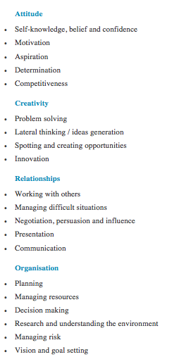
Appendix A – ACRO Model

(Big Ideas Wales, 2017)
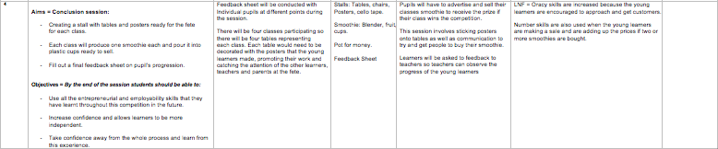
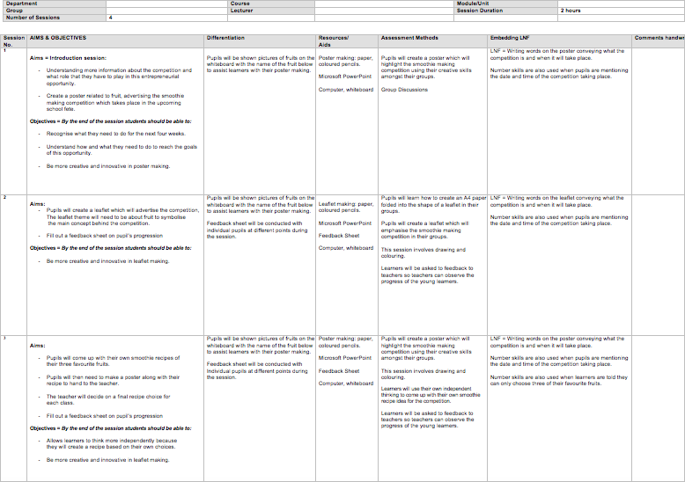
Appendix B – Scheme of Work

Appendix C – Lesson Plan
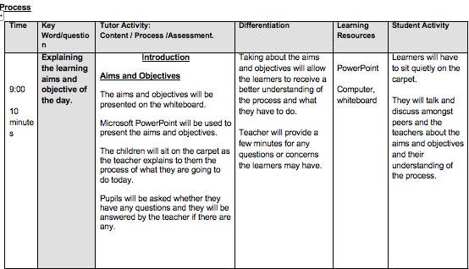
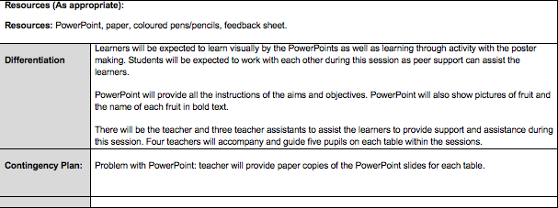
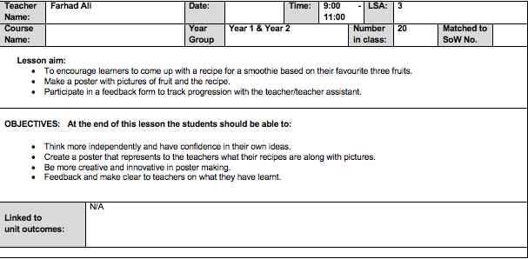
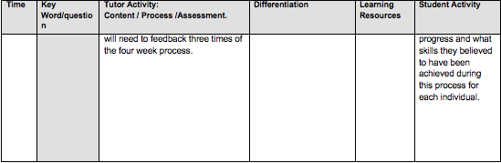
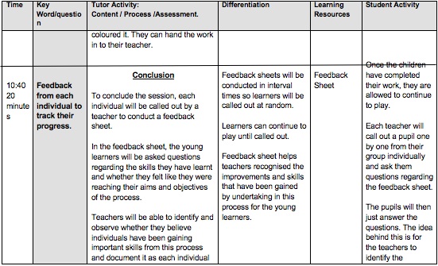
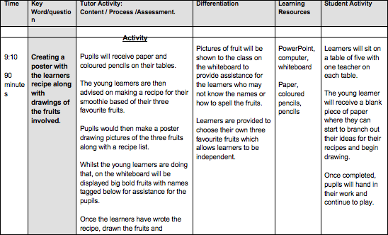
Appendix D – Obesity Rates in four to five-year olds in Wales

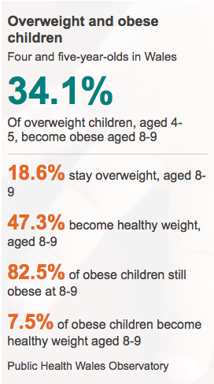

(Clarke, 2015)

Appendix E – Feedback Sheet

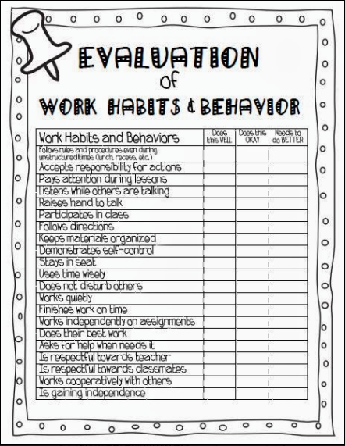

Retrieved from http://mrsterhune.blogspot.co.uk/2013/10/ready-for-parentteacher-conferences.html
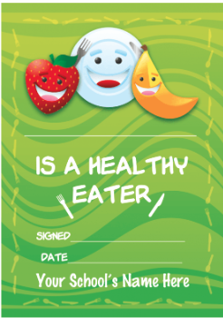
Appendix F – Certificate

Retrieved from http://www.schoolstickers.com/en-gb/lunchtime-healthy-eater-certificate

