Lloyd Thomas (P147195)
[Email address]
E-commerce
Sue Maw

Contents
1 An introduction to the organisation 3
2 SWOT analysis 3
Strengths 3
Weakness 3
Opportunity 3
3 Threat 3
4 An assessment of the existing site 4
Nodder’s phases of B2B E-Commerce (B2B 4
5 Recognize need 4
6 Determine product specifics 4
7 Research 4
8 Select 4
9 Buy 4
10 Evaluate 4
11 research with a potential customer (B2C 4
Analysis of user requirements 5
12 analysis of the e-commerce business model 5
13 Chaffey’s Micro 5
14 The suppliers 5
15 The resellers 5
16 The customers 5
17 The competition 5
18 The general public 5
19 Macro Environment factors 5
20 Demographic forces 5
21 Economic factors 6
22 Natural/physical forces 6
23 Technological factors 6
24 Political and legal forces 6
25 Social and cultural forces 6
27 Timmer’s 8 Key Elements. 7
28 Value proposition 7
29 Revenue model 8
30 Market opportunity 8
31 Competitive environment 8
32 Competitive advantage 8
33 Market strategy 8
34 e-procurement 8
36 13.E-marketing 9
37 One–to-many 9
38 Many-to-one 9
39 Many-to-many 9
40 Application of appropriate frameworks. 10
41 Recommendations for the internationalization of the site 10
42 Hofstede’s comparison 10
Power distance 10
Individualism 10
Masculinity 10
Uncertainty avoidance 11
Long term orientation 11
Indulgence 11
43 Implementation issues for the organisation 11
44 recommendations for site features 12
the recommendations that would be useful to a user if the site had more information on 12
45 Including your explanation of whether or not a device such as Amazon Echo would be compatible with your chosen business. 12

- An introduction to the organisation
The organisation that is being talked about in this report is the Coca-Cola company as they have many companies worldwide and sells various drinks to consumers and has a chain of suppliers that they collect their product off to create their various drink product.

- SWOT analysis

Strengths
- multiple products
- worldwide production company
- leading soft drink manufactures
- large revenue income

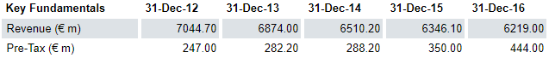
Figure 1 yearly profits
Strengths in the Coca-Cola company is that there a range of products that they own and produce worldwide and is one of the leading soft drink manufactures other than Pepsi.

Weakness
- Competitors (Pepsi, iru-bru)
- Lack of social media
Weaknesses in the Coca-Cola company is areas that the company can address to turn in to a strength such as competitors these can be watched and coke will compete with products and marketing that will help them in their social media aspect by interacting with their consumers.

Opportunity
Customers buy multiple products
Able to earn profit of multiple products

Threat
- Brexit
- Sugar tax
The threats that are happening to the Coca-Cola Company such as Brexit which will make it difficult to procure some of their supplies that are from abroad such as sugar, flavourings. There is also the new sugar tax that is coming in to effect this will affect how Coca-Cola sells their product as their product will have to respond to the tax by ether making the drinks smaller or reducing the amount of sugar in their drinks. [1] [2] [3]

- An assessment of the existing site
Nodder’s phases of B2B E-Commerce (B2B)

Recognize need
As coke was developed more than 100 years ago so this had given them a time when there was less soft drinks/sodas at that time this also lets the company design there drink as well as create there formula for the drink and this will create a fan base and this was helped when McDonald’s added Coca-Cola to their menu.

Determine product specifics

Research
The first stage is to check the market to find how many products are on the market similar to what the product as this will cause the sale of the product as if the product is similar to another product this may affect the sales.

Select
This second stage is to select a product that will be sold as it is useable best to have a range of test products that the company will give to a select test group to have a more diverse answer on whether the product they are making will be any good for the country or will they need to look at selling it in another country.

Buy
The third stage is to see how people will react to a test release as if a lot of people buy the drink and it turns in to a popular drink after the testing stage the drink may stay as it can earn the company money this will help the company and improve there standing among the consumers and the store chains.

Evaluate
This is the final stage is to see how the testers have sold and if the consumers enjoyed the drink and what social media is saying about the drink as this will be useful to the company as to allow them to create a evaluation on how well the drink sold and with which age group this sold well with.
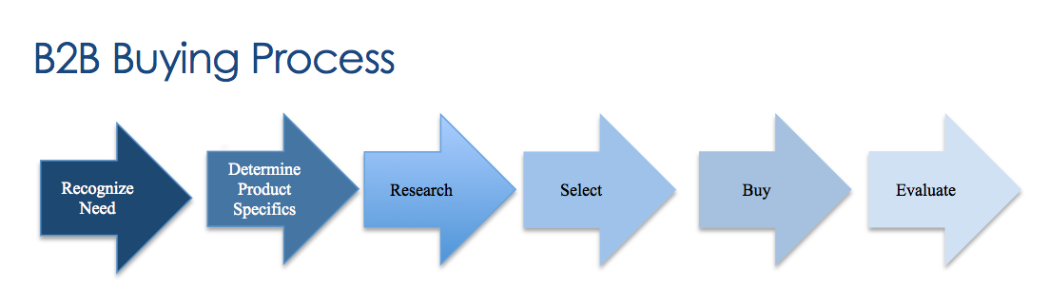
- research with a potential customer (B2C)
the Coca-Cola company has sold to many consumers and has had many different versions of their products some of their products are the Coca-Cola, coke zero and the coke diet all of these products have had a new flavour designed for them and this flavour has either been a hit in some countries or a flop such as coke cherry, vanilla, melon, peach and orange now some of these drinks stayed in the uk while others where discontinued but in other countries the drinks where still made as they are popular enough.

Analysis of user requirements

analysis of the e-commerce business model

Chaffey’s Micro
- The suppliers: with Coca-Cola being a worldwide organisation it is not uncommon that the company will need a steady stream of supplies to create the products that is sold worldwide and as there will be a new sugar tax this will now increases the price of sugar that Coca-Cola will need to pay more for sugar drinks.
- The resellers Coca-Cola sell their brand worldwide via: stores such as Tesco, Asda and other smaller brand shops that will be bought by consumers there is also the popular way of the entertainment industry that will supply coca to the consumer as they enjoy activities such as: cinemas, ten pin bowling, abroad and in pubs.
- The customers Coca-Cola has a huge customer base that is worldwide and has a variety of flavours that are sold in specific parts of the world as this is where the flavours such as cherry,orange,lime,vanilla,zero,raspberry and lemon most of these flavours are American based but only a few can be found in the uk such as cherry,zero,vanilla and lime there is also a yogurt flavour coke that is sold in japan but there are even more flavours that are sold in foreign countries all except from Cuba and north Korea as Coca-Cola is band or there is a trade embargo with these countries.
- The competition the usa has many drinks that will compete with Coca-Cola that will be sold on a daily basis as there is a range of off-brands that are similar to the original brands such as Fanta, coke and other popular brands these brands are in competition with each other as the off-brands are usually cheaper than the official brands as coke is the most popular in four of the states in the USA whereas cokes competitors Pepsi are only popular in one state.
- The general public: Coca-Cola has a worldwide and is always interacting with their public whetherthat is with events or through social media as there is always a new product that will be advertised or some pop-up events or events that coke is sponsoring.

- Macro Environment factors

Demographic forces
Education/Health-boiling coke, leaving teeth in coke, sugar free drinks
Coca-Cola has a large demographic as their brand is known worldwide and there is four areas of the demographic that I am focusing on more than others such as education and health as most schools would have done a science experiment using Coca-Cola and the most usual one that people do is to leave a tooth in coke for a set amount of time and see how bad it gets after the month or the week, there is also the boiling of coke which will show how much the coke will caramelize compared to other soft drinks at the time, there is also the change to the Coca-Cola that people will drink to be more healthy such as a switch from coke too coke zero.

Lifestyle-small bottles, bows, bottle names
The Coca-Cola company has a way of improve lifestyle for their bottles and there user base as there has been a range of different coke bottles over the various years that coke has been sold and to make sure that users keep buying the company will change their bottle or there labelling of the product sum of these examples are the small bottles that would only hold 400ml and was packaged with a football style as they were released around the 2010 world cup there is also a bow that was released around Christmas and the bow was able to be used as a actual bow to tie on to presents, there is also the personalisation bottles that have a consumers name and it will add in some unique phrases like mother, father and son.

Cultural-Christmas, Santa, truck, polar bear
The Coca-Cola company has been around for a long time and has built a culture around there seasonal sales of Christmas and how they advertise their brand over the Christmas time there has been many ways that this has been done such as the Coca-Cola polar bear that would be used to sell coke first then the company started to use Santa clause that is still used to this day along with the Coca-Cola truck that will travel around the country on Christmas.

Economic factors
The environment that a Coca-Cola will be sold in can vary throughout the year such as in the UK it is normally raining and the sun is not as strong as it is in many places such as the USA but the drink is sold similarly in both countries.

Natural/physical forces
The Coca-Cola company uses the earth’s resources such as sugar, caffeine and carbonated water these ingredients are only used in the Coca-Cola drink brand where as if you look at all of the drinks under the control of Coca-Cola company there is a lot more than just a few ingredients such as citrus,orange,apple,red current, strawberry and cherry just to name a few of the supplies that Coca-Cola need to make kia-ora another of their brands that they own but with the uk leaving the EU it is going to be harder for the company to collect their supplies and ship them worldwide.

Technological factors
The Coca-Cola company has been around for 132 years this has given them the opportunity to hone their craft at making soft drinks and as they were one of the first drink manufactures this also lead them to have more of a user base as the company grew this also lead to their accusation of more products such as Fanta, Dr. pepper and kia-ora.
- Political and legal forces
The Coca-Cola company will be dealing with the political back lash as the uk is about to leave the E.U this will cause a lot of problems for their supply lines as Brexit will make trading with the uk much harder and exporting much harder as well as their supplies will be coming from outside the uk so the coca cola company will need to have an experienced legal force to have these products and supplies shipped to the UK.

Social and cultural forces
The Coca-Cola company is making the users that visit their website aware that they are trying to address the problem with litter being thrown in the ocean and on the beaches this is why the company is trying to help address the issues there in the united kingdom an example of this is that the plastic that coke uses for their bottles are 100% recyclable and that will include the bottle top as well where as in the usa is using 50% lemons, beet and sugar from a more sustainable source 60%of their bottles where refilled and recycled and there was also 221B water replenished across the globe during 2016.

  - 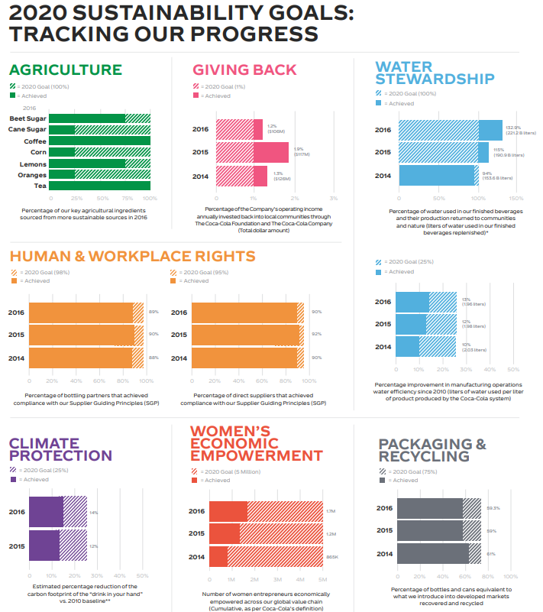 [4]
- Figure 2020 sustainability goals

Timmer’s 8 Key Elements.

Value proposition
Coca cola is a company that looks forward to working with top brands that will have a high growth rate due to the environment that they are from and now in, there is also the chance for the brand to be market attractive and have an increasing product influence (Fanta, Dr. pepper and Evian).

Revenue model
The revenue is one that they sell drinks worldwide there is four different areas that coca cola uses these are the customer segments, business offerings & revenue source, company and cost element
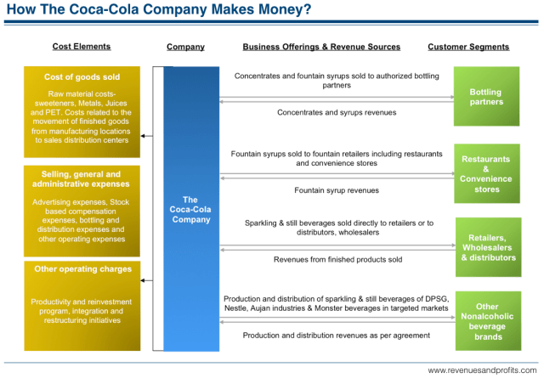

Market opportunity
Coca-Cola is sold internationally but the market for the drink is very slim as there are many drinks similar to the other drinks on the market that Coca-Cola has been around longer than most other drinks on the market this will lead to a following within families.

Competitive environment
With Coca-Cola not being the only drink that is manufactured worldwide most countries have a favourite drink such as Scotland with Iru-bru and other countries would drink more healthier drinks or drinks such as mounting dew.

Competitive advantage
Coca cola is one of the main drinks manufactures worldwide and have a range of brands that all come under the Coca-Cola company brands that can give Coca-Cola an advantage with the market foreign and United Kingdom.

Market strategy
The Coca-Cola company has a one brand campaign that will link all their brands under the Coca-Cola trademark this will link all products such as Dr Pepper, Fanta and Evian.

- e-procurement
Coca-Cola is a worldwide company that have factories all over the world in places such as japan, USA, United Kingdom and Greece this will allow for Coca-Cola to send supplies to varies areas of the world as there will be a storage warehouse near the bottling facility this will allow the company to create their products faster and easier and will allow them to have their produce on hand unless they need to order which they will then send for a supplier to deliver to one of their many warehouses.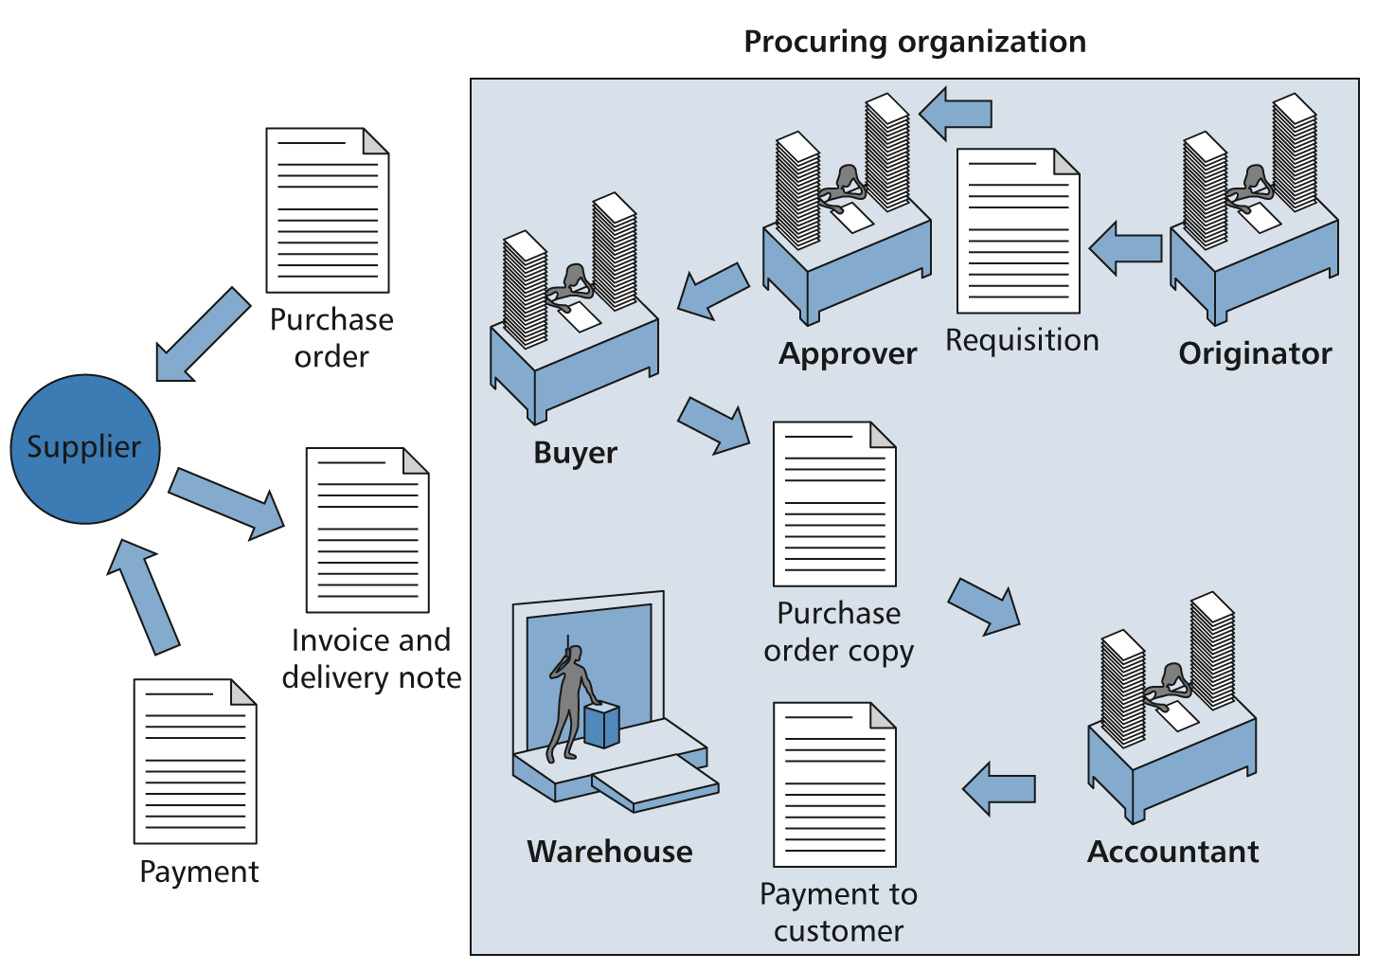 [5]
Figure 3e-procurement organization

E-marketing

One–to-many
One supplier can sell to many companies as the supplier can sell to multiple companies as they can make more profit from selling to multiple companies unless they are under a contract with the one company to deliver exclusively to that company.

Many-to-one
Many suppliers can sell to one company this can be accomplished by having suppliers sign a contract that will have the suppliers be selling their supplies to the company exclusively to the company but this will have the supplies loss some of their profits as if they were able to sell to another company while selling to the company this would increase their profit but the more companies they have to supplier to the more stress the supplier will be under to deliver.

Many-to-many
This is a way that can be show as the company will ship to suppliers/retailer around the world from their factories this will allow for the retailer to sell the product and will allow for the retailers to send the funds that it raised from the sales of products to pay for more shipments of the products this will help the company to buy more supplies to make more products and the cycle will continue.

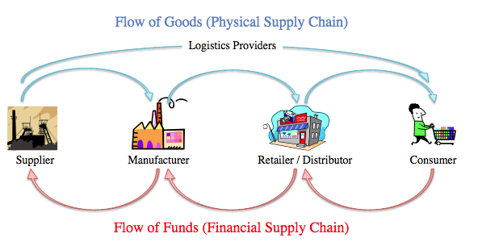
Figure 4 supply chain

- Application of appropriate frameworks.

Recommendations for the internationalization of the site.
Create one single webpage that will change with a user’s selection of their countries such as if a uk citizen visited the Coca-Cola web page and selected the French page the page would transit them towards the French page there should also be a translate button that allows the words English to be read in welsh or in the local language of the country that the user is from.
Hofstede’s comparison
The Coca-Cola Company is a world-wide company that will use the Hofstede comparison when creating a new product there are certain cultural different in the country that the company must decide on when creating a new product such as: [6]

Power distance
The power distance in japan is build-up of people mare born equal that are able to get ahead if they study enough but in the UK the power distance is less as most people have more control over their own life and only need to follow rules set by a government and a boss if they themselves are not a boss.

Individualism
Individualism is how each country is preserved such as the UK and USA have a similar individuality whereas japans individual is the lowest as the people of the country is more of a group-based country.

Masculinity
The score for this one can be split in too two groups such as masculine and feminine if the score is low it will be a feminine country but the scores will be used to tell how the country is such as japan is high and UK and USA is a medium so this will be a mix of masculine and feminine as people that live in the country and this can be used by the company to decide what country to release drinks in

Uncertainty avoidance
This is a huge part in the country of japan as their country is normally hit with earthquakes and tsunamis and this would lead them to be looking forward to their own country instead of other country.

Long term orientation
The long-term orientation is most important in a country such as japan as they are a country that keep moving forward but have a rich history that will be in their culture and they will try to not harm any of the historic buildings while they build forward toward the future whereas united states has the lowest orientation as they build more buildings to accommodate the ever-growing number of people that are moving to their shores to find word.

Indulgence
In the UK and the USA, the indulgence is higher than japan as people in both USA and UK are more indulgent than japan as the country will use their money to live as they may spend money on some luxury items but this may not include the product that you have created.

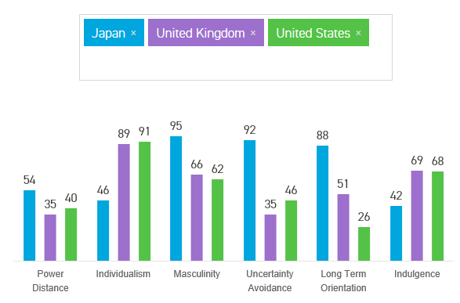

- Implementation issues for the organisation,
The implementation of the Coca-Cola company will be a simple one for the company as they are a company that has been around for a long time and this has given them the advantage over many of their competitors as well as allowing them to create a plan that will show how their drinks are made all from the design stages to the testing stages to the shipping stages.

- recommendations for site features
the recommendations that would be useful to a user if the site had more information on how much the drink is in sugar and other harmful products to the consumers body there is also the improvement of adding more information about what is happening around the community such as in the local area or region.

Including your explanation of whether or not a device such as Amazon Echo would be compatible with your chosen business.
The amazon echo was built to be used as a simple and hands free tool that will allow a user to simply say “buy me a coke” this will not be a good function as if the consumer wanted a coke at 10 at night the drink would not be delivered until tomorrow it would be much easier to buy the drink in store, although if the user was to buy a pack of coke for their home instead of just the single can then this would be more useful.

References

[1] | M. T. C. Team, “SWOT Analysis (Strengths, Weaknesses Opportunities, Threats),” MindTools, 2018. [Online]. Available: https://www.mindtools.com/pages/article/newTMC_05.htm. [Accessed 06 02 2018].
[2] | L. G. Fine, “The SWOT Analysis Using your Strength to overcome Weaknesses, Using Opportunities to overcome Threats,” [Online]. Available: http://lawrencefine.com/downloads/SWOT - PDF.pdf. [Accessed 06 02 2018].
[3] | Marketline, “The Coca-Cola Co SWOT Analysis.: Business Source,” Marketline, 2017. [Online]. Available: http://web.a.ebscohost.com.ezproxy.uwtsd.ac.uk/bsi/pdfviewer/pdfviewer?vid=5&sid=28b9d056-9472-46ba-80ae-8d6feb5c19f1%40sessionmgr4009. [Accessed 06 02 2017].
[4] | L. S. Exchange, “London Stock Exchange,” 2015. [Online]. Available: http://www.londonstockexchange.com/exchange/prices-and-markets/stocks/summary/company-summary/CH0198251305GBGBXSET1.html. [Accessed 06 02 2018].
[5] | s. maw, power point slide, swansea: sue maw, 2018.
[6] | A. A. Biswas, “Coke vs Pepsi - Local and Global Strategies,” Economic and Political Weekly, vol. 34, no. 26, pp. 1701-1708, 1999.
[7] | “The Coca-Cola Company - Explore - Google Trends,” Google, [Online]. Available: https://trends.google.co.uk/trends/explore?q=%2Fm%2F03phgz. [Accessed 22 02 2018].
[8] | “Country Comparison - Hofstede Insights,” Hofstede Insights, [Online]. Available: https://www.hofstede-insights.com/country-comparison/japan,the-uk,the-usa/. [Accessed 22 02 2018].

