Zujaja Tabassum Kharal
1919419
Univesity of wales trinity st david’s
Report on Developing Innovation & Creativity for Business Advantage of Amazon

Executive Summary
This is a research report on developing innovation and creativity for the business advantage of Amazon Company. Amazon is the world's most famous online store where people can find every item of their choice, making it a favourite online store for most people. The innovative approaches which Amazon uses to gain this current level of popularity and fame are also discussed in this report. The research found that Amazon uses radical and sustaining innovation strategies and provides a technological turnover for the marketplace through its innovative AI services and products. The approach used by Amazon is customer-centric, which makes it more popular among its target audiences. The main aim of Amazon is to adapt itself and its products and services to the constantly changing trends, and it helps the company to strive through various levels of marketing. Following the innovation and creativity trends, amazon has created several artificial intelligence services for its customers, and all of these services are tempting for the customers that they are eager to buy those innovative products and services. Through the assessment of effectiveness using Kurt Lewin's approach, it is found that there are many driving forces behind Amazon's creative and innovative development and the driving forces compared to the restraining forces are far more substantial.

Contents
Executive Summary 1
1.0 Introduction 3
1.1 Innovation and Creativity 3
1.2 Approaches of implementing innovation 4
2.0 - Main Findings 6
2.1- Overview of the Innovation Opportunity 6
2.2– Type of Innovation 7
2.3– The Creativity Thinking Process 9
2.4.1 – Open and closed innovation: 10
2.4.2 – The innovation Process: 10
2.4.3 - 4p’s to innovation: 11
2.5 – Assessment of Effectiveness: 12
2.5.1 Barriers and Risk: 12
2.6 – Leadership and management: 14
3.0 Conclusion 15
4.0 References: 19

- Introduction
This research report has been written to study the development of innovation and creativity for business advantage. For this research, Amazon Company also Amazon.com has been selected and studied thoroughly.
Amazon was founded in 1995 and started its journey as an online bookselling retailer, named Cadabra originally, but later changed its name to Amazon.
With constant updates and development, Amazon is currently the world's largest and most known online retailing brand. It has a wide variety of products and gadgets for daily use, comfort, and luxury. Amazon is one of the most significant online e-commerce businesses that set up backups by cloud computing and provides its services through Artificial Intelligence. The buyer can have any branded items, including clothes, bags, shoes, makeup products, furniture, kitchen items and many more. Continuing the innovation and creative process, Amazon has achieved an admirable status worldwide, and it is still in the growth process. Amazon keeps changing its strategy for betterment and uniqueness (Yasar, 2022).

1.1 Innovation and Creativity
Innovation is a new strategy that any company uses to grow its business. It could either be the innovative production of a new service or product or the upgrade of the previously available services to grow and develop a business (Brunswicker, 2016). Creativity, on the other hand, is a way of thinking that will help create new and innovative products or services, providing a solution to a problem the audience faces. Creative thinking will provide more opportunities for a company to expand its business and have the benefits of economic growth (Seelig, 2012). In a business, creativity and innovation are linked, where creativity is the brainstorming of new ideas, and innovation is the implementation stage of creative ideas. Creative thinking and implementing these ideas into innovation is the primary step for organizational development (Al-Tameemi, Alshawi, and Ahmed, 2018).

1.2 Approaches of implementing innovation
To implement creative ideas for innovations in a company, the company needs to develop business plans and models to be followed. When these business models are being followed, according to Christensen and Overdorf (2000), there are four types of innovation:
1.2.1 Sustaining Innovation:
In this type of innovation, the business model is being followed as it is without changes in the organizational and management system.
1.2.2 Disruptive Innovation:
In this type of innovation, the newly adopted business model can be implemented only when there are some basic changes in the organizational system. The innovation process cannot take place without these necessary changes.
1.2.3 Architectural Innovation
In this type of innovation, there is constant and gradual growth in the system of an organization by creating and producing innovative products and services.
1.2.4 Radical Innovation
Radical innovation is creating innovative and technological products and services that will be a turnover in the marketplace.
Creativity and innovation are essential parts of organizational growth, where they contribute to increasing the opportunities, productivity, market value and constant improvement of an organization. The creativity and design thinking leading to new and innovative products produce a stable competitive environment in the market. Providing innovative solutions to the problems the target audience faces will prove extremely beneficial as it will prove economic leverage and fame to the brand name. Amazon has reached its current stage through creative design thinking as well as through innovation by implementing innovative business strategies for its cause.

- Main Findings

In this section, the innovation opportunities of all products and services of Amazon are viewed, along with the types of innovation present in the organizational system of Amazon. The creative thinking of Amazon on the innovation of products and services related to artificial intelligence (AI) will also be discussed. The models of innovation, open and closed innovation, as well as the innovation process, is also described. Kurt Lewin’s' approach is used to access the innovation of Amazon along with the barriers and risks.

2.1- Overview of the Innovation Opportunity
An innovation opportunity refers to the opportunity which is available to any company, and the company identifies it as a chance to produce something new in the market or for the process of creating new solutions by design thinking along with the problems. Amazon, as the most re-known company, has created a lot of products and services for its customers. The brand received this opportunity with the fame and durability of Amazon along with its customers. Amazon has gained the trust of its audience and customers by retailing excellent quality products. The customers' trust values enabled Amazon its design thinking and create innovative products and services. Now Amazon is widely known for its AI (artificial intelligence) services, along with many other privately owned brands by Amazon (Yasar, 2022). Some of the AI products and services provided by Amazon are as follows:
- Amazon Kindle (for online e-book retaining)
- Amazon Alexa (a cloud-based personal online assistant)
- Amazon Astro (Amazon home monitoring robot that works along Alexa)
- Amazon Echo (for music, videos and echo video call services)
- Amazon Echo Dot (personal assistant who will read for you, answer your queries and plays music)
Customers are more than willing to buy anything from Amazon which is purposeful and serves them solutions to their problems. The long-term thinking and the next generation planning strategy of Amazon is the main reason for its long-term success. For such a long-term innovation process, Amazon hires engineers for its future innovations and technological programmes. Providing complete facilities for innovative and creative minds, Amazon creates innovation opportunities for its future growth (Reed, 2017).

2.2– Type of Innovation
By using the innovation matrix by Davila et al. (2012), it was identified that Amazon is using these types of innovations, described as follows and illustrated in appendix 1:
- Radical innovation Radical innovation for the creation of its innovative products. Radical innovation is defined as a breakthrough which disrupts and transforms the industry creating new market value through innovative products or services (Davila, 2012). Amazon has constant change at its core, identifying the constantly changing trends it tries to keep up with the current ongoing trends. The customer-centric approach of Amazon enables the company to develop such products which the customers require; they either belong to the category of customers' needs or to the demands where Amazon is using its design thinking and innovation to create a customer-centred approach such as the products and services related to the artificial intelligence. It is using technological innovation for its customers by setting a target audience. For instance, the AI services owned by Amazon, such as Amazon Sege maker, Amazon Polly, and Amazon, transcribe and translate. Alexa voice service, all of these artificial intelligence services provided by Amazon, keep the market at an edge and tempts the customer to purchase it.

- Architectural Innovation is the constant growth by the innovation of new products and services for the sake of the economic growth of the company as well as for making it a re-known brand. There are many privately owned businesses by Amazon, such as good threads, Mama Bear, Amazon Essentials, Amazon Basics, Happy Belly, Amazon Elements, and many others as such. Through these constant and gradual increments in the business, amazon is making the marketplace and market value for its products and the company itself.

- Incremental Innovations Amazon itself, as a retailer, is using Incremental Innovations to increase and update the services provides by the online retail store shipping worldwide constantly and gradually.
(See appendix 1).

2.3– The Creativity Thinking Process
The creative thinking process creates innovation that creates demand in the market and creates market value for the company itself. Jeff Bezos, the chairman of Amazon, uses a creative thinking process for innovative products and services and uses it at the industrial level to make Amazon the world's leading innovative brand name (Robischon, 2017). The creative thinking process used by amazon is described as described below and illustrated in appendix 2:
Preparation: Here, the ideas are prepared through creative thinking. The target audience's problems are kept in view to produce a new solution for those problems. The idea of Amazon as an online retailer was by a single individual. And later, the idea is also copied by many other online service providers. Creative thinking can also be a part of a group process as teamwork. The main aim is to create such products which will disrupt the industry.
Investigation: In this step, surveys or questionnaires collect data about the previously thought problem. A team can gather up to collect data about a common issue faced by the target audience to create a solution for the problem. Amazon also uses a customer-centric approach and develops products and services that are in demand.
Composition: In this step, surveys or questionnaires collect data about the previously thought problem. A team can gather up to collect data about a common issue faced by the target audience to create a solution for the problem. Amazon also uses a customer-centric approach and develops products and services that are in demand.
Verification: It is the final stage where the ideas are tested by creating innovative products or services. It is an organizational process where amazon tests its products and services through the hired testers. When the product is verified, it is launched in the market. With the launching of many Amazon AI services, the market value of Amazon has increased in its potential.

2.4 – Models of innovation
According to Greg Satel there are four models of innovation, which include:
- Incremental
- Disruptive
- Architectural
- Radical

2.4.1 – Open and closed innovation:
Innovation is important for any company to provide a platform for the investors to show their creativity and have a chance to prove themselves proactive in moving forward with their ideas.
Closed innovation depends on the internal staff for every step of the creative process as the beginning ideas come from in-house staff, so they can do many stages of development, marking and testing. Especially the complete planning is carried out inside the Amazon. In ancient to that, all the property rights, which are intellectual machinery and technology, belong to the website of Amazon, and these remain under the company's control. Closed innovation is preferable when the innovation is producing important technology improvements that Amazon is about to utilize a substantial advantage in its market. Open innovation is preferable if the innovation process is ongoing and there are benefits to have through increasing cooperation. Appendix-3 illustrates how companies proceed through open as well as closed innovative strategies.

2.4.2 – The innovation Process:
A strong and organized process of innovation is helping to optimize the identification duration, capturing the managed ideas, and bringing them into reality. The innovation process is the implication of innovative ideas to bring them into existence. When the innovation process was applied on Amazon, it was found that the process started with generating ideas. An organized and manageable idea can come anytime and anywhere from your staff or team of the whole organization of Amazon. Then the idea is reviewed and evaluated on daily life problems to ensure that they can create an innovative product or service and receive immediate feedback by testing. 4P's model of innovation is used to study the innovative process, which is mentioned below.

2.4.3 - 4p’s to innovation:
As innovation is the process of creating innovative solutions to problems, the innovation process includes four essential stages through which an innovative product or service comes into existence (Bureau, 2020). The 4P's of innovation help in explaining the innovation process carried out by a company as it is illustrated in appendix 4 that the innovation process has four essential elements. The 4P's of innovations are as follows:
Product Innovation:
Product innovation includes the changes occurring in the service, or product Amazon has to offer. Product innovation involves a change in the product's design or the whole product or service; it is an integral part of helping in creating a new space in a slightly saturated market.
Process Innovation:
There is a factor shift in the innovation environment which is because of factors like globalization of the market, liberalization, increasing demand from the customer and the deregulation of competition.
Paradigm Innovation:
Paradigm innovation is referred to in the model, which is underlying metal through a change in business status. Many of the brands which collaborate with Amazon face a shift in their paradigms through digital consumption as they are shifting their businesses to create a newly developed market.
Position Innovation:
Amazon started by targeting a specific audience but, through time, switched to other audiences or expanded its range to a wider audience. Position innovation is majorly about repositioning, taking a service or a product and offering it in a new market. (See Appendix-3)

2.5 – Assessment of Effectiveness:
Kurt Lewins' Force Field analysis was constructed in the 1940s, where it can be used to test the effectiveness of the organizational strategies of Amazon. The force field analysis can describe the two opposing forces (such as the driving and restraining forces) that have enabled the organization to stay at its current position. An organization can never become successful if its driving force is weaker than its restraining forces. Neither an organization be successful if its driving force is just as equal to the restring force. For a company to succeed enough, its driving force must always be far greater than its restraining force.
Amazon is a successful company whose driving forces are far higher than its restraining forces, as seen in appendix 5. Currently, amazon's fame, brand name, outstanding product quality and customer-centric approaches are the biggest factors working as its strong driving force. On the other hand, there are fewer restraints for Amazon, which could be the high competition in the market, working as a weak restraining force.

2.5.1 Barriers and Risk:
Appendix 5 illustrates the risks as the restraining forces for Amazon Company. The few barriers and risks Amazon faces are that salaries are challenged while learning the shipping option and details duplicate listing by box competition negotiating fees. They have seen that their client is suffering from one part-time employee managing their Amazon program to dedicate an experienced team and bring out agency once they are ready to see the sales in their channel.

2.6 – Leadership and management:
The leadership and management principle for Amazon includes customer's-obsession; this means that the staff always endeavour to work from what the customer is thinking or wants. Amazon is one of the most successful AI companies in the current times (Bieler, 2021), so its leadership includes simplifying things and inventing new things from time to time. A leader should be fact-based and objective; they are also willing to admit their mistake when they are wrong. A leader is expected to have the right of confidence to lead in the direction which seems to be the best. The trait theory of leadership presents that a leader's character traits influence the employees. Therefore – the leaders to drive AI should be democratic, where they must support their employees' creative and innovative ideas. And he must devise action plans for his workers to create an excellent management system to create innovative products and services. The management system should be creative and transformational. It will allow creative thinkers to produce an innovative product that will transform the market.

Conclusion
Amazon is the world's most famous and widely known company for online retailing and selling all kinds of objects, brands and items. In this research report, we studied Amazon Company for its innovative and creative development in the highly competitive market. It was found that Amazon is using radical as well as sustaining innovation to make a firm place for its brand name in the market. Amazon is using a customer-centric approach, which helps the company develop products that are in demand by the target audience. And therefore, this customer-centric approach is the main cause of Amazon's success. Through Kurt Lewins' approach to organizational change, it was found that the driving force of Amazon is far greater than its restraining force. Its demand and brand name are one of the main causes behind its successful innovations and creativity.

Appendices:
Appendix 1 – Innovation Matrix
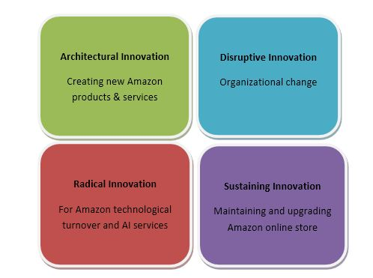
Appendix 2 – Open and Closed Innovation
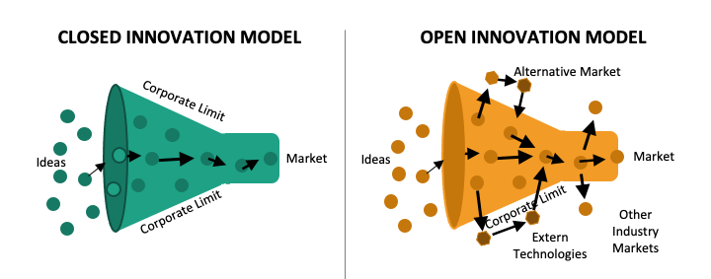

Appendix 3 – 4P’s to Innovation
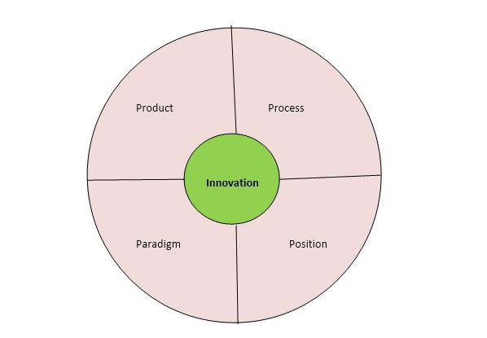
Appendix 4 – Force Field Analysis
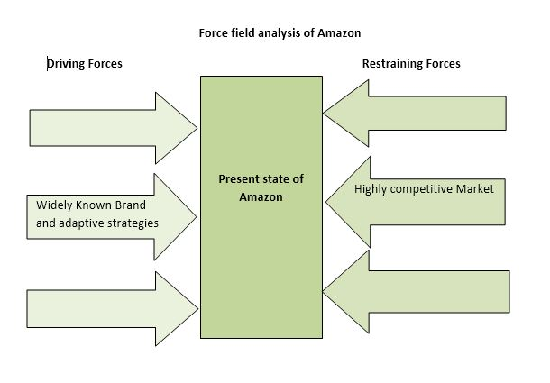

4.0 References:
- Bratnicka-Myśliwiec, K., 2015. Relationship between leadership styles and organizational creativity. Management and Business Administration. Central Europe, (1), pp.69-78.
- Brunswicker, S., 2016. Managing open innovation in small and medium-sized enterprises (SMEs). Open Tourism: Open Innovation, Crowdsourcing and Co-Creation Challenging the Tourism Industry, pp.171-187.
- Ettlie, J., 2007. Managing innovation. Routledge.
- O’Reilly, C. and Binns, A.J., 2019. The three stages of disruptive innovation: Idea generation, incubation, and scaling. California Management Review, 61(3), pp.49-71.
- Seelig, T., 2012. inGenius: A crash course on creativity. Hay House, Inc.
- Amabile, T.M., Conti, R., Coon, H., Lazenby, J. and Herron, M., 1996. Assessing the work environment for creativity. Academy of management journal, 39(5), pp.1154-1184.
- Al-Tameemi, K., Alshawi, M. and Ahmed, V., 2018. Integrating Business Improvement and Innovation Models: A Step Change Approach for Organisational Performance Improvement. International Journal of Engineering and Technology, 7(4.20), pp.619-628.
- Davila, T., Epstein, M. and Shelton, R., 2012. Making innovation work: How to manage it, measure it, and profit from it. FT press.
- Reed, N. 2017. Why Amazon Is The World’s Most Innovative Company Of 2017. Fast Company.
- Fox Rubin, B. 2017. 2 big innovations that made Amazon’s Kindle a success. CNET.
- Manyika, J., Chui, M., Bughin, J., Dobbs, R., Bisson, P., and Marrs, A. 2013. Disruptive technologies: Advances that will transform life, business, and the global economy. McKinsey Global Institute.
- Amazon (2019). 6 things that make Amazon a ‘Best Workplace for Innovators’. [online] About Amazon. Available at: https://www.aboutamazon.com/news/workplace/6-things-that-make-amazon-a-best-workplace-for-innovators.
- Anastasia Shch. (n.d.). Creativity in business. [online] Available at: https://www.anastasiashch.com/business-creativity#:~:text=Creativity%20in%20business%20is%20a.
- Bieler, D. (2021). Learn From Amazon’s Approach To Innovation. [online] Forrester. Available at: https://www.forrester.com/blogs/learn-from-amazons-approach-to-innovation/#:~:text=Amazon.
- Boyles, M. (2022). Innovation in Business: What It Is & Why It’s So Important. [online] Business Insights Blog. Available at: https://online.hbs.edu/blog/post/importance-of-innovation-in-business#:~:text=Simply%20put%3A%20Innovation%20is%20a.
- MindTools (2020). MindTools | Home. [online] www.mindtools.com. Available at: https://www.mindtools.com/a23ewmr/force-field-analysis.
- World Economic Forum. (n.d.). What’s the difference between creativity and innovation? [online] Available at: https://www.weforum.org/agenda/2015/01/whats-the-difference-between-creativity-and-innovation/#:~:text=Creativity%20is%20coming%20up%20with.
- Yasar, K. (2022). What is Amazon? [online] WhatIs.com. Available at: https://www.techtarget.com/whatis/definition/Amazon.
- Dowsett, B. (2020). What’s The Difference Between Open And Closed Innovation? | Tax Cloud. [online] www.taxcloud.ie. Available at: https://www.taxcloud.ie/blog/2020/difference-between-open-and-closed-innovation#:~:text=The%20main%20difference%20between%20open.
- Bureau, A. (2020). The Innovation Process: Importance, Steps, Types, Examples, and Risks Involved. [online] ALCOR FUND. Available at: https://alcorfund.com/insight/the-innovation-process-importance-steps-types-examples-and-risks-involved/.
- Anon, (n.d.). Innovation at Amazon and Alibaba – Accurate Essays. [online] Available at: https://www.accurateessays.com/samples/innovation-at-amazon-and-alibaba/ [Accessed 3 Feb. 2023].
- Adlucent (n.d.). The Top Three Amazon Challenges, And How To Solve Them. [online] Adlucent. Available at: https://www.adlucent.com/resources/blog/the-top-three-amazon-challenges-and-how-to-solve-them/.
- Management Consulted. (2019). Amazon Leadership Principles | Corporate Training & Consulting Resource. [online] Available at: https://managementconsulted.com/amazon-leadership-principles/.
- Hepburn, M. 2020. Amazon’s AutoGluon helps developers deploy deep learning models with just a few lines of code. Amazon.
- Simon, M. 2019. Inside the Amazon Warehouse Where Humans and Machines Become One. Wired.

