Eve Alexandra Jones
P147113 / 1550727
MA Youth and Community Work



SJYW7014 Professional Practice: Fieldwork 1 A Professional Journal

Contents
Chapter 1
Risk Assessments
Page

Chapter 2
Observation of Lovetodance Academy
Page

Chapter 3
Reflective Practice
Page

Chapter 4
Community Profile
Page

Chapter 5
Case study
Page

Chapter 6
Critical reflection
Page

Chapter 7
Summary
Page

Risk Assessments
Highlighting risk is essential in all aspects of work, especially when working with children and young people. A Risk assessment is giving guidance on health and safety in all aspects as well as giving information and assurance that all protocols are being met. The risk assessment focuses on all generic duties which are undertaken by staff within the placement this applies in all areas which includes the dance school for this placement (RAD.2017).
The Royal Academy of Dance (RAD) sets out the rules and regulations when teaching their syllabus and they state that risk assessments are to be done as they hold a responsibility to ensure that the health and safety of all students, families and employees while they are within the building of where the classes are being taught. They and the dance school who are delivering the classes are to keep risk assessments up to date and review each year/ if there is a change in where or how the classes are being taught. (RAD,2017)
The following risk assessment focuses on the basic duties which are done by the teacher / assistances when taking a dance class within the dance studio. (See evidence)

Observation
Lovetodance Academy is a dance school which teaches ballet, character, and tap, modern / jazz from the ages of 3years – adult. It is based over three venues in three different communities Brecon, Llandovery and Ystrad. There is the principle and then an assistant teacher for most classes, it is a small school and has up to 100 students male, female all races and religions which go to classes once every week. Due to the areas being so rural it is so important to have something for the young people to do. It takes a step away from formal education and concentrates on new ways of socialising and learning new skills while also bring a community together. Cohesive communities is also recognised as one of the aims of wellbeing of future generations Wales Act (2015).
The school works with the training of the Royal Academy of Dance (RAD), who provide classes for people of all ages. They are a known group within the dance world and have trained some of the world’s greatest dancers like Darsey Bussel, whose reputation in the dance world brings a sense of prestige. This enables individuals to work to the best of their abilities. The main aim of the school is that individuals enjoy and have fun while still learning not only dance but also a vast amount of skills and disciplines which can be transferred to daily life. Transferable skills are abilities or competencies that an individual has developed in one area of their life which they can transfer to another area of their life. This is a time where the young people learn many transferable skills which important for future life, this is due to the skills they learn being used widely in daily life for example leadership, problem solving, communication and listening just to name a few.
Even though the school is a profitable business it does not work just for money, the individuals come first and they are the soul of the school, so making sure that they are happy is the most important aspect. The RAD also offer some grants for students who are from a low income background to help provide uniform so that they are able to take part within the classes, this then takes a big pressure off the parents/ guardian to pay for all the fees and all the uniform. The school is providing an opportunity for individuals to do an activity outside of school and community groups so that they have either a new hobby or for taking the first steps into their career of being a dancer. Money is recognised to being a barrier to learning and inequalities for many and unfortunately there isn’t also enough help available for individuals in these situations. This is where it is nice to see a big organisation taking this into account and helping those in need.
The school covers a wide range of skills as each class is different, the young ones of the school do exercises which are focusing on not only their dance skills but also to improve their fine gross motor skills and also a vast amount of daily skills, these include confidence, social skills, emotional, listening and imagination. Imagination is key as the school try to involve the younger individuals to learn by how they want to. For example, when doing heavy and light walks they encourage the use of picking a light and heavy animal. As students get older then the focus moves more to their actual dance ability and improving on certain aspect of their dance skills.
The school enter the students into exams every 1 – 2 years and they have a 100% pass rate, which shows how well the school are doing and how they are being taught what is essential while also shows that they are doing what they have learnt to a very good level. As well as exams the school put on a performance every year so that the parents and local community can see what the students have been learning. Involving community - cohesive community Wellbeing of Future Generations Act. This is giving the students so much opportunity for going on stage and performing in front of people and also be show their abilities in dance. Again this experiences involves the children as they are encouraged to have a voice in what they would like to do with some actually coming up with their own chorography.
Even though this is not a youth work setting the school does have many aspects of youth work skills which are being used throughout their lessons. When focusing on the five pillars (2014-2018).
Educative – the school is providing education in dance, but also educating the young people about skills, understanding, relationship building, independence, confidence as well as attitudes and values for how you should behave around others.
Expressive – the young people have the opportunity to express themselves not only by words but also movement. This opportunity is provided every month where they are able to show how they are feeling in their dances. This has shown to be very positive as the young people who may feel too shy to communicate are showing their feelings and emotions when dancing.
Participative – The young people are present every week without fail and are given opportunities to work together and join in with their ideas. This is included within not just the class but also exams and shows.
Inclusive – With the school bringing in young people from outside the area as well as in the school is diverse. The young people are learning to form relationships with everyone around them not just the people that they have grown up with and around all the time. The school and young people from different backgrounds, different languages and cultural identity. Wellbeing of Future Generations Act (2015).
Empowering – The school will also try their best to empower the young people by giving them their own choice, even though it is very similar to a school setting it has an aspect of freedom so the young people can be themselves and learn through dance. It is also creating resilience and showing the importance of it.

All students are part of this dance school because they want to be unlike a normal main stream school it is not compulsory, this is noticeable as all the children seem to fully enjoy what they are doing with very little disruptive behaviour and amazing achievement rates.
Focusing on the negative aspects of the school, it is the only dance school in the local area which means that there is no competition. This means that the dance school can set their prices to what they think is appropriate. While the classes are at a reasonable price there is nothing in place for the young people whose families have a low income. This is definitely something which could be considered as it would be giving an opportunity to the whole community rather than just the individuals who can afford it. Barriers to people inequalities etc While focusing on this aspect the school do have a programme with the RAD where if families are struggling with the costs of uniform, exams, travel and fees they are able to offer support. This is done by offering a discount on some exams and also providing full uniform to each individual. For this to be achieved there is a process which has to be completed by the teacher to prove that the family are unable to afford the uniform etc. It is very helpful but when it has been offered before it has made some parents feel like they are being “put into a category” so it is only now used as a last resort. ‘Poverty stigma creates divisions between “the poor” and the “non-poor” which serve to justify and maintain socioeconomic inequalities, and can also cause people living in poverty to feel socially excluded and ashamed (SCPHRP,2016).

The school is not only offering dance but also a wide range of skills to the young people which they can carry on into their future. The young people are encouraged to work together in a team which is demonstrating the importance of team working which is focusing on discussion to be able to create a dance or small routine. They also like to give the young people some responsibility more so when it comes to the show. The young people are asked what they would like to do in their dances and also asked what costumes they would like to wear. This is teaching them how to be independent and make their own choices. Another massive positive is the school allows young people to work together with people outside of their friendship group. They have young people coming from around the local area which means they are not all in the same school. This has proven to create new friendships and giving the young people an opportunity to meet and work with new people which is letting them take a step outside of their comfort zone (Cohesive communities Wellbeing Act,2015).
Over all the school has a strong presence in the local community and also provides a service to the young people where they are not just learning dance but learning a wide range of skills which can be carried on into their future lives.
Reflective Practice
This chapter will critically reflect on eight journals where something significant has happened or on experiences within a lesson. Reflection is important when focusing on development as it is an opportunity for an individual to learn from their experiences. The following reflective journals are based upon Gibbs Model of Reflection Cycle (1988) so that each stage is being reflected on and allows the author to recognise many aspects within each scenario. Gibbs theory allows, six different areas to be explored, these include description (what happened within the session), feelings (what were you feeling and thinking during this time), evaluation (what within the session was good or bad), analysis (what can you sense from the situation which happened), conclusion (what’s else could have been done), action plan (what would you do I this situation was to happen again). Each journal is titled with the main theme of each reflection, the author found this the best way to reflect as there are clear titles to be able to break down each situation.
Journal 1 – Aggressive Physical Behaviour
One of the young people in the class started to show aggressive physical behaviour towards one of the other children. This was the first time that anything like this had happened within the class but according to the parents it often happened in school. The young person decided that she was going to punch another child in the arm with force. It was done very discreetly but was noticed by both members of staff. This was reported in the appropriate way and both parents were informed about this behaviour and reminded that it is not acceptable in or outside of class. The young person was also spoken to by a member of staff and reminded that this behaviour was not acceptable at all (YW01). I tried to speak to the young person to find out why this incident had happened but they could not understand why they had done it. From here it was decided that we would keep them separated as much as possible when in class, this did help but was also very difficult because this behaviour was still happening within school but the appropriate steps were not being taken to tackle the issue (YW09).
Feelings
When I could start to see this situation arise, I did feel a little nervous because I had only recently met this young person and had not seen her show any of this behaviour before. I also was not sure how the young person was going to react. I could see how the situation was planning out which did make me overthink about what could happen next. I felt like I was overthinking purely because I was not expecting a situation like this to arise and due to me not knowing the young person I did not know how she would react to me speaking to her about the situation. I did start to pay more attention to this one individual rather than focusing on the whole class. I did start to notice this as I realised that I was missing out on what the other young people were doing. This is something which should not have happened even though it could not really be helped. It is important to make sure that all young people are getting the same attention when in a class because it can sometimes cause a feeling of not being good enough when children are not getting the same treatment (YW13).
Evaluation
It is unclear why this behaviour occurred but there was not anything that could have stopped it, as it happened very quickly. The young person knew what she was doing in the way that when the staff had full attention on all the young people she did not do anything but when our backs were turned this is where she was able to display this behaviour. The session itself was going well but the behaviour was unacceptable and then carried on to leave a bad vibe within the class. The situation was definitely dealt with in the most appropriate way and hopefully this behaviour will not be displayed again.
Conclusion
The situation could not have been changed in any way, it all happened very fast and I do not think the staff could have done anything different. It may have been worth taking the young person to one side and asking what was causing this behaviour but we are also aware that there are others in the class (YW14). It is really difficult because students are paying to have dance lessons and not to be sitting on the side having a chat. I personally feel that regardless of what we are there for it is also vital for the young people’s general health and wellbeing to be monitored and if we are able to help in any way then we will. Due to this matter also arising in school it is something that the school should be highlighting and focusing on. It would have possibly been a benefit if the parents had told us about these issues (YW15).
Action
As mentioned the situation was dealt with in what the staff believed was the most appropriate way. If this behaviour is to continue then there is definitely a need to investigate further so that we can try to help the young person to control their behaviour. Worst case scenario would unfortunately be not letting the young person carry on with the classes. This is what the principle of the school believes is best when a situation is not able to be fixed. This is purely because it can take up a lot of time within a class and has the ability to stop the others from learning as well as the possibility of losing students (YW20).

Journal 2 – Disrupting the Class
Description
Class started and a young person arrived late. As they joined in with the class they started to disrupt the others by trying to talk to them and tell everyone about their day. This was not an appropriate time so they were asked to stop talking about it now and we would have the discussion at the end of class. The young person agreed but within five minutes decided they were not going to listen and only participate when they wanted to. I again spoke with the young person and gave them a warning that they were to listen and join in an appropriate manner if they wanted to continue in the class. The young person then seemed to calm down and join in with the class. They did many of the exercises correctly and did not try to get any attention or talk to others. As we came to the end of the class and each child was doing their individual dances the young person became withdrawn and had no interest in watching the other children. When it came to their turn they made it clear that they wanted everyone to listen and watch. They continued with the dance which they had been doing for weeks and have been doing well. They then did one of the steps wrong and gave up saying they could not do it anymore and never wanted to do the dance again. The other children tried to reassure the person by saying that it was a hard step and they had all struggled with it but she did not listen and decided that she would never do the dance again. After giving them some space for a couple of minutes it was then the end of the class. The young person apologised to both staff and also the students for their behaviour in the lesson and stated that it will not happen again.
Feelings
I felt that a warning was definitely necessary in this situation as it gave the young people an opportunity to improve on their behaviour (YW19). I did consider that would have been enough but it was not. I felt like I was having to repeat myself a few times as the young people were reminded before the individual dances that talking was not acceptable. I am happy with how I dealt with the situation but also feel like I could have possibly taken the young person aside at the end of the lesson to speak to her about why she was not feeling confident when dancing. I do feel nervous in some of these situations but this is purely because the working relationship I have with the young people is very knew and even though it is important to keep boundaries and stay professional at all time, I want them to feel like they are able to speak to me if needed and actually enjoy being in my lesson (YW30). This is purely because it has shown that when a young person is enjoying something it stimulates their learning.
Evaluation
The class was going well up until this young person came into the lesson, it was clear to see that because they were late it disrupted them as they had missed out on some activities and the focus was automatically on her when she walked into the room with everyone looking. I do feel like because the attention was placed on that young person for being late this is part of the reason why they started to misbehave because they then instantly felt like that they were in the wrong. I definitely feel that is this young person arrived on time and entered the class the same as everyone else then this behaviour would not have occurred (YW02).

Conclusion
Maybe the staff should have gone straight into doing the solos instead of starting in smaller groups (YW06). This is something which can be worked on, but at the same time are also wanting to improve the young people’s confidence. Confidence is such a massive part of life so we want to try and give them this opportunity especially when it comes to preparing for exams (YW02). Also it may have been an idea for the teaching assistant to go over and work closely to the young person who was talking as it would distract them from trying to talk to anyone else.

Action
If this situation was to arise again I would still do the same, by giving the young person a warning as I believe it gives them a chance to correct their behaviour. A Smart Action Goal is that in the future at the start of every class I will have a conversation with the young people to remind them of the rules when in a ballet class. The young people do have to do the dances alone when it comes to their exams but an option would maybe be to do the dance a couple of times as a group first then split it down into pairs and then solo when it is clear they are more confident to work alone (YW06). This is just a process which helps them to become more confident, as it can be scary doing something like this alone.
Journal 3 – Fall out between friends
Description
Two young people who are normal best friends came into class did not talk to each other or stand anywhere near each other. This was very strange as the girls are always stuck by each other’s sides and do everything together. Myself and the teacher noticed but decided not to say anything for the time being. As the class was going on even thought they were nowhere near each other it was clear that something was wrong because they were rolling their eyes at each other and giving each other evil looks. As the class went on this was becoming very noticeable and when one of them would do a mistake the other one would laugh. This started to be noticed by the rest of the class and cause a slight disruption. We spoke to the young people to find out what had happened and tried to find a way of resolving the situation.
Feelings
I firstly did not think anything of it and put it down to normal behaviour which happens when in high school between friendship groups. I did feel a bit nervous when thinking about how to go about the situation as normally it would be left, but it was causing an issue in the classroom between other students with the awkwardness. It was the immature behaviour of rolling eyes and pulling faces at each other that started to distract other in the class. This did start to make me feel a little annoyed because there was no need for that behaviour and it was clearly making both young people angry. After speaking to the young people it made the situation a little easier, we made it clear that we were not trying to fix the issue but trying to make it not affect the lesson (YW18).
Evaluation
It was good that we spoke to them about the behaviour because of how it affected our lessons, but I do not feel like it is our place to get involved and try to resolve because the issue had clearly started in the school and was being dealt with by them. It gave off negative energy but the situation its self was as positive as it could be, the girls became more aware in class over the following weeks and the behaviour improved even though they chose not to speak to each other (YW16).
Conclusion
It was again a positive way of improving communication, the young people learnt how to communicate their feelings rather than doing it behind a screen or via body language. I would not do anything different because I feel like we are a place for them to enjoy their hobby not to put on the same rules like in school. For us the best way to go around these situations is to communicate and talk about everything (YW07).
Action
In future we would monitor these situations and everything we have done we would do the same. It is about making sure all young people in the class are happy and enjoying. We do not want them to feel like they cannot come to lessons because of others we want them all to enjoy and benefit from the service which we are providing. SMART Action Goal following the matter was to establish protocol to deal with something similar and convey this protocol to all staff and put it in place by the start of the next session.

Journal 4 – Positive session on lesson planning
Description
This session was a very positive session with no issues throughout. I took this time to reflect upon my teaching abilities within the class. I had noticed that even though I made a structured plan for teaching the lesson it did get followed throughout the lesson due to the young people enjoying what was planned at the start and them wanting to do it again (YW11). This is a downfall as it is about the young people enjoying and learning but it is a learning curve for me to show that I do not have to put as many activities into a session but rather have a backup tool kit with activities so I do have a backup if needed.
Feelings
I was feeling very positive throughout this situation because it was a really good class which had no issues. As mentioned it gave me the opportunity to reflect on my personal abilities which was needed. I feel like this has given me an opportunity to improve on myself and work towards a more beneficial way of teaching which gives all round positive feelings for myself, colleagues and young people (YW04).
Evaluation
It was a great chance for me to reflect upon myself and my teaching abilities, it made me realise where I need to improve and focusing on the best way of taking these steps to improve. There were no real negative issues and I noticed that even where I needed to improve the situation originally was not that bad it was just a case of learning ways to make teaching a little easier (YW30).

Conclusion
It was a good experience all round as it was bale to help my learning. I feel like maybe I need to develop on my organisation skills a little more and not to stress so much over things. I felt that it was always important to have a full session plan ready and I had to follow it at all times but that is not the case. It is good to stick to it as best as possible but sometimes this is not always possible but that is ok. It shows better ways of working when you are able to adapt to a situation and that is what I have been able to learn (no.35).

Action
I would definitely take more time to reflect on what I have been doing, looking at what has been done and focusing on the positives and negatives of that situation. Looking at how to improve on situations and experiences. A SMART Actin goal would be to twice monthly reflect on how successful or unsuccessful my classes have been (YW30).

Journal 5 – Body confidence
Description
A young person has come into class and is wearing a baggy top over her leotard as she normally does at the start of a session. Once the warm up is done all young people are asked to remove their tops but this young person refused to. We reminded her that it is not part of the uniform but she started to get a little upset. After I took her aside to have a chat she disclosed that she had been bullied this week in school about her weight and that people had been calling her fat and ugly. We had a discussion about this and I made sure that the issue was being dealt with by the teacher in school. We spoke about body confidence and she then said that when she was to return the following week she could not be wearing her baggy top throughout the class on for the warm up.
Feelings
I had a feeling that something was not going to be right due to young person’s body language importance of non-verbal communication when she came in. I was a little worried about talking to the young person because I did not want to out words in her mouth or make something out of a situation which may be nothing. Young people have so many different ways of coping so it is often difficult to know what to say at the right time (YW01).
Evaluation
The overall outcome was positive, although it was a little negative around the situation itself and the feelings which she was experiencing. However, I believe I handled the situation in the best way possible. I did not want to upset the young person but I had to have the conversation. It was needed and provided information as to the reasons why she wanted to wear that she did. I believe I handled the situation in the best way possible by having a clear conversation. I think that it was definitely a good idea to have a conversation about body confidence as it is important to have positive body image and body confidence to give her a chance to believe in herself and feel positive which is helping towards self-esteem (YW18).

Conclusion
I think the situation went well there were no hard feelings and the situation was handled in the best possible way. I would definitely consider having more conversations around body confidence before the young person gets to the point of feeling that uncomfortable. I would do the situation the same but maybe not put too much pressure on the young person to not have the baggy t-shirt on. I feel like it is a case of having very clear communication and explaining the reasons for why we are asking that the young people do not wear baggy t-shirt (YW19). A smart action goal for this could be research and informing the young people about being more body confident and focusing on body positivity.

Action
Moving forward it is vital that we always explain the rules and the reasons for having these rules in place. Also we could look at what we can put in place for the young people that have body confidence issues, ways in which we could possibly change their uniform or let them wear clothes which are to standard with the RAD (YW28).
Journal 6 – Struggling with a dance
Description
A young person was struggling with one of their dances and came to me for help. They felt comfortable in coming to be and letting me help and support them the best that I could. They were getting very frustrated with themselves as they were not able to get the steps right. As a bit of reassurances and a breakdown of what she was meant to be doing she understood and picked up the dance perfectly in no time. She then went onto perform it in front of the class with great confidence and impressed everyone that was watching.
Feelings
I had an initial feeling of happiness when they came to me, it made me feel like they trusted me and were happy to talk to work with me (YW01). I feel like the young person was overwhelmed with all the steps they were being taught and just needed a minute to break it down. I think she felt a little disheartened because others were picking the steps up before her. After we broke everything down she was much happier and picked all the steps up (YW02). It made me feel confident in the way I was teaching her and gave me some positivity and belief in myself.

Evaluation
It was a good situation because it was giving the young person a chance to ask for help, she did put herself down which was a negative but when she learnt that it was ok to ask for help then she was more positive. It would have been a little easier if we had more time to be able to break things down as a whole class but the coped in the time we had and the situation was resolved. By me breaking everything down for her and just going over what we had done at a slower pace it helped (YW04).
Conclusion
The situation was not really a big negative to start as it was easy to resolve. The young person just needed to ask for support which she did and she received it. Looking at if this situation was to arise I think it would be more the fact of how we initially taught the session. Giving all the students more time to process the steps and maybe going over the routine a little slowly so they could off pick it up. It is again a case of improving the communication skills and being a little more practical with the demonstrations if steps. Most of your students find it easy to learn visually but sometimes we are unable to do this as they need to learn the theory for their exams (YW05).
Action
In future we need to break everything down and work to the students learning needs. While some are more based around theory and others visual, this could be an opportunity for us to slip the class into smaller groups when teacher (YW06). Being in a smaller group often helps them to understand better and gives them more of an opportunity to show off what they have learnt. This is also allowing us to focus more on the young people while they are performing and provide more personal feedback (YW07).

Journal 7 – Scratching when going wrong
Description
We noticed that a young person was scratching the top part of their back a lot one lesson. When asked if she was ok she replied with yes it is just a rash. As the class continued it was clear that something was not right and the young person would dig her nails into her back and starch very hard when she was doing a movement wrong or if she was not happy with what she was doing. Rather than highlighting the issue again we closely monitored to see how she was reacting when she did get the steps right. The teacher took her to one side with mum at the end of the lesson and explained to them both what we had noticed. After explaining and reassuring her that she was a good dancer and there was no need for her to put pressure on herself she seemed to improve from here on in.

Feelings
My first feelings were that this could be the first signs of self-harm. More because this behaviour was only happening when she was getting something wrong. It was clear that she was not comfortable and would become annoyed at herself which made me feel slightly concerned with how she was reacting. If she was reacting like this in class, then how was she reacting to things going wring outside of the dance school. I spoke to the teacher about my feelings and thoughts and she agreed with everything that I had said. (YW18, YW19, YW21,YW04).
Evaluation
The main positive aspect of this was that we noticed the behaviour and after communicating with her and offering reassurance she improved massively and the scratching in class quickly stopped. She handled the situation very well and responded in a very mature way which then led to the behaviour stopping (YW18). The overall outcome was positive and how the situation was handled was done in the best way, looking forward I would like to have more confidence in myself to be able to have more of an input in communicating with the mother to inform her, but I did not feel confident enough at this point as I had not been in the placement long.

Conclusion
I think if the situation was to arise again it would be handled in the same way, we went about it in what I believe was the best way. I would definitely have a bit more confidence if this was to happen again because I have now had an experience of it. I do need to develop on my communication and also focusing on the steps I would take to monitor the situation (no.34)
Action
I would say I am now definitely more prepared if this situation was to arise again. Looking forward we now know what has been happening and that we keep a close eye on the young person’s behaviour when in class. This is something which we can take forward and keep an eye on with all students. Dance does have a lot of pressure with it and it can be difficult for the young people to manage when they start to do things wrong. SMART Action point Staff awareness training.
Journal 8 – Nerves about the show
Description
A show happens every year within the dance school and it is a time where all the young people start to become very nervous. This time is difficult because there are so many young people worried that they are going to go wrong, fall or ruin a dance. We took this time to focus on reminding them that this is sometimes what happens but we just pick ourselves back up and carry on. It was a lesson for them to learn a bit about the staff as we were able to share our stories from when we would perform on stage and it seemed to relax them and make their experience more enjoyable. They seemed to become slightly less worried as they knew that we had been through the processes many a time (YW02, YW03). Learning from shared experiences, importance of shared experiences.
Feelings
This was something that I was very used to from personal experiences as well as being involved in shows in the past. The only things I could do was to talk to the young people and try to take their mind off the feelings they had. I was not too worried about this situation and felt confident in how I handled the situation. Once the young people had done their performance they realised that it was not that bad at all and laughed at how nervous they were (YW01).
Evaluation
The young people were nervous because they do feel a sense of pressure to be able to get everything right and to be up on stage in front of everyone dancing. This is really good for the young people because it is teaching them how to be confident and perform to their best ability. It has given them a sense of how to overcome fears and how to cope when these situations arise. I contributed in a positive way to try and calm the situation down and feel like the only negative aspect was their feelings rather than the situation being negative (YW02).
Conclusion
In conclusion the situation was dealt with in what I would believe to be the best way. There needs to be more open communication about how to handle these feelings and emotions and possibly creating coping mechanisms. For some having these feelings boosted them to perform better and gave them a feeling of achievement and then for others it was a way in which they learnt. Learning how to grow and improve on their confidence and feelings (no.32).
Action
A SMART Action goal would be to have discussions around being nervous and the feelings they may face before the show day. This is something which can be actioned at every rehearsal. When in a lesson or rehearsals just having that conversation for how to deal with nerves. The biggest worry they have is going from and it about reassuring that it does not matter, taking the pressure off so that they know mistakes can happen and it is a normal process of life. Making it clear to them that what they are doing is a massive achievement in itself.

Community Profiling
The School is based in a small town called Llandovery which is on the edge of Carmarthenshire. It is a very rural community but does have a lot within the town. According to the census 2011 & 2017 Llandovery covers an area of 116km2 which includes parks, schools, shops, cafes and pubs. The population of the town has decreased over the years from 2,870 in 2001, 2,689 in 2011 and an estimate of 2,565 in 2017. When focusing on the area of Llandovery and the people who are living in the area there are a few factors why the numbers are dropping. Llandovery is an older town due to it being so flat there are many of the older generations living here. The town itself is slowly dying as it has lost of all its banks and also the secondary school has closed down and moved to the next town 12 miles away. This has definitely had a big effect on the town as people no longer want to live in an area which is not providing the daily activities which are required. Llandovery is a prestigious place which does create a lot of positivity in the area. They are recognised by many and have had many famous faces got through their education there. Llandovery is a very close community and people who live there are often arranging events to encourage people into the community. This helps to not only bring the community closer but brings outsiders into the community. Due to Llandovery being in the country side it encourages a lot of walkers and tourists to visit so during the busy times the town is busy with many people around.
Figure 1: Map of Llandovery
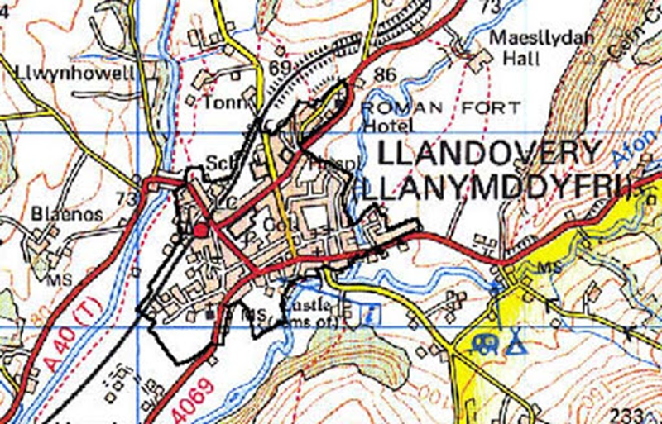

When observing Llandovery and driving through there does not seem to be many youths walking around. Which to a degree is a good thing due to there being a busy road running through the middle of the town. After asking two local children to do a map of where they spend most of their time when out with friends this clearly showed that there are youths out playing but they tend to spend time away from the centre of town in the parks on the edge of the towns or in the playing fields which are hidden away.

Table 1 : Opportunities for education and activities for the youth in Llandovery
LYCC – Llandovery Youth and Community Centre | This centre is situated in the middle of the town and is open Monday to Friday all day. They provide a youth club in the evenings and holidays for the youth and then open to the community to come in for advice and information the rest of the time. They are also used as a hub for outside parties who come into the community for information giving.
Cylch Merihryn | Child care for children between the ages of 2 – 4 mainly though the medium of Welsh.
Cariad a cwtch | A nursery providing care for children and educational aspects from 0 – 4.
Llandovery College | A private school which has a college nursery which offers nursery care from 0 – 4 as well as holiday clubs and after school clubs.
Ysgol Rhys Pritchard | The local primary school providing education for 4 – 11 year olds, while also offering extra care within breakfast and afterschool club.
Brownies, Rainbows, Guides, Beavers and Cubs | Runs once a week after school
Football and Rugby Club | Both run once a week for training and then a game on the weekends.
Towy Youth Actors and Karate | Again both run once a week.

It is clear that the biggest issue within Llandovery is that the school closed and is taking the young people away from the community and where the town used to be full of the youths walking to and from school as well as meeting up after school this does not seem to be the case. All the youths are using the transport provided and then in their free time meeting friends in Llandeilo where the new school is.
After talking to children from Llandovery they marked on the map below where they would spend their time on a day out. The map shows that they chose to visit the skate park, river, youth club, town centre arches and the rugby club. Other times were spent walking around and going into shops. When asked what would they improve they stated that they have to make their own entertainment so Llandovery could offer more for them to do. They find that Llandovery is very quiet but they do feel safe when walking around. Even though the main A40 runs through they feel like there are never any problems due to Llandovery being away from everything else and in the middle of nowhere. It has the locals, tourists and people just driving past.
Unfortunately, the young people in Llandovery do not go out as much as they would like to, or as much as they used to. There is great involvement in the local clubs and community groups but the young people do not meet up outside of these activities. There is a positive aspect which is that there is enough for the young people to do. On the other hand, could it be classed as a positive that the young people are no longer “hanging around” in the town in the evenings. This is also demonstrating that the young people are happy being at home which is a massive bonus because they are safe and off the street.
Case study – participant is named Emma for the purpose of this work
Emma is a young female aged 13years from Llandovery who is very mature for her age. She does all the classes including ballet, character, tap and modern dance. Emma is a happy girl who really does enjoy dance and have very good abilities to dance, she is able to perform and deliver the dances at a very high level. She has been dancing with the school from the age of three so is very familiar with the teacher and the others within the class.
When Emma was asked about the classes she said “I really do enjoying coming to my dance classes, I feel that I am learning a lot and I always try my best, I do sometimes get stuck with the moves but I will ask for help and then it is explained to me. I think I am a quick learner and I am willing to give anything ago”. From observing Emma I would agree with her statement she really does get into what she is doing and it is clear to see how much she is enjoying the class by the look on her face. She is a very quick learner and can often pick steps up a little quicker than others in her class. She has a very good relationship with the class teacher and also the others within the class which is a good sign as it shows that she is comfortable around everyone.
In relation to Emma’s background she goes to a private school and excels in all subjects with the most recent exam results all being over 75%. She also goes to a drama school which is similar to Lovetodance in how they do exams and work on singing, performing arts and dance. This gives her many opportunities to perform in big venues including royal theatres in London. Emma lives at home with her mum and now grandparents due to their ill health. Emma’s father moved out 4 years ago and she used to spend time with him every other weekend but now it does not seem to be that often. Emma does seem to miss her father and was missing a father figure until her grandfather moved into the home. She has become a lot happier now that they have moved into the home. This is showing that Emma was clearly missing a male role model within her daily life. Even though when her parents were together her father worked away throughout the weeks and would return on a weekend. The grandparents have now moved back to their own home and this did not seem to be an issue when they left as Emma was happy to have her mum back and it just being the both of them. Emma is a very popular girl with her peers and within the local community as she is known for her achievements. Emma is a very caring and loving girl who has so much to give but can occasionally forget about herself and put others first.
Focusing on Emma’s behaviour overall she is a well behaved student, but on times she does seem to doubt herself and become disengaged. This is highlighted more when she is tired as she will refuse to do a certain exercise because she “can’t be bothered” and “she can’t do it”. I noticed that she did know what she was doing because the week before she did the whole exercise without any issues. This seems to be a way of seeking attention so that the teacher puts her full attention onto her. Also on the other hand if others in the class do not know a step and they need to take time to go over it but Emma already knows she is can become disruptive in the sense that she will start talking to others which is then distracting the ones which want to learn. Emma can be very difficult to understand sometimes due to her abilities and also the way which she goes about certain things.
The reasons for this behaviour seem to be tiredness, laziness, boredom or wanting attention. She can occasionally get upset with herself but then once she has stopped she comes back and is fully able to do what has been asked. Emma does enjoy being the centre of attention and this is clear on times and can often be frustrating because when Emma is acting in this way she will then start talking to other in the class and encourage them to laugh at her and join in. Emma can be difficult to understand due to her massive success rates in not only class but also performing ability and exam results. It is clear to see that Emma is a talented teenager but due to her age she still has many demands which are forgotten due to her maturity, this can be taken in different ways by different people, but overall Emma is a pleasure to have within the class and 90% of the time she will also give her all in everything that she does.
Critical reflection
Throughout my placement in lovetodance academy I worked as a teaching assistant, this gave me an opportunity to learn about taking a class and also about how to handle situations as they arise. I felt confident while in my placement and enjoyed every aspect of it. I feel like I gained a strong working relationship with the children as well as their parents. I would say that even thought this placement was very enjoyable however I did learn some simple lessons about how children behave. This is clear within the journals and case study above. It is not that every session was difficult or had an issue but a couple of them did. This did help me, through good practice following youth work guidelines, for me to learn how to deal with such behaviours and the appropriate steps to take to ensure that the child is safe while also making sure that they understand the behaviour they are showing is not acceptable. Children are constantly learning and sometimes they do lose control of their feelings and emotions which is then demonstrated in their behaviour. I did often question if what I had said and done in that time was appropriate but with the support of my line manager I realised that what I have learnt over the years has now come into practice. I always felt supported and this was a vital step together with the information I have learned during my academic studies to make sure that my placement was being done in the best possible way.
I feel like I did take a step out of my comfort zone when the teacher allowed me to speak to parents in regards to poor behaviour. This was something that I wanted to do as a learning curve but at the same time I was a little nervous as to how they would react. Luckily in this situation they were very understanding and which made the whole process a lot easier.
To conclude overall I feel like I am confident individual who is willing to put my hand to anything while making the most out of every situation. It is clear that how I am feeling can easily reflect on the young people and they do pick up on your feelings in a situation and will react based on how you handle a situation. I feel like the teacher definitely pushed me to be in control of situations and gave me plenty of opportunities to improve on my workplace skills. By taking part in this placement I have definitely learnt the importance of reflection and how important it helps me professionally and improve on my own practice.
By using SMART action goals it helps to achieve change in a planned way, as well as making sure that changes are made in a particular timeframe. It also leads to being more engaged in youth work in an effective way and being more productive. It is allowing the chance to increase opportunities as well as develop youth creativity (youth working it, 2011).

From this placement even though it was not youth worker based it was related to young people and therefore I consider that is has given me a strong foundation for working with young people in a more traditional youth setting and has taught me how to take lead within a situation. From here I would like to set myself some targets and challenges to work on improvement:

- To learn more about young people’s behaviour and some of the reasons for why they behave in such ways,
- To have more confidence in planning for sessions for sessions, by giving myself more time and being a bit more structural when planning,
- Stepping out into other areas of work which I have not been in before to help me get a better understanding of youth work.

Summary
To conclude I found that doing a workplace folder really did help with the process of beginning placement. By focusing on aspects like community profiling and observation of the workplace it meant that I had a greater understanding of the area and what to except within placement. By working within a small community it meant that working relationships were easy to gain and it was nice to be able to observe the same young people each week as it showed the development of how I was going through the process of creating and keeping a professional working relationship. There have been some difficult times when the young people’s behaviour changed in a negative way but for this to be dealt with in such a positive way every time has been rewarding especially as there were no further issues. By the time the class finished the issues were resolved and everything was clear and ready to start the following week. It has been very interesting and eye opening to meet so many young people with so many different background but this has been a massive positive in my understanding. I found that there have been some aspects of disorganisation on my part during this process but it has made room for learning by using reflective practise. Without mistakes and issues there would never be anything to learn from. After putting this workplace folder together, it has clearly highlighted the importance of each section and clearly highlighted my strengths and weakness as a leader and it follows my journey to becoming an effective reflective practitioner. I have noticed the value of case studies and how effective they can be for learning. It is a way of breaking down a situation and recognising what is actually happening in that situation. It is then giving the ability to improve and support that situation. I am also aware that though out my written work I still struggle with my connections to theory which is recognised in my referencing. This is definitely something that I need to be more organised with and something which needs to be improved.

References

Alliance, T., 2021. The Stigma of Poverty. [online] Making Change Happen. Available at: <https://povertyalliance.wordpress.com/2016/10/19/the-stigma-of-poverty>.
Communitydance.org.uk. 2021. People Dancing :: Risk assessment & useful resources list :: Foundation for Community Dance. [online] Available at: <https://www.communitydance.org.uk/DB/news-and-views-2/news_and_views/risk-assessment-and-useful-resources-list>.
Mind.org.uk. 2021. Five ways to wellbeing. [online] Available at: <https://www.mind.org.uk/workplace/mental-health-at-work/taking-care-of-yourself/five-ways-to-wellbeing/> .
research, T., 2021. The importance of case studies in social research. [online] Changeworks. Available at: https://www.changeworks.org.uk/news-and-events/blog/the-importance-of-case-studies-in-social-research.
ResearchGate. 2021. (PDF) Researching reflective practice: a case study of youth work education. [online] Available at: <https://www.researchgate.net/publication/240525420_Researching_reflective_practice_a_case_study_of_youth_work_education>.
Sqa.org.uk. 2021. [online] Available at: <https://www.sqa.org.uk/files/aq/HD9W04.pdf>.
Ukstandards.org.uk. 2021. Home. [online] Available at: <https://www.ukstandards.org.uk/>
United Kingdom. 2021. The Royal Academy of Dance (RAD) | United Kingdom. [online] Available at: https://www.royalacademyofdance.org/.

Matrix Evidence
YW02 – Assist young people to express and to realise their goals
YW03 – engage with communities to promote the interest and contributions of young people
The school put on a showcase every year which is open to all. They have an arrangement within the local town where they use the old high school to perform. They have use of the building for dressing rooms and then use the main hall and stage for the performance. They also have help from the local Young Farmers Club as they have a lot of tech for the sound and lighting. Students from Llandovery College are also able to get involved as they are able to use the performance as part of their course work for their work backstage helping with lighting etc. Every year there are donations from parents and local community centres which helps to purchase costumes and equipment. The local pub also comes along to do a pop up bar and donates the profits to the school. This is a great opportunity to bring the community together while giving the young people an opportunity to showcase all their hard work over the year. Wellbeing of Future Generations (Wales) Act 2015 cohesive communities

YW05 – enable young people to use their learning to enhance their future development
The young people have the opportunity to develop not necessarily just through the school but through the Duke of Edinburgh Award, PE and Welsh Baccalaureate which are providing transferable skills. Most of the young people who take part in these subjects in school will use the school and their skills to complete their logs. We are able to offer volunteering opportunities which include helping out in lessons to having an active role around the show with preparing costumes and having an input with some of the dances being taught. We are always trying to encourage the young people to get involved, take a lead and use all their skills to succeed.
YW06 – Enabling young people to work in groups
As you can see from the pictures below the young people are often asked to work together in groups to create dances and discuss ways of improving dances.

YW11 – Plan prepare and facilitate activities with young people
We allow the young people to get involved with the show prep, we ask for help with costumes and also help with setting up for the show. We are able to give the older children a chance to take a role in what we are doing. Not only are they involved with the prep but some will also be activity helping when the show is on backstage and helped to look after the younger children.

YW12 – Work with young people to manage resources for youth work activates
In Figure 2 all the costumes were prepared with the help and support form the young people
YW14 – Facilitate young people’s exploration of their values and beliefs
The young people have the opportunity to take on dance as a career. With the school being RAD registered it means that the opportunity to work towards a future is there. The staff talk to the young people about how they are able to push themselves to be successful within dance. This included conversations over what level they should be at, how they can improve, what needs to be done to get to their goals and also how important exams are for the stepping stones into their future. Ballet is not a career for all young people and there is no pressure on the young people to be pushing themselves to a professional level but rather to just enjoy and use this time as a hobby. Ballet is a disciplined form of dance and teaches the young people many deadlines which they may come across in life.
YW16 enable young people to access information to make decisions
The young people are given the opportunity to do dance exams every 1 – 2 years depending on level of ability. They are given this opportunity as it is not only teaching them the discipline and giving them an experience of a formal situation but also the opportunity to start the build-up of results for their futures. After a certain grade the exams also give the young people the opportunity to collect UCAS points which are used when applying for university. It is also teaching them about the time and dedication which is needed in this setting. Again exams are not for everyone but they are an opportunity which is offered and 99% of the students will go thought this process at least once.
YW30 work as an effective and reflective youth worker practitioner
This has been shown within the reflective journals. By reflecting on the work which I have done it means I am noticing what was good and bad about situations. This is one of the best ways to improve my learning and skills because I am able to reflect on how I was within a situation and compare with youth work practice. This is allowing me to focus on the pillars of youth work and makes sure that I am working to the standard required to be a youth worker.

3: Map showing areas within Llandovery Town © (Sheepfestivalinfo,2019).
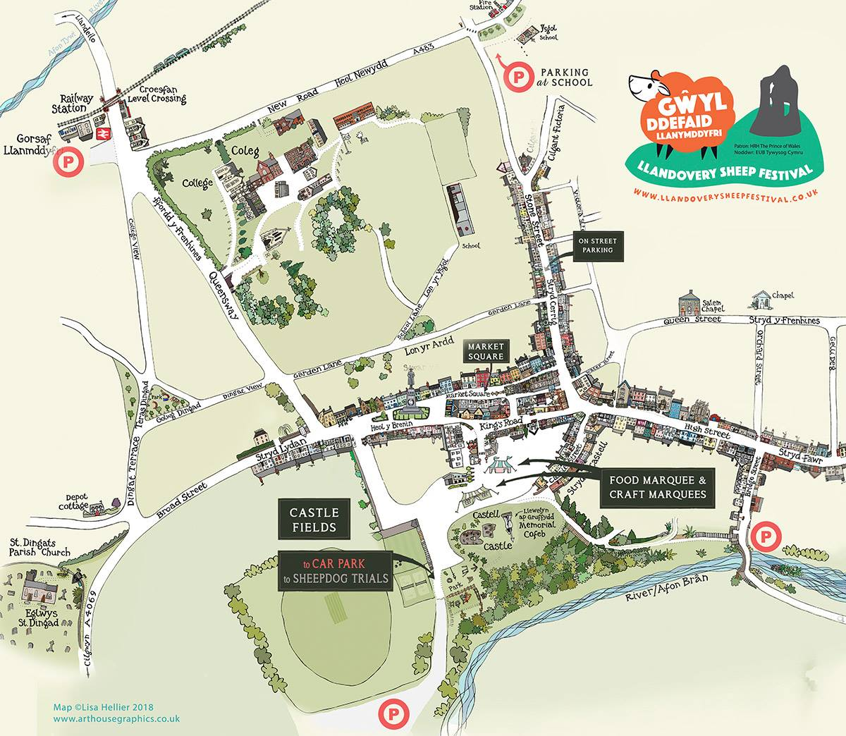

Quotes from Young People
“I like Llandovery it makes me feel safe, but there isn’t much to do in the nights”

“There are lots of clubs, but I don’t really like what there is to do, I just like to chill out with my friends”

“I am with my friends in school and can talk to them on my phone, so instead of going out in the cold we just snapchat and play online games”

“Llandovery is very quiet and there isn’t much to do with my friends when I go out”

“I enjoy going to the youth club but not all my friends go because they think it is boring”

“I don’t like sports so there aren’t any clubs for me to go to really in Llandovery”

“I like to go out in town with my friends, but we are always outside, we will buy some food from the shop and sit under the arch or go to the park. Its good but gets boring sometimes”

“I don’t really go out in town I prefer to sit at home on my Xbox and talk to my friends online”

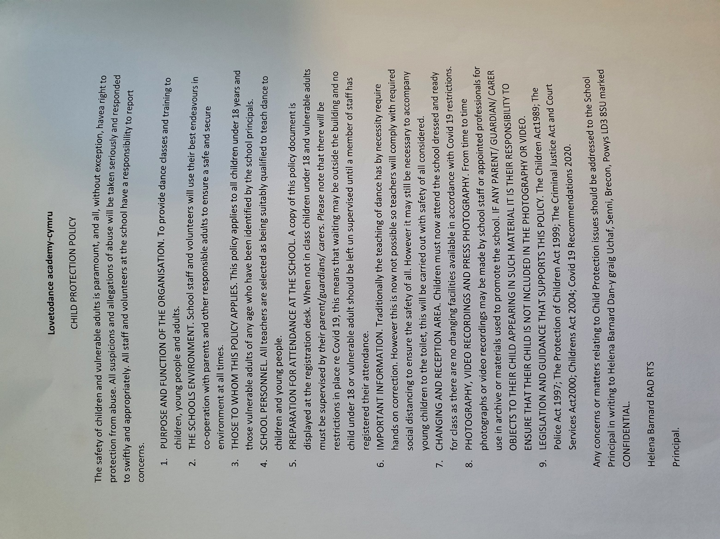

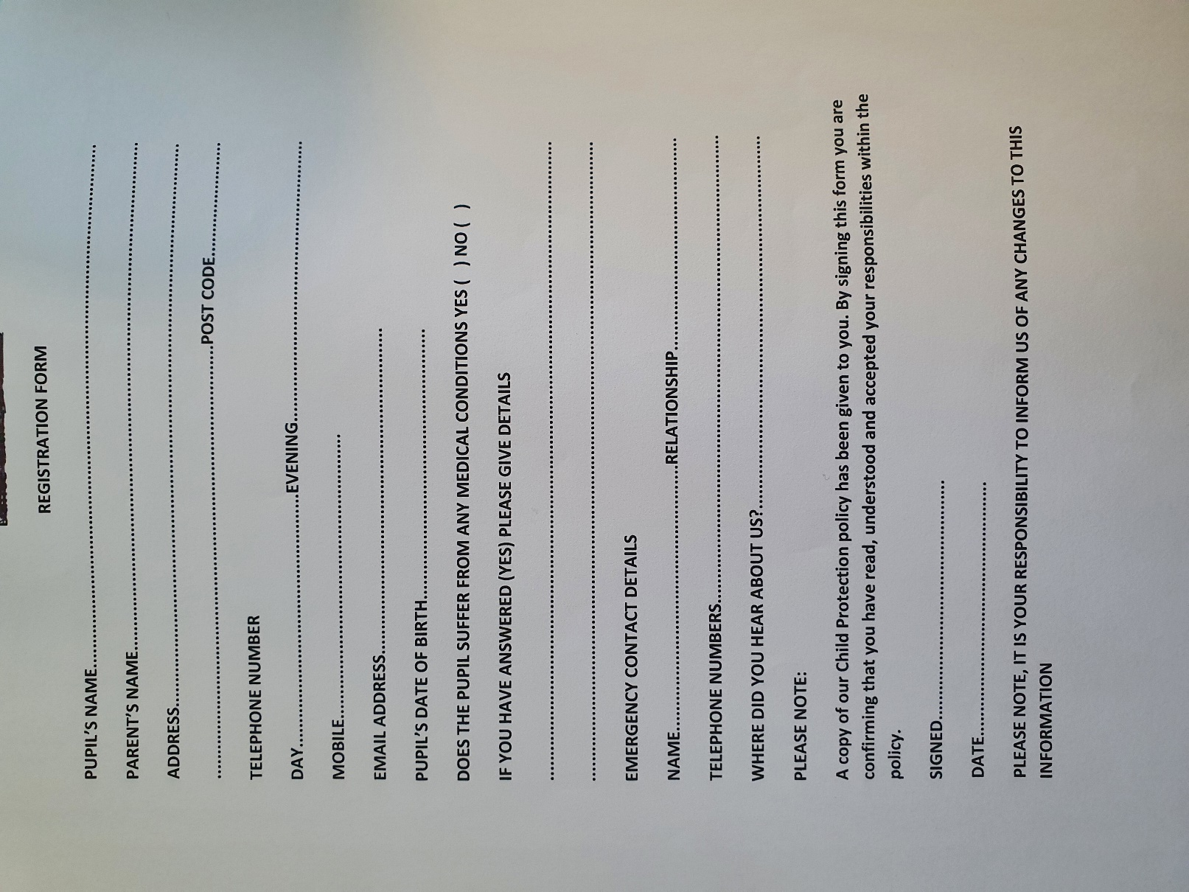

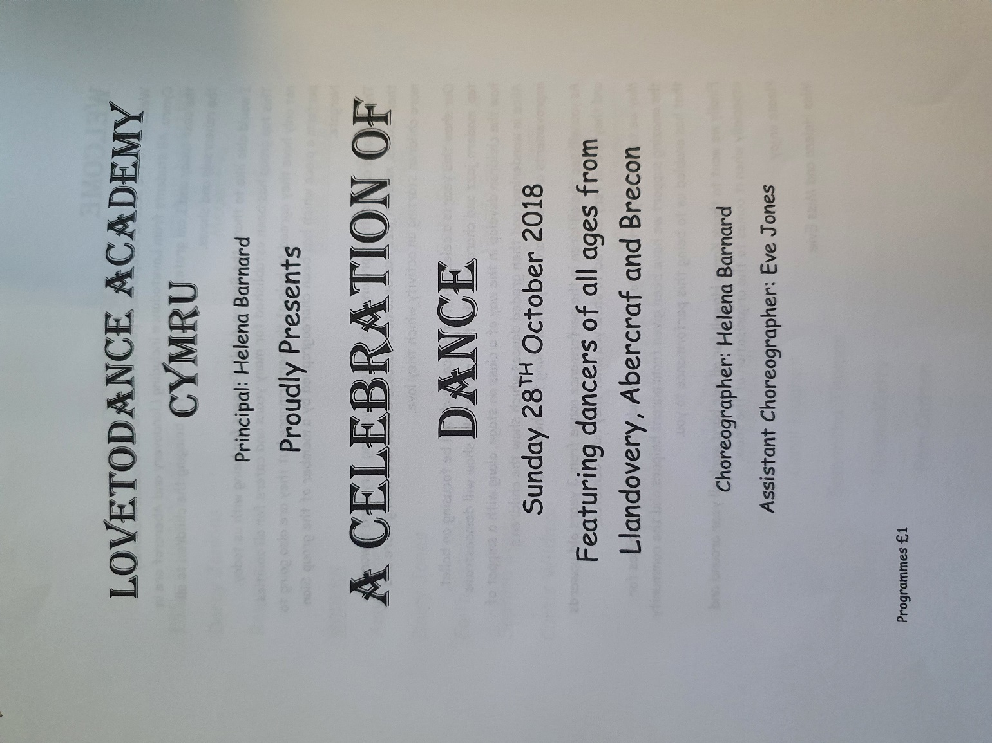

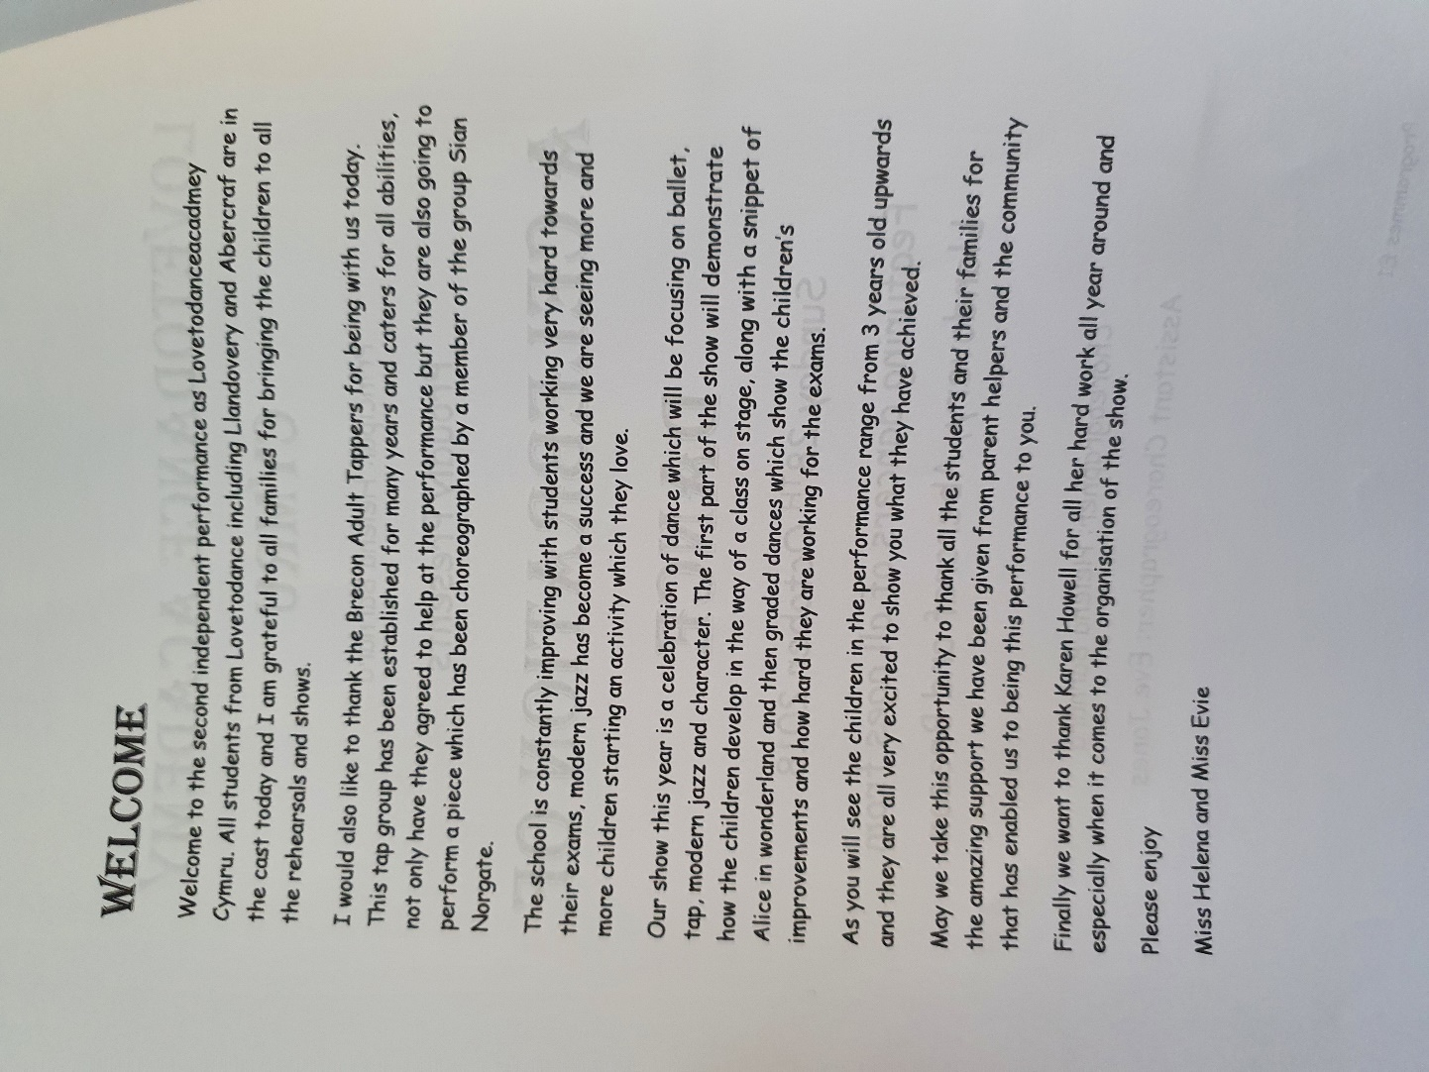

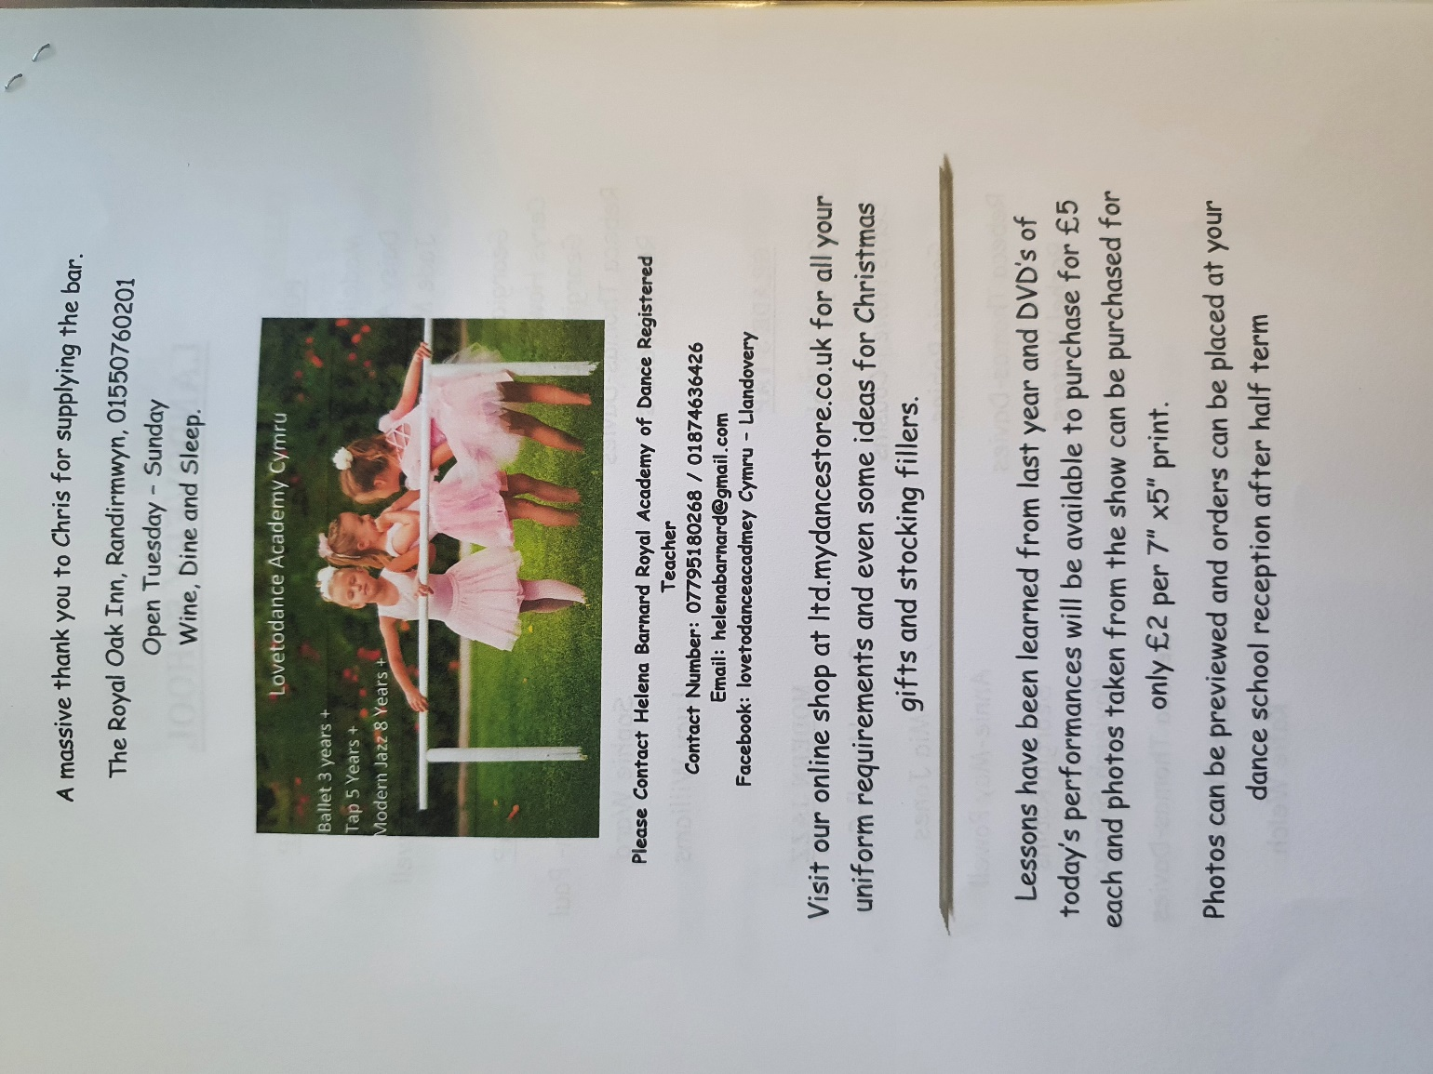

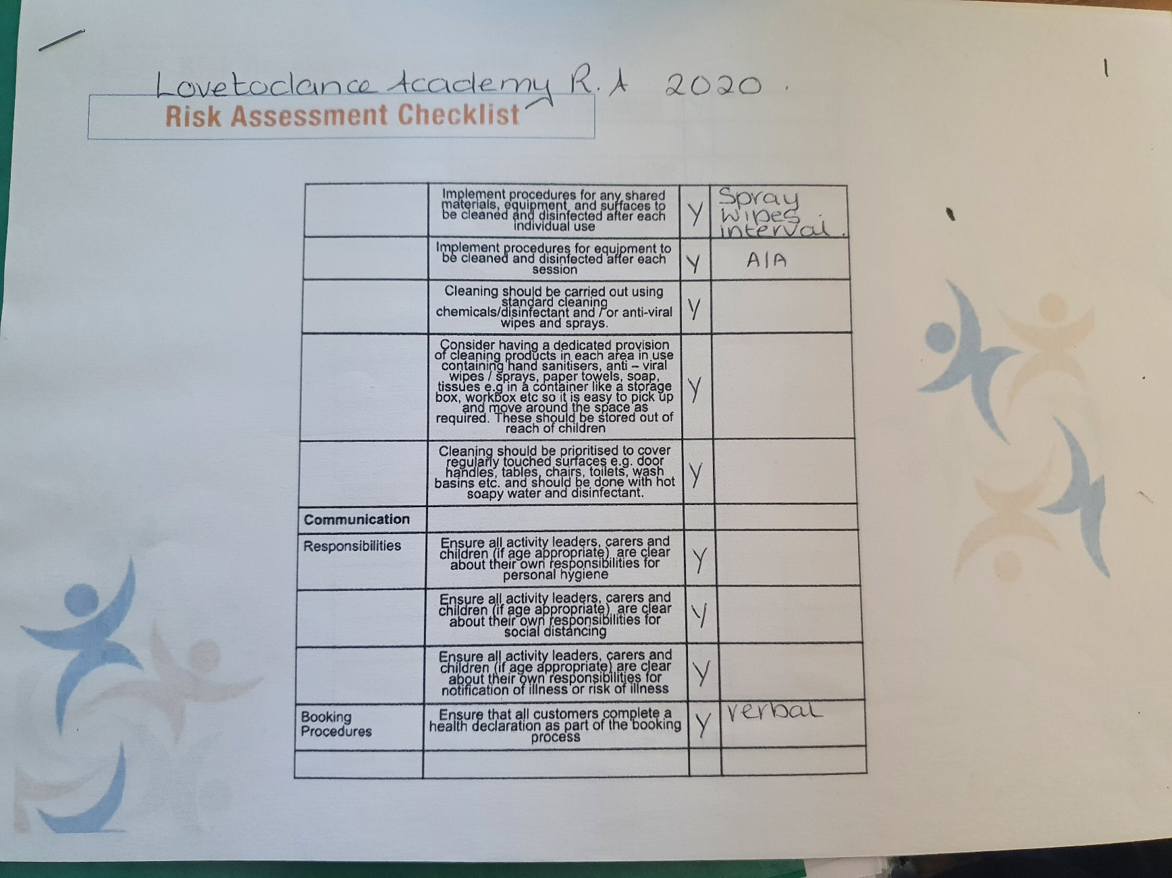
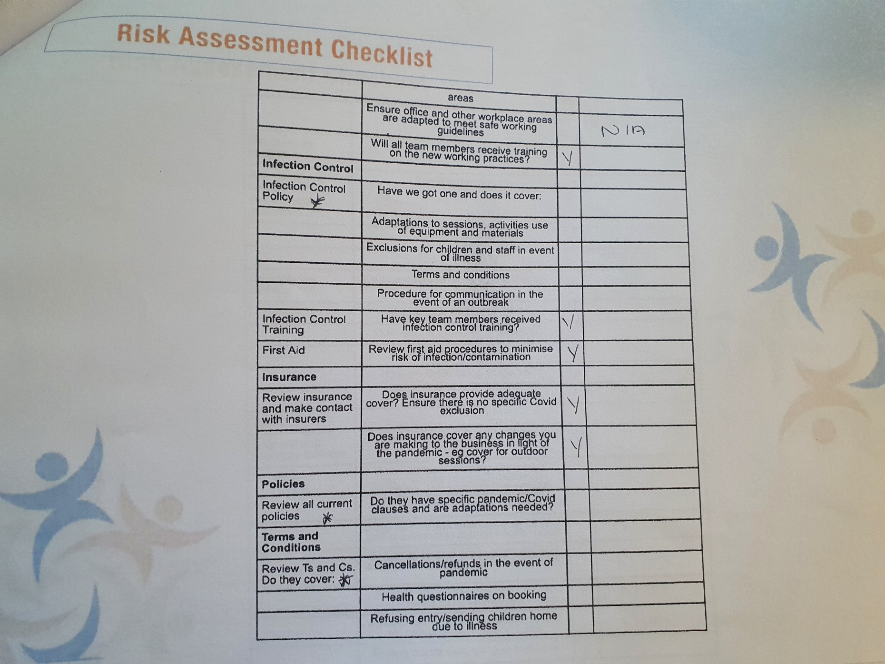

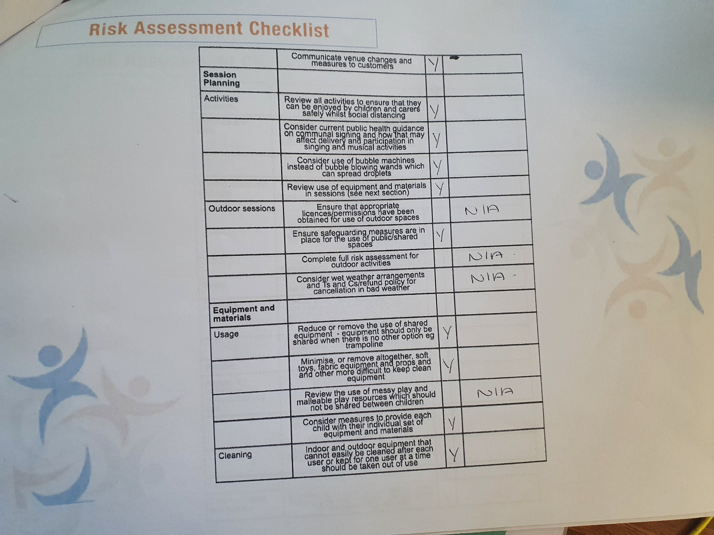

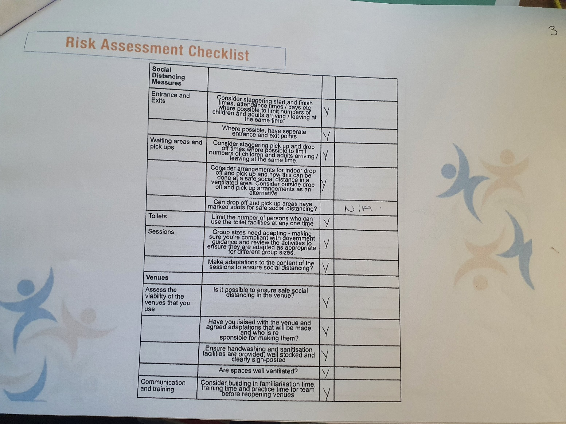

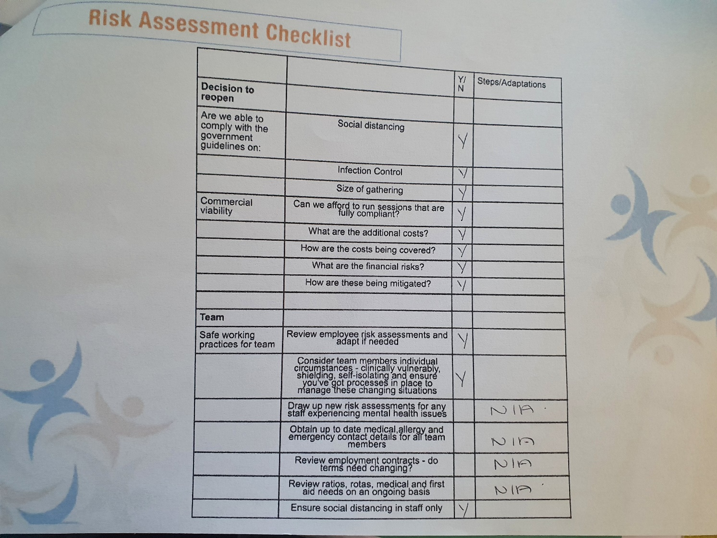

FIELDWORK PLACEMENT CONTRACT
Where possible please complete this information electronically, the text boxes will expand to contain the necessary information.
STUDENT INFORMATION
Student Name | Eve Alexandra Jones
Student Address | The Cottage  5 Chapel Street  Trecastle,  Brecon,  Powys,  LD3 8UF
Student University e mail | Ejones.147113@student.uwtsd.ac.uk
Student DBS Status and date
Additional requirements
Name of fieldwork supervisor | Ruth Letten
Fieldwork supervisor Tel.
Fieldwork supervisor e mail | ruth@drmz.co.uk

HOST ORGANISATION INFORMATION

Name of Organisation |  |  | LovetoDance Academy
Tel. |  |  | 07795180286
Email |  |  | helenabarnard@gmail.com
Aims/ Purpose of the Organisation |  |  | Dance school offering different dance styles for the ages of 3 – adult.
Duration of placement |  |  | Level 7 Placement: 200 hours (100 or more face to face Youth Work).
Please detail the activities expected of the student  (Use more space if necessary) |  |  | To assist with teaching the lessons and then take her own classes in time.
Facilities/equipment available to student |  |  | Music equipment,  Props,  Syllabus books.
Please confirm that your organisation has in place the following and where the student can have access to them:
a. Equal Opportunities Policy and procedures |  |  | Yes school policy file
b. Safeguarding policy and procedures including a designated child protection officer |  |  | Yes school policy file
c. Disability Policy (please state how you will meet any special requirements noted by the student) |  |  | No special requirements - school policy file
d. Health and Safety Policy and procedures |  |  | Yes school policy file
e. Risk assessments including significant risks identified? A copy to be forwarded to the University. |  |  | Yes – school policy file
During induction the student will be made fully aware of the organisation's rules of conduct (including boundary management), practices and policies, including Safeguarding and Health and Safety (e.g. accident reporting).

The student will be covered by your employer's liability insurance whilst on your premises and undertaking any assigned tasks.

Yes No

During the placement, the student will be responsible to:
Name of Line Manager | Helena Barnard
Position | Principle
Telephone No. | 07795180286
Email | helanabarnard@gmail.com
UNIVERSITY INFORMATION

Name of visiting tutor
Telephone Number
Email address

Student, line manager, and visiting tutor to sign below:

I hereby agree to the terms and conditions outlined above

Signed (student) EAJONES Date:

Signed (line manager) GHarris Date …………………

Signed (visiting tutor)………………………………………… Date: ………………….

FIELDWORK PRACTICE SUPERVISION CONTRACT

Practicalities | Sessions are to be booked in advance and scheduled on zoom.  Any cancelations must be made 24 hours prior unless.  If an emergency arises during the meeting which you must attend then this is acceptable, or if you are expecting a phone call etc let me know at the start of the session.
For example - timing, frequency, place, what are reasonable interruptions.
Boundaries | Confidentiality is essential, if this is broken then a warning will be given,  Anything can be discussed which we are comfortable with,  If you do not want to talk about something then just say you don’t want to,
What can be discussed, what cannot, confidentiality, how will gossip be dealt with.
Working together | The relationship will be a professional working relationship. There will be a focus plan for each session and we are able to share and explore experiences if there is a natural flow.
Sharing expectations, what the focus of the relationship will be hopes and fears, the ethos of the supervision.
Session Format | - General catch up about the placement,  - Agenda discussed of what the student wants to discuss,  - Talk about the individual points,  - Reflective journals,  - Points to note for future sessions,
What will each session be like? Will all the time be spent on one incident; are supervisees expected to bring written recordings or verbatim accounts?
Organisational & Professional context | The initial introduction covers all aspects that are required for stayed professional and setting the boundaries which are needed for supervision. The responsivities of both are also discussed so we are clear of what is expected of ourselves.
Expectations, fitness to practise, responsibilities on supervisor and supervisee, professional and ethical boundary discussions.

Signed (supervisee) EAJONES Date:

Signed (supervisor) Date:

Supervision Recording Format

SUPERVISION RECORDING
DATE:8/03/21
TIME: 1pm
PEOPLE PRESENT: Ruth and Eve
DURATION OF THE MEETING: 2 hours
AGENDA/ DISCUSSION POINTS
- Introduction to supervision and planning
- Reflective theories
- Exploring placement
- Organisational skills

NOTES/ ACTION OF EACH ITEM
Basic points to remember over the supervision period and basic planning, meeting every Monday at 1pm for 2 hour sessions. Making sure that what is expected of myself has been achieved by the following session.

Using different theorists Gibbs, Kolb, Schon, Boud, Dewey and noticing the use of SMART action points.

Explaining what the placement is and the ways in which this can be connected to youth work practice.

Be more organised with my work academically, setting myself targets and goals to meet each week. Keeping my supervision notes updated and also keeping my line manager updated on how my placement is going.
PROBLEMS ENCOUNTERED
Not being organised within my academic work, lack of communication with the university and not talking about how my work load is progression or when I am struggling. Seeking extra support from the university to assist with my dyslexia.
REFLECTION on effectiveness of supervision.
This supervision session helped me a great amount, especially with my organisational skills around my academic work. Being able to speak to someone and create a plan made the process a lot easier to understand and work on.
LINKS TO LEARNING OUTCOMES, FURTHER QUESTIONS ARISING
DATE OF NEXT MEETING:15/03/21
SIGNED:
STUDENT: EAJONES
SUPERVISOR

SUPERVISION RECORDING
DATE: 15/03/21
TIME: 1PM
PEOPLE PRESENT: Ruth and Eve
DURATION OF THE MEETING: 2 hours
AGENDA/ DISCUSSION POINTS
- Reflections x2
- Building positive working relationships
- Ways of dealing with aggressive behaviour
- Areas of development
NOTES/ ACTION OF EACH ITEM
Need to be more critical in my work and focusing on using more academic ways of writing. Allowing room for improvement but also noticing the positive aspects of my work.

Positive working relationships with staff, volunteers and young people leading onto a better practice for the group and myself. Remembering that team work is key and then leads to more positive outcomes.

Putting yourself first and making sure

PROBLEMS ENCOUNTERED
The main issue was the way in which my reflections were being written, not including enough references to theory and the use of my academic wording was poor.
REFLECTION on effectiveness of supervision.
The importance of using theories within my work and the different ways in which we are able to reflect for example Kolb, Gibbs, National standard, NOS.
The supervision session made it very clear where I was going wrong within my reflections and how this can be corrected.
DATE OF NEXT MEETING: 22/03/21
SIGNED:
STUDENT: EAJONES
SUPERVISOR

SUPERVISION RECORDING
DATE:
TIME:1PM
PEOPLE PRESENT: Ruth and Eve
DURATION OF THE MEETING: 2 hours
AGENDA/ DISCUSSION POINTS
- Evidence throughout
- Reflective journals x2
- Highlight safety
- Planning

NOTES/ ACTION OF EACH ITEM
Adding in more evidence to back up what has been said, discussion around the importance of it and where is should be used. Reflective journals are getting better read out loud to recognising the mistake of grammar throughout don’t forget to make links. Notice safety all round risk assessment of the possible physical dangers and dangers to a young person. How planning makes sessions a lot easier and also to protect yourself, but sticking to the plan doesn’t always go to plan. This is ok and shows that you can think on your feet, sometimes situations change depending on the mood, day and feelings of all involved and that’s ok.
PROBLEMS ENCOUNTERED
Not being clear enough with evidence, making statements but not backing them up with the reference. Reflecting on myself more within the journals highlighting my feelings more rather than focusing on others.
REFLECTION on effectiveness of supervision.
It was reassuring to remember that planned sessions don’t always work but that is ok. Thinking on your feet find ways around the issues which may of raised and to go with the flow.

DATE OF NEXT MEETING: N/A
SIGNED:
STUDENT: EAJONES
SUPERVISOR

PROFESSIONAL DEVELOPMENT PLAN
For completion by the student after consultation with the Line Manager and Fieldwork Supervisor at the outset of the Placement
Student | Eve Alexandra Jones
Line Manager | Helena Barnard
Placement | LovetoDance Academy
Date | 06/11/2018

Students will be expected to consider their placement experience to demonstrate competence in the key aspects of youth work outlined in the table below based on the National Occupational Standards for Youth Work (LSIS, 2012) and the Principles and Purposes Document (WAG, 2013).

Line manager’s opening comments about the placement – exactly what type of work will the placement involve?
This placement is for all individuals from the ages of 3 to adult. The basics of the role is the teach different dance styles in some cases as a hobby but also for some individuals to work towards exams and also annual shows. Eve will be required to take on a few different roles, these will start with observing, meeting parents and students, learning the way in which we work and then to take her own classes. There has been a clear introduction set out and targets set so that Eve will be able to take her own classes by the end of her placement.
Student initial comments about the Placement.
I am happy with the placement and what has been planned by my mine manger. We have had a clear introduction and everything has been made clear for what the school does and also what is expected of me as a student. I am looking forward to getting started and looking forward to hopefully being able to gain working professional relationships and take my own session in time.

PROFESSIONAL DEVELOPMENT PLAN

Please complete the form electronically to enable the boxes to expand, ensuring you provide adequate detail.

 | 1. Work in accordance with the 5 pillars of Principles and Purposes of Youth Work in Wales (2013) (Educative, Expressive, Participative, Inclusive, Empowering). | 2. Facilitate the personal, social and educational development of young people | 3. Promote inclusion, equality and young people’s interests and wellbeing | 4. Work with young people and others | 5.Develop youth work strategy and practice | 6. Develop, lead and manage self and others
What do you need to learn? | How the 5 pillars can be transferred into a dance setting.  Considering the ability of the young people and their personal needs for example language barrier. | The ways in which this can be done via a dance class.  Recognising the educational development which is found within these classes and the benefits they have. | The ways in which students engage with positive results.  Taking into consideration their understanding around inclusion and equality. | The ways in which young people engage the most.  Recognising their relationships with each other to create better working relationships. | The way in which youth work can be noticed and developed within this setting. | How to constantly develop working relationships.  Also recognising the importance of these relationships within the setting,
Activities you will learn from (how will you learn, what will you learn from) | This would be done via the normal lesson but focusing on reflections to recognise if the pillars have been used. Upon reflection if they have not then work to include them in the following session. | By having discussion with the students and letting them have their own voice. Doing exams and working towards the annual show. | When doing the annual show making sure all student have a fair opportunity as well as constantly checking in on their wellbeing, as doing these shows can often cause a mixture of emotions. | Doing different activities and assessing the ways in which they best react. | When planning the sessions basing them around youth work, transferring the skills between them both. | Working with all individuals who are involved within the school students, staff, parents and the community.

Student | EAJONES
Supervisor | H BARNARD
Date | 06/11/2018

Fieldwork Supervisors Final Report - Key areas of competence
When considering the level of competence of a student in supervision please refer to the marking criteria outlined below:

Grade | Description | Equivalent % marks towards HE qualification
A | An exceptional trainee Youth worker who is a reflective practitioner; shows initiative and an ability to work independently for a sustained period; demonstrates thoroughness and commitment to all aspects of professional practice. | 70%+
B | An effective trainee youth worker who displays a degree of independence and commitment to further professional development. | 60-69%
C | A satisfactory trainee youth worker who has met the requirements appropriate for a professionally qualified Youth Worker and with further experience should develop into an effective youth worker. | 50-59%
D | A rather weak trainee youth worker with a basic level of knowledge or skill. May be very poorly organised with very limited understanding of important concepts. | 40-49%
E Fail | A weak trainee youth worker who has been unable or unwilling to meet the required standard, may demonstrate inappropriate values or lack understanding or attention to detail. | Below 40%

FIELDWORK SUPERVISOR’S FINAL REPORT
This section of the report should be completed by the fieldwork supervisor. To complete the report we would like you to use the headings below giving specific examples to support your observations and make reference to the Table above.
How did the student use supervision and respond to feedback?
To what extent did the student seek challenging situations, and how were these worked with?
To what extent did the student show enthusiasm, commitment, creativity and innovation?
How well was the student able to relate theory to practice and reflect on her/his own practice and that of others?
How did the student articulate her/his own beliefs and values and relate them to the work?
How pro-active was the student in demonstrating anti oppressive beliefs, language, and behaviour?
In your professional opinion has the student achieved the necessary standards to function as a professionally qualified Youth and Community Worker?
Provisional grade for supervision (%).

Signed Supervisor
Signed Student | EAJONES
Date

LINE MANAGER’S FINAL REPORT
The University would like to remind the line manager of the importance of their role in the assessment of the student. This role is fundamental in ensuring standards of practice of those working with young people in communities, and cannot be taken lightly.

To ensure the desired results are achieved, all those involved in the placement are required to understand and remain committed to the process of supervised practice. Issues of competence which might jeopardise a student’s ability to complete the module successfully should be identified and communicated to the visiting tutor or fieldwork coordinator as soon as possible.

After the student’s induction to the placement, the student will have drawn up a professional development plan balancing the needs of the student and the requirements of the programme. As line manager you will have carried out managerial supervision and an interim review of the placement. This document is the final report, and will include your final assessment of the standards achieved by the student on placement.

Key areas of competence
When considering the level of competence of a student please refer to the marking criteria outlined below:

Grade | Description | Equivalent % marks HE qualification
A | An exceptional trainee Youth worker who is a reflective practitioner; shows initiative and an ability to work independently for a sustained period; demonstrates thoroughness and commitment to all aspects of professional practice. | 70%+
B | An effective trainee youth worker who displays a degree of independence and commitment to further professional development. | 60-69%
C | A satisfactory trainee youth worker who has met the requirements appropriate for a professionally qualified Youth Worker and with further experience should develop into an effective youth worker. | 50-59%
D | A rather weak trainee youth worker with a basic level of knowledge or skill. May be very poorly organised with very limited understanding of important concepts. | 40-49%
E Fail | A weak trainee youth worker who has been unable or unwilling to meet the required standard, may demonstrate inappropriate values or lack understanding or attention to detail. | Below 40%

LINE MANAGER’S FINAL REPORT (continued)
Work in accordance with the pillars of Youth Work in Wales: Principles and Purposes
A Exceptional  70%+ | B Effective  60-69% | C Satisfactory  50-59% | D Rather weak  40-49% | E Weak  0-39%
100%
Facilitate the personal, social and educational development of young people
A Exceptional  70%+ | B Effective  60-69% | C Satisfactory  50-59% | D Rather weak  40-49% | E Weak  0-39%
100%

Promote inclusion, equality and young people’s interests and wellbeing
A Exceptional  70%+ | B Effective  60-69% | C Satisfactory  50-59% | D Rather weak  40-49% | E Weak  0-39%
100%

Work with young people and others
A Exceptional  70%+ | B Effective  60-69% | C Satisfactory  50-59% | D Rather weak  40-49% | E Weak  0-39%
100%

Develop youth work strategy and practice
A Exceptional  70%+ | B Effective  60-69% | C Satisfactory  50-59% | D Rather weak  40-49% | E Weak  0-39%
100%

Develop, lead and manage others
A Exceptional  70%+ | B Effective  60-69% | C Satisfactory  50-59% | D Rather weak  40-49% | E Weak  0-39%
100%

LINE MANAGER’S FINAL REPORT (continued)
How has the student developed during the placement?
Eve came to the placement with exceptional Skills. During the placement she
Observed the teaching of the students in accordance with the Royal Academy of
Dance (RAD) Code of Conduct and using the RAD materials.
Eve then assisted in the teaching of the students. She demonstrated inclusion by
taking on the extra supervision and one to one teaching of a child in the school
with behavioural issues who was a looked after child and without close
supervision was quite hostile to other students. This help meant that the child
could be included in the class with other students and could therefore take part in
activities that she would otherwise not be able to, due to maintaining the safety of
the other students.
Eve then began to deliver the body of several lessons with me taking on just a
supervision role.
It is with confidence that I conclude Eve is an effective youth worker showing her
skills in all areas and a high degree of professionalism.

What are your suggestions for further professional development?
Eve should develop by taking on her own classes and in the future complete the
RAD teaching certificate should she decide to do so.

Has the student passed the placement? Please take into account your view of the student’s performance in each of the Key Aspects of Youth Work (Please circle clearly).
Yes, Pass | No, Fail
Line Manager’s Provision Grade for the Student (%)
100%
Further Comments
I would have no reservation in offering Eve an independent role in my school.

Signed Line Manager | E Jones
Signed Student | EAJONES
Date | 21/10/2019

University Of Wales Trinity Saint David
BA (Hons)/ MA Youth Work and Social Education
Level 7 Fieldwork Placement Observation

Student Name: Eve Jones
Observer: Darrel Williams
Line Manager: Helena Barnard
Project Title: Dance School
Setting: Llandovery, Rhys Pritchard Memorial Hall
Date: 6th November 2020
Description of participants: Young people who haven’t thrived in school settings, transitioning them to moving on to college.
Age: 11-18, single gender group of girls.

Staff: Eve worked with the support of Helena
The student’s fieldwork placement is with the Love to Dance Academy

Eve makes judgements about the preparedness of the students to complete the session which is planned. Sometimes supporting the dancers developing their literacy as well as teamwork. In addition to this Eve has supported students to develop ‘soft’ skills, relationship building through projects in the community.
Eve had provided a detailed verbal briefing for me outlining the aims and objectives of her work on placement. The project involved young people as part of a dance group encouraging the young people to keep fit, engaged and to keep motivated. Eve was well prepared. It has been evident from discussions that the young people responded positively and were usually fully engaged in sessions. Required resources were minimal due to the nature of the project, one of the main resources being Eve herself.
It was evident that the student could engage consistently with individuals within the group, the young people and other members of the staff team. The student’s use of language and instructions was appropriate. Eve is generally of a calm disposition, she is able to gain respect and build relationships with young people and staff because of the calm and confident attitude she portrays. Eve is approachable and seems to be a very good listener.
During placement tutorials and lectures Eve has attended well and has been able to relate theoretical learning to practice. The student is an effective trainee youth worker who shows initiative and has the ability to work independently for a sustained period of time. She demonstrates thoroughness and commitment to the work. The communication, administration and management of the placement has generally been a very positive aspect of the fieldwork experience although at times communication has been patchy.
Provisional Observation Grade: 66
These grades are provisional and subject to further scrutiny and approval by the relevant examination board.

