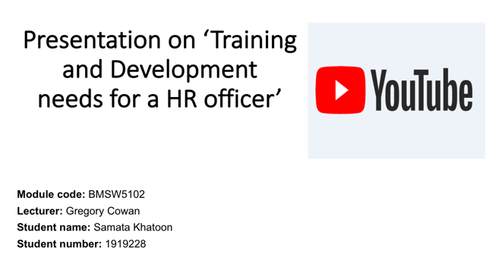

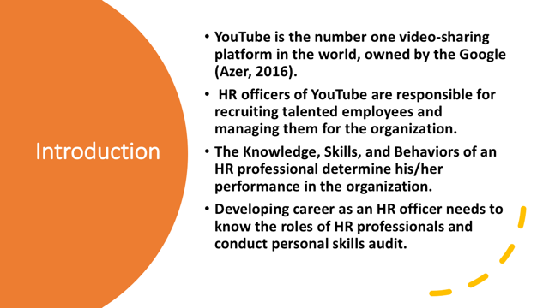
Speaker notes

- The latest studies for 2021 of YouTube statistics in the UK
- The second most popular social media site is YouTube
- 35.6 million adults in the UK use the YouTube platform
- 35% of the UK population are -an active user of the Youtube
- 46% of women use YouTube in the UK vs 54% of men
- Youtube use is growing the fastest amongst Baby Boomers and Gen-X-ers
- The most active demographic are aged 25- 44.
- The most popular YouTube channel in the UK was Ed Sheeran with 43 million subscribers

- https://www.socialfilms.co.uk/blog/youtube-uk-statistics
https://www.statista.com/statistics/296227/us-youtube-reach-age-gender/

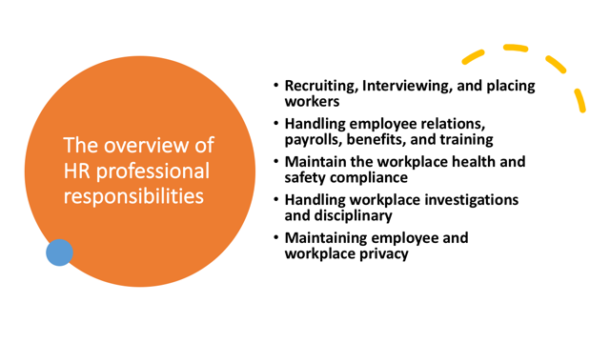
Speaker notes

- The HR managers supervise the company or organisations hiring process from recruiting and interviewing.
- Improve employee engagement, build a strategy and talent resources plans.
- As the HR manager- I will take ownership of all HR matters across the company from recruitment to performance reviews, wage reviews, disciplinary action, learning and development, and knowledge on legal requirements in this role.
Lecture notes - Gregory Cowan

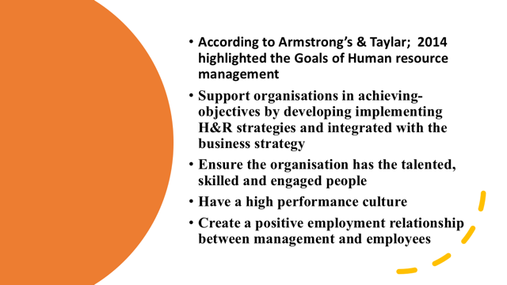

Speaker notes

Further knowledge the HR manager should have as follows.
According to Armstrong’s & Taylar; 2014 highlighted the Goals of Human resource management
Support organisations in achieving objectives by developing and implementing HR strategies and integrated with the business strategy
Ensure the organisation has the talented, skilled and engaged people
Have a high performance culture
Create a positive employment relationship between management and employees

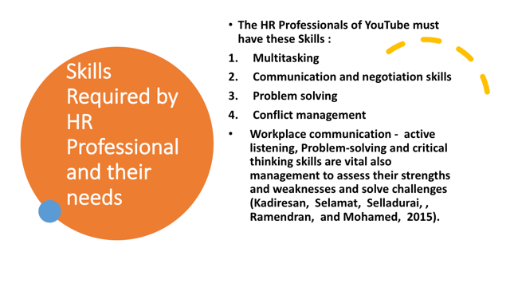

Speaker notes

The HR Professionals of YouTube must have these Skills :
- Multitasking
- Communication and negotiation skills
- Problem solving
- Conflict management
Workplace communication - active listening, Problem-solving and critical thinking skills are also vital management techniques to assess their strengths and weaknesses and solve challenges (Kadiresan, Selamat, Selvadurai, , Ramendran, and Mohamed, 2015).

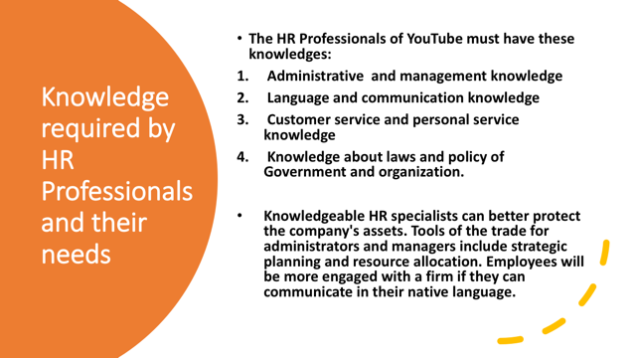

Speaker notes
The HR Professionals of YouTube must have these knowledges:
1. Administrative and management knowledge
2. Language and communication knowledge
3. Customer service and personal service knowledge
4. Knowledge about laws and policy of Government and organization
Knowledgeable HR specialists can better protect the company's assets. Tools of the trade for administrators and managers include strategic planning and resource allocation. Employees will be more engaged with a firm if they can communicate in their native language.

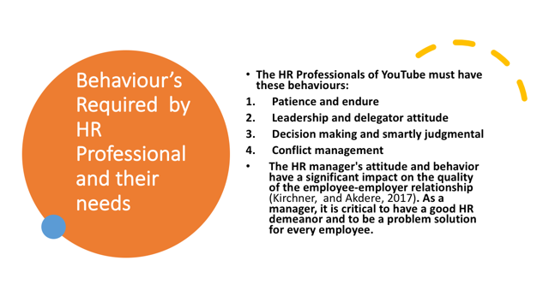
Speaker notes

The HR Professionals of YouTube must have these behaviours:
- Patience and endure
- Leadership and delegator attitude
- Decision making and smartly judgmental
- Conflict management
The HR manager's attitude and behavior have a significant impact on the quality of the employee-employer relationship (Kirchner, and Akdere, 2017). As a manager, it is critical to have a good HR demeanor and to be a problem solver for every employee.

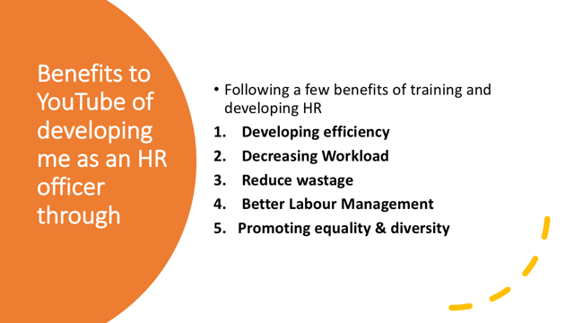

Speaker notes

Following a few benefits of training and developing HR
- Developing efficiency: A successful training program may improve the productivity of YouTube's personnel. People acquire self-assurance as a consequence of training, which is reflected in their work product and outcomes.
- Decreasing Workload: An employee must be monitored while he is at work. It is less necessary to supervise an individual who has received adequate training since errors are less likely to be made. The supervisor's burden is reduced as a result of this.
- Reduce wastage: When an employee is on the clock, it is necessary to keep tabs on him. Because mistakes are less likely to be committed by someone who has gotten proper training, it is not as important to oversee them. This reduces the strain on the supervisor.
- Better Labour Management: The relationship between management and workers is critical to the success of any company. The unions get a message from corporations that they care about their workers' well-being when they create training programs and prepare their people for future employment and promotions. Because of this, the unions also take a more constructive attitude, and labour-management relations improve
- Promoting equality & diversity

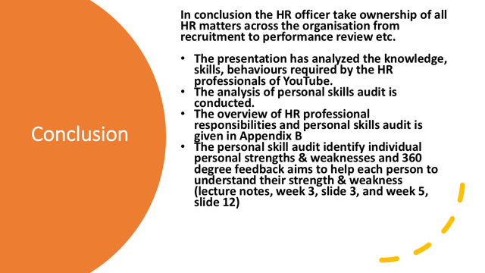

Speaker notes
The 360 degree feedback – a development tool which the helps improvement of individual performance.

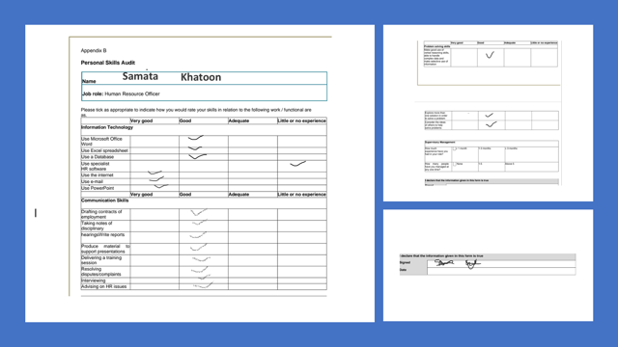

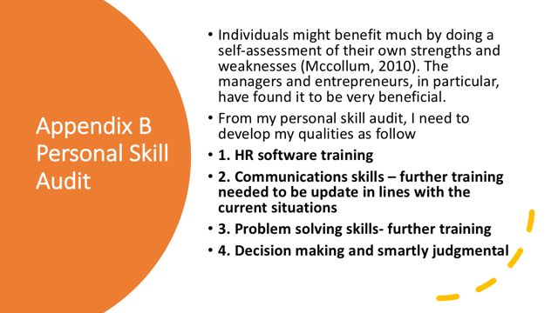

Speaker note
Individuals might benefit much by doing a self-assessment of their own strengths and weaknesses (McCollum, 2010). The managers and entrepreneurs, in particular, have found it to be very beneficial. From my personal skill audit, I need to develop my qualities in HR software training, communication skills, problem solving skills and decision making.

I believe that everyone should take customer service and personal service knowledge training: I can use this information to assist my team to grow more confident, knowledgeable, and be effective. These attributes will be reflected in their interactions with customers, which will lead to increased customer satisfaction and sales in the long term.

Decision-making and smartly judgmental: Decision-making is important for any organization and for the authority of the higher level of the pyramid. My decision-making skills needs to be stronger than my other skill, as an HR I need to develop this skill. Predicting what would happen if various options are taken is essential to making sound judgments. Accuracy and consistency are two metrics that may be used to assess the validity of these conclusions. Analytical study defining the requirements for both accuracy and consistency is the basis for these studies




