Student name | Cristina Stici
Student number | 1814630
Module No: | BMSW5102
Module Title | Developing relationships and Workplace Achievement
Lecturer | Ze Zook

Training and Development Needs for HR officer

Presentation
Slides:
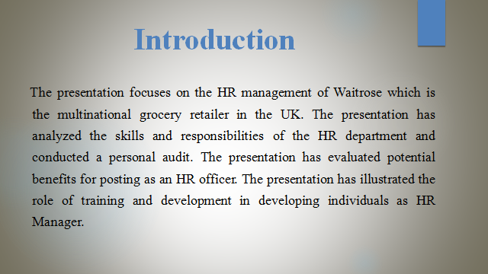

Waitrose offers high-quality groceries and wines to customers. The company offers special discounts and gift vouchers to customers on special occasions. The grocery retailer has also introduced a loyalty scheme for its potential customers. Waitrose mainly takes advantage of social media platforms to engage with customers and resolve their issues regarding specific product (Alfes, 2010 ). The HR manager of Waitrose offers wide employment opportunities to employees for professional development. The company owns more than 350 shops and adopts a differentiation strategy to enhance the customer experience. Waitrose has established a collaborative culture for its staff members and holds a good brand position in the market.
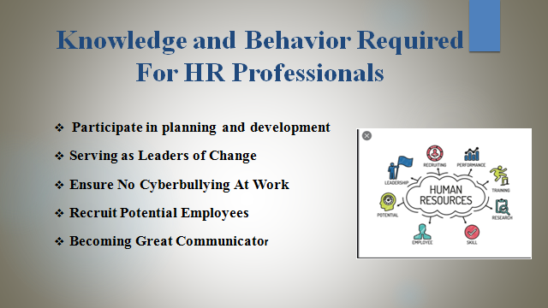
Participate in planning and development: The HR department serves as strategic partners for the organization. HR executives make sure that employees' performance is aligned with business objectives. They have a deep understanding of business activities and motivate employees to become more accountable towards significant tasks (Gramberg, 2006 ). HR managers are ultimately responsible for the sustainable growth of the business. HR professionals take active participation in the execution and development of corporate objectives. They develop effective strategies to achieve corporate goals and may influence employees' behavior.
Serving as Leaders of Change: At present, HR managers implement effective change initiatives to enhance business performance. These managers possess strong project management skills in their corporate toolboxes. HR professionals maintain a close connection with their stakeholders to bring positive change for the company’s success. In this way, HR managers can easily reduce change resistance. HR managers play a crucial role in shaping organizational culture and gain satisfaction from staff members. The HR department tries to evaluate employees' progress regularly.
Ensure No Cyberbullying At Work: HR professionals take the effective initiative to ensure employees' health and safety. They do not discriminate against employees based on their cultural background, skills, and knowledge. HR managers often conduct career workshops and mentorship programs to support the personal and professional development of employees. The HR department makes sure that employees work in a safe and fun working environment (Hailey, 2005 ). HR managers try to eliminate negativity and conflict among staff members. They try to build honesty and commitment among workers.
Recruit Potential Employees: Nowadays, HR managers post ads and interviews to fill the vacant positions. Modern HR Professionals try to formulate the employer brand to attract a highly-skilled workforce. The HR department tries to create a positive culture and offer greater support to staff members under stressful situations. These HR managers may help corporate stakeholders in accepting change. HR managers offer better compensation to staff members. This may motivate employees to become more loyal to their jobs.
Becoming Great Communicator: HR professionals maintains a good relationship with their staff members to monitor business activities. The HR department organizes special meetings and conferences to analyze employee's opinions regarding business policies and operations. HR managers are active listeners and respect others' opinions. They provide proper instructions and guidance to employees regarding customer service. HR managers often encourage their staff members to express their opinions without any fear.
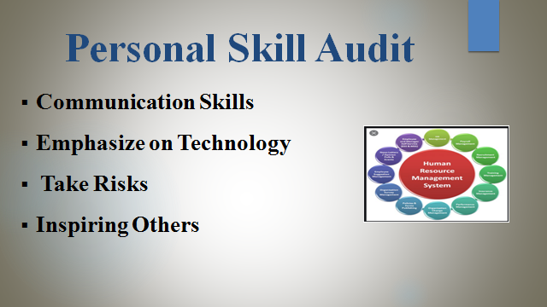
Communication Skills: As an HR manager, I will accept constructive criticism and motivate employees to work harder towards achieving business objectives. HR professionals draft suitable employment contracts for their staff members (Meyers, 2020 ). The HR department is quite specialized in identifying improvement areas for staff members. They also encourage staff members to discover new things and handle the complex problems effectively.
Emphasize on Technology: I mainly believe that efficient technology and procedures are quite useful in improving HR effectiveness. I have taken active participation in online educational courses to understand business operations effectively. HR professionals mainly used IT systems to accomplish corporate goals.
Take Risks: HR professionals often take the necessary risks to enhance business performance and become more profitable in the market. To occupy the HR position, I have attended several recruitment programs to understand business activities. HR professionals offer equal opportunity to each employee to showcase their talent and knowledge with other subordinates (Ybema, 2020 ). The HR department often maintains a separate checklist to review employees' performance regularly.
Inspiring Others: HR managers play a crucial role in boosting employees' self-esteem and confidence. The HR department tries to spread enthusiasm and happiness among staff members. HR professionals appreciate employees for their efforts and dedication towards business activities.
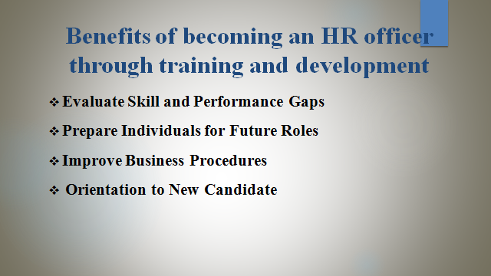
Evaluate Skill and Performance Gaps: Training and Development programs may help individuals to identify performance gaps. This may help individuals to create professional image among top-level managers and supervisors (Alfes, 2010 ). HR managers play a crucial role in increasing productivity and reduce employee turnover.
Prepare Individuals for Future Roles: Individuals can easily occupy the HR position by taking active participation in training programs. HR officers are capable enough to identify improvement areas and make decisions accordingly. Training programs may help individuals to gain leadership skills and systematically perform a certain activity.
Improve Business Procedures: HR officers may increase operational efficiency and access the latest technology to enhance the customer experience. Training programs may help employees to find suitable ways for performing significant tasks. HR professionals often used an efficient computerized system to reduce errors and resolve customer issues.
Orientation to New Candidate: Training and Development is an integral part of the HR function. In this way, individuals may interact with the management team regarding career goals and work independently. Online training courses may help employees to choose better career options and achieve success in their personal life.



