KAMILAH MAYNARD
2014670

HEALTH ASSESSMENT REPORT

THE NERVOUS SYSTEM AND EPILEPSY

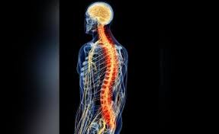
(Source: Yale school of medicine, 2016).

MUHAMMED HUMZA SAEED
BMHP5003_BIRM

CONTENTS

TITLE | PAGE NUMBERS
Introduction | 3
Case Study | 4
Assessment Report  - The Central Nervous System  - The Automatic Nervous System  - The Somatic Nervous System | 5-8  5-6  7  8
What Causes Epileptic Seizures | 9-11
Recommendations | 12-13
Conclusion | 14
References | 15-16
Appendix 1 | 17

INTRODUCTION

The case study report will examine the functioning and structural components of the nervous system of the human body.
The report will discuss how the person diagnosed in the case study nervous system is affected by their abnormalities.
There will be a detailed physiological breakdown on the anatomy relating to the nervous system followed by a healthcare plan for the individual.
The person in the case study is diagnosed with epilepsy, this condition will be discussed with a focus on the type of epilepsy the individual in the report has been identified with.
The importance of routine data management in healthcare practice and medical information being accurate and kept safe (GDPR) for patients to receive the correct healthcare and support from professionals. Alongside, being able to identify and use the data for research purposes regarding medication, services and developing preventions.


(Source: Marketing Donut, 2022).

CASE STUDY

This case study is about a young male aged 19 years old named Mekhi Roberts who suffers from Juvenile Myoclonic Epilepsy (JME). Mekhi does not drink or smoke, is physically fit and is of average weight and height for his age.
Mekhi developed epilepsy at age 15. His condition means he suffers with full body seizures, jerks and is at risk of Sudden Unexpected Death in Epilepsy (SUDEP).
“Epilepsy is a common condition that affects the brain and causes frequent seizures” (NHS, 2020). The seizures are known to be explosions of electricity active in the brain affecting how it operates temporarily. The symptoms are commonly lifelong and can occur from childhood or in adults over 60, sometimes getting better overtime.
According to National Center for Advancing Translational Sciences, Juvenile myoclonic epilepsy is caused by lack of sleep or exhaustion, so will occur first thing in the morning, or can be related to stress or increased alcohol consumption. This type of epilepsy is distinctive to jerks of the arms and legs. The symptoms start during adolescence in individuals who were otherwise healthy. Studies show the occurrence of Juvenile myoclonic epilepsy is unknown, but it is evident that the genetic change in a number of genes, “including the GABRA1 and EFHC1 genes, can cause or increase susceptibility to this condition” (National Center for Advancing Translational Sciences, 2021).
Mekhi will be given a healthcare plan surrounding person-centred care following assessments and his medical details.
Medical Questionnaire. See Appendix 1.

ASSESSMENT REPORT

The Nervous System
The Nervous System is the “complex network that coordinates our actions, reflexes, and sensations (University of Queensland Australia). Without the nervous system our bodies would not function.
There are two parts of the nervous system:
- The central nervous system (CNS) - the brain and spinal cord.
- The peripheral nervous system (PNS) - the body which connects to the CNS.

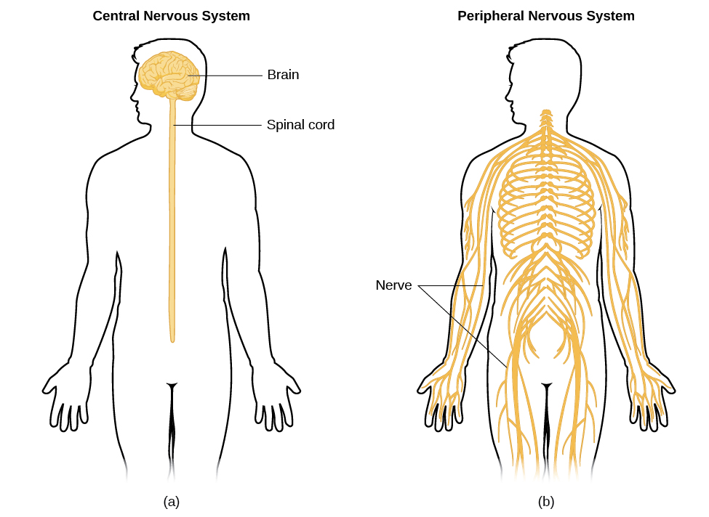
(Source: Press Books, 2022).

The peripheral nervous system carries messages to-and-fro and consists “of thick bundles of axons, called nerves” (Dumper, et al. 2022), this occurs between the CNS, organs, senses and muscles “in the periphery of the body” (Dumper, et al. 2022).
In this report the Central Nervous System will be highlighted for the system which affects epilepsy. The CNS embodies the brain and spinal cord. The process is protected by “three layers of membranes known as meninges” (University of Queensland Australia, 2022). The skull is in place to further protect the brain while the bony vertebrae guard the spinal cord alongside cerebrospinal fluid. This fluid reduces impact amidst the two pairs.
The brain is made up of fat and water. The 40% combines protein, salts, and carbohydrates. “It contains blood vessels and nerves, including neurons and glial cells” (John Hopkins Medicine, 2022).
The gray matter of the brain is where the neurons live. The neurons (nerve cells) stay on the outside of the brain composing a string of networks with individual tasks for consistent bodily functions, such as, sense of smell, hearing and seeing. The white matter is on the inside of the brain. The role of the matter is reversed within the spinal cord.
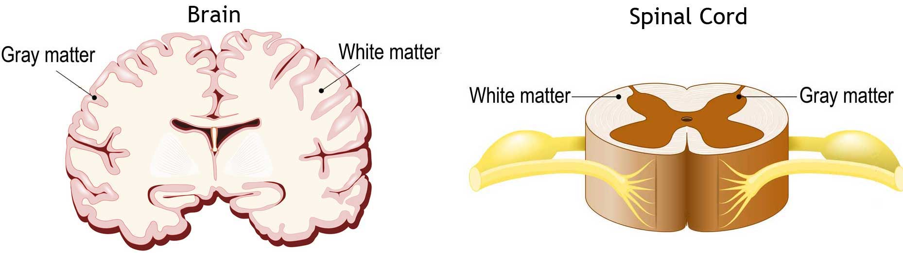
(Source: John Hopkins Medicine, 2022).

The white matter transfers information through its axons (long stems) to other parts of the nervous system secondary to the gray matter in each region.

The Autonomic Nervous System (ANS)
The ANS (Automatic Nervous System) is a cluster of neurons located in the spinal cord and brain stem. There are two systems unconsciously operating, the parasympathetic nervous system (PNS) and the sympathetic nervous system (SNS), these are shown in the diagram below (Haider, 2022).

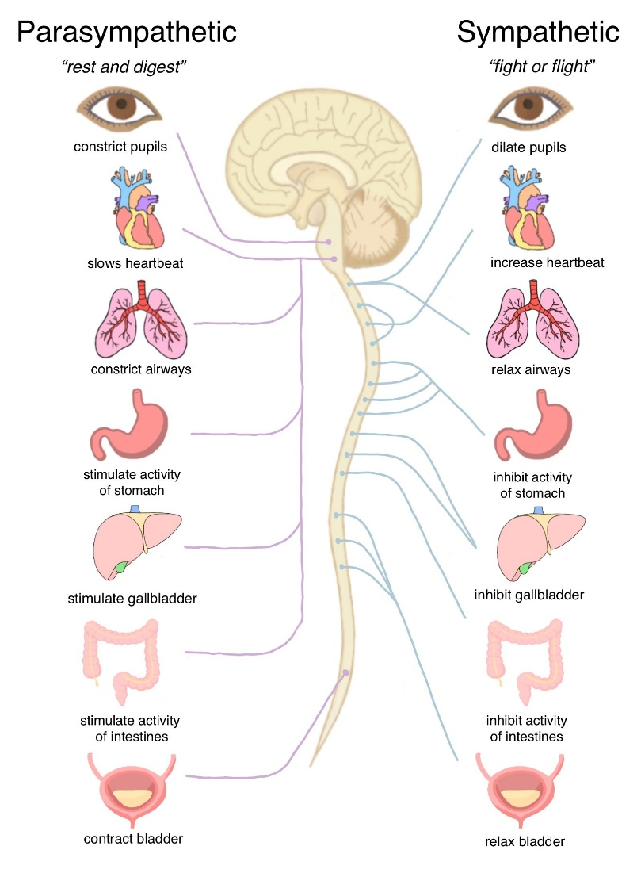
(Source: Haider, 2022).

“The SNS regulates our ‘flight or fight’ response, while the PNS regulates our ‘rest and digest’ response” (Haider, 2022). The ANS system synchronises the heart rate “involuntary bodily processes” (Haider, 2022), alongside breathing, blood pressure and body temperature. The two systems work in symmetry.

The Somatic Nervous System
The somatic nervous system reaches throughout the body and is a partition of the peripheral nervous system. This system uses the nerves to distribute the information sent from the brain to the muscles for movement signals (Cleveland Clinic, 2022).
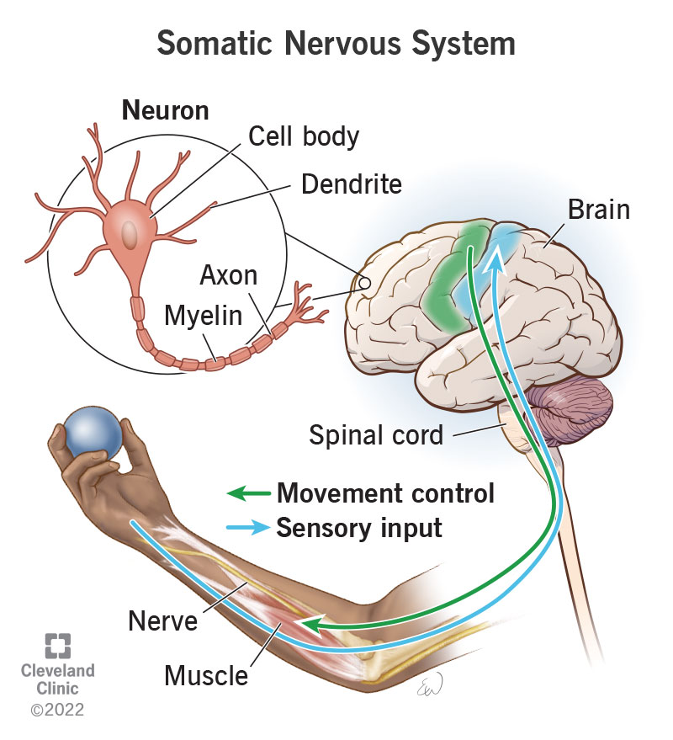
(Source: Cleveland Clinic, 2022).

What Causes Epileptic Seizures?

A sudden burst of fierce electricity in the brain messes with the cell's activity in the brain causing short term disruption to the brain normal functioning resulting in an epileptic seizure.
Epileptic seizures occur in various ways depending on the part of the brain affected by the electrical disruption “and how far the seizure spreads” (Epilepsy Action, 2022). There are seizures where the individual loses their awareness and others where they may still be alert of their surroundings. The different types of seizures can create unusual movements, sensations and feelings. The individual can also go jerk, go stiff or fall over.
A seizure is caused by an irritation of the brain which causes the nerves to act abnormally for a moment resulting electrical impulses.
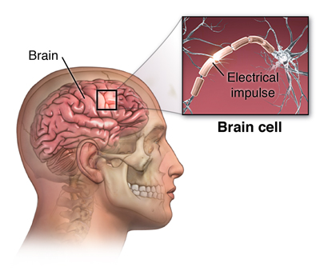
(Source: Stanford Medicine, 2022).
The warning signs of a seizure may vary, but these are the common triggers, according to Standford Medicine, 2022.
- Jerking of the body
- Loss of consciousness
- Staring into space
- No control over bladder or bowel movements
- Body stiffness
- Sudden loss of balance
- Confusion or hazy
- Loss of breath
- Rapid eye blinking
- No response
- Nodding of the head rhythmically
In the time of the seizure, the persons lips may be blue tinted, while their breathing rate becomes abnormal. Once the seizure has passed the individual may feel confused and tired.
The diagnosis
The medical history report will enable the health professionals to determine the type of epilepsy the Mekhi has, such as, substance abuse, any recent head injuries, genetic abnormalities or risk of fever or infection.
The epilepsy is established through neurological examination. This is conducted alongside, blood tests for sugar levels and brain imaging tests, for example, MRI and CT scan. Further tests include EEG (Electroencephalogram) for brain electrical activity health. The lumbar puncture, also known as the spinal tap, is to test brain and spinal canal related problems.
Epilepsy Foundation
Mekhi has been diagnosed with Juvenile Myoclonic Epilepsy (JME) meaning he will suffer from sudden jerks or seizures. Generally, occurring within 1 to 2 hours of rising from a sleep or rest. The process can be described as “shock-like and irregular movements of both arms” (Epilepsy Foundation, 2022), at times only happening in only parts of the body.
Mekhi can also experience isolated muscle reactions, especially occurring when he is about to go to sleep. These are called hypnic jerks as they are not muscle related.

The Importance of Recording Patient Data
First and foremost, it is essential for patient data to be stored correctly, safely, and for the patient to understand how their data is used. General Data Protection Regulation (GDPR) is a government data law for the process and collection of personal data. The regulation is in place for all organisations to understand the restrictions and storage of specific data.
“Your whole care team, whether in a GP practice, a hospital or a care home, needs to have access to up-to-date information about you to inform your treatment, and to provide the best care” (Understanding Patient Data, 2022).
All patients should have access to information related to their condition and clinical healthcare. This enables the patient to gather their own knowledge and cross examine information to make clear decisions on how to deal with their own care plan.
Understanding Patient Data, 2022, suggests the patterns from collected patient data help create innovative new ways to improve healthcare and develop new diagnosis for the sickness, for example,
- Advanced NHS services and government policies
- Better understanding of causes and risks
- New treatment developed to prevent cases
- Improved patient care
- Regulate diagnosis

RECOMMENDATIONS

Patient Medical Data
Medical records are kept for patient identity. The adequate information is necessary to support the condition/diagnosis with the correct clinical care, medication, treatment and services. The information champions documentation of the condition, care results, access to medical professionals and justifies the care service provided (Understanding Patient Data, 2022).

What treatments are available for epilepsy patients?
To treat epilepsy Mekhi needs to take controlled medicine prescribed by their GP. The treatment varies to cater for the many types of epilepsy, so it is important to get diagnosed properly after tests by a healthcare professional. The medication will be based on the individual’s age, the side effects, how it is used and the type of seizures. Most medications are taken orally, such as, tablets, syrup, capsules or sprinkles. The hospital bound can be given treatment through injection or even the rectum.
Mekhi must take his prescribed medication, most likely being Valproic acid, this being the most effective for Juvenile Myoclonic Epilepsy, on time for it to be effective. There will be side effects, but for the best seizure control the schedule must be adhered to. Regular check-ups are recommended by healthcare providers to manage treatment and to check the effectiveness of the medication.
Tips for living with epilepsy
- Get enough rest
- Medicine to be taken as directed and on time
- Avoid triggers, e.g flashing lights
- Keep in contact with healthcare provider
- Seek appropriate emotional outlets to avoid stress build up
- Avoid alcohol
Counselling
Seeing a counsellor or psychologist may help Mekhi with his mental health while living with epilepsy. This will give him the opportunity to release any stress and talk about his issues at his own pace. The counsellor is there to support Mekhi and develop new ways of coping emotionally. They can set practical ways of how to manage situations. Counsellors can be referred by GPs and usually are based on six-week sessions.

Self-management course
The courses are in place to educate and help with self-sufficiency. The course includes:
- Coping with fatigue and pain
- Managing depression
- Help with relaxation techniques
- Dealing with medication
- Healthy communication tips
- Making future plans.

Charities
Epilepsy Foundation – Gateway to support for epilepsy sufferers.
The Channel Organisation – Charity for children and young people with epilepsy.
Epilepsy Action – Support helpline.

CONCLUSION

The central nervous system dominates most of the body and mind operating external functions.
Epilepsy is a central nervous system neurological disorder but, there is no clear reason what causes epilepsy. The theory is it could be affected by genes or damage to the brain from a brain tumour, drug abuse or alcohol abuse, a stroke, brain infection or lack of oxygen during birth.
Mekhi will need to take his medication for the foreseeable future and have regular check-ups to ensure his medication is working, if the doses need increasing or decreasing, and or if there are any visible side effects. JME is known to improve in the fourth decade of life with most medications being 90% effective.
The report reveals the importance of medical records providing standards for healthcare and essential information with medical professionals having easy access to provide accurate care plans to govern the diagnosis and treatment using the person-centred care approach following government guidelines and policies.

REFERENCES

Dreamstime.com. (2022) Epilepsy Vector Illustration. [Online Image Epilepsy]. Available at: https://www.dreamstime.com/epilepsy-vector-illustration-labeled-sick-cns-disorder-educational-scheme-epilepsy-vector-illustration-labeled-sick-cns-disorder-image147570875 (Accessed: 25 July 2022).
Dumper, K., et al. (2022) Introductory Psychology: Parts of the Nervous System. [Online Image Nervous System]. Available at: https://opentext.wsu.edu/psych105/chapter/parts-of-the-nervous-system/ (Accessed: 25 July 2022).
Dumper, K., et al. (2022) Introductory Psychology: Parts of the Nervous System. [Online]. Available at: https://opentext.wsu.edu/psych105/chapter/parts-of-the-nervous-system/ (Accessed: 25 July 2022).
Cleveland Clinic. (2022) Somatic Nervous System. [Online Image]. Available at: https://my.clevelandclinic.org/health/body/23291-somatic-nervous-system (Accessed: 26 July 2022).
Cleveland Clinic. (2022) Somatic Nervous System. [Online]. Available at: https://my.clevelandclinic.org/health/body/23291-somatic-nervous-system (Accessed: 26 July 2022).
Epilepsy Action. (2022) What is epilepsy? [Online]. Available at: https://www.epilepsy.org.uk/info/what-is-epilepsy (Accessed: 26 July 2022).
Epilepsy Foundation. (2022) Juvenile Myoclonic Epilepsy. [Online]. Available at: https://www.epilepsy.com/what-is-epilepsy/syndromes/juvenile-myoclonic-epilepsy (Accessed: 27 July 2022).
Epilepsy Society. (2021) Finding Support. [Online]. Available at: https://epilepsysociety.org.uk/living-epilepsy/wellbeing/finding-support (Accessed: 27 July 2022).
Haider, D. (2022) Autonomic Nervous System (ANS) Dysfunction. [Online Image]. Available at: https://www.concussionalliance.org/autonomic-nervous-system-dysfunction (Accessed: 26 July 2022).
Haider, D. (2022) Autonomic Nervous System (ANS) Dysfunction. [Online]. Available at: https://www.concussionalliance.org/autonomic-nervous-system-dysfunction (Accessed: 26 July 2022).
John Hopkins Medicine. (2022) Brain Anatomy and How the Brain Works. [Online]. Available at: https://www.hopkinsmedicine.org/health/conditions-and-diseases/anatomy-of-the-brain (Accessed: 26 July 2022).
Marketing Donut. (2022) How to promote your business by writing a killer case study. [Online Image Case Study]. Available at: https://www.marketingdonut.co.uk/pr/pr-opportunities/how-to-promote-your-business-by-writing-a-killer-case-study (Accessed: 25 July 2022).
Medical College. (n.d) Readers ask: What Is A Medical Record? [Online]. https://mrmcw.org/medical/readers-ask-what-is-a-medical-record.html (Accessed: 20 July 2022).
National Center for Advancing Translational Sciences. (2021) Juvenile myoclonic epilepsy. [Online]. Available at: https://rarediseases.info.nih.gov/diseases/6808/juvenile-myoclonic-epilepsy (Accessed: 27 July 2022).
NHS (2020) Epilepsy. [Online]. Available at: https://www.nhs.uk/conditions/epilepsy/ (Accessed: 25 July 2022).
Stanford Medicine: Children’s Health. (2022) Epilepsy and Seizures. [Online Image]. Available at: https://www.stanfordchildrens.org/en/topic/default?id=epilepsy-and-seizures-135-4 (Accessed: 26 July, 2022).
Understanding Patient Data. (2022) Why is it important to use patient data? [Online]. Available at: https://understandingpatientdata.org.uk/why (Accessed: 30 July 2022).
University of Queensland Australia. (2022) Central Nervous System: brain and spinal cord. [Online]. Available at: https://qbi.uq.edu.au/brain/brain-anatomy/central-nervous-system-brain-and-spinal-cord#:~:text=Broadly%20speaking%2C%20the%20nervous%20system,of%20membranes%20known%20as%20meninges (Accessed: 26 July 2022).
University of the Highlands and Islands (UHI). (n.d) The Seven Principles. [Online]. Available at: https://www.uhi.ac.uk/en/about-uhi/governance/policies-and-regulations/data-protection/the-seven-principles/ (Accessed 27 July 2022).
Yale school of medicine. (2016) Central Nervous System Inflammation: A Pathway and Possible Drug Target. [Online Image Skeleton]. Available at: https://medicine.yale.edu/news-article/central-nervous-system-inflammation-a-pathway-and-possible-drug-target/ (Accessed: 25 July 2022).

