Student Name: Bogdan Draghici
Student ID: 2027588
Lecturer Name: Shao-Lan Yuen
BMSW4001
Academic and Employability Skills (ACE)
Task 2 topic: Write an appropriately structured academic report where you reflect on your learning in this module, using a recognised model of reflection (one). Discuss 3-4 topics from those covered during the term (listed below) and reflect on how useful they have been to you, taking into consideration what you already knew and any learning you undertook outside of the classroom. You will need to explain the chosen model of reflection and apply it to each topic. You will also need to analyse published literature relating to the specific topics you discuss and use the feedback you received on all in-class activities
Table of contents

Introduction

Time Management

CV and Cover Letter writing

Public Speaking

1. Introduction
1.1. This is a reflective report about what I have learned on the Academic and Employability module. In the future I want to run my own human resources management organisation where I will help vulnerable people get better paid jobs. After a thorough research and a brief SWOT analysis I have concluded that, for the field chosen, the most useful topics covered on this module are going to be Time Management, CV/Cover Letter writing and Public Speaking.
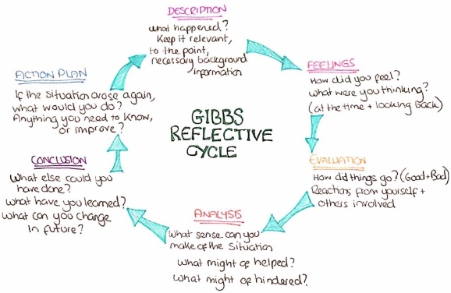
1.2. I will be using Gibbs Model of Reflection to analyse each topic. This model was first published in 1988 by Professor Graham Gibbs. He stated that an experience can be easily forgotten if you do not reflect upon it, and you don’t analyse the feelings and thoughts that are emerging from that situation (Gibbs, 1988). There are many methods of reflection, but I chose this because it includes the feelings in the process of reflection. There are 6 Stages, and they are: Description, Feeling, Evaluation, Analysis, Conclusion and Action Plan.

2. Time Management
2.1. Before starting this university course, I knew I am a procrastinator, A few weeks after I have found out that I have ADHD and I started to have a better understanding of my way of thinking. Time Management was one of the first topics covered in this module, so it presented me few tools to cope with this.
2.2. The experience. I must write a 2000-word report for the ACE module. I know about the task from week 4. When I am writing these words is week ten and I have less than 12 hours to present the first part of my paper. At this point I don`t think I can finish it.
2.3. The feelings that I have right now are mixed. A part of me wants to quit, to leave it for later, it is not important, the deadline is not the final one, it is only for feedback. Another part of me thinks that that feedback is important, and I should motivate myself to finish the task. And finally, there is that part of me that is panicking right now.
2.4. Evaluation. A good thing about this situation that I am in right now is that it makes me think about how I can make my brain focus for more than 10 minutes at a time. But I must do it fast before I lose the momentum. I must focus on the fact that until this point I have more than five hundred words written, and I should keep writing.
2.5. Analysis
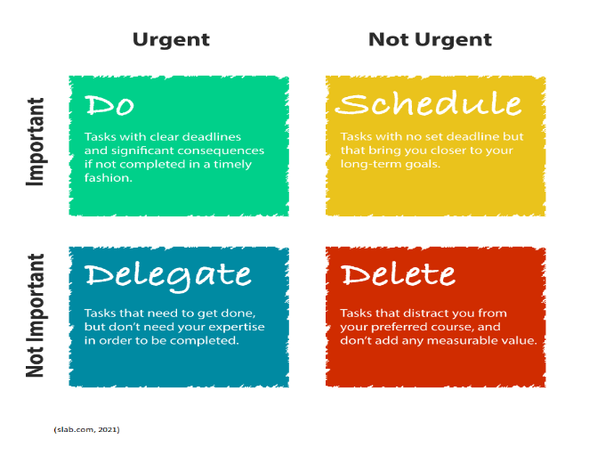
This situation could have been more manageable if I would have had used the tools that the teacher presented in class. Tracy (2017) points out that I should plan every day in advance and “make time for getting big tasks done every day” (Tracy, 2017, p.30). I have tried to do that, but I have noticed that I can easily snooze or dismiss the reminder. The Pareto principle states that 80% of consequences come from 20% of the causes (1896/97). When applying this principle, I have realised that I cannot properly estimate the duration of the task, this is because people with ADHD are having difficulties with this.
A very useful tool for me was the Eisenhower matrix where I must prioritise the tasks according to their importance. I have learned how to classify my tasks in the following categories: Do First, Schedule, Delegate and Don`t do. I found this tool useful because it is easy to use and organise my tasks accordingly.
But the lifesaving tool that I found is the Pomodoro technique, this time management system encouraged me to focus more on the time I have than the time I have left. (Boogard, 2021). I have adapted this technique to suit my needs so, instead of using a timer I have made a few playlists of 20-25 minutes each and I use them as my timer. Using this technique, I have managed to write more than 600 words for this paper.
2.6 Conclusion
Thinking back, I would do several things differently. I should have started the writing earlier so I would not be panicking right now. I should have tested more time management tools and noted the results. I thought I have enough time, but it ran out very quickly and now everything seems too complicated.
There are a lot of techniques, authors and examples that are teaching how to manage my time, I just need to find the right ones for me, test them and use them in the way that will help me become a more professional person.

2.7. Action Plan
For my next assignment, I will follow the advice of Tracy and use the Creative Procrastination method and start choosing what I will procrastinate on. I will have to learn how to say no when distractions appear.
3. CV/Cover letter writing
3.1. The experience During the years, I had countless of CVs and Cover Letters written either by me or by somebody else and apparently, they are not so good because I don’t get any replies to the applications. I know the fact that my CV/Cover letter is the first contact that the employer and I will have but I don’t know how to make them stand out and make the recruiter spend few more minutes reading my CV and possibly give me the interview.
3.2. I wanted to write that I feel frustrated and sad and other platitudes that my teacher probably read repeatedly. But to be honest, I know that this is a rigged game, and the employers are taking advantage. The jobseekers will end up killing themselves over the fact that they are not good enough to get a customer service job in Tesco. Therefore, I thought of starting the Project.
3.3. My CV was evaluated by few employers and the feedback was relatively positive, in a sense that I have worked in few places, which some employers do not enjoy too much. But I have realised that it is not my fault. I am built to follow rules, procedures, and my brain cannot take it. I get frustrated when people are uncapable to do their job as they are supposed to do. I used to write operational procedures for a major bank in Romania, so following one, for me is very important. So, when these things happen, I simply quit my job without considering the consequences.
3.4. According to Innes, a recruiter probably thinks more of the after-work pint rather than at the CVs that it receives (2009). I agree with him, I will go further and say that the hiring managers have a God complex. In their opinion, they have the power to decide someone’s future, or if they will be able to afford lunch next day. And they will reject a candidate just because they have used a semicolon in the wrong place, but the job listing is full of spelling and grammar mistakes.
3.5. I have realised that even if my CV is not perfect, I am not applying for NASA. I mean let’s be serious, the company barely pays the minimum wage, and they want Garamond typeface. Or after I got a cashier job, I realise that my colleague does not know how to send an email, in 2015, not in 1999. So, instead of concentrating on the CV, my focus should be on the Cover Letter. An honest, well written cover letter probably will have more impact than a CV that I have paid for it.
3.6. I am not going to change my CV. The plan is to study the job listing and the company and write a cover letter that will cover the key points of my experience that are required for the position and explain what I can bring in the organisation. The idea is to establish from the beginning that I know what I am doing, that I am willing to learn, I am keen to adhere to the company values but only if this will be a two-way street and if the procedures are optional, I should not be considered for the position. I know, probably I will be unemployed for a long time.
4. Public Speaking.
4.1. In the primary school, when the teacher asked a question, we were supposed to raise hand, and if a student was selected to give the answer they were supposed to stand and give the answer. When it was my turn, during the one second that took me to stand, I was forgetting the answer. I was ending in a standing position, with my hand scratching my head wondering what the question was; then the tears started running. When I was a teen, I started to practice Greco-Roman wrestling and I was pretty good at it, I have participated in a World Championship, a few International Tournaments, and multiple national ones. But in the moments before entering the mat I couldn't breathe, basically there was no air entering my lungs, I was on the edge of blacking out. I couldn’t even hear my coach’s indications. After I got a job at a bank, in a meeting with the CEO and other VPs, when asked a question on a topic that I was very familiar with, I lost consciousness for a second.
4.2. My teachers, my colleagues, even my family, they were all laughing at me, calling me names like careless and stupid, so I started to believe that I am. To avoid the humiliation, I have started to speak without being asked, to interrupt conversations, to be annoying. I must thank my lecturer, Shao-Lan for the fact that, when I was doing this in the class, she was discretely changing the subject or ignoring my comments. I have become very angry when I realised that I’m not stupid, and my ADHD and Social Anxiety, if they were discovered on time, they could have been easily managed and maybe my life would have been very different.
4.3. Unfortunately, I am stuck at this topic, I don’t know how to manage this skill. I have tried a lot of things, like preparing for the interview in advance, rehearsing, but nothing works. My thoughts get scrambled, I studder, I am a mess.
A lot of advice, videos, instructions, and other stuff are available to help me with this issue, and I agree with Dweck that the human qualities can be cultivated (2012) but I think this can be achieved when it starts in the early life. I believe that every human is different and instead of cultivating new qualities, we should enhance the ones that they have, this will be the purpose of my Project.
I wanted to name Churchill as my public speaking idol, he mobilised an entire country and won the war. An old man, with many vices and a broken voice. But people were different in those days, radio was a relatively recent piece of technology and Hitler, was a big threat for UK and the world, so I thought I move towards a more recent personality. And I found it very close to us, Mr Boris Johnson. He is so confident when talking so much nonsense that you start believing him. Amazing!
5. Conclusion. I am fully aware that, in this world and for the moment, I must play to the rules, and I am going to do this. The most important things that I have learned so far and I will continue to use will be the Time Management tools and Gibbs model of reflection. I believe that from this point forward I must build a structure in my life and these tools are going to help me. I am happy that I have started this course with this University where I met a lot of interesting people and amazing teachers.

(Gibbs Model of Reflection, 1988)

References
- 2021. Eisenhower Matrix. [image] Available at: <https://slab.com/blog/eisenhower-matrix/> [Accessed 18 August 2021].
- Boogard, K., 2021. I Hate All Productivity Hacks, Except for This One. [online] The Muse. Available at: <https://www.themuse.com/advice/take-it-from-someone-who-hates-productivity-hacksthe-pomodoro-technique-actually-works> [Accessed 18 August 2021].
- Dweck, C., 2012. Mindset. [Kennett Square, PA]: Soundview Executive Book Summaries.
- Innes, J., 2009. The CV book. Great Britain: Prentice Hall.
- Tracy, B., 2017. Eat that frog!. London: Yellow Kite, an imprint of Hodder & Stoughton.

