INTERNATIONAL MARKETING (LCMB7006)

MARKET STRATEGY COMPARISON OF
DIAGEOIN UK AND INDIA

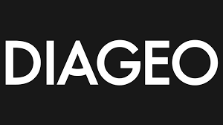

Student name: Simranpreet Kaur
Student Number: 2226227
Lecturer: Tushara Balendran
Submission Date: 21 August 2023

Table of Contents
Introduction 2
DIAGEO Background 2
Macro Environmental analysis 4
PESTLE Analysis 5
Porters Five Forces Model: 8
SWOT Analysis: 9
Segmentation, Targeting & Positioning: 11
Segmentation, targeting and positioning to DIAGEO 12
Marketing mix (7Ps) 16
Comparison of the market entry methods utilised in the different countries could be included in the ‘Place’ element of the marketing mix. 16
Marketing mix elements (7Ps) 17
Directional development strategy 19
Ansoff Matrix 20
Market Penetration and Market Development for India and the UK 21
Conclusion 23
Recommendation………………………………………………………………………………24
References………………………………………………………………………………………….….26

Introduction
International marketing indicates the process and techniques for promoting the products and services outside of the brand. A business organisation gets the chance of entering global markets by international marketing. In this study, the overall discussion is on the international marketing strategy of Diageo, the famous alcoholic beverage brand within the UK and India. This report has provided the brief background of this brand to identify its current global position. Both the context of macro and microenvironments are used in this study to identify the favourable and unfavourable factors of Diageo in the UK and India. Therefore, the theoretical context of 7Ps marketing, STP analysis and directional development strategy of Diageo within these selected countries has been highlighted here. Moreover, the Ansoff matrix of this popular beverage brand has been analysed to explore the strategic similarities and dissimilarities between the UK and India.

DIAGEO Background
Diageo was formed in 1997 by the merging of Grand Metropolitan and Guinness, headquartered in London, UK. Although their brands went back far further, with some dating back to the 17th century. DIAGEO is a worldwide alcoholic beverage leader with an impressive portfolio of spirits and beer brands, Brandy, vodka, scotch, rum, whisky, gin, tequila, and ready-to-drink (RTD) alcoholic beverages are among the items sold by the corporation. To focus on premium drinks, Diageo divested culinary assets such as Burger King (in 2002) and Pillsbury (in 2000). Diageo owns 132 production facilities worldwide, it is driven to be the world's best brand builder, leading the way in premium drinks, with over 200 brands and sales in more than 180 countries. Diageo has acquired numerous brands since 1997, including Johnnie Walker, Chase Distillery Aviation Gin LLC & Davos Brand LLC (2020), Casamigos; the fastest growing super premium Tequilla in the United States (2017), and many more. As of august 2023, Diageo employed more than 30,000 people (DIAGEO, 2023).
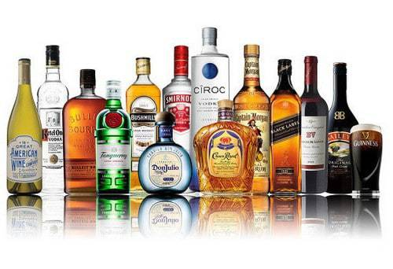

The following chart shows Diageo's annual revenue history, net income history, and growth rate from 2020 to 2023.

Figure 1: Diageo’s Annual Total Revenue and Net Income of DIAGEO since 2020
(Source: macrotrends, 2023)

Diageo's annual revenue for 2023 increased by 0.22% from 2022, with a 20.02% increase from 2021. The company's annual net income for 2023 increased by 4%, 20.8%, and 101.53% from 2020, reaching $3.58B, a 101.53% increase from 2020 (macrotrends, 2023).
The current worldwide market capital of this company is GBP 94.68 billion (Macrotrends.net, 2023). However, Diageo has faced a 1.63% fall in employee retention in 2021 and works with 28025 employees. The reason behind this decline was the negative impact of Covid-19, changing labour market and wage issues.

Macro Environmental analysis
The macro-environment, the uppermost layer, comprises of broad environmental elements that affect many organizations, businesses, and sectors. The second tier is the industry or sector, which consists of organizations that produce the same products or services, and the third layer is the specific competitors and marketplaces that surround organizations. Organizations rely on their surroundings to survive, which include political, economic, social, technological, legal, and environmental elements. These issues, such as the impact of the Internet, economic growth rates, climate change, and ageing populations on various activities, give both opportunities and challenges (Whittington, Richard, et al, 2020). It is very important to understand the macro-environment to respond to marketing changes and to be aware of the changing nature of change itself.
Micro-environment
Figure 2: Organisational Enviornmnet
(Source: Whittington, et al., 2019)

PESTLE Analysis
PESTLE analysis is going to be used to assess external effects on the Alcohol business. It is based on analysis of marketing, but these outside forces on the sector will be utilised to evaluate the elements influencing the industry's long-term viability. PESTLE is an acronym that implies Political, Economic, Social, Technological, Legal, and Environmental considerations. It provides a comprehensive overview of the alcohol industry's overall environment. The criteria for economic, environmental, socioecological, and global sustainability will be determined by the investigation. It provides a framework for connection with production technologies to assess the strengths and weaknesses of various production pathways (Achinas et al., 2019).
Political and Legal
India: The political stability of this country in the year 2021 was marketed by a score of -0.62 (Theglobaleconomy.com, 2023). Therefore, Diageo experiences several political barriers in India while processing operational activities such as marketing and entering a new market.
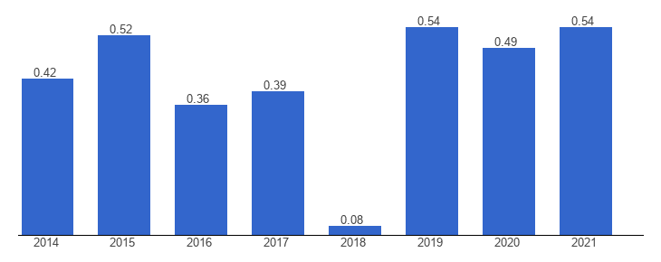
Figure 3: Political Index of the UK
(Source: Theglobaleconomy.com, 2023)
United Kingdom: On the other hand, with a score of 0.54, the stable and peaceful political environment of the UK was measured in 2021 (Theglobaleconomy.com, 2023). In international marketing, Diageo can adopt new marketing or management strategies with minimal political barriers.
Economical
India: In 2023, the total revenue of the alcohol drinks market of India is GBP 49580 million and it is expected that this market will grow by 6.53% within 2017 (Satista.com, 2023). Hence, Diageo can use the opportunity of this favourable economic factor in growing business in India through international marketing.
United Kingdom: It has been assumed that the alcohol market growth of the UK can increase by 4% within 2024 (Statista.com, 2023). Thus, the UK economic force is also favourable to Diageo in the case of business expansion.
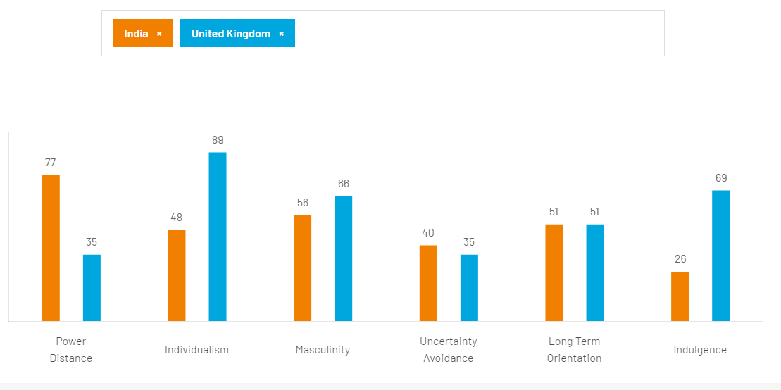
Figure 4: Hofstede Cultural Dimensions between the UK and India
(Source: Hofstede-insights.com, 2023)
Hofstede's Cultural Dimensions model has been used for identifying the favourable and unfavourable social and cultural factors of Diageo UK and India in terms of power distance, individualism, masculinity, uncertainty avoidance, long-term orientation, and indulgence. The above figure has highlighted the social and cultural scores of both the UK and India.
India: In terms of individualism and indulgence, India has a low score of 48 and 28 (Hofstede-insights.com, 2023). It indicates that Diageo faces issues with controlling the Indian employees as they are impacted by families, friends and others. On the other hand, with a score of 77 in power distance, the dependence of the Indian employees in Diageo has been represented. These unfavourable factors create barriers to this company while expanding its business in the UK.
United Kingdom: Most of the social and cultural components such as power distance, individualism and masculinity are favourable to Diageo in the UK (Hofstede-insights.com, 2023). It can process the activities of business growth and expansion with supportive and productive employees.

Technological
India: The average R&D ratio in India is 0.7% and the large alcoholic drinks brand (Thehindu.com, 2023). Diageo cannot find investors in this country for technological development in marketing or manufacturing.
United Kingdom: In the UK, online alcohol retailing is increased by 7.3% in 2023 and every wine shop in this country depends on digital technology for marketing (Jernigan and Ross, 2020). This favourable factor regarding technological growth score in the UK assists Diageo in making the international marketing automated.
Environmental
India: Less opportunity for waste management and air and water pollution in India make the environmental factor unfavourable to Diageo (Timesofindia.indiatimes.com, 2023).
United Kingdom: The issues of temperature change, and high levels of social and air pollution can affect the quality of beverage products negatively. Diageo has to issue of this unfavourable factor while processing business activities in the UK.

Porters Five Forces Model:
Dr. Michael Porter's Five Forces Model, established at Harvard Business School, is a strategic management tool for analysing competitive advantage in specific industries. It focuses on the competitive intensity of industry competitors as well as external forces such as new entrants, bargaining power, and substitutes. The approach assists managers in developing threat-mitigation measures (Rice & John, 2022).
Threat of new entrant in Industry
India: “Threat of new entrants” to Diageom India is moderate to low as any new start-up has to create a market presence by handling the political issues and inflation problem. On the other hand, Diageo has developed a leading presence in the Indian alcoholic drink market using a joint venture strategy (Diageo.com, 2023). In addition, handling such market issues together can be difficult for any company.
United Kingdom: The UK provides a positive environment for business growth. Any new entrants regarding beverage companies can use the same strategies for sustainable growth as Diageo (Diageo.com, 2023). Hence, the “Threat of new entrants” of this company is high.
Competition in the Industry
India: In this country, Diageo has a strong competitor “Eastroc Beverage (Group)”
Yakult, and “Calidad Pascual”. Thus, the competitive rivalry is high to this company.
United Kingdom: “Pernod Ricard”, “Heineken”, “Brown-Forman” and “Constellation Brands” are some strong competitors of Diageo which uses to sell luxury and premium alcoholic drinks in the UK. This high competitive rivalry brings threats to Diageo.
Power of suppliers
India: The power of suppliers of India is moderate to Diageo as this company does not capture the alcohol drinks market totally yet.
United Kingdom: Considering the factors of competition and the opportunity of new entrants increases the power of the suppliers high to Diageo UK.
Power of buyers
India: Companies like Heineken and Bacardi sell alcoholic drinks at a low range than Diageo and it makes the power of the buyers high.
United Kingdom: Power of buyers is moderate in the UK to Diageo because of the strong competition.
Threats of existing substitutes
India and United Kingdom: The threat of existing substitutes to Diageo is low in both in the UK and India as they sell more than 200 premium alcohol drinks.

SWOT Analysis:
SWOT analysis is a technique for categorising an organization's resources and environment into four categories: strengths, weaknesses, opportunities, and threats. It assists organisations in determining their key capabilities for making choices, organising, and strategy development. The ease of use has made it widely adopted in major business and educational institutions since it was developed in the 1960s (Phadermrod, et al., 2019)
Strengths
India: In India, Diageo is one of the best-performing companies within the alcohol drinks market (Media.Diageo.com, 2023). This company uses the process of making partnerships with the hotels and restaurants of this country and reach to the customers in an effective manner.
United Kingdom: Diageo has 4% of the total market share of the alcohol drinks market of the UK (Diageo.com, 2023). This company sells premium brands of alcohol in this country and targets both male and female customers.
Hence, Diageo has a leading market power in both of these countries.
Weaknesses
United Kingdom: Diageo got into a lot of financial trouble from Brexit and related trade restrictions since most of the Scotch whiskey which makes up more than 25 % of their global business is manufactured in the United Kingdom.
India: Diageo faces the issue related to the volatile global macroeconomic environment in India. In addition, this brand led to an accumulated loss in 2021 due to the economic downfall of this country (Diageo.com, 2023).
Hence, Diageo faced the issues of the negative impact of the covid-19 both in the countries.
Opportunities
India: In this country, Diageo has designed a multilayer SCM program for improving business agility (Diageo.com, 2023). In the Indian market, this type of SCM program can be helpful in attracting more investors. On the other hand, the investment in the “Women’s Premier League” in India promotes the presence of this company.
United Kingdom: In the UK, Diageo has mainly started to invest in the sustainability and quality growth of alcoholic drinks. In addition, keeping the average marginal revenue and return to shareholders are another two focused areas of this company while operating business in the UK (Diageo.com, 2023). In future, these approaches help this company to improve its market power and presence.
It has been identified that Diageo has different areas for creating marketing opportunities and improvement in the UK and India.

Threats
India: The harmonised cost structure after the positive inflation issues of India has brought marketing barriers to this company (Economictimes.indiatimes.com, 2023). This company has to change their internal business policy under the GST regime of India which disrupts its manufacturing and marketing flow.
United Kingdom: In the UK, Diageo has strong competitors such as Bacardi, Pernod Ricard, Brown-Forman, and others. This company faces strong competition in international marketing while creating a global competitive advantage.
Diageo is experiencing different types of threats in operating business in the UK and India.

Segmentation, Targeting & Positioning:

Smith established segmentation in 1957 to categorize consumers based on their needs. It seeks to identify smaller and more homogeneous sub-groups with comparable behavior, backgrounds, values, and demands than the market (Blythe & Martin, 2019, p. 75).
Targeting is the process of determining which segments marketers should target to fulfil marketing objectives. Segmentation gives information on profitable segments and assists organizations in achieving strategic goals ((Blythe & Martin, 2019, p. 76)
Positioning refers to a brand's relationship with other brands aimed at the same category, with a focus on perceptions and market position compared to other brands (Blythe & Martin, 2019, p. 76).
Discuss any similarities and differences with the India and UK in relation to STP.

Segmentation, targeting and positioning to DIAGEO

“Segmentation Similarities of the UK and India” | “Segmentation differences between the UK and India”
The UK and India both have language diversity, cultural diversity and political diversity. Both countries have social norms that bound the different cultural people in a single module. | - The UK has a less diverse culture and people diversity based on religion and ethnicity than India.  - The UK has a uniform economic structure that distributes power equally among the states, on the other hand, India experiences economic inequality among states.  - The caste system is present in India but not in the UK. India has a federal parliamentary democratic republic system and the UK has a parliamentary constitutional monarchy.

Table: “ Segmentation Similarities and Differences between the UK and India”
(Source: Self-developed)

Brand - DIAGEO | The UK | India | Similarities | Differences
Segmentation | DIAGEO has strong market segmentation in the UK. Currently, this company holds a 4% value share in the UK (Diageo.com, 2023). Increasing its vodka market proposition by up to 17% across the world including the UK. | People of India who are fond of alcohol are the audience of DIAGEO in India. The company holds USD 35 billion market share in the alcoholic beverage market in India (Diageoindia.com, 2023). This company increased its market share by up to 17% and improved its market in India. | The UK and India have offered significant audiences to DIAGEO who have a wide choice of alcoholic drinks. | India is a culturally and religiously more diverse country than the UK, hence the preference of drinking and consumption capacity is different in states of India. Therefore, The UK has more specific customers who have a specific choice of DIAGEO products.  Continued….
Targeting | Primary target groups are luxury customers, Middle-class people who love quality alcohol and female customers who love Vodka and Tequila. | The Target Audience of the company belongs to most of the age group of 30-50 who have a selective choice of alcohol. | Middle-aged people, Luxury and middle-income group people have a significant choice of DIAGEO’s products. | The UK has more luxurious female customers than India. whiskey is preferable in India, On the other hand, UK customers offer more propositions of other products of DIAGEO along with whiskey.
Positioning | 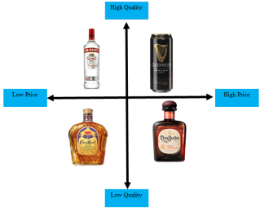 | 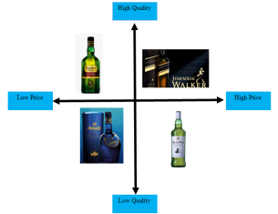 | Bacardi and Heineken are the biggest competitors of DIAGEO in India and the UK. | Eastroc Beverage Group along with Heineken and Bacardi are the competitors of the company in India. On the other hand, Pernod Richard, Brown-Forman including Heineken are the competitors of the UK market.

Table 3: STP strategy for DIAGEO
(Source: Self-developed)
Analysis
DIAGEO India has 50 manufacturing plants and facilities across the states and territories of India. This company set strong distribution channels and networks across the country. “Johnnie Walker'', “Black Dog”, “Black & White”, “Vat 69”, “Antiquity, Signature”, “Singleton”, “Royal Challenge”, “McDowell’s No 1”, “Smirnoff, Ketel One”, “Tanqueray and Captain Morgan” are the various product of DIAGEO in the Indian market (Diageoindia.com, 2023). With a market share of USD 35 billion, the Indian market shows a great market position for the company. DIAGEO’s market share increased to 17% which improved the sales network of United Spirit (Economictimes.indiatimes.com, 2023). “Johnnie Walker'' is the most popular product of DIAGEO in the UK market followed by “Tanqueray(gin)""Smirnoff (Vodka)” and “Guinness(stout)” (Diageo.com, 2023). Hence segmentation, positioning and target audience proposition for both the UK and India shows a strong business sustainability of DIAGEO.

Marketing mix (7Ps)
The marketing mix is a set of marketing tools used by organizations to influence demand for their services. In the manufacturing industry, the 4Ps model is used, which includes tangible products. In the service industry, the 7Ps approach is used, which includes product, price, place, promotion, people, physical facilities, and processes. The 4Ps model focuses on product quality, pricing, promotion, and place, while the 7Ps model includes personnel, physical assets, and procedures. The quality, skills, and attitude of employees play a significant role in shaping customers' decisions. The service process, including the behaviour of those delivering the product, is crucial for customer satisfaction. The 7Ps model can be applied to RT services due to similarities in their characteristics. Overall, the marketing mix plays a crucial role in determining an organization's response to its target markets (Do & Vu, 2020).

Figure 5: Marketing Mix 7ps
Source: (Do & Vu, 2020)

Marketing mix elements (7Ps)
“Market Mix Similarities of the UK and India” | “Market mix differences between the UK and India”
The UK and India both have the same product base choice and target audience. | India has more diversity and cultural aspects than the UK. Hence, DIAGEO needs more marketing processes in India than in the UK.

Table: Marketing Mix Similarities and Differences of the UK and India
(Source: Self-developed)

Product:
“Johnnie Walker”, “Black Dog”, “Black & White”, “Vat 69”, “Antiquity, Signature”, “Singleton”, “Royal Challenge”, “McDowell’s No 1”, “Smirnoff, Ketel One”, “Tanqueray and Captain Morgan” are the product of DIAGEO in India.
“Johnnie Walker”, “Tanqueray(gin)” “Smirnoff (Vodka)” and “Guinness(stout)”, (Diageo.com, 2023). “Captain Morgan” and “Crown Royal” are the most popular products of DIAGEO in the UK.
Promotion:
Diago follows an intensive marketing strategy for both countries that maintains its sustainability and success. Various marketing channels such as advertising, influencer marketing and social media platforms are effectively used by the company to promote its product.
Diageo India MD&CEO “Hina Nagarajan” states that the company follows a new marketing strategy that successfully meets the needs of the changing market condition of India (Thehindubusinessline.com, 2023). Authentic quality and massive consumer loyalty to the product such as “signature” and “Royal challenges '' promote the brand value of Diageo in India.
In the UK market, Diago promotes a positive drinking culture, “DRINKiQ” is emerging as the promotional process of the company in the UK that is aware of positive drinking and harmful use of alcohol (Diageo.com, 2023). This process also tackles underage drinking and aims to educate 10 million young people by 2030 are educated about the ethical process of alcohol drinking.
Price:
Diageo has a wide list of products that include whiskey; Gin, Scotch, Vodka, Soput and tequila are various segments. Following the people's choice of both country and market segmentation, Diago has a stronger market base in the Indian context than the UK. This company has quality products that hold different prices according to their quality and distillation process. “Johnnie Walker” is the most expensive product with red labelled scotch in both countries. But, Diageo offers affordable and quality products to customers, especially in India such as “Signature”, “Royal Challenge” and “McDowell’s No 1” to satisfy middle-income group customers.
Place:
Diageo India has a significant distribution channel and business network that maintains its business sustainability in India. This company has a 260-million-strong spirit market that dominates “Indian-made foreign liquor (IMFL)” brands led by United Spirits. This company holds 53.4% of the stake in the United Spirit in the Indian market. Diageo officials in India state that due to the excellence in quality and pricing, the company witnessed a 24% increase in sales of Vodka in the Indian market (Business-standard.com, 2023). On the other hand, the UK market of Diageo offers a significant distribution and market that maintains the company’s competitiveness (Diageo.com, 2023). The European market including the UK consists of 30 distilleries in Scotland and “Diageo GB” and “Justerini & Brooks Fine Wine” are the most trusted product distribution wholesaler of the company in Europe including the UK.

People:
“Hina Nagarajan” is the Managing Director and CEO of Diageo India and the Board of Directors of Diageo has appointed “Debra Crew” as CEO and Executive director of the company’s operation in the UK.
Process:
Diageo has enhanced a significant process to develop strong competitiveness in the Indian market as this market offers the company huge and diverse customers. Marketing approach by using different digital and advertising channels, this company promotes its product to Indian as well as UK customers. Engaging in the road safety program, and advocating alcohol policies in the Indian states, Diageo enhances its positive promotional process (Diageo.com, 2023). On the other hand, “DRINKiQ” is the positive drinking process awareness program of the company that reflects its ethical business process in the UK.
Physical evidence:
The Indian market has a different consumption history of Diageo’s products in different states of the nation. Based on affordability, whisky products are the main physical product that has great demand in India. On the other hand, the UK market has a strong demand for Gin, Vodka and tequila along with Whiskey.

Directional development strategy
A directional development strategy is an essential tool for firms to use in planning their growth journey and guiding them to new heights of success. It is a planned move that considers one's strengths, interests, and available resources. Companies create targets and timetables for achieving their growth goals, ensuring that every decision is deliberate and connected with the end aim. The Ansoff Matrix gives growth techniques that fit with the growth trajectories defined in the strategy. This comprehensive framework for strategic growth planning assists firms in navigating difficulties and opportunities on their way to success and growth (Chron Contributor, 2021).
Diageo has a strong market position in the Indian alcohol drinks market. Diago has USD 35 billion market share in the alcoholic beverage market in India (Diageoindia.com, 2023). The mission, vision and values of the company state that it follows the customers' need and provides a quality product at an affordable rate that maintains its sustainability in the Indian market. Diageo's premium offering surged by 23.6% year on year in the Indian market and accounts for 72 % of net shares worth USD 1.2 billion (Diageo.com, 2023). On the other hand, Diageo enhanced a directional and development strategy in the UK market to maintain its sustainability in the spirit industry. This company assigned “€500 million of fixed rate euro-denominated bonds under its European Debt Issuance Programme” which shows its strong marketing and directional strategy to hold the spirit market in the UK (Diageo.com). Therefore, positive drinking and a 17% increase in the spout section of the United Spirit reflect the strong market hold of Diageo. Hence strong market holds, and diverse customer specifications give more business opportunities and development plans for Diageo in the Indian market than in the UK market.

Ansoff Matrix
The Ansoff Matrix is a tool that helps publishing companies visualise their product offers and market, as well as plan for future growth. It provides four growth paths, each with its own set of hazards. Market penetration is the least risky approach, whereas product development brings new items. The market development plan is concerned with reaching new markets with existing products, whereas the diversification strategy is concerned with entering new markets(Bullock, et al., 2019).

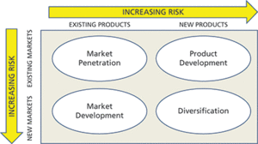
Figure 6: Ansoff matrix
(Source: Bullock, et al., 2019)

Market Penetration and Market Development for India and the UK
In order to develop the marketing plan it is essential to identify the purpose of the business where the main variables are product and marketplace. Here products and the marketplace can be existing or new which plays a prime role in business development. Here, Diageo is one of the largest organisations that manufacture various alcohol products such as “Johnnie Walker”, “Black Dog”, “Black & White”, “Vat 69”, “Antiquity, Signature”, “Singleton”, “Royal Challenge”, “McDowell’s No 1”, “Smirnoff, Ketel One”, “Tanqueray and Captain Morgan” and “Johnnie Walker”, “Tanqueray(gin)” “Smirnoff(Vodka)” and “Guinness(stout)” are emerging as the world best products according to customers choice . In the UK and India, this organisation has already set up its business. Hence, in the existing market, they need to take up any market penetration strategy to give a boost to the business.
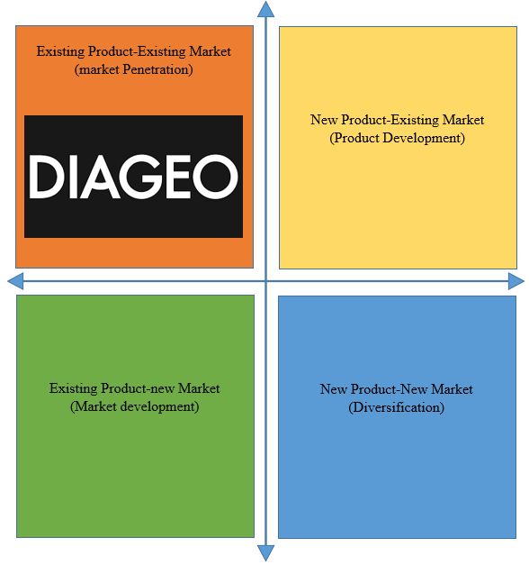
Figure: Ansoff matrix for DIAGEO
(Source: self-developed)
Product Development
India: Conducting regular market research is a significant marketing strategy that is beneficial for Diageo while operating in India. Product development is necessary by gathering effective knowledge about demands and preferences of customers (Granato et al. 2020). Research on current trends and functions helps to conduct business effectively by utilising available potential resources for developing products and services as per customer preferences. Diageo is developing its business following a strategy of sustaining quality development to increase its profitability and revenue by enhancing customer satisfaction (Diageo.com, 2023). Thus, regular and consistent market research is necessary for developing products as per current trends and customer demands.
United Kingdom: Product development strategy depends on creating new products or modifying the existing ones to increase profitability and revenue. Modification of currently existing products is a significant product development strategy that would be useful for Diageo for conducting business in UK. Existing products can be improved for offering enhanced and new services to customers for increasing sales and revenue (Alamsyah et al. 2021). Thus, Diageo can modify and improve its existing products by investing a potential amount to increase consumption and demand for its products.
Diversification
India: Diageo can focus on diversification of its activities by engaging vertical diversification as it is looking for business development and market growth by creating new products in sustaining product lines. Vertical diversification means new products launched and created by Diageo would be similar to existing product lines, groups and categories (Smith and Merritt, 2020). Thus, Diageo can be able to increase its sales and revenue by increasing customer satisfaction with the creation of new products.
United Kingdom: Diageo can follow the strategy of engaging horizontal diversification to operate its activities successfully in UK by launching new products. Horizontal diversification includes introduction of new products that are not associated with existing products (Wilson et al. 2020). Thus, Diageo can explore the market with new business concepts for significant economic growth by diversifying its activities with a new business.

Conclusion
It can be concluded that operating in UK and Indian markets is much more effective for Diageo as business environments of both these countries are much more business-friendly to increase profit and sales. India’s economic activities are pretending to be improving at a fast pace and Indian consumers are interested to adopt Western culture. UK consumers are much more focused on having healthy drinks. Political condition of both these countries is much more stable and democratic to take independent business decisions. Increasing middle-class income and inflationary pressure are regarded as key factors which are influencing Indian business environment. Economic condition of UK is enhanced by following current trends in media and social media platforms. Both Indian and UK markets are dependent on influencer marketing strategies as current market environment is dependent on social media platforms to increase brand reputation and image. Thus, Indian and UK business environment are fruitful for Diageo as per current business trends and activities.

Recommendations

Recommendations for UK market
Diageo is operating its functions by focusing on developing its activities by engaging effective and important business strategies to increase sales and revenue by attracting more customers. Business UK market is dependent on health and safety product development functions to enhance customer satisfaction by increasing sales and revenue (Mehdikhani and Valmohammadi, 2019). Targeting potential customers depending on behavioural and psychographic segment would be beneficial for Diageo while operating its business in UK. Customers in UK are much concerned about their health and thus Diageo can focus on introducing a healthy products line in order to increase profit and revenue. For example, Morrisons is conducting its business by focusing on healthy product development strategy by delivering fresh and healthy foods to its potential customers.
Improvement of supply chain is essential for distributing finished products as per requirements of customers and Diageo can develop its supply chain to conduct business in UK. For example, Tesco has developed its supply chain for sourcing raw materials and delivering finished products to UK customers.

Recommendations for Indian market
Diageo can conduct its operation in India by focusing on Indian culture while developing and creating its products and services. A comprehensive knowledge of culture of a marketplace is necessary and important for understanding preferences and demands of customers (Alamsyah et al. 2021). Following Indian culture is beneficial for gathering knowledge on customer demand and it is beneficial for increasing sales. For example, Zara is a famous retail brand that has focused on Indian culture for developing its product while conducting its business in India.
Diageo can follow a value-based pricing strategy for determining prices of its products as per perceived value of customers. Value-based pricing would be beneficial for increasing profit and revenue by determining price as per perceived value of products (Christen et al. 2022). For example, Unilever is conducting its business in UK by following value-based pricing to increase sales and revenue by attracting more customers.

References
Achinas, S., Horjus, J., Achinas, V. and Euverink, G.J.W. (2019). A PESTLE Analysis of Biofuels Energy Industry in Europe. Sustainability, [online] 11(21), p.5981. Available at: doi:https://doi.org/10.3390/su11215981
[Accessed on 25 July 2023]

Alamsyah, D.P., Ratnapuri, C.I., Aryanto, R. and Othman, N.A., (2021). Digital marketing: Implementation of digital advertising preference to support brand awareness. Academy of Strategic Management Journal, 20(2), pp.1-10.
Alcoholic Drinks - India. Statista.com, (2023). Available at: https://www.statista.com/outlook/cmo/alcoholicdrinks/india#:~:text=Revenue%20in%20the%20Alcoholic%20Drinks,US%2434%2C470m%20in%202023.
[Accessed on 21 July 2023]

Blythe, J. and Martin, J. (2019). Essentials of marketing. 7th ed. [online] login.microsoftonline.com, Harlow, England: Pearson education limited, pp.75–76. Available at: https://ebookcentral.proquest.com/lib/trinity/reader.action?docID=5731459
[Accessed 20 July 2023]

Bullock, A., Jennings, C. and Timbrell, N. (2019). [Online] librarysearch.uwtsd.ac.uk. Available at: https://librarysearch.uwtsd.ac.uk/discovery/fulldisplay?docid=cdi_oup_oro_10_1093_acref_9780191863592_013_0009&context=PC&vid=44WHELF_UWTSD:44WHELF_UWTSD_VU1&lang=en&search_scope=MyInst_and_CI&adaptor=Primo%20Central&tab=Everything&query=any
[Accessed 20 Aug 2023]

Business-standard.com (2023). Diageo to ride on United Spirits India distribution.https://www.business-standard.com/article/companies/diageo-to-ride-on-united-spirits-india-distribution-1121110000441.html
[Accessed on 21st August 2023]

Christen, T., Hess, M., Grichnik, D. and Wincent, J., (2022). Value-based pricing in digital platforms: A machine learning approach to signaling beyond core product attributes in cross-platform settings. Journal of Business Research, 152, pp.82-92.
Chron Contributor (2021). What Is Directional Strategy? [online] smallbusiness.chron.com. Available at: https://smallbusiness.chron.com/directional-strategy-23688.html
[Accessed 25 Jul. 2023].

Diageo (2023). Our history. [online] Diageo. Available at: https://www.diageo.com/en/our-business/our-history
[Accessed 25 Jul. 2023].

Diageo.com (2023).Diageo Business Operations in India [Online] Available at: https://www.diageo.com/en/careers/locations/asia-pacific/india
[Accessed on 21th August 2023]

Diageo.com (2023).Diageo Great Britain [Online] Available at: https://www.diageo.com/en/our-business/where-we-operate/europe/diageo-great-britain
[Accessed on 21th August 2023]

Diageo.com (2023).Diageo prices €500 million of fixed rate euro-denominated bonds [Online] Available at: https://www.diageo.com/en/news-and-media/press-releases/2023/diageo-prices-500-million-of-fixed-rate-euro-denominated-bonds
[Accessed on 21th August 2023]

Diageo.com (2023).DRINKiQ [Online] Available at: https://www.diageo.com/en/esg/promote-positive-drinking
[Accessed on 21th August 2023]

Diageo.com (2023).Our locations and markets [Online] Available at : https://www.diageo.com/en/our-business/where-we-operate/Europe
[Accessed on 21th August 2023]

Diageo.com, (2023). Diageo Asia Pacific. [Online] Available at: https://www.diageo.com/en/our-business/where-we-operate/asia-pacific
[Accessed on:21.08.2023]

Diageo.com, (2023). Diageo India. [Online] Available at: https://www.diageoindia.com/en/about-us
[Accessed on:21.08.2023]

Diageo.com, (2023). Our business [Online]. Available at: https://www.diageo.com/en/careers/why-diageo/purpose-culture-and-values
[Accessed on:21.08.2023]

Do, Q.H. and Vu, T.H.A. (2020). [online] 10(6). Available at: https://librarysearch.uwtsd.ac.uk/discovery/fulldisplay?docid=cdi_doaj_primary_oai_doaj_org_article_d46718af9cf14e7784af5a8225163e6f&context=PC&vid=44WHELF_UWTSD:44WHELF_UWTSD_VU1&lang=en&search_scope=MyInst_and_CI&adaptor=Primo%20Central&tab=Everything&query=any
[Accessed 20 Jul. 2023].

Economictimes.indiatimes.com (2023). Diageo India bullish on India; advocates for the inflation-indexed price increase, harmonised tax structure Available at: https://economictimes.indiatimes.com/industry/cons-products/liquor/diageo-india-bullish-on-india-advocates-for-inflation-indexed-price-increase-harmonised-tax-structure/articleshow/100913817.cms?from=mdra
[Accessed on 21st August 2023]
Economictimes.indiatimes.com (2023).Diageo's market share increases to 17%; buoyed by access to the sales network of United Spirits Available : https://www.diageoindia.com/en/about-us
[Accessed on 21st August 2023]

Economictimes.indiatimes.com, (2023). Synopsis. Available at: https://economictimes.indiatimes.com/industry/cons-products/liquor/diageo-india-bullish-on-india-advocates-for-inflation-indexed-price-increase-harmonised-tax-structure/articleshow/100913817.cms?from=mdr
[Accessed on:21.08.2023]

Granato, D., Barba, F.J., Bursać Kovačević, D., Lorenzo, J.M., Cruz, A.G. and Putnik, P., (2020). Functional foods: Product development, technological trends, efficacy testing, and safety. Annual review of food science and technology, 11, pp.93-118.
Jernigan, D. and Ross, C.S., (2020).
[Accessed on:21.08.2023]

The alcohol marketing landscape: Alcohol industry size, structure, strategies, and public health responses. Journal of Studies on Alcohol and Drugs, Supplement, (s19), pp.13-25. Available at: https://www.jsad.com/doi/abs/10.15288/jsads.2020.s19.13
[Accessed on:21.08.2023]

macrotrends (2023). Diageo Net Income 2010-2023 | DEO. [online] www.macrotrends.net. Available at: https://www.macrotrends.net/stocks/charts/DEO/diageo/net-income
[Accessed 25 Jul. 2023].

Macrotrends.net, (2023). Number of employees. Available at: https://www.macrotrends.net/stocks/charts/DEO/diageo/number-of-employees#:~:text=Diageo%20total%20number%20of%20employees%20in%202021%20was,a%201.63%25%20decline%20from%202020
[Accessed on:21.08.2023]

Media.diageo.com, (2023).Diageo.
Available at: https://media.diageo.com/diageo-corporate-media/media/d5ohbuzy/earnings-call-transcript-fy24-q1.pdf
[Accessed on:21.08.2023]

Mehdikhani, R. and Valmohammadi, C., (2019). Strategic collaboration and sustainable supply chain management: The mediating role of internal and external knowledge sharing. Journal of Enterprise Information Management, 32(5), pp.778-806.
Phadermrod, B., Crowder, R.M. and Wills, G.B. (2019). Importance-Performance Analysis based SWOT analysis. Uwtsd.ac.uk, [online] 44, pp.194–203. Available at: https://wwwsciencedirectcom.ezproxy.uwtsd.ac.uk/science/article/pii/S0268401216301694
[Accessed 20 Aug. 2023].
Rice and John (2023). Adaptation of Porter’s Five Forces Model To Risk Management. [online] Uwtsd.ac.uk. Available at: https://web-p-ebscohost-com.ezproxy.uwtsd.ac.uk/ehost/pdfviewer/pdfviewer?vid=0&sid=4cd3942f-be3e-4efb-a273-36a32c830c3e%40redis
[Accessed 23 Jul. 2023].

Smith, P.G. and Merritt, G.M., (2020). Proactive risk management: Controlling uncertainty in product development. CRC Press.
Statista.com, (2023). Alcoholic Drinks - United Kingdom. Available at: https://www.statista.com/outlook/cmo/alcoholic-drinks/united-kingdom#:~:text=In%20the%20Alcoholic%20Drinks%20market%2C%20volume%20is%20expected%20to%20amount,to%2084.26L%20in%202023.
[Accessed on:21.08.2023]

Theglobaleconomy.com, (2023).United Kingdom: Political stability. Available at: https://www.theglobaleconomy.com/United-Kingdom/wb_political_stability/#:~:text=Political%20stability%20index%20(%2D2.5%20weak%3B%202.5%20strong)&text=The%20average%20value%20for%20the,from%202021%20is%200.54%20points
[Accessed on:07.08.2023]

Thehindu.com, (2023).India’s R&D. Available at: https://www.thehindu.com/opinion/op-ed/indias-rd-estimates-are-an-incomplete-picture/article66545931.ece
[Accessed on:21.08.2023]

Thehindubusinessline.com (2023). High Spirits. How Diageo India is shaking it up. Available at: https://www.thehindubusinessline.com/catalyst/how-diageo-india-is-shaking-it-up/article65193106.ece.
[Accessed on 21th August 2023]

Timesofindia.indiatimes.com, (2023). Environmental Issues. Available at: https://timesofindia.indiatimes.com/topic/environmental-issues/news
[Accessed on:21.08.2023]

Whittington, R., Regnér, P., Angwin, D., Johnson, G. and Scholes, K. (2020). Exploring Strategy. 12th ed. [online] login.microsoftonline.com, Harlow, England: Pearson, pp.35–36. Available at: https://ebookcentral.proquest.com/lib/trinity/reader.action?docID=5987036
[Accessed 5 Jul. 2023].

Wilson, G.A., Perepelkin, J. and Zhang, D.D., (2020). The roles of diversification and specialization strategies in the entrepreneurial orientation and performance relationship. Journal of Small Business & Entrepreneurship, 32(5), pp.457-476.

