Ashleigh Jones (1707088)

Abstract
BY the means of CAD and FEA; designing, testing and analysis of a suspension system to gain an understanding of the motion and forces of the components to allow the development of a particular component part.
Motion Simulation and fea
Motorsport Engineering BSc
CAD & FEA
Andrew harrison

Table of Contents
1. List of Figures 2
2. Introduction 3
3. Research 3
4. Methodology 4
5. Analysis 5
4a. Original Hub 5
4b. Modified Hub 1 6
4c. Modified Hub 2 8
4d. Modification 3 10
4e. Modification 4 12
6. Conclusion 14
7. References 15
8. Abstract 16

List of Figures
Figure 1 Un Modified Hub “Von Mises Stress” right side 4
Figure 2 Un Modified Hub “Von Mises Stress” left side 5
Figure 3 Modified hub to distribute the stress 5
Figure 4 Modified Hub 1“Von Mises Stress” right side 6
Figure 5 Modified Hub 1 “Von Mises Stress” left side 7
Figure 6 Modified hub 2 7
Figure 7 Modified Hub 2 “Von Mises Stress” right side 8
Figure 8 Modification 3 9
Figure 9 Modified Hub 3 “Von Mises Stress” left side 10
Figure 10 Modified Hub 3 “Von Mises Stress” right side 10
Figure 11 Modified Hub 4 “Von Mises Stress” left side 12
Figure 12 Modified Hub 4 “Von Mises Stress” right side 12

Table 2 Von Mises Stress on the original hub 4
Table 3 Von Mises Stress Modification 1 6
Table 4 Von Mises Stress Modification 2 8
Table 5 Von Mises Stress Modified 3 9
Table 6 Von Mises Stress Modified 4 11

Introduction
Cad is used to design, develop and test ideas and designed to gain an understand what the product will look like, how it interacts and the forces applied to it. Cad is vital to the development process to reduce the research and development cost of products and designs. Before designs were made through trial and error. A hand made drawing was created initially and then test parts were made to create a physical assembly. These parts can be modified, tested of changed entirely to gain an understanding of what the idea will look like and how it reacts between each part. If a part is unsuitable then that part is modified and replaced. Problem is with physical testing is that it can get expensive making the parts combined with the trial and errors created. With cad, these models can be created virtually and modified according within the software. Those components can be tested within the software to gain a further understanding on how the part will react with different loads acting upon it.
With this software, a suspension system will be modelled and analysed to firstly gain an understanding of the forces is it being subjected and to develop a design to increase its strength. This component that will be developed is a ford fiesta mk6 front driver side wheel hub. This is due to the fact that the fiesta is the most common vehicle on the road. This means that many of these cars are subjected to many different forces that can cause parts to fail. This can lead to injury or and damage to the vehicle. By ensure that a part can Withstand the normal forces being applied to it but can withstand the extreme forces. BY the means of finite element analysis (FEA) to analyse the forces that being applied to the hub to gain an understanding of the forces that’s being applied to it.

Research
Von Mises Stress
Von Mises Stress is a unit of measurement that determines if a material will fail. If a material is underload, and the load that acting upon that material is more or equal to the yield limit, then that material will fail/fracture this is proven by (Ugural & Fenster, 2011) when a body is subjected to a force, it deforms until it reaches a mechanical equilibrium or deformed state. This deformation of the body is called stress-strain relations. These relations represent properties of the material which is known as constitutive equations. (Simscale , 2019)

Methodology
The suspension components are measured and translated on the CAD models. These parts are accurate to the “mm” to ensure that the completed model is as accurate as possible. This is to ensure accurate simulation model testing. Without the accuracies in the model, the design may become inaccurate when the simulation is conducted. The simulation and FEA testing were done to give an accurate understanding of the forces acting upon a specific component. This it’s the first line in product design testing and manufacturing. This allows the designer to create components that can withstand the forces acting upon it as well as improving the design to its maximum potential. Once all of the components are designed, it’s all assembled in the model to allow the component to be subjected to real world forces to ensure accurate simulations. The model is applying to motion analysis to ensure real world forces is applies to the model. This includes gravity, road contact, spring loads and motion of the road. Once this is applied to the model, the analysis can begin. This is to test the model to gather data. Once the test concludes, the motion loads is imported for simulation and a time frame is selected. Once this is imported, the data is then run though different simulation scenarios through each frame. This is to get the Von Mises Stress data and many other data out of the model at the selected timeframe. Once the simulation is concluded, maximum stress is identified through the exportation of excel and a specific sector is chosen. This can then be opened to display the hub with the different stresses acting upon it illustrated by colour which represents the Von Mises Stress applied to it. This can then be analysed to identify the problem areas of then design which is modified to amend these issues to allow the development of a project. This is then repeated multiple times to develop the hub further.
In the simulation conducted, the hub was chosen to analyse and test. This is due to the fact that the hub withstands many different forces so it needs to be tough so that the component dose not fail. As stated, that was modelled accurately from the genuine part from a ford fiesta so that an understanding of the part’s flaws. This is done by analysing the model of the suspension setup travelling over a speedbump. Data is then outputted by the means of visual aids of the “Von Mises Stress” which shows at what section of the part that experiences the most load. This is useful to develop the part to strengthen certain sections. The Vol Mises Stress can be plotted graphically to give an understand of the maximum stress of the components at certain timeframes. This can be over layer with the simulation to give an understanding where the stress is being exerted on the model.
Once the hub is analysed for the stress, and the stress points is identified, then the model can be modified to ensure that the pare doesn’t brake. These modifications can then be tested again to ensure that the part perform correctly and as expected. Once the part is ensured that it won’t break, then optimization can be carried out to the part. Making the hub lighter is vital to decrease the unspring mass of the suspension. Methods to make the part lighter is employed and tested to ensure that the part can withstand the modifications. Without this development process in CAD, designing would be physically, creating the components and doing manual stress testing. This can be too expensive and time consuming for the manufactures so developing and testing the part on the CAD software saves these costs.

Analysis

4a. Original Hub
As disguised, the hub is created and modelled within the suspension system and tested to identify the stress being applied to the component at certain locations. This creates the “Von Mises Stress” physically on the component. The data that is produced can be exported onto an excel spreadsheet. This spreadsheet can then be used to identify the Von Mises Stress graphically (Table 1). This is used to identify the maximum amount of stress experienced by the part. This is then used to identify the sector and so the clouded stress on the part can be displayed accordingly. In this case, sector 7 has the maximum amount of stress applied to it. This is due to the fact that the wheel is hitting the speedbump causing the spike in the graph. The progressive decrease in the graph spike is the wheel traveling up the bump and the stress on the model is become less as the wheel reaches the top of the bump. The octanol oscillations is the wheel bouncing off the bump due to the spring.
Table 2 Von Mises Stress on the original hub

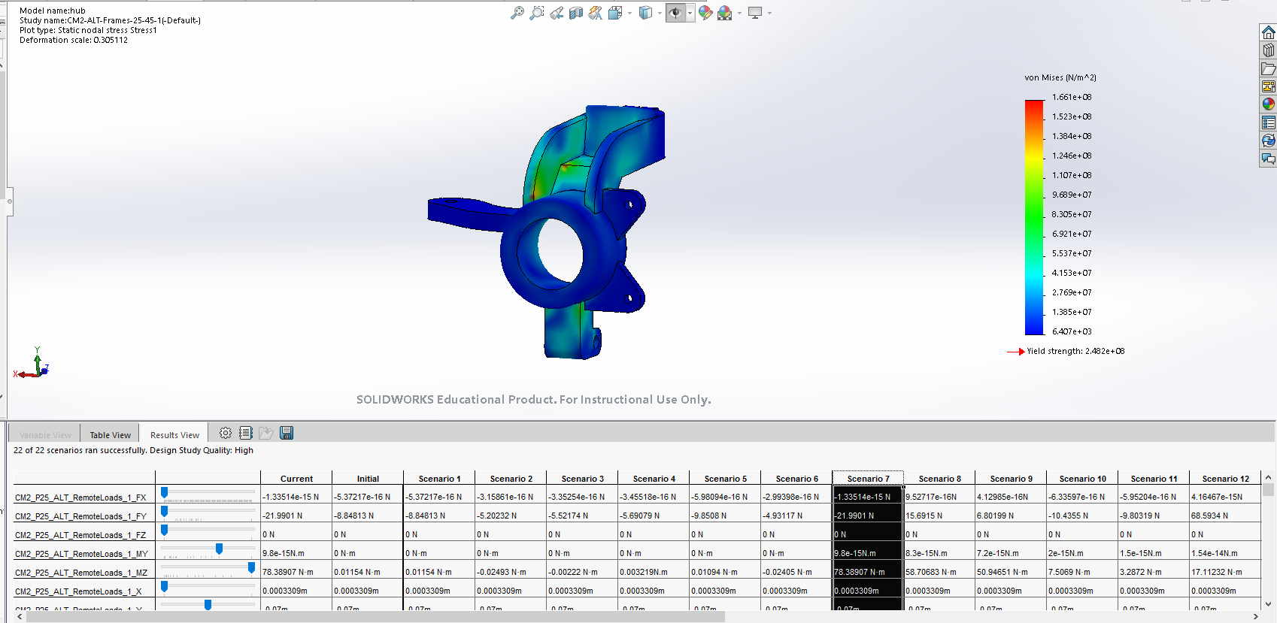
Figure 1 Un Modified Hub “Von Mises Stress” right side
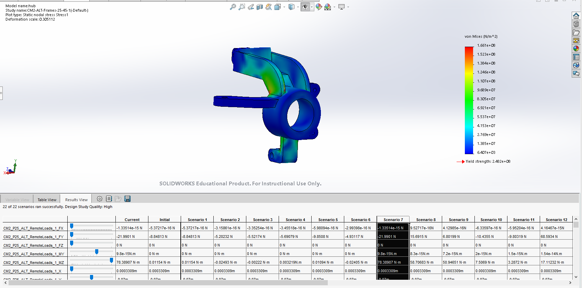
Figure 2 Un Modified Hub “Von Mises Stress” left side
By looking at the figures 1 & 2 shows the stresses concentrating in three areas on the hub which are circled. On figure 1 shows the most concentration of stress which highlights in red. In this section the part fails and breaks. The Von Mises colour chart illustrates the amount the stress the part is subjected to ranging from red which is a large amount of stress, to blue which denoted a low amount of stress. The red section of the key shows a stress of 7.761e+10N/m^2 shows at this particular section the stress is extremely high and the part has failed. Modification to this particular feature needs to be conducted to strengthen this part.

4b. Modified Hub 1
In the image below (Figure 3) shows the modified part with champers on the top of the hub allowing the load to be distributed throughout the part allowing the stress to be reduced.
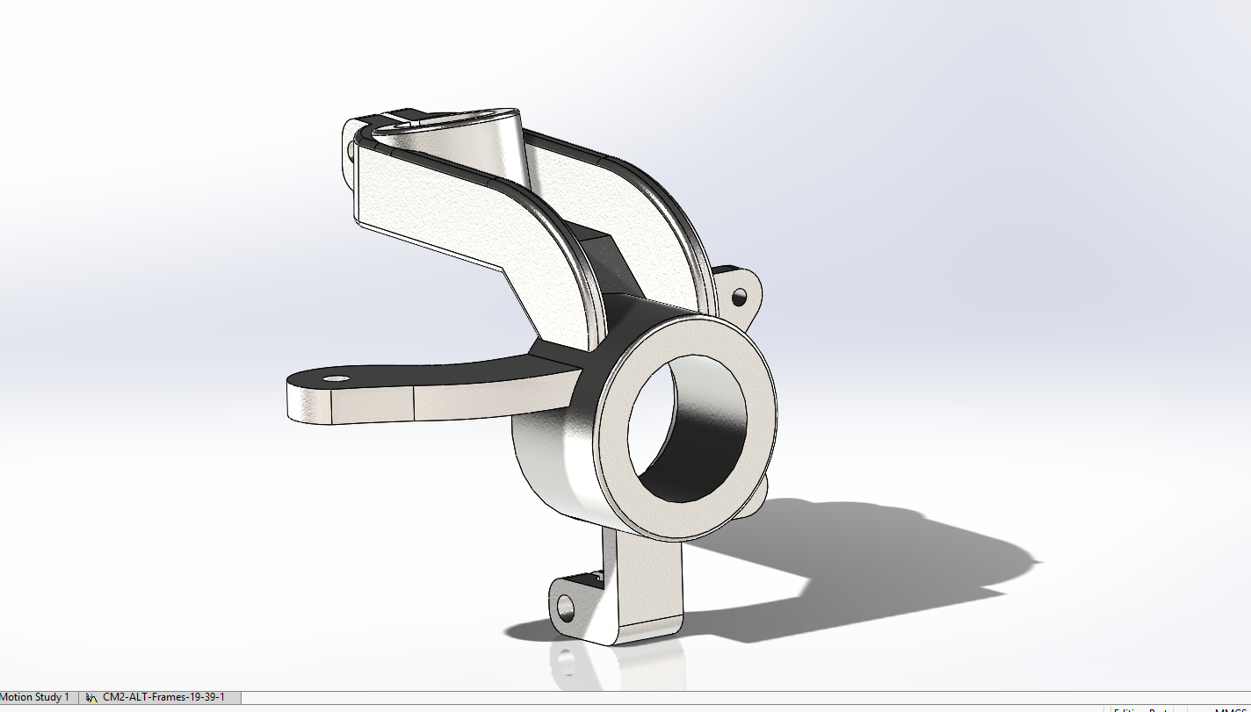
Figure 3 Modified hub to distribute the stress

By using the table (Table 2), the maximum stress can be identified which is sector 5.
Table 3 Von Mises Stress Modification 1

In the von mises stress of the modified hub shows the stress on the top of the part (Figure 4A) to be reduced and distributed throughout the hub which is ideal this has caused the part to be stronger but has caused a knock-on effect to the stress to be more directed to the bottom ball joint mount. Looking at the stress scale shows the maximum stress to be 3.424e+7n/m^2 (figure 4B) which means that the part hasn’t failed. This design can be improved further to improve overall strength.
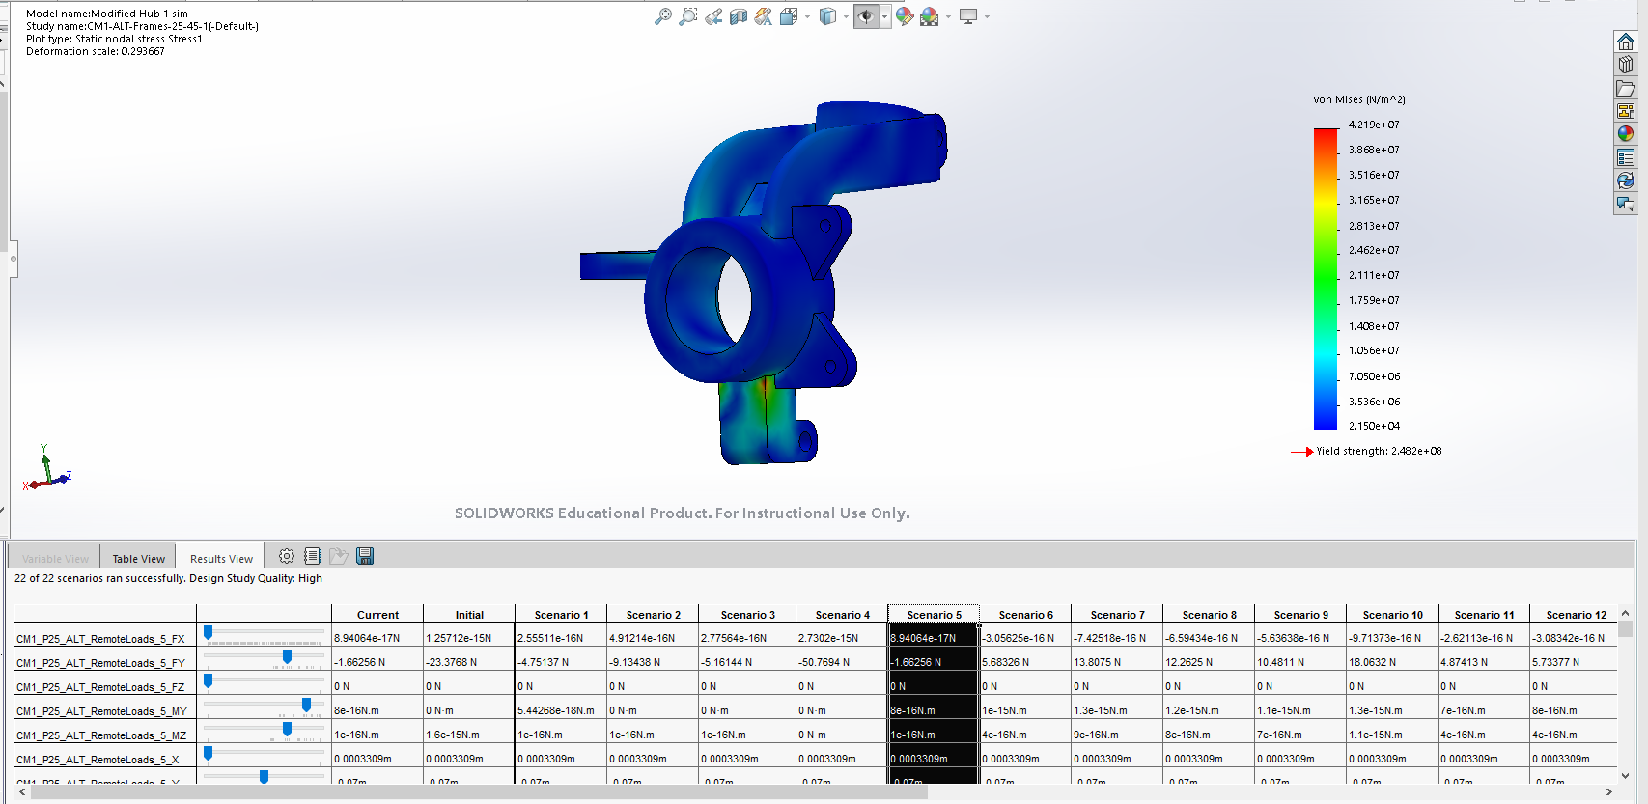
A
B
Figure 4 Modified Hub 1“Von Mises Stress” right side
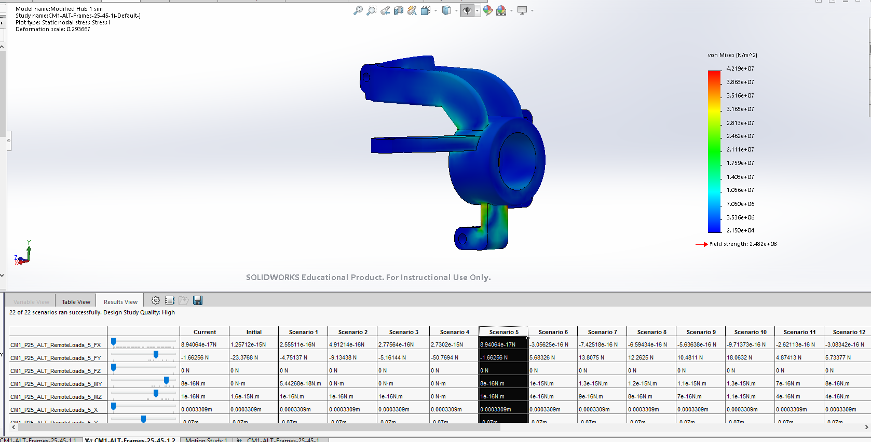
Figure 5 Modified Hub 1 “Von Mises Stress” left side
In figure 5 also shows the stress to be applied to this area which is circled on the image. This section of the hub can be strengthened to achieve a stronger part.

4c. Modified Hub 2
Below is the second literation of the modified hub (Figure 6). This design also incorporates champers to distribute loads across the hub. In particular, the ball joint mounting point has champers to accommodate for the load distribution.
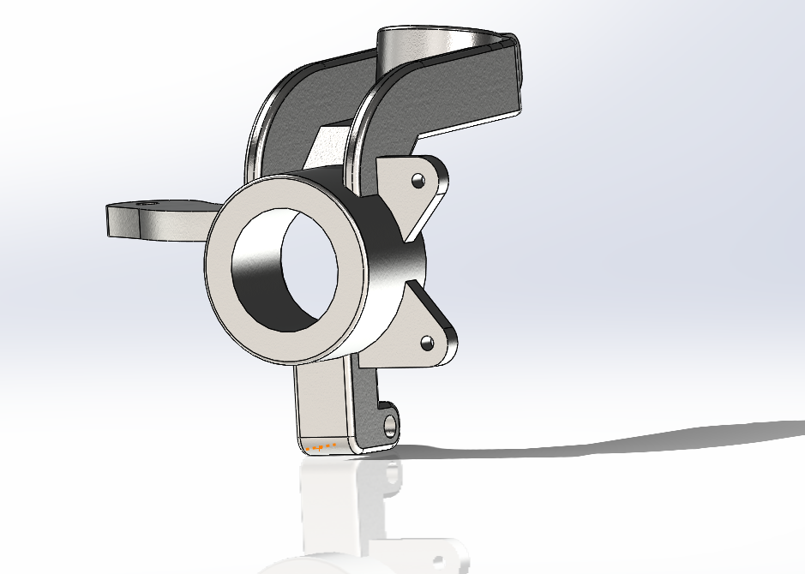
Figure 6 Modified hub 2

Again, using the excel table (Table 3), the maximum stress can be identified which is sector 6.

Table 4 Von Mises Stress Modification 2

Below is the von mises stress analysis for the second modified hub. As described, the ball joint mount is chaptered along the sides accommodate for the distribution of the loads across the hub. By analysing the stress points of the part shows a stress concentration in red to be 6.595e+7n/m^2 (Figure 7A) which is more than the un-chaptered section but the part still hasn’t failed. But as expected the load has distributed along more evenly throughout the part as seen by the colourations distributed on the part on figure 7 compared to figure 4 where the colourations are more centralised and there aren’t any load distributions.
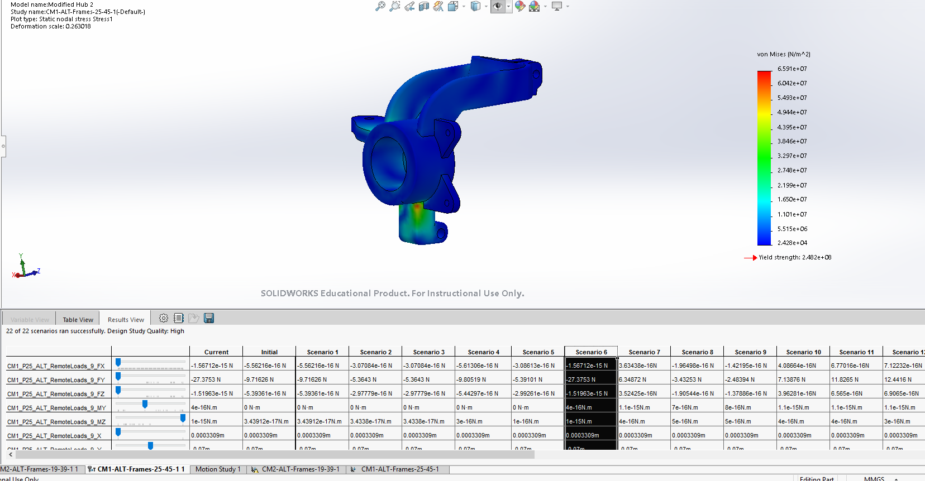
A
Figure 7 Modified Hub 2 “Von Mises Stress” right side

4d. Modification 3
The stress has increased by adding champers along the side of the lower ball joint mount. This is subsequently been temporally removed to trial supporting champers where the mount meets the body of the hub. This is to hopefully distribute the stress around the side of the hub instead on a certain point. In figure 8 illastrates the modification made of the hub.
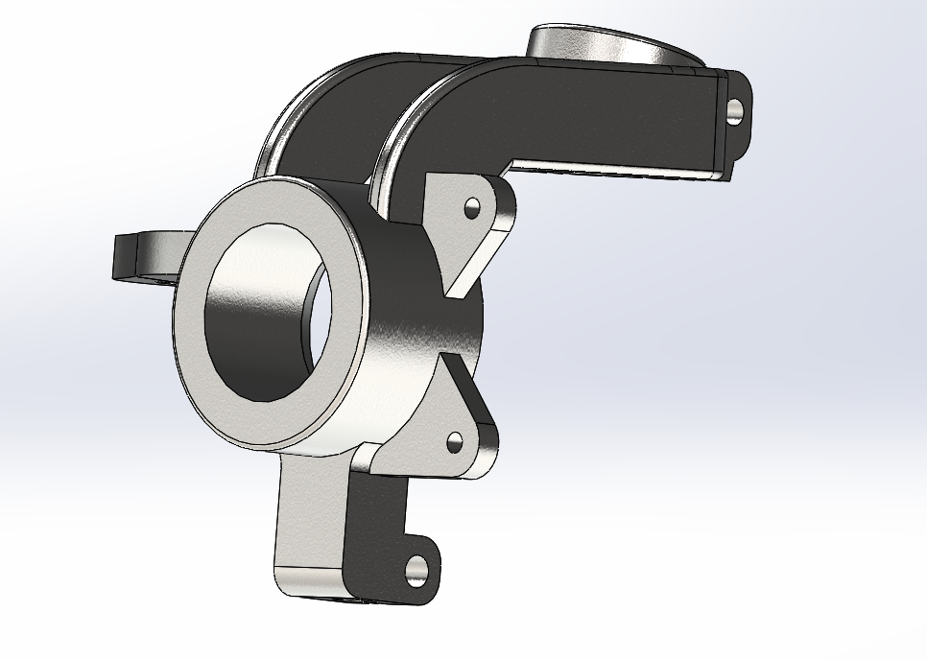
Figure 8 Modification 3
The maximum stress is also identified to gain a understanding of the maximum stress applies to the part. In this case sector 6 has the highest stress (table 4).
Table 5 Von Mises Stress Modified 3

Looking at the recent modification, stress on figure 8A shows a decrease in point stress but has transferred the stress to lower point in the hub. The reduction of point loads is ideal but sometimes can’t be avoided. This is evident in figure 9 where the point load has increased which is highlighted by figure 9A where the stress has increased on the right-angle corner. This increase in stress on this corner wasn’t an issue in hub modification 2 but can be resolved by modifying distributing the load further. Looking at the maximum stress on the stress colour chare sees a maximum of 6.580e+7N/m^2 which is about the same as figure 7 but this design has a evenly distributed stress compared to modification 2.
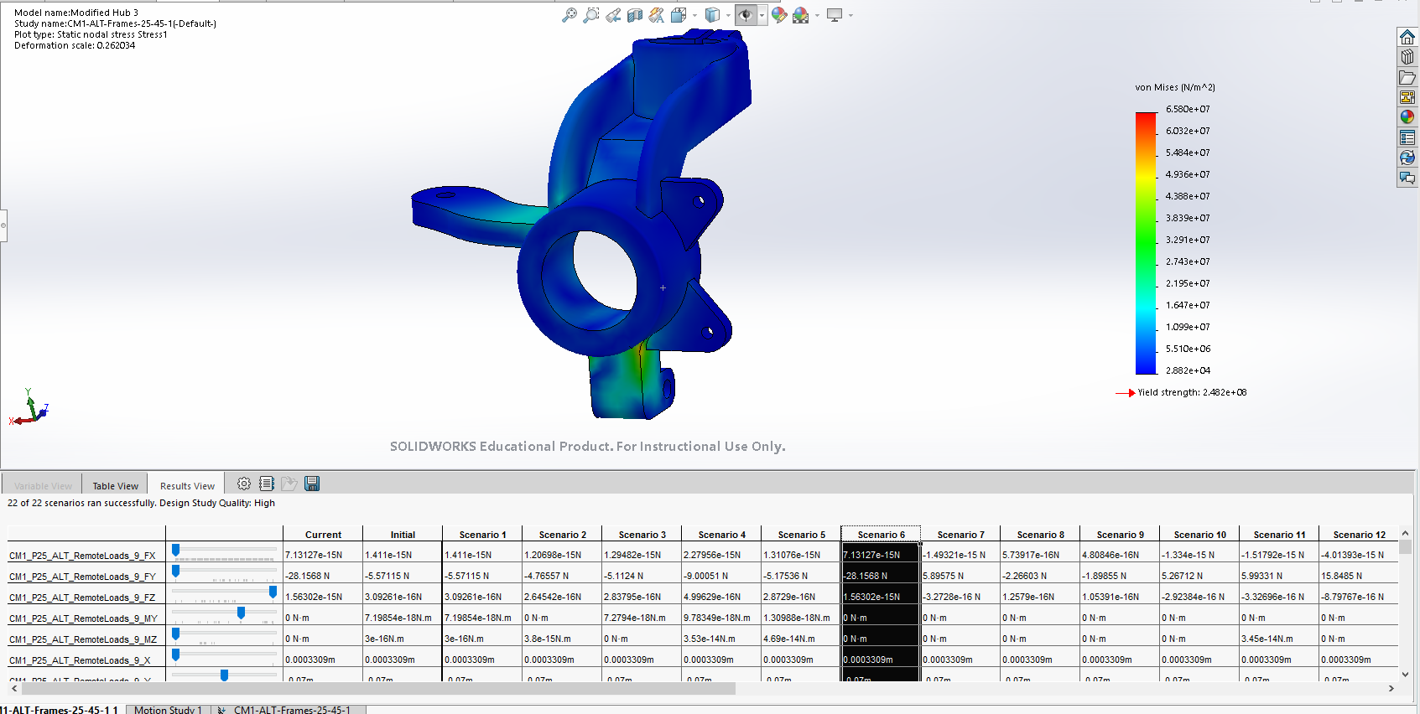
Figure 9 Modified Hub 3 “Von Mises Stress” left side
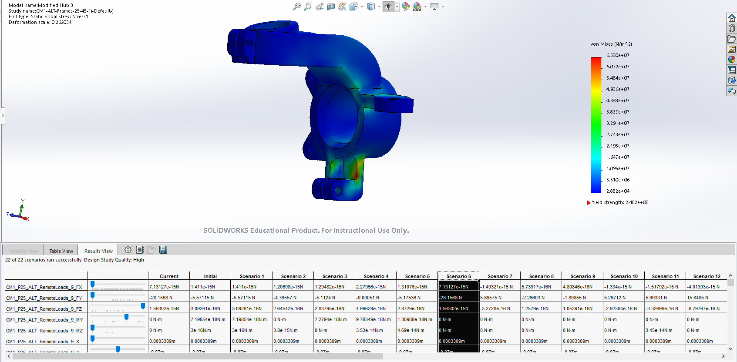
Figure 10 Modified Hub 3 “Von Mises Stress” right side

4e. Modification 4
Below (Figure 11) is the combination of methods utilised. Chamfering the ball joint mount upright and chamfer the area where the two meets. This is to hopefully distribute the loads more evenly and to create a stronger part.
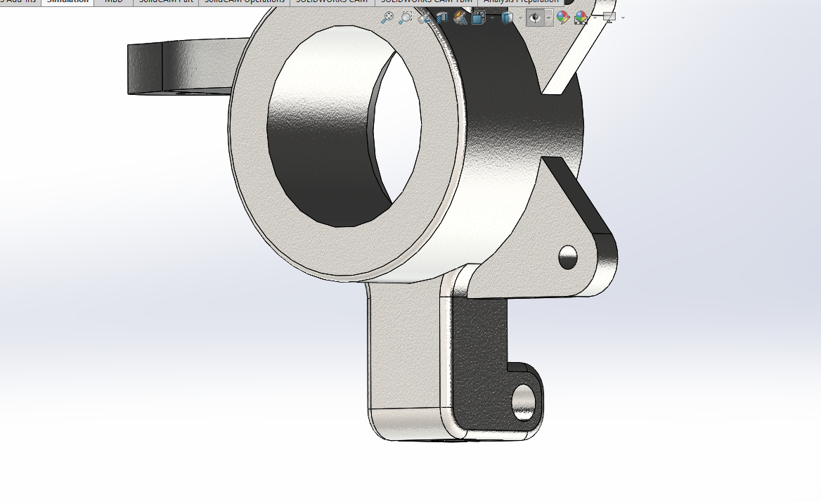
Using the excel graph, the maximum stress can be identified which is sector 7. This graph is a lot more jagged than the other designs. This is causes by the bounce between the wheel and the ground. This can be eliminated by possibly having a stiffer spring or damper.
Table 6 Von Mises Stress Modified 4

Looking at the hub (figure 11), the stress has been distributed evenly throughout the lower ball joint mount. By looking at the colours on the hub and comparing it to the stress colour chart, the left section is only hitting 4.600e+7N/m^2 which is low. This is an ideal condition for a strong component.
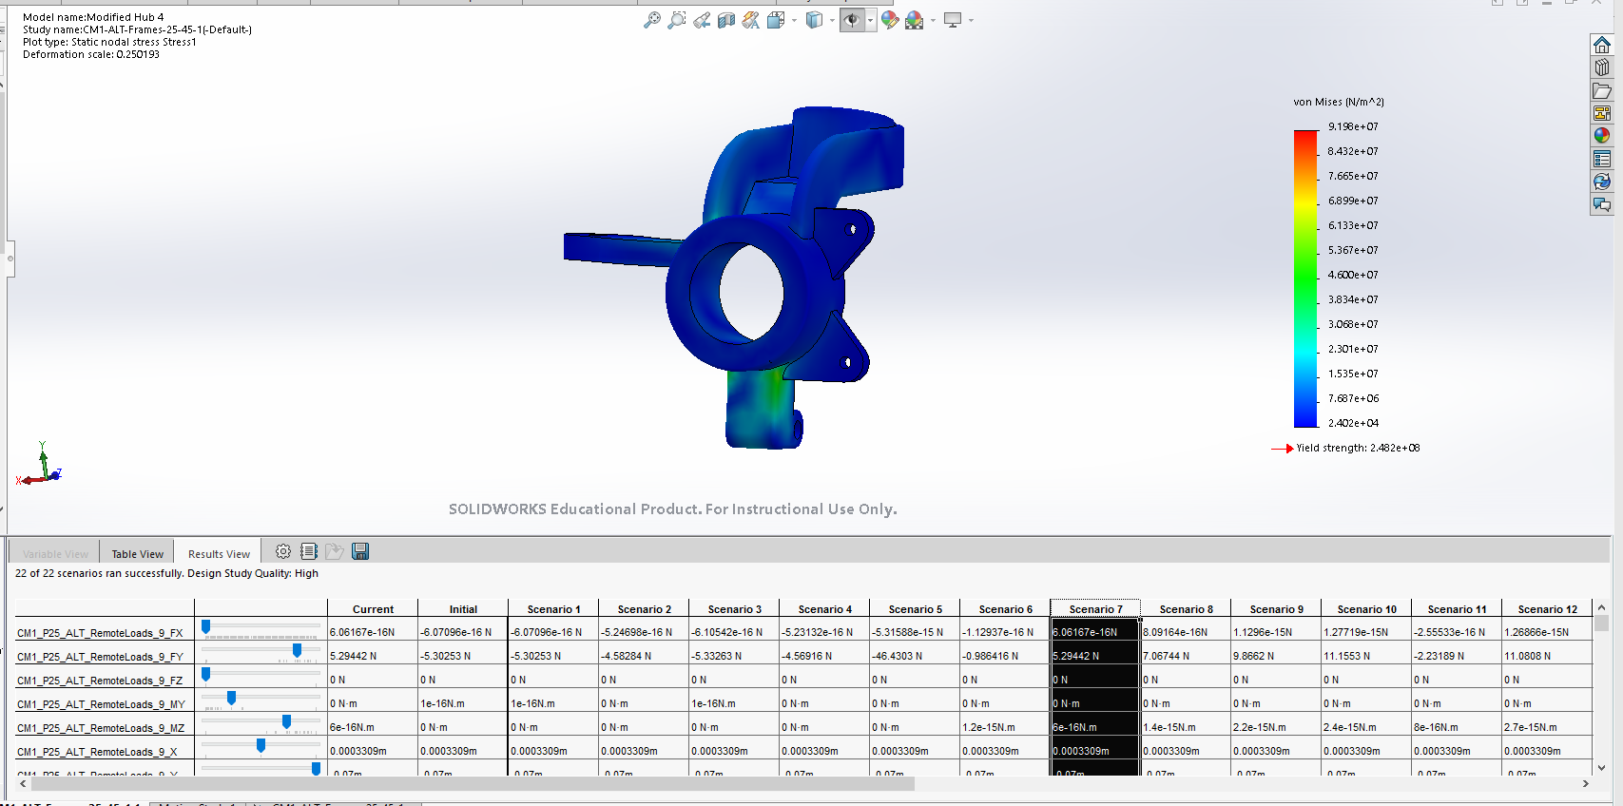
Figure 11 Modified Hub 4 “Von Mises Stress” left side
When analysing the hub on the back side, one thing is apparent. The stress at the right angel corner is extremely high which is reading 9.198e+7N/m^2 at figure 12A. Looking at the amount of stress this component undergoes is so small and insignificant it won’t seriously affect the structure of the hub. This although can have a longer lasting issue of the part may fatigue over a prolonged period of time. This can cause the part to crack or possibly fail eventually. Since this hub is for the domestic ford fiesta where longevity is essential this could possibly be a problem but considering the side of the stress, it is assumed that this wont have a issue further down the line. In terms of stress distribution, its evenly distributed within the part allowing the component to spread the load.
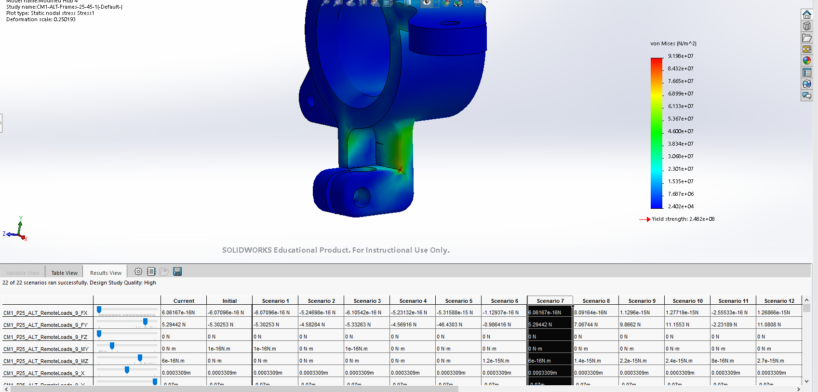
A
Figure 12 Modified Hub 4 “Von Mises Stress” right side

Conclusion
Developing these 5 designs allows a progression and development the hub. This allows the design to be improved vastly over the original with the combination of design modification and testing. The original design had its problem with the stress on the top of the hub in several location causing a bending moment on the arm of the hub which can cause fatigue overtime. This issue is then solved by chamfering the edges of the ram to distribute the stress throughout the model. This theory worked but transferred the stressed down to the ball joint mounting point. This developed one main stress point on the amount which again can cause fatigue. Looking at the stress patter also indicates that the design is loaded to the left of the amount causing a moment acting upon it causing unwanted stress. Two solutions were tried. One was chamfering the ball joint mount upright edges to distribute the loads around the mount. This caused the model to inherit more concentrated stress on one point. This idea was then replaced by supporting the mount with the adjoining hub assembly. This helped the issue but still had problem with the stress distribution of the mount which can cause the rest of the hub to be unsettled.
Both solutions were implemented to both distribute the stress around the mount and support the mount from the top. This intern causes the stress within the part to become distributed evenly ensure that the stress on the component is minimal. The only downside of this solution is the point stress on the right-angle face on the backside of the mount. Although very small, its Hight in magnitude which can cause problems down the line with material fatigue. But again, due to how small the point stress, its not a issue to worry about.
Comparing the 4th hub modification and original design has one main difference. The first design only had stress on the top of the hub. Once the hub was reinforced, the stress moved to the next weakest area. This causes the stress in the design to shift to each weak spot when the design is being developed. Another difference between designs is that the original design failed due to the forces exceeding the maximum yield stress. The 4th design didn’t fail dur to the modifications that’s allows the model to be stronger compared to the first design.

References
Simscale . (2019, 1 1). Simscale . Retrieved from Finite Element Analysis, what is von Mises Stress?: https://www.simscale.com/docs/content/simwiki/fea/what-is-von-mises-stress.html
Ugural, A. c., & Fenster, k. S. (2011). Advanced Mechanics of Materials and Applied Elasticity. New Jersey: Prentice Hall. Retrieved from SimScale .

Abstract
- Excel of the exported FEA data of the un-modified part
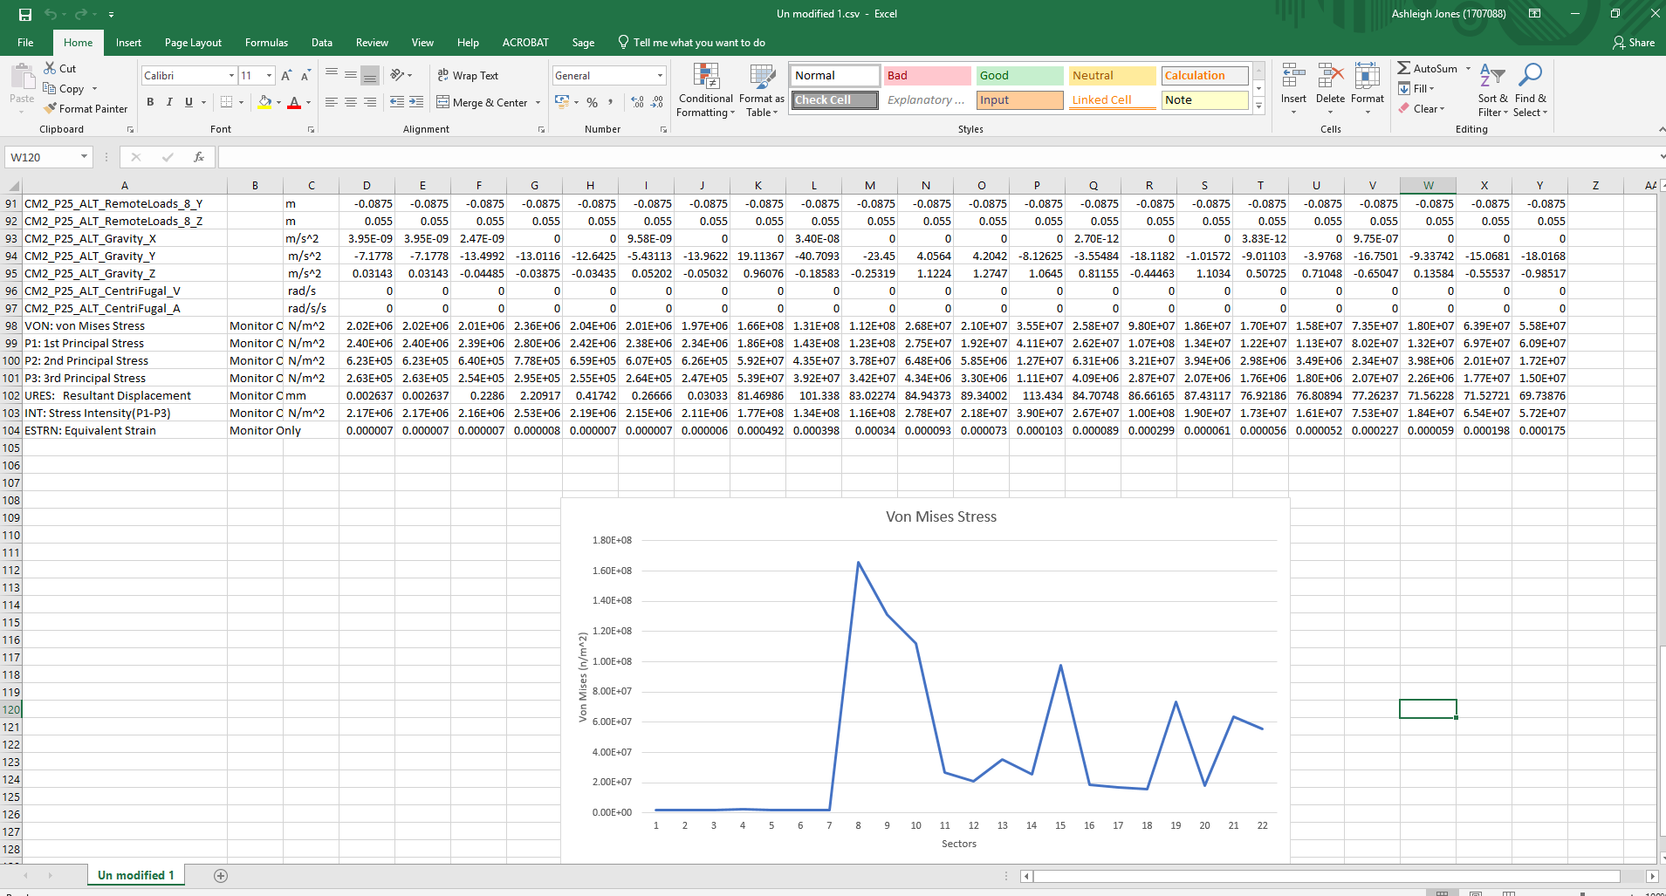

- Excel of the exported FEA data of the modified hub 1

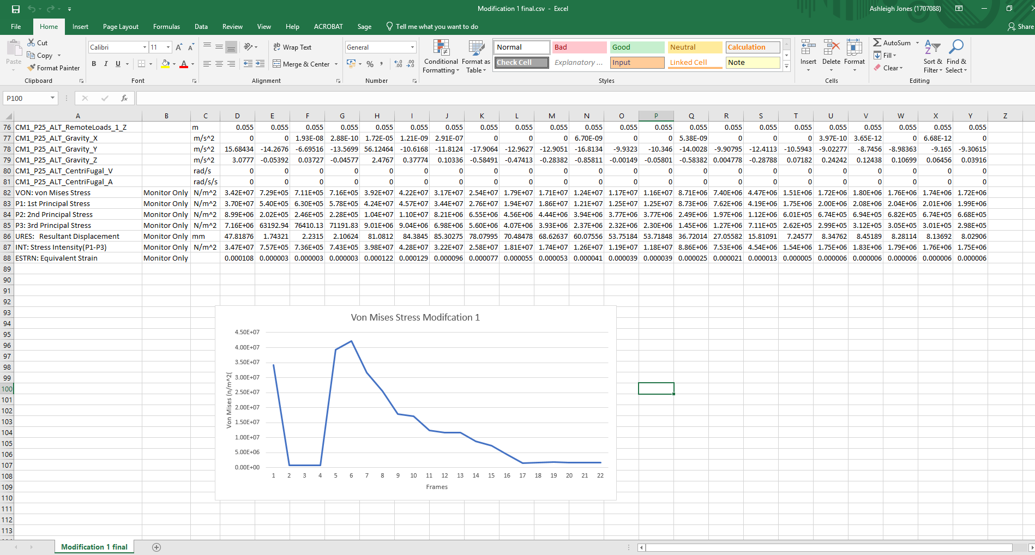

- Excel of the exported FEA data of the modified hub 2

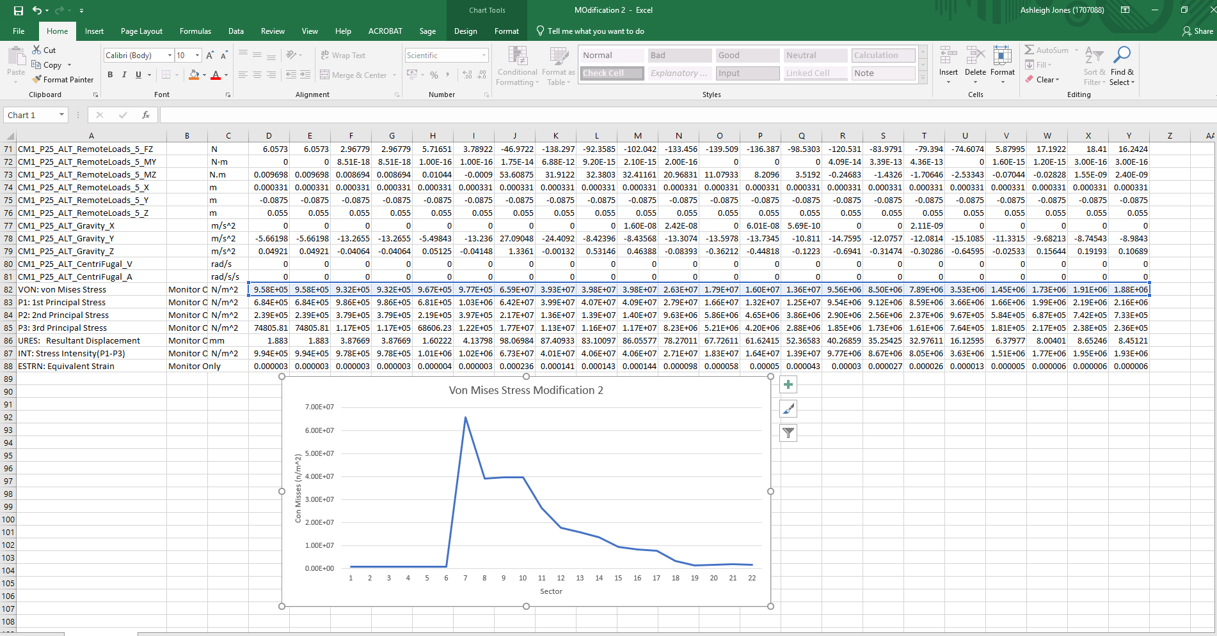
- Excel of the exported FEA data of the modified hub 3
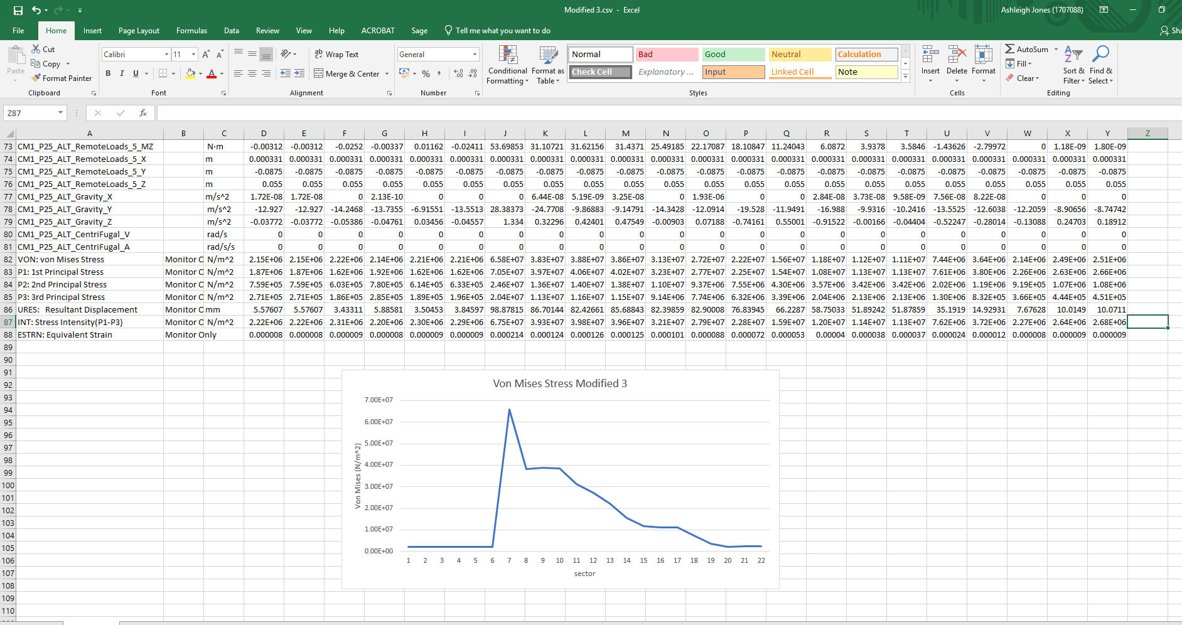
- Excel of the exported FEA data of the modified hub 4



