

Socket programming and Concurrency
ACCA6028

Implementing Client/Server Chat Room

Submitted by:
Anthony Smith

Submitted to:
Dr Tim Bashford

May 2021
Contents
Abstract 2
1. Introduction 2
2. The chat room 2
2.1 The code 3
3. Testing the code 4
Conclusion 6
Appendix 8
Chat room code 8
Bibliography 12

Abstract
The intention of this assignment, was to create a networked application, deriving from research and what had been discussed in lectures. The implementation of sockets within the chosen task had to be of upmost importance. For the task, a chat room had been selected for creation, allowing multiple clients to connect via a server and granting communication rights. Within the correlating report, an explanation as to the reasons behind certain design features and the how the chat room adheres to best practises were provided.

1. Introduction
Socket programming utilises communication connection endpoints that contain addresses and enable links from a source device to a target device, over a network. Sockets allow the exchange of data through stand alone or network applications. This is made possible by bounding a specific port number to a server that is running on computer. The main role of the socket is listening for incoming connection requests, which can then be relayed to the waiting server. For the client to interact with the server, the hostname and port number must be available so a request to connect can be called. The connection will only be possible if the client has been bound to a local port number that the server requires for authentication. Sockets must be bound to port numbers to ensure the TCP layer can identify the application that the information will be sent to [1] [2].

2. The chat room
Communication between two parties, transpires constantly, whether it is face to face, video conferences or emails and texts. It was this realisation that was behind the motivation to create a chat room.
Within the educational environment, certain criteria had been asked for when implementing the functionality of the task. The involvement of multi-threads to allow concurrency to several connections within the chosen application was an important factor. However, due to unforeseen circumstances regarding COVID-19, an abundance of online research was achieved, in part to the educational body having a very busy schedule. The conclusion of the research led to the belief that multi-threads within a chat room scenario was more of a backward step than an advantage. For a chat room to operate at its optimum, a single thread application would be better suited, and this would be down to the synchronous functionality of the code.
Implementing a single thread means allowing one command or operation to run at a time, and this single thread schedules the run, pause and wait of the application. Relating to the chat room task, as the CPU is not under any major pressure and the thread allows one communication to occur before allowing the next, the speed of the process is unphased. In fact, it has been documented that multithreaded processes can have their fair share of concurrency problems.
The synchronicity of the I/O operations is relatively fast compared to its asynchronicity counterpart and is more beneficial for processing kernel I/O requests [3] [4] [5].

2.1 The code
Although the full code can be found in the appendix of this report, the following screenshots will highlight several of the implementations and the reasons behind those choices.

- Select function (Fig 1.1)
This function will determine the status of one or more sockets and will execute synchronous I/O. The select function will allow callers for each socket to request data on the read, write or error status. Within the code the status requested is indicated by the file descriptor (fd_set) structure. If the socket is in the listen state, it will be readable if an incoming connection has been detected. It will also be completed without blocking. The entire operation for a single thread multi-client chat room relies on the select function. Due to the synchronous I/O this function is equivalent to a queuing system. [6]
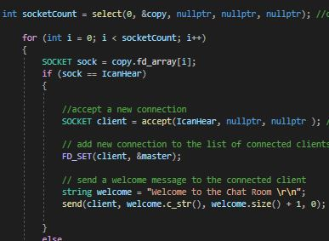

(Fig 1.1) Implementation of the select function

- Bind (Fig 1.2)
This structure binds the IP address and port number to a socket. This process is carried out to ensure the clients that connect to the port number will always have a predefined number to connect to [7].
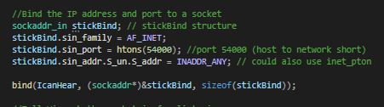

(Fig 1.2) Binding structure to IP and port number 54000.

- ZeroMemory, Buff and ClientbytesIn (Fig 1.3)
- ClientbytesIn - relates to the client receiving an incoming message.
- Buff – As the project will require less than 4kb to operate, the size of the client buffer was set to 4096.
- ZeroMemory – provided by windows header files and is equivalent to the memset function and clears a block of memory, setting the memory to 0. [8]

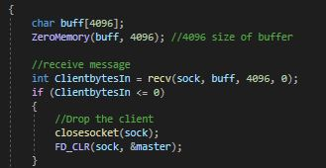

(Fig 1.3) displaying buffer, ZeroMemory and receiving message functions

3. Testing the code
Once the code was complete, test cases were carried out to analyse the functionality of the code and gather feedback. If elements of the code did not work, opportunities were available to remedy the problems.
To connect multiple clients to the server, an open source SSH and telnet client program called puTTY was employed (Fig 1.4).
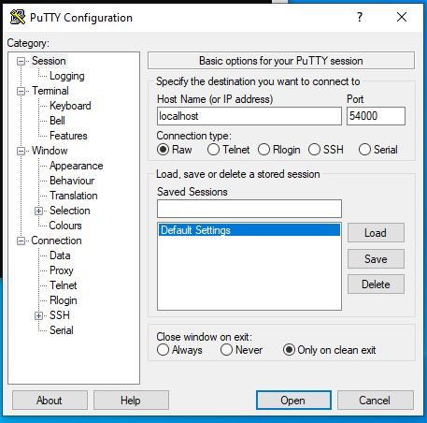

(Fig 1.4) puTTY configuration.
Once the server was running through Visual studios, a slight configuration had to take place to connect puTTY clients to the server (Fig 1.4). By using local host as the host name, inputting port 54000 (which is the bind port number), connection type to Raw and highlighting the default settings, the client was available to communicate (Fig 1.5).
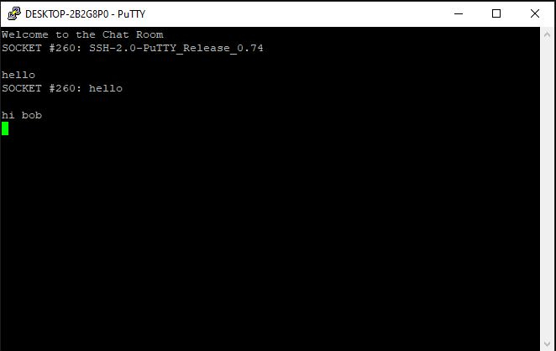

(Fig 1.5) The client successfully connected to the server.

Test case 1 - Connecting client to the server
As Fig 1.5 shows, a successful connection was made by the initial client to the server.
Test case 2- Connecting multiple clients to the server
Through puTTY, multiple clients can be created, but all most go through the same configuration process. Once the second client was created it successfully communicated with client one (Fig 1.6), in fact, no errors or problems were found even when a test had included 5 clients running.

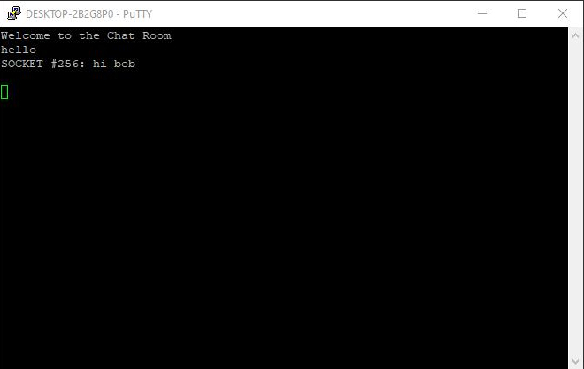

(Fig 1.6) A second client was in communication with client 1.

Conclusion
Overall, the performance of the chat room worked well and had no major issues with the connection or communication. However, from a cosmetic point of view, several alterations are needed to bring the chat room up to competing standards. The client is recognised through the socket number and not by a username. This problem had several attempts to be rectified, but due to lack of knowledge, it was not possible. One such problem that had arisen when attempting to implement the username input option was that it would allow the user to be inputted through the server and not the client window (Fig 1.7). A similar problem was that the username would be given to all clients and not allow individual names.
Socket programming is a very interesting subject, and one that would have been far more enjoyable if the circumstances would have been better. This insight into socket programming has given the enthusiasm needed to implement other server/client based programs especially a multi-thread chat room. It is definitely a subject that the author of this report would like to progress further in.

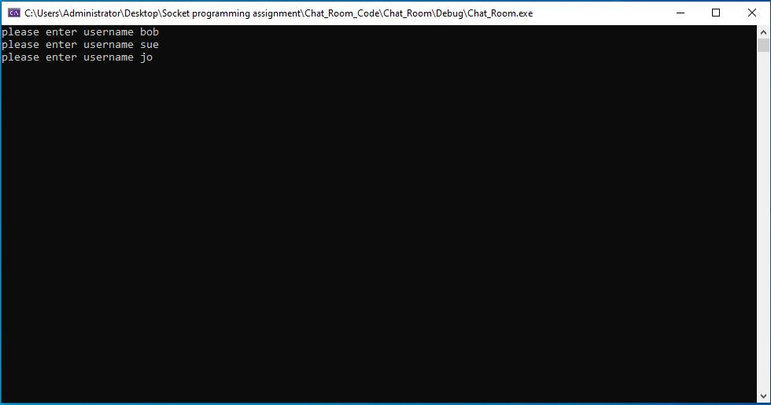
(Fig 1.7) Clients names were entered via the server and not client window.

Appendix

Chat room code

#include <iostream>
#include <WS2tcpip.h>
#include <string>
#include <sstream>

#pragma comment (lib, "ws2_32.lib")

using namespace std;

void main()
{
//Initialze WInsock
WSADATA wsData; //call to winsock startup
WORD ver = MAKEWORD(2, 2); // version 2.2

int wsOK = WSAStartup(ver, &wsData); // icludes version (ver) and pointer to the WSdata
if (wsOK != 0) // if it can not initialise winsock..
{
cout << "Can't Initialise Winsock, I'm Quitting!" << endl;
return;
}

//Create a Socket //socket is an end point that is matched up with a port and an IP address. A socket can be classed as just a number. A file descriptor in linux
SOCKET IcanHear = socket(AF_INET, SOCK_STREAM, 0); // sock_stream = tcp socket, address family = AF_INET, 0 = flag
if (IcanHear == INVALID_SOCKET)
{
cout << "Can't create a Socket, I'm Quitting!" << endl; // can use cerr (cerror) instead of cout
return;
}

//Bind the IP address and port to a socket
sockaddr_in stickBind; // stickBind structure
stickBind.sin_family = AF_INET;
stickBind.sin_port = htons(54000); //port 54000 (host to network short)
stickBind.sin_addr.S_un.S_addr = INADDR_ANY; // could also use inet_pton

bind(IcanHear, (sockaddr*)&stickBind, sizeof(stickBind));

//Tell Winsock the socket is for listening
listen(IcanHear, SOMAXCONN); //somaxconn = maximum connections
//***********************************************************************************************************************************************************************************************************
fd_set master; //define the set, the master set
FD_ZERO(&master); // clears the master set

FD_SET(IcanHear, &master); //adding the listening socket to the set

while (true) // creating a running server to handle multiple connections that will run for infinity
{
fd_set copy = master; //need to make a copy of the master set, because everytime i call select, it would destroy the master file descriptor set

int socketCount = select(0, &copy, nullptr, nullptr, nullptr); //contains alot of functions but the main one is readfds // using synchronous I/O it is a queue system

for (int i = 0; i < socketCount; i++)
{
SOCKET sock = copy.fd_array[i];
if (sock == IcanHear)
{

//accept a new connection
SOCKET client = accept(IcanHear, nullptr, nullptr ); // the NULL can be info on the client such as name

// add new connection to the list of connected clients - to the master file set
FD_SET(client, &master);

// send a welcome message to the connected client
string welcome = "Welcome to the Chat Room \r\n";
send(client, welcome.c_str(), welcome.size() + 1, 0); // sending message out to the client

}
else
{
char buff[4096];
ZeroMemory(buff, 4096); //4096 size of buffer

//receive message
int ClientbytesIn = recv(sock, buff, 4096, 0);
if (ClientbytesIn <= 0)
{
//Drop the client
closesocket(sock);
FD_CLR(sock, &master);
}
else
{
// send message to other clients, and not the listening socket

for (int i = 0; i < master.fd_count; i++)
{
SOCKET outSock = master.fd_array[i];
if (outSock != IcanHear && outSock != sock)
{
ostringstream ss;

ss << "SOCKET #" << sock << ": " << buff << "\r\n"; // displays client socket number as ID
string strOut = ss.str();
send(outSock, strOut.c_str(), strOut.size() +1, 0); //sends message back out
}
}
}

}
}

}
//****************************************************************************************************************************************************************************************************************
//Cleanup winsock
WSACleanup();
system("pause");

} [9] [10] [11] [12]

Bibliography

[1] | Oracle, “The java tutorials,” [Online]. Available: https://docs.oracle.com/javase/tutorial/networking/sockets/definition.html. [Accessed 12 May 2021].
[2] | IBM, “Socket programming,” [Online]. Available: https://www.ibm.com/docs/en/i/7.1?topic=communications-socket-programming. [Accessed 12 May 2021].
[3] | Microsoft Build, “Synchronus and Asynchronous I/O,” 5 May 2018. [Online]. Available: https://docs.microsoft.com/en-us/windows/win32/fileio/synchronous-and-asynchronous-i-o. [Accessed 11 May 2021].
[4] | D. Meador, “single-threaded and multi-threaded processes,” 11 Oct 2018. [Online]. Available: https://www.tutorialspoint.com/single-threaded-and-multi-threaded-processes. [Accessed 10 May 2021].
[5] | D. Millward, “What is the benefit of using a single threaded process over a process without any threads?,” 28 Apr 2020. [Online]. Available: https://www.quora.com/What-is-the-benefit-of-using-a-single-threaded-process-over-a-process-without-any-threads. [Accessed 10 May 2021].
[6] | Microsoft Build, “Select function,” 5 May 2018. [Online]. Available: https://docs.microsoft.com/en-us/windows/win32/api/winsock2/nf-winsock2-select#:~:text=The%20select%20function%20returns%20the,retrieve%20a%20specific%20error%20code.. [Accessed 2 May 2021].
[7] | IBM, “Binding a socket to a specific port number,” [Online]. Available: https://www.ibm.com/docs/en/zos/2.2.0?topic=program-binding-socket-specific-port-number. [Accessed 4 May 2021].
[8] | Microsoft Build, “ZeroMemory macro,” [Online]. Available: https://docs.microsoft.com/en-us/previous-versions/windows/desktop/legacy/aa366920(v=vs.85)#:~:text=Use%20ZeroMemory%20to%20clear%20a,defined%20as%20the%20RtlZeroMemory%20macro.. [Accessed 20 May 2021].
[9] | J. Sorber, “How to write a Mutithreaded server in C,” 20 Sep 2019. [Online]. Available: https://www.youtube.com/watch?v=Pg_4Jz8ZIH4. [Accessed 19 Apr 2021].
[10] | E. l. solutions, “socket programming tutorial in C for beginners,” 29 Jun 2017. [Online]. Available: https://www.youtube.com/watch?v=LtXEMwSG5-8. [Accessed 20 Apr 2021].
[11] | T. Cherno, “Threads in C++,” 11 Mar 2018. [Online]. Available: https://www.youtube.com/watch?v=wXBcwHwIt_I. [Accessed 20 Apr 2021].
[12] | S. Kelly, “Multiple chat clients:one thread,” 19 Jun 2017. [Online]. Available: https://www.youtube.com/watch?v=dquxuXeZXgo. [Accessed 26 Apr 2021].

