
Effective Teamwork and Communication
1808066
Omah Hunter
09/01/2019

Contents
Introduction 2
Working Collaboratively 3
Negotiating and developing ideas 3
Group dynamics theories 4
The Tuckman’s group development model: 4
Theories of team structures 4
Group strategies 5
Interpersonal communication 6
Written communication 7
Strategies for improving clarity 7
Communication with the audience using visual and electronic resources 9
Conclusion 11
References 12

Introduction
Teamwork is the accumulation of the works of individuals in a collective way where the individuals work as a team to meet the goals of the organisation. The organisational work is basically dependent on the teamwork of the organisation and the effective teamwork is a must for any organisation to ensure a working environment in the organisation along with the efficiency of the organisation. The communication is the process that helps an individual to communicate with others and effective communication skills are a must for good teamwork. This paper will discuss the teamwork dynamics, group theories and varies aspects of communication with the organisational context of Mark and Spencer (M&S) which is a large company and around 85000 employees are working in the organisation.

Working Collaboratively
The teamwork is working collaboratively and the process of the teamwork shares some duties within the individuals and they are given below:
- Shared ownership: In the process of the teamwork, the individuals in the team working for the same goals also share the ownership and the effectiveness of working collaboratively depends on the shared ownership.
- Responsibility: The people working in a team share responsibilities and the team members are responsible for their action in the work. The employees of the M&S work as a team and they share responsibilities in achieving the goals of the organisation. The responsibility ensures them to work collaboratively (Hall et al, 2012).
- Issues related to confidentiality: The teamwork also ensures the confidentiality of the job and the team members keep the confidential things secret for the sake of the organisation and because of the duties to the organisation. The issues related to confidentiality ensures the teamwork and confidentiality ensure the working collaboratively.

Negotiating and developing ideas
The teamwork needs negotiation and the negotiation in the team help to develop the ideas in the team that helps to meet the objectives of the organisation. The team working in the organisation has to face many problems and has to meet particular objectives. In the team working process, the team members negotiate about the ideas that need to be applied in the organisation to meet the goals (Huczynski et al, 2013). The negotiation is a very important process in the teamwork and the process help to develop ideas and the developed ideas help the organisation to meet the goals.

Group dynamics theories

The Tuckman’s group development model:
The Tuckman’s group development model shows that there are different stages involved in the development of the effective and efficient team. The model focuses on the development of the individual’s skills and the cultural based environment and the stages are described below:
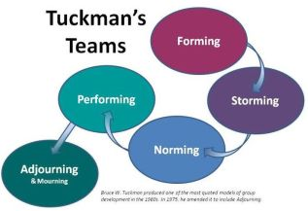
Forming: The first stage is to form a team and the individuals in the team do not know each other or share the same skills and that is why it is very important to provide training in the team to develop the skills of the team members. M&S ensures the training for the employees working in the organisation as a team (Wiedow and Konradt, 2011).
Storming: The storming is the process where the members get to know each other and the process help to understand the culture of others and to develop an understanding among the team members.
Norming: In this stage, the team members start to work as a team and the organisation M&S acts on the skills development and the team working of the employees working as a team.
Performing: This is the final stage and in this stage, the results can get as the development of the team and their performance (Nielsen and Randall, 2012).

Theories of team structures
The Belbin’s team role is a renowned theory of team structure and the theory is described below:
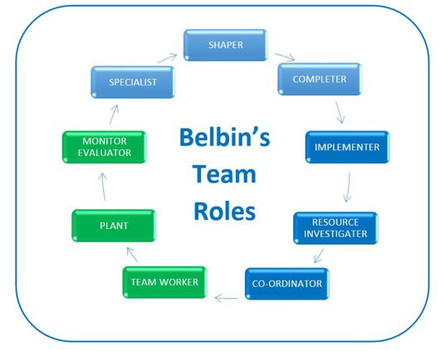
Figure: Belbin’s Team Roles
Source: (Dietz et al, 2014)
The Belbin’s theory of team structure shows that the team need to divide the works among the team members and the team members are given with a particular role to play in the team. The team worker works a team where the plant gives ideas to meet the goals. The monitor supervises the teamwork and the specialist has the role to give expert instruction. The shaper shapes the work and the resource investigator reaches about the resources. The co-ordination coordinates the work in the team. The above structure is used in organisations like M&S to ensure an effective and sufficient team.

Group strategies
The teamwork and the group strategies of an effective team are given below:
- Shared objectives: The group strategy of an effective team is to share the same objective and the share objectives help the team to meet the objectives of the organisation.
- Group agreement: The group agreement is the process where the team members of the group agree on the agreement of the group and the group agreement of the team help them to work together with the same objective (Baldwin et al, 2012).
- Meaningful schedules: The schedules of the work need to prepare a meaningful schedule so that the group can meet the objectives of the organisation and the success of the group depends partially on the schedules of the teamwork.
- Effective delegation: The effective teamwork needs effective delegation and the performance of the team depends on the delegation of the team.
M&S follow the above-mentioned group strategies so that the employees of the organisation can meet the goals of the organisation and the organisation can form an effective team to meet the goals of the organisation.

Interpersonal communication
Interpersonal communication means communication among the person and communication can be face to face communication. The interpersonal communication determines the effectiveness of the team and the interpersonal communication skills play a very significant role in forming an effective team. The interpersonal communication is described below:
Body language: The body language is very important in interpersonal communication as the body language of a person refers the gesture of the person in the time of communication. in the team working context, the team members need to share a friendly body language for the effectiveness of the communication (Powell et al, 2011).
Active listening: The communication process requires active listening and feedback on the communication process is not possible without active listening. The team workers need to listen actively while communicating with the other team members in the organisation like M&S so that the teamwork can be effective and sufficient (Kajko-Mattsson, 2010).
Personal presentation: The personal presentation of the team workers needs to be concise and informative and there should be clarity in the presentation. The concise information and good personal presentation is a must for an effective team that is why M&S develops the personal presentation skills of the employees.
Context awareness: The group members need to become aware of the context of the discussion because the discussion needs feedback in the effective teamwork and that is not possible if the members are not aware of the context.

Written communication
The organisational communication needs written communication and the formats and the structure of the written communication needs to be formal communication in the organisational context (Singhal and Rogers, 2012). M&S develops the skills of the employees of the organisation and the organisation provides training for the development of the written communication skills of the employees. The format which is formal is used in the organisation for written communication and the teamwork also needs written communication in the organisation. The structure of the written communication also needs to be followed by employees for effective communication. The written communication is a formal form of communication and the communication needs the use of concise and clear information or the chances of misinterpretation gets higher (Jotshi et al, 2011).

Strategies for improving clarity
The communication process needs to have clarity for effective communication and that is why it is very important to know about the communication model to understand the communication process clearly.
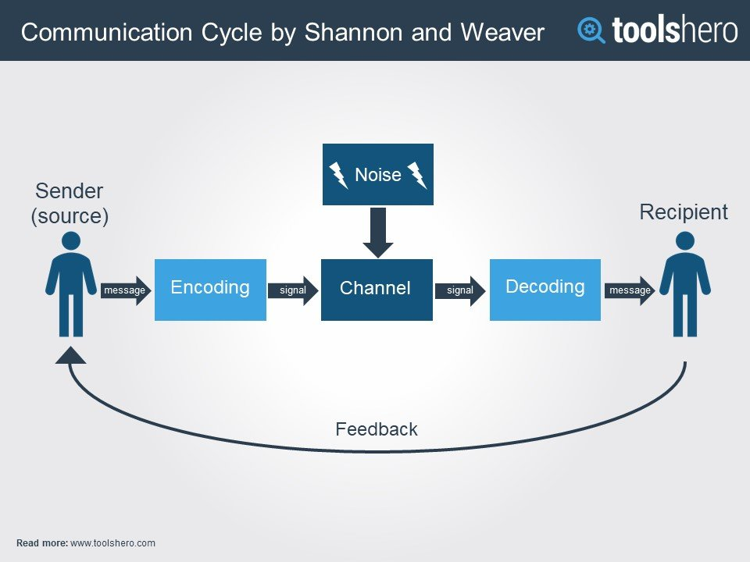
Figure: Shannon Weaver Model of communication
Source: tools here
The sender sends the message in the Shannon Weaver’s model of communication and the message gets encoded in the process. Then the encoded message goes through the channel and reaches to the receiver. The receiver decodes the message and the reads the message. The box called noise is the disturbance in the channel to communicate. The communication is good when the noise of the channel is low and the communication is bad when the noise in the channel is high. The receiver feedbacks the sender and the feedback in the communication process helps to develop the communication (McQuail and Windahl, 2015).
There are some things that need to follow to make the communication effective and the strategies to make communication effective are given below:
Clarity of expression: The expression in the communication should be clear so that the receiver can understand the communication clearly. The clarity in the expression ensures the effectiveness of communication. The expression in the communication within should be clear and the process will help the team to work for the goals of the organisation and the process will also ensure the effectiveness of the team. M&S ensures the clarity of expression while communication.
Clarity of grammar: There should also be clarity in the grammar used by the sender or the message will get misinterpreted by the receiver. The clarity in the grammar ensures the clarity n the message and the grammatical mistakes in the communication especially, in the written form is very harmful for the organisation. M&S ensures the development of the skills of the employees working in the organisation as a team and the organisation ensures the clarity of grammar in communication because it is very important to meet the goals of the organisation.
Clarity of syntax and punctuation: There should also be clarity of syntax and punctuation and the clarity is very important for the effectiveness of the communication. The team workers need to use the clear and same syntax and proper punctuation to ensure the effectiveness of the communication.
Clarity of presentation: The presentation is very important in the communication process and it is also very important in the team working process. The organisation like M&S emphases on the development of the presentation skills of the employees and the clarity of the presentation is a must for effective communication. The clarity of the presentation makes the participants understand the context and the clarity of the presentation is very important for the effectiveness of the presentation skills.

Communication with the audience using visual and electronic resources
There are different modes of communication among them the verbal communication is the most used communication and written communication is the formal way of communication. The technological advances have also brought a revolutionary change in the mode of communication. The use of the technology has brought video conferencing which is the visual mode of communication and the electronic mail has brought the electronic mode of written communication.
The video conferencing is the audiovisual communication and the process of the communication can be performed from the remotest areas of the world and the internet makes the communication possible for communication with others in the visual manners using the electronic resources (Nutbeam et al, 2010).
The electronic mail has brought a huge change in the communication of the organisation and the form of the letter has been converted into the electronic way of communication and the message can be sent with no time. The process has brought a huge swiftness in the communication process and the communication has become more effective in this form of communication.

Conclusion
The teamwork and communication are very important to understand because communication ensures the effectiveness of the teamwork where no organisation can meet the goals of the organisation without effective teamwork. This paper has discussed the dynamics of group forming and the formation of the team theory has also been discussed n this paper. This paper has discussed communication models and the ways to make the communication effective. The effective communication and effective teamwork will ensure M&S to meet the goals of the organisation. The organisational communication plays a very important role in the effectiveness of the organisation and the teamwork.

References
- Baldwin, R., Cave, M. and Lodge, M., (2012). Understanding regulation: theory, strategy, and practice. Oxford University Press on Demand.

- Dietz, A.S., Pronovost, P.J., Mendez-Tellez, P.A., Wyskiel, R., Marsteller, J.A., Thompson, D.A. and Rosen, M.A., (2014). A systematic review of teamwork in the intensive care unit: What do we know about teamwork, team tasks, and improvement strategies?. Journal of critical care, 29(6), pp.908-914.

- Hall, K.L., Vogel, A.L., Stipelman, B.A., Stokols, D., Morgan, G. and Gehlert, S., (2012). A four-phase model of transdisciplinary team-based research: goals, team processes, and strategies. Translational behavioral medicine, 2(4), pp.415-430.

- Huczynski, A., Buchanan, D.A. and Huczynski, A.A., (2013). Organizational behaviour (p. 82). London: Pearson.

- Jothi, P.S., Neelamalar, M. and Prasad, R.S., (2011). Analysis of social networking sites: A study on effective communication strategy in developing brand communication. Journal of media and communication studies, 3(7), pp.234-242.

- Kajko-Mattsson, M., (2010). Intra-Organizational Model of Communicaton on Serious Risks. In Proceedings of the International MultiConference of Engineers and Computer Scientists (Vol. 1).

- McQuail, D. and Windahl, S., (2015). Communication models for the study of mass communications. Routledge.

- Nielsen, K. and Randall, R., (2012). The importance of employee participation and perceptions of changes in procedures in a teamworking intervention. Work & Stress, 26(2), pp.91-111.

- Nutbeam, D., Harris, E. and Wise, W., (2010). Theory in a nutshell: a practical guide to health promotion theories. McGraw-Hill.

- Powell, T.C., Lovallo, D. and Fox, C.R., (2011). Behavioral strategy. Strategic Management Journal, 32(13), pp.1369-1386.

- Singhal, A. and Rogers, E., (2012). Entertainment-education: A communication strategy for social change. Routledge.

- Wiedow, A. and Konradt, U., (2011). Two-dimensional structure of team process improvement: Team reflection and team adaptation. Small Group Research, 42(1), pp.32-54.

