Task 1
So here is what I should write about from the assessment. For this task a career of computer science was chosen to investigate necessary skills for. To see detailed overview of skills needed to complete a computer science interview, see Figure 1 below.
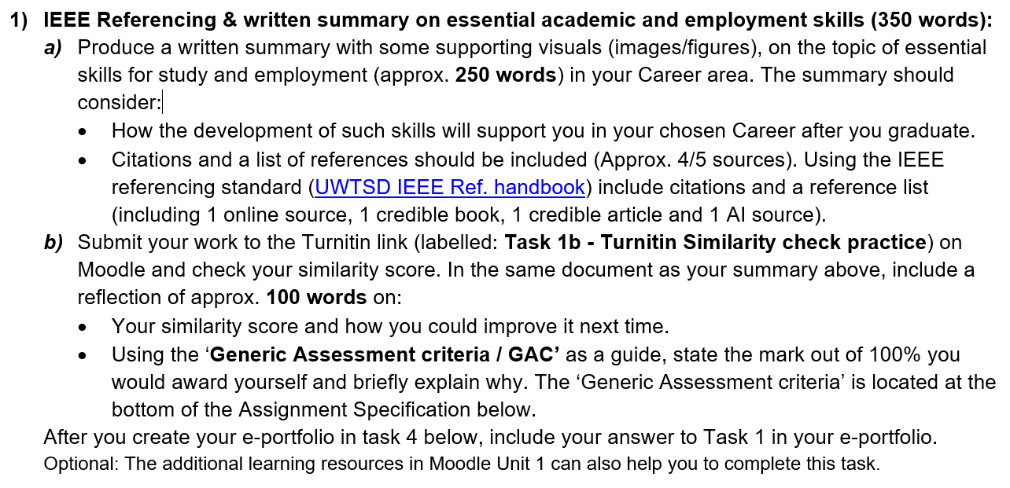
Fig. 1: An overview of skills necessary for becoming a computer scientist [1].

References:
[1]
C. Chen and H. Jiang, “Important Skills for Data Scientists in China: Two Delphi Studies,” The Journal of computer information systems, vol. 60, no. 3, pp. 287–296, May 2020, doi: 10.1080/08874417.2018.1472047.

