Marketing essentials
BMIH4005

Student name: Cristian Rogoz
Student ID: 2220458
Lecturer: Luciana Suardi
Word Count: 1319

Table of Contents
Introduction 3
Situation analysis 3
SWOT analysis 3
Segmentation and targeting 3
Perceptual positioning map and Bowman’s Strategy Clock 3
Partnerships and franchises 4
PESTEL analysis 4
SMART Objectives 4
Strategy 5
Tactics 5
Marketing mix 5
Action 6
Conclusion 7

Introduction
The purpose of this marketing plan is to identify marketing opportunity for Hilton Hotel which is a USA based multinational hospitality company. The hotel brand is operating and managing a brand portfolio of hotels and resorts (Çetin, Tuna Ultav and Uz, 2019). As per the requirement of the task, the report will be presented through performing situation analysis including SWOT, segmentation, targeting and positioning, competitor analysis, PESTLE analysis and so on. SMART target of the business will be demonstrated along with the strategic orientation of the business will be discussed. Tactics of the business will be performed through demonstrating marketing mix. An action plan and control will also be discussed in this report.

Situation analysis

SWOT analysis
Having brands worldwide is a strength of the company for which Hilton Hotel has been operating its hotel business properly. However, overdependence on the US market is a weakness of this hotel brand. There are opportunities for market development of the company. However, rising competition is a possible threat to this hotel brand (Hilton, 2022).

Segmentation and targeting
This hotel brand segments the customers according to the income portfolio and geographical orientation. Hilton Hotel targets the segment who are subjected to take regular hotel facilities and services. Valuing needs of the customers is the positioning orientation of the business (Ferrell, 2016).

Perceptual positioning map and Bowman’s Strategy Clock
Hilton Hotel determines its competitive analysis by positioning the brand according to the value proposition orientation. According to Gao and Hafsi (2018), pricing strategy is obtained as per the orientation of competitive scenario. According to Bowman’s Strategy Clock, this hotel brand maintains differentiation strategy which can be identical from the competitors by determining high perceived value.

Partnerships and franchises
Hilton Hotel performs business under Hilton Worldwide where the company operates its hospitality and hotel services through making partnerships, collaborations and franchises (Çetin, Tuna Ultav and Uz, 2019). This hotel brand owns certain franchises including LXR Hotels & Resorts, Conrad Hotels & Resorts, Signia by Hilton and so on.

PESTEL analysis
Political: Corporate taxation rate is 19% currently which has not been changed in the recent times (GOV.UK, 2022). Political factors are not threats for Hilton Hotel brother significant opportunities are undertaken by the hotel brand for performing its hotel services.
Economic: The UK economy is experiencing the recession period for which higher inflation rate is prevailing currently which is 11.2% (ONS, 2022). This higher rate is influencing the business operations negatively because of organisations are bound to rice the price of production services.
Social factors: The UK population is aging for which the arrangement of hotel services depends on the demographic factors (Zhou, 2020). And Hilton Hotel has to evaluate the social factors properly for arranging its hotel services. As stated by SimilarWeb, the website has more views from females, aged 25-34.
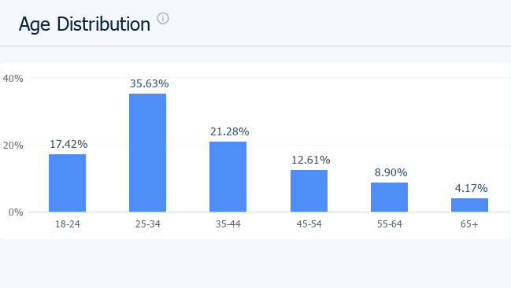
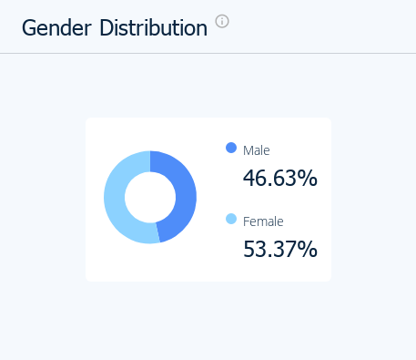
Technological factors: Technological infrastructure of the UK is advanced where most of the hotel brands including Hilton Hotel have started using online facilities for providing greater experience to the consumers.
Environmental factors: The UK government is strictly maintaining the environment of regulations for lowering the carbon emission for which Hilton Hotel has to maintain the sustainable approach properly (Zhou, 2020).
Legal factors: Equality Act, Data Protection Act, Employment Act and so on have to be maintained properly for the purpose of performing the hotel services properly in the UK.

SMART Objectives
The aim of the marketing plan of Hilton Hotel is to enhance the market share by 5% at the end of 2023. The company will undertake certain marketing strategies for the purpose of achieving the target within the time period. The target is specific and measurable as per the goal of the business. This hotel brand has the capability to achieve the target. The target is also relevant for the business orientation of Hilton Hotel. As the target has a definite time period, the goal is also time bound.

Strategy
Hilton Hotel determines the value proposition of the brand properly for the purpose of serving the target customers in a very significant way. The hotel brand has specific segments of customers which have been identified and demonstrated. According to Kang (2016), Hilton Hotel will communicate the value proposition through determining its industries standing and reputed brand portfolio. The hotel band is performing its hotel and hospital services under one of the largest hospitality groups in the world having a positive brand proposition in the world market. The hotel brand deals with high end hotels and quality services to the clients for which the target customers can also be served and delivered properly. Hilton Hotel has effective global reach and significant international network of hotels which are effective enough to communicate the value proposition and deliver services to the customers properly.

Tactics

Marketing mix
Product: Product will be the main tactic of Hilton Hotel for obtaining its marketing goal (Polo, 2020). Hotel services, hospitality services, food services and so on will be offered to the target customers as per the segmentation. The hotel brand will be determined to maintain effective quality towards the hotel services for satisfying the customers. Innovative services will be added regularly for the prospect of serving the consumers in a very effective way.
Place: Ferrell (2016) states that place and distribution strategy is very significant for obtaining the marketing goal. Hilton Hotel will offer the hotel services and other services to the customers of the UK. The company will integrate own distribution channel for promoting and advertising the hotel services to the target customers. Customers will get the opportunity to make online booking system for the purpose of providing them with advanced facilities and services.
Price: Price is the tactic of marketing which is denoted as the value by which customers can avail the product or service, mentioned by Ferrell (2016). Hilton Hotel will maintain value-based pricing strategy for the purpose of attracting the customers to determine their needs and demands. There will be a variety of price points for visitors depending on the expected hotel services of the customers. Customers will be provided the best services determining the pricing value.
Promotion: Promotion is the significant tactic for reaching to the target customers. Hilton Hotel will focus on maintaining both traditional and digital promotional strategy for grabbing the target customers. Target consumers will be communicated through social media where RACE model will be used. Digital media will be used for reach, act, convert and engage the target customers for achieving the marketing goal.

Action
Action | M  1 | M  2 | M  3 | M  4 | M  5 | M  6 | M  7 | M  8 | M  9 | M  10 | M  11 | M  12
Setting Smart objectives
Collecting all resources
Conducting team meeting
Developing content for social media and traditional marketing
Publishing content
Evaluating public reaction
Taking corrective action
Completing the project

Control
It will be significant for Hilton Hotel to determine effective control of the planning so that the successful measurement can be determined properly. The company will rely on certain factors for dealing with the success factors. Number of new customers will be a significant factor and parameter for determining control measure of the marketing plan (Brooksbank, 2019). Positive attitudes towards the brand of the target customers will be another parameter for determining successful measures. At the end of the period, financial efficiency of the company will be analysed through understanding if the profits will get increased or not. Such factor will be another access measure of the company.

Conclusion
The report has been presented through performing situation analysis including SWOT, segmentation, targeting and positioning, competitor analysis and PESTLE analysis. SMART target of the business has been demonstrated along with the strategic orientation of the business has been discussed. Tactics of the business have been performed through demonstrating marketing mix. An action plan and control has also been discussed in this report. It is recommended to the company to focus on digital marketing for the purpose of achieving the goal.

Reference list
Brooksbank, R. (2019). Essential Characteristics for an Effective Marketing Plan. Marketing Intelligence & Planning, 9(7), pp.17–20.
Çetin, H.A., Tuna Ultav, Z. and Uz, F. (2019). Reflections of the İstanbul Hilton Hotel on Mid-century Hotel Buildings in Turkey. Art-Sanat, pp.57–88. doi:https://doi.org/10.26650/artsanat.2019.12.0016.
Ferrell, O.C. (2016). Marketing strategy. Cengage.
Gao, Y. and Hafsi, T. (2018). Does charitable giving substitute or complement firm differentiation strategy? Evidence from Chinese private SMEs. European Management Review, 1(1). doi:https://doi.org/10.1111/emre.12180.
GOV.UK (2022). Rates and allowances for Corporation Tax. [online] GOV.UK. Available at: https://www.gov.uk/government/publications/rates-and-allowances-corporation-tax#:~:text=The%20rates%20tables%20have%20also [Accessed 3 Mar. 2023].
Hilton (2022). Hotels by Hilton - Book the Best Rates Across All Brands. [online] Hilton. Available at: https://www.hilton.com/en/ [Accessed 3 Mar. 2023].
Kang, J.M. (2016). Saul Alinsky’s Communication Strategy : Its Application for Political Communication in Korea. Journal of political science and communication, 19(1), p.351. doi:https://doi.org/10.15617/psc.2016.02.19.1.351.
ONS (2022). Inflation and price indices - Office for National Statistics. [online] ons.gov.uk. Available at: https://www.ons.gov.uk/economy/inflationandpriceindices [Accessed 3 Mar. 2023].
Polo, M.P. (2020). Acts or events? A perspective from the marketing mix. IROCAMM-International Review Of Communication And Marketing Mix, 1(1), pp.56–66.
Zhou, Y. (2020). Analysis on the Current Situation of Business Environment Research in China-Literature Review. DEStech Transactions on Economics, Business and Management, (icaem). doi:https://doi.org/10.12783/dtem/icaem2019/31131.

