10/16/2025
Assessment
Portfolio Report on Contemporary Software Applications for Business


Name: Djassic Correia
Student ID: 2510403
Group: 2

Module NaMe: Software solutions for business
Module Code: ACCA 4026
Lecturer: Amitave Banik
Trinity saint david University of Wales (London Campus)

Table of Contents
Introduction 2
Main Body 2
Task 1 2
e-Commerce Website builders/software solutions 2
Wix 2
WooCommerce 3
Task 2 3
Mind-map of Contemporary Software Applications 3
Task 3 6
Office Applications for Creating, Storing, Presenting, and Analysing Data 6
Microsoft Word 6
Microsoft PowerPoint 6
Microsoft Excel 7
Microsoft Access 7
Mail merge 8
Pivot Table 19
Task 4 28
Communication and Collaboration applications 28
Microsoft Teams 28
SharePoint 29
Teams Practical use 31
SharePoint Practical use 36
Conclusion 39
References 40

Introduction

In this work there are 4 tasks to tackle, where the first is about e-commerce website builders/software solutions to choose two software and talk about them, the second is about a mind map of contemporary software applications to explain the benefits and create a mind map, the third is about Office Applications to talk about the four MS Word, MS PowerPoint, MS Excel, and MS Access, and the last, the fourth, is about Communication and Collaboration applications.

Main Body

Task 1

e-Commerce Website builders/software solutions

The most popular e-commerce are, Shopify, WooCommerce, BigCommerce, Squarespace, Square Online, Adobe Commerce, Presta shop and Wix.

Wix
Wix is a no-code website builder with tools to help you create everything from a simple personal blog to a complex enterprise-level online business, featuring integrated functionalities for e-commerce and marketing [1].
One of the most impressive benefits of Wix is the quality of the templates offered, with incredible designs and predefined layouts for various segments, making it easy to find a look that suits your project. Unlike other website creation platforms, Wix offers customization; you can adjust every detail of your blog or website according to your preferences. You can also enable automatic backup, allowing restoration to previous versions, thus preventing important information from being lost [2].
Some of Wix's limitations include loading speed, where templates with many visual elements can make the site heavier and affect speed performance, also difficulty in changing templates, and Wix does not allow migrating content from one site to a new template after editing, restrictions on certain business categories, such as adult content stores, configuration time, where there are up to 30 days to complete the tool setup after receiving the first payment, otherwise all money is refunded to the customer [2].

WooCommerce
WooCommerce is an open-source eCommerce platform (WordPress Plugin) that allows people to sell products or services, coming with many features and being easy to use, with software that is easy to install and allows anyone to create an online store without needing much technical web experience, they can create categories and subcategories, add product images and create their own shipping and payment options.
WooCommerce Benefits is a plugin installed on a WordPress site that provides many common features found in an online store, such as product management, order management, category creation, customer management, discount coupons, shipping costs, payment and much more [3].
One of the limitations is that all e-commerce ventures have to use WordPress to support their online stores, which may not be suitable for those who want to use something other than WordPress.

Task 2

Mind-map of Contemporary Software Applications
A mind map is a tool for visualising ideas, a way to organise thoughts, which helps users understand concepts by breaking them down into parts, and also helps generate better ideas and organise and comprehend information better [4].
The most significant benefit of mind mapping is the increase in productivity, a cohesive and organised structure of a mind map makes it easier for teams to share ideas. The simplicity of explaining topics allows teams to quickly get on the same page, and with that they can start working to achieve the desired results. This alignment can lead to a more efficient team that solves challenges easily, increasing productivity. Some aspects of business are planning projects, developing, strategizing, and mind mapping makes this type of complex business task easier, allowing executives to consume, understand, and retain complex issues more quickly.
Mind mapping is an effective tool for encouraging collaboration and communication among teams, as it visually demonstrates how different departments work together towards a common goal. This helps to identify gaps in processes, develop connections and facilitate idea generation. For example, a mind map can help departments work together during a product launch, illustrating how marketing, sales and development teams should align to plan strategies and prepare for potential obstacles. This approach encourages collaborative and innovative thinking, which can enable teams to share ideas, see their impact on the company and work together to reach a solution [5].

Link: https://mm.tt/map/3895355868?t=j7sD5ZTEUj

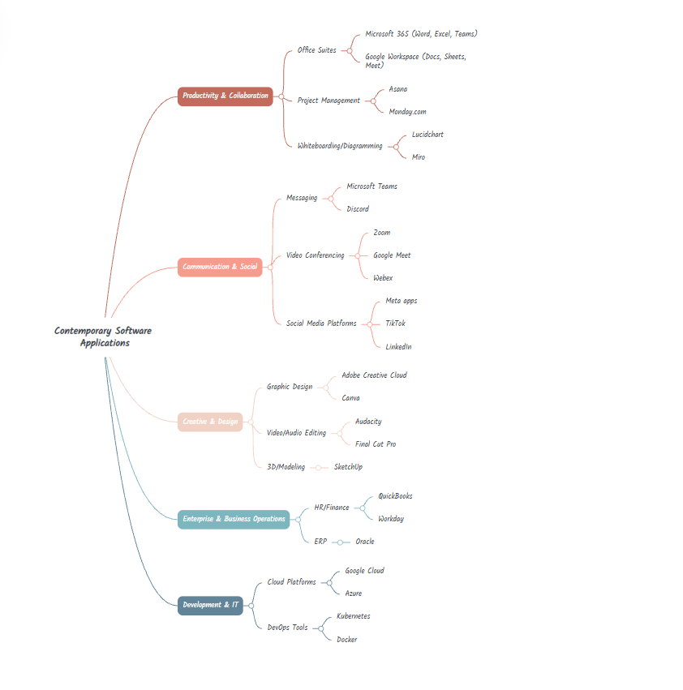

Figure 1: Mind map, created with Mindmeister tool.

Task 3

Office Applications for Creating, Storing, Presenting, and Analysing Data

Microsoft Word

Microsoft Word is a component of Microsoft Office that helps in creating, editing and formatting documents. It includes features for spelling and grammar checking, as well as text formatting, and also allows the inclusion of photos, tables and charts, for tasks such as formal communication [6].
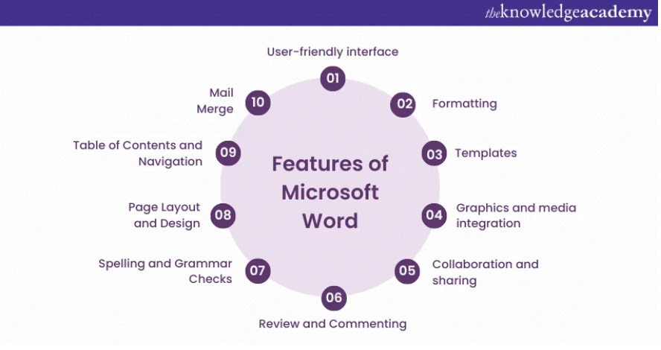
Figure 2: From The Knowledge Academy [6].

Microsoft PowerPoint

Microsoft PowerPoint is a presentation software widely used to create presentations of valuable information through charts and images. It is commonly used in school and business presentations, and it is a complete presentation graphics package that provides everything needed to create a professional-looking presentation, offering tools for word processing, drawing, creating diagrams, charts, and presentation management [7].

Microsoft Excel

Ms Excel is a Microsoft spreadsheet program and a component for business applications. Microsoft Excel allows users to format, organise, and calculate data in a spreadsheet. By organising data using Excel, data analysts and other users can make information easier to visualise as data is added or changed. Excel contains a large number of boxes called cells, which are organised into rows and columns, and data is placed in these cells.
Excel is widely used in business environments, it is used in business analysis, human resources management, operations management and performance reporting. Excel uses a large collection of formatted cells to organise and manipulate data and perform mathematical functions, it can organise data on the spreadsheet using chart tools, pivot tables and formulas [8].

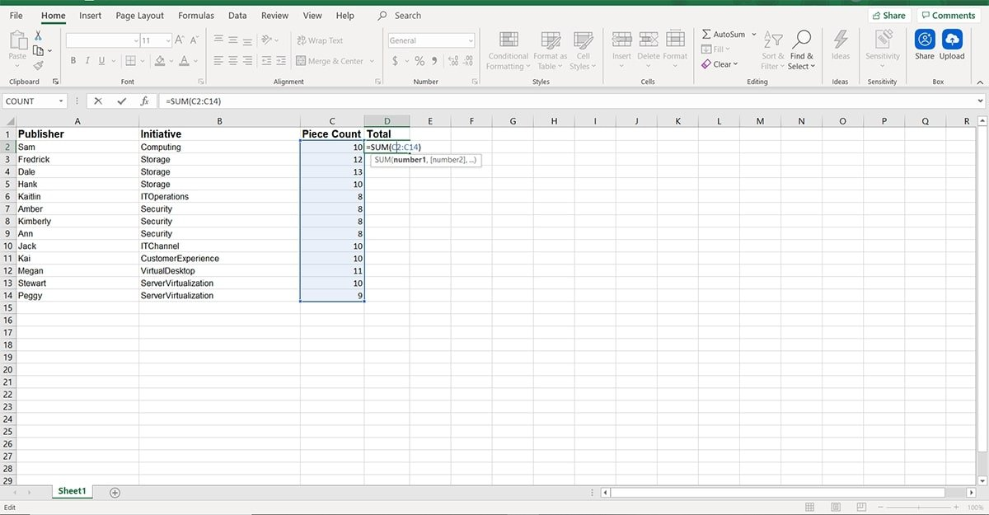
Figure 3: From Techtarget [8].

Microsoft Access

Microsoft Access is used to create, manage and analyse databases with a user-friendly interface, Access allows the creation of databases, data entry, retrieval, manipulation and report generation, and integrates seamlessly with Microsoft Office tools such as Excel and Word for increased productivity [9].

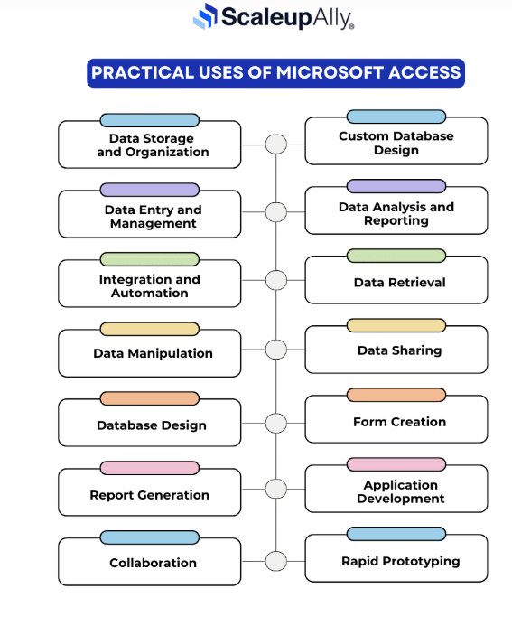
Figure 4: From Scaleupally [9].
Explain four office software solutions for business operations (MS Word, MS PowerPoint, MS Excel, and MS Access), highlighting their major features, benefits, and limitations (if there are any). You can use some images in addition to text (approx. 4/5 sources).

Mail merge

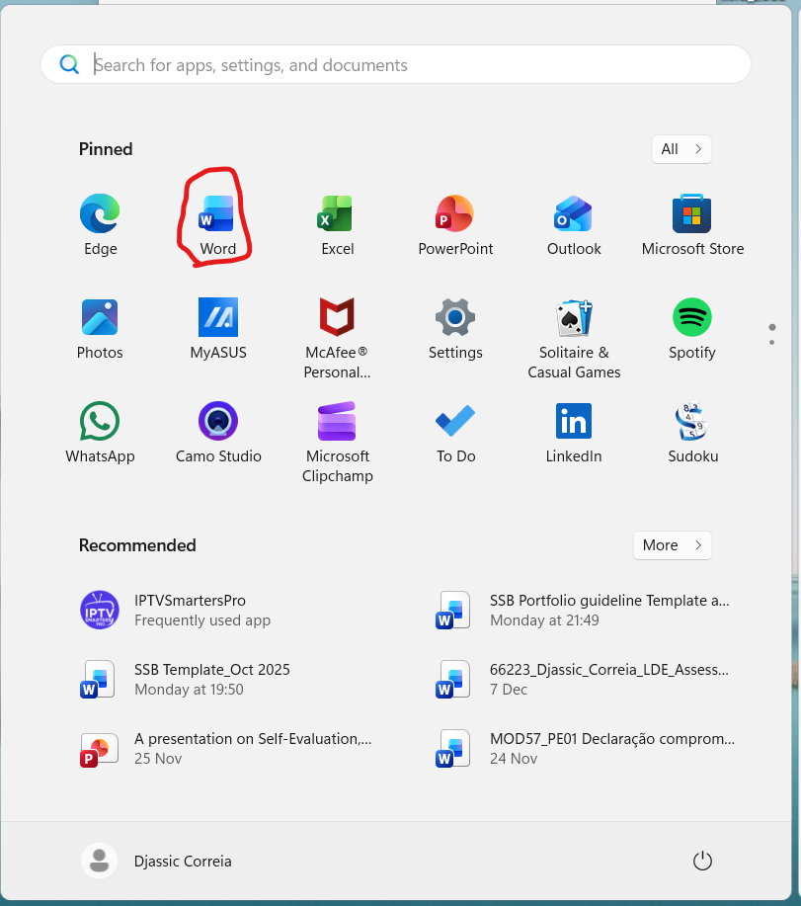
Figure 5: Find Ms Word

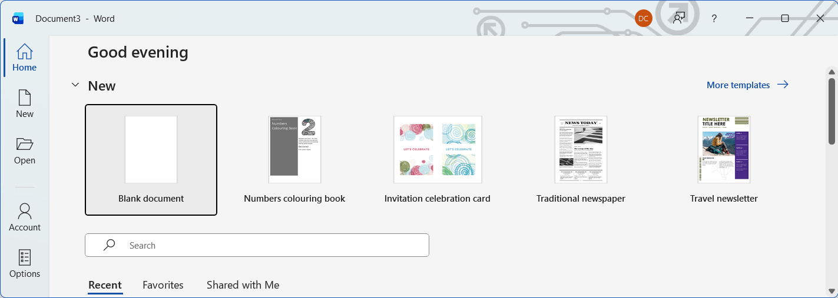
Figure 6: Open a blank page in MS Word

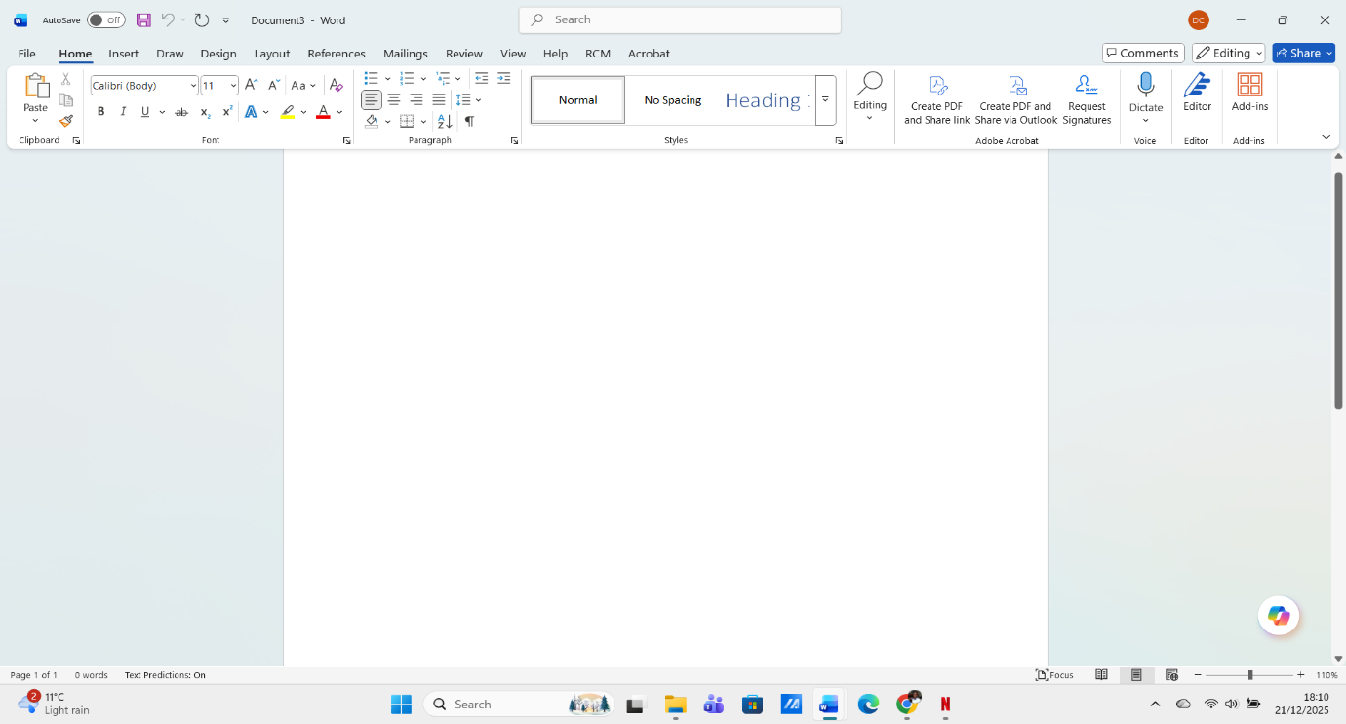
Figure 7: Blank page in Ms Word

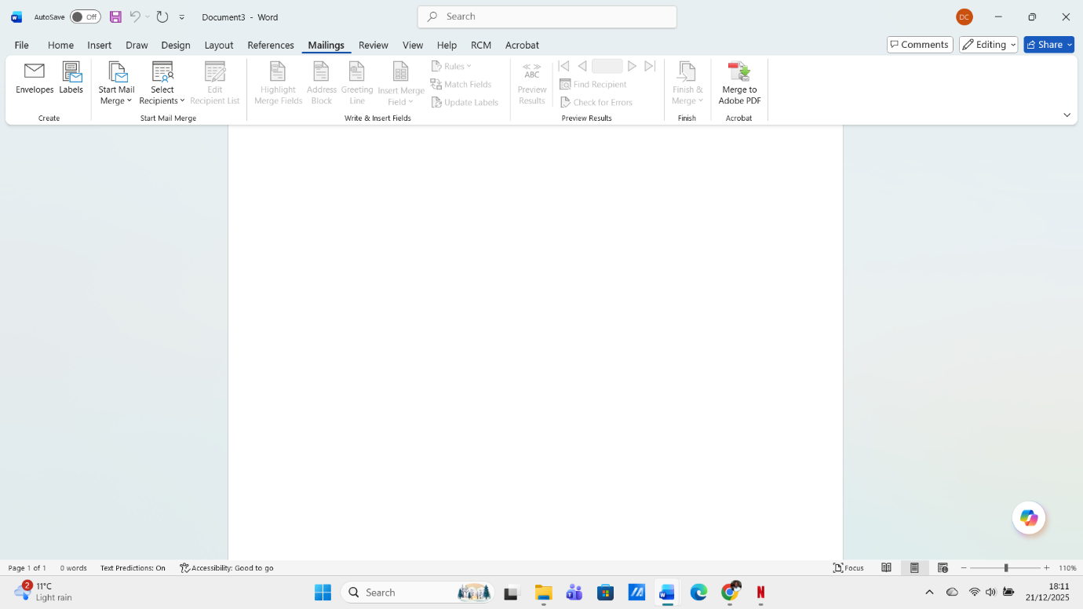
Figure 8: Open Mailings
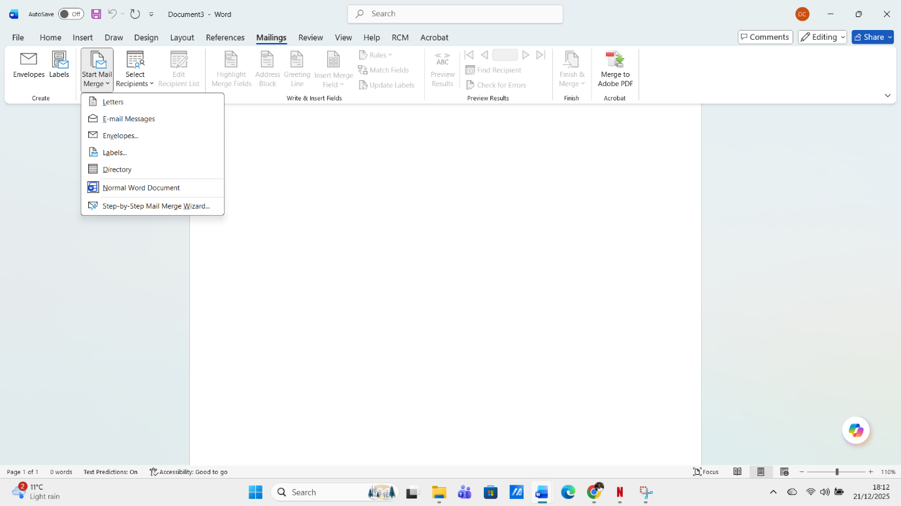
Figure 9: Starting Mail Merge

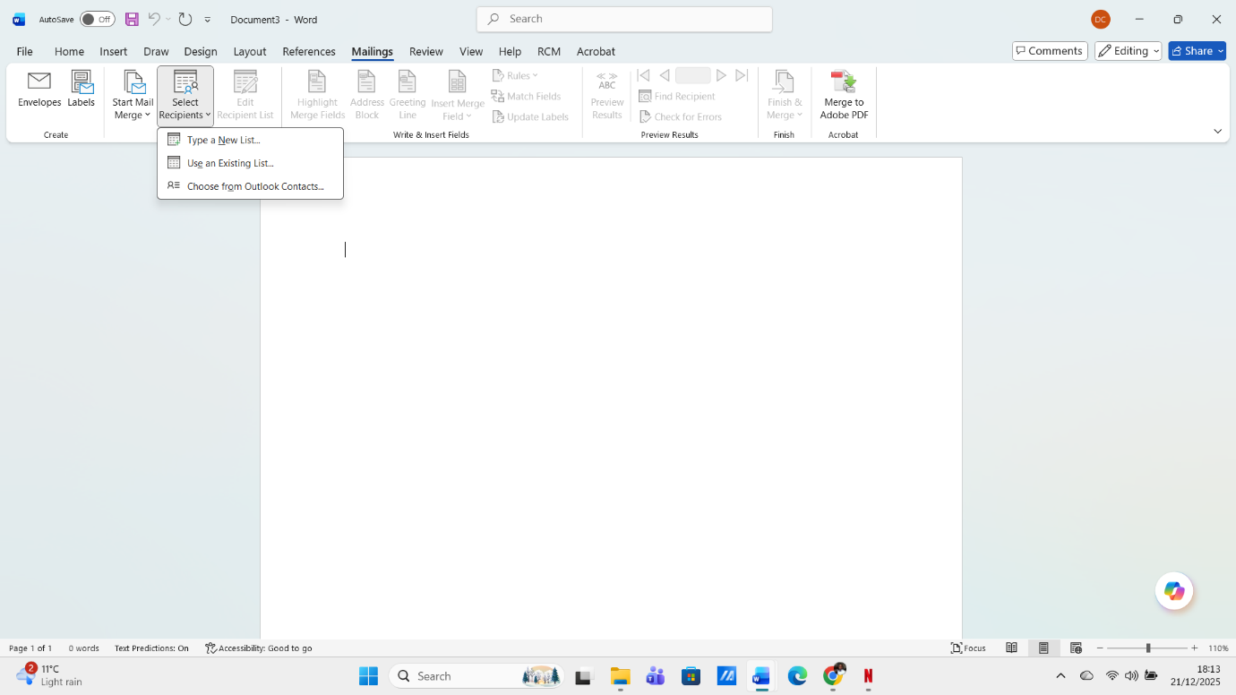
Figure 10: Star to select recipients
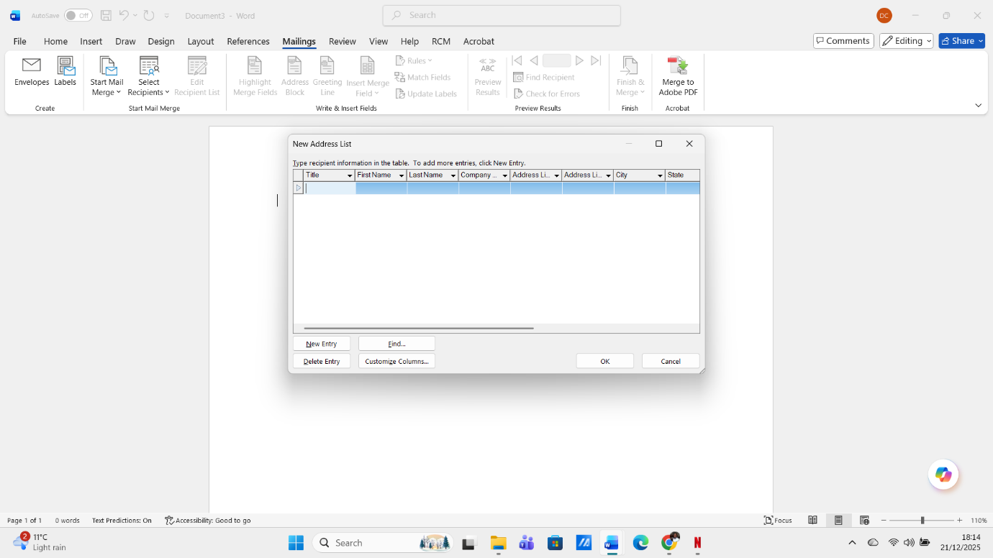
Figure 11: Create list of Recipients

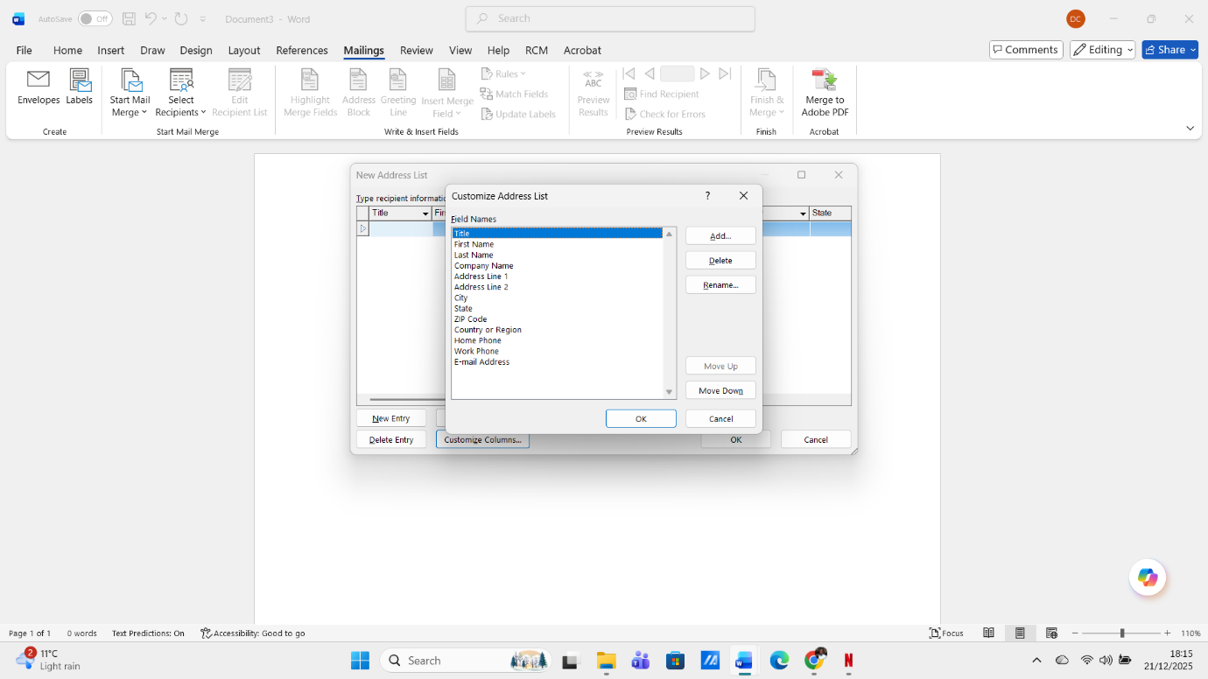

Figure 12: Customize address list of recipients
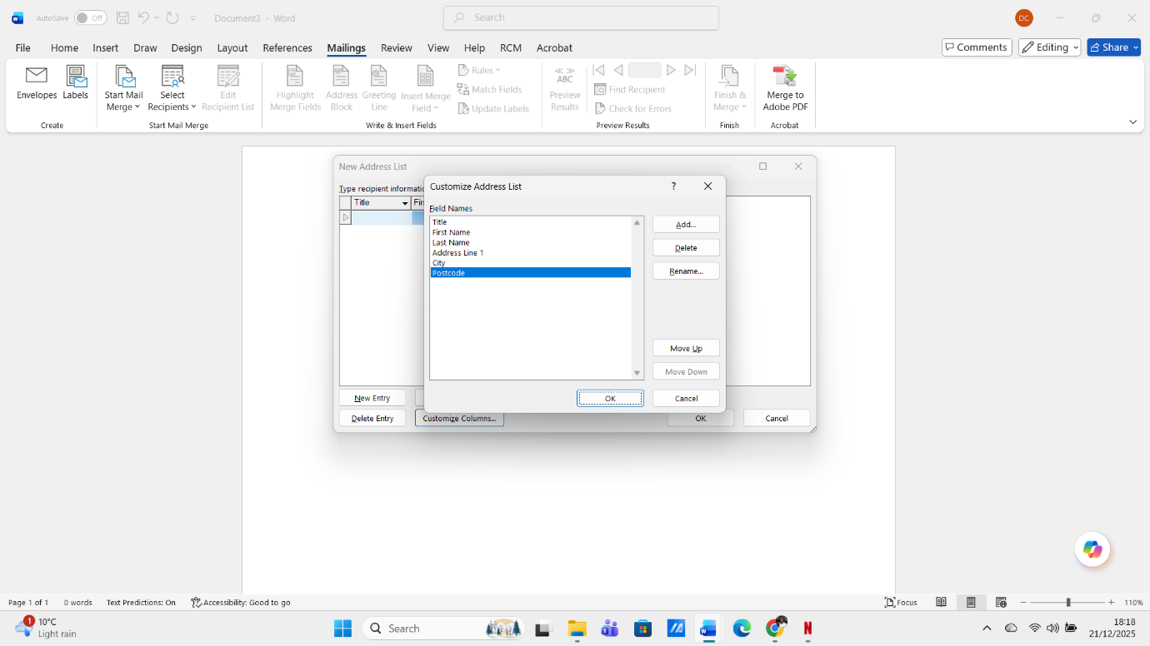
Figure 13: After customising the list with details that I will use

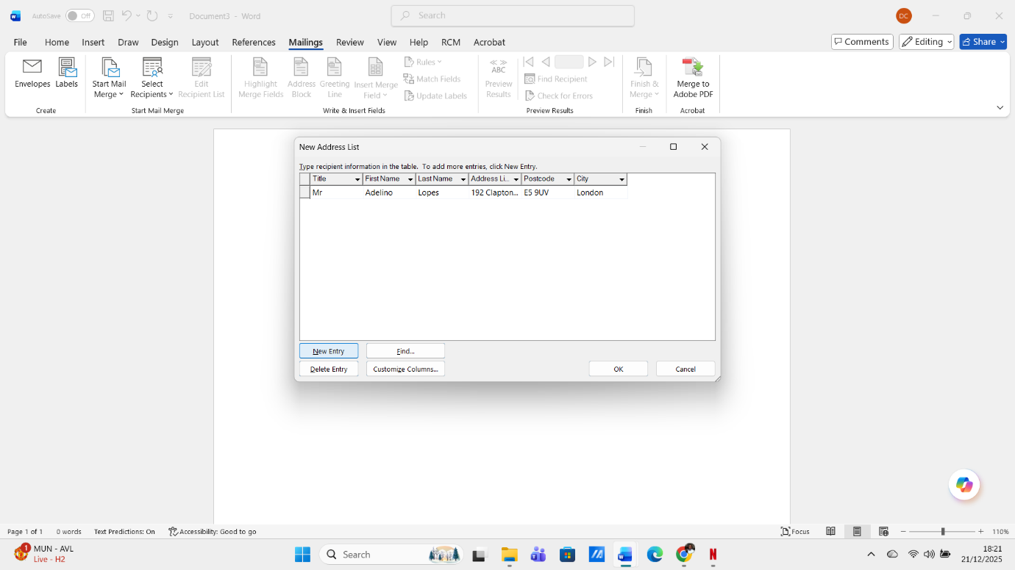
Figure 14: Fill in the Recipients details
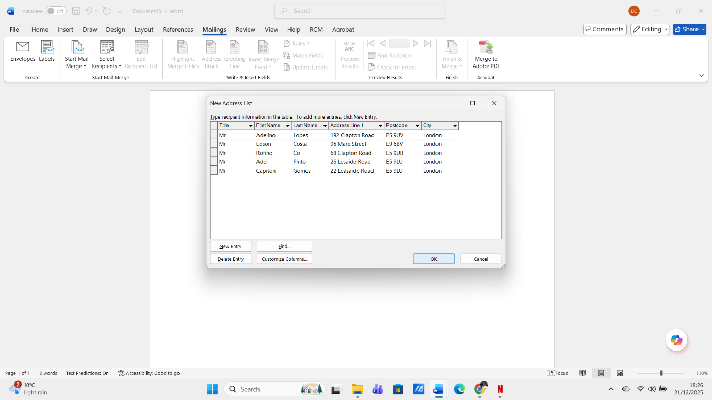
Figure 15: All recipients done

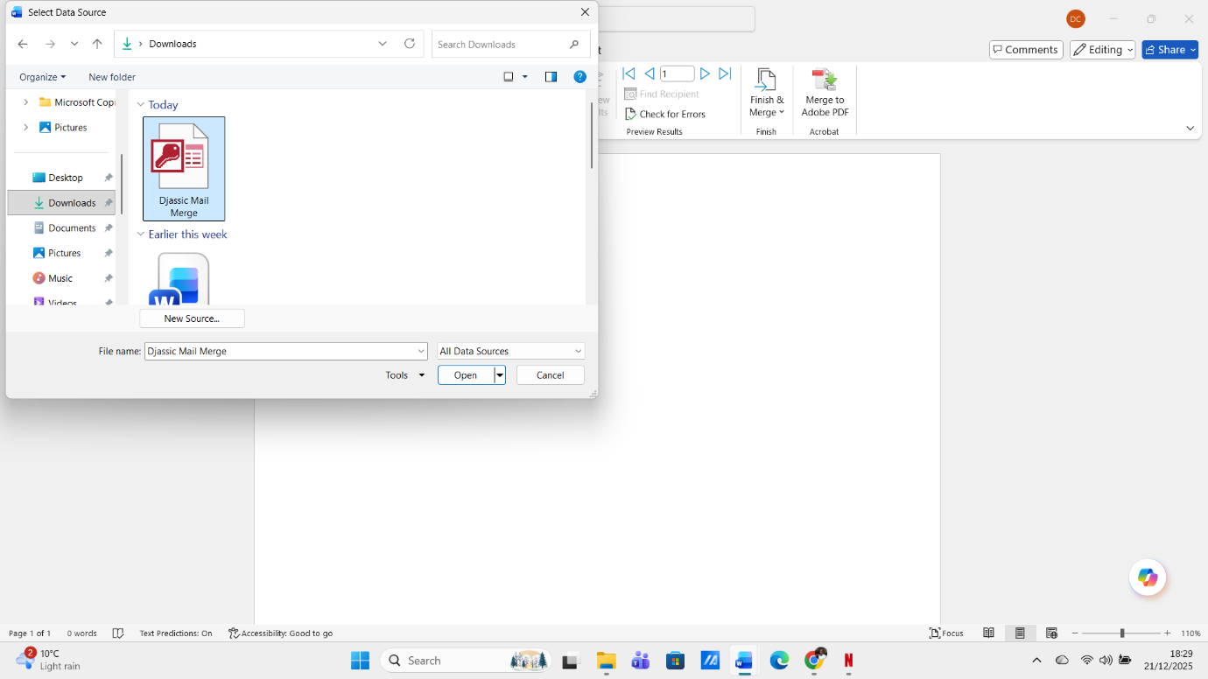
Figure 16: Save list of recipients
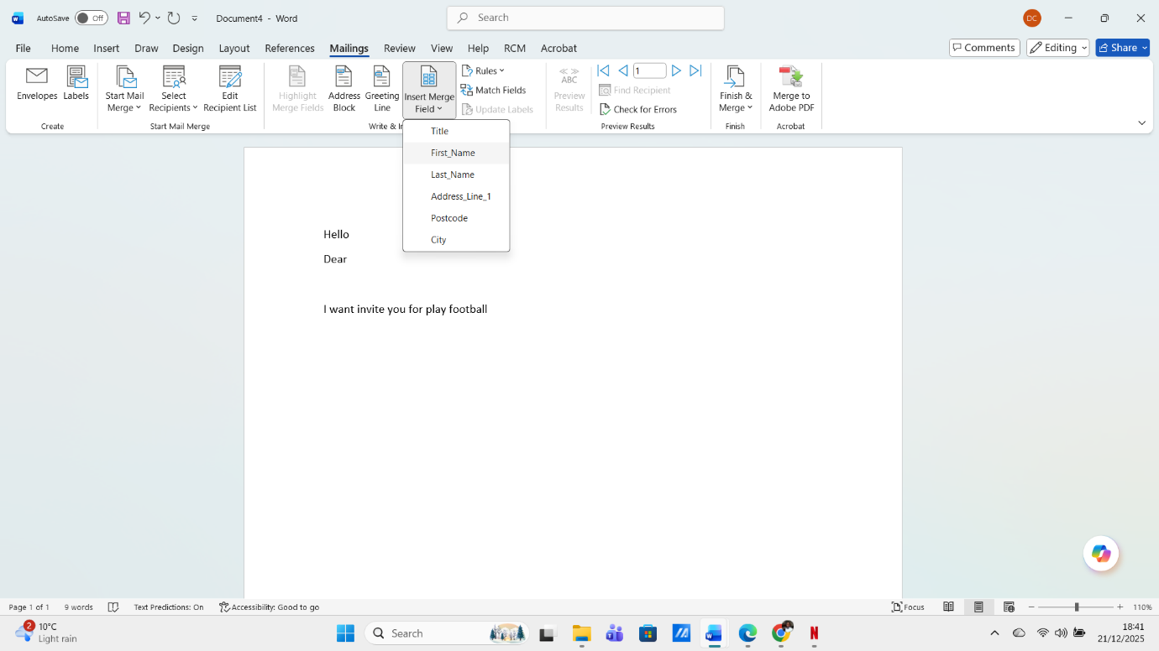
Figure 17: Insert Merge Fiel

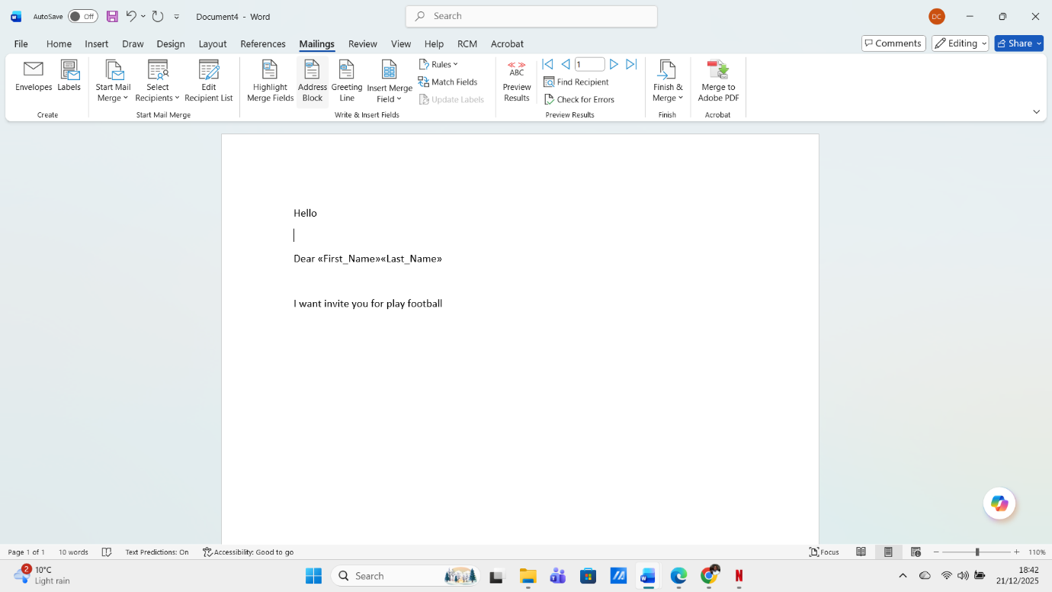
Figure 18: Merge Field Name And Last Name
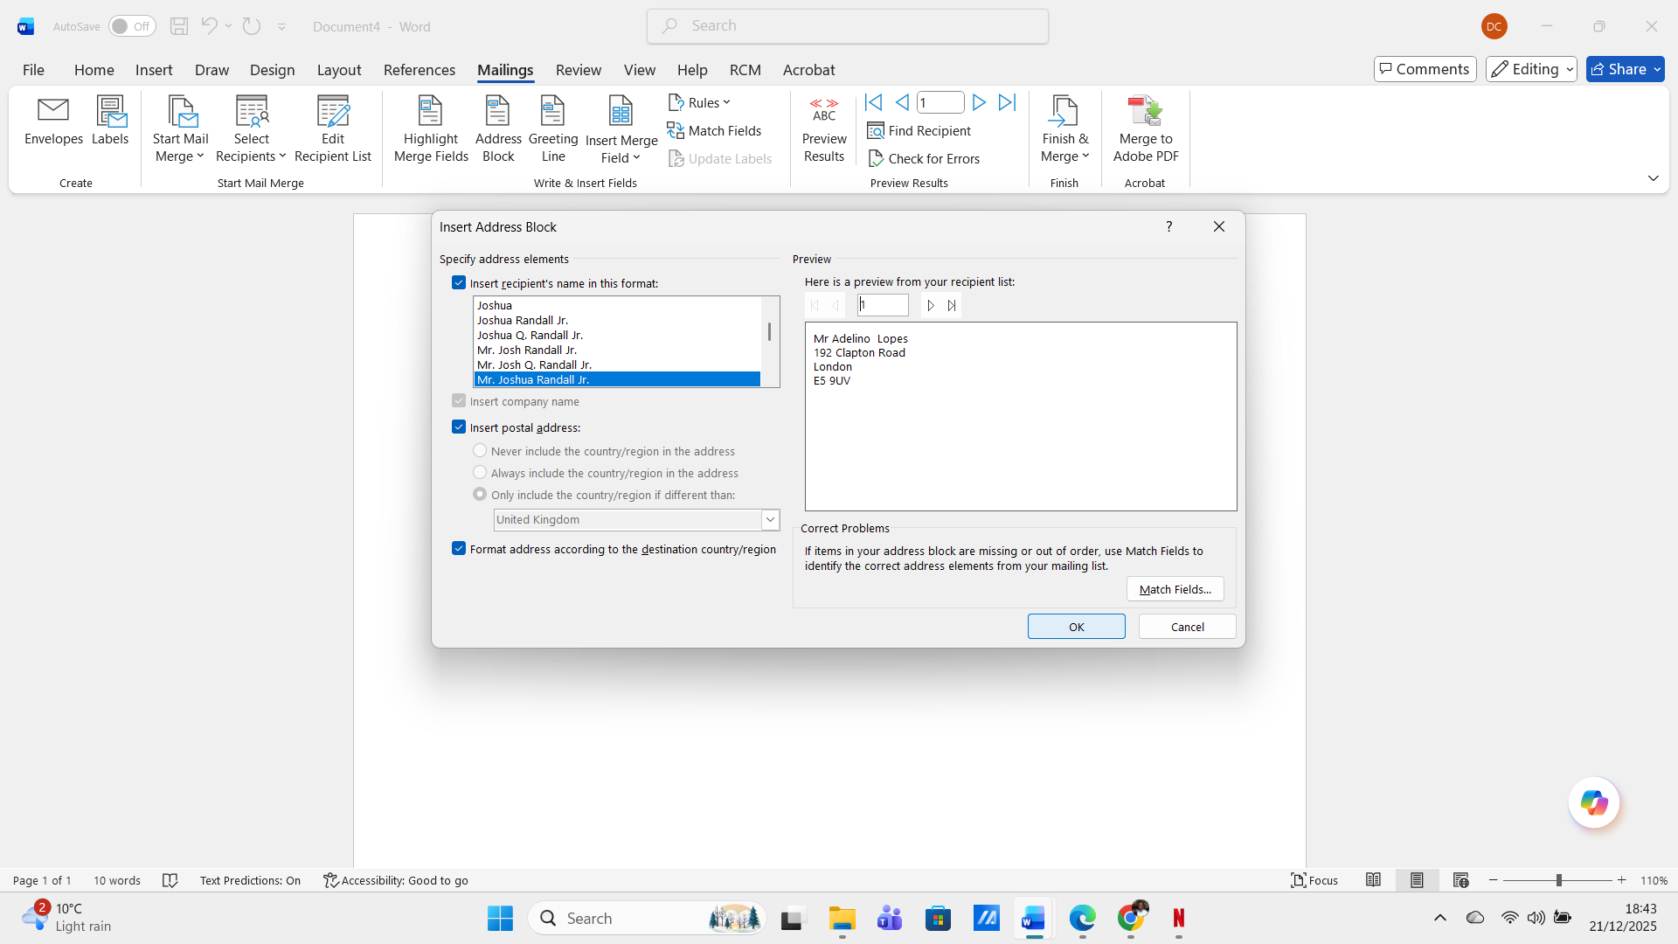
Figure 19: Address Block

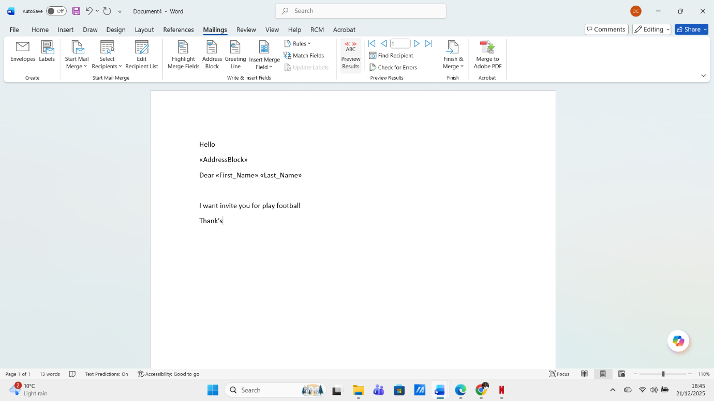
Figure 20: Address Block inserted
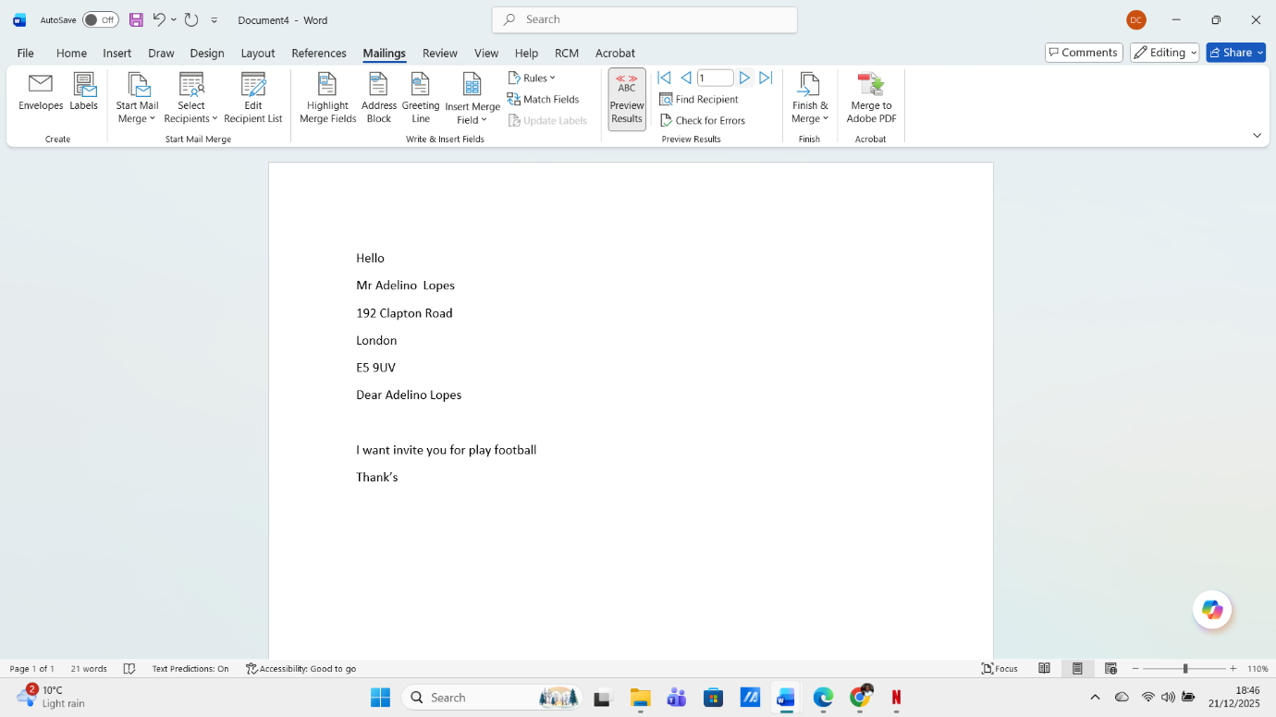
Figure 21: Preview Letter with Mail Merge

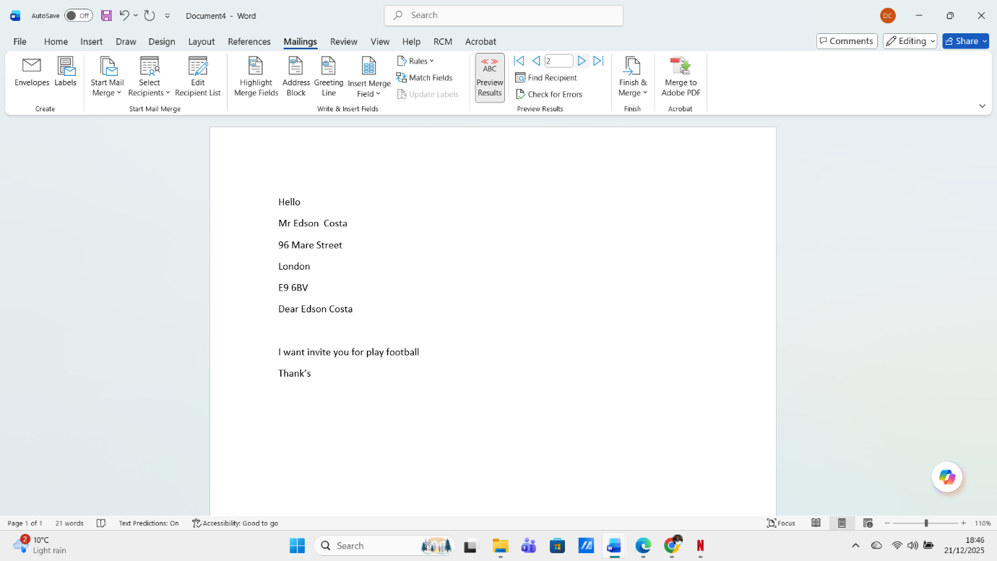
Figure 22: Preview others Recipients
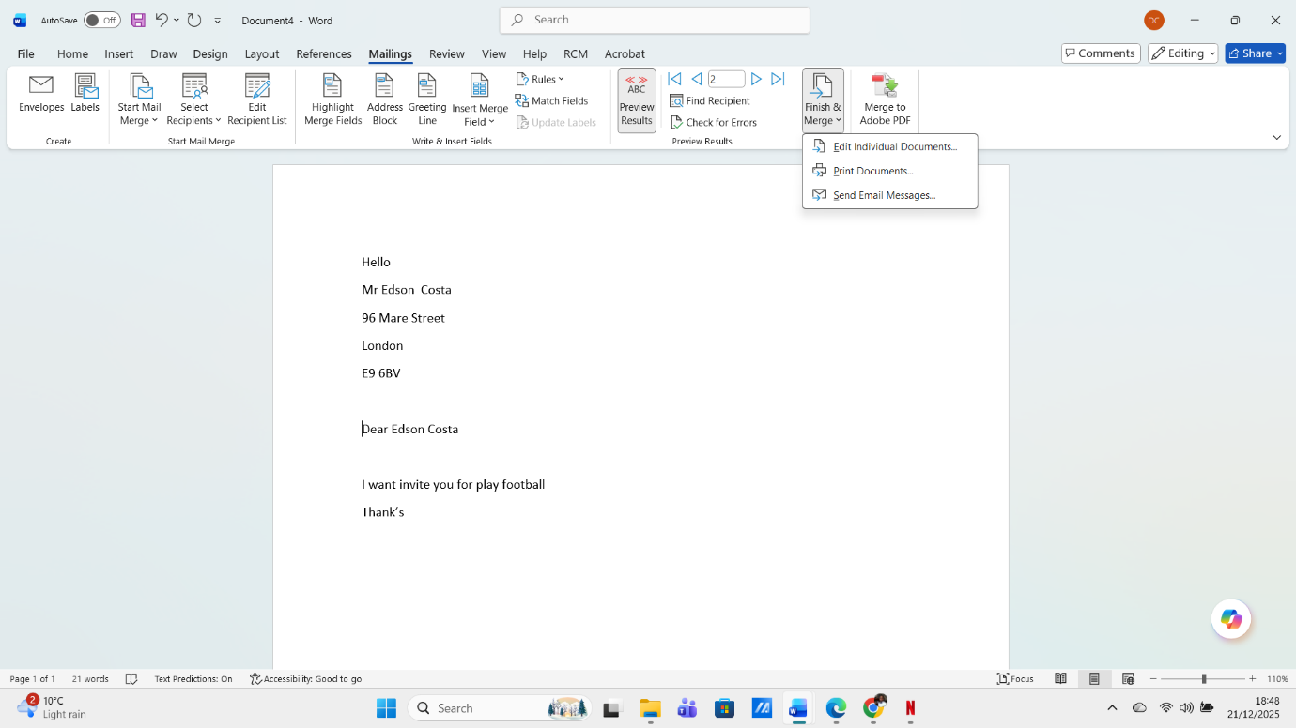
Figure 23: Finishing Mail Merge And Send or Printed

Mail merge is a tool that can be found in most word processing and data applications, and with it, you can send letters or important documents with the same content to multiple recipients.

Pivot Table

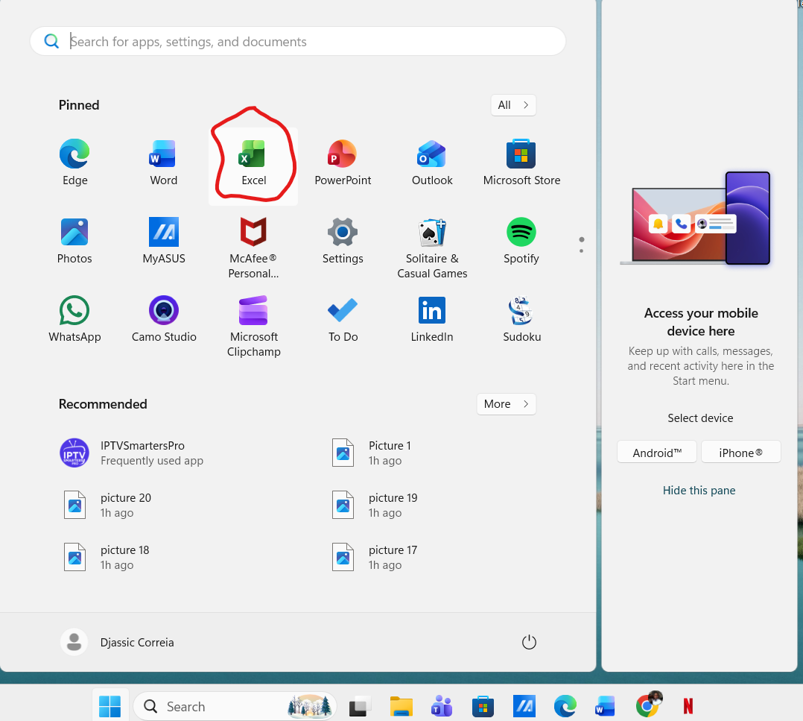

Figure 24: find Excell in Pc
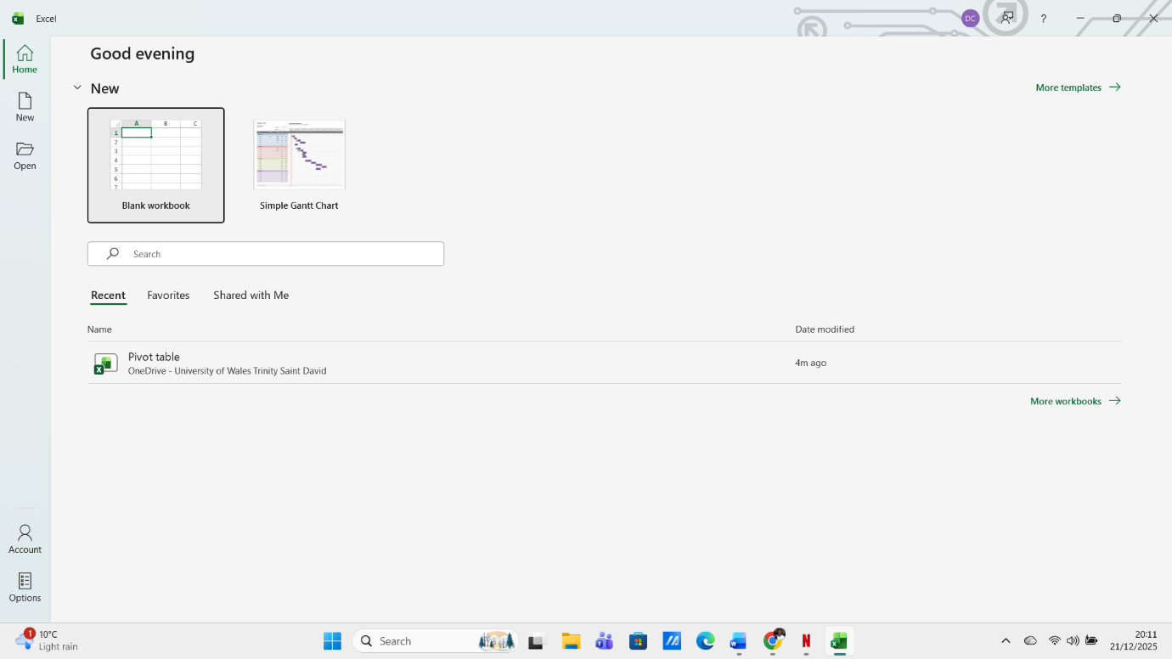
Figure 25: Open Blank page

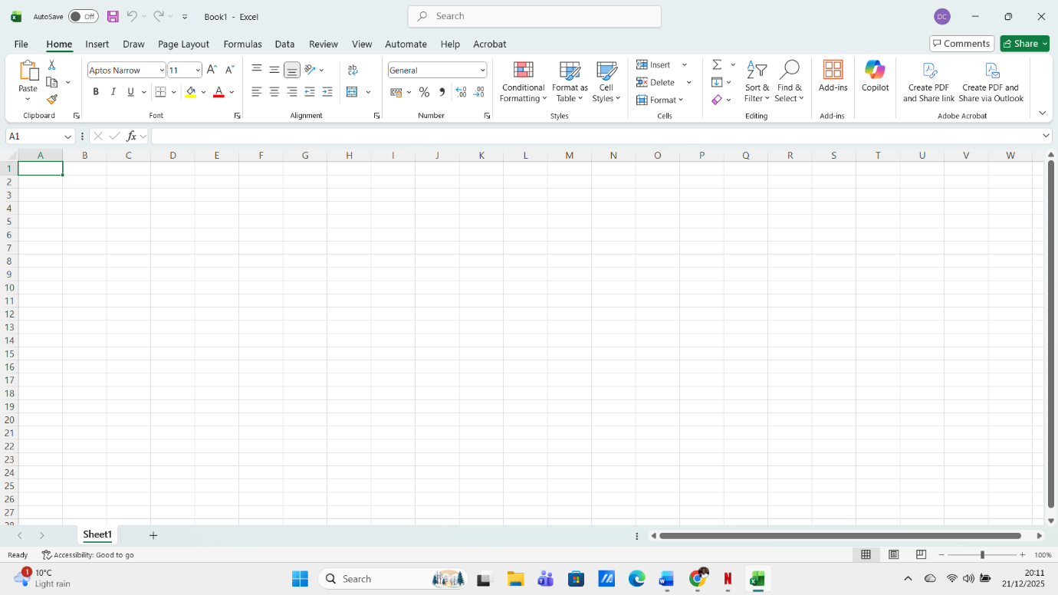
Figure 26: Blank page opened
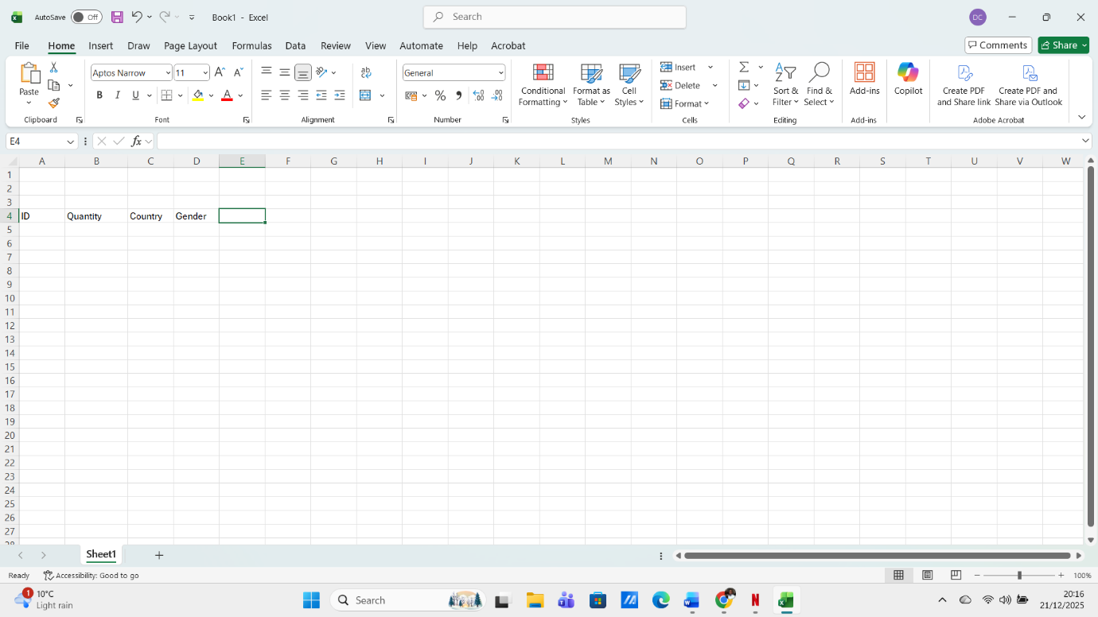
Figure 27: Enter data

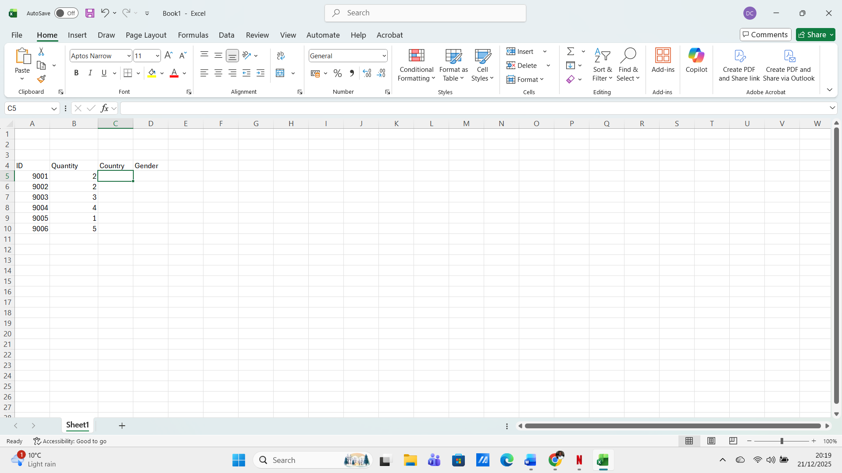
Figure 28
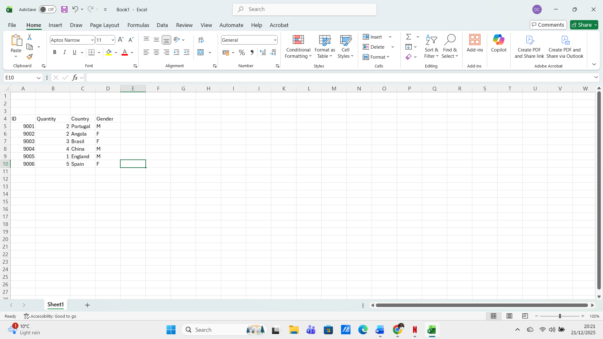
Figure 29:

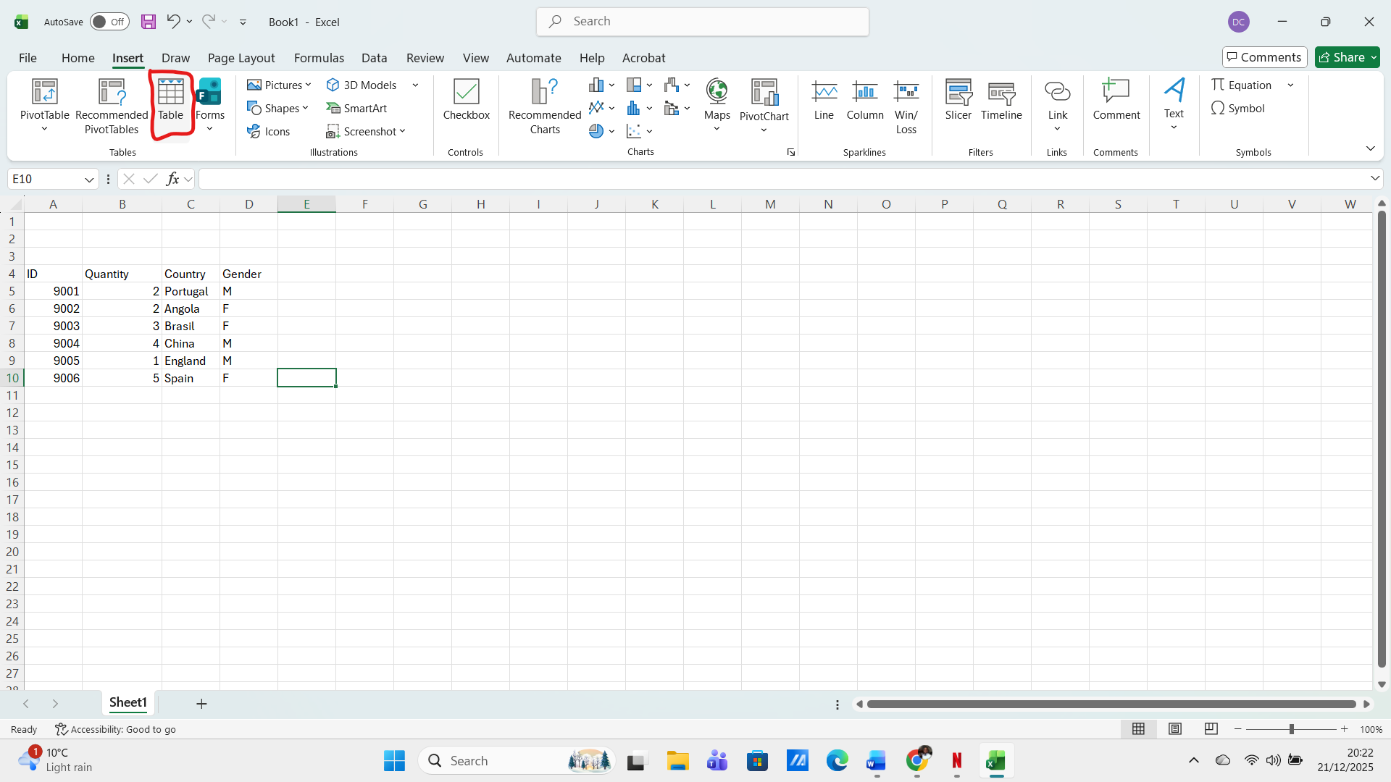

Figure 30:
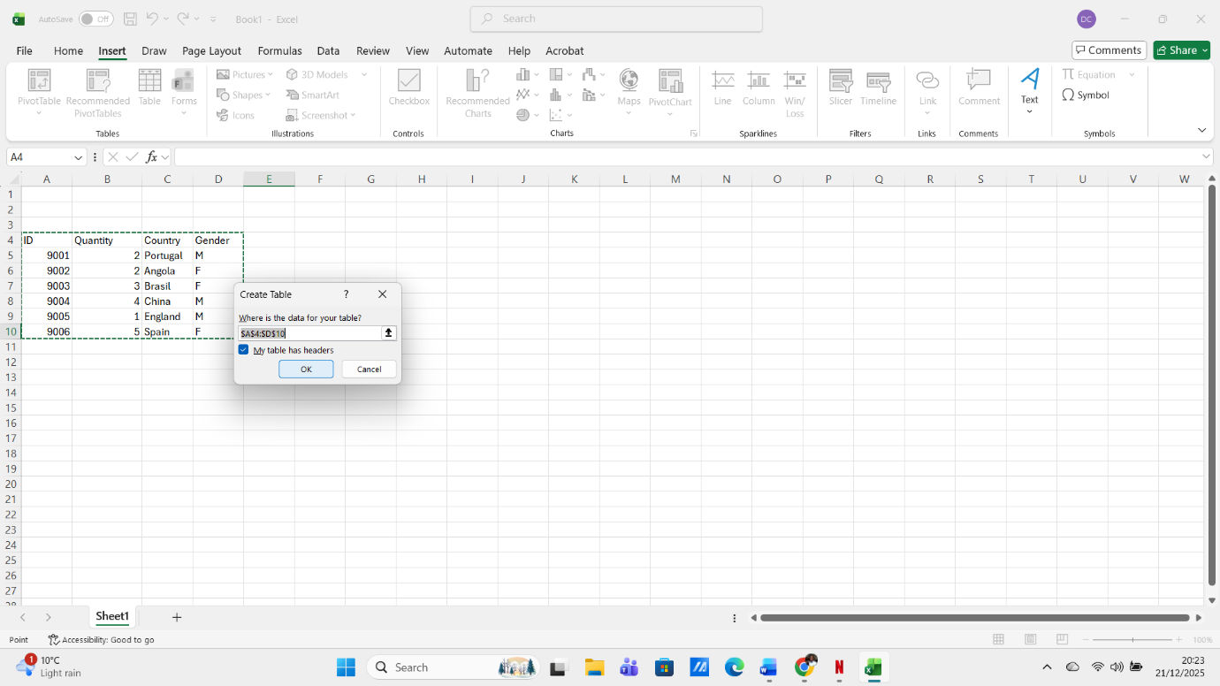
Figure 31: insert columns

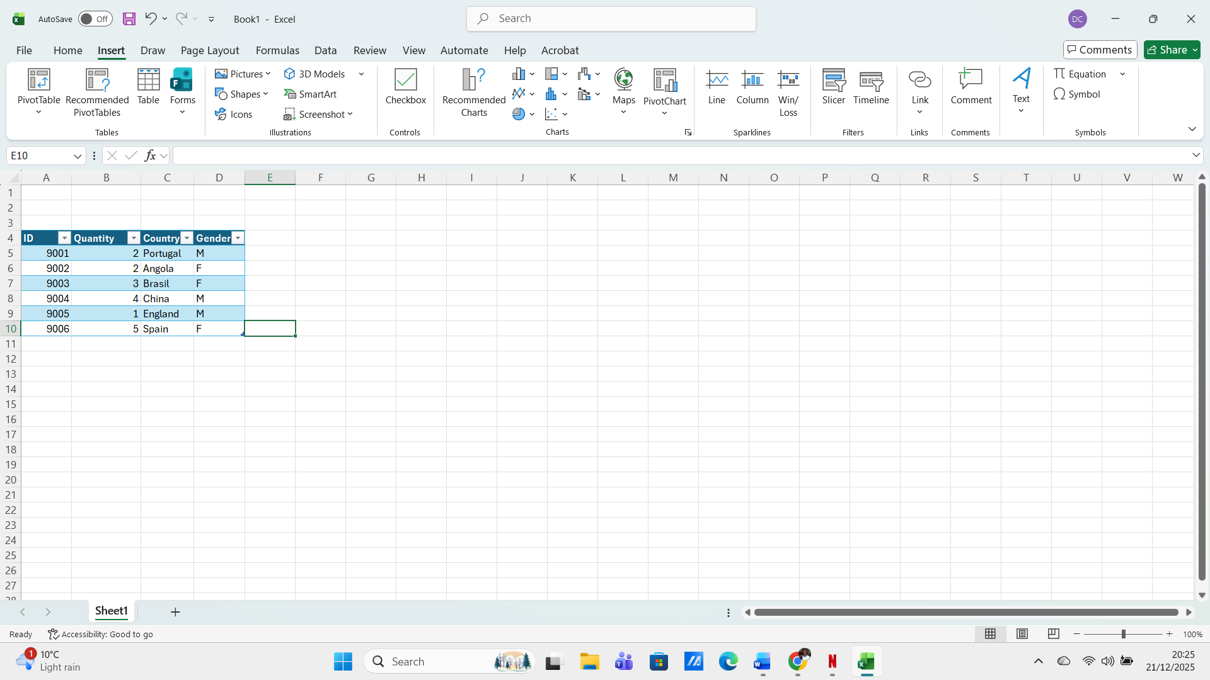
Figure 32: inserted columns
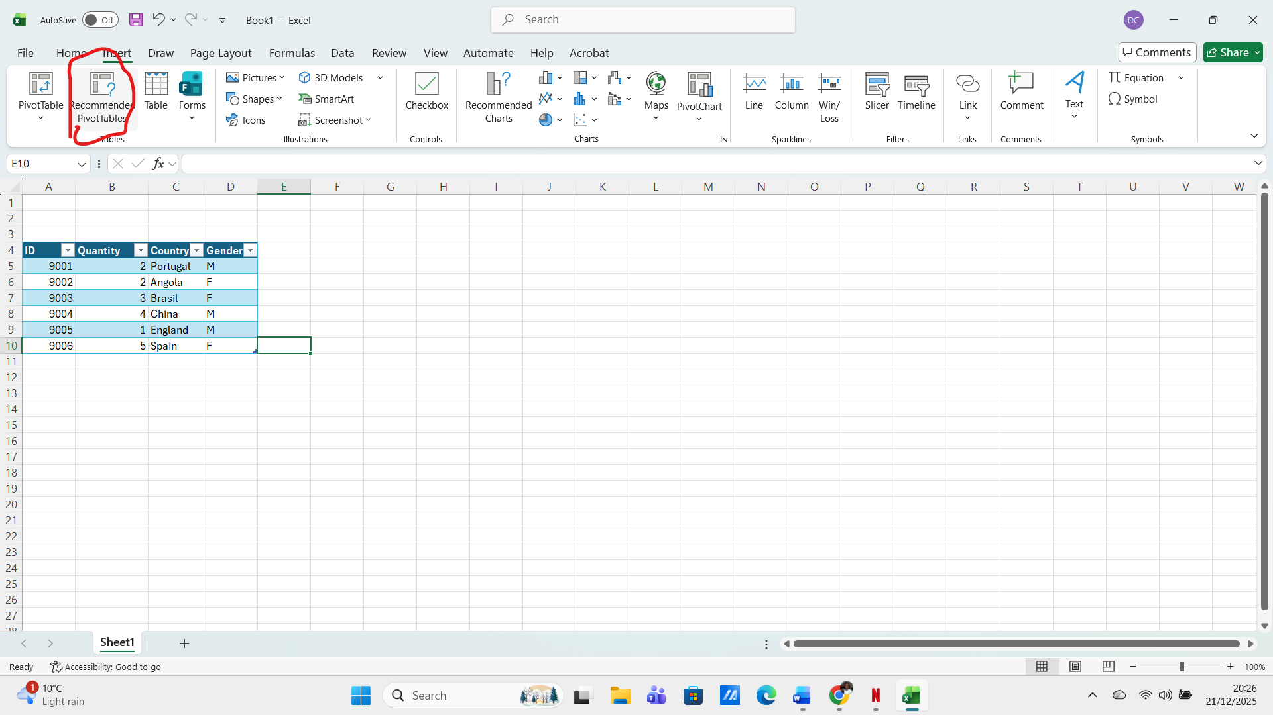
Figure 33: start creation of Pivot Tables.

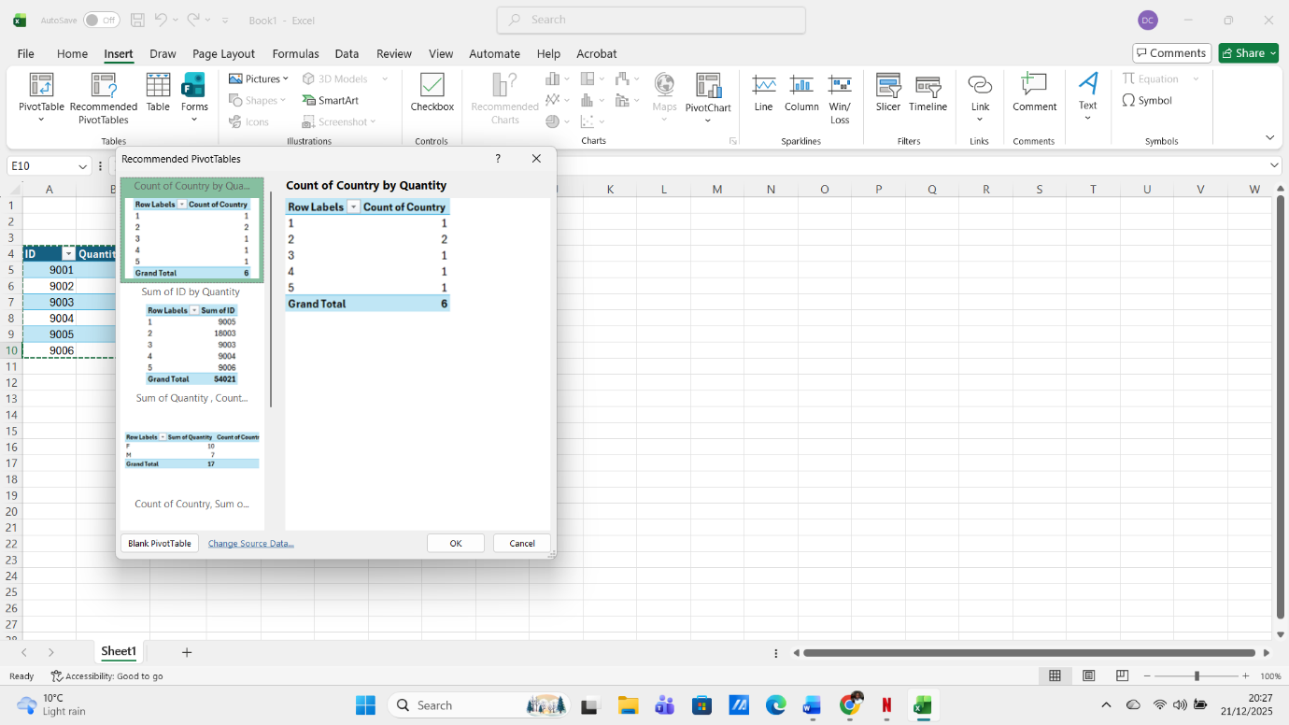
Figure 34: Choose which one I want to use
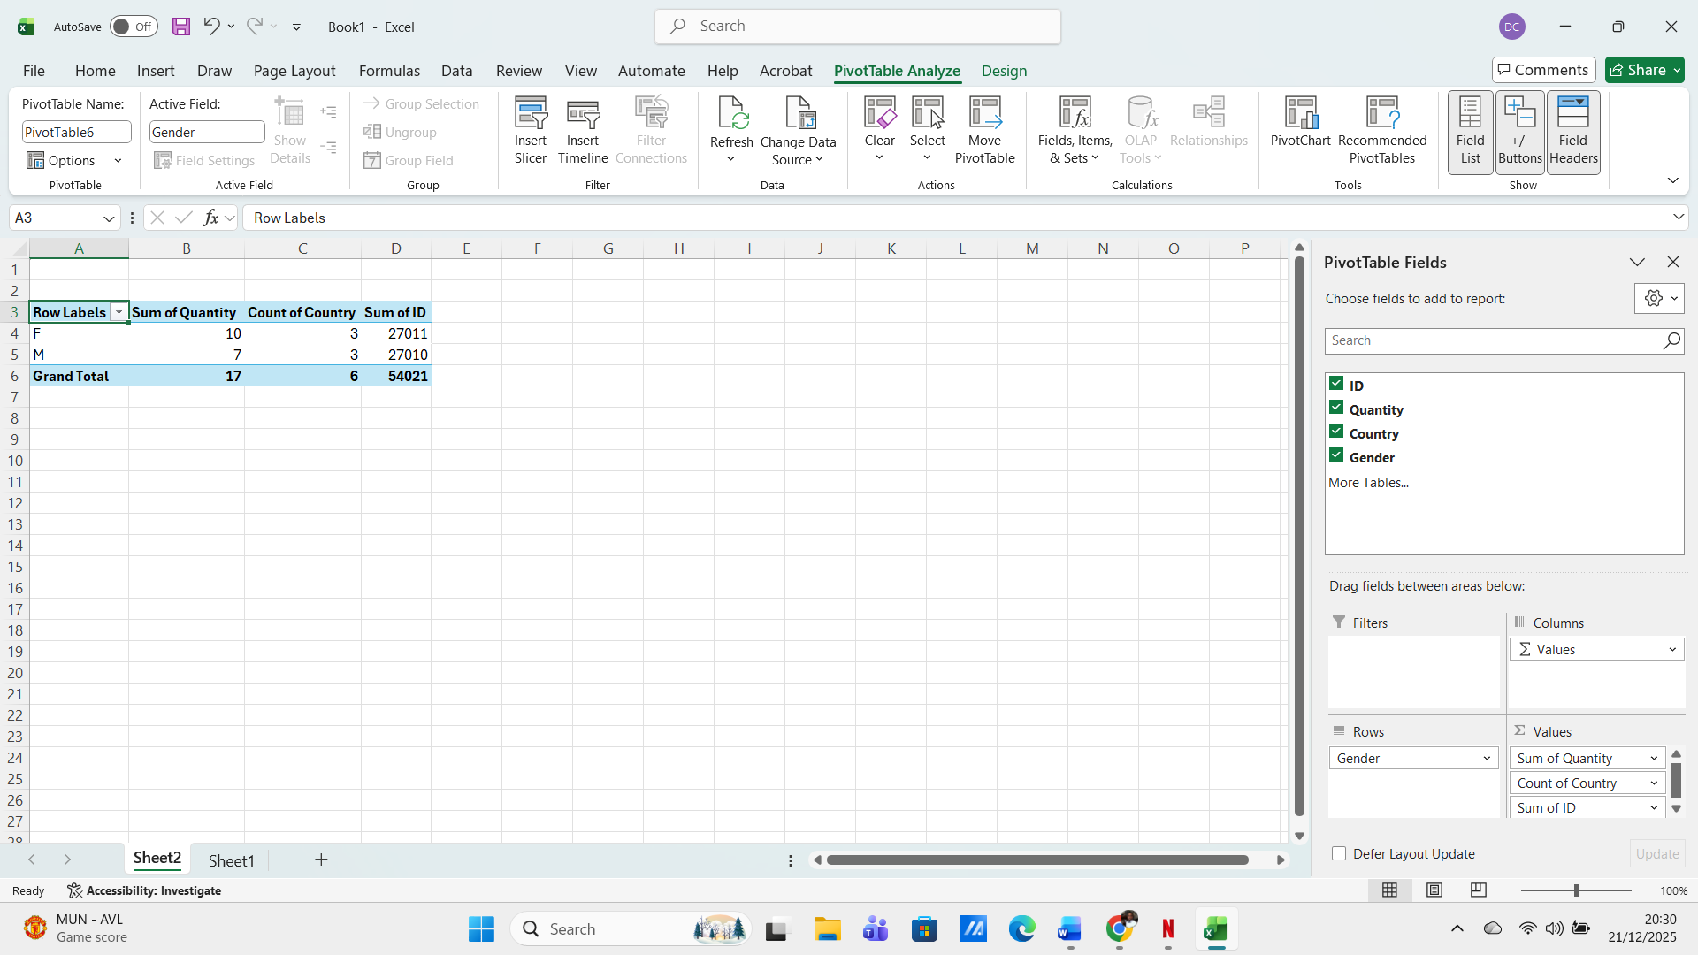
Figure 35: Pivot Tables created

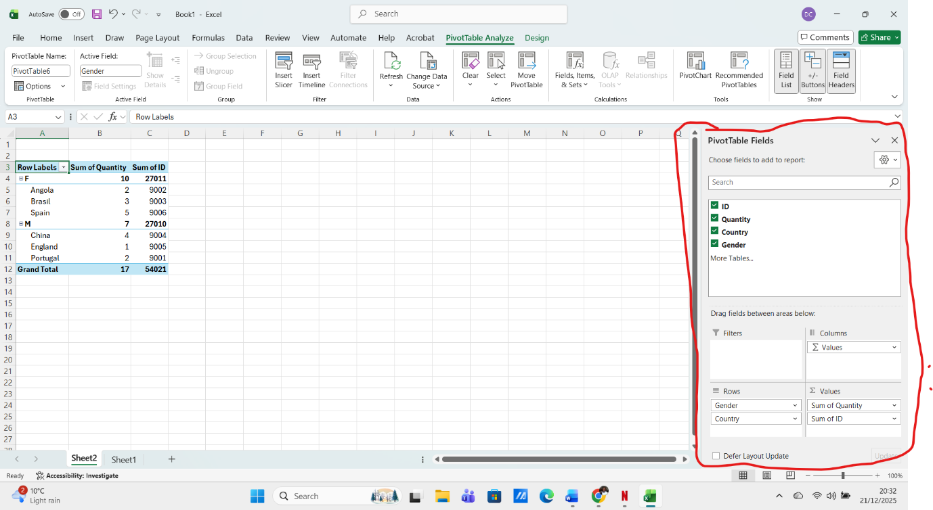
Figure 36: I can chose fields I want to add
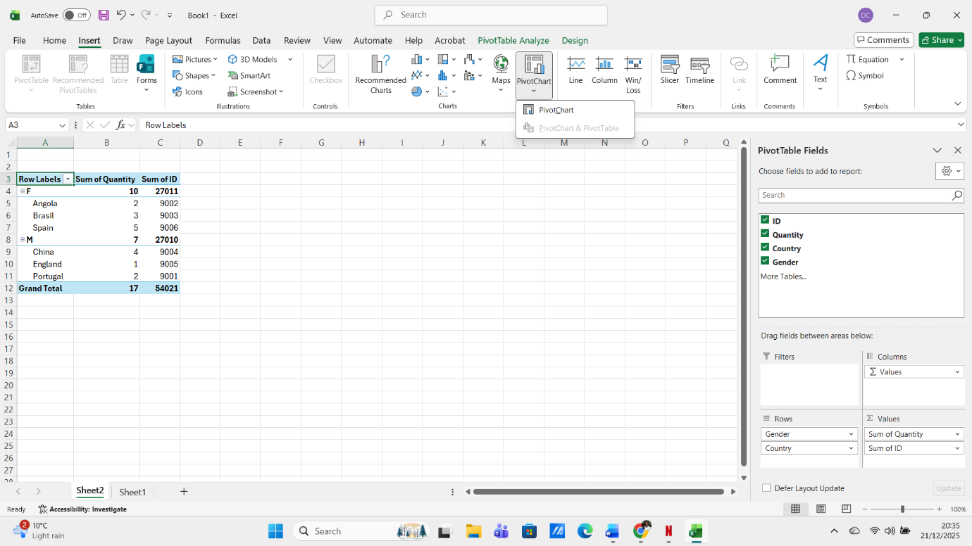
Figure 37:

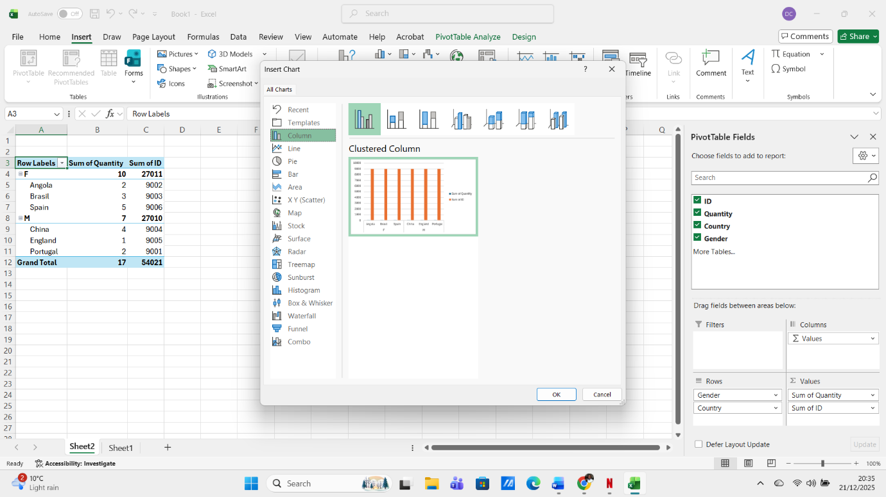
Figure 38: insert Chart
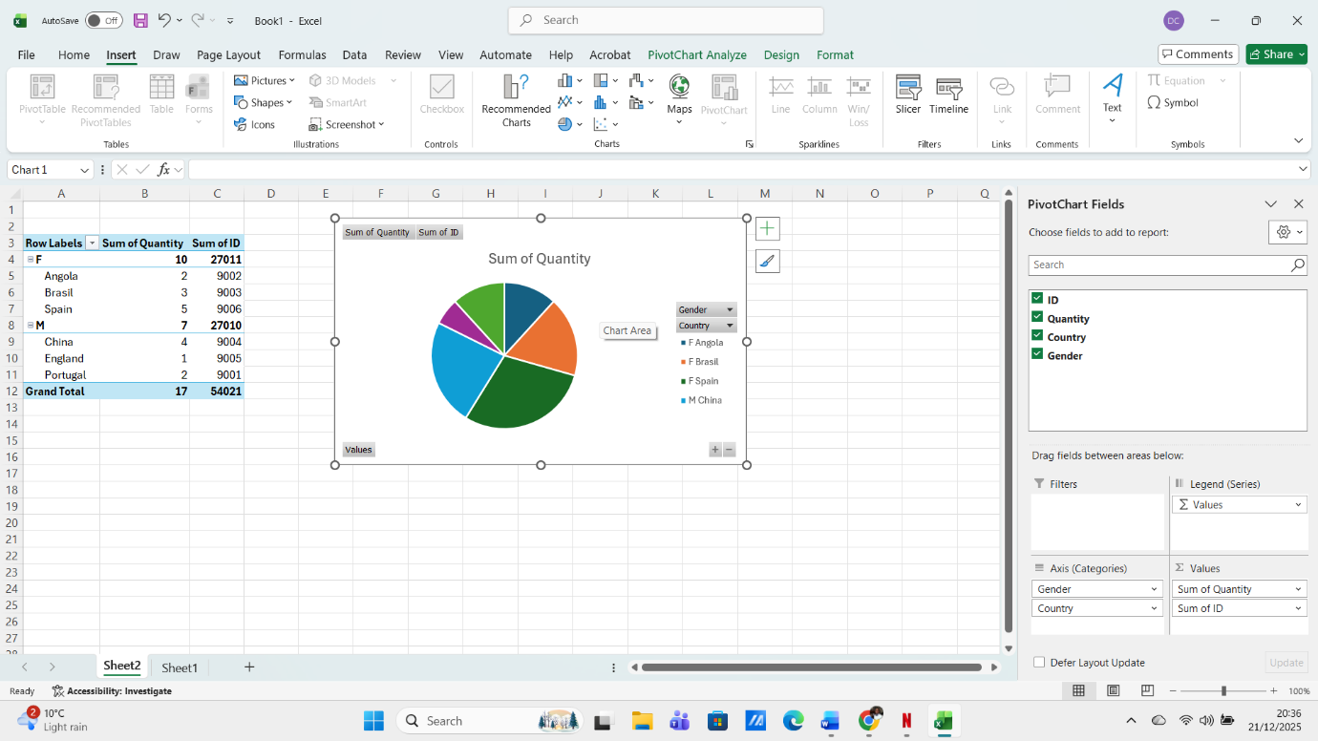
Figure 39: Chart inserted

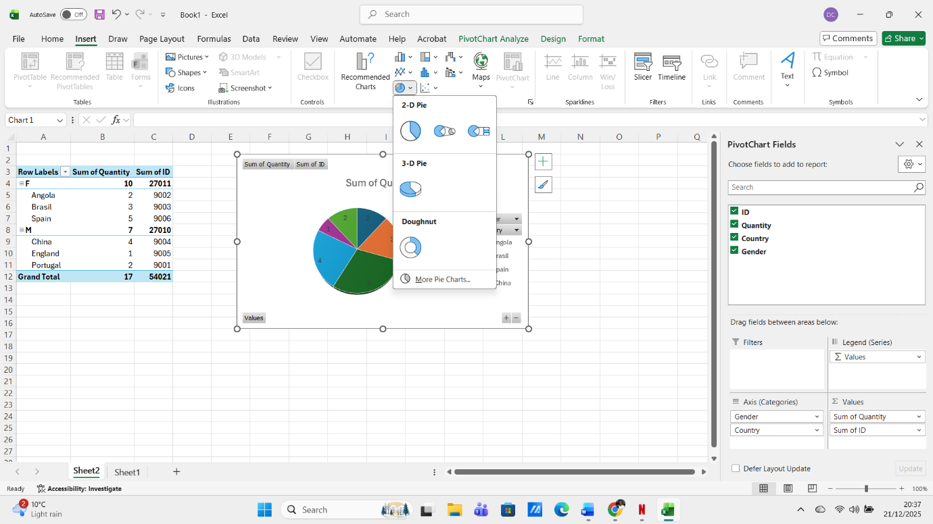
Figure 40: Add Pie, you can chose 2-D Pie or 3-D Pie

A pivot table takes a specific data field and converts the header of each column into a data option that can be easily manipulated by the user; columns containing data can be removed, added or moved within the table with ease, with pivot tables, you can handle large amounts of data at once, these tables allow you to traverse thousands of data points and consolidate the information into simple results [10].

Task 4

Communication and Collaboration applications

Microsoft Teams
Microsoft Teams is a cloud-based collaboration platform designed to bring teams together, regardless of their location, serving as a central hub and simplifying communication, collaboration and information sharing, making it easier for teams to work together in real time, whether in a chat or holding video meetings, sharing files or integrating with other Microsoft applications.
Microsoft Teams serves as an all-in-one shared workspace that meets all your employees' collaboration and communication needs; its collaboration capabilities boost productivity and team dynamics by shifting focus from traditional meetings to more collaborative workflows. These are the main benefits of using collaboration features, mobility, real time communication, easy scheduling, seamless integration, enhanced security.
In today's increasingly remote and distributed work environment, Microsoft Teams stands out as a powerful tool that bridges the physical distance of effective collaboration, with its robust set of features, Teams ensures that remote workers remain connected, productive and engaged, regardless of where they are located. One of the most notable benefits of Microsoft Teams for remote work is its ability to facilitate virtual meetings. Teams users can host virtual meetings with up to 10,000 participants, making it an ideal solution for large-scale webinars, company-wide meetings and client presentations. Advanced meeting features, such as real-time captions, transcription and recording, enhance the meeting experience, ensuring that all participants can follow and review the content as needed [11].
The Microsoft Teams application is available on multiple platforms, including Windows, macOS, iOS and Android, ensuring that teams can stay connected and collaborate effectively, regardless of device or location. With Microsoft Teams Premium, users have access to enhanced features such as advanced meeting protection, AI-powered summaries and personalised insights, further increasing productivity and security.
Microsoft Teams has evolved to become one of the most powerful collaboration tools available today, offering a comprehensive set of features that enhance communication, teamwork and productivity, from team channels and group chats to advanced meeting capabilities and Microsoft Teams Rooms, the platform serves businesses of all sizes, ensuring seamless collaboration in remote and hybrid work environments, with its continuous updates including Teams Premium, enhanced security and AI-supported meeting summaries Microsoft Teams remains at the forefront of digital workplace solutions, whether you are hosting a meeting on Teams, managing meeting participants or integrating with other Microsoft applications, the platform provides the flexibility and functionality needed for modern businesses to thrive [12].

SharePoint
SharePoint is a Microsoft web application that allows you to store and organise any content and information, including documents, images, videos, news, links, data lists, web pages and tasks [13].
Microsoft SharePoint helps teams store and manage information more efficiently through a robust collaboration system. With Microsoft 365 integration, this platform facilitates teamwork by allowing users to work on content together in real time and control document versions while adding automation to improve efficiency. People can work together securely from any device through SharePoint. Key points how is work is, document management, collaboration, integration, workflows, security and access control and customisation.
Microsoft SharePoint offers numerous benefits, like improved collaboration, enhanced productivity, efficient document management, centralised information repository, effective team sites, flexible work environment, enhanced security, business process automation, improved Decision making and integration with Microsoft Tools.
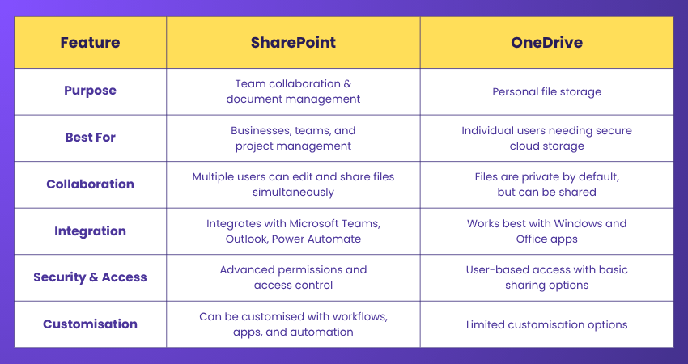
Figure 41: from The Knowledge Academy [14].

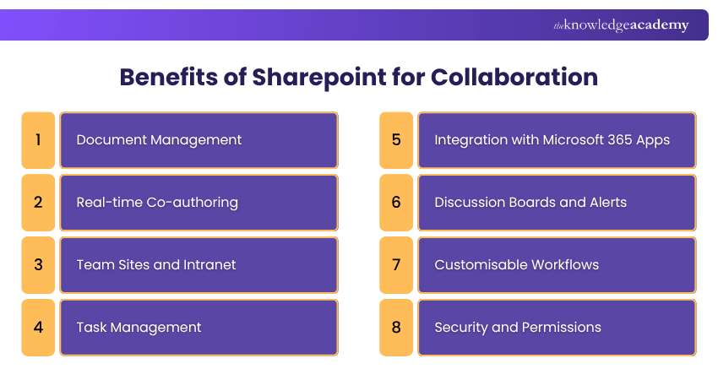
Figure 42: from The Knowledge Academy [14].

Microsoft SharePoint is a robust platform aimed at boosting collaboration, document management, and workflow automation within organisations, whether utilised for file storage, team collaboration, or integration with other Microsoft 365 tools, SharePoint provides a versatile solution that caters to diverse business needs, Its various deployment options, customisation capabilities, and seamless integration features can greatly enhance productivity, security, and overall organisational efficiency [14].

Teams Practical use

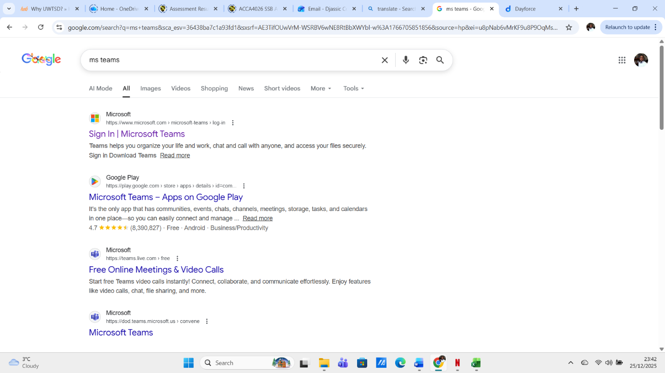
Figure 43: Search for Teams in Google

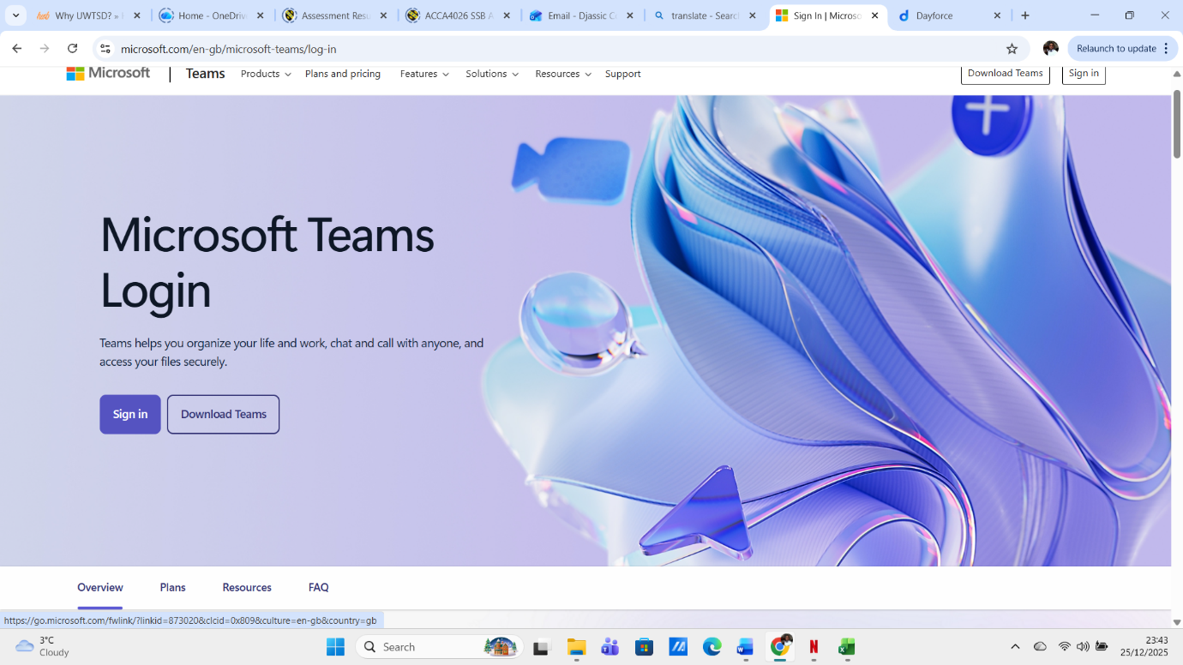
Figure 44: Teams
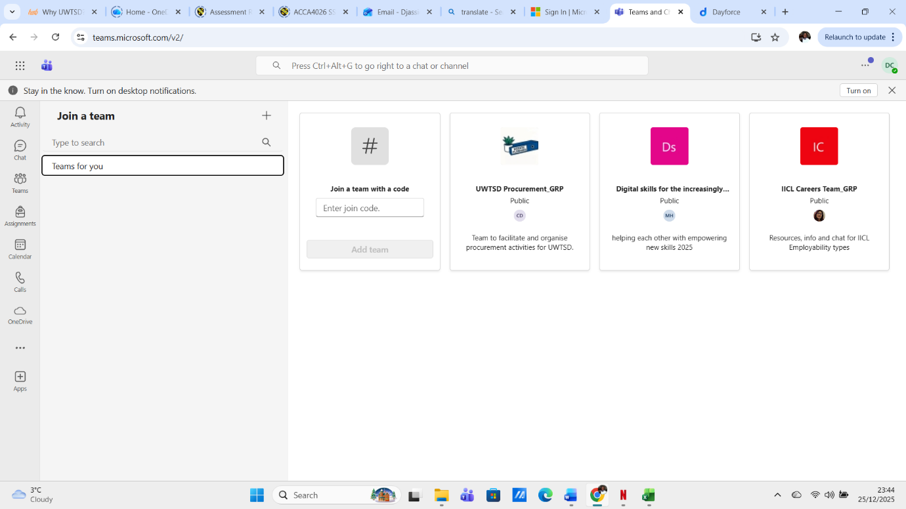
Figure 45:

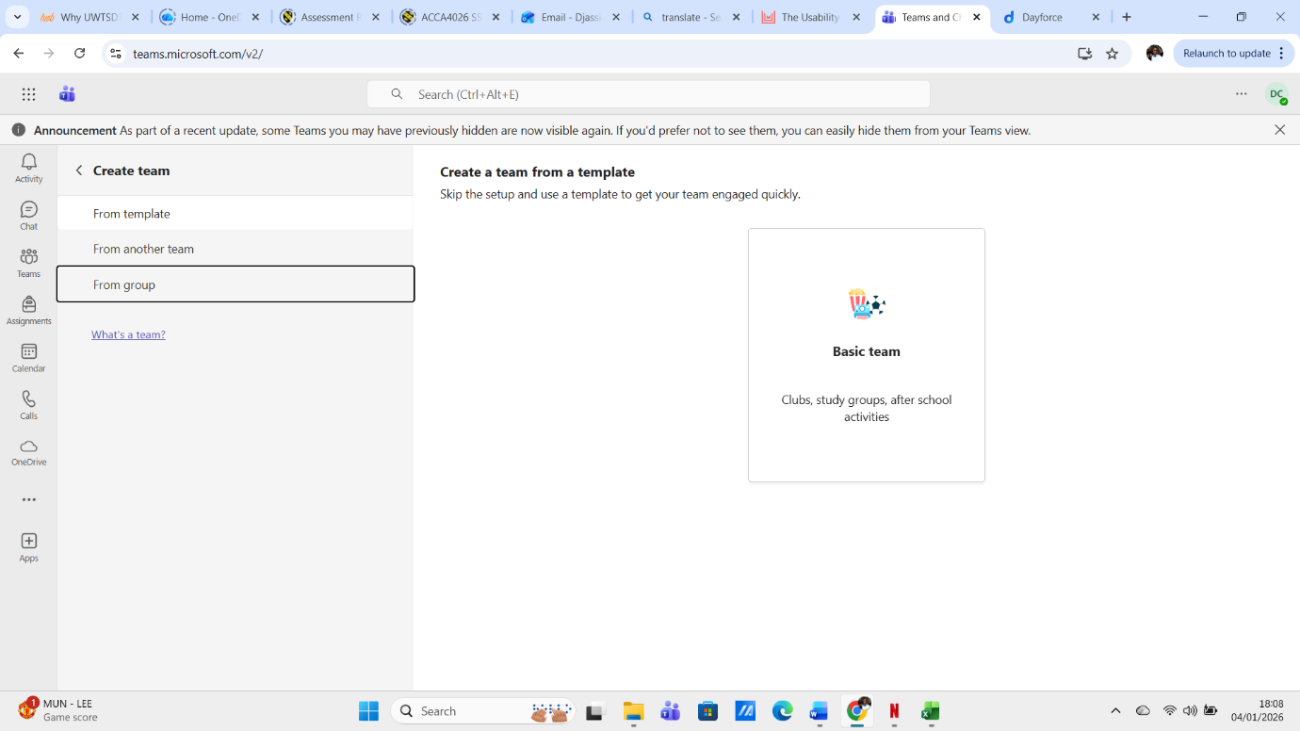
Figure 46: Created channel
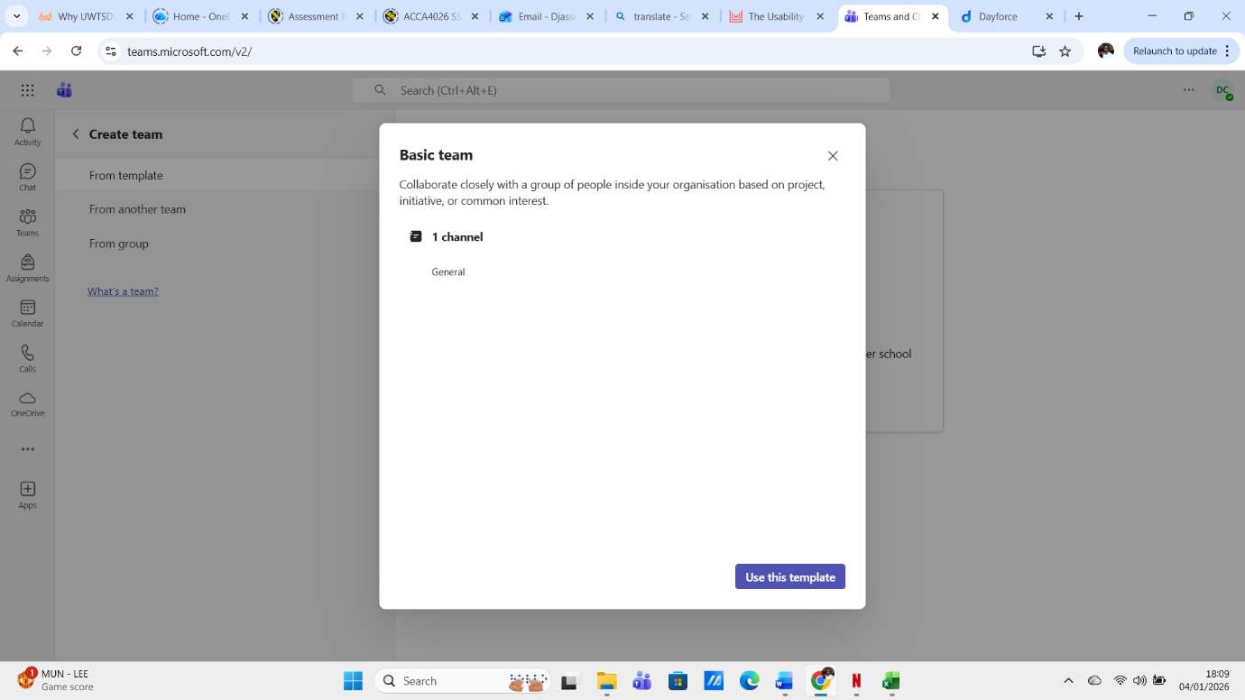
Figure 47:

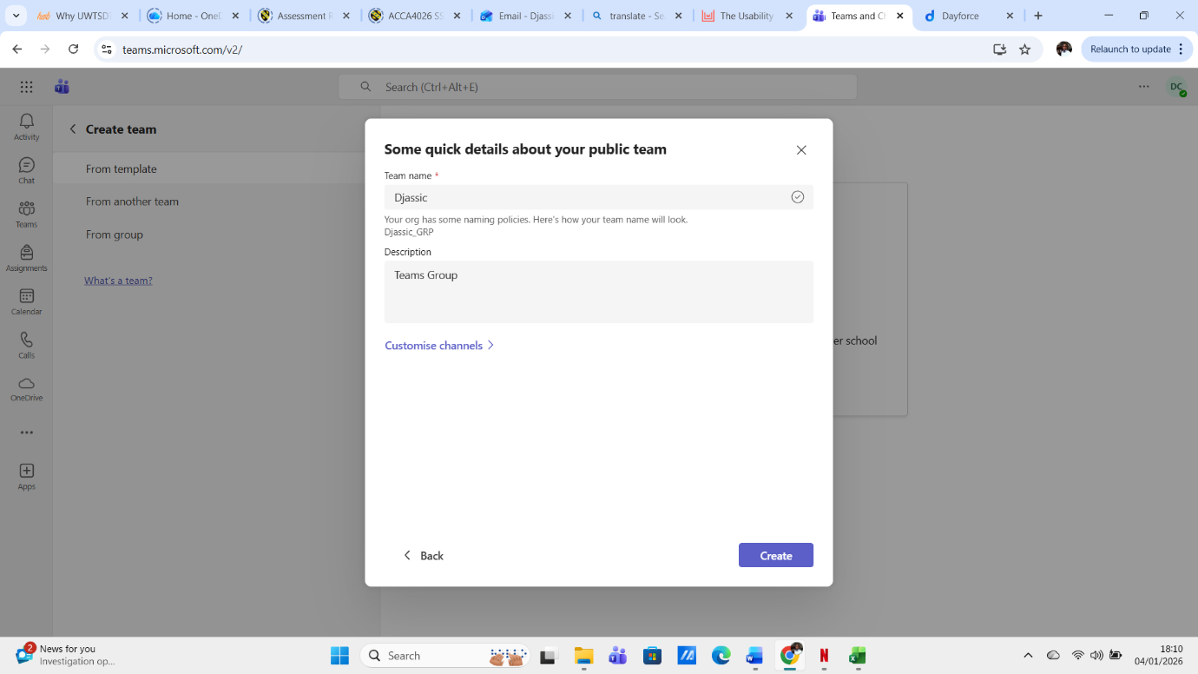
Figure 48: Details about team

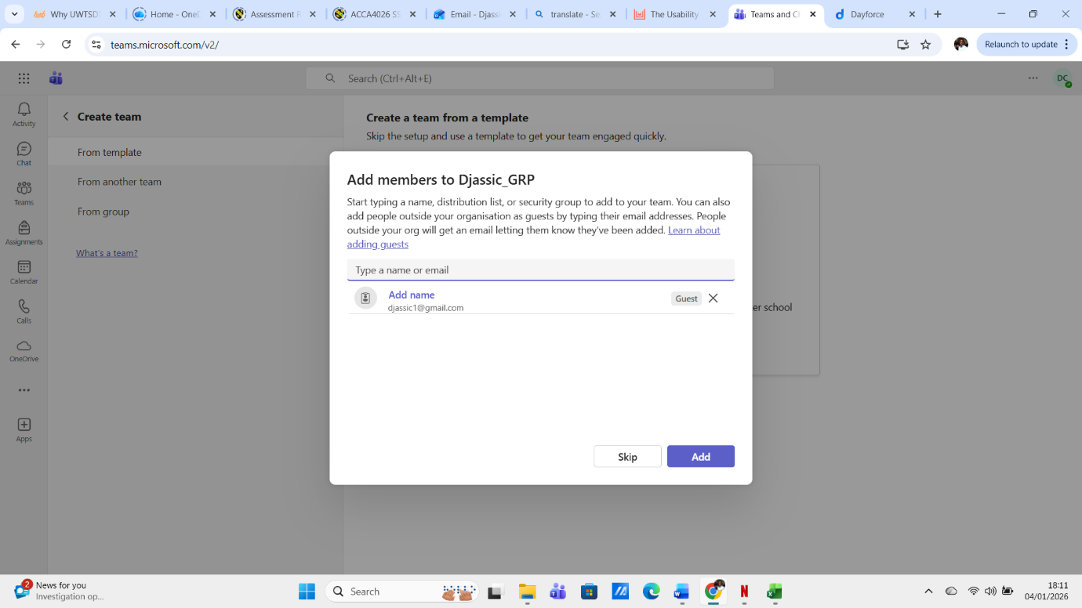
Figure 49: Add members

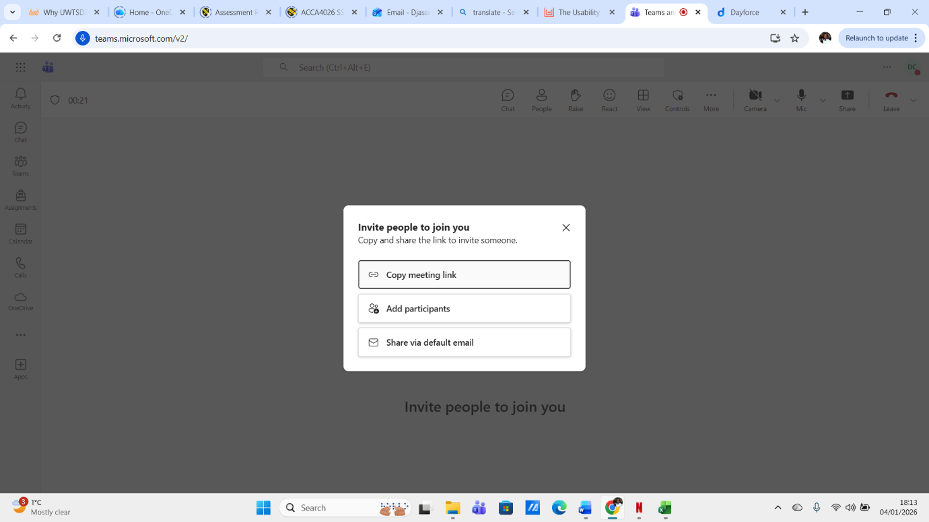
Figure 50: Invite People to join meeting

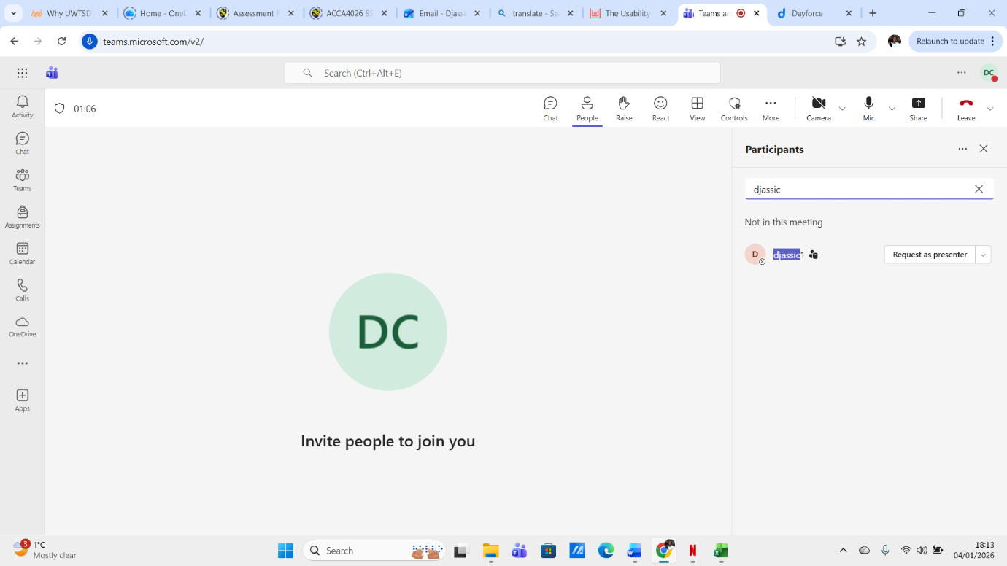
Figure 51: Add participants

Microsoft Teams has emerged as a leading collaboration platform due to its usability, driven by its integration with Microsoft 365, user-friendly interface, powerful collaboration features, and strong security measures. As organisations continue to embrace remote and hybrid work models, the platform’s usability will play a crucial role in its sustained success, whether you’re a small business or a large enterprise, Microsoft Teams offers a flexible, reliable, and secure platform to keep your team connected and productive. The statistics and references cited in this blog underscore its effectiveness in improving workplace collaboration and efficiency [15].

SharePoint Practical use

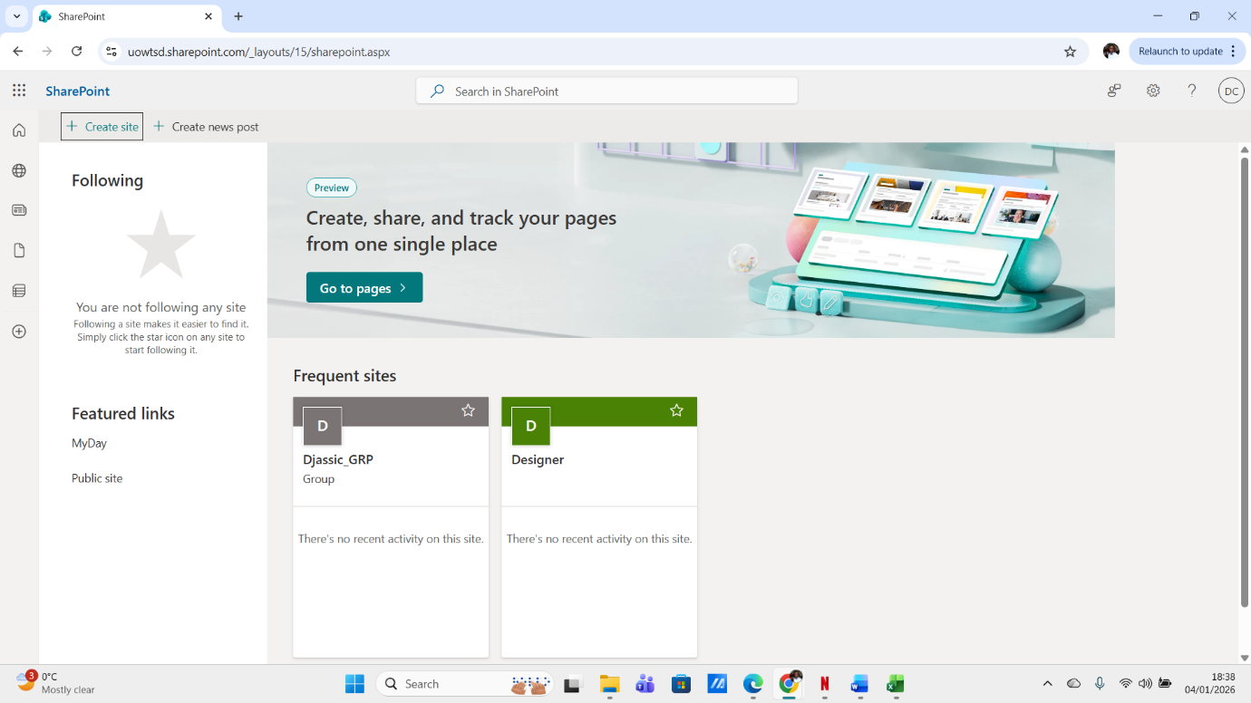
Figure 52: SharePoint Web

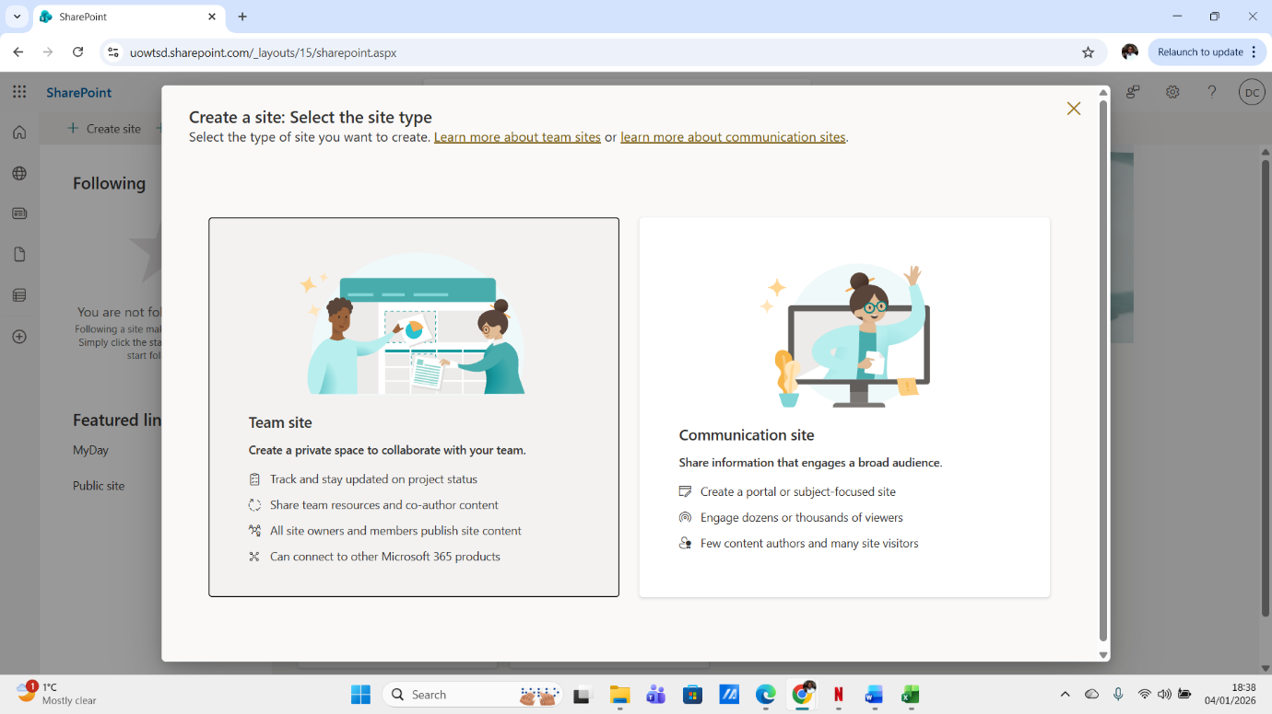
Figure 53: Create Site
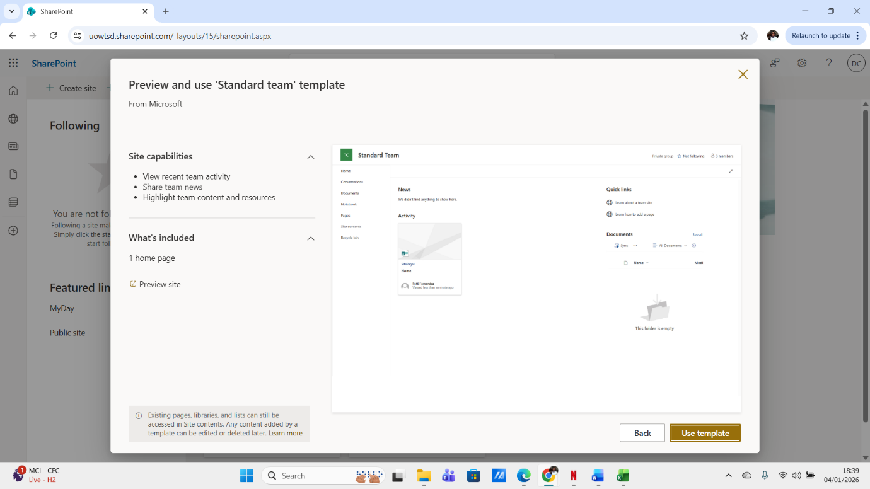
Figure 54:

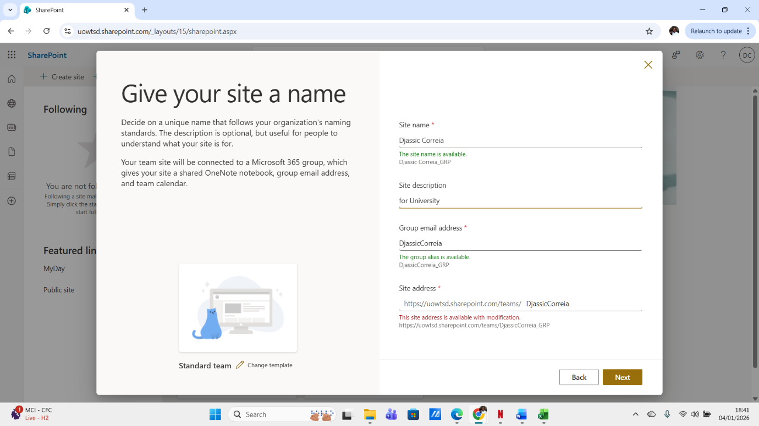
Figure 55: Details about Site

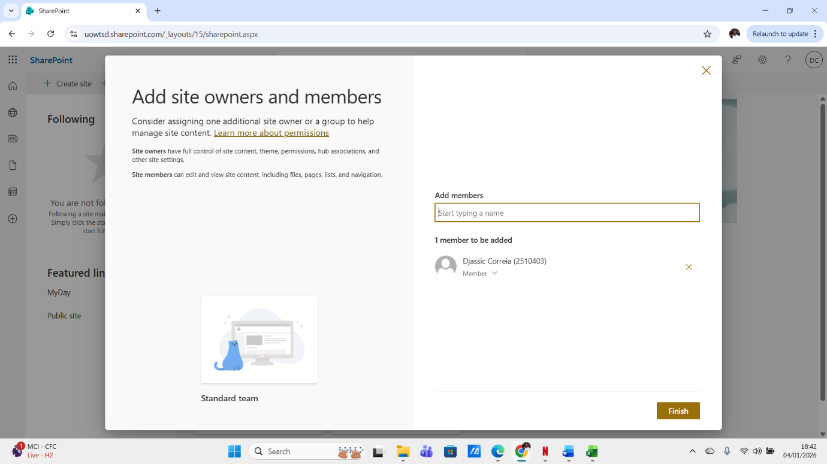
Figure 56: Add members

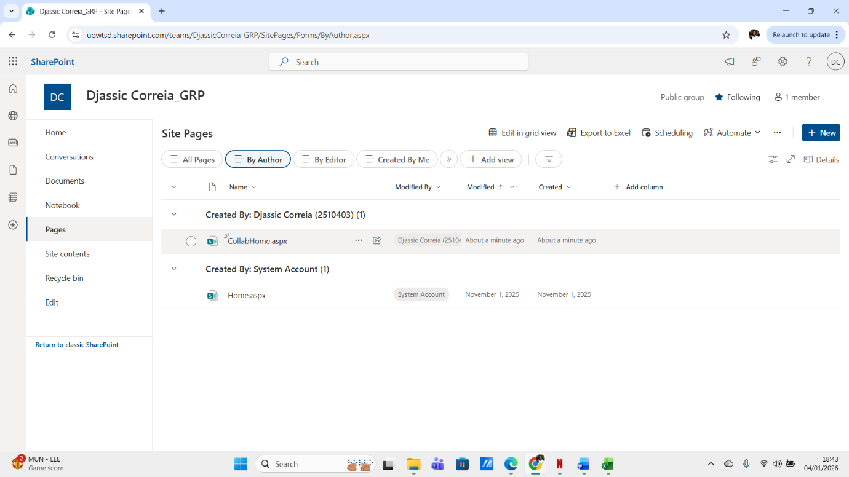
Figure 57:
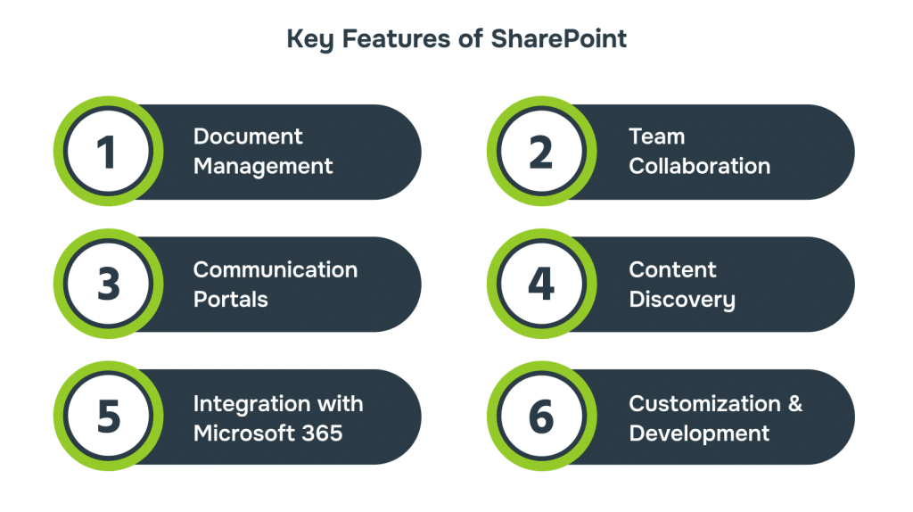
Figure 58: From Alberton [16].
SharePoint has evolved into more than just a document management system, it’s a powerful, flexible platform that brings people, content, and processes together, from centralising resources to enabling seamless collaboration, it plays a vital role in boosting productivity and supporting hybrid work environments, for businesses looking to scale, improve efficiency and stay competitive [16].

Conclusion

This work helped me understand more about Microsoft Office, where I discovered many features of Microsoft Office, such as learning to use the tools of MS Word, MS PowerPoint, MS Access, MS Excel, MS Teams, SharePoint, OneDrive and much more. The practice in the lessons made it easier to complete this work, and now with what I have learned so far and what I will discover more about Microsoft Office, it will help me improve further for future tasks and face even fewer difficulties in upcoming assessments.
I also learned about e-commerce website builders, business software, where I learned about some software like Wix, Shopify, WooCommerce and much more. I also learned how to create a Mind map and its concept.

References

[1] | E. Shwake, “Wix,” 8 September 2023. [Online]. Available: https://www.wix.com/blog/what-is-wix.
[2] | “bling!,” [Online]. Available: https://blog.bling.com.br/wix-vantagens-desvantagens/.
[3] | P. Shah, “London Web Desingers,” 13 May 2022. [Online]. Available: https://dcpweb.co.uk/blog/what-is-woocommerce-an-introduction-to-the-best-ecommerce-platform-for-wordpress.
[4] | “Atlassian,” [Online]. Available: https://www.atlassian.com/work-management/project-management/mind-mapping.
[5] | S. Peek, “The Benefits of Mind Mapping for Busy Professionals,” Business.com.
[6] | “The Knowledge Academy,” [Online]. Available: https://www.theknowledgeacademy.com/blog/what-is-microsoft-word/.
[7] | “testbook,” [Online]. Available: https://testbook.com/computer-awareness/microsoft-powerpoint.
[8] | Alexander S. Gillis, “techtarget,” [Online]. Available: https://www.techtarget.com/searchenterprisedesktop/definition/Excel.
[9] | T. Singh, “scaleupally,” 3 September 2024. [Online]. Available: https://scaleupally.io/blog/what-is-microsoft-access-used-for/.
[10] | L. Education, “Lorman,” 6 April 2022. [Online]. Available: https://www.lorman.com/resources/the-6-benefits-of-using-a-pivot-table-in-excel-17423?srsltid=AfmBOopnFySif-OXOyXKvDyizbAv-lzD_2wJJVjKdxKHf-0XB-9TupXR.
[11] | “momentum,” [Online]. Available: https://gomomentum.com/exploring-the-benefits-of-microsoft-teams/.
[12] | “zenzero,” 7 May 2024. [Online]. Available: https://zenzero.co.uk/news/microsoft-teams-features.
[13] | G. Zelfond, sharepointmaven, 1 November 2022.
[14] | “The Knowledge Academy,” [Online]. Available: https://www.theknowledgeacademy.com/blog/what-is-microsoft-sharepoint/.
[15] | MacroView, “ MacroView,” 29 08 2024. [Online]. Available: https://macroview365.com/the-usability-of-microsoft-teams-a-comprehensive-overview/.
[16] | “alberon,” [Online]. Available: https://www.alberon.co.uk/sharepoint-benefits/.

