
Advanced Thermofluid Mechanics
Design and Analysis of Extended Surfaces

Student Name/ Student Number
Anerurin Barclay 2215833
April 7, 2025
University of Wales Trinity Saint David

Abstract

This research looks at the use of fins as extended surfaces in automobile and microprocessor cooling systems. It chronicles the history of fin technology, from early 20th-century air-cooled engines to modern high-efficiency thermal management in electric vehicles and computers. The examination focusses on how fin design advances, such as microchannel architectures and hybrid systems, improve heat dissipation, resulting in improved performance and reliability. The report also contains mathematical modelling and experimental comparisons of fin efficiency and heat loss across different materials. Using MATLAB simulations and temperature distribution graphs, the study calculates the best fin lengths for greatest thermal efficiency, providing useful insights for engineering applications.

Table of Contents
Abstract 1
1. Introduction 3
2. The Application of Fins in Automotive and Microprocessor Design 4
2.1. The Evolution of Fins in Automotive Design 4
2.1.1. Early Automotive Cooling Systems (1900s–1950s) 4
2.1.2. Mid-20th Century Advancements (1950s–1990s) 6
2.1.3. Modern Automotive Cooling (1990s–Present) 7
2.1.4. Extended Surfaces in Microprocessor Cooling 9
3. Designing a Fin of Finite Length 11
4. Analysis of Four long Length Rods of Varying Materials 13
4.1. Temperature Distribution Along Four Rods 13
4.2. Heat Loss for the Four Rods 14
4.3. Optimum Length of the Four Rods and Heat Loss 15
4.4. Optimal Length Temperature Distribution Along the Rods 16
4.5. Accurate Length for the Infinite Fin Approximation 17
5. Conclusion 19
6. Bibliography 20
7. Appendix 22
Appendix A: Temperature Distribution Table for Four Long Rods 22
Appendix B: Heat Loss Table for Four Long Rods 24
Appendix C: Temperature Distribution at Optimal Length Along the Rods 25

Table 1 – Table showing the Optimum Length and Heat Loss calculated for each material. 16
Table 2 – Table showing the heat loss at the same length in Table 1 from the results in 4.2. 16
Table 3 – Table showing optimum length temperature distribution. 17
Table 4 – Table showing the accurate length values and temperature distribution calculated. 17
Table 5 – Table showing the lengths determined from each of the sections. 18
Table 6 – Table showing the temperature distribution from each of the sections. 18

Introduction

In both the automotive and electronics sectors, efficient heat dissipation is crucial to component performance, reliability, and lifetime. One of the most successful and extensively accepted thermal management solutions is the use of expanded surfaces, sometimes known as fins. These structures improve heat transmission by increasing the available surface area for convective cooling, allowing systems to dissipate heat more effectively under extreme conditions.
The report investigates the historical and technological history of fin applications in two major engineering fields: automotive systems and microprocessor design. It describes the evolution of early air-cooled engines to modern liquid-cooled systems with advanced fin structures, as well as related advances in computer hardware, such as finned heat sinks and liquid cooling systems that handle rising thermal load. In addition to this discussion, the study includes engineering calculations and simulations that examine fin efficiency, ideal length, temperature distribution, and material performance, offering a full overview of fin-based heat dissipation systems used in a variety of applications.

The Application of Fins in Automotive and Microprocessor Design

The Evolution of Fins in Automotive Design

Heat dissipation is a major issue in internal combustion engines, with 30-40% of fuel energy lost as heat. If excess heat is not properly controlled, it can cause a variety of performance and reliability difficulties. One important issue is engine knock, which occurs when high temperatures force the air-fuel mixture to ignite prematurely (Heywood, 1988). This affects efficiency and may harm engine components. Overheating also leads to decreased efficiency by putting engine elements under thermal stress, increasing friction losses, affecting lubrication, and lowering overall performance. In more severe circumstances, prolonged high temperatures can cause component failure, causing parts to distort, crack, or seize, resulting in expensive repairs or engine failure (Pulkrabek, 2013).
To reduce these hazards, automobile designs were created to have a variety of cooling solutions, ranging from classic liquid and air-cooling systems to more sophisticated thermal management tactics (Stone, 2012). Extended surfaces, such as fins, play an important role in heat dissipation, especially in air-cooled engines and other heat-sensitive components. Fins enhance cooling efficiency by increasing the surface area available for heat transfer, allowing engines to run more smoothly under demanding conditions.

Early Automotive Cooling Systems (1900s–1950s)

The radiator, which is a key component of automotive cooling systems, appeared in the late nineteenth century as vehicles switched from steam to internal combustion engines. This advancement was critical for successfully controlling engine temperatures, resulting in optimal performance and endurance (Automotivequest.com, 2025). These systems used a network of metal tubes and fins to dissipate heat from circulating coolant, preventing engines from overheating. Early radiator designs were simple, often consisting of honeycomb or vertical tube arrangements, with airflow naturally cooling the heated water as it passed through the radiator core (Lichty, 1967), see Figure 1 below for an image of a honeycomb design radiator.

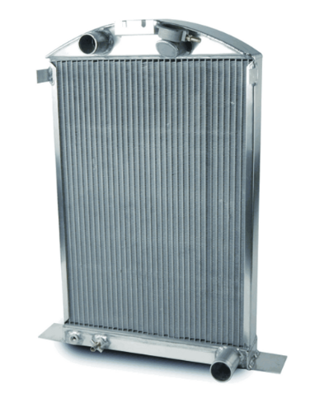

Figure 1 – Early Radiator Honeycomb Design (Beefcakeracing.com, 2025).

However, as car manufacturers sought more compact and cost-effective cooling solutions, air-cooled engines emerged as an alternative, especially in smaller and lightweight vehicles. Instead of using water circulation, these engines dissipated heat directly through extended surfaces known as cooling fins, which were cast into the cylinder heads and engine blocks. The fins, often made of cast iron or aluminium, increased surface area for heat transfer and allowed heat to be dissipated more efficiently into the surrounding air (Borgnakke & Sonntag, 2012).
Radial finned structures became a common design choice, improving convective cooling efficiency. Rear-engine layouts, such as those found in early Porsche and Volkswagen models, optimised airflow for natural cooling. The Volkswagen Beetle (1938–2003) is a notable example of an air-cooled vehicle that utilised a flat-four engine with cast aluminium fins to regulate temperatures. A belt-driven fan was later incorporated to enhance airflow across the fins, further improving heat dissipation (Copping, 2014).

Mid-20th Century Advancements (1950s–1990s)

As engine power and efficiency needs grew in the mid-twentieth century, air-cooled engines were increasingly replaced by water-cooled systems that included radiators with finned heat exchangers. One of the most significant technological advances during this period was the creation of crossflow radiators, in which coolant ran horizontally across a finned heat exchanger, enhancing heat dissipation. Multi-pass fin designs were also introduced, which allowed coolant to flow through finned portions numerous times to maximise temperature reduction (Taylor, 2005). Stone (2012) states that another key innovation was the introduction of louvred fins, which had tiny openings that caused turbulence, so disrupting the boundary layer and increasing convection.

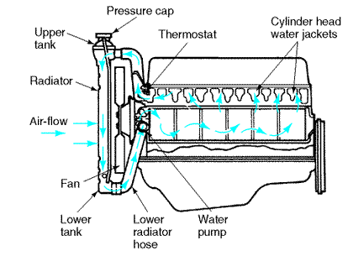

Figure 2 – Water Cooled Radiator Diagram With Water Pump (Angelfire.com, 2025).

The Porsche 911, which was built from 1964 until 1998, is a famous example of this era. Early variants had an air-cooled flat-six engine with huge, radial cooling fins for heat dispersion. Later, Porsche introduced a hybrid air-oil cooling system that combined oil-cooled heat exchangers with finned structures to increase thermal performance (Frere, 2013). The introduction of water cooling in 1998 with the Porsche 996 signalled the end of mainstream air-cooled sports cars, reflecting the industry's shift towards more efficient and powerful cooling technologies (Ludvigsen, 2008).

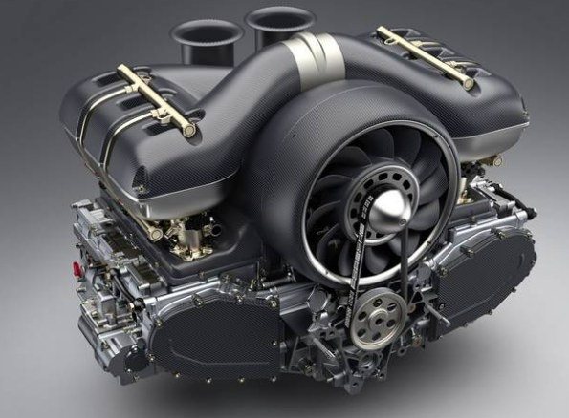

Figure 3 – An image of an Air-Cooled Flat-Six Porsche Engine (Agis, 2017).

Radiator-based cooling systems provided various benefits over classic air-cooled versions. They enabled for higher engine power output without the risk of overheating and lower aerodynamic drag when compared to externally finned engines (Heywood, 1988). Furthermore, these technologies improved temperature regulation, contributing to increased fuel efficiency and engine longevity.

Modern Automotive Cooling (1990s–Present)

Since the 1990s, current car cooling systems have improved dramatically, with innovative fin structures in radiators, intercoolers, and battery cooling systems. High-performance and electric vehicles now rely on novel finned designs to better regulate heat and increase overall performance.
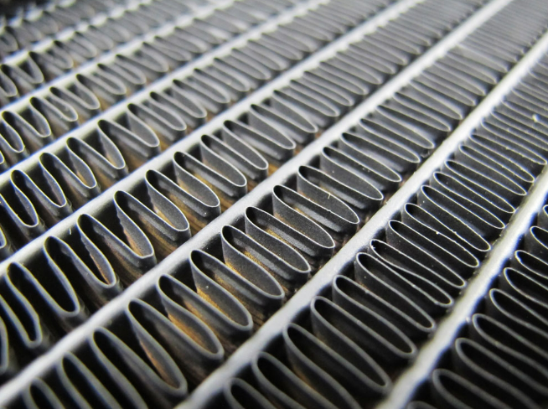

Figure 4 – An image of a fin structure in an automotive radiator (XSPC, 2025).
One significant breakthrough is the introduction of microchannel fins, which are very useful in electric vehicle battery cooling. These fins help manage heat accumulation and limit the possibility of thermal runaway, while also enhancing coolant flow distribution for maximum heat dissipation (Su et al., 2021). Another innovation is plate-fin heat exchangers, which are typically seen in turbocharger intercoolers. These compact, high-efficiency cooling components are intended to maintain appropriate temperatures in high-performance vehicles, assuring consistent power output and dependability.
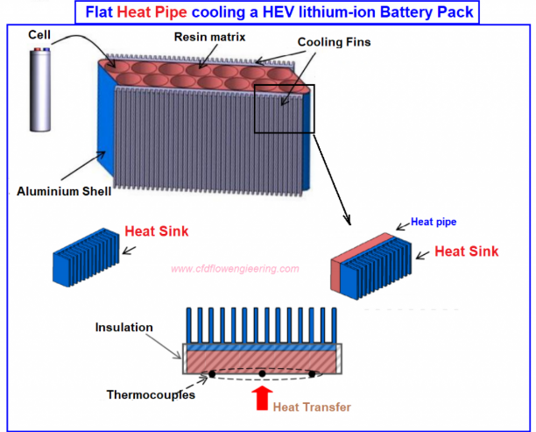

Figure 5 – An image that shows cooling fins used in a HEV lithium-ion battery in electric vehicles (CFD Flow Engineering, 2025).
Some hybrid vehicles also use phase-change material (PCM) cooling, which includes fins that actively absorb and dissipate heat (Shah and Sekulic, 2003). Ahmad, Dhamodharan and Kim (2025) states that this technology lowers temperature spikes under high-load conditions, extending the life and efficiency of crucial components. Tesla, for example, uses a liquid-cooled system with micro-finned aluminium heat exchangers to keep battery temperatures steady and avoid degradation. Computational Fluid Dynamics (CFD) simulations have improved fin design by optimising airflow and thermal performance to achieve optimal cooling efficiency (Mahek et al., 2024 and Incropera et al., 2011).

Extended Surfaces in Microprocessor Cooling

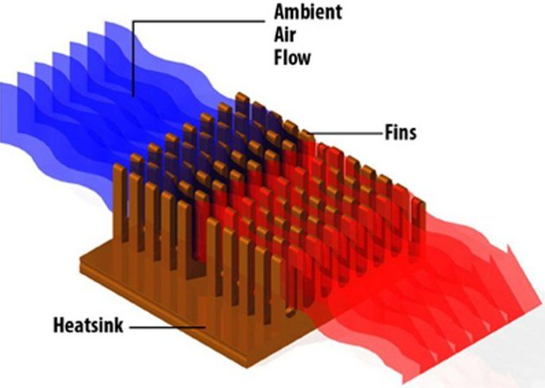
As microprocessors have improved, their power consumption and heat output have risen dramatically, requiring effective cooling solutions to retain performance and avoid overheating. Extended surfaces, often known as fins, play an important part in modern heat sink and liquid cooling designs by increasing the available surface area for heat dissipation. This fundamental notion has been essential for managing thermal loads in CPUs, GPUs, and high-performance computing systems (Incropera et al., 2013).
Figure 6 – An image of heat sink and fins for microprocessors (Morgan, 2024).

During the early days of computing, microprocessors including the Intel 4004 and IBM mainframes generated comparatively low heat loads, often less than 10W. As a result, passive cooling with simple extruded aluminium finned heat sinks was sufficient to passively disperse heat by convection (Schmidt, 2011). These heat sinks used expanded surfaces to improve heat transmission, eliminating the need for active cooling devices. However, when computing power increased throughout the Pentium period of the 1990s, heat dissipation became increasingly difficult. CPUs began producing between 50W and 100W of heat, rendering passive cooling ineffective. This resulted in the widespread use of active cooling, which combines fans with finned heat sinks to improve airflow and convective heat transfer (Linden and Reay, 2016).
Since the early 2000s, heat sink technology has advanced dramatically to accommodate current CPUs and GPUs that produce up to 250W of heat. One significant advancement has been the combination of stacked aluminium fin structures and embedded copper heat pipes, which improves heat conduction and dissipation. Dual-tower heat sinks, such as the Noctua NH-D15, have the use of finned structures to increase surface area and airflow, often surpassing liquid cooling systems in air-cooled configurations (Tiwari and Chhabra, 2019).
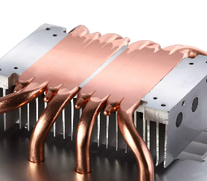

Figure 7 – An image of an aluminium fin structure with copper pipes (turkish.aluminiumdiecastingparts.com, 2025).

Liquid cooling methods have also adopted innovative extended surface designs, such as micro-finned heat exchangers used in water-cooled GPUs like the NVIDIA RTX 4090. These microchannel fins improve liquid-to-surface heat transfer, enhancing cooling performance while keeping designs small (Wang et al., 2021).
Recent advances in extended surface technology have resulted in the development of new materials, structures, and manufacturing procedures that improve cooling efficiency. The development of 3D-printed fin structures has enabled the customisation of fin forms to optimise airflow and turbulence, lowering weight and enhancing heat dissipation (Chung et al., 2020). AI-optimised cooling systems currently use computational simulations to fine-tune fin spacing, orientation, and turbulence patterns, which is especially useful in applications like data centres where heat control is important (Jouhara et al. 2017).

Designing a Fin of Finite Length

This task involves analysing the heat transfer efficiency of a fin with a finite length and an adiabatic tip by comparing it to an infinitely long fin. Using the function $\frac{\dot{Q}finite}{\dot{Q} ∞}= tanh(mL)$, the ratio of heat transfer against the fin parameter mL can be plotted. The aim is to determine the optimal fin length, typically considered to be around mL ≈ 2.65, where the heat transfer reaches approximately 99% of the maximum possible value. A MATLAB code was created to calculate this and a graph determined from this calculation as seen below:
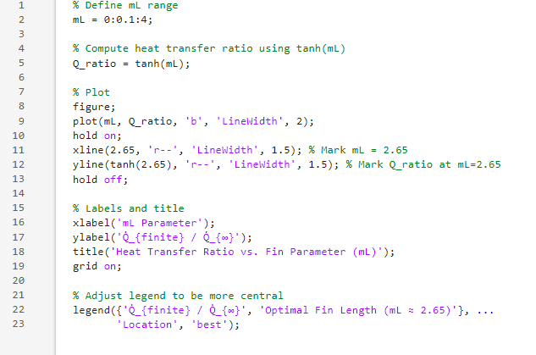
Figure 8 – MATLAB code for determining Heat Ratio vs Fin Parameter.

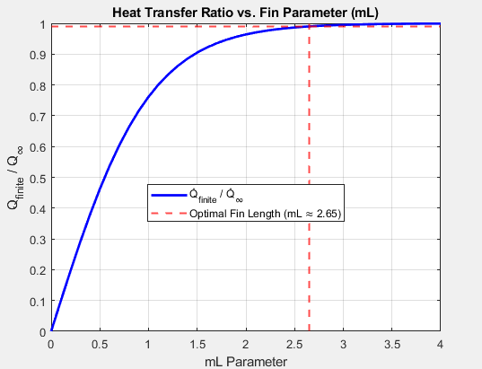
Figure 9 – Graph showing Heat Transfer Ratio vs Fin Parameter.
As seen in the above graph, mL increases as the heat transfer ratio approaches 1, meaning the fin is transferring nearly as much heat as an infinitely long fin. However, the main analysis from the graph shows that beyond mL ≈ 2.65mL, the curve flattens out, indicating that additional length provides minimal improvement in heat transfer. At mL = 2.65, the heat transfer is already about 99% of the maximum possible value. This confirms that making a fin longer than this threshold does not significantly improve performance but does increase material usage and cost. Engineers use this principle to optimise fin design, ensuring that the fin is long enough to be effective but not unnecessarily extended beyond the point of diminishing returns.

Analysis of Four long Length Rods of Varying Materials

Temperature Distribution Along Four Rods

To determine the temperature distribution along 0.4m length rods of four different materials; which include 2024 Aluminium Alloy, Brass, Copper and 304 Stainless Steel, a calculation was completed to determine the temperature at 0.01m increments using the following formula under adiabatic conditions:
$$T\left(x\right)=T∞+\left(T_{0}- T_{∞}\right) ×\frac{cosh\left(m×(L-x)\right)}{\cosh{(m×L)}}$$
$m= √\frac{h×p}{k×A}$: Thermal parameter for each material.
The graph below is a visual representation of the temperature distribution and the graph reveals that there a distinct cooling behaviour based on the materials’ thermal properties.

Figure 10 – A graph showing the temperature distribution along the four rods.

Copper shows the slowest rate of cooling as it has a higher thermal conductivity (k = 398 W/mK) compared to the other materials. The temperature remains higher along a portion of the rod’s length compared to the three other materials. 304 Stainless Steel has the steepest temperature drop which reflects its lower thermal conductivity (k = 16 W/mK) and higher m value (15.81) compared to the other materials. Aluminium Alloy and Brass show an intermediate cooling rate, with aluminium distributing the heat more efficiently than that of Brass.

Heat Loss for the Four Rods

The formula used is as shown:
$$Q= \sqrt{h×P×A}×(T_{0}-T_{∞})×tanh⁡(m×L)$$
$m= √\frac{h×p}{k×A}$: Thermal parameter derived for the fin.
See Appendix B for the table that shows the values given for heat loss for the four rods analysed in section 4.1. The corresponding graph for this section is as shown:
Figure 11 – A graph showing the heat loss for the four rods analysed.

The 2024 aluminium alloy had the largest heat loss over all measured lengths, reaching roughly 7.00 W at x = 0.4m. Its high thermal conductivity (𝑘 = 186W/mK) enables rapid heat dissipation, making it ideal for applications requiring efficient heat removal. Copper exhibits a constant and gradual increase in heat loss, reaching 6.86 W at x = 0.4m. At x = 0.4m, brass has a heat loss of 5.12 W, slightly lower than aluminium. 304 stainless steel has the lowest heat loss, hardly reaching 1.03 W at x = 0.4m.

Optimum Length of the Four Rods and Heat Loss
The formula used for calculating optimum fin length Is as shown:
$$L_{optimum= \frac{2.65}{m}}$$
Once the optimum length was determined for each rod, heat loss was then calculated using the following equation:
$$Q= \sqrt{h×P×A}×(T_{0}-T_{∞})×tanh⁡(m×L_{optimum})$$
The below table shows the results calculated for each of the materials:
Table 1 – Table showing the Optimum Length and Heat Loss calculated for each material.
Material | Optimum Length | Heat Loss
2024 Aluminium Alloy | 0.29 | 6.94E+00
Brass | 0.21 | 5.06E+00
Copper | 0.59 | 7.18E+00
304 Stainless Steel | 0.17 | 1.02E+00

Comparing that with the results from 4.2. as shown from the table below:
Table 2 – Table showing the heat loss at the same length in Table 1 from the results in 4.2.
Material | Heat Loss
2024 Aluminium Alloy | 6.95E+00
Brass | 5.11E+00
Copper | 6.25E+00
304 Stainless Steel | 1.03E+00

The optimal length for the 2024 aluminium alloy results in a heat loss of 6.94W, while 4.2. heat loss for x = 0.29m is 6.95W. These nearly similar numbers show that the estimated optimal length delivers heat dissipation that is very close to the maximum measured for this specific rod length.
For brass, the optimal length (0.21m) leads to a heat loss of 5.06W, compared to 5.11W for x = 0.27m (see section 4.2). The calculated optimum length of L = 0.21m results in heat transfer efficiency near to the peak observed at 0.27m.
Copper, on the other hand, exhibits a more notable deviation. Its optimum length produces a heat loss of 7.18W, whereas the results in section 4.2. shows only 6.25W at x = 0.29m. This discrepancy highlights the impact of its longer optimum length (Loptimum = 0.59m), which significantly enhances heat dissipation.

Optimal Length Temperature Distribution Along the Rods

The formula used for this calculation is the same as section 4.1. (see 4.1. for the formula used).
The graph below shows the optimal length temperature distribution along the four rods (see Appendix C for the full results table corresponding to the graph below).

Figure 12 – A graph plotting the optimal length temperature distribution along the four rods.

Table 3 – Table showing optimum length temperature distribution.
Material | Optimum Length | Temperature Distribution
2024 Aluminium Alloy | 0.29 | 30.94
Brass | 0.21 | 30.93
Copper | 0.59 | 30.94
304 Stainless Steel | 0.17 | 30.94

The temperature at the tip of each rod is approximately identical across all materials (30.93−30.94°C), showing that the chosen optimal lengths efficiently meet the criteria of near-ambient temperature ($T_{∞}$ = 18°C). This uniformity implies that the optimal lengths balance heat transmission efficiency, ensuring that the tip temperature converges with ambient circumstances.

Accurate Length for the Infinite Fin Approximation

Table 4 – Table showing the accurate length values and temperature distribution calculated.
Material | Thermal Parameter | Accurate Length | Temperature Distribution
2024 Aluminium Alloy | 9.27 | 0.422 | 19.840
Brass | 12.71 | 0.308 | 19.840
Copper | 4.48 | 0.873 | 19.840
304 Stainless Steel | 15.81 | 0.247 | 19.840

Table 5 – Table showing the lengths determined from each of the sections.
Material | Section 4.1. Length (m) | Section 4.4.Length (m) | Section 4.5. Length (m)
2024 Aluminium Alloy | 0.4 | 0.29 | 0.422
Brass | 0.4 | 0.21 | 0.308
Copper | 0.4 | 0.59 | 0.873
304 Stainless Steel | 0.4 | 0.17 | 0.247

Section 4.5. lengths exceed the optimum lengths (Section 4.4.) for all materials due to the tougher constraint of 𝑒 - 𝑚𝐿 < 0.02. This keeps the tip temperature closer to $T_{∞}$ , requiring longer rod lengths. Copper displays the highest increase in length, in line with its high thermal conductivity (𝑘=398W/mK), requiring a longer fin to achieve the criterion.

Table 6 – Table showing the temperature distribution from each of the sections.
Material | Section 4.1. Temperature Distribution | Section 4.4. Temperature Distribution | Section 4.5. Temperature Distribution
2024 Aluminium Alloy | 22.51 | 30.94 | 19.84
Brass | 19.14 | 30.93 | 19.84
Copper | 47.83 | 30.94 | 19.84
304 Stainless Steel | 18.33 | 30.94 | 19.84

In section 4.5, all materials attain a tip temperature of roughly 𝑇 (𝑥 = 𝐿accurate) ≈ 19.84°C, which is near to the ambient fluid temperature of $T_{∞}$ = 18°C. This result meets the more rigorous criteria 𝑒−𝑚𝐿 < 0.02, suggesting higher convergence and precision relative to previous sections.
In contrast, the data from section 4.1 reveal that the tip temperatures for aluminium alloy, brass, and copper remain very high, indicating insufficient cooling due to the shorter fin lengths used. Meanwhile, in section 4.4, all materials' tip temperatures range from 30.93 to 30.94°C. This means that, while the calculated optimum lengths are useful, they are based on a less stringent criterion than the infinite fin approximation used in section 4.5.

Conclusion

Fins have played an important role in advancing thermal management solutions in both the automobile and semiconductor sectors. From early honeycomb radiators to today's microchannel heat exchangers in electric vehicles, fin design has developed to meet the increased requirements for efficiency and performance. Similarly, in computing, the shift from passive aluminium heat sinks to AI-optimized, 3D-printed fin structures exemplifies how extended surface innovation enables increasingly powerful and compact hardware.
The engineering analyses given emphasise the relevance of fin design and material selection in obtaining maximum heat transmission. After a specific threshold (mL = 2.65), increasing fin length provides minimal incremental advantage, guiding cost-effective and efficient design. Aluminium and copper outperformed the other materials evaluated in terms of heat loss, whereas stainless steel had the lowest efficiency due to its inferior thermal conductivity. Finally, incorporating smart fin design into modern thermal systems is critical for enhancing performance, reducing failure, and enabling the next generation of technological improvements.

Bibliography

- Aegis, F. (2017). A new Lightweight Porsche 911 engine | WordlessTech. [Online] WordlessTech. Available at: https://wordlesstech.com/a-new-lightweight-porsche-911-engine/ [Accessed 2 Apr. 2025].
- Ahmad, H., Dhamodharan, P. and Kim, S. (2025). Advances in Cooling Technologies for Electric Vehicle Drive Motors, Reducers, and Inverters: A Comprehensive Review. Energy Technology. doi:https://doi.org/10.1002/ente.202401691.
- Angelfire.com. (2025). Easy Car Maintenance. [Online] Available at: https://www.angelfire.com/ia3/autocare/coolingsystem.htm [Accessed 1 April 2025].
- Beefcake Racing. (2025). Afco Racing Aluminum Polish Radiator 1937 Ford Car Chevy AFCO. [Online] Available at: https://www.beefcakeracing.com/80142-p-na-n/ [Accessed 2 April 2025].
- Borgnakke, C., and Sonntag, R. (2012). Fundamentals of Thermodynamics. 8th ed. USA: Wiley.
- CFD Flow Engineering. (2021). Battery Cooling Techniques in Electric Vehicle · CFD Flow Engineering. [Online] Available at: https://cfdflowengineering.com/battery-cooling-techniques-in-electric-vehicle/ [Accessed 6 April 2025].
- Chung, H., Lee, S., & Kim, J. (2020). Optimization of 3D-Printed Fin Structures for Enhanced Thermal Management. International Journal of Heat and Mass Transfer, 160, 120398.
- Copping, R. (2014). VW Beetle: The Car of the 20th Century. Dorchester: Veloce Publishing
- Frère, P. (2013). Porsche 911 story. California: Haynes North America Inc.
- Gao, Y., Zhang, T., & Chen, L. (2022). Bio-Inspired Cooling Structures: Applications and Future Directions. Journal of Thermal Science and Engineering Applications, 14(2), 320-337.
- Heywood, J. B. (1988). Internal Combustion Engine Fundamentals. New York: McGraw-Hill.
- Incropera, F., Bergman, T., Dewitt, D., Lavine, A, Seetharamu, K. (2011). Fundamentals of heat and mass transfer. 7th ed. New Delhi: Wiley.
- Incropera, F.P., Dewitt, D.P., Bergman, T.L., & Lavine, A.S. (2013). Fundamentals of Heat and Mass Transfer. Wiley.
- Jouhara, H., Axcell, B., and Holton, A. (2017). Computational Fluid Dynamics Optimization of Extended Surface Cooling in Data Centers. Applied Thermal Engineering, 125, 253-264.
- Kim, H., Park, J., and Song, C. (2018). Advancements in Vapor Chamber Heat Sink Technology for Compact Electronics. IEEE Transactions on Components, Packaging and Manufacturing Technology, 8(4), 674-682.
- Lichty, L. (1967). Internal Combustion Engines. 6th edn. Kogakusha: McGraw-Hill.
- LiFong (HK) Industrial Co. (2025). LiFong(HK) Industrial Co.,Limited. [Online] Available at: https://turkish.aluminiumdiecastingparts.com [Accessed 6 April 2025].
- Linden, J., and Reay, D. (2016). Heat Pipes: Theory, Design and Applications. Dubai: Butterworth-Heinemann.
- Ludvigsen, K. (2008). Porsche : excellence was expected : the comprehensive history of the company, its cars, and its racing heritage. Cambridge, Mass: Bentley Publishers.
- Mahek, M., Ramadan, M., bin Dol, S., Ghazal, M. and Alkhedher, M. (2024). A comprehensive review of thermoelectric cooling technologies for enhanced thermal management in lithium-ion battery systems. Heliyon, 10(24), p.e40649. doi:https://doi.org/10.1016/j.heliyon.2024.e40649.
- Pulkrabek, W. (2013). Engineering Fundamentals of the Internal Combustion Engine. 2nd edn. Edinburgh: Pearson.
- Rapid Direct. (2021). Optimize Your Heat Sink Design: Principles and Four Practical Tips | RapidDirect Blog. [Online] Available at: https://www.rapiddirect.com/blog/heat-sink-design/ [Accessed 3 April 2025].
- Schmidt, P. (2011). Historical Development of Microprocessor Thermal Management. Microelectronics Journal, 42(9), 1173-1184.
- Shah, R. and Sekuli, D. (2003). Fundamentals of Heat Exchanger Design. New Jersey: John Wiley & Sons, Inc.
- Stone, R. (2012). Introduction to internal combustion engines. 4th edn. Basingstoke: Palgrave Macmillan.
- Su, S., Li, W., Li, Y., Garg, A., Gao, L. and Zhou, Q. (2021). Multi-objective design optimization of battery thermal management system for electric vehicles. Applied Thermal Engineering, 196, p.117235. doi:https://doi.org/10.1016/j.applthermaleng.2021.117235.
- Taylor, C. (2005). The internal-combustion engine in theory and practice. Vol. 1, Thermodynamics, fluid flow, performance. 2nd edn. Massachusetts: M.I.T. Press.
- Tiwari, S., and Chhabra, D. (2019). Advances in Passive and Active Cooling Techniques for High-Performance Computing. Materials Today: Proceedings, 11(3), 483-490.
- Wang, X., Li, J., and Zhang, R. (2021). Micro-Finned Liquid Cooling Systems for High-Power GPUs. Thermal Science and Engineering Progress, 24, 100962.
- Water, P. (2023). XSPC - Performance PC Water Cooling. [Online] XSPC - Performance PC Water Cooling. Available at: https://www.xs-pc.com/radiators-rs-series [Accessed 2 April 2025].
- Yadav, R., Kumar, V., and Singh, H. (2019). Carbon Nanotube-Coated Fin Structures for Enhanced Thermal Conductivity. International Journal of Heat and Fluid Flow, 78, 213-226.

Appendix

Appendix A: Temperature Distribution Table for Four Long Rods
X Value (m) | 2024 Aluminium Alloy | Brass | Copper | 304 Stainless Steel
0 | 110 | 110 | 110 | 110
0.01 | 101.86522 | 99.02030 | 106.19212 | 96.54642
0.02 | 94.45164 | 89.35119 | 102.56127 | 85.06025
0.03 | 87.69550 | 80.83627 | 99.10018 | 75.25378
0.04 | 81.53870 | 73.33780 | 95.80187 | 66.88139
0.05 | 75.92830 | 66.73449 | 92.65975 | 59.73337
0.06 | 70.81606 | 60.91951 | 89.66750 | 53.63067
0.07 | 66.15800 | 55.79881 | 86.81911 | 48.42044
0.08 | 61.91407 | 51.28955 | 84.10887 | 43.97217
0.09 | 58.04778 | 47.31878 | 81.53133 | 40.17445
0.1 | 54.52588 | 43.82228 | 79.08132 | 36.93214
0.11 | 51.31808 | 40.74349 | 76.75393 | 34.16405
0.12 | 48.39679 | 38.03259 | 74.54447 | 31.80082
0.13 | 45.73691 | 35.64575 | 72.44853 | 29.78328
0.14 | 43.31554 | 33.54435 | 70.46188 | 28.06088
0.15 | 41.11187 | 31.69440 | 68.58054 | 26.59048
0.16 | 39.10696 | 30.06597 | 66.80074 | 25.33525
0.17 | 37.28355 | 28.63272 | 65.11890 | 24.26375
0.18 | 35.62597 | 27.37146 | 63.53164 | 23.34915
0.19 | 34.11996 | 26.26181 | 62.03579 | 22.56853
0.2 | 32.75258 | 25.28579 | 60.62832 | 21.90234
0.21 | 31.51206 | 24.42763 | 59.30643 | 21.33390
0.22 | 30.38773 | 23.67345 | 58.06746 | 20.84896
0.23 | 29.36994 | 23.01104 | 56.90892 | 20.43538
0.24 | 28.44991 | 22.42969 | 55.82848 | 20.08281
0.25 | 27.61976 | 21.92000 | 54.82398 | 19.78240
0.26 | 26.87232 | 21.47372 | 53.89340 | 19.52664
0.27 | 26.20119 | 21.08363 | 53.03487 | 19.30911
0.28 | 25.60058 | 20.74342 | 52.24667 | 19.12438
0.29 | 25.06533 | 20.44758 | 51.52721 | 18.96781
0.3 | 24.59084 | 20.19134 | 50.87506 | 18.83548
0.31 | 24.17302 | 19.97055 | 50.28890 | 18.72408
0.32 | 23.80829 | 19.78164 | 49.76755 | 18.63082
0.33 | 23.49351 | 19.62154 | 49.30998 | 18.55335
0.34 | 23.22597 | 19.48767 | 48.91525 | 18.48975
0.35 | 23.00337 | 19.37787 | 48.58259 | 18.43841
0.36 | 22.82379 | 19.29036 | 48.31131 | 18.39806
0.37 | 22.68570 | 19.22372 | 48.10088 | 18.36767
0.38 | 22.58790 | 19.17688 | 47.95087 | 18.34649
0.39 | 22.52956 | 19.14907 | 47.86099 | 18.33400
0.4 | 22.51017 | 19.13985 | 47.83105 | 18.32987

Appendix B: Heat Loss Table for Four Long Rods
X Value (m) | 2024 Aluminium Alloy | Brass | Copper | 304 Stainless Steel
0 | 0 | 0 | 0 | 0
0.01 | 0.64825 | 0.64682 | 0.32476 | 0.16125
0.02 | 1.28551 | 1.27328 | 0.64822 | 0.31477
0.03 | 1.90154 | 1.86153 | 0.96910 | 0.45423
0.04 | 2.48745 | 2.39805 | 1.28617 | 0.57562
0.05 | 3.03615 | 2.87454 | 1.59824 | 0.67742
0.06 | 3.54263 | 3.28783 | 1.90422 | 0.76017
0.07 | 4.00392 | 3.63902 | 2.20308 | 0.82572
0.08 | 4.41897 | 3.93226 | 2.49393 | 0.87662
0.09 | 4.78832 | 4.17357 | 2.77596 | 0.91552
0.1 | 5.11382 | 4.36976 | 3.04849 | 0.94488
0.11 | 5.39822 | 4.52771 | 3.31096 | 0.96686
0.12 | 5.64483 | 4.65388 | 3.56291 | 0.98318
0.13 | 5.85728 | 4.75402 | 3.80402 | 0.99525
0.14 | 6.03928 | 4.83311 | 4.03407 | 1.00414
0.15 | 6.19445 | 4.89533 | 4.25294 | 1.01067
0.16 | 6.32619 | 4.94411 | 4.46061 | 1.01546
0.17 | 6.43765 | 4.98228 | 4.65716 | 1.01896
0.18 | 6.53167 | 5.01208 | 4.84272 | 1.02152
0.19 | 6.61079 | 5.03531 | 5.01752 | 1.02339
0.2 | 6.67722 | 5.05340 | 5.18181 | 1.02476
0.21 | 6.73291 | 5.06748 | 5.33592 | 1.02575
0.22 | 6.77952 | 5.07842 | 5.48020 | 1.02648
0.23 | 6.81848 | 5.08692 | 5.61505 | 1.02701
0.24 | 6.85102 | 5.09352 | 5.74085 | 1.02740
0.25 | 6.87817 | 5.09865 | 5.85805 | 1.02768
0.26 | 6.90080 | 5.10263 | 5.96707 | 1.02788
0.27 | 6.91966 | 5.10572 | 6.06835 | 1.02803
0.28 | 6.93537 | 5.10811 | 6.16231 | 1.02814
0.29 | 6.94845 | 5.10997 | 6.24939 | 1.02822
0.3 | 6.95933 | 5.11142 | 6.33000 | 1.02828
0.31 | 6.96838 | 5.11254 | 6.40455 | 1.02832
0.32 | 6.97591 | 5.11340 | 6.47343 | 1.02835
0.33 | 6.98217 | 5.11408 | 6.53701 | 1.02838
0.34 | 6.98738 | 5.11460 | 6.59567 | 1.02839
0.35 | 6.99171 | 5.11500 | 6.64974 | 1.02840
0.36 | 6.99531 | 5.11532 | 6.69954 | 1.02841
0.37 | 6.99830 | 5.11556 | 6.74539 | 1.02842
0.38 | 7.00078 | 5.11575 | 6.78757 | 1.02842
0.39 | 7.00285 | 5.11590 | 6.82636 | 1.02843
0.4 | 7.00457 | 5.11601 | 6.86202 | 1.02843

Appendix C: Temperature Distribution at Optimal Length Along the Rods

Distance (x) | 2024 Aluminium Alloy | Brass | Copper | 304 Stainless Steel
0 | 110 | 110 | 110 | 110
0.01 | 101.94 | 99.14 | 106.01 | 96.69
0.02 | 94.60 | 89.59 | 102.20 | 85.35
0.03 | 87.92 | 81.20 | 98.55 | 75.70
0.04 | 81.84 | 73.83 | 95.07 | 67.49
0.05 | 76.31 | 67.36 | 91.74 | 60.52
0.06 | 71.28 | 61.69 | 88.57 | 54.62
0.07 | 66.72 | 56.73 | 85.53 | 49.64
0.08 | 62.56 | 52.39 | 82.63 | 45.44
0.09 | 58.80 | 48.61 | 79.85 | 41.94
0.1 | 55.38 | 45.33 | 77.20 | 39.03
0.11 | 52.28 | 42.49 | 74.68 | 36.65
0.12 | 49.48 | 40.04 | 72.26 | 34.74
0.13 | 46.95 | 37.95 | 69.95 | 33.25
0.14 | 44.67 | 36.19 | 67.75 | 32.14
0.15 | 42.62 | 34.72 | 65.65 | 31.38
0.16 | 40.78 | 33.51 | 63.64 | 30.96
0.17 | 39.14 | 32.56 | 61.73 | 30.86
0.18 | 37.68 | 31.85 | 59.90
0.19 | 36.38 | 31.36 | 58.15
0.2 | 35.25 | 31.08 | 56.49
0.21 | 34.26 | 31.02 | 54.91
0.22 | 33.41 |  | 53.39
0.23 | 32.70 |  | 51.95
0.24 | 32.11 |  | 50.58
0.25 | 31.65 |  | 49.27
0.26 | 31.30 |  | 48.03
0.27 | 31.06 |  | 46.85
0.28 | 30.94 |  | 45.72
0.29 | 30.93 |  | 44.65
0.3 |  |  | 43.63
0.31 |  |  | 42.67
0.32 |  |  | 41.75
0.33 |  |  | 40.88
0.34 |  |  | 40.06
0.35 |  |  | 39.28
0.36 |  |  | 38.55
0.37 |  |  | 37.86
0.38 |  |  | 37.20
0.39 |  |  | 36.59
0.4 |  |  | 36.01
0.41 |  |  | 35.47
0.42 |  |  | 34.96
0.43 |  |  | 34.49
0.44 |  |  | 34.05
0.45 |  |  | 33.64
0.46 |  |  | 33.26
0.47 |  |  | 32.92
0.48 |  |  | 32.60
0.49 |  |  | 32.32
0.5 |  |  | 32.06
0.51 |  |  | 31.83
0.52 |  |  | 31.63
0.53 |  |  | 31.45
0.54 |  |  | 31.30
0.55 |  |  | 31.18
0.56 |  |  | 31.09
0.57 |  |  | 31.02
0.58 |  |  | 30.98
0.59 |  |  | 30.97

