

Student Name : Mohammed Shoeb
Student ID : 2214606
Programme : Master of Business Administration
Module Name : MARKETING MANAGEMENT
Module code : LCMB7001
Assignment Title : Marketing Management Assessment - 1
Module Coordinator/Lecturer : Tushara Balendran

Table of Contents
Introduction 3
Background of Company 3
Innovative marketing strategies for raising awareness of a brand 3
Sustainability framework 5
Engaging with different stakeholders 7
Transformation at BP, UK 8
Maximizing satisfaction of a customer 9
Managing and evaluating the journey of customers 10
Conclusion 13
Reference list 14

Introduction
Marketing is considered an essential part of business, including determining the price of a product, incorporating promotional activities, and deciding on people. This study shed light on discussing the marketing strategies used by British Petroleum [BP] for raising brand awareness in different parts of the UK. It also discusses various marketing activities along with the marketing department's contribution to business organization.

Background of Company
British Petroleum [BP] is regarded as a British multinational business whose main activity is producing oil and gas, and its headquarters is in London. BP is considered a super major in oil and gas and is estimated to be one of the most significant business ventures that can be measured by revenue or by earning capacity of profit (Bp.com, 2021).
The Company is involved in each stage of oil and natural gas supply chain, from the exploration based on sales to the marketing of energy products. The specified Company generates fuel, energy, and different petrochemical-based products. Management of this Company also aims to provide retail services across the world.
Definition of communication
Communication can be defined as the two-way process which often involves a particular sender, message a medium along with the receiver and attending feedback. Communication can also be defined as long term process by which information its estimated to be exchanged in between individuals through a common system of a symbols, science or behaviour
Explaining communication model
Different models of a communication often known to simplify the process by providing a visual representation of a different expect of a communication.
- Linear model of a communication
Linear model of a communication the linear model which is also known as the transmission model of a communication often describe a communication as they are linear one-way process where a sender intentionally known to transmit a message to a receiver. This model often focuses on the sender and message within a communication encounter.
- Interactive model of communication
Interactive for model of a communication the interactive or interaction mode of a communication can often be described the communication as long-term process in which a participant alternative position as both sender and receiver and generate same meaning by sending a message and receiving feedback
Transaction model of communication
This same model also a describe a communication as long-term process in which your communicators often generate social realities within social relational and cultural context. In this context the role of a sender and receiver in the transaction model of a communication also tend to differ significantly from the other models.
Definition of Integrated Marketing Communications
Integrated marketing communication IMC can be defined as a planning process that are often designed on ensuring that all brand contracts that are received by a customer or a promoting a particular product and services. IMC can also be demonstrated as long-term strategy that aim at delivering a unified message all across the marketing channel that the brand tends to use. Moreover, it aimed at a providing consistency wherever a customer chooses to interact with a particular company.
IMC is a considered to be beneficial for offering a smooth and customer focused experience by incorporating a different elements of marketing communication. It also takes into consideration a public relation, analysing social media along with a promoting the mode of advertising. It also implies that the message needs to have a unified look and tone across different channels.
New promotional strategies company used for raising awareness in brand
A promotional strategy can be incorporated as a key for a positioning the brand on market. Different promotional strategy that can be used by a business for raising awareness include uses of social media. The company make uses of a social media during a marketing campaign as it is considered to be one of the efficient approaches to reach the audience without any hindrance.
Referral programs are also considered to be another promotional strategy that can be used. Using existing consumer for a boosting a particular business is a considered to be one of the effective promotional strategies. The marketer or the top-level management can make use of referral program with aim of a motivating customers to tell their friends and family about a particular business for providing incentives.
Promotional strategies that BP used for raising awareness of brand
According to a report passed on a financial year 2018 on 10th of March it can be reported that BP make use mix of geographic segmentation form of strategy with aim of collaboratively working with different customer and understanding their changing needs. In order to promote brand, the marketing department at a BP often uses a television, website, implication of a social media channel along with billboards to promote a particular brand (Martínez-López et al. 2020). It can also be seen that the company BP also use is gas station and different petrol pump for advertising about its product. It can further be recommended to marketing team associated with BP to undertake promotional strategies in context of implementing SEO marketing that management required to enhance sales. On the other hand, implication of E-mail marketing along with social media marketing are other approaches used to promote revenue and profitability scale of business.
You need to recommend the NEW promotional strategies that the company can adopt not the existing strategies.
Definition of branding and brand equity
Branding
The process of a branding can be defined as a creating a distinct form of identity for a particular business in a mind of a targeted audience and customers. Brand marketing can also be demonstrated as a long term of process of establishing and growing a relationship in between a brand and a consumer.
Brand equity
Brand equity can be demonstrated as long term marketing term that often tend to describe a particular brand value (Bob, Jumadil and Marlena, 2020). There are 4 different dimensions of a brand equity including promoting a loyalty of a particular brand enhancing awareness of a brand. It also includes promoting the brand association and analysing the perceived quality of a particular a product.
You need to include a diagram of the Keller’s model, describe and relate the brand/company to each of the levels.
Keller’s model
According to Keller brand Equity model aims at promoting strong brand when management team tend to create appropriate brand image in terms of constructing strong brand as it often encounters or faces experiences. Six different stages of Keller’s model can be discussed as:
- Initiating with brand identity
Brand salience or brand awareness often refers on implementing perceived by customers. This brand identity needs to be incorporated by marketing team at BP to promote brand loyalty and reduce vulnerability (Bob, Jumadil and Marlena, 2020).
- Understanding and communicating meaning of brand
The building blocks undertaken by BP for step 3 includes Performance and Imagery. According to management team of BP the performance often indicates how well a particular product is used for satisfying needs of customers.
- Sort of responses
According to management at BP, humans need to be associated by constantly making assumptions based on their observation level.
- Understanding relationship
Managing brand resonance in BP incorporate how a particular customer identify themselves with a brand.
Keller’s Brand Equity
Advantages
- For building a strong brand by shaping the thinking and feeling a process of a customer
- assist in identifying the stage where a brand belongs
- Increase in brand loyalty and reducing vulnerability to promote the competitive form of marketing
Disadvantages
- No perceived value
- Lower level of a merging being achieved
- lack of maintaining the brand consistency
- ineffective use of a business insight and disconnecting the sales metrics
- higher rate of a customer retain cost which often requires a skilled sales system
Customer journey
A customer journey Can be a defined as a tool that often aids marketer in understanding Both are potential along with engaging in different types of customers
The stages in the customer journey should be described
Stages of customer journey
Awareness stage
Initial stage incorporates awareness where are the customer face a problem or required for finding an effective solution.
Consideration stage
in this stage a consumer or customers are a considering the company against other with similar of products or services. at this point of a time a potential a customer often wants a deeper understanding of a different aspects of offering.
Decision stage
in this stage your customer needs to decide what they want to purchase about a product or services. the customer often makes decision by implementing a well-designed and user-friendly level of website which often aim at a providing clear pricing source of information along with offering a multiple payment option.
Customer loyalty
As stated by Marinchak, Forrest and Hoanca (2018), fourth stage is associated with the customer journey stages incorporate about maintaining loyalty. creating a loyal customer who often can be advocated on behalf of the company as well as about the product and services which is regarded as invaluable.
Customer touchpoint for business organization
Customer touch point can be demonstrated as brand point of a customer contact from initiation to finish. For example, customer need to find your business online or in a promoting and advertisement sing the rating and review. different touchpoints of a customer include implication of a social media, analysing the online advertisement along with the promoting that digital marketing concept. It can also be incorporated that the touchpoint of a customer includes providing spear referrals along with managing the ecommerce sector of a particular business (Deepak and Jeyakumar, 2019). The touchpoints that the company uses in the pre purchase, purchase and post purchase stages should be determined.
In words of Chernev (2018), Management at BP often make uses of social media, content sponsorship along with word of mouth for pre purchase decision. In addition, during purchase decision making process management need to incorporate peer referral along with promoting online advertisement. On the other hand, during post purchase stage management need to determine products-based review along with managing loyalty programs
Explanation of a customer journey map
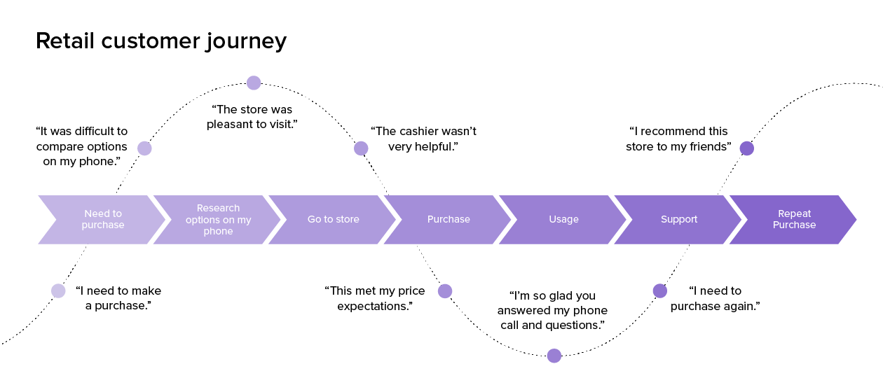
Figure 1: Customer journey map
A diagram and explanation of a customer journey map for the brand should be included.
Strength and weakness of customer journey map
Strength
- Emphasising the customer
- Providing or identifying gap in service Oregon communication
- predicting the customer behaviour
- Improving the customer journey
- providing a visual aid for different stakeholders
weakness
- Failed to define the goals and objectives of a particular a project
- Using non-reliable form of a data
- Conducting interview of only loyal customers
- Not a focusing on early stage of interaction
- Inducing a limited number of a touch points
Total Engagement Model
Total engagement model can be demonstrated as engaging customer it’s one of the process that incorporate high insight of a particular business. The total engagement of model aims at the providing fresh and through provoking insight on different customers promoting the engagement of a particular employee along with enhancing the branding and leadership prospects (Verhoeven, Sinn and Herden, 2018).
Different new customer touchpoints
Different customer touch point which can be incorporated in a particular business include users of a different channels of a social media. It also includes the promoting a product or services through users of online mode of advertisement along with using the digital marketing content

Innovative marketing strategies for raising awareness of a brand
A top-level executive at BP often sets a creative approach that enables them to pivot from being an international-based oil company. This Company primarily focuses on producing more resources through using an integrated level of the energy business that mainly focuses on delivering solutions to different customers in the long term (Deepak and Jeyakumar, 2019).
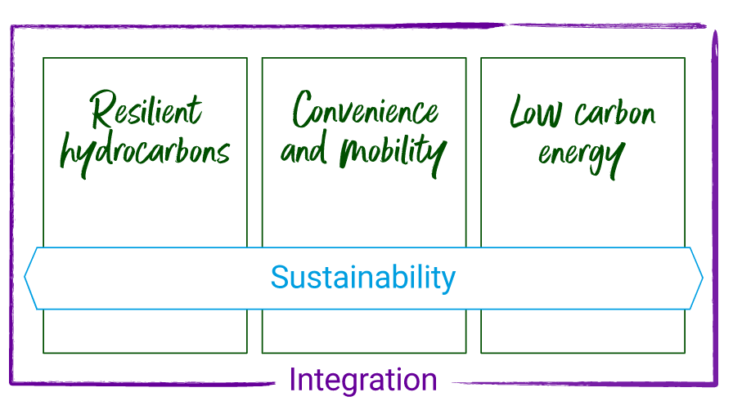
Figure 1: Three Processes of sustainability
(Source: Martínez-López et al. 2020)
From the above diagram, it can be demonstrated that management at BP follows three significant types of sustainability, including managing resilient hydrocarbon, working convenience, and mobility. BP's third sustainability approach includes managing a low-carbon form of energy. It can further be noticed that these three approaches of sustainability followed in a BP directly aim at promoting the integration approaches in the long term.
As stated by Marinchak, Forrest and Hoanca (2018), the long-term strategy that is followed in a BP integrates Building purpose and belief about managing an energy system's future. The other techniques include building on three focus areas based on different activities, and its three sources of differentiation process are used to amplify a business's values. Three focus areas consider resilient-based hydrocarbons, which aim to promote a portfolio's high grading, mitigating or lowering emissions along with driving returns. The second focus area followed in a BP implies promoting a high level of convenience along with mobility. In this second stage, comfort and mobility can be enhanced by adjusting EBITDA, sustaining a high rate of returns, and focusing on customers in the long run. On the other hand, top-level executives and managers at a BP need to build scale with capital and expect return focus in evaluating a low-carbon form of energy (Kotler et al. 2018).
Management level at a BP believes in the fact that they possess scale and expertise in navigating complex market structures and aim at managing the increasing rate of using an integrated level of energy systems. The integrating energy system can harness the collective form of capabilities as the energy system aims to make a transition. This type of energy system is also essential for aiding customers in receiving the energy demanded and creating long-term and compelling value for a different shareholder (Krings, Palmer and Inversini, 2021).
In promoting the innovative strategy used at BP, management needs to partner with different countries, cities, and industries. On beginning the partnering process, the Company can leverage long-term relationships and build new partnership processes. In addition, forming a new form of partnership aims to provide an integrated energy level and promote mobility solutions. In turn, it aims at aiding cities and industries in mitigating or reducing the status of carbon emissions while executing exciting opportunities for a business in the long term.
As proposed by Kotabe and Helsen (2022), another principal aim that can be used in BP is driving digital innovation. The management of this Company often aims at innovating the business structure by focusing strongly on the digital mode of operation. The use of digital operation processes aims at actively driving operational efficiency, empowering the workforce to engage in a better mood with different customers. Driving digital innovation at BP includes developing new business prospects through forming ventures at a BP along with a lounge pad. Thus, by following this strategy manager expects the specified Company to become a different energy-based company by the end of the financial year 2023 (Bob, Jumadil and Marlena, 2020).

Sustainability framework
In words of Chernev (2018), managing sustainability approaches at BP aims at creating high values of connecting the long-term business opportunities of the energy transition. It also considers objectives for people, demonstrating strategies for our planet and gaining net zero in the long term.
In demonstrating the sustainability frame in a BP, management focuses on reimagining energy that can be shown for people and our planet. The three central focus areas followed at BP include promoting a net zero approach, managing people, and demonstrating the earth. It also contains different prioritized themes associated with UN-based sustainability development-based goals and practices (Iacobucci, 2021). In the context of embedding into DNA Top-level executives at BP, planned to drive the sustainability framework by using the operating-based model, promoting governance and the building culture while conducting the operation of a business. It can further be demonstrated that in the context of a promoting external rate of collaboration, the management needs to decide for a continuing search for a partnership that can, in turn, help the business drive progress. It is also essential for enhancing the skills that a manager fails to process, along with aiding in shipping the future together (Brown, Foroudi and Hafeez, 2019)
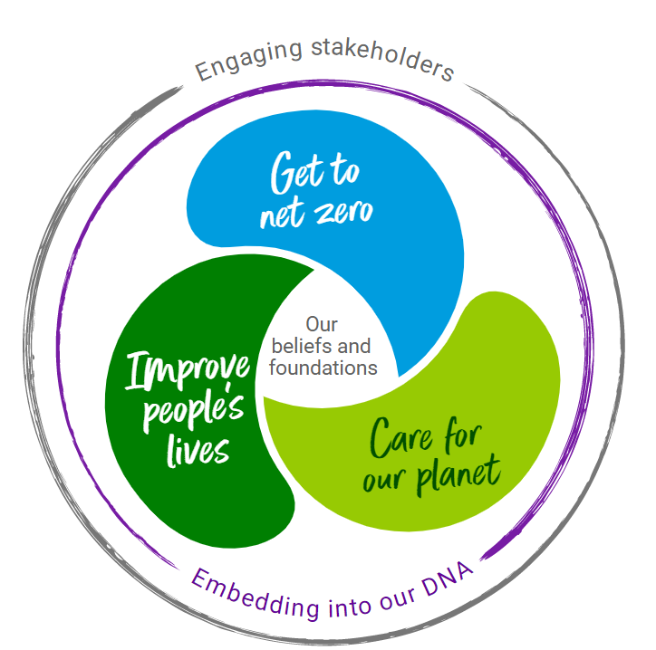
Figure 2: Implication of a sustainability frame
(Source: Kootenaie and Kootenaie, 2021)
From the above figure, it can be demonstrated that the sustainability frame often underpins long-term strategies to become an integrated form of energy company. It is also essential in evaluating and translating the part and purpose of business into actions. Using a sustainability frame is also necessary for setting out aims in different areas; their management believes that they can make the most significant difference for business undertakings, stakeholders, and from society's point of view (Kootenaie and Kootenaie, 2021).
Aims and objectives that are undertaken by management at BP include:
- Demonstrating ten purposes for getting BP to attend NetZero strategy that, in turn, will help in improving the lives of people (Lai, Sun and Ren, 2018).
In the financial year 2020, management at BP decided to set the goal of achieving net zero Company by the end of 2050, which will, in turn, help the world reach net zero. Another aim that a specified Company can undertake is improving people's lives as they often recognize the Benefits of providing access to energy in the billing system and aim at supporting the energy level of transition. It also aims at treating people or staff with high respect, providing support to help healthcare, managing well-being, enhancing diversity and equity, and inclusion strategies. The five people at BP often aim to build solid and stringent social impact and managing requirements that can mitigate risk while promoting the operation management system (Sun et al. 2020).
In the context of caring for a planet, the five-planet strategy at BP aims at covering the enhancement of a biodiversity process, the implication of water management along with the promotion of a nature-based solution. It also includes reducing or removing carbon-based emissions, circularity, and promoting sustainable purchasing (Copacino, 2019).

Engaging with different stakeholders
In the context of promoting the process of collaboration, it helps in achieving strategic as well as sustainable goals. At BP, engaging different stakeholders can take place by managing commercial partnerships with other cities and corporations. In words of Verhoeven, Sinn and Herden (2018), operating partnership is also beneficial as it helps meet decarbonization goals by forming a strategic level of collaboration. Apart from that, in the context of engaging different stakeholders, top-level executives need to use shared initiatives to raise standards and set new benchmark-based sustainability. Apart from that, in promoting engaging stakeholders, management has to encourage the investors' level of engagement. Joint advocacy can also be followed to promote engagement with other stakeholders and share knowledge and learning processes (Perboli, Musso and Rosano, 2018).
The approach to sustainability followed by BP is estimated to be targeted, systematic, and collaborative. It often rests on the fact that it was building robust and practical foundation guides promoting safety purposes and managing non-negotiable commitments to gain ethics and compliance. In words of Chen et al. (2019), the top-level executive associated with a BP often aims to set a high standard for Maintaining ethics and compliance with the following code of conduct. The management team also creates value for the society for different purposes, including their product and services and managing the compelling relationship between an employee and a taxpayer. The value creation at a BP can also be promoted by using participants of a supply chain or investors in local communities (Chen et al. 2019).
In terms of gaining a competitive advantage, pm management aims to promote safety precautions as their core value. Safety is often underpinned by using an operating-based management system [OMS], which usually sets out the procedure for delivering safe, reliable, sustainable modes of operation in the business (Verhoeven, Sinn and Herden, 2018).
Within10 financial years management team at BP aims to increase the low annual rate of carbon investment by 10-fold, which can be estimated at $5 billion in a particular financial year. In the context of delivering or managing net-zero ambition, management needs to focus on reducing emissions associated with carbon during oil and gas production by an estimated 35 to 40% by the end of the financial year 2030. Other objectives include reducing the intensity of cardboard based on a different product sold by more than 15% by the end of 2030 (Lai, Sun and Ren, 2018).

Transformation at BP, UK
By the end of the financial year 2030, the Management Group of BP aims to become a different type of energy-based Company. In the context of evaluating these changes, management aimed at carbonizing along with diversifying various activities of a business (Sun et al. 2020).
By the end of 2030, the marketing department has estimated to reduce oil and gas production and reduce emissions. In addition, they also aim at keeping up cash flow by maintaining high grading of a portfolio along with growing bioenergy. Investing in low-carbon energy is often effective as it aims at rapidly scaling up in the context of solar and offshore wind. It is also essential for developing new and innovative opportunities that, in turn, will promote the capture of carbon along with hydrogen (Copacino, 2019).
While switching on 1,00,000 EV-based charging points and initiating more than 1000 strategic convenience-based sites. The management team at BP decided to double the five-transition growth rate of a business and conduct the process of planning for more than 40% Of the total amount of capital investment. The means need to invest in bioenergy promoting convenience level, Using EV charging along with renewables and hydrogens by the end of 2050. It can also be demonstrated that Company BP often forms a partnership structure of the business with the significant purpose of accelerating change. Changes are an inevitable part of a business, as, without effective change, a company will fail to achieve its long-term objectives and gain profit. It is forming partnership management aimed at tackling climatic forms of changes that have failed to be performed in isolation as it often needs everyone to pull together strategies of a business. This is considered to be a top reason for the marketing team at BP to form a collaboration with different expectational partners across various cities and corporations on a journey towards achieving net zero (Perboli, Musso and Rosano, 2018).

Maximizing satisfaction of a customer
A BP manager must understand customers' demands and needs meds, as, without them, A business cannot achieve its long-term objectives. In addition, intending to promote customer satisfaction levels, a management team must create a custom form of a centric culture. Customers are considered an essential part of a business, as growing the base of customers can be achieved by delivering excellent products and services.
From the customer's and products' points of view, the management team at BP is innovating their strategies by using new business models. This business also uses different service platforms intending to deliver the future of mobility, managing energy, and services for long-term customers.
The management team decided on a transforming customer and a product for working together towards achieving business objectives. They often work together as an integrated team to provide different customer services by supplying excellent products globally. BP is considered to be proud of its customer-facing, global along with regional activity business. This business successfully manufactures and delivers Castrol-based lubricants, aviation-fulfilling processes, mobility, and convenience. Thus, it can be estimated that this business will collaborate with fuel suppliers and midstream. The team also aims to promote Future mobility along with providing a solution to customers to maximize value and develop customer offers. The commitment level at BP often aims at demonstrating a safe and reliable mode of operation that tends to remain unchanged from the past financial years, as safety is considered the core value of a business.
Team members at BP are primarily committed on:
- Putting preference for customers at the initial level. In this notion, it can be demonstrated that being agile, as well as responsive, is essential for managing changing needs of customers along with understanding the dynamic market structure
- The team at BP are also committed to focusing on growth as well as developing offers to customers which will aim to promote the operation of a business
- It also aims at optimizing the fuel-based value chain with the sole purpose of maximizing the integrated value of a business in the long term
- The team members are committed to contributing to reducing the intensity of carbon based on the product manufactured and sale by 50% by the end of the year 2050 or at sooner point in a time
- In the context of creating strategic partnerships that aim at driving long-term value for managing customers and products that are being digitally enabled. It also aims at empowering insights of customers along with working data to deliver effective solutions
Hence, based on the above discussion, it can further be demonstrated that customers are regarded as the driving force for energy broadband services being demanded. The management team will often unlock the power of collaboration by forming a team. Thus, this team is considered a customer-centric process was aiming to promote digital mode and analyze agile in business. It can be noted that team members often focus on meeting a customer's needs and wants, delivering efficient quality of products and services along with managing a low carbon-based Future.

Managing and evaluating the journey of customers
The customer journey can be defined as a customer's entire experience while being introduced to the Company and a brand. The five stages that can be used during a customer journey include promoting a high level of awareness, managing consideration, and the implication of a purchase. The other two stages are based on a customer journey that often has retention and promotes advocacy in the long run.
The customer journey can be managed by involving three activities: understanding users and their needs and wants and design an introduction to support the users and their goals. It also aims at orchestrating high-level interventions known to be personalized for each customer in conducting the operation of a business.
Managing a customer journey is considered an essential element in promoting the operation and activities of a business. The four components that can be incorporated into a customer journey include promoting the audience's engagement level and nurturing customers' needs and want smears. The other elements include leads converting into customers along with fulfilling expectation levels. It can further be demonstrated that a customer journey map is regarded as a visual storyline that shows a customer's engagement with service products and a brand. Creating a journey map often aims at putting the business organization directly in the mind of customers so that they can understand and notify the process needs along with a different perception of a particular customer.
In BP, the customer journey comprises different stages, from the presale stage of enhancing customer awareness to the post-sales level of advocacy. Top-level executives and business management need to understand each phase of the customer journey, which is key to attaining the success rate of a business. Understanding phases based on customer journeys can benefit business ventures in producing content. Producing content will, in turn, aids the customer in moving through the journey from initial attachment to post-sale.
The five different stages of a customer journey can be discussed as follows:
- A phase of raising awareness
Different customers' perspectives often initiate the awareness stage. Better end-users face a problem and continually look for answers. At this point, customers often seek to gain based educational content about the services that could assist them in solving problems.
- The consideration phases
During this phase, customers often compare the offerings made by business organizations to close competitors. In the present scenario, using blog content and managing success stories with email-based nurturing campaigns can aid business organizations in continuing engagement with different audience members.
- Purchase or Making decision phase
It can be a notified that for a marketing manager, the initial two phases are considered the most important as the time the continuous cap needs to capture and nurture leads. Customers at this stage commonly possess a short list of companies from where they will likely purchase where the final decision in regards to a particular product is decided.
- Retention phase
The last two phases of the customer journey often happen post-sale of a product. It can often be prompted that the sales representative is primarily responsible for making the sales, onboarding notions of customers, and waiting until the renewal time. However, it can be seen that a successful business organization often continues to market along with engaging different customers. Engaging customers in business aims to promote the customer's life cycle, which in turn helps to achieve higher profitability in business and probably other products.
In the retention phase, a business organization can often incorporate loyalty, A loyalty-based program, or a knowledge-based FAQ. In addition, top-level executives must regularly communicate with a company or manage a product advancement to different customers. A business organization needs to hold regular training sessions for various products or offer other promotional processes throughout the entire lifecycle of a customer. Integration of a standard mode of communication between the top-level executive and lower level of staff can often lead to enhanced customer engagement, Furthering the education level and providing value for customers.
From a report, it can be demonstrated that retention is considered to be one of the most effective strategies that can be undertaken by any business rather than the customer acquisition process. If any business organization can decrease the turnover rate, it often aims to enable ten positive customer experiences and offer higher quality goods and services in the long term. In this notion, it can be believed that word of mouth can be considered one of the most effective marketing strategies that and that can be used for spreading and passing the information of possessing a quality-based product.
- Advocacy phase
The stage of advocacy often accompanies a practical customer experience during a time of onboarding new customers. A business organization must understand the customer's expectations toward purchasing a product or a service. It can also be noted that satisfied customers aim to enhance the number of other prospects in business. The advocacy of customers can often result in leading word-of-mouth marketing which can, in turn, many new customer purchases for purchasing the brand. Apart from advertising strategy, word of mouth is regarded as an effective strategy that also aim at attracting large customers following referral strategies. On the other hand, usages of social media marketing can also be considered to be an essential marketing strategy that are used by marketing team at BP to promote the operational strategy in long term.

Conclusion
Hence, based on a buffer discussion, it can be concluded that to achieve a business's long-term success, a brand manager must promote awareness in the context of enhancing a business's operation and demonstrating the customer journey. A recommendation can further be provided that in terms of promoting satisfaction level of a customer practical communication tools need to be used that helps to mitigate lack of a misunderstanding and meeting the customers' expectation. Managing of a customer journey is important as it aim at enhancing the operation of business, promoting business activities and gaining high rate of productivity. Hence, based on above for discussion it can also be a concluded that using social media channels are considered to be one of the best marketing strategies that can be incorporated. Social media channels are also essential to promote the operation of a business and thereby earning high amount of profit.

Reference list
Bob, F., Jumadil, S. and Marlena, G., 2020. Communication strategy planning in influencing the intention to visit: An implication to marketing management. Polish Journal of Management Studies, 22(1), pp.117-133.
Bp.com. (2021), Our strategy. Available at: 12th November 2022 from: https://www.bp.com/en/global/corporate/what-we-do/our-strategy.html
Brown, D., Foroudi, P. and Hafeez, K., 2019. Marketing management capability: the construct and its dimensions: An examination of managers’ and entrepreneurs’ perceptions in a retail setting. Qualitative Market Research: An International Journal
Chang, C.L., McAleer, M. and Wong, W.K., 2018. Big data, computational science, economics, finance, marketing, management, and psychology: connections. Journal of Risk and Financial Management, 11(1), p.15.
Chen, D., Ignatius, J., Sun, D., Zhan, S., Zhou, C., Marra, M. and Demirbag, M., 2019. Reverse logistics pricing strategy for a green supply chain: A view of customers' environmental awareness. International Journal of Production Economics, 217, pp.197-210.
Chen, D., Ignatius, J., Sun, D., Zhan, S., Zhou, C., Marra, M. and Demirbag, M., 2019. Reverse logistics pricing strategy for a green supply chain: A view of customers' environmental awareness. International Journal of Production Economics, 217, pp.197-210.
Chernev, A., 2018. Strategic marketing management. Cerebellum Press.
Copacino, W.C., 2019. Supply chain management: The basics and beyond. Routledge.
Deepak, R.K.A. and Jeyakumar, S., 2019. Marketing management. Educreation Publishing.
Iacobucci, D., 2021. Marketing management. Cengage Learning.
Kootenaie, M.F. and Kootenaie, S.M., 2021. Investigating the Impact of Information Technology on Marketing Management and Shahrvand Store Performance chains. Journal of Social, Management and Tourism Letter, 2021, pp.1-7.
Kootenaie, M.F. and Kootenaie, S.M., 2021. Investigating the Impact of Information Technology on Marketing Management and Shahrvand Store Performance chains. Journal of Social, Management and Tourism Letter, 2021, pp.1-7.
Kotabe, M.M. and Helsen, K., 2022. Global marketing management. John Wiley & Sons.
Kotler, P., Keller, K.L., Ang, S.H., Tan, C.T. and Leong, S.M., 2018. Marketing management: an Asian perspective. Harlow: Pearson.
Krings, W., Palmer, R. and Inversini, A., 2021. Industrial marketing management digital media optimization for B2B marketing. Industrial Marketing Management, 93, pp.174-186.
Lai, Y., Sun, H. and Ren, J., 2018. Understanding the determinants of big data analytics (BDA) adoption in logistics and supply chain management: An empirical investigation. The International Journal of Logistics Management.
Marinchak, C.M., Forrest, E. and Hoanca, B., 2018. Artificial intelligence: Redefining marketing management and the customer experience. International Journal of E-Entrepreneurship and Innovation (IJEEI), 8(2), pp.14-24.
Martínez-López, F.J., Merigó, J.M., Gázquez-Abad, J.C. and Ruiz-Real, J.L., 2020. Industrial marketing management: Bibliometric overview since its foundation. Industrial Marketing Management, 84, pp.19-38.
Perboli, G., Musso, S. and Rosano, M., 2018. Blockchain in logistics and supply chain: A lean approach for designing real-world use cases. Ieee Access, 6, pp.62018-62028.
Sun, L., Zhao, Y., Sun, W. and Liu, Z., 2020. Study on supply chain strategy based on cost income model and multi-access edge computing under the background of the Internet of Things. Neural Computing and Applications, 32(19), pp.15357-15368.
Verhoeven, P., Sinn, F. and Herden, T.T., 2018. Examples from blockchain implementations in logistics and supply chain management: exploring the mindful use of a new technology. Logistics, 2(3), p.20.

