The Astronautical Orientations of Minoan Palace Courtyards: Their Link to Star Path Navigation, Maritime Trade Routes & Mythology

Alessandro Berio
Dissertation submitted in partial fulfilment of a Master of Arts in Cultural Astronomy and Astrology at the University of Wales Trinity Saint David, 2021

Word Count: 15,740

Master’s Degrees by Examination and Dissertation
Declaration Form
1. This work has not previously been accepted in substance for any degree and is not being concurrently submitted in candidature for any degree.
Name..Alberto Alessandro Berio
Date …September 29, 2021
2. This dissertation is being submitted in partial fulfilment of the requirements for the degree of …M.A. Cultural Astronomy and Astrology
Name..Alberto Alessandro Berio
Date …September 29, 2021

3. This dissertation is the result of my own independent work/investigation, except where otherwise stated.
Other sources are acknowledged by footnotes giving explicit references.
A bibliography is appended.
Name..Alberto Alessandro Berio
Date …September 29, 2021

4. I hereby give consent for my dissertation, if accepted, to be available for photocopying, inter- library loan, and for deposit in the University’s digital repository
Name..Alberto Alessandro Berio
Date …September 29, 2021
Supervisor’s Declaration.
I am satisfied that this work is the result of the student’s own efforts.
Signed: …………………………………………………………………………...
Date: …………………………………………………………………………..

Table of Contents
Table of Contents 3
List of Illustrations and Tables 5
Acknowledgments 7
Abstract 8
Introduction - Academic Rationale 9
The Archaeological Sites 10
Minoan Palace Courtyards 12
The Archaeoastronomy of Crete 14
Summary 16
Minoan Maritime Trade 17
Minoan Trade Routes 20
Egyptian Trade 23
Levantine Contacts 24
Maritime Proficiency 26
Summary 27
Ethnographic Parallels 28
The Basics of Star Path Sailing 29
Using The Sidereal Compass 32
Azimuths Not Declinations 35
Astronautical Orientations 37
Summary 40
Star Sailing in the Aegean 41
Constellations as Mnemonic Devices 42
Historical Evidence of Star Navigation 44
The Star Myth of Europa 46
Summary 48
In The Field 50
Instruments 50
Methodology 51
Discussion 56
Knossos to Sidon 60
Knossos to Tyre 64
Phaistos to Qatna and Kadesh 66
Phaistos to Byblos 69
Malia To Kabri or Akko 72
Zakros to Pelusium 73
Conclusion 77
Appendix 79
Bibliography 80

List of Illustrations and Tables

Fig. 1 Map of Minoan Crete with sites cited in the study. Google Earth Pro. 12
Fig. 2 Doxtater’s proposal of geometric alignments between sites in Minoan Crete. Doxtater, p. 9. 14
Fig. 3 Circular Bronze Age trade route around the Mediterranean. Hesse, p. 55. 19
Fig. 4 Predominant surface currents of the Mediterranean. Hesse, p. 54. 21
Fig. 5 Sea routes between the Aegean and Cyprus as conjectured by Davis. Davis, p. 68. 22
Fig. 6 Star path steering for course adjustments due to currents. Goodenough and Thomas, p. 13 31
Fig. 7 Carolinean sidereal compass with orientations toward islands. Lewis, ‘Navigators’, p. 108. 33
Fig. 8 Carolinian star compass. Lewis, ‘Navigators’, p. 142. 34
Fig. 9 Celestial coordinate system with the azimuth and altitude centered on the observer. Markus Nielbock, ‘Navigation in the Ancient Mediterranean and Beyond’, arXiv preprint arXiv:1708.07700: (2017), p. 2 36
Fig. 10 A Gilbertese sky dome. Lewis, ‘Voyaging’, p. 9 37
Fig. 11 Aurorae navigation stone orientations with estimated target islands. Akira and others, p. 114. 39
Fig. 12 Line drawing detail of the ship procession fresco at Thera after Wachsmann. Wachsmann, p. 92. 41
Fig. 13 Drawing renditions of early Cretan seal stones depicting sailing galleys after Evans. Evans, ‘Nilotic’, p. 207. 42
Fig. 14 Bronze Roman coin from Sidon, 2nd century ce, 24 mm. Europa on the bull of Zeus. Alfredo De La Fe, p. 1. 48
Fig. 15 Knossos measured orientations. Red arrow indicates in situ measurements, blue arrow indicates virtual measurements. 52
Table 1. List of the measurements of the palace courtyard with axis adjusted for an east-west orientation. 56
Fig. 16 Radar plot showing measured azimuth orientations of Minoan palace courtyards. 57
Table 2. Comparison of palace courtyard axes with rhumb line azimuths of possible trade route destinations. 58
Fig 17. Rhumb lines between palaces and non-Minoan ports associated to courtyard orientations and star paths. 59
Fig. 18. Distance between Knossos and Sidon. Google Earth Pro. 61
Fig. 19 Recreation of a Minoan bowsprit aiming at Spica setting, following the rhumb line from Sidon to Knossos. 62
Fig. 20 Etesian summer winds in the Eastern Meditarranean. 63
Fig. 21. Skyscape visualization of a rhumb line navigation from Knossos to Tyre along the Antares star path during the Old Palace Period. 65
Fig. 22. Direct route through Cyprus to Qatna. Google Earth Pro. 67
Fig. 23. Terrestrial trade routes in the Bronze Age. 68
Fig. 24. Skyscape visualization of a rhumb line navigation from Phaistos to Qatna or Kadesh along the Betelgeuse star path during the New Palace period. 69
Fig. 25. Phaistos New Palace orientation (A), Old Palace orientation (B), oblique ‘drain’ (C). Google Earth Pro. 70
Fig. 26 Rhumb line from Zakros to Pelusium on the Nile Delta. Google Earth Pro. 74
Fig. 27 Minoan Rhumb Lines Between Zakros and Pelusium associated to courtyard orientation and star paths. 75
Fig. 28 Map of proposed Minoan star path direct trade routes to the Levant and Egypt. Google Earth Pro. 77
Fig. 29. Zakros virtual measurement of the place courtyard. Google Earth Pro. 79
Fig. 30. Malia virtual and live fieldwork measurements. Google Earth Pro. 79

Acknowledgments

First and foremost, I would like to thank my advisor Dr. Bernadette Brady, whose guidance, dedication, and encouragement was of inestimable value for the completion of this dissertation. I am very grateful also to Dr. Nick Campion, Director of the Sophia Centre, for his help throughout the M.A. program; as well as the other tutors in the Cultural Astronomy and Astrology program at the University of Wales Trinity St. David. My special thanks to Dr. Kostis Christakis, the Knossos Curator at the British School of Athens, who instructed me on the sites to visit in Crete, and also very graciously permitted me to research at their library.

Abstract

A debate has grown over the years as to the reasons for the orientations of the Minoan palace courtyards, which eschew any evident systematic pattern. The dissertation explores if these orientations may have been cultural and architectural manifestations of star path navigation trade routes. The ample archaeological proof of contact between Crete, ancient Egypt, and the Levant underscores the reliance of Minoan civilization on seaborne exchange cycles. Therefore, the study begins by establishing the extensiveness of the Minoan mercantile network in the Mediterranean.
The research then presents the argument that Bronze Age sailors made direct maritime routes on the open sea involving nocturnal voyages. The historical record supports the view that steering by the stars was known by at least the Greek age and perhaps even earlier. An ethnographic analysis of Polynesian and Micronesian star sailing techniques introduces new means of understanding how Bronze Age sea routes may have been established and navigated by the Minoans.
With these insights, the dissertation advances a new methodology that combines traditional archaeoastronomy fieldwork, virtual analysis of long-distance loxodromic measurements, and star path azimuths to ascertain possible astronautical orientations. The results appear to indicate within a high degree of certainty that the Minoans oriented their palace courtyards toward major ports and cities on the Levantine and Egyptian coastline via star paths of high magnitude stars.

Introduction - Academic Rationale

This research aims to investigate if Minoan palace courtyards were oriented toward significant star paths which may have been used for steering toward important trade route destinations that imbued historical and commercial significance to Bronze Age Cretans. While it has been suggested that the Minoans and other Bronze Age Mediterranean cultures may have used celestial navigation techniques, there has been no detailed and in-depth analysis of this hypothesis.
Clive Ruggles defines archaeoastronomy as ‘the study of beliefs and practices concerning the sky in the past, particularly in the absence of written records, and the uses to which people’s understanding of the sky was put.’ This deficiency is indeed one of the challenges imposed by Minoan culture, where its systems of writings, Linear A and Cretan Hieroglyphs, resist decipherment. The obscurity of Minoan culture persists even though quintessential elements of it were inherited by the Mycenaean civilisation, which co-opted and expanded its trade routes, of which only archaeological evidence remains. As such, there is a lacuna of knowledge regarding specific sea-borne trade routes and Minoan navigation techniques.
The lack of academic consensus on the motivations for the orientation of Minoan palace courtyards generates uncertainty within archaeoastronomical discussions of Bronze Age Crete. The research methodology attempts to resolve this issue by matching the azimuths of the Minoan palace courtyard axes with loxodromic long-distance orientations, or rhumb lines, toward historically significant localities across their Mediterranean trade network. The orientations were aligned with star path azimuths that may have been used in a hypothetical Minoan celestial navigation tradition to reach particular destinations. The archaeological record, literary corpus, and astral mythologies were analysed to provide a cultural context for the proposed alignments.

The Archaeological Sites

The Island of Crete, the most sizeable in the Aegean, measures 250 km wide and towers mountain ranges that thrust 2456 m high (Mt. Ida). Neolithic farmers inhabited Knossos since at least 7000 bce. Excavations of the Bronze Age civilisation, denominated the ‘Minoans’ by Arthur Evans, commenced in the late 19th century. Although Minoan civilization spanned from circa 3650-3500 bce to the Late Bronze Age, the period which will be investigated is from around 1900 bce, or the Old Palace period, until the end of the New Palace period around 1500 bce. Jan Driessen situates the early Minoan palaces as ‘monumentalised courts’ five hundred years prior in the Prepalatial period, or circa 2400 bce. The grand rectangular central courtyards, oriented north-south on the long axis, are the defining architectural characteristic of the four recognised Minoan ‘palaces’ analysed in the current research: Knossos, Phaistos, Zakros, and Malia (Fig. 1). The smaller sites of Gournia, Petras, Kommos, and Galatas, also contain rectangular courtyards, although they are outside of the scope of this research, along with the unexcavated palace of Kydonia.
Driessen argues that, ‘that the Central Court was the “raison de vivre” of a Minoan “Palace”’. He suggests the Minoan courtyards may be compared to New World ceremonial centres, serving as integrating devices for a wider area. In Pre-Columbian archaeology, these centres were an enclave of public buildings, including shrines and market places, where scattered populations converged seasonally to feast, dance, and have cultic processions. According to Warren DeBoer and John Blitz these centres were ‘a calendar, court, church, and necropolis all wrapped up in one’. Driessen observes how the Protopalatial raised walkways orchestrated ritual circulation patterns that culminated in the central courtyard. Nanno Marinatos argues that ideological considerations inspired the architectural uniformity of the nucleic courtyards which functioned as an imago mundi.
The central courtyard of the Palace of Minos at Knossos is a monumental open quadrangle of almost 54 by 28 m. Once ruled by the legendary King Minos, the complex was the most sprawling of the palaces in Bronze Age Crete. Minos was so revered in ancient Greece, he was mythologized as one of the judges of Hades. While Homer and Hesiod wrote of only one Minos, later accounts also name his grandson Minos, who like his grandfather was occasionally christened the son of Zeus. The second Minos commanded the powerful Minoan navy and was associated with the legends of the Minotaur and the labyrinth.
Phaistos, the legendary home of Minos’ brother Rhadamanthys, was one of the principal palaces of Bronze Age Crete, second only to Knossos. The site’s chronology comprises of two principle building phases: the Old Palace period and the New Palace period. The Phaistos Old Palace apparently aligns to the sacred Kamares cave on the Psiloritis mountain range. Meanwhile, the palace of Malia was constructed as late as the Middle Minoan IIIB or the beginning of Late Minoan IA, however, the Central and West Court may have existed from Early Minoan IIB. In any case, according to Driessen, the original Early Minoan IIA architecture was simpler and oriented differently. An archaeological excavation at the courtyard penetrated as far down as a red earth floor at the Middle Minoan IA stratigraphy. Zakros, the fourth site, was constructed during the New Palace period on the far eastern coast of Crete. With challenging terrestrial access, it may have acted as a significant hub of sea traffic from the East and the Southeast Mediterranean, which is highly indicative of mercantile relations with Egypt.

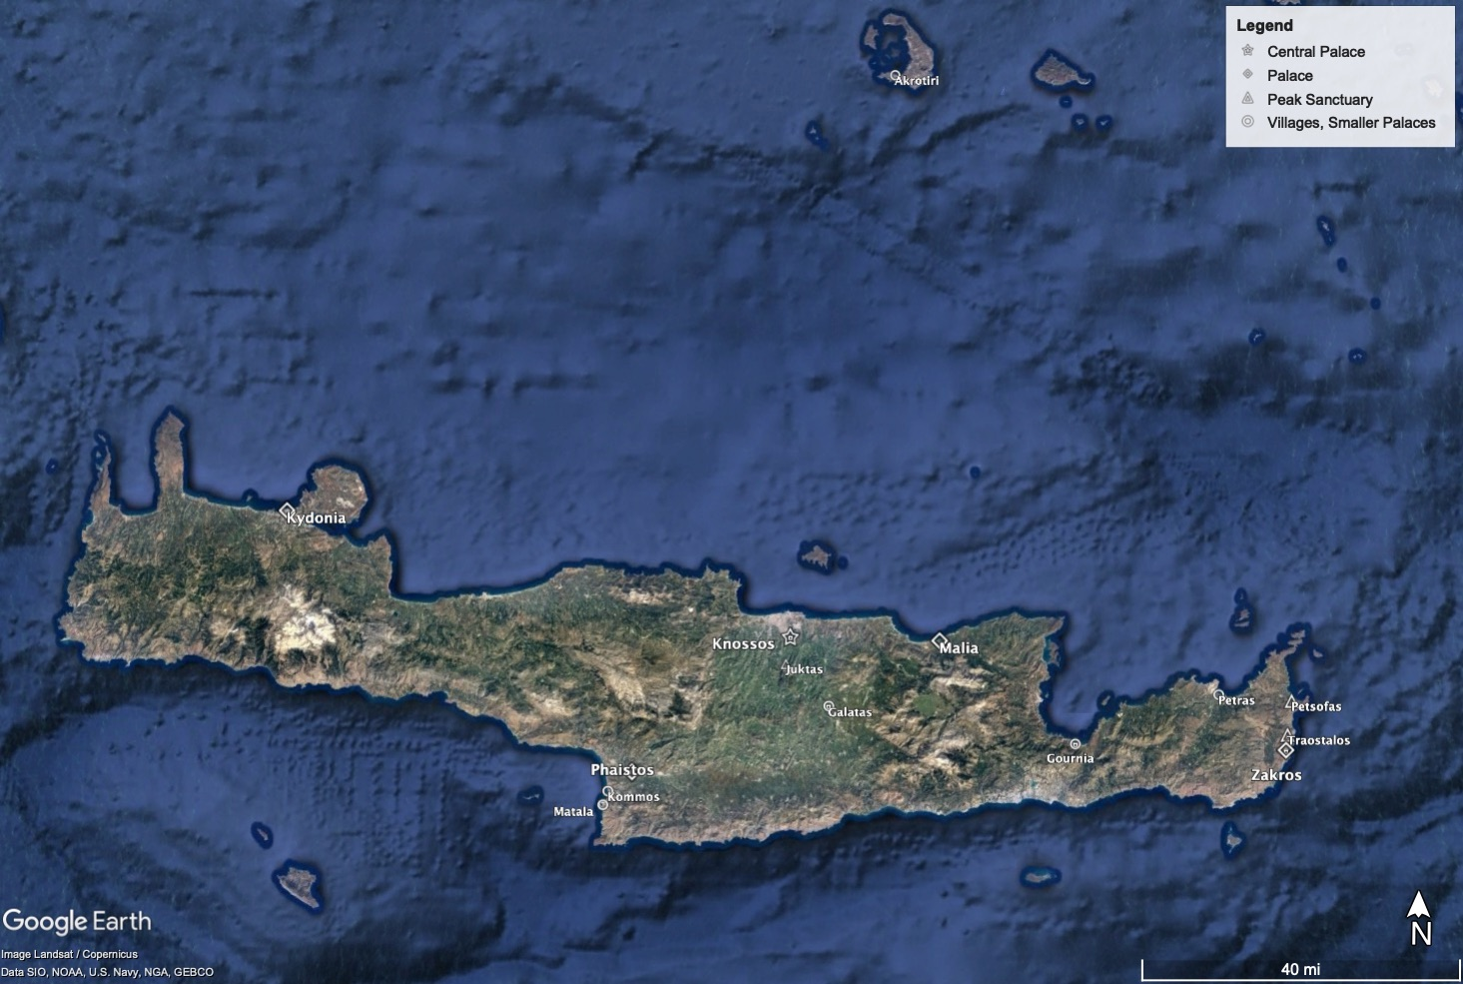

Fig. 1 Map of Minoan Crete with sites cited in the study. Google Earth Pro.

Minoan Palace Courtyards

An academic debate surrounding the motivations for the geometry and orientation of the Minoan palace courtyards has intensified over the last few decades. Although the courtyards are more extensive in the north-south direction, Evans advances the view that the rooms on the west side of the court served ceremonial functions; albeit, their specific purpose remains obscure to this day. Building on this theory, Joseph Shaw argues that the Minoans planned the palaces not with the long axis in mind, but for the shorter east-west orientation, due to the natural illumination entering the western façades where the supposed sacred structures were located. As Dennis Doxtater argues, however, Shaw does not arrive at any firm conclusions regarding his measurements, symbolic or otherwise.
The initial suggestion that the palaces were oriented toward distant geographies was put forth by W.E. Belknap in 1973, in the now unavailable paper, ‘A Guide to Cretan Sunrises’. As cited by Shaw, Belknap proposed the courtyard axes of Tiryns, Phaistos, Knossos, and Malia aimed at the same location on the coast of Northern Africa, near Tobruk at 32°N latitude. According to this same theory, Gournia directed its courtyard toward Delos. Shaw criticises this hypothesis:

Such a theory assumes, of course, that the Minoans were so skilled in astronomy and geography that they could make such a calculation, and also that they were quite knowledgeable about and concerned with the exact positions of Cycladic, Mainland, as well as North African sites, aside from certain omissions, archaeological incongruities, and certain errors in the method of estimating direction.

Belknap’s theory appears to have been hampered by faulty methodology, which Shaw criticised by pointing to errors in calculations and chronology.

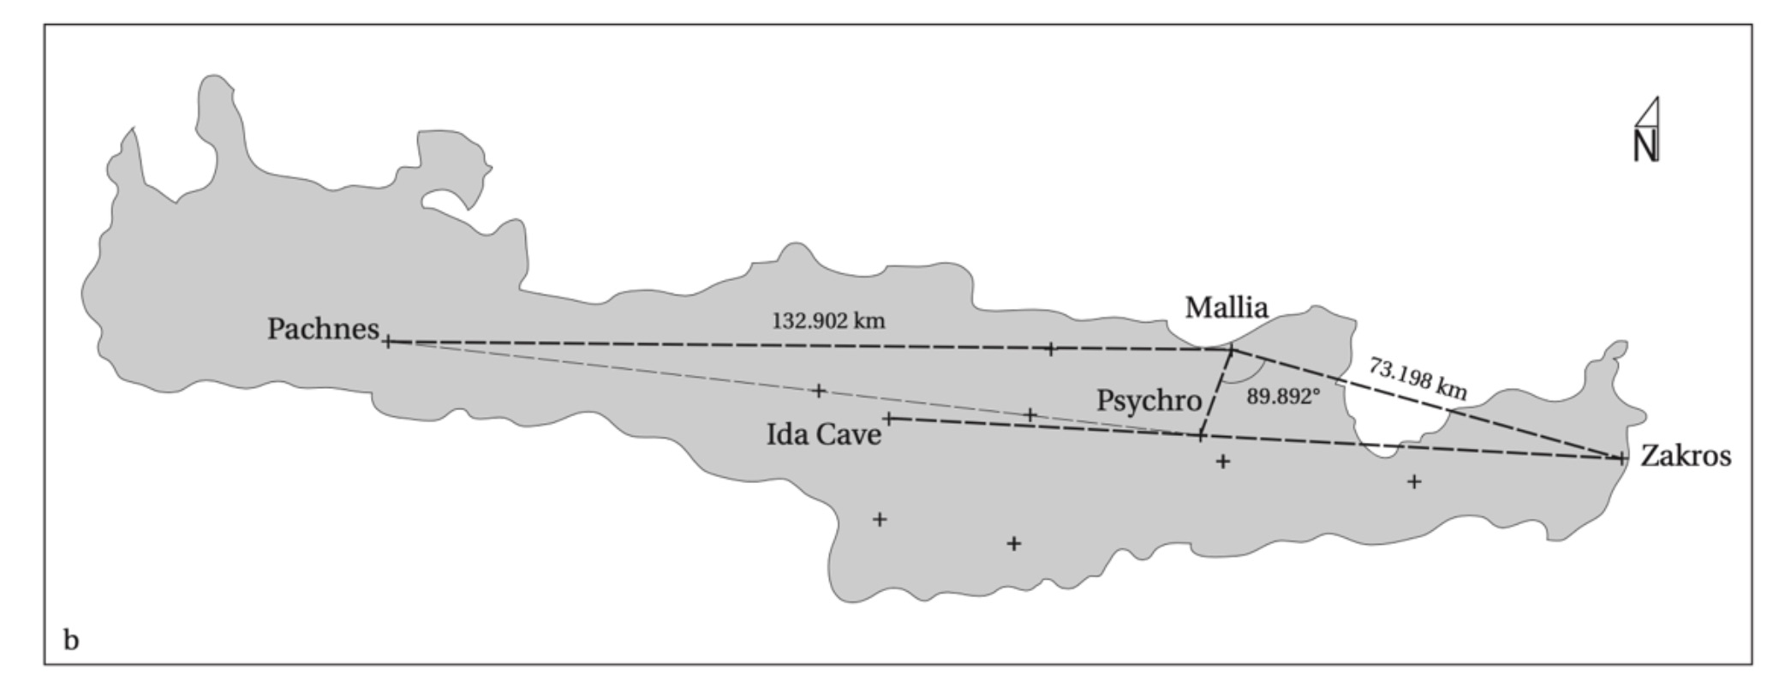

Fig. 2 Doxtater’s proposal of geometric alignments between sites in Minoan Crete. Doxtater, p. 9.

More recently, Doxtater’s contemporary geospatial methodologies propose that the Minoans situated the palaces with intentional geometric relations to each other and the sacred caves interspersed on the island. The twelve points in his analysis have Knossos as the apex of an island-wide design with the presence of a right angle between Psychro, Malia, and Zakros (Fig. 2). According to Shaw, there is ‘little evidence to indicate Minoan expertise in long-range observation and complex geographical measurement’. Doxtater cites the signal fires lit 177 km apart as disclosed in Aeschylus’ Agamemnon as substantiating the feasibility of long-distance surveying. However, Doxtater does not go further in proposing an intentional geometric relationship between Crete and coastal sites around the Mediterranean.

The Archaeoastronomy of Crete

The Uppsala Project, led by Mary Blomberg and Göran Henriksson, surveyed various Minoan sites around Crete. They propose that the slight variability in the orientation of the west and older side of the Phaistos palace courtyard, as compared to the New Palace orientation, ‘is nearly equal to the rate of precession of the equinoxes in 150 years’. Notwithstanding that, they acknowledge the shift is eastwards while precession actually progresses westwards. They hypothesise that the long axis of the central courtyard of Phaistos was oriented toward the star Canopus (α Car) without direct sightline behind the mountains to the South of the palace.
Blomberg and Henriksson’s survey of Minoan open-air mountain top temples, known as peak sanctuaries, corroborate the link between the Minoan skyscape and celestial navigation. Their results constitute evidence that the peak sanctuaries of Petsophas, Traostalos, Juktas, Pyrgos, Gonies, Vrysinas, the palaces at Knossos, Gournia, Malia, Phaistos, Zakros, and the villas at Agia Triada, Tylissos, Vathypetro, ‘all show orientations to significant celestial events’. They indicate that a wall at the peak sanctuary of Traostalos may be oriented toward the limits of the Northern circumpolar ring, composed of stars which never set below the horizon.
The researchers suggest that the walls at both Petsophas and Traostalos aimed toward Arcturus (α Boo), which the third century bce poet, Aratus, associated with tempestuous seas. According to Blomberg and Henriksson, the cosmical setting of Arcturus on the 11th of May and its heliacal setting on the 13th of October during the Middle Bronze Age, may have signaled the limits of the traditional sailing season as documented by Hesiod and Vegetius. They write that given the unimpeded view of the eastern horizon over the ocean from the mountain peak, and ‘the absence of obvious orientations towards the sun and the moon, may indicate that the site was specialised to the study of the stars for navigation’. With their towering vantage points, peak sanctuaries, such as Mount Juktas overlooking Knossos, provide a flat horizon profile which mimics the ocean’s expansiveness, conditioning a opportune circumstance for would-be celestial navigators to contemplate and learn the stars during night-time rituals. However, Blomberg and Henriksson do not make an unambiguous connection between celestial navigation and the Minoan palace orientations.

Summary

The defining feature of Minoan palaces was the central courtyard, whose reasons for orientations are still debated. While Belknap proposed that they pointed toward the coast of North Africa, Shaw insists this presumes the Minoans could make such calculations and were aware of these distant localities. Doxtater believes the palaces were laid out in geometrical relation to each other and to sacred caves around the island. Blomberg and Henriksson surveyed the peak sanctuary orientations and conclude that some mountain temples may have been associated with navigational stars.

Minoan Maritime Trade

At the crux of Minoan culture was its dependence on navigation and international trade. As Chryssolouaki writes, ‘The island’s geopolitical location gave it the opportunity to participate in a kaleidoscope of local cultures, a laboratory of civilisations’. Crete was at a safe distance from the coast of three continents while being at the crossroads of sea routes between the Hellespont, Asia Minor, the Levant, and the Nile Delta. Maritime navigation has prehistoric origins in the Island of Crete. Around 130,000 years ago, geologically dated Palaeolithic artefacts found in Crete suggest 15-20 kilometre sea crossings occurred in the Mediterranean. Broodbank and Strasser argue that Crete itself was colonised between the 8th to 7th millennium bce as a seaborne migration from Anatolia, to establish farming communities. There is evidence of 15–20 km open sea journeys to pre-Neolithic Crete around 15,000 years ago. Pieces of obsidian originating from Melos, in the Cyclades, were found in the Franchthi cave in the Argolid, suggesting maritime activity in the region dating to 11,000 years ago (Fig. 6).
Lionel Casson argues that the Minoan dominant navy and merchant marine may be deduced by the absence of fortifications on harbour cities and the extensive archaeological record of Minoan trade found throughout the Mediterranean. In his History of the Peloponnesian War, Thucydides famously describes a Minoan thalassocracy:

Minos is the first to whom tradition ascribes the possession of a navy. He made himself master of a great part of what is now termed the Hellenic sea; he conquered the Cyclades, and was the first coloniser of most of them, expelling the Carians and appointing his own sons to govern in them. Lastly, it was he who, from a natural desire to protect his growing revenues, sought, as far as he was able, to clear the sea of pirates.

Claude Baurain questions Thucydides’ claim of a Minoan maritime empire by contextualising it within the naval imperialism of a democratic Athens. However, the notion of a naval superpower finds support in the phenomenon described as the ‘Minoan Explosion’. In addition, the island’s centrality may have been spurred by its active participation in the economic and cultural burgeoning of the Bronze Age, while being an impetus for the internal development of the palace system.
Thomas Tartaron coalesces the view that Minoans and Mycenaeans may have participated in bilateral maritime exchange cycles with the Eastern Mediterranean, unlike previous conceptions of ex oriente lux, which proposed a unilateral influence from an advanced Near East to a barbaric Europe. Mediterranean Bronze Age trade was a multicultural and international affair with a ‘wide variety of people, of varying nationalities’ spurred by long-distance voyages made by specialised merchants. This is exemplified by the 14th century bce Ulu Burun shipwreck off the coast of Southern Turkey. It likely counted with two Mycenaean envoys aboard and was destined to the Aegean or the Mycenaean heartland on a circular trade route around the Mediterranean (Fig. 3). The exceptional discovery included:

[…]ox-hide-shaped copper ingots, tin ingots, glass ingots, pieces of ebony, an elephant tusk and hippopotamus tusks, Cypriote, Mycenaean and other pottery, faience beads, amber beads, a bronze weight, and individual luxury items, such as gold vessels, gold and silver jewelry, an ivory box, a bronze and gold figurine, seals, and amulets.

The objects aboard, from ten different ancient cultures, the primary of which were Cypriot and Canaanite, also included ‘northern Europe to tropical Africa and from Sicily in the west to Mesopotamia in the east’. The evidence points to multi-cultural and prosperous trade routes within the Bronze Age Mediterranean.

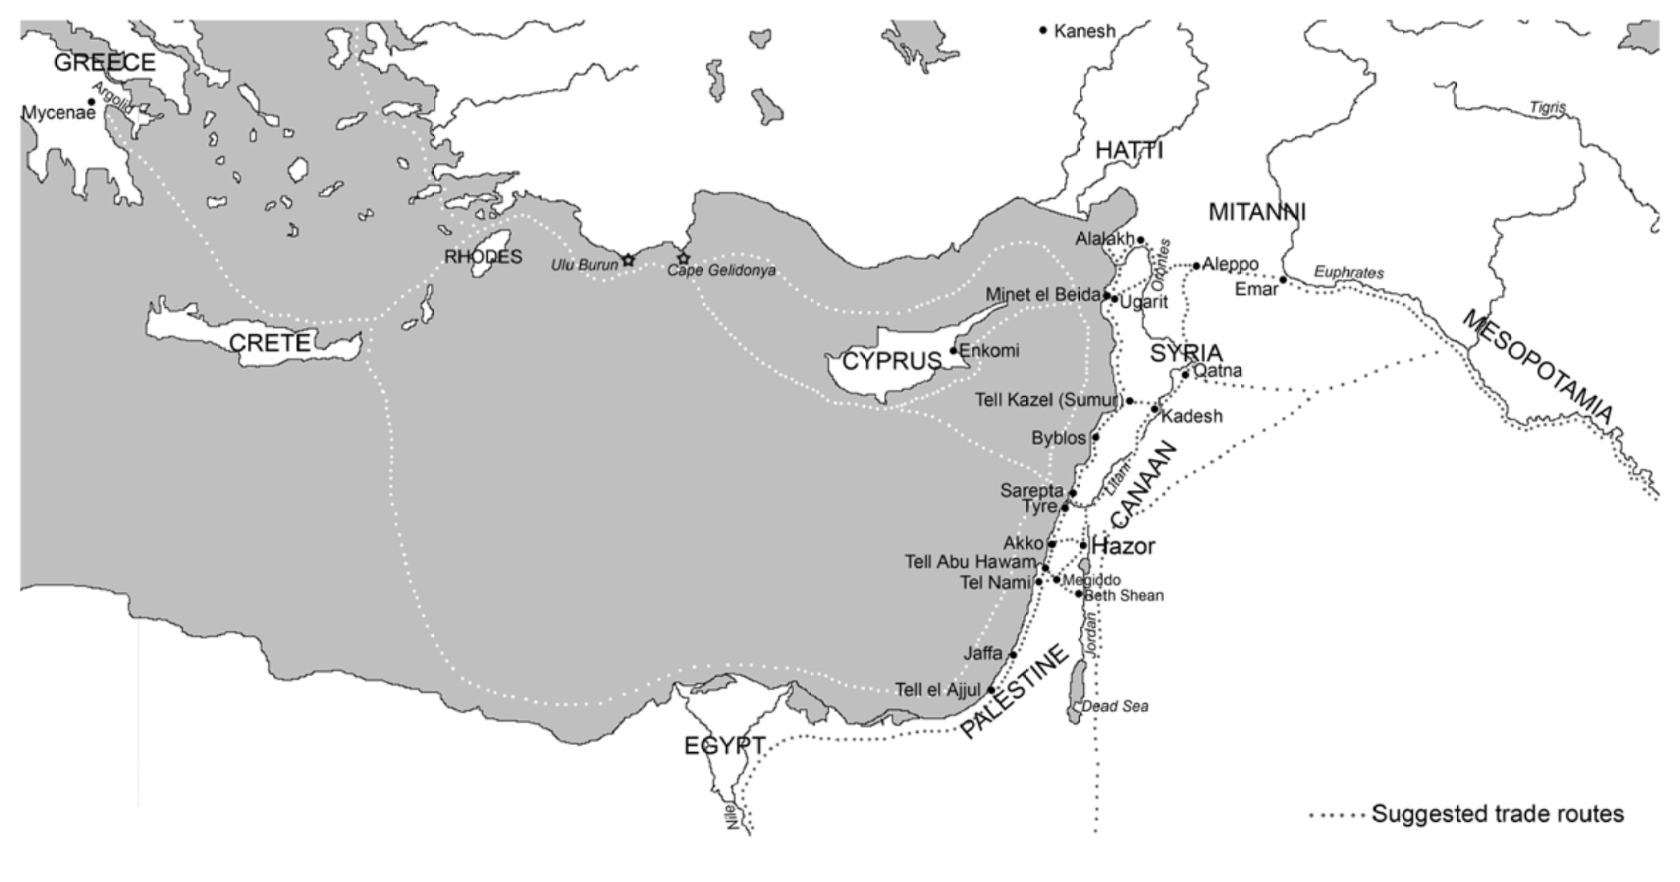

Fig. 3 Circular Bronze Age trade route around the Mediterranean. Hesse, p. 55.

At its essence, as Stella Chryssoulaki argues, a thalassocracy presupposes ‘control, vigilance and defense of trade routes’, which included the maintenance of sea routes and the protection of harbours. Safe sea routes enabled Minoan merchants to cross the Mediterranean and reach the Euphrates to trade tin at Mari or sail toward Egypt, purveying their coveted objets d’art. At the same time, skilful Cretan artisans painted vivid frescoes on palaces around the shores of the Mediterranean. The Minoan control of sea lanes and long distance trade networks persisted until the destruction of Crete during the Late Minoan IB ended the Neo-Palatial period, and Mycenaean elites overtook Knossos, the only functioning palace at the time.

Minoan Trade Routes

‘Life is lived, I reasoned, along paths, not just in places, and paths are lines of a sort. It is along paths, too, that people grow into a knowledge of the world around them, and describe this world in the stories they tell’. Tim Ingold

Rather than focusing on the actual paths navigated, discussions concerning the hypothetical shipping routes of the Bronze Age Mediterranean have centred on the locations where raw materials could be acquired, coastal locations where supplies were refreshed, and the final emporia where goods would be traded. To trace these navigation routes, as Chryssoulaki states, it is not enough to only calculate nautical distances between destinations, but also to analyse environmental factors, such as currents and winds, and also the political and economic factors (Fig. 4). Furthermore, to understand the Minoan maritime trade routes, one must understand the actual paths navigated and how they might have been sailed.

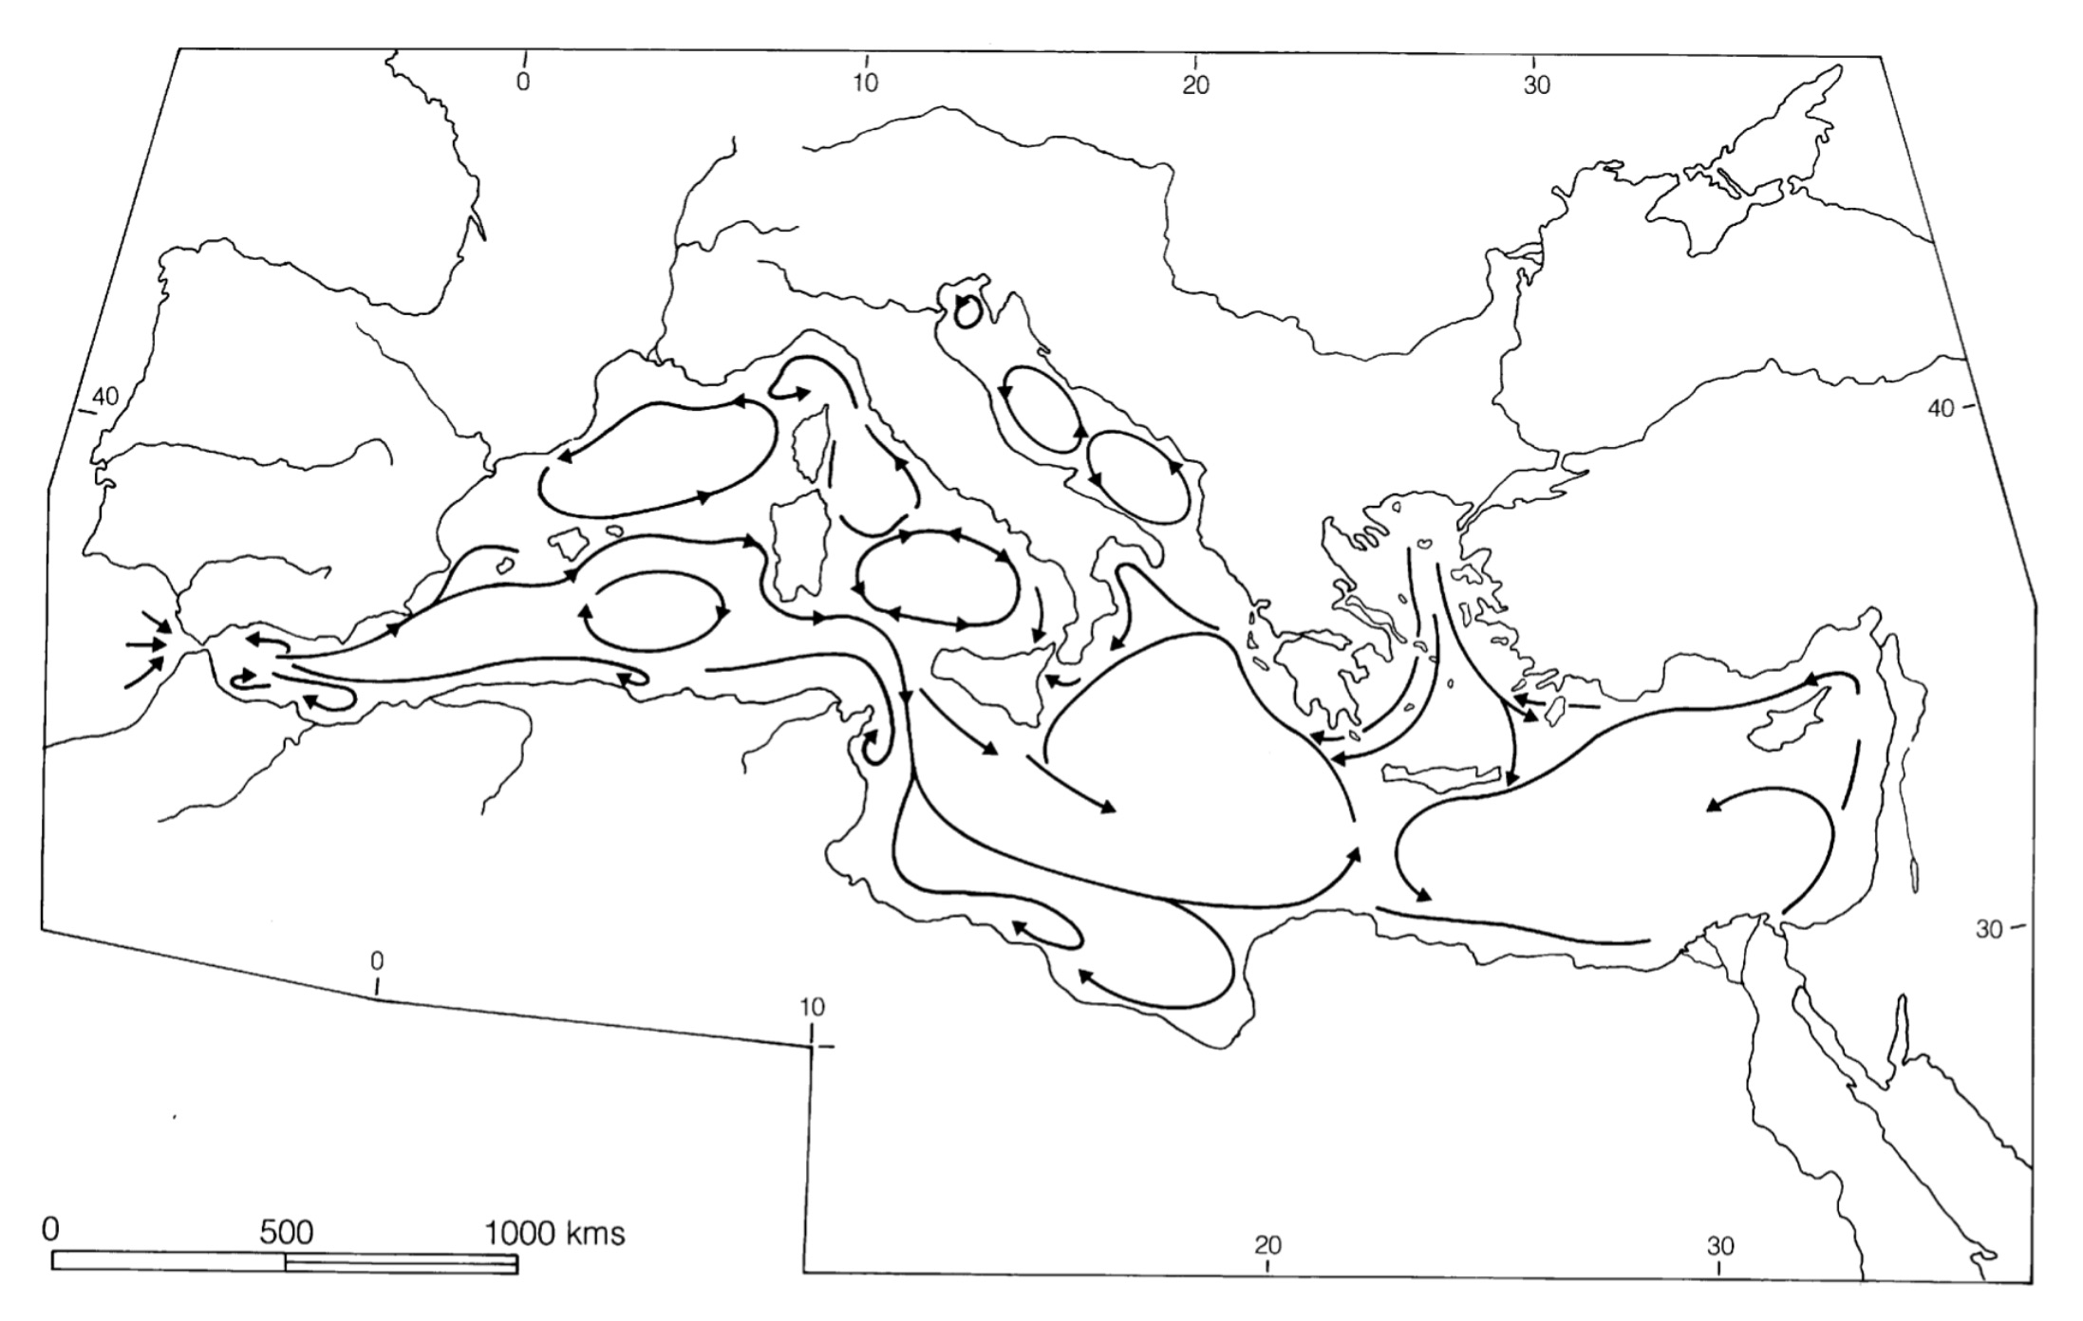

Fig. 4 Predominant surface currents of the Mediterranean. Hesse, p. 54.

Traditionally, it is believed that there were two main trade routes in the Eastern Mediterranean. Kristina Hesse explains:

The traditional view of the counter clockwise sea routes in the Eastern Mediterranean goes from the Greek mainland to Crete, south to Egypt, north to Syria-Palestine and Cyprus then completing the circle via the southern coast of Anatolia, Rhodes and the Cyclades. The clockwise route departs from Egypt to Crete and further into Mainland Greece. From there the journey continues via the Cyclades, Rhodes, Anatolia, Cyprus, Syria-Palestine and back to Egypt.

A third conjectured Minoan route went from Crete directly to Cyprus and then circled the island, following the coast of Anatolia, to Rhodes and back to Crete (Fig. 5).

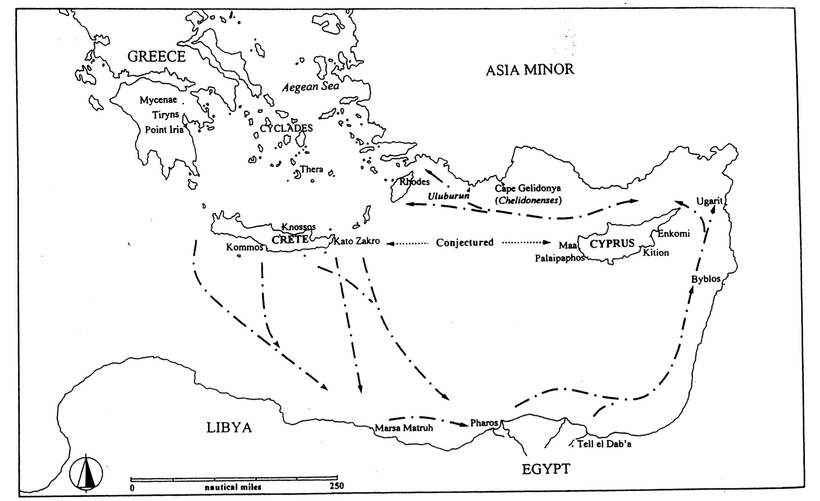

Fig. 5 Sea routes between the Aegean and Cyprus as conjectured by Davis. Davis, p. 68.

Despite these reconstructed circular itineraries, it is plausible that Bronze Age mediterranean sailors plotted direct routes to their destinations. Neil Puckett argues that coastal journeys may have been less efficient than direct lines toward destinations. He writes, ‘Unless the winds failed to cooperate, travelling directly to one’s destination would have been considerable faster. There are numerous ancient accounts of Mediterranean seamen sailing for multiple days in order to take direct routes from one point to another.’ It has been argued, although inconclusively, that the Minoans and Mycenaeans had the navigational and organisational skills to make direct voyages to Egypt and the Levant. The potential use of sea circulation, for instance, favoured voyages on the open sea, which were not necessarily even limited to summertime. Furthermore, Homeric characters often strayed from specific sea routes and got lost in meandering adventures, implying the existence of direct lanes toward destinations. Even the notion that ancient sailors stayed on land during the winter months, apprehensive of tempestuous weather, may be a modern fallacy as Puckett argues, since active winter voyaging is mentioned by Thucydides, Andocides, and in the Ahiqar text. Therefore, it may be conjectured that direct sea routes from Crete toward the Eastern Mediterranean may have been active.

Egyptian Trade

Egyptian ware excavated in Crete indicates maritime crossings and trade relations between the two coasts at the culmination of the Aegean Neolithic. Native Cretans adopted the sail probably via contact with Egypt between 2200-1950 bce. Although the possibility of their utilisation prior to this date cannot be excluded, according to Cyprian Broodbank, the sail transformed Aegean interactions with the East. The 12th Dynasty ‘Mit Rahineh’ inscription attests to distant sea voyages undertaken by the Egyptians of 20th century bce, while early Minoan boats depicted on seals resemble the kbnt 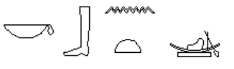, ‘Byblos’ ships. Direct trade between Crete and Egypt is evidenced by Egyptian pottery excavated at the Minoan site of Kommos, on the southern coast of the Crete, and Minoan sherds found at Marsa Matruh, on the coast of the Egyptian-Libyan border.
Depicted on the tombs of nobles from Thebes, dating to the reigns of Hatshepsut and Thutmose III, are a procession of inhabitants from kftyw 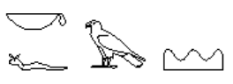 (Crete) and from the ‘The Isles in the Midst of the Sea’ bearing ornate tributes and royal gifts. There is also textual evidence of direct contact between the two cultures, from the so-called Aegean List inscribed on five statue bases on the mortuary temple complex of Amenhotep III (circa 1390–1352 bce). The list includes the ethnic identities: Tanaja (perhaps mainland Greece) and Keftiu. Then it lists the Cretan cities: Amnisos, Phaistos, Kydonia, Mycenae, Thebes, Kato Zakro, Methana, Messana, Nauplion, Kythera, Ilios (Troy), Knossos, Amnisos again, and Lyktos.
There is evidence of palatial gift exchanges from the Old Palace period with Egypt and the Near East, such as palatial Kamares ceramics, precious metal cups, fine textiles, and gold jewellery. The Minoans themselves were conferred royal gifts, such as an alabaster vase lid inscribed with the cartouche of Khyan, the Hyksos pharaoh of Avaris sent to the monarchs of Knossos. There is both archaeological and textual evidence attesting to diplomatic and mercantile relations between both Egypt and Crete.

Levantine Contacts

The reconstruction of Bronze Age maritime trade networks in the East Mediterranean is founded on speculation of presumed redistribution and reciprocity (gift exchange), rather than archaeological evidence of ports and naval yards. Nonetheless, by the Early Minoan II period, Crete had direct or indirect contact with the Levant, probably in search of natural resources with a likely primary destination of Byblos due to its substantial link with Egypt. Annette Sørensen compiles the current archaeological record of Minoica uncovered throughout the Near East, perhaps distributed from coastal emporia inland via intermediaries. The list should is not definitive, since the archaeological record may underrepresent trading colonies and networks. Nonetheless, Byblos tops the inventory with the largest surviving Minoan archive.
A tin inventory from Mari, dating to Zimri-Lim’s reign (circa 1780-1760 bce), is the first textual evidence of Minoan contact in the Levant. Shelley Wachsmann suggests that the presence of a bilingual Ugaritian interpreter conversing with a Caphtorite (Minoan) may indicate stronger ties between the two cultures than is currently understood. The Ugaritic god of handicrafts, Kothar-wa-Khasis, who constructed the legendary palace for the god Baal, was said to reside in Crete, perhaps confirming the high value prescribed to Minoan craftsmanship.
Archaeologists have uncovered Minoan-style murals painted on the palace walls of various locations across the Eastern Mediterranean and Egypt. These appear to embody a ‘trans-regional elite network’ which include discoveries at Tel Kabri, Alalakh, Qatna, and Tell el Dab’a (Avaris) in the Nile Delta. The sites appear to be at the western end of a sequence of palaces that stretch as far East as the Euphrates and the Tigris, suggesting the extensiveness of Minoan diplomatic relations. While it was initially believed the Alalakh murals were the work of travelling ‘Asian’ craftsmen, the discovery of the other murals has since returned agency to the Aegean by being considered technically and iconographically Minoan. Niemeier and Niemeier argue that the lack of archival evidence of inter-palatial exchange between Crete and the Near East, may be due to the fact that the Minoan Hieroglyphic and Linear A writing systems remain undeciphered.

Maritime Proficiency

Considering the extensive Minoan seaborne trade network, the question remains how the Minoans may have reached these remote locations. Until recently, historians discounted the possibility that ancient navigators could sail the open seas, much less at night. This was a standard view as exemplified by Thomazi’s 1947, Histoire de la Navigation, ‘Ancient peoples were mediocre sailors who were so afraid of the sea that they took every possible opportunity to travel by land. They would never sail at night unless they absolutely had to’. Chryssoulaki also believes that due to the possible limitations of Late Minoan I shipbuilding, long-distance travels far from shore and overnight sea voyages were unlikely.
However, contrary to earlier assessments, neolithic sailors already braved nocturnal sea journeys. During the later Palaeolithic and Mesolithic, paddled boats regularly crossed from the Argolid to Melos on open sea in stretches of 10 to 20 nautical miles. These voyages edged the limits of daylight, indicating nighttime sailing. According to Davis, the constraints of paddled craft and the maintenance of colonies on the Aegean Islands and Cyprus in the Final Neolithic suggest a ‘celestial navigation system embracing celestial observation was in place this early’. He points to the voyages from Crete to Thera, the closest Cycladic Island, whose distance of 50 nautical miles, suggests at least one overnight voyage. Due to the paucity of textual evidence, any understanding of possible Minoan celestial navigation techniques will have to be inferred from ethnographic parallels, iconographic representations, or posterior historical records from the Greek age.

Summary

Located at the crossroads of various sea routes, Crete has an ancient navigation tradition going back at least 15,000 years. The Minoans, with their naval supremacy, participated in exchange cycles with the Eastern Mediterranean. The Ulu Burun shipwreck from the Mycenaean age attests to the international multi-cultural trade networks. The control of these prosperous sea-lanes probably involved a counter-clockwise route from Crete to Egypt around Cyprus and back. However, a direct route from Crete to Cyprus and to other locations is also possible. Trade with ancient Egypt from Crete has a long history, with evidence dating as early as the Aegean Neolithic and the Middle Kingdom of Egypt. Minoica have been uncovered through the Near East, along with remnants of Minoan-style frescos in various foreign palaces. The prospect that Minoans had the proficiency to embark on direct voyages to Egypt and the Levant may be evidenced by later historical records of night time sailing and the fact that by the Neolithic sailors were already braving nocturnal sea crossings.

Ethnographic Parallels

‘A word of ethnography is worth a thousand alignments,’ Clive Ruggles.

Despite centuries of acculturation, ethnographic data confirms the presence of traditional star navigation in ‘Central Carolines and, to varying degrees, in the Santa Cruz Outer Reef Islands, Tikopia, Ninigo, the Gilberts and Tonga’. Getting their bearings by the stars, sun, wind and currents, Pacific Islanders sailed 50-200 nautical miles, distances comparable to those traveled by Mediterranean sailors. The hypothesis that Polynesia may have been settled by accident and not intentional star navigation, thereby undervaluing traditional techniques, was put forth by Andrew Sharp in the 1960’s. Computer modelling by Irwin and others have shown the unlikelihood of accidental colonisation of the Pacific Islands, underpinning the efficacy of stellar wayfinding techniques. Experiential archaeologists and anthropologists have also shown the viability of navigating by the stars in ancient water craft. For instance, anthropologist Marianne George documented the creation of traditional Polynesian voyaging canoe, the Vaka Taumako. Unlike previous reconstructions made since the 1960’s, Vaka Taumako was composed of only ancient materials, tools, and methods, allowing them to teach and preserve the dwindling art of star navigation.
A comparative analysis of surviving navigation traditions from the Pacific may illustrate how the Minoans may have navigated the Aegean and the Mediterranean. Puckett writes, ‘A comparable contemporary skillset used by Polynesian seafarers helps to identify techniques that may have been useful for the Phoenicians’. Davis proposes that ethnographic reports of time-tested celestial navigation techniques from Polynesia and Micronesia can be ‘productive and relevant’ comparisons that further our understanding of ancient mediterranean sailing techniques, since Pacific ‘inter island distances mirror those of the Eastern Mediterranean’. Likewise, Tartaron argues that ‘Ethnographic studies of seafaring in the Pacific are a good point of departure since they offer detailed reconstructions of maritime knowledge and its transmission in a nonliterate society’. These citations confirm the value of comparing Pacific navigation techniques with those from the ancient Mediterranean.

The Basics of Star Path Sailing

Fundamental to maintaining course by the stars is the observance of horizon stars as they rise or set. By memorising the stars on the same declinations, ‘star paths’ or linear constellations could be established to represent directions and facilitate recognition throughout the night. Lewis explains:

The most accurate direction indicators for Pacific Islanders, still used in many parts of the Oceania, are stars low in the sky that have either just risen or are about to set, that is, horizon or guiding stars. You steer toward whichever star rises or sets in the direction of the island you wish to visit. In more technical terms, the direction or bearing of your objective, that is, the course you must follow, is the direction (azimuth or bearing) of its guiding star, at rise if the course be an easterly one, at set if it be westerly.

When a star had risen too far up in altitude, the next star in a similar bearing was used in its location, thus creating a star path, known as ‘avei‘a by the Tahitians, as kaveinga (*‘ > k, *‘ >ng) by the Tongans and kavenga by the Tikopiam (whose island lie 2,500 miles westward from Tahiti). Compensating for winds and currents, navigators would use the boat’s rigging to maintain the guide stars on either bow or quarter, aligning toward the proper destination. Although a unique named star was used to identify and denote a star path, such as was the case in the Carolines, it would not connote the sum of the sailing directions to reach a location. However, it is rare for night voyages to require more than 10 guide stars, or circa 12 hours in the tropics. The star courses also represented geographic rather than actual navigation courses since they did not account for winds, currents and other ephemeral factors.
Due to shifting winds or the need to travel upwind, a sailor often maintains an irregular course, or a ‘traverse’, during a journey. Goodenough and Thomas describe how skilful Micronesian sailors dealt with this situation: ‘Navigators take advantage of opportunities to check the direction of swells against the stars. […] The navigator can steer by the alignment of these peaks or “wave nodes,” as he calls them’. By measuring their leeway angle, Micronesian navigators demonstrate how ancient sailors may have adjusted their course by aiming toward a particular star path, then depending on the currents, aim at another star, until correcting back later (Fig. 6). This fusion of skyscape and seascape in the Polynesian worldview is encapsulated by the language of the Gilbert Islands, which has no word for ‘astronomer’, as Grimble records, instead ‘If you would find an expert on stars, you must ask for a tiaborau or navigator’.

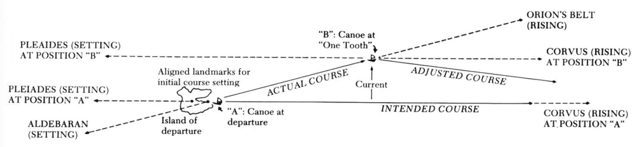

Fig. 6 Star path steering for course adjustments due to currents. Goodenough and Thomas, p. 13

There is some evidence that the Greeks were familiar with a concept analogous to star paths. Sergey Zhitomirsky’s analysis of Aratus’ 3rd century BC, ‘Phaenomena’ confirms that the poem’s descriptions of the intersections of the celestial tropics and equator with the constellations were based on real-world observations. This indicates that at least as far as the Hellenistic age, knowledge of these celestial circles was available. The tropic of Capricorn and Cancer can be understood as star paths at their particular latitudes. Zhitomirsky writes that star paths may ‘have been useful not only to seamen but to nomad cattlebreeders as well’. Blomberg and Henriksson agree, suggesting that the descriptions of setting and rising constellations in the Phaenomena would be more beneficial to sailors than for calendrics. According to Bernadette Brady, the poem infers that Neolithic and Bronze Age observers of the night sky ‘saw groups of stars on pathways or lines which were defined by the horizon calendar events’. Therefore, the notion of linear constellations, or star paths, may have been already been present in ancient Greece. Given the well-established practicality of such sailing techniques, as recorded ethnographically in Polynesia and Micronesia, it can be conjectured that hypothetical analogous methods of nocturnal wayfinding may have existed in Bronze Age Mediterranean.

Using The Sidereal Compass

The notion of directionality, cardinal or otherwise, is intrinsic to ancient native cosmologies worldwide. In the Carolines, the directions took on a more detailed and practical refinement, in the form of a sidereal compass which survived to this day unaltered. It was named a ‘sidereal compass’ by contemporary anthropologists since it is analogous to a mariner’s compass. Thomas Gladwin writes, ‘In this way the sky on a clear night becomes a vast compass, the various headings picked out by familiar stars as they move up and down near the horizon’. Ethnographic records from other Indo-Pacific peoples attest to a sidereal compass navigation system that seems to have been widespread beyond the Carolines. The 15th century Arab navigation treatise, Fawa’id, by Ibn Majid, describes an Arab stellar compass used from at least 840 ce in the Indian Ocean. Fernando Pimenta suggests that when comparing the Middle Eastern with the Indo-Pacific sidereal compass, its ‘replacement of the Southern Cross by Canopus in the Arab stellar compass may indicate its northern derivation or adaptation’. This may demonstrate that the practicality of the sidereal compass as a primordial wayfinding technique may not have been exclusive to one culture alone.
In the Carolinian ‘star structure’, each axis of the sidereal compass corresponded to an outlying island which was reachable via that azimuth (Fig. 7). Thirty-two unevenly spaced points, drawn with sticks and stones on a square on the floor, marked the rising and setting of stars used for navigation (Fig. 8). Pimenta writes:

With the exception of Polaris, which indicates north, and the Southern Cross, each star is used to identify two directions: one at rising and another at setting. The Southern Cross is used to identify five directions in the south: b Cru rising, the Southern Cross direction when a Cen is rising, the Southern Cross in the vertical position, the Southern Cross direction when a Cen is at the meridian, and d Cru setting.

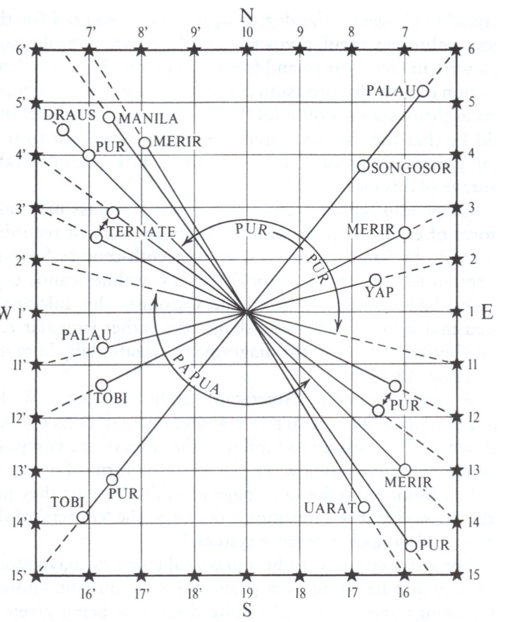

Fig. 7 Carolinean sidereal compass with orientations toward islands. Lewis, ‘Navigators’, p. 108.

Gladwin also points out that the northern points were indicated by constellations (Ursa Major, Ursa Minor and Cassiopeia) rather than the single stars of the other directions. In most of the Carolinian Islands, 32 points are defined, although extra gradations are employed in Sonsorol, Pulo Anna, and Merir. Coincidentally, the European mariner’s compass also utilises 32 points since the total is a factor of 4 (the sum of the cardinal directions: 4,8,16,32). Although not sidereal, the Tahitian sun-wind compass had 16 points. A comparison may be made with Zhitomirsky’s observation regarding Aratus that ‘Calling for attention is also the rough division of the celestial circles into eight parts, rather unusual for the astronomy of later times’. As he suggests, it is intriguing then that this Greek tradition was concerned with dividing star paths by a factor of 4.

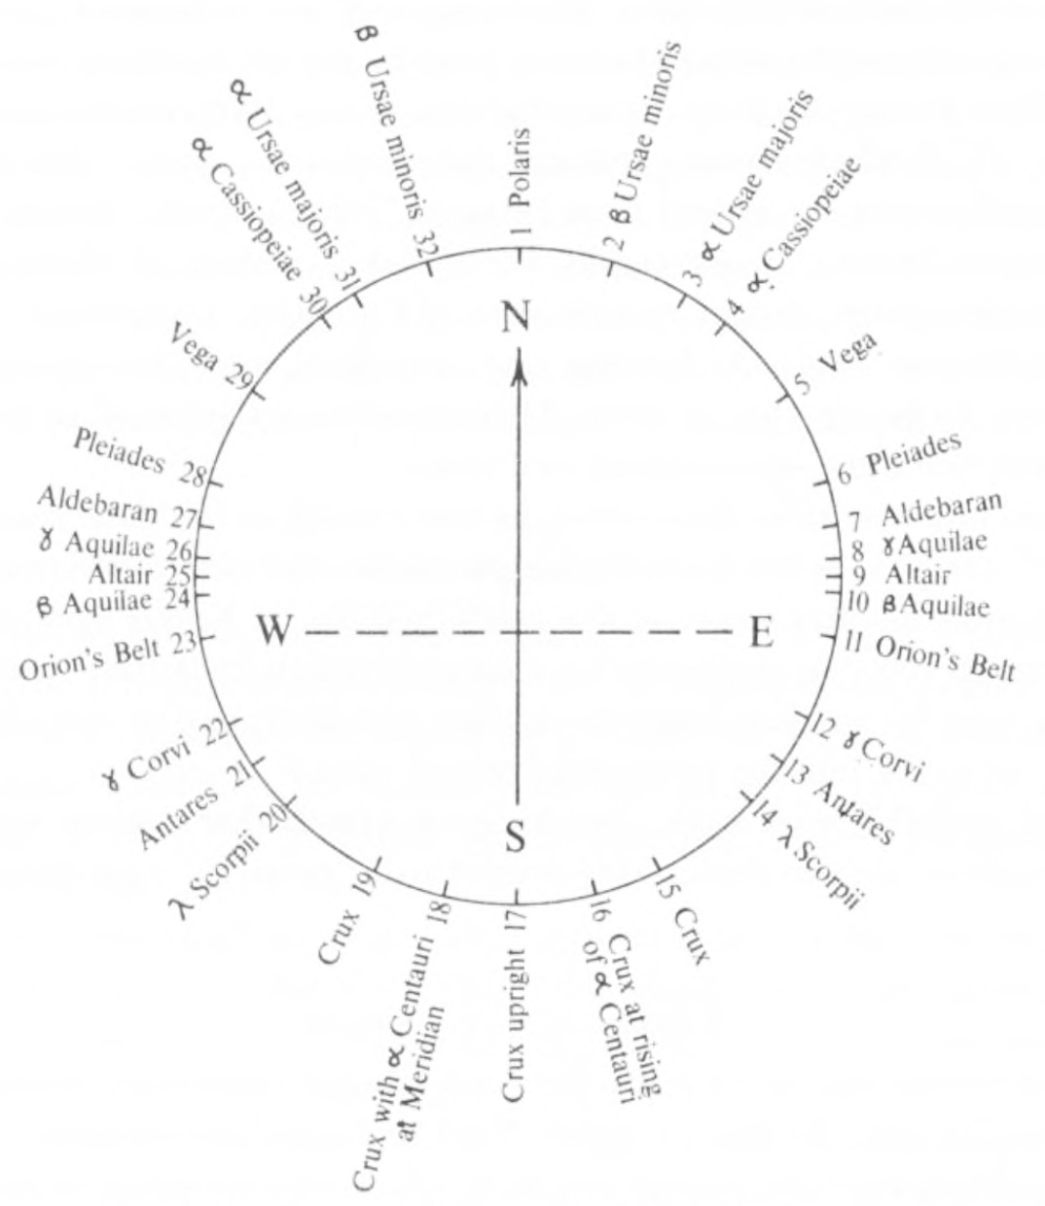

Fig. 8 Carolinian star compass. Lewis, ‘Navigators’, p. 142.

In practicality, Lewis record that navigators used ‘stars abeam, behind, or at any angle to the actual track, either in default of a suitable star in front or because clouds obscure part of the sky’. Wayfinding by the stars then was a dynamic endeavour. Goodenough and Thomas write, ‘After learning the compass points, a student of navigation is taught all their reciprocals. The reciprocal of the rising of Vega in the northeast, for example, is the setting of Antares in the southwest. For every reciprocal pair a student must then learn what other reciprocal pair lies at right angle to it’. Traditional Micronesian navigators see themselves at the epicentre of the star compass, so whichever way they are facing, they are aware of the direction diametrically opposed, the reciprocal point behind them. Star compass points and their opposite reciprocals were specifically memorised by Micronesian sailors. The Carolinian sidereal compass embodies a highly developed and intricate knowledge system of star path steering, which relied on the methodical memorisation of stars azimuths and their corresponding maritime routes.

Azimuths Not Declinations

The proven viability of Pacific Islander star sailing techniques may inform the current examination into how the Minoans may have embedded skyscape and seascape within their architectural landscape. One of the tenets of archaeoastronomical research is the pursuit of ‘alignments’ established by the declination of celestial bodies. Frank Pendergast explains:

The majority of archaeoastronomical surveys are undertaken to initially determine, inter alia, the orientation of a site, monument, or tomb. When combined with location (latitude) and profiles of the local horizon (azimuth and altitude), these data computationally yield astronomical declinations of the indicated positions of prominent celestial bodies of interest – either on the local horizon (rise/set), or of non-horizon events such as a transit phenomenon (Fig. 9).

In the case of traditional star navigation, as documented in Polynesia and Micronesia, there is a reliance on azimuths rather than declinations due to the level surface of the ocean’s horizon. Charlotte Kursh and Theodora Kreps write, ‘In the starpath system, on the contrary, the horizon line is of central importance in the determination of space as well as time. It is thus characteristically a sea-level system, since the sea-level horizon can be depended on to remain stable’. Therefore, astronautical orientations which rely on azimuths instead of declinations, may be underrepresented or unrecognised in the archaeological datum. Circumstantially, star path steering may require observing a star’s course as it rises many degrees of altitude until another suitable star on the horizon is available; however, its azimuth is the starting point of any route.

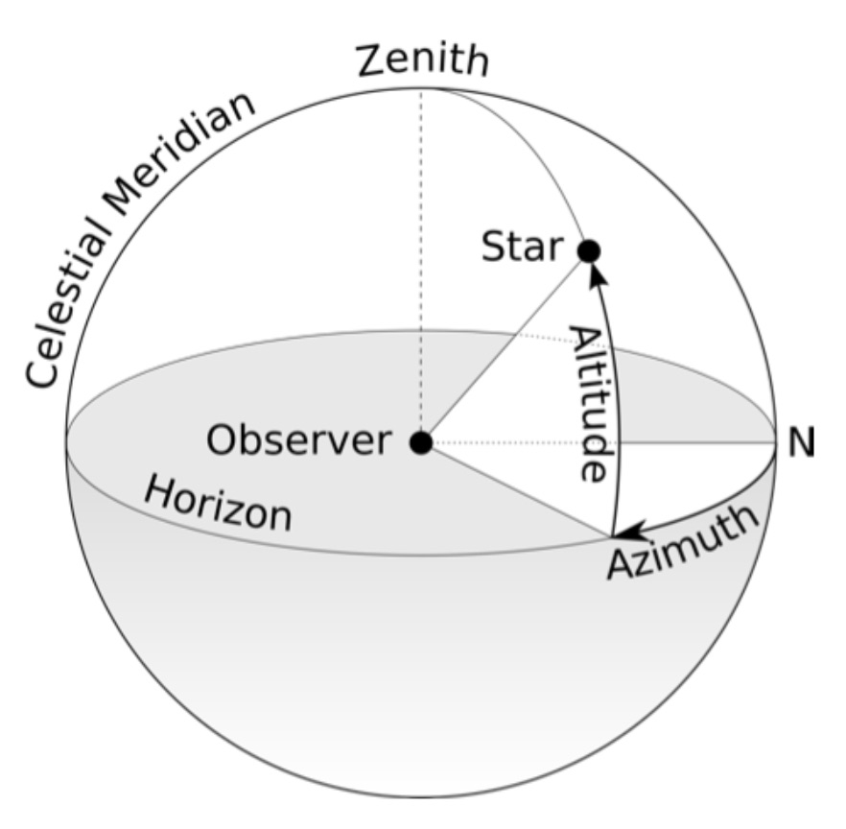

Fig. 9 Celestial coordinate system with the azimuth and altitude centered on the observer. Markus Nielbock, ‘Navigation in the Ancient Mediterranean and Beyond’, arXiv preprint arXiv:1708.07700: (2017), p. 2

The potential underrepresentation of astronautical orientations may have a corollary with some structures not incorporating observable sight lines to horizon events. Given the often tenuous meteorological conditions at sea, successful star sailors need to memorise the appropriate directions of rising and setting stars by foregoing direct visibility. Anecdotally, from the Kerkennah Islands near Tunisia to the Moce Islands of Fiji, ubiquitous folktales narrate how legendary sailors could navigate blindly. According to David Lewis, Gilbertese navigators were not educated regarding the stars under the open sky, but in roofed meeting-houses called maneabas (Fig. 10):

As a pupil he had been seated at the base of the central pillar, supporting the ridge pole of the maneaba, facing the eastern slope of the roof, which represented the eastern sky. The ridgepole was the meridian, and the central pillar, by which he sat, the star Rigel. Stars and constellations were allotted places on the thatch north and south of the pillar.

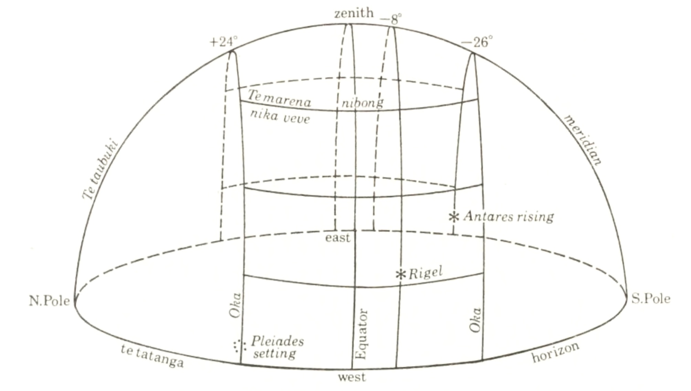

Fig. 10 A Gilbertese sky dome. Lewis, ‘Voyaging’, p. 9

In such cases, the structural syntax of the site serves as a metaphor for the vaulted sky, with the student at the epicentre. Such constructions forego the necessity for direct astronomical sightlines, as is traditionally investigated in archaeoastronomy. Logically, without such ethnographic reports, the lack of a direct sight line provides less satisfying and provable conclusions to such examinations. Although, it can be argued, this absence may be supplanted by the discovery of orientations toward long-distance localities.

Astronautical Orientations

The unique Minoan maritime prowess and their likely reliance on stellar wayfinding, suggests that Minoan worldview may have been a convergence of landscape, seascape, and skyscape. Besides the previously discussed evidence suggested by Blomberg and Henriksson, there are examples of structures worldwide that embedded astronautical orientations. The Temple of Apollo at Delphi was ostensibly aligned to Delphinus, a constellation associated with stellar navigation in Greek mythology. According to Efrosyni Boutsikas, the temple faces an atypical elevated horizon that by delaying the heliacal rising of the constellation by two weeks, ‘would offer advance warning for visitors travelling from across the Greek world to consult the oracle, in order to arrive at the oracle on time for the annual consultation’. The ‘Homeric Hymns to Apollo’ chronicle how Apollo metamorphosed into the dolphin that was consequently positioned among the stars to guide sailors to his oracle.
The ‘sighting wall’ in the southernmost point of the Hawaiian Island of Maui, through which the Southern Cross could be seen when it was upright, may be another case of an astronautical structure that embodied celestial alignments used in maritime navigation. According to Ruggles, ‘Various linguistic, ethnohistoric, and ethnographic arguments combine to suggest that this was a symbolic alignment memorialising voyaging traditions’. According to Patrick Kirch and Ruggles, the Hawaiian heiau temple system, which is a descendant of the Polynesian Marae sacred places, and dates as far back as the 12th century ad, contained stellar alignments to the rising of stars such as the Pleiades, and in some instances, was oriented toward topographic targets on other islands, such as enemy territories.
In Micronesia, there is an important surviving example of stones that were astronautically orientated toward neighbouring islands (Fig. 11). In the Arorae Island, southern Kiribati, the so-called ‘navigation stones’, Te Atibu ni Borau, aimed at shores more than 80 miles away. They were originally surveyed and documented ethnographically by Brett Hilder in 1957, who estimates that the orientations were intentionally askew by about 5° from each island due to Equatorial Currents. Brett Hilder supposes they were ‘aides-memoire, or sailing directions, used in the Polynesian lore of navigation as well as being used to set departure courses from a standard “starting-point”’. Through the use of sighting stones they may have functioned as training devices for regional star path navigation.
The stones were immune to the unhurried spin of the earth’s axial precession. As such, they may have solidified oral traditions for succeeding generations in what Brady terms a ‘knowledge-based compass’. Recently, Akira and others have confirmed the stones’ functions as pedagogical tools for instructing navigation and indigenous calendar centred on the constellations. Hilder conjectures that the absence of similar navigation stones in the other islands may be due to European colonial explorers overlooking solitary stone or wood markers.

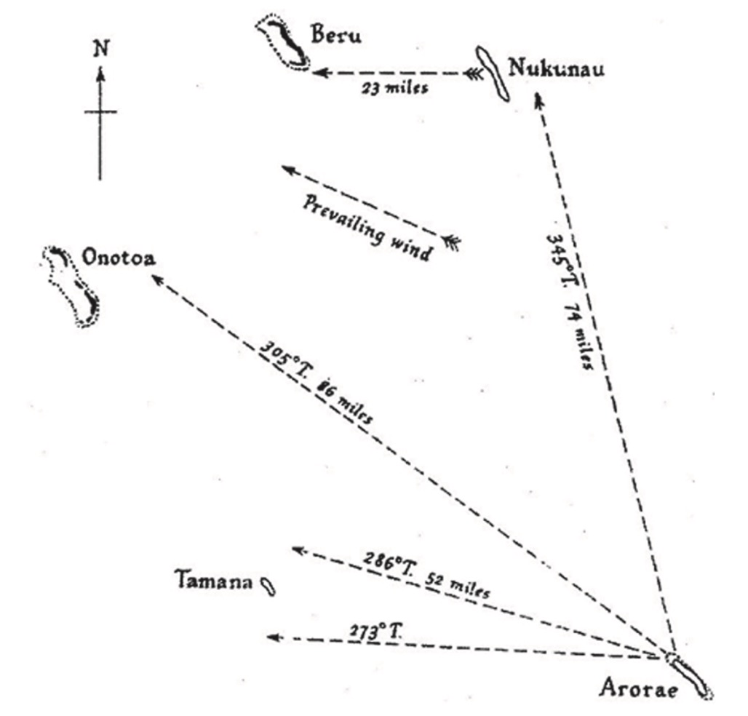

Fig. 11 Aurorae navigation stone orientations with estimated target islands. Akira and others, p. 114.

Finally, at the heart of the Inca empire was the religious complex of Coricancha in the capital Cuzco from which all 41 or 42 ceque lines radiated outward like solar rays. Sacrificial victims were prepared within the central courtyard and then marched outward along one of the ceque paths. The Inca ceque system consolidated cosmology, long-distance orientations, and sidereal calendrics. As Ruggles writes:

The broad conception of dividing the landscape using straight lines radiating out from a center is evident in the Andes in later Inca times (AD 1438–1532) in the “ceque” system centered upon Cusco. Numerous straight lines in the Bolivian and Chilean altiplano region radiate out from villages, connecting them to distant shrines on hilltops or remote plains. Some of these were used for ceremonial processions until at least the 1980s, and some continue to be walked in the course of specific rituals.

While the Incan ceque system is not maritime, like the Aurorae navigation stones and the Hawaiian heiaus, it may have been composed of luni-stellar orientations toward far-flung destinations. These examples elucidate if and how ancient structures, perhaps unrecognised until now, may have embedded astronautical orientations.

Summary

A comparison of traditional star sailing techniques from the Pacific may inform how the Minoans reached the distant shores of Egypt and the Eastern Mediterranean. Pacific Islanders used star paths as a sidereal compass to navigate toward islands sometimes hundreds of nautical miles away. The concept of ‘star paths’ may have been present at least by the Greek classical age as recorded in Aratus. The Carolinian sidereal compass divided the horizon into 32 rising and setting stars that associated azimuths with routes toward distant shores. The Aurorae Island ‘navigation stones’ are a model example of star path orientations, which guided itinerant sailors toward neighbouring islands. Other examples of stellar alignments associated with navigation exist, from the ‘sighting wall’ in Hawai’i to the Temple of Delphi in Greece. In some instances, the Hawaiian heiau temple system incorporated stellar alignments, and was oriented toward distant topographies, such as other locations on the archipelago. The Inca ceque system linked long-distance orientations with a ritual sidereal calendar.

Star Sailing in the Aegean

The appearance of astronautical motifs in Minoan art coincides with the advent of the sail in the Aegean, spurred by the flourishing of maritime trade during the Bronze Age. On the Cycladic Island of Thera, a devastating volcanic explosion around Late Minoan 1A (circa 1600-1500 bce) buried the Minoan village of Akrotiri. Preserved beneath the volcanic ash were richly colored wall paintings of a cultic water procession. On the larger vessels, sixteen-pointed stars adorned the bowsprits (Fig. 12). Davis suggests they may have symbolised heavenly bodies. Its placement at the front of the bowsprit may have signified its function as a ‘guide’ to the navigators. The standard 16 points could also be based on a numerical factor of the 4 cardinal directions (4, 8, 16, 32…). Fragments of a painting from Pylos, depicts an 8-pointed starburst on the bow of the ship. A Late Minoan I or Late Minoan IA fresco from Ayia Irini on Kea, also represents a stellar symbol above the ships’ bows.

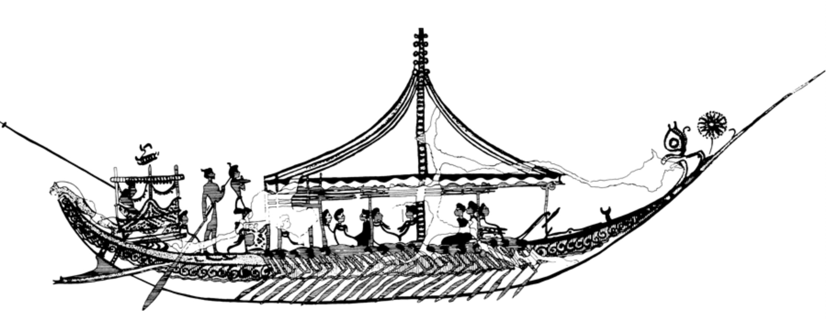

Fig. 12 Line drawing detail of the ship procession fresco at Thera after Wachsmann. Wachsmann, p. 92.

Astronautical motifs, such as stars, spirals, and paddled boats, appear on the so-called ‘frying pan’ artefacts from the Early Cycladic II period. The symbolism of the iconography on the ‘frying pans’ may have represented life and death, the cycle of day and night, and fertility. Cretan hieroglyphic seal depicts what appear to be full moons, lunar crescents, or floating disks which could potentially be stars, above the sheer of the ships (Fig. 13). Evans speculated that the glyptic symbols ‘refer to the duration of the voyages undertaken; the crescent moons would in this case mean two month [sic] and the disk a still longer voyage’. The profusion of astronautical iconography in Aegean art suggests that the Bronze Age trade explosion may have been spurred in part by advances in night-time sailing techniques.

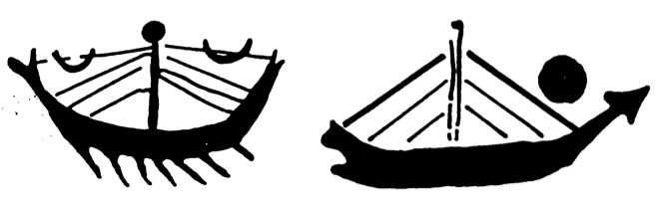

Fig. 13 Drawing renditions of early Cretan seal stones depicting sailing galleys after Evans. Evans, ‘Nilotic’, p. 207.

Constellations as Mnemonic Devices

‘Looking up at the night sky, we imagine the stars to be invisibly connected by ghostly lines into constellations. Only by doing so can we tell stories about them’. Tim Ingold

Blomberg and Henriksson speculate that Aratus’ Phaenomena was part of an oral tradition of didactic poetry dating back to the Bronze Age, similar to the transmission of stellar navigation know-how in the South Pacific. Boutsikas writes, ‘The use of mythology as a memory device for the constellations populating the ancient Greek sky meant that constellations were linked with ancient Greek religion through catasterism myths’. In the Polynesian and Micronesian maritime communities, astronautical lore was orally transmitted in cryptic chants, whose true meaning was only revealed by the exegesis of an elder. Maritime arcanum may have been preserved within star tales handed down from generation to generation.
Bradley Schaefer argues that, ‘no evidence for the old Greek constellations has been found in Minoan Crete or elsewhere before the first millennium b.c.,’ and that ‘the lack of all constellations other than the obvious Orion and Big Bear from Hesiod and Homer argues that these were unknown to the early Greeks and Mycenaeans’. On the other hand, Kyriakdis suggests that ‘Any seafaring and trading nation needs to be able to read the stars. Minoan Crete, one of the main regional sea powers of its time, would have classified the stars into constellations to act as mnemonic devices’. Thus, the creation of star paths and constellations may be seen as a logical culmination of the necessity of memorising the directions during nocturnal navigation.
Inevitably, star sailors have to apply the star paths to a mental map within an easily applicable form such sidereal compasses or within easily transmissible star myth narratives. Akira and others comment:

Navigators had to memorize the names of more than 178 stars and also learned their courses and positions at particular seasons and times. One of the methods of memorizing the guiding stars was to create a tale about them, wherein they figured as persons or objects seen during the voyage. Folk stories were often adapted to this purpose.

The tome of knowledge a navigation student was expected to learn was considerable. As Lewis records, ‘[…]from a navigator on Puluwat a list covering several pages of fine print giving sailing directions in terms of his compass from every known place to every other known place. He gives each course both directly and with respect to a third island or reef to provide another point of reference.” These directions composed complex navigational methods, such as the Etak, where mental recordings of ‘moving’ off-course reference islands segmented a journey. The practicality and necessity of star sailing leads toward the conclusion that the Minoans would have likely organised their skyscape around constellations, asterisms, or star paths which would have facilitated memorisation and thereby their use out at sea.

Historical Evidence of Star Navigation

The earliest historical mention of stellar navigation is preserved in a famous passage from Homer’s 8th century bce, ‘The Odyssey’, when the hero, Odysseus, steered his ship as he:

[…]watched the Pleiades and late-setting Böotes, and the Bear, which is also called the Wain; it circles where it is and keeps an eye on Orion. It alone has no part in the baths of Ocean. The beautiful goddess Calypso advised him to keep this one on his left as he sailed over the sea.

Ursa Major, often cited in ancient nautical texts, was known as the Bear or the Wain, translated from the Greek Arktos, Helix, or Axis. Apollonius’ epic poem, the Argonautica, describes how ‘on the sea sailors from their ships looked to Helice and the stars of Orion’. This passage may indicate that navigating by non-circumpolar constellations, such as Orion, may have been a familiar technique to Apollonius’ contemporaries. Aratus also details the different methods of steering by the circumpolar constellations:

In order to steer their ships, the Achaeans on the sea take their mark by Helice (Ursa Major), whereas the Phoenicians cross the sea trusting in the other (Ursa Minor or Cynosura). But Helice, appearing clear at earliest night, is easily recognized; but the other is small, yet better for sailors; for all of her stars wheel in a smaller orbit; by her, then, the Sidonians sail their ships.

Numerous ancient authors cite night-time sailing with frequency, including Herodotus, Xenophon, Thucydides, and others. In his epic poem, Punica, Silius Italicus describes how Sidonian sailors preferred nocturnal rather than diurnal sailing:

By observing the stars do we navigate across these valleys, for daylight confuses the path; and over the vast fields does Cynosura (Ursa Minor), that constellation most faithful to Sidonian sailors, lead the traveler who sees himself always in the middle of the plain.

A possible literary reference to celestial navigation in Minoan Crete may be found in the account of Ovid’s Ars Amatoriae where Daedalus and his son Icarus flee the wrath of King Minos on wax wings. He urges his son to not ‘look toward the Tegean maid (Callisto, Ursa Major) nor sword-bearing Orion, companion of Böotes’, suggesting that even in this mythical flight, the stars symbolised orientations.
Blomberg and Henriksson suggest that the Minoans may have used star path navigation techniques similar to the traditions of the South Pacific. They cite Aratus, who wrote:

Now too a sailor on a clear night at sea can observe the first bend of the River (Eridanus) emerging from the sea, as he waits for Orion himself, to see if a sign will at some point predict for him the length of either the night or the voyage; for everywhere the gods give these many predictions to men.

However, they do not detail specific star paths the Minoans may have employed, beyond a general course to the Nile by aiming toward the stars of the river constellation Eridanus. The robust references in classical texts to celestial navigation in the Mediterranean suggest the possibility that the Minoans may have employed similar techniques, which along with the trade routes they first established, may have been preserved by the Myceneans, the Phoenicians and the later Greeks.

The Star Myth of Europa

According to Brady, star paths may have been preserved within local mythologies that preserved ancestral knowledge. As Brady writes:

In this way the sun, with its sunrise and sunset horizon events, would be fixed and permanent, and thus possibly more sacred, while the star-paths, which may have been full of mythical figures and their narratives, would be animated by precession. The two, the fixed nature of the sun and horizon and the animated mythical characters of the stars were bought together by the fixed bearing of the stones, which linked them in a cosmic and cultural knot; a union that offered the tribe knowledge of navigation.

In this manner, the original immigration from the Levant to Crete, and the founding of the Minoan civilization, may be related to celestial navigation as memorialised in the myth of Europa and Zeus. In some accounts, King Minos was the son of Zeus with a mortal mother, Europa, herself the daughter of Agenor, king of Tyre. She was abducted from the beaches of Sidon by Zeus in the form of a bull, who absconded with the virgin princess to Crete. Ovid’s Metamorphoses recounts how Zeus commanded his son Hermes to aid him in sequestering the princess Europa:

Son,— thou faithful minister of my commands.—
let naught delay thee—swiftly take the way,
accustomed, to the land of Sidon (which
adores thy mother’s star upon the left).

Hermes did as Zeus bade him, and he drove the royal kine toward the beach where Europa, the king’s daughter, frolicked with other Tyrian virgins. Together, they traversed the Mediterranean and disembarked on Cretan soil. According to one telling, the pair made landfall at Matala, a beach in the sphere of influence of the palace of Phaistos.
According to Lucian of Samosata (2nd century ce), the Phoenicians built a great temple, which in some accounts, was sacred to Minos’ mother:

There is likewise in Phœnicia a temple of great size owned by the Sidonians. They call it the temple of Astarte. I hold this Astarte to be no other than the moon-goddess. But according to the story of one of the priests this temple is sacred to Europa, the sister of Cadmus.

Lucian then confirms that current among the ancient Sidonians was the numismatic effigy of Europa riding on the back of taurine Zeus, linking the myth with the city (Fig. 14).

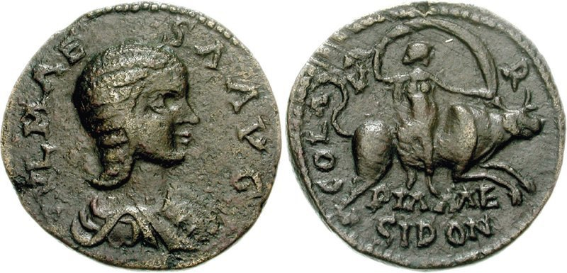

Fig. 14 Bronze Roman coin from Sidon, 2nd century ce, 24 mm. Europa on the bull of Zeus. Alfredo De La Fe, p. 1.

In the myth, Europa rides the bull which may symbolise the constellation of Taurus, suggesting Europa may represent a celestial body. James Frazer speculates that:

If Europa was, as seems possible, a personification of the moon in the shape of a cow, we might perhaps interpret the quest of the sons of Agenor for their lost sister as a mythical description of Phoenician mariners steering westward towards the moon which they saw with her silver horns setting in the sea.

This interpretation would make the myth an astronautical retelling of a sea journey. The Manilius version of the myth of Europa is more explicit in associating the myth of Europa with the stars. In his telling, Hermes is commanded to go, ‘to the land of Sidon (which adores thy mother's star upon the left)’, meaning the star Maia, named after the mother of Hermes, which is in the Pleiades. The Greek name Πλειάδες may originate from the word πλεῖν meaning ‘to sail’, suggesting its possible utility in stellar navigation. Therefore, the mythological founding of Crete may point toward an archaic star sailing tradition as preserved in the astral myth of Europa and Zeus.

Summary

The appearance of astronautical motifs in Aegean art coincided with the explosion of maritime trade in the Bronze Age. Noctunral voyaging likely necessitated that the Minoans envisaged star paths or constellations for the purpose of memorization. There is evidence that by the time of Aratus, the Greeks were aware of a concept analogous to star paths. While there is no direct evidence of constellations in Minoan Crete, multiple literary accounts exist from Homer and others discussing the use of stars and circumpolar constellations for navigation in the ancient Mediterranean. The myth of Europa may connect the founding of Cretan civilization with celestial navigation.

In The Field

Instruments

During the survey of the four main Minoan palaces, the in situ measurements were taken with a Suunto Compass & Clinometer, which has a stated accuracy of ±1/3°. I adjusted the measurement values for magnetic declination via the NOAA website. These readings were compared with those taken from a digital Theodolite app, virtual measurements from Google Earth, and with Shaw’s theodolite readings. The research also utilised the open-source planetarium software Stellarium (v0.20.1), which enables virtual archaeoastronomy research. Due to its implementation of a long-time model for the precessional motion of the earth’s axis, Stellarium can accurately simulate ancient skyscapes. The simulation allowed for the visualisation of the rising and setting of high magnitude stars at their respective azimuths in Bronze Age Crete. The Observability Analysis plugin for Stellarium listed the acronychal and heliacal dates for these stars to determine if they were within the timeframe of the navigation season in the Mediterranean. The software OpenCPN estimated the rhumb lines between the candidate destinations. The website Planet Calc provided more precise rhumb lines calculations of the corresponding coordinates.

Methodology

The fieldwork initiated in October of 2020, while subsequent visits with more detailed measurements were hampered due to the current global pandemic. It was determined that all four palaces should be measured in order to avoid the pitfall of the dictum “testis unus, testis nullus”, where ‘one-off’ archaeoastronomical alignments can be persuasive, and only if a consistent pattern emerged, should the results be satisfactory. As Ruggles argues:

Fortuitous stellar alignments can be fitted to structural orientations with relative ease by the unwary. Nonetheless, cautious approaches taking into account a broader range of cultural evidence, as well as paying due attention to potential methodological pitfalls, have been successful in identifying credible stellar alignments—and constructing plausible assessments of their cultural significance—in a variety of circumstances.

The decision was made to visit all four main Minoan palaces in Crete, while the supposed fifth large palace of Kydonia, which has not been fully excavated, was not measured. The other smaller ‘palaces’ were also not measured for this research.
The first visit was phenomenological in nature, since no clear archaeoastronomical objective had been pre-determined. Readings were taken of suitable walls with straight edges which were deemed to fairly represent the axis of the palace, such as the case with the palace of Knossos (Fig. 15). Therefore, the initial data collection was not focussed on the courtyard axes, which as Shaw defined, were the defining characteristic of the Minoan palaces. Such a virtual analysis may be justified since as Ruggles explains, ‘In many cases, it may not be necessary to make survey measurements in the field at all, if sufficiently accurate data are retrievable from site plans or maps, although one must beware potential errors…’ Therefore, due to travel restrictions, virtual measurements of the courtyards supplemented the original live fieldwork (Fig 15:B).

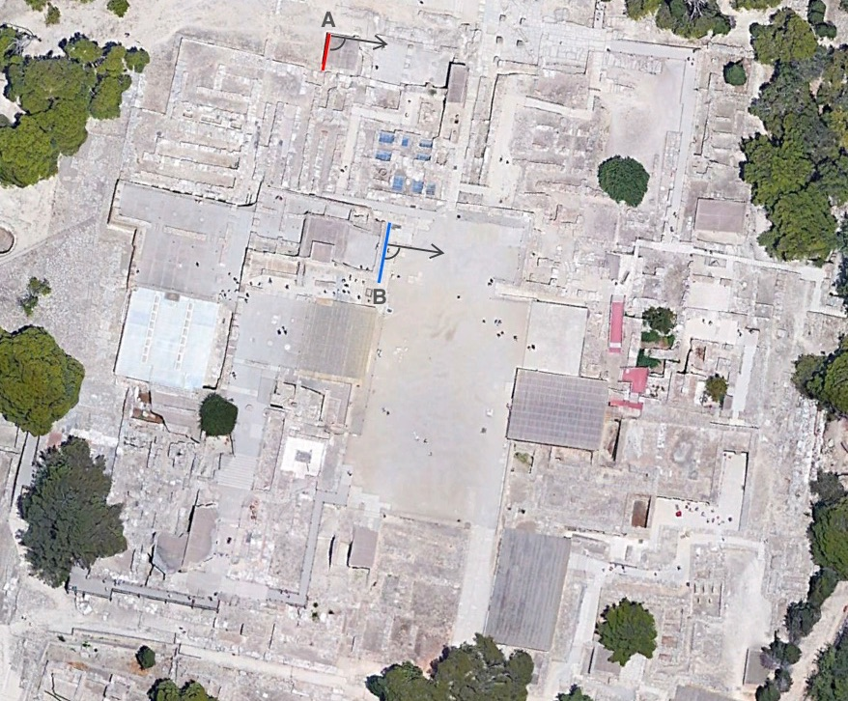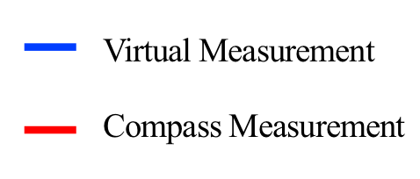

Fig. 15 Knossos measured orientations. Red arrow indicates in situ measurements, blue arrow indicates virtual measurements.

Evans conjectures the western sides of the courtyards appear to include rooms with ceremonial use. As previously discussed, Shaw raises the possibility of the importance of natural illumination which would enter the sacred structures of the western façade of the courtyard. Furthermore, the main trading partners of the Minoans lay to the East, therefore, preference was given to the orientations collected on the short east-west axis. When a suitable measurement was only available for the long north-south axis, the value was adjusted by adding or subtracting 90°.
The palatial azimuths were then projected outward as a loxodromic curve, to define potential target localities. This new method I devised employed the open-source software OpenCPN for plotting navigation routes and rhumb lines between two distant points. Rhumb lines are a constant navigation course, as Cotter writes, ‘If a ship sails on a constant course, cutting each meridian at a constant angle she traverses a rhumb line, and that angle is her course’. In 1774, Andia y Barela, who led the Spanish expedition at the time, recorded how native Tahitians used rhumb lines to navigate the ocean:

When the night is a clear one they steer by the stars; and this is the easiest navigation for them because these being man [in number], not only do they note by them the bearings on which the several islands with which they are in touch lie, but also the harbors in them, so that they make straight for the entrance by following the rhumb of the particular star that rises or sets over it; and they hit it off with as much precision as the most expert navigator of civilized nations could achieve.

Early attempts at finding the azimuths between locations through Google Earth were hindered by the software’s use of great circle (orthodromic distances) instead of rhumb lines, also known as loxodromic distances or constant azimuths. While great circle navigation provides the shortest distance between two points on the surface of the sphere, it is mathematically complex and inviable as a method for maintaining course by the stars since it requires the course to be continually adjusted.
To better understand these complex navigational questions, I undertook a two-day sailing course with ‘Uncle’ Spinelli, a well-known navigator and instructor who has traversed the Atlantic twice from Brazil to South Africa on his sailboat, ‘Soneca’, with scant usage of electronic equipment. The objective was to gather sailing knowledge from an ‘experimental archaeology’ perspective which might inform me with a practical understanding and which might be applied to ancient sailing techniques. Although modern sailing boats are markedly different from Minoan sailboats, many of the techniques and concepts remain the same. ‘Focus on the route!’ was the oft-heard exclamation from Uncle Spinelli, as it was clear that maintaining a direct course to a distant landmark, seamark or star necessitated skillful navigation.
Feeling the wind, the currents, observing the sea, steering the rudder, tacking the sails, tying and untying knots endlessly, proved to be a challenging yet satisfying endeavour. Sleeping aboard the boat was a lesson in rationing food, water, and space. At night, on the deck of the boat, Uncle Spinelli gave a lesson on how he finds the southern celestial pole by measuring the distance with his hands from the Southern Cross, and how that could be used to navigate at night. Significantly, Uncle Spinelli demonstrated the use of the OpenCPN software to me.
The OpenCPN rhumb lines were then compared to this list of major trading cities on the Eastern Mediterranean. When an approximate match was encountered, the latitude and longitude of the palace and the candidate city were inputed into the website Planet Calc, in order to calculate the specific constant azimuth (rhumb line) between the two locations. These were then compared with the azimuthal orientations of the palaces.To determine the probable celestial navigation routes, it was noted, through the use of virtual fieldwork, whether any particular star path and palace axis coincided with a direct route to a relevant Minoan trading partner (Chart 1). In practice, a single navigational star would not have been used to reach such distant localities. As previously discussed, the Polynesians elected a main guiding star for each star path route.
Belmonte and Shaltout’s rule of thumb that a star surges to visibility at about the altitude equivalent to its magnitude was used for rough estimates of the altitude of stars on the horizon. The extinction co-efficient of 0.25 was used within Stellarium, which according to Schaefer is the average for a night at sea level. Both setting and rising stars were considered, since as discussed previously, Polynesian and Micronesian sailors used stars and their reciprocals for navigation. When a setting star with a western azimuth was used in accordance with an easterly orientation and rhumb line, the value of the star azimuth was subtracted by 180°.
In addition, the matching high magnitude stars should have served as adequate navigational stars visible during the Mediterranean sailing season. To determine the window of possible dates in which a rising or setting star might have been used to navigate, it was conjectured that this would occur from the time the star had its heliacal rise, until its apparent acronychal rise, which Ruggles defines as when the star ‘is seen to rise just as the sky gets sufficiently dark in the evening following sunset’. Likewise, for the azimuth of a setting star, the timeframe calculated was from its heliacal set (sometimes confusingly termed acronychal set).
In practicality, Polynesian and Micronesian sailors did not have to be exact to the degree of the azimuth of a star when sailing toward an island. The use of sea marks, water coloration, currents, and especially the presence of birds, indicated the general vicinity of an island to an acceptable margin of error. For the present study, a level of uncertainty of ~1° in the azimuth orientations was deemed acceptable, which is beyond the accuracy necessary for star path steering, since as Kursh suggests, star paths were actually bands, that involved several degrees of declination.
Finally, if it was determined that there was a recurring pattern of alignment within the data-set comprising the orientations of the east-west axis of the four known Minoan palaces with significant star path trade routes to cities that flourished economically within that time period, then a cultural analysis would be undertaken. Although this was not the focus of the present study, a preliminary ‘thick description’ could be established of possibly relevant star myths and historical records and traditions which may have preserved memory of these hypothetical star path trade routes. The precession of the relevant star paths was taken into account and will be dealt with later.

Discussion

The live fieldwork (LF) readings for Phaistos and Malia fall within the 1/3° level of uncertainty compared to Shaw’s theodolite readings (Table 1). The measurement for Knossos is +2/3° from Shaw’s reading, which may be comprehensible given that the measurement was not taken directly from the courtyard but from an adjacent building that provided a more easily measurable surface as discussed in the methodology (Fig.15:A). A future visit with more detailed measurements should improve the level of accuracy. No satisfactory live fieldwork readings were taken for the Zakros courtyard nor the western side of the Phaistos courtyard, which included an older axis. Therefore, these were supplemented with virtual measurements (VF).

Palace | LF | VF | Theodolite (Shaw) | Difference
Knossos Courtyard Axis | 101.03° |  | 101.6189° | 0.5889°
Phaistos Courtyard Axis | 92.9833° |  | 92.59389° | 0.38941°
Phaistos Old Palace Axis |  | 91.03° (-90) |  | n/a
Malia Courtyard Axis | 106.99° | 107.22° | 107.03° | 0.04°
Zakros Courtyard Axis |  | 127.73° | 127.5528° | -0.1772°

Table 1. List of the measurements of the palace courtyard with axis adjusted for an east-west orientation.

If natural illumination of the religious rooms on the western side of the courtyard was one of the determining architectural consideration as suggested by Shaw, one would suspect that all palaces would have been oriented consistently to within the solar range to maximize such a visual effect. However, there is a variation of around 35° between the major palaces (Fig. 16). By Shaw’s own admission, the courtyard of the Zakros palace, unlike the other palaces, lies outside the solar range of the equinoctial midpoint and the winter solstice, which could indicate that the solar light phenomena was not a systematic consideration for the orientations.

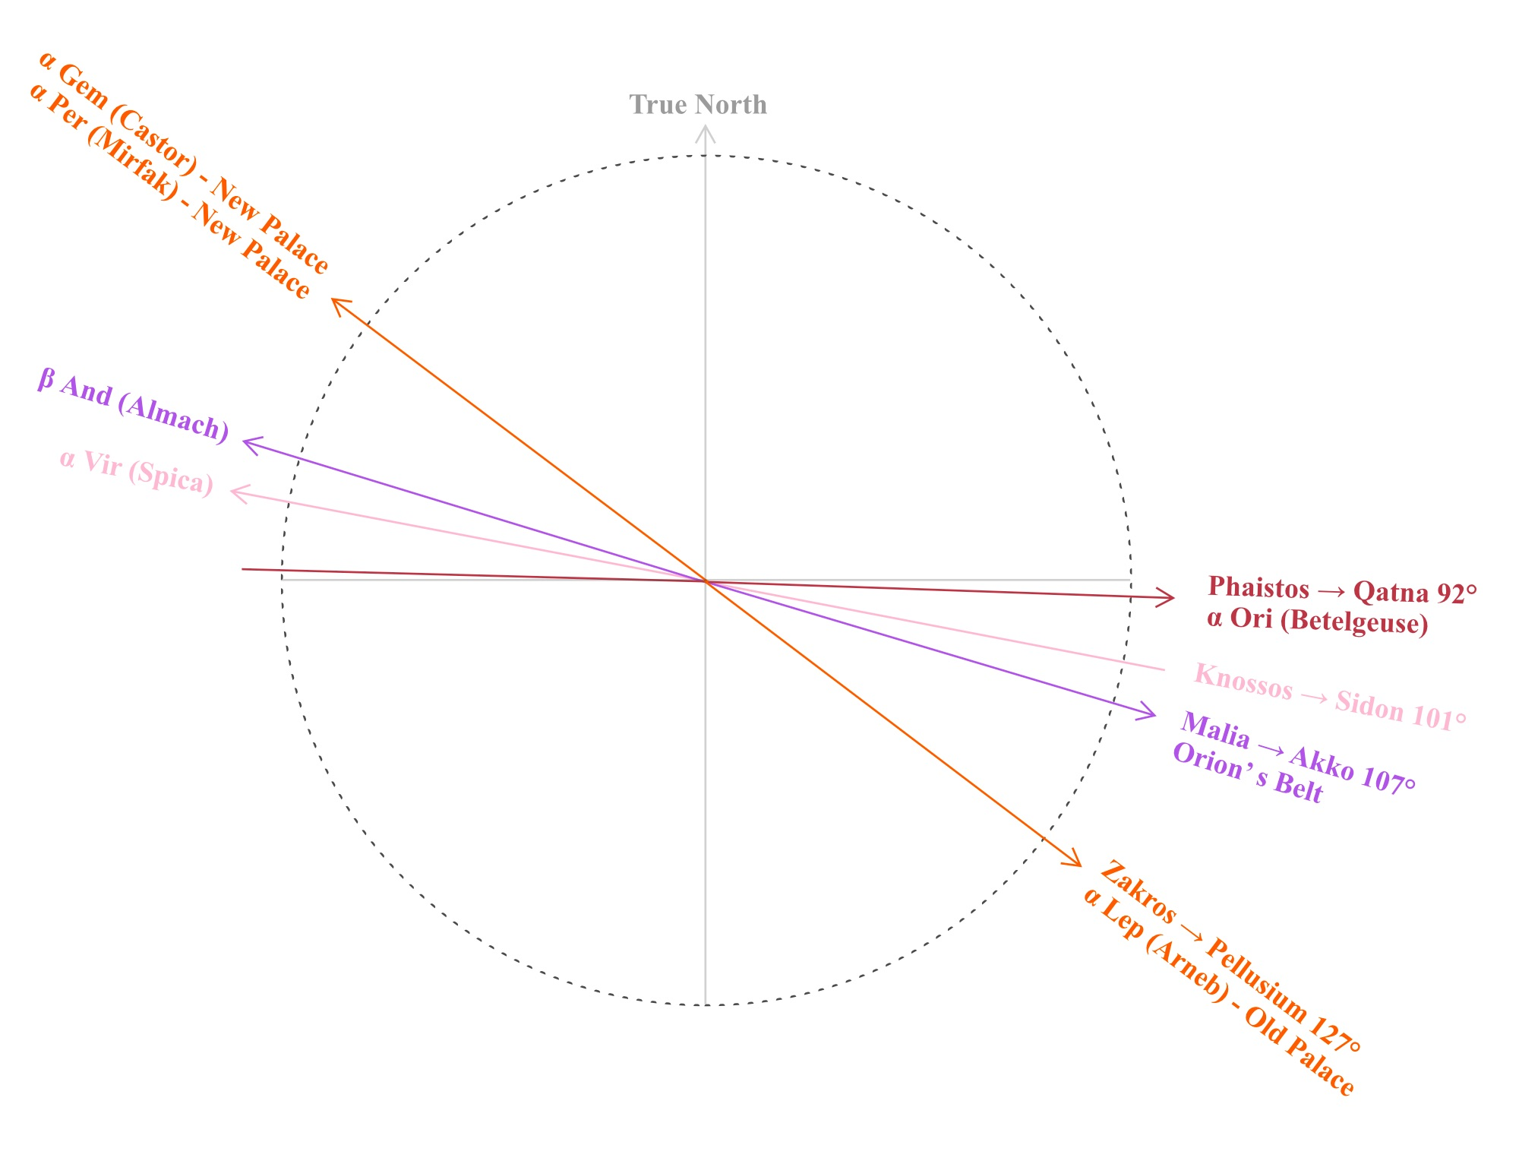

Fig. 16 Radar plot showing measured azimuth orientations of Minoan palace courtyards.

Perhaps, Belknap misses a crucial opportunity when he suggests the palaces’ longer north-south axis pointed to locations on the North African coast, where no major Minoan trading centers have been uncovered. Shaw’s analysis proposes that that the palaces were originally constructed with the east-west shorter axis in mind. The possibility of direct trade routes to Egypt and the Levant from Crete would be in line with east or southeast orientations for the courtyards. This notion conforms to Chryssolouaki’s proposal that specific Minoan centres may have had their unique agreements with particular markets and emporia in distant lands, ensuring exclusivity of particular goods. Therefore, the variability in orientations between the palaces could result from direct trade routes between Minoan palaces and their particular trade partners across the ocean.
The archaeological material record provides evidence of the Bronze Age cities around the Mediterranean, particularly in Egypt and the Levant, that were direct or indirect trading partners with Minoan Crete. These include Byblos, Sidon, Tyre, Ugarit, Alalakh, Tel Kabri, Qatna, and Avaris, among others. Other Levantine cities, such as Akko, that contained no archaeological evidence of Minoan contact, yet were known as major ports during the Bronze Age, were also considered for the analysis. Therefore, unlike Belknap’s proposal, the shorter east-west axes were given priority in the systematic investigation and were then compared to rhumb lines of the candidate cities to the east and southeast of Crete (Table 2).

Palace | Court Axis | Rhumb Lines | Possible Destination | Difference
Knossos | 101.03° | 101.56° | Sidon | 0.53°
 | n/a | 103.63° | Tyre | n/a
Malia | 107.03° | 106.57° | Acre (Akko) | 0.46°
Phaistos | 92.9833° | 92.92° | Kadesh | -0.0633°
Phaistos Older Axis | 91.03° | 91.25° | Qatna | 0.22°
Phaistos Drain Axis | 95.21° | 95.86° | Byblos | 0.65°
Zakros | 127.5528° | 127.43° | Pellusium | 0.1228°

Table 2. Comparison of palace courtyard axes with rhumb line azimuths of possible trade route destinations.

Three factors were major complicators for achieving a high degree of accuracy. First, the construction dates for the palaces can only be estimated, and in some cases it is unknown whether Old Palace constructions had similar orientations as the New Palace phases. Second, the beginning of trade relations between Crete and the corresponding Levantine cities are unclear in some cases. Third, as it is well known, stars do not maintain a single rising or setting azimuth throughout the passing centuries due to the effects of axial precession. Therefore, the azimuth of the high magnitude candidate stars were plotted on a chart (Fig. 17). The palace courtyard axes and the rhumb lines were compared to the star paths to find probable time range periods where they coincide. One can see that all four palaces are oriented toward the brightest stars of their particular constellations: Phaistos with α Tauri (Aldebaran) and α Orionis (Betelgeuse), Knossos with α Virginis (Spica), and Zakros with α Leporem (Arneb), α Perseii and α Geminorum (Castor). Malia’s β Andromedae (Mirach) is the exception, although it may be considered the brightest star of Andromeda, since Alpheratz (α And) is traditionally also part of Pegasus.

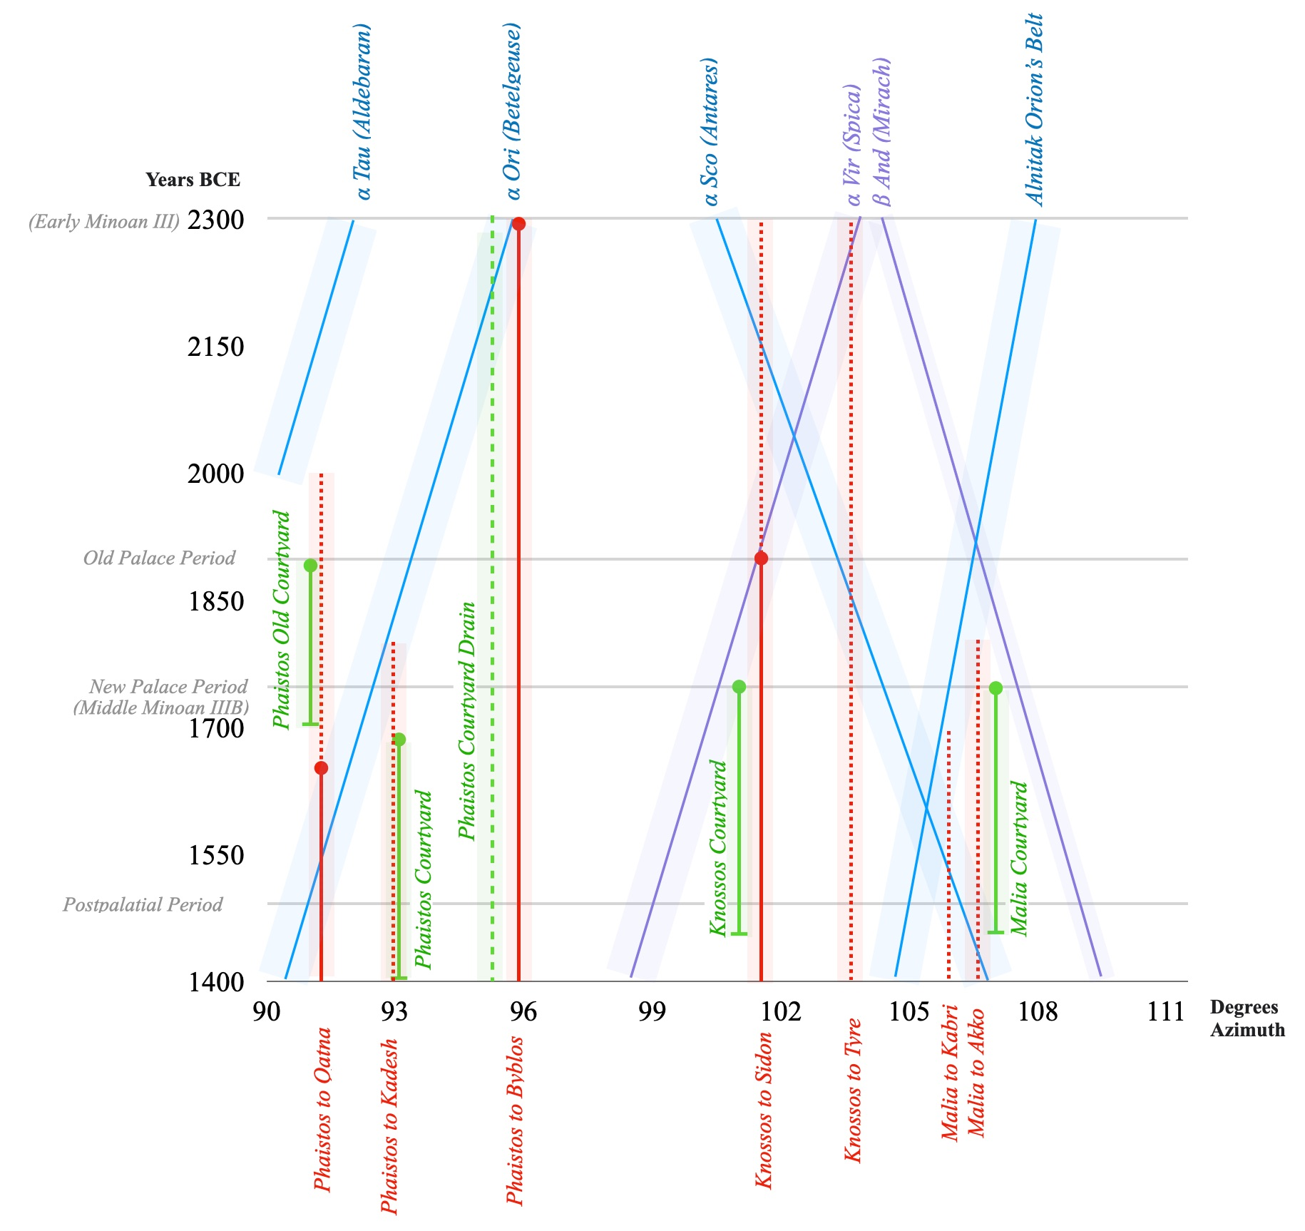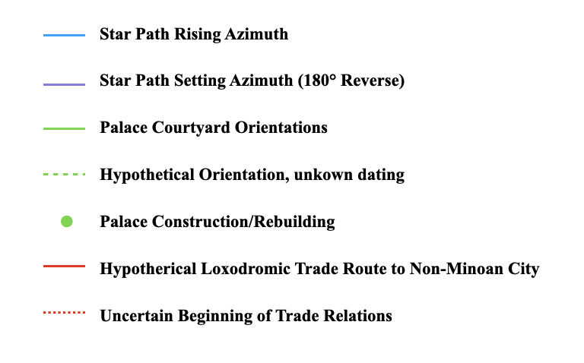

Fig 17. Rhumb lines between palaces and non-Minoan ports associated to courtyard orientations and star paths.

Any systematic analysis of Minoan culture must rest on the culture’s heavy reliance on international maritime trade. Although the current findings do not exclude Doxtater’s hypothesis that the Minoans laid out the palaces in a large-scale geometry to each other and sacred caves, he did not consider stellar navigation as a motivational factor for the orientations. As already cited, Blomberg and Henriksson, on other hand, suggest that the celestial alignments on peak sanctuaries may be related star navigation techniques. They even propose that the Minoans may have used similar techniques as the Pacific islanders for navigation. However, their research did not link star paths, rhumb lines, trading destinations, and palace orientations. A discussion of the particular palace orientations with associated star paths and rhumb lines follows.

Knossos to Sidon

The collected compass data records that the Knossos palace’s east-west axis was oriented toward the azimuth of 101.03° (Table 1). The rhumb line from Knossos, traversing Crete’s eastern shore, reaches Sidon at the constant azimuth of 101.56°, a variation of half a degree from the palace axis (Table 1). Shaw’s theodolite measurement is even more precisely aligned to the rhumb line at 101.6189°, a minimal deviation of only +0.0589°. Considering the distance of 517 nautical miles between both cities (Fig. 18), it is unclear how the Minoans may have arrived at <1° accuracy in the azimuths between their palaces and localities hundreds of nautical miles away. As a parallel, Gladwin comments regarding Polynesian wayfinding, ‘One can only guess how the stars were originally determined for such distant islands. There are stars too for courses between island pairs so remote that navigators are not even sure which are real and which are mythical’. This doubt, which Hilder also inquired in regards to Polynesian navigation stones, will remain out of the scope of the present study.

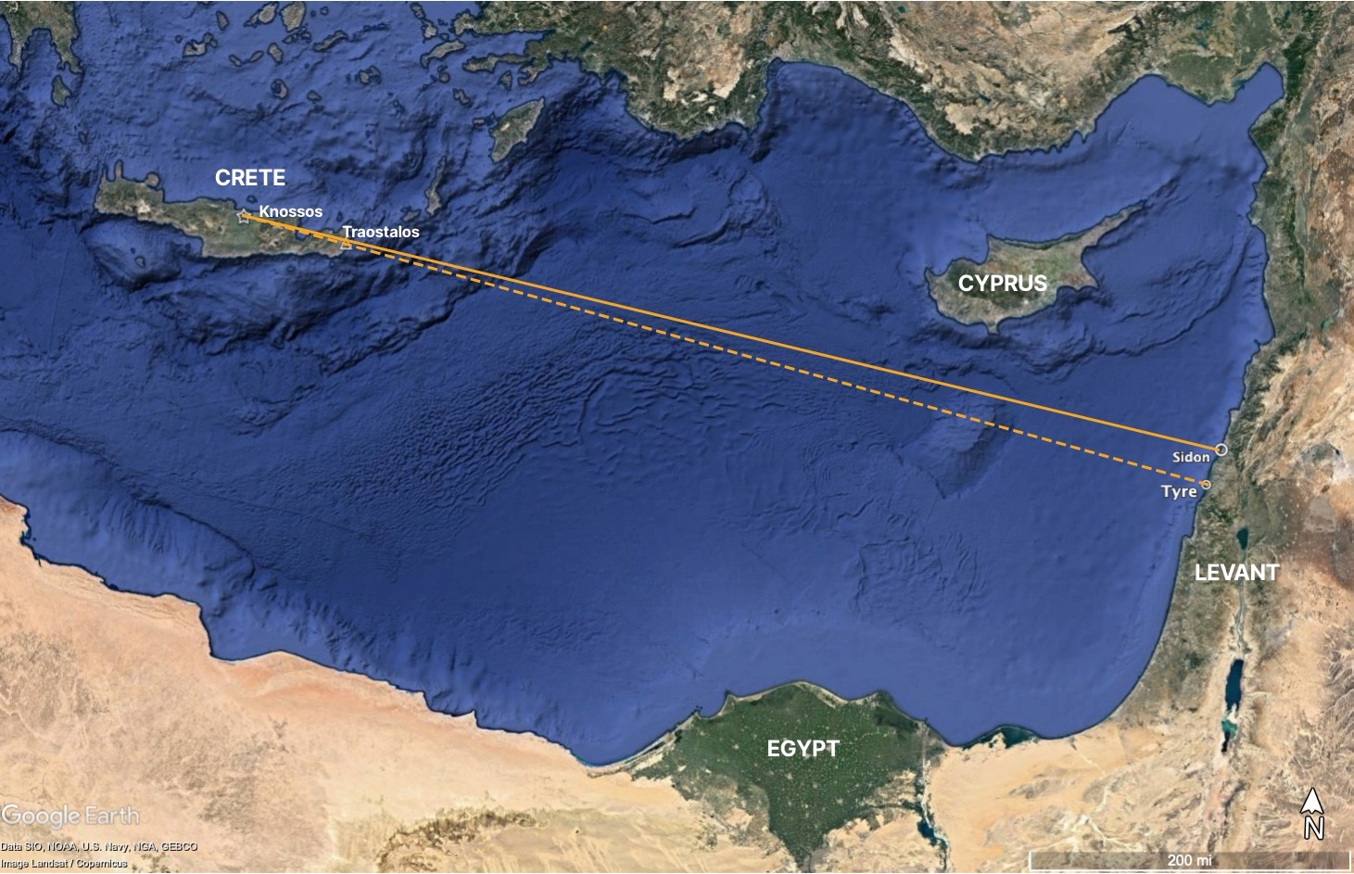

Fig. 18. Distance between Knossos and Sidon. Google Earth Pro.

A Minoan navigator could have guided himself by Spica (α Vir) setting astern along the route from Sidon beginning around the Old Palace to the New Palace period (Fig. 19). Polynesian and Micronesian ethnographic reports suggest that by memorising reciprocal stars, navigating by stars astern was a common feat. A Minoan cup excavated in Sidon suggests a direct or at minimum indirect trade between Crete and Sidon from at least the Old Palace period. The rhumb line azimuth from Knossos to Sidon intersects with that of a setting Spica precisely around 1900 bce, when this evidence of trade between both cities was documented (Fig. 17).
The rhumb line from Knossos to Sidon traverses by 2/3 of a kilometre the peak sanctuary of Traostalos (the rhumb line from Knossos to Traostalos is 100.73°). Therefore, Knossian sailors may have rounded the eastern coast of Crete until they arrived at the shores where the peak sanctuary was visible, then started their journey toward Sidon via Spica. As discussed previously, the peak sanctuary of Traostalos may have been associated with star navigation, as Blomberg and Henriksson propose.

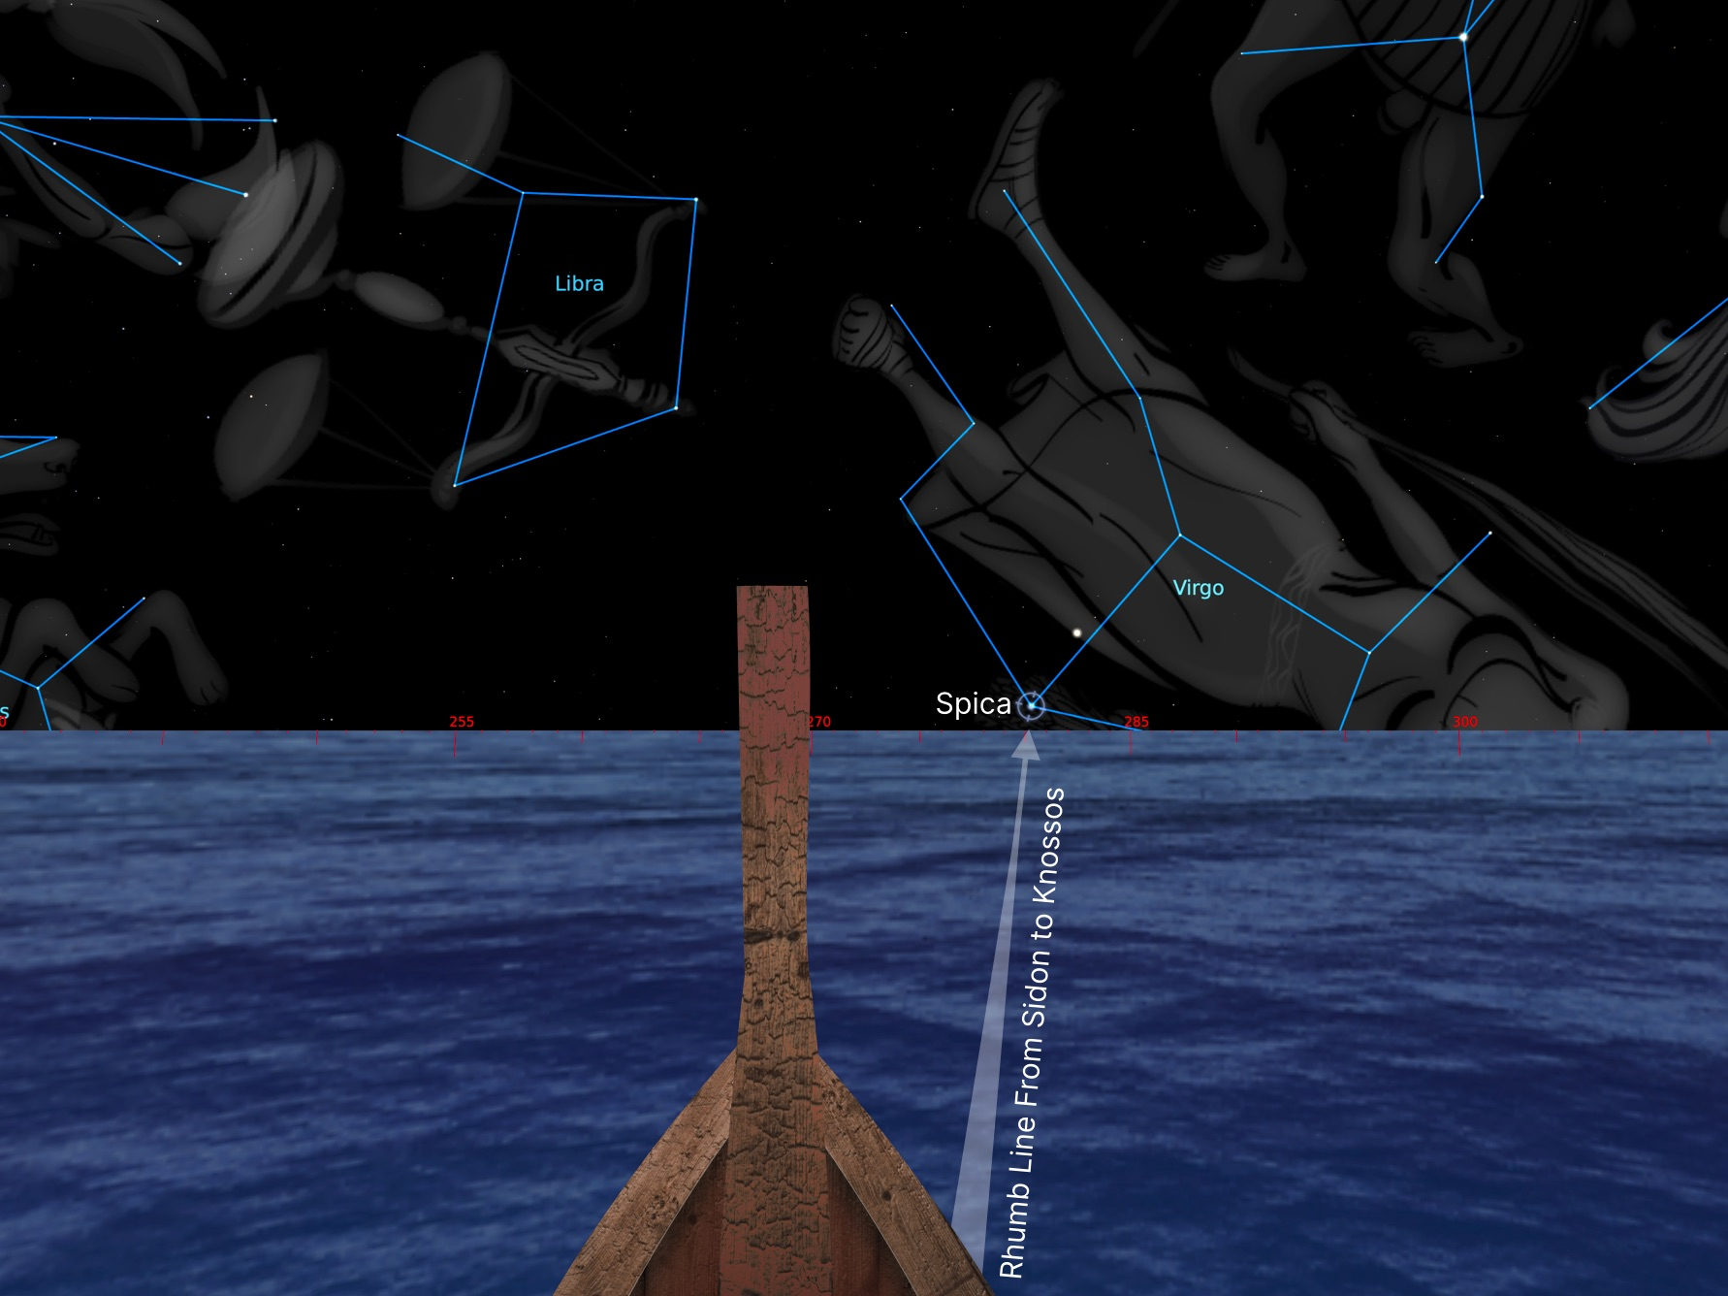

Fig. 19 Recreation of a Minoan bowsprit aiming at Spica setting, following the rhumb line from Sidon to Knossos.

Given the bidirectional use of star paths, the proposed rhumb lines do not suggest the direction of travel, which may be informed by analysing currents and wind patterns. In this case, the Etesian winds may have propelled sailors from Crete directly toward the Levant and Sidon (Fig. 20). However, a direct trade route to or from eastern Crete to the Levant has not been previously confirmed since a circular itinerary around the Mediterranean is most commonly asserted (Fig. 3). Nonetheless, during the New Palace period, Spica setting astern could have been a beneficial navigational star during the Spring and Summer from its acronychal rise around March 8th to its heliacal set around August 15th, within the timeframe of the Etesian winds. Undoubtedly, this would have been a challenging route, sailing in the open sea for 500 nautical miles, often without land in sight.

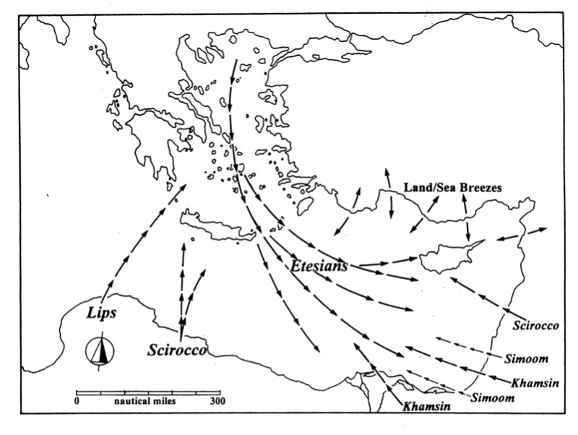

Fig. 20 Etesian summer winds in the Eastern Meditarranean.

Although outside of the scope, a brief discussion regarding Europa’s legend may give insights into how it may have memorialised this trade route in mythopoetic form. As previously discussed, Zeus abducted King Minos’ mother, Europa, from the beaches of Sidon and brought her to Crete. She was venerated by the Sidonians, who as recorded by Silius, navigated by the stars. Recent genetic research suggests demographic properties of Cretan haplogroups consistent with Anatolian and Syro-Palestine origins, indicating an ancestral relationship between Crete and the Levantine coast. As Nick Campion writes, ‘cultures which assume that ancestors and ancestral beings are associated with the land develop a profoundly personal relationship with it, and are required to care for it: thus land, sky and people exist in a system of integrated, inter-dependent and interlocking mutual relationships.’ In fact, the rhumb line toward Sidon, and the courtyard orientation East, faces the Ailias hill where a Minoan cemetery from the Middle Minoan period has been uncovered.
Pausanias writes that ‘There is also a sanctuary of Demeter surnamed Europa’. Demeter, the Greek goddess of grain and fertility, was associated with the constellation of Virgo, syncretised with the Roman Ceres, as written in the 1st century ce Astronomica, by Manilius, ‘the Virgin with her sheaf belongs to Ceres’. In addition, the Homeric Hymn to Demeter, the earth goddess came ‘from Crete over the sea’s wide (εὐρέα) back’. Europa’s name, Εὐρώπη, contains the morpheme εὐρύς, ‘wide, broad’. This term is the most common epithet used to describe the ‘earth’ in Indo-European poetic traditions. Thus, contrary to Frazer, Europa may have been associated with the earth and Demeter, and by extension Virgo, and not the moon in the shape of a cow. Supposing this early myth represented a celestial navigation route from the Levant to the Aegean, as Frazer suggested, then it could have taught the star path trade route to or from Sidon via Spica, as embedded in the New Palace courtyard orientation of Knossos.

Knossos to Tyre

As outlined previously, Driessen proposes palaces began as ‘monumentalized courts’ during Early Minoan IIB, or circa 2400 bce. During this early date, the star path from Virgo did not align to Sidon, but instead, it pointed precisely at its sister city of Tyre, where Europa was born (Fig. 17). However, due to precession, this orientation changed. The rhumb line from Knossos to Tyre was 103.63°, which coincided with the azimuth of bright red Antares (α Sco) in Scorpius from the Old Palace to the New Palace period (Fig. 21). Thus, the star paths for Sidon and Tyre from Knossos may have interchanged between Spica and Antares by the Old Palace period linking the two ‘sister cities’ (Fig. 17).
Archaeologists have not yet found material evidence of Minoan trade with Tyre from Early Minoan III period, which could justify the proposed star path via Spica to Tyre. The Late Minoan IB ‘Marseille ewer’ was initially contemplated to have originated in Tyre. However, the first historical textual mention of Tyre surfaces around the 19th century bce, concurrent with the earliest evidence of trade between Knossos and Tyre’s sister city, Sidon. By this date, Antares could have steered celestial navigators on their journey from its heliacal rise on November 8th to its acronychal rise on April 25th. However, this maritime feat may have entailed navigating during the Halcyon days of the dangerous winter months or during the beginning of the safer spring.

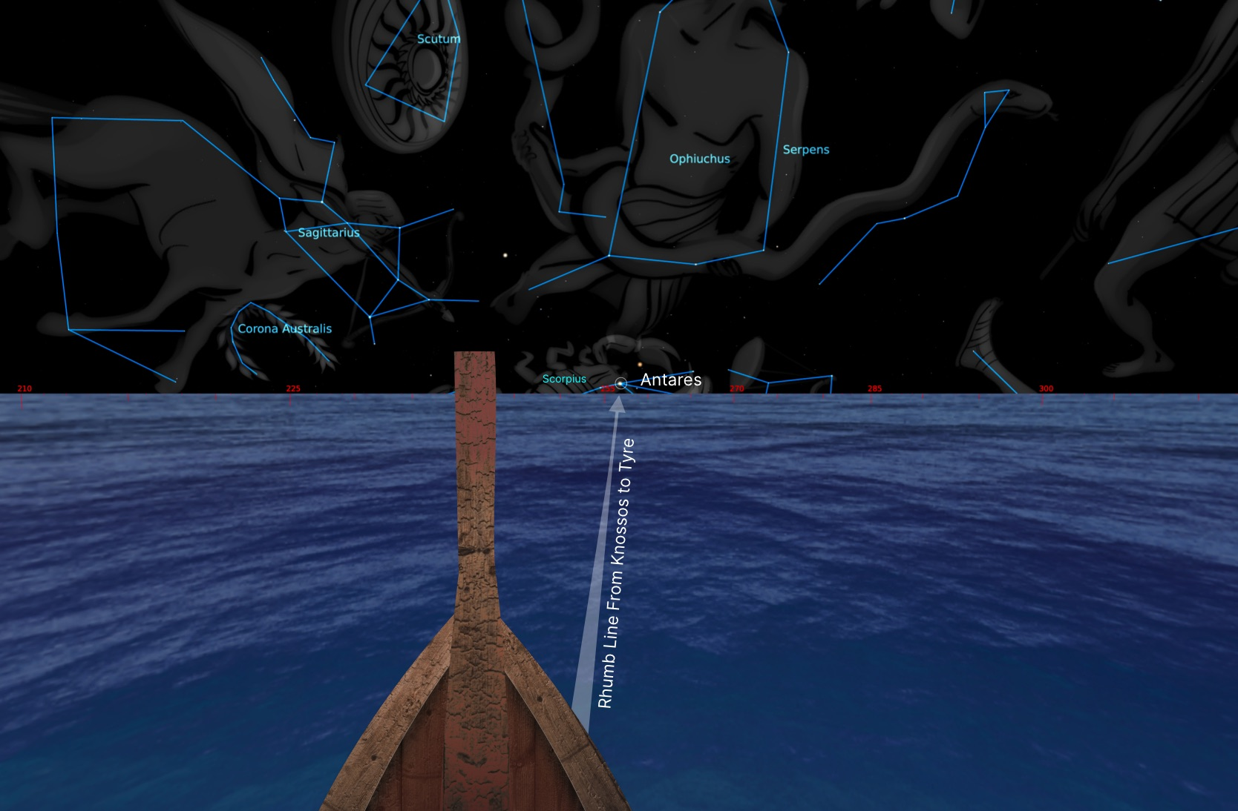

Fig. 21. Skyscape visualization of a rhumb line navigation from Knossos to Tyre along the Antares star path during the Old Palace Period.

Phaistos to Qatna and Kadesh

During the Old Palace period, the Phaistos courtyard short axis orientation of 91.03° pointed toward the rising of Aldebaran (α Tauri) to within one degree of accuracy (Fig. 17). Following a rhumb line along Aldebaran’s star path, one would traverse Crete and make landfall at Cyprus (Fig. 22). This route would eventually lead to Hala Sultan Tekke, where numerous examples of Minoan pottery from the Late Minoan periods have been found. Merchants based at Phaistos could have sailed to or from Kommos, the main harbor of Southern Crete, where significant evidence of trade between Crete and Cyprus exists. According to Zeman-Wiśniewska, Kommos contains the ‘most visible trace of contacts between the two islands’ in the Middle Minoan period. Hala Sultan Tekke later became the Phoenician city of Kition, while Kommos itself flourished as a Phoenician trading post. By continuing on this star path, Minoan merchants would have reached the Levantine coast and then journeyed to the inland kingdom of Qatna.
A century prior to the Old Palace period, circa 2000 bce, Qatna rose to become the regional capital in what would become modern-day Syria. Qatna was a major Syrian kingdom and commercial centre, positioned at the crossroads of the north-south route between Anatolia to Egypt (from Aleppo via Hama to Damascus), and the east-west roads connecting to Mesopotamia (from Mari across the Syrian desert to the Mediterranean) (Fig. 23). The palace of Qatna contains Minoan frescoes rarely found outside the Aegean. Dating to circa 1650-1550 bce, they depict typical Minoan motifs such as palm trees, rivers, spirals, and a dolphin. Text 30 of the Zimri-Lim texts mention Cretan officials alongside the kings of Qatna and Hazor.

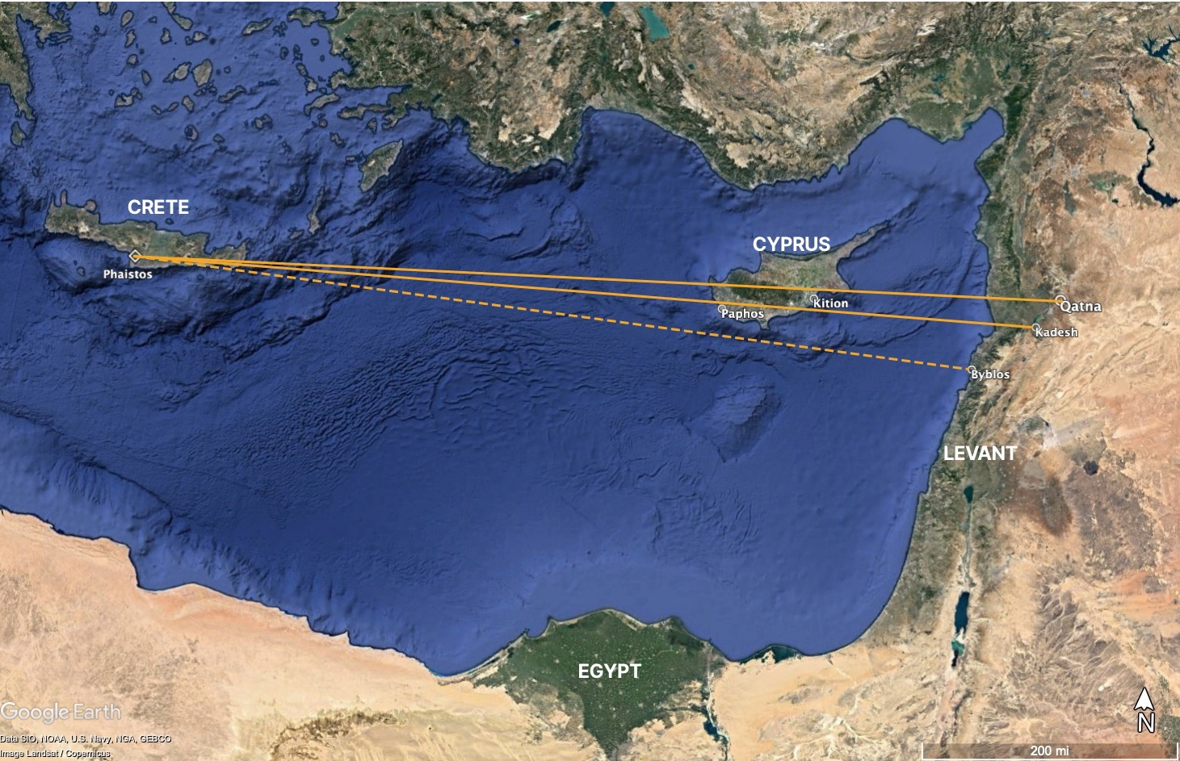

Fig. 22. Direct route through Cyprus to Qatna. Google Earth Pro.

The rhumb line from Phaistos to Qatna differs by +0.23° from the Old Palace courtyard orientation (Table 2). The orientation is almost exactly due east-west toward the equinoctial sunrise or sunset. By the New Palace period (circa 1700 bce), when the Minoanized Qatna palace was constructed, the rhumb line from Phaistos matched more closely with the star path to Betelgeuse (α Orionis) rising rather than Aldebaran (Fig. 17, 24). However, the palace orientation may have been adjusted during this phase of construction, consistent with a rhumb line toward Kadesh, which may have been a royal residence at the time. A century before the New Palace period, king Ishi-Addu of Qatna had taken up residence in Kadesh, one of the principal cities of the kingdom, to quell a local rebellion. Coincidentally, circa 1800 bce the rhumb line to Kadesh was oriented exactly to the star path of Betelgeuse (Fig. 17). Therefore, this shift in orientation may reflect political as well as astronautical considerations.

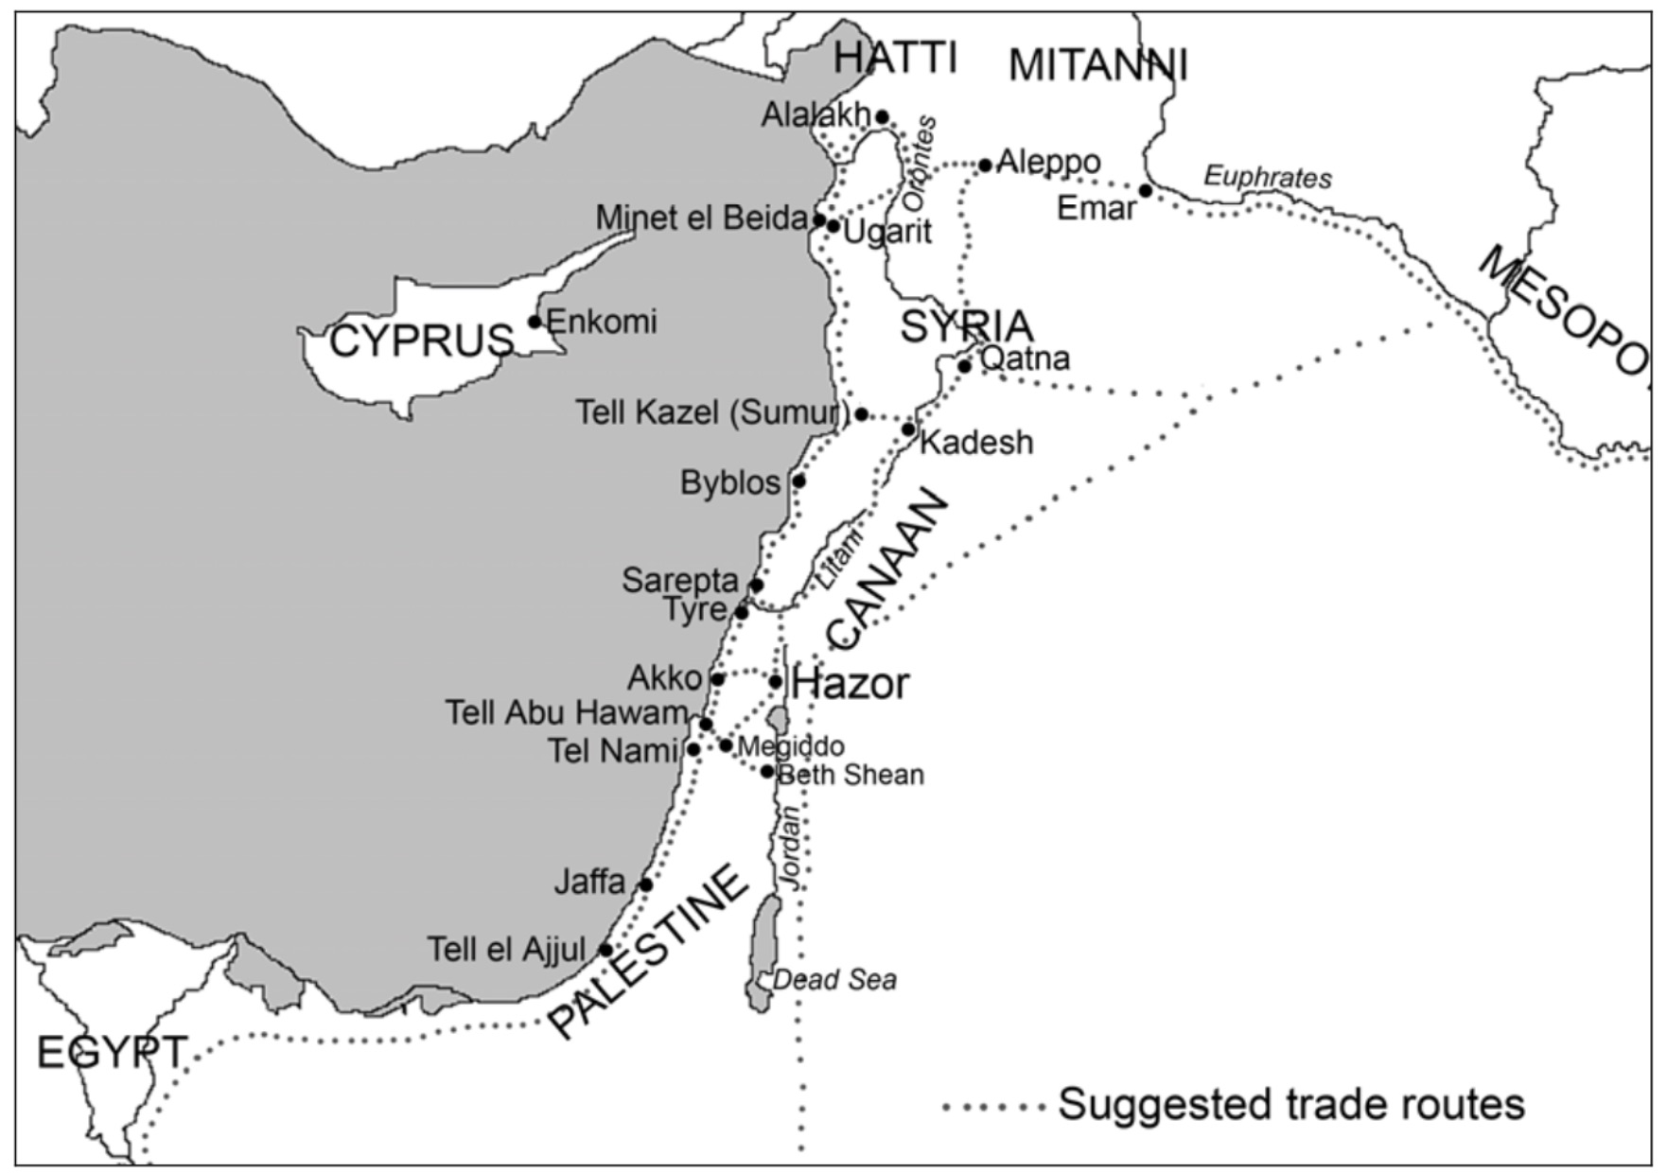

Fig. 23. Terrestrial trade routes in the Bronze Age.

If aligning due east during the Old Palace was the intention (disregarding the 1° apparent error in orientation), why would the builders have slightly realigned the building during the New Palace? The rhumb lines to Qatna and then Kadesh present a plausible explanation for why the palace is not oriented precisely to the cardinal east. Unlike Blomberg and Henriksson’s view, this hypothesis not only accounts for the different construction phases of the palace, but also considers the use of possible navigational stars. Blomberg and Henriksson’s proposal that the Phaistos long axis was oriented toward Canopus, does not consider any navigational or rhumb line directions associated with this star, only that it may have been an equinoctial marker. However, it would not have been practical since it was not directly visible from the courtyard. The orientation toward Qatna during the Old Palace does not preclude an intentional alignment to the Kamares cave as well.

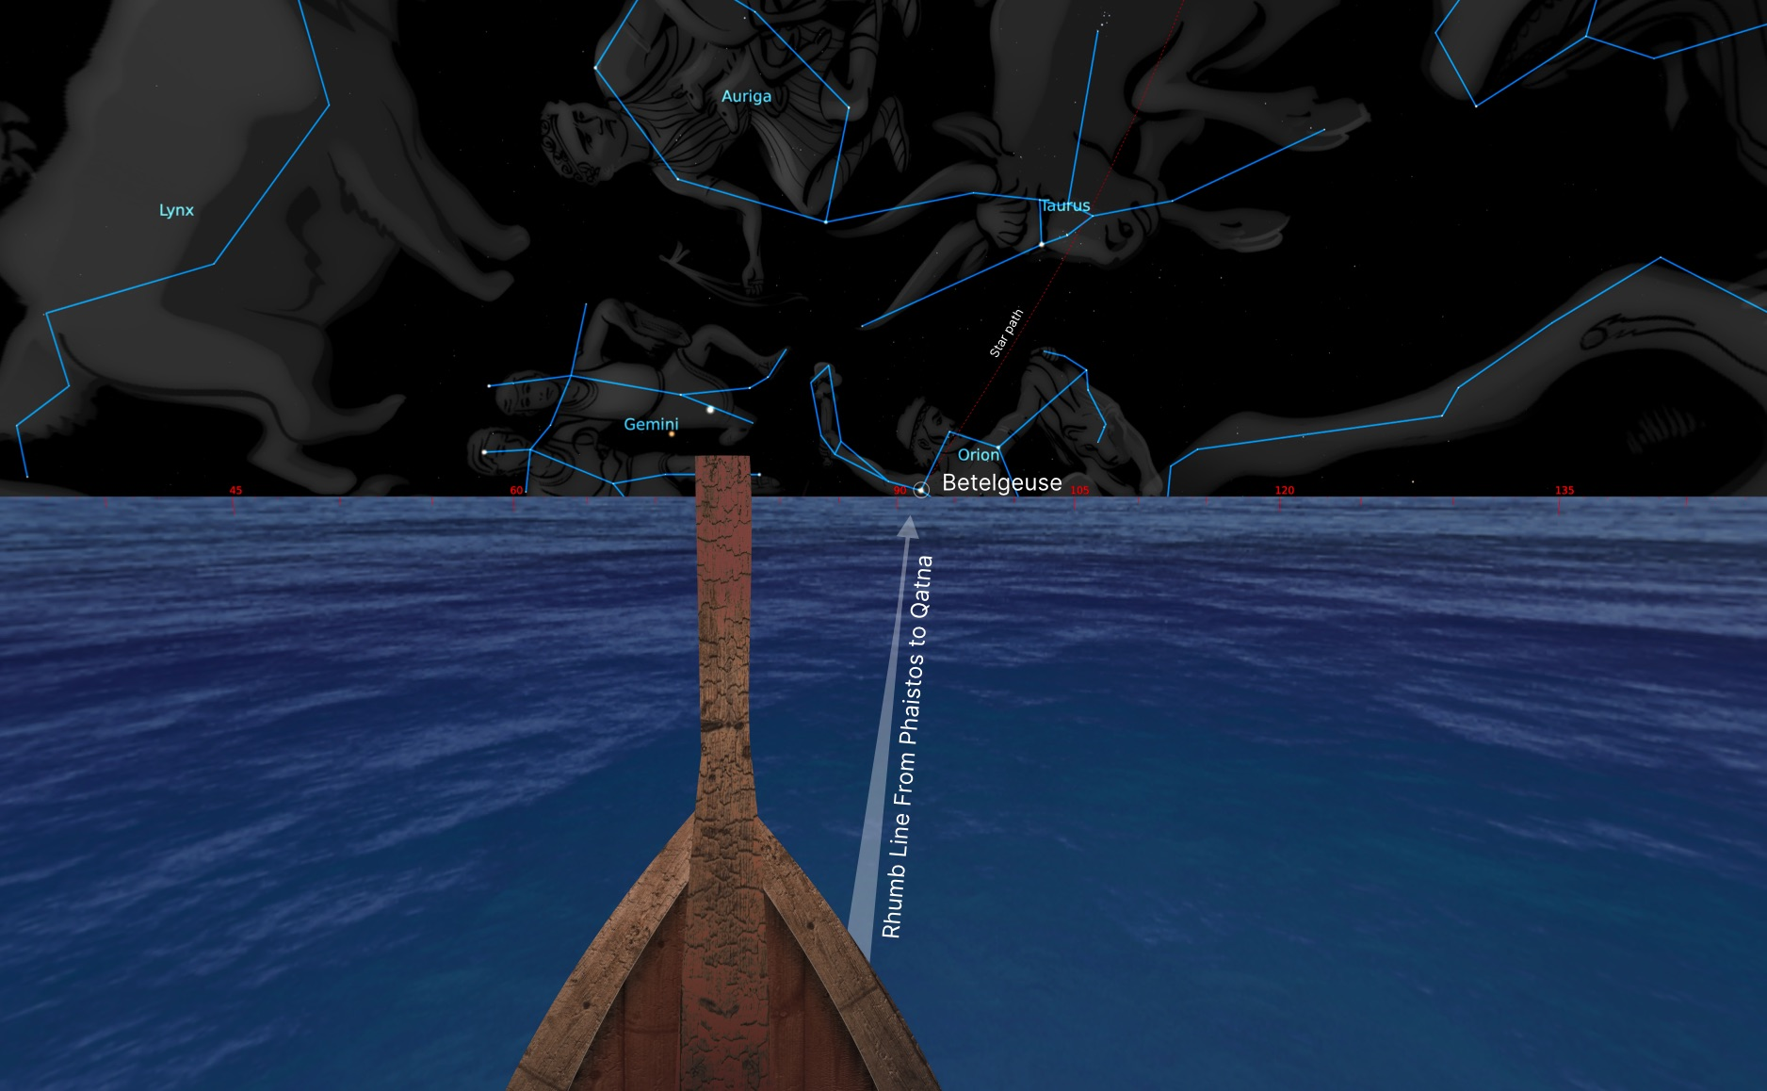

Fig. 24. Skyscape visualization of a rhumb line navigation from Phaistos to Qatna or Kadesh along the Betelgeuse star path during the New Palace period.

Furthermore, one can observe that there is a lacuna between the Old Palace orientation and its alignment to the star path of Aldebaran circa 2000 bce versus the New Palace orientation to Betelgeuse circa 1650 bce (Figure 17). As previously discussed, there was a well-documented tradition of sailing by the circumpolar stars in the Mediterranean. Supposing such a technique was known to the Minoans, the northern stars may have guided sailors on their journey due east, or its reverse, due west. They would forgo the necessity of a precise star path to Qatna, since they may have maintained course with the celestial north pole exactly port side or starboard.

Phaistos to Byblos

A stratigraphic analysis of Phaistos has demonstrated that features initially associated with the New Palace period actually belonged to the Prepalatial period. Around 2300-2400 bce, during the Early Minoan IIB, when the Minoans set the first foundations for the later palaces, it can be observed that the star path of Betelgeuse intersects directly with a rhumb line from Phaistos toward Byblos at 95.86° (Fig. 17)). There might be evidence of the Prepalatial orientation at the northern entrance of the courtyard where there is drain canal following an oblique trajectory (Fig. 25:C). It was measured virtually with the azimuth of 95.21° (when adjusted for an east-west direction), or around .65° off from the rhumb line to Byblos along the Betelgeuse star path. Its proximity to the courtyard and offset angle from the palace axis calls attention to itself. Although speculative, if this channel preserved the original Prepalatial orientation it may have pointed toward the star path of Betelgeuse and the rhumb line toward Byblos.

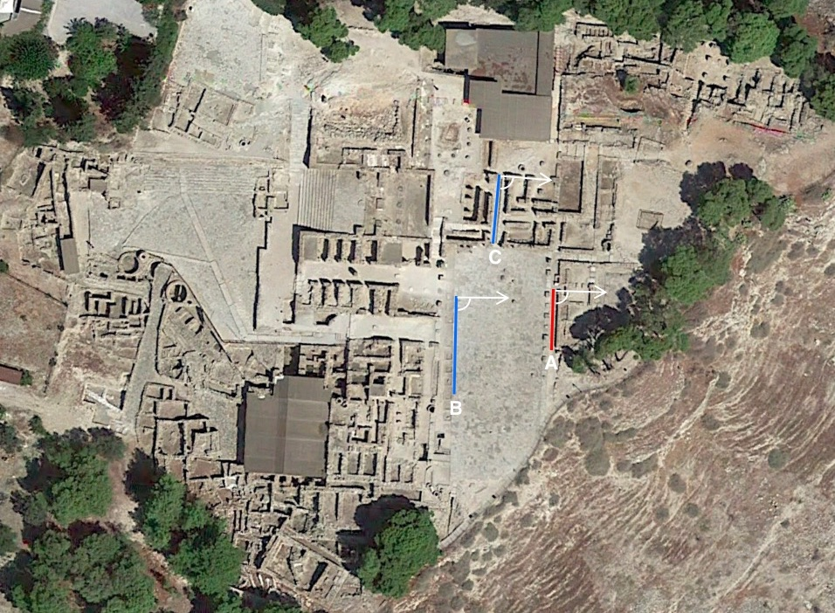

Fig. 25. Phaistos New Palace orientation (A), Old Palace orientation (B), oblique ‘drain’ (C). Google Earth Pro.
Betelgeuse is one of the principal navigational stars of Polynesia and Micronesia. Lewis writes night’s journey steered by this star:

After nightfall Tevake directed the helmsman to steer by Betelgeuse (Trkapekau ki Taumako), rising ahead on a bearing of about 083°. An hour and a half after sunset found us still steering by Betelgueue in Orion, the northern wingtip of the Polynesian constellation Giant Bird, whose head is Sirius and whose nether wingtip is Canopus.

The importance of Betelgeuse in Pacific Islander navigation corroborates its possible utility for ancient Aegean sailors. Around 1750 bce, Betelgeuse may have served as a navigational star from its heliacal rise on June 26th, to its acronychal rise on December 4th, within range of the favorable summer months for sailing. While a direct route from Crete to Byblos is conjectured, similar winds as those that may have taken Cretans to Sidon and Tyre, may have billowed the sails of those aiming for Byblos and Qatna.
According to Keith Branigan, the earliest imports in Crete originated from Byblos and dated to the end of the 3rd millennium bce during the EM III period. During the second dynasty of Egypt, a trade route from Egypt to Byblos was established to acquire precious timber used to manufacture boats and coffins. As Sørensen confirms, ‘A tentative conclusion to be drawn from the material presented would be that Byblos was chosen as a favourite port of call at least from EM II–MM II(A?)’. A survey of the Minoica collected in the Levant reveals that more than half were excavated in Byblos, Ugarit, and Alalakh, all which functioned as persistent trade centers during the Bronze Age. In the Old Kingdom Pyramid Texts, Orion personified Osiris as sꜢḥ. Plutarch recounts the legend of Osiris how was murdered by his brother Seth, and how the chest with his body washed ashore in Byblos. It can be speculated that this parable, which links Byblos with Orion, may have been a cultural embedding of the triangular trade route between Crete, Egypt and the Levantine port city.
It is conceivable then that the short axis of Phaistos was initially aligned to Betelgeuse as a star path trade route to Byblos. Still with the passage of the centuries, it was realigned to Qatna along the star path of Aldebaran, coinciding with the flourishing of the city. It was subsequently aligned to Kadesh which again coincided with the star path of Betelgeuse. The hypothesis of a Prepalatial orientation toward Byblos may be confirmed or denied by further archaeological research at Phaistos.

Malia To Kabri or Akko

As Shaw discussed, the palace of Malia was constructed over an open area, unhindered by geography, suggesting that the orientation was not fortuitous. My live fieldwork of the palace courtyard measured 106.99°, consistent with Shaw’s theodolite reading of 107.03°. This orientation intersects with the azimuths of Mirach (β And) setting during the New Palace period (Fig. 17). There are two candidate cities in the Levant within acceptable range of this star path and orientation. The first, Kabri, where fragments of Minoan frescoes have been found, was one of the major South Levantine sites during the Middle Bronze Age II period. Sørensen writes:

According to the present excavators of Kabri, the city thrived from the MB I period until its destruction around 1600 bc. During its heyday, a port at the small fortified site of Nahariya could have been in use by the rulers and traders of Kabri to conduct seaborne trade. Hazor lay 40 km east of Kabri, almost in a straight line, with no great mountains to cross.

The constant azimuth from Malia to Kabri is 105.9° or about 1° off from the courtyard axis. During the Middle Bronze Age II circa 1700 bce, the rhumb line to Kabri from Malia aligned to the rising of the Belt of Orion when the third star Alnitak became visible on the horizon (Fig. 17). The belt was a known navigational aid in Polynesia and Micronesia.
The more compelling candidate for the Malia courtyard orientation is the harbour town of Akko. Situated in Galilee, modern-day Israel, Akko was the region’s largest port, and was urbanized at least from the early 2nd millennium bce. Akko was an early settlement by the Middle Bronze Age and part of an international maritime trade network by Middle Bronze Age IIA, which included Cyprus, the Aegean world, and Egypt (as evidenced by 18th and 19th dynasty Egyptian scarabs). Cypriot and Mycenaean pottery from the Late Bronze Age discovered at the site attests to its importance as an international trade hub. Hesse writes:

Akko had a perfect location next to a natural harbour and at the mouth of the Na’aman River, which also served as an anchorage. In addition it was situated at the crossroad of two important trade routes, the coastal highway, leading northwards to Syria and southwards to Egypt, and a lateral road leading to and from the Syrian hinterland.

Ancient Egyptian execration texts from around 1800 bce and the Thutmose III list record the toponym Akko. The constant azimuth from Malia to Akko is 106.5667° or less than half a degree between the star path following Mirach and the palace courtyard axis of 107.03° circa 1750 bce (Fig. 17). While no archaeological evidence of trade between Akko and the Minoans has been found yet, the New Palace construction and orientation coincides with the earliest references to Akko in the Egyptian Execration texts

Zakros to Pelusium

Measured at 127.73°, the oblique main axis of the Zakros palace appears to be an outlier when compared to the other three main palaces (Fig. 16). Shaw hypothesises that the Minoans may have have shifted the axis of the Zakros palace by 20° to shelter the courtyard from the forceful Eltemi summer winds. As previously discussed, the concentration of ritual rooms on the western side of the courtyard may have been facing the direction of the rhumb line toward the distant trading emporia on the Levantine and Egyptian coasts. The present research indicates the orientation for Zakros was further South than the other major palaces because it may have pointed toward the Egyptian and not the Levantine coast (Fig. 26).

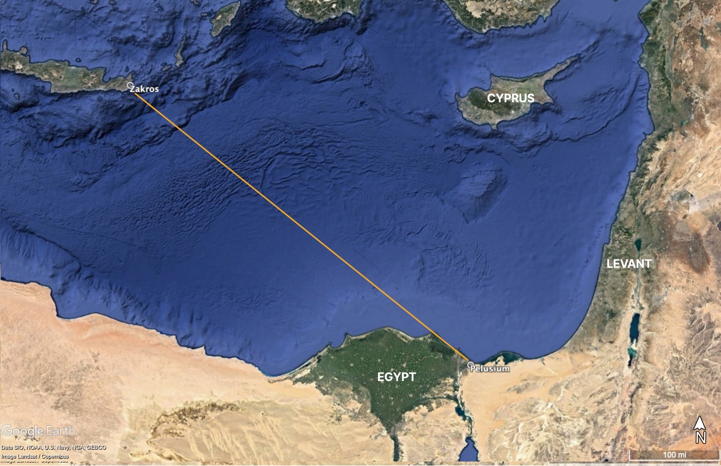

Fig. 26 Rhumb line from Zakros to Pelusium on the Nile Delta. Google Earth Pro.

The short axis of the Zakros palace courtyard orients to 127.73°, which is only slightly askew from Shaw’s theodolite reading of 127.5528° (Table 1). Meanwhile, the rhumb line toward Pelusium (Tel Farama), at the mouth of the Pellusiac branch of the River Nile, was at the constant azimuth of 127.43°, a difference of only 0.1228° (Table 2). Pelusium, the easternmost major city of Lower Egypt, functioned as the regional centre for terrestrial and maritime trade with the Levant. It is unclear, but the historical and archaeological record suggests it was founded between the Middle Kingdom in the early 2nd millennium bce and the Saite to Persian eras in the 8th to 6th centuries bce. Perhaps, known as Sĭn in the biblical Book of Ezekiel, it may have served as a navigational hub from at least the 18th and 19th dynasties of the New Kingdom. Given the importance of Pelusium as a port connecting Egypt with the Levant, it remains a strong candidate for the astronautical orientation of Zakros.

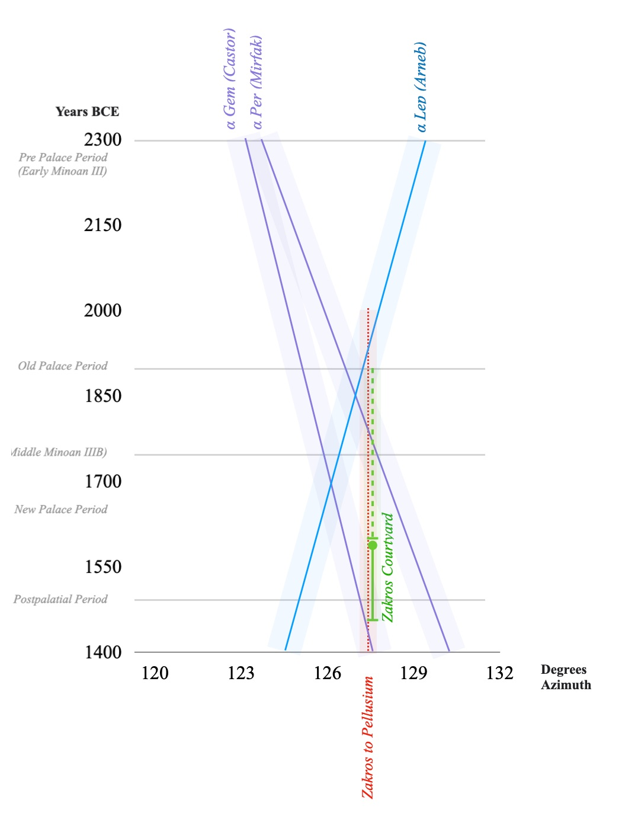

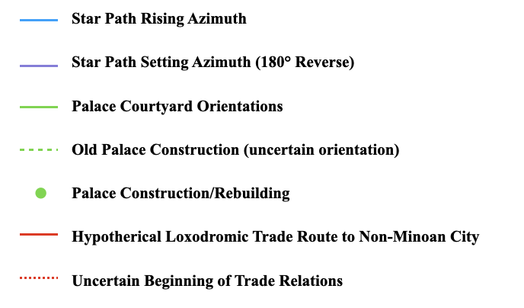

Fig. 27 Minoan Rhumb Lines Between Zakros and Pelusium associated to courtyard orientation and star paths.

Pelusium was a bustling oriental-Egyptian city, which functioned as a ‘link between Egypt and the rest of the ancient world with a special allowance towards the cities of the Near East’ and was teaming with Carian and Ionian settlers alongside the presence of exotic gods and cults. Foreign merchants would have cruised upriver to the military outpost of Tjaru or to Avaris, the Hyksos capital, also on the Pellusiac branch. According to Manfred Bietak, the regional pharaonic naval base of prw nfr, where keftiu ships were documented to have reached, would have received large influxes of non-Egyptian immigrants or tradesmen selling their imported wares.
While there is some debate as to the founding date of the Zakros Palace, Platon has suggested there was a Middle Minoan palace below the New Palace with a larger courtyard, similar to what occurred at Malia and Knossos. During the New Palace period, the orientation of the palace was well served by both Castor (α Geminorem) and Mirfak (α Persei) setting (Fig. 27). A Middle Minoan date for the Zakros courtyard would coincide with the upper limit of the foundation date for Pelusium during the Middle Kingdom (Fig. 27). If the orientation of the Middle Minoan courtyard can be presumed to have stayed the same, then at its founding, Zakros could have been precisely aligned to a star path guided by Arneb (α Leporem), the brightest star in Lepus.

Conclusion

The aim of this research was to investigate if the short axis of Minoan palace courtyards were oriented toward star paths aimed at distant coastal emporia in the Levant and Egypt, destinations imbued with historical and commercial significance. The evidence suggests that the Minoans may have relied on wayfinding methods analogous to those from Polynesia and Micronesia and relied on star paths for the memorisation, practical use, and oral transmission of trade routes. This is supported by literary evidence of star steering by classical Greek and Levantine sailors.

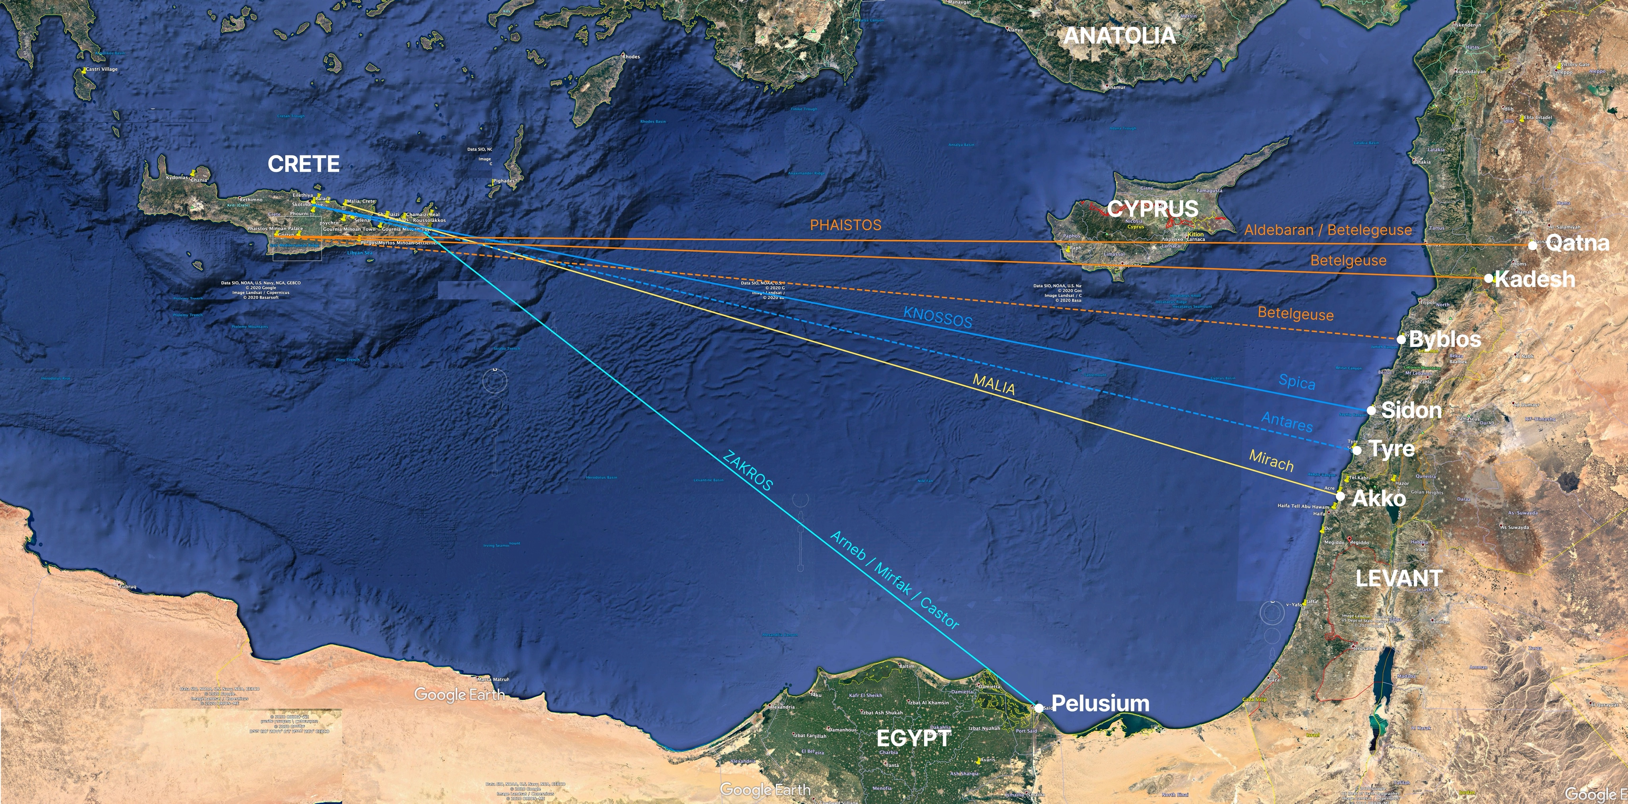

Fig. 28 Map of proposed Minoan star path direct trade routes to the Levant and Egypt. Google Earth Pro.

While Shaw criticised Belknap for his attempt at linking orientations of the palaces to distant locations on the coast of North Africa, modern technologies, such as precision astronomical softwares and satellite mapping have facilitated more accurate archaeoastronomical analysis. With these advances, a new methodology was devised that synthesises traditional skyscape archaeology fieldwork and measurements with virtual fieldwork centred on astronautical orientations along rhumb lines. The results appear to indicate, beyond apparent coincidence, the use of bright primary stars as guides toward the busiest ports on the Eastern Mediterranean (Fig. 28). It can be observed then that the rhumb lines appear to follow the brightest stars of their respective Greek constellations (Fig. 17). The results also take into account the earth’s axial precession and suggests the possibility, which should be further investigated, that progressive re-orienting of the palaces may have been in accordance with realignments to the slow-changing star paths, the economic flourishing of port cities, and other geo-political factors.
Astral mythology, handed down by the ancient Greeks, may have been created to preserve and teach the trade routes, perhaps similar to the tales told in Polynesia and Micronesia by master sailors to instruct and help students memorise journeys. Would-be Minoan navigators could be taught about the star paths within palace buildings, similar to the maneabas, without direct sight lines to the stars on the horizon, or on peak sanctuaries. Like the navigation stone of Aurorae Islands or the Hawaiian heiau system, the orientations of the palace courtyards may have pointed to important destinations across the ocean, perhaps as aides-memoire or educational tools. Mythological evidence may support the existence of some of these star path rhumb lines, such as the navigation via Spica toward Sidon, where Zeus abducted Europa.
Minoan courtyards may have converged rituals associated with the rhumb line directions in the same way as celebratory processions radiated from Coricancha along the ceque paths. Thus, the palace courtyard acted as the economic, cultic, and astronautical heart of Minoan culture, embedding long-distance navigational knowledge within its axial space and synthesising landscape, seascape, and skyscape. Future research will investigate mythological and linguistic considerations alongside with measurements of the smaller palaces of Minoan Crete.

Appendix

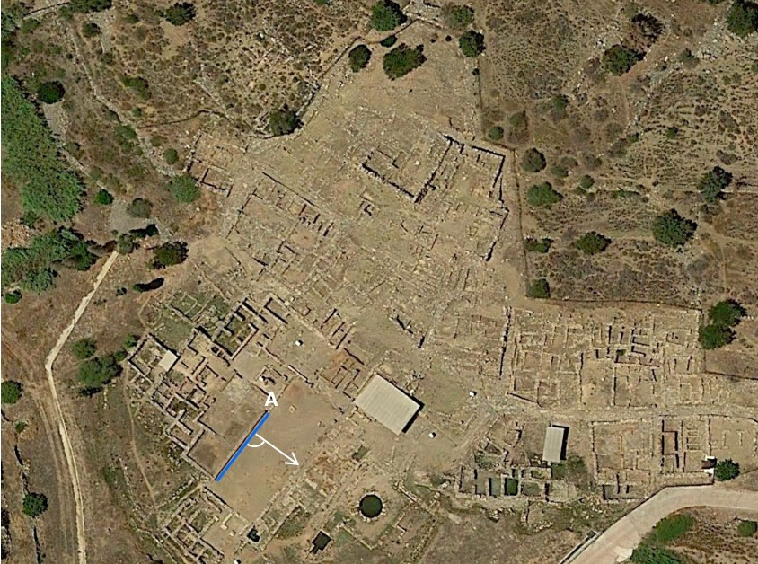

Fig. 29. Zakros virtual measurement of the place courtyard. Google Earth Pro.

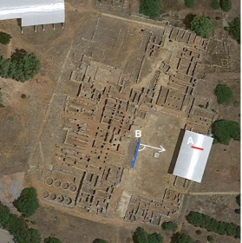

Fig. 30. Malia virtual and live fieldwork measurements. Google Earth Pro.

Bibliography

Primary Sources

al-Najdī, A.I.M., A.I.M. al-Nadjdī, A.M. Saʿdī, G.R. Tibbetts, and A.M. al-Sadi, Arab Navigation in the Indian Ocean before the Coming of the Portuguese: Being a Translation of Kitāb Al-Fawāi̓Dfī Usūl Al-Bahr Wa’l-Qawā’id of Ahmad B. Mājid Al-Najdī (Royal Asiatic Society of Great Britain and Ireland, 1971).

Apollodorus, The Library (W. Heinemann; G. P. Putnam’s sons: London New York, 1921).

Evelyn-White, Hugh Gerard, Hesiod, the Homeric Hymns, and Homerica (W. Heinemann, 1920).

Hesiod, and R. M. Frazer, The Poems of Hesiod (University of Oklahoma Press: Norman, 1983).

Homer, The Odyssey (Cambridge, MA: Harvard University Press, 1919).

Jowett, Benjamin, and AP Peabody, History of the Peloponnesian War (1900).

Lamb, John, The Phenomena and Diosemeia of Aratus (John W. Parker, 1848).

Manilius, Marcus, Astronomica (2015).

More, Brookes, and Ovid, Metamorphoses (Boston: Cornhill Publishing Co, 1922).

Plutarch, Isis and Osiris (Loeb Classical Library edition, 1936).

Strong, Herbert Augustus, The Syrian Goddess: Being a Translation of Lucian’s ‘De Dea Syria’: With a Life of Lucian (Constable, 1913).

Wycherley, Richard Ernest, Pausanias Description of Greece (Harvard University Press, 1918).

Secondary Sources

Agouridis, Christos, ‘Sea Routes and Navigation in the Third Millennium Aegean', Oxford Journal of Archaeology, 16 (1997), pp. 1-24.

Akira, Goto, Ohnishi Hideyuki, and Ishimura Tomo, ‘A Report on the Reassessment of Navigation Stones on Arorae, Kiribati', People and Culture in Oceania, 35 (2019), pp. 109-25.

De La Fe, Alfredo, ‘The Coin Project’ from <http://www.coinproject.com/search_city_result.php?city=Sidon&region=SYRIA,-PHOENICIA&type=5> [accessed September 10, 2021].

Andrews, P.B.S., ‘The Myth of Europa and Minos’, Greece & Rome, 16 (1969), pp. 60-66.

Anton, ‘Course Angle and the Distance between the Two Points on Loxodrome (rhumb Line)’, Online Calculators from <https://planetcalc.com/713> [Accessed September 15, 2021].

Artzy, Michal, ‘From Akko/Acco to Beit She’an/Beth Shan in the Late Bronze Age’, Ägypten und Levante/Egypt and the Levant, 28: (2018), pp. 85-98.

Baurain, Claude, ‘Minos Et La Thalassocratie Minoenne. Réflexions Historiographiques Sur La Naissance D’un Mythe’, Thalassa. L’Égée préhistorique et la mer («Aegaeum» 7), éd. par R. Laffineur-L. Basch, Liège: (1991), pp. 255-66.

Belmonte, Juan Antonio, ‘Finding Our Place in the Cosmos: The Role of Astronomy in Ancient Cultures’, Journal of Cosmology, 9: (2010), pp. 2052-62.

Belmonte, Juan Antonio, Mosalam Shaltout, and Magdi Fekri. ‘Astronomy, Landscape and Symbolism: A Study of the Orientation of Ancient Egyptian Temples’ (Cairo: Supreme Council of Antiquities press, 2009), pp. 211-82.

Bietak, Manfred, ‘Minoan Presence in the Pharaonic Naval Base of “Peru-Nefer”’, British School at Athens Studies: (2010), pp. 11-24.

Blomberg, Mary, and Göran Henriksson, ‘Evidence for the Minoan Origins of Stellar Navigation in the Aegean’ (1999).

Blomberg, Mary, and Göran Henriksson, ‘Orientations of the Minoan Palace at Phaistos in Crete’, Ancient watching of cosmic space and observation of astronomical phenomena, 6-10 April, 2006, Rhodes, Greece (2007), pp. 185-92.

Bloomberg, Mary and Göran Henriksson. ‘Crossing Geographical Borders from Minoan Crete’. In Crossing Borders: Trade and Production in Premonetary Greece. Proceedings of the 7th, 8th and 9th International Workshops, Athens (1997), pp. 191-210.

Boutsikas, Efrosyni, ‘Greek Temples and Rituals’, Handbook of Archaeoastronomy and Ethnoastronomy (2015).

Brady, Bernadette, ‘Star-Paths, Stones and Horizon Astronomy’ in SEAC 2011 Stars and Stones: Voyages in Archaeoastronomy and Cultural Astronomy (2015), pp. 58-62.

Branigan, Keith, ‘Further Light on Prehistoric Relations between Crete and Byblos’, American Journal of Archaeology, 71 (1967), pp. 117-21.

Broodbank, Cyprian, An Island Archaeology of the Early Cyclades (Cambridge University Press, 2002).

Broodbank, Cyprian, and Thomas F. Strasser, ‘Migrant Farmers and the Neolithic Colonization of Crete’, Antiquity, 65 (1991).

Bryce, Trevor, The Routledge Handbook of the Peoples and Places of Ancient Western Asia: The near East from the Early Bronze Age to the Fall of the Persian Empire (Routledge, 2009).

Burkert, Walter, Greek Religion (Harvard University Press, 1985).

Campion, Nicholas, ‘Skyscapes: Locating Archaeoastronomy within Academia’, Skyscapes: The Role and Importance of the Sky in Archaeology, edited by F. Silva and N. Campion (2015), pp. 8-19.

Cartwright, Mark. ‘Coricancha’. World History Encyclopedia, from <https://www.worldhistory.org/Coricancha/> [Accessed on September 17th, 2021].

Chryssoulaki, Stella. ‘The Imaginary Navy of Minoan Crete: Rocky Coasts and Probable Harbours’ in Emporia: Aegeans in the Central and Eastern Mediterranean. Proceedings of the 10th International Aegean Conference, Athens, Italian School of Archaeology, 14–18 April 2004 (Aegaeum, 2005), pp. 77-89.

Cline, Eric H., ‘Rethinking Mycenaean International Trade with Egypt and the near East’, Rethinking Mycenaean Palaces II (2007), pp. 190-200.

Coleman, John E., ‘“Frying Pans” of the Early Bronze Age Aegean’, American Journal of Archaeology: (1985), pp. 191-219.

Cotter, H., ‘The Early History of Great Circle Sailing’, The Journal of Navigation, 29 (1976), pp. 254-62.

Davis, Danny Lee, ‘Navigation in the Ancient Eastern Mediterranean’, (Thesis, Texas A&M University 2001).

DeBoer, Warren R., and John H. Blitz, ‘Ceremonial Centers of the Chachi’, Expedition, 33 (1991), p. 53.

Doxtater, Dennis, ‘Rethinking the Sacred Landscape Minoan Palaces in a Georitual Framework of Natural Features on Crete’, Landscape Journal, 28 (2009), pp. 1-21.

Driessen, Jan, ‘IIb or Not IIb: On the Beginnings of Minoan Monument Building’ (2007).

Driessen, Jan, ‘Malia’ in The Oxford Handbook of the Bronze Age Aegean (2010).

Evans, Arthur J., ‘The Early Nilotic, Libyan and Egyptian Relations with Minoan Crete’, The Journal of the Royal Anthropological Institute of Great Britain and Ireland, 55 (1925), pp. 199-228.

Evans, Arthur J., The Palace of Minos at Knossos Vol. 2 (1928).

Fischer, Peter M., and Teresa Bürge, ‘Tombs and Offering Pits at the Late Bronze Age Metropolis of Hala Sultan Tekke, Cyprus’, Bulletin of the American Schools of Oriental Research, 377 (2017), pp. 161-218.

Galaty, M.L., H. Tomas, and W.A. Parkinson, ‘Bronze Age European Elites: From the Aegean to the Adriatic and Back Again’, The Cambridge Prehistory of the Bronze and Iron Age Mediterranean (2014), pp. 157-77.

George, Marianne, ‘The Return of Lata: Building an Authentic Polynesian Voyaging Canoe’, Sea History Journal, 84: (1998), pp. 40-42.

Gifford, John A., and Stylianos Alexiou, Stephanie Fay, and Steve Renick, The Aerial Atlas of Ancient Crete (Univ of California Press, 1992).

Gladwin, Thomas, and Thomas Gladwin, East Is a Big Bird: Navigation and Logic on Puluwat Atoll (Harvard University Press, 2009).

Goodenough, Ward H., and Stephen D. Thomas, ‘Traditional Navigation in the Western Pacific’, Expedition, 29 (1987), pp. 3-14.

Goodenough, Ward H., Native Astronomy in the Central Carolines (University Museum, University of Pennsylvania, 1953).

Grimble, Arthur, ‘Gilbertese Astronomy and Astronomical Observances’, The Journal of the Polynesian Society, 40: (1931), pp. 197-224.

Halpern, Michael David, ‘The Origins of the Carolinian Sidereal Compass’, (Texas A&M University 1985)

Hilder, Brett, ‘Polynesian Navigational Stones’, The Journal of Navigation, 12 (1959), pp. 90-97.

Hood, Sinclair, ‘The Middle Minoan Cemetery on Ailias at Knossos’, British School at Athens Studies (2010), pp. 161-68.

Ingold, Tim, Lines: A Brief History (Routledge, 2016).

Irwin, Geoffrey, Simon Bickler, and Philip Quirke, ‘Voyaging by Canoe and Computer: Experiments in the Settlement of the Pacific Ocean’, Antiquity, 64 (1990), pp. 34-50.

Jakubiak, Krzysztof, ‘Tell Farama (Pelusium). The City on Sinai - Where Egypt and Middle East Meet’ in Soma 2012 (2013).

Josephson Hesse, Kristina. ‘Late Bronze Age Maritime Trade in the Eastern Mediterranean: An Inland Levantine Perspective’ (2008).

King, Roy J., S.S. Özcan, Tristan Carter, E. Kalfoğlu, Sevil Atasoy, Costas Triantaphyllidis, Anastasia Kouvatsi, Alice A. Lin, C‐ET Chow, and Lev A. Zhivotovsky, ‘Differential Y‐Chromosome Anatolian Influences on the Greek and Cretan Neolithic’, Annals of human genetics, 72 (2008), pp. 205-14.

Kirch, Patrick V., Clive Ruggles, and Warren D Sharp, ‘The Pānānā or “Sighting Wall” at Hanamauloa, Kahiknui, Maui: Archaeological Investigation of a Possible Navigational Monument’, The Journal of the Polynesian Society (2013), pp. 45-68.

Kirch, Patrick Vinton, and Clive Ruggles, Heiau,‘Āina, Lani: The Hawaiian Temple System in Ancient Kahikinui and Kaupō, Maui (University of Hawaii Press, 2019).

Kos, S, and D Brþiü, ‘Approximation Models of Orthodromic Navigation’, Methods and Algorithms in Navigation: Marine Navigation and Safety of Sea Transportation (2011), p. 133.

Kursh, Charlotte O., and Theodora C. Kreps, ‘Starpaths: Linear Constellations in Tropical Navigation’, Current Anthropology, 15 (1974), pp. 334-37.

Kyriakidis, Evangelos, ‘Unidentified Floating Objects on Minoan Seals’, American Journal of Archaeology (2005), pp. 137-54.

Lambrou-Phillipson, Connie, ‘Seafaring in the Bronze Age Mediterranean: The Parameters Involved in Maritime Travel', in THALASSA: L’Egée préhistorique et la mer. Actes de la troisième Rencontre égéenne internationale de l’Université de Liège, Calvi, Corse, 23–25 avril 1990 Aegaeum, 7 (1991), pp. 11-20.

Lewis, David, ‘Voyaging Stars: Aspects of Polynesian and Micronesian Astronomy’, Philosophical Transactions of the Royal Society of London. Series A, Mathematical and Physical Sciences, 276 (1974), pp. 133-48.

Lewis, David, We, the Navigators: The Ancient Art of Landfinding in the Pacific (University of Hawaii Press, 1994).

Lionel, Casson. "Ships and Seamanship in the Ancient World, Princeton, Newjersey." (Princeton, University Press, 1971).

MacGillivray, Joseph Alexander, ‘A Middle Minoan Cup from Sidon’, Archaeology & history in Lebanon (2003), pp. 20-24.

Marinatos, Nanno, Minoan Religion: Ritual, Image, and Symbol (University of South Carolina Press, 1993).

National Geophysical Data Center, ‘NCEI Geomagnetic Calculators’. NCEI Geomagnetic Calculators. U.S. Department of Commerce from <https://www.ngdc.noaa.gov/geomag/calculators/magcalc.shtml> [Accessed September 15, 2021].

Negbi, Ora, ‘Early Phoenician Presence in the Mediterranean Islands: A Reappraisal’, American Journal of Archaeology (1992), pp. 599-615.

Nielbock, Markus, ‘Navigation in the Ancient Mediterranean and Beyond’, arXiv preprint arXiv:1708.07700 (2017).

Niemeier, W.D., and B. Niemeier, ‘Minoan Frescoes in the Eastern Mediterranean. The Aegean and the Orient in the Second Millennium’ in Proceedings of the 50th Anniversary Symposium Cincinati (1997), pp. 18-20.

Noureddine, Ibrahim, and Mior, Aaron, ‘Archaeological Survey of the Phoenician Harbour at Tyre, Lebanon’, Bulletin d’Archéologie et d’Architecture Libanaises (2018), pp. 95-112.

Novák, Mirko, ‘The Chronology of the Bronze Age Palace of Qatna’, Ägypten und Levante, 14: (2004).

OpenCPN, ‘OpenCPN Chart Plotter NAVIGATION’. OpenCPN Official Site from <https://opencpn.org> [Accessed September 15, 2021].

Papageorgiou, Despoina, ‘The Marine Environment and Its Influence on Seafaring and Maritime Routes in the Prehistoric Aegean’, European Journal of Archaeology, 11 (2008), pp. 199-222.

Papathanassiou, Maria. ‘Archaeoastronomy in Greece: Data, Problems and Perspectives’ (1994).

Pelgrift, Henry Curtis, ‘Archaeological Excavations at Tel Kabri’, Ancient History Encyclopedia: (2015).

Pfälzner, Peter, ‘Levantine Kingdoms of the Late Bronze Age’ (2012).

Pimenta, Fernando, ‘Astronomy and Navigation’, Handbook of Archaeoastronomy and Ethnoastronomy: (2015), p. 43.

Platon, Nikolaos, ‘The Discovery of a Lost Palace of Ancient Crete’, New York: (1971).

Prendergast, Frank, ‘Techniques of Field Survey’, Handbook of Archaeoastronomy and Ethnoastronomy (2015), p. 389.

Puckett, Neil, ‘The Phoenician Trade Network: Tracing a Mediterranean Exchange System’ (2012).

Renfrew, Colin and Arnold Aspinall, ‘Aegean Obsidian and Franchthi Cave’, Les industries lithiques taillées de Franchthi (Argolide, Grèce). Les industries du Mésolithique et du Néolithique initial, Excavations at Franchthi Cave, fasc, 5 (1990), pp. 257-70.

Ruggles, Clive L.N., Ancient Astronomy: An Encyclopedia of Cosmologies and Myth (Abc-Clio, 2005).

Ruggles, Clive L.N., ‘Analyzing Orientations’, Handbook of Archaeoastronomy and Ethnoastronomy (2015a), p. 411.

Ruggles, Clive L.N., ‘Geoglyphs of the Peruvian Coast’, Handbook of Archaeoastronomy and Ethnoastronomy (2015b), p. 821.

Ruggles, Clive L.N., ‘Nature and Analysis of Material Evidence Relevant to Archaeoastronomy’, Handbook of Archaeoastronomy and Ethnoastronomy (2015c), p. 353.

Ruggles, Clive L.N., ‘Stellar Alignments-Identification and Analysis’, Handbook of Archaeoastronomy and Ethnoastronomy (2015d), p. 517.

Schaefer, Bradley E., ‘Heliacal Rise Phenomena’, Journal for the History of Astronomy, 18 (1987), pp. 19-33.

Schaefer, Bradley E., ‘The Latitude and Epoch for the Formation of the Southern Greek Constellations’, Journal for the History of Astronomy, 33 (2002), pp. 313-50.

Schaefer, Bradley E., ‘The Origin of the Greek Constellations’, Scientific American (2006), pp. 96-101.

Sharp, Andrew, ‘Polynesian Navigation to Distant Islands’, The Journal of the Polynesian Society: (1961), pp. 219-26.

Shaw, Joseph W., ‘The Orientation of the Minoan Palaces’, Antichita Cretesi (Catania) I (1977).

Shaw, Joseph W., Elite Minoan Architecture: Its Development at Knossos, Phaistos, and Malia (INSTAP Academic Press, 2015).

Silver, Morris, ‘The Mythical Conflict between Osiris and Seth and Egypt’s Trade with Byblos During the Old Kingdom’, Ancient Economy in Mythology: East and West (1991), pp. 193-96.

Silverberg, Joel, ‘The Sailings: The Mathematics of Eighteenth Century Navigation in the American Colonies’, Proceedings of the Canadian Society for the History and Philosophy of Mathematics, 18 (2005).

Smith, William, Dictionary of Greek and Roman Biography and Mythology (CC Little and J. Brown, 1849).

Sørensen, Annette Højen, ‘Approaching Levantine Shores: Aspects of Cretan Contacts with Western Asia During the Mm-Lm Periods’, Proceedings of the Danish Institute at Athens: (2009), pp. 9-55.

Spalinger, Anthony J., ‘The Northern Wars of Seti I: An Integrative Study’, Journal of the American Research Center in Egypt, 16 (1979), pp. 29-47.

Stanley, Jean-Daniel, Maria Pia Bernasconi, and Thomas F. Jorstad, ‘Pelusium, an Ancient Port Fortress on Egypt’s Nile Delta Coast: Its Evolving Environmental Setting from Foundation to Demise', Journal of Coastal Research, 24 (2008), pp. 451-62.

Suunto, ‘Suunto Tandem/360PC/360R G Clino/compass - Compass & Clinometer’ from <https://www.suunto.com/Products/Compasses/Suunto-Tandem/Suunto-Tandem-360PC-360R-G-Clino-Compass/> [Accessed September 15, 2021].

Tartaron, Thomas F., Maritime Networks in the Mycenaean World (Cambridge University Press, 2013).

Theodolite, ‘Theodolite Augmented Reality Viewfinder for iPhone and iPad. (n.d.)’, Hunter LLC from <http://hrtapps.com/theodolite/> [Accessed September 15, 2021].

Todaro, Simona, ‘The Latest Prepalatial Period and the Foundation of the First Palace at Phaistos: A Stratigraphic and Chronological Re-Assessment’, Creta Antica (2009), pp. 105-45.

Van de Noort, Robert. "Argonauts of the North Sea-a Social Maritime Archaeology for the 2nd Millennium Bc." Proceedings of the prehistoric Society (2006) pp. 267-87.

Vianello, Andrea, ‘The Ship and Its Symbolism in the European Bronze Age’, Bar International Series, 1737 (2008).

von Rüden, Constance, ‘Minoanizing Paintings in the Eastern Mediterranean’, The Encyclopedia of Ancient History (2013), pp. 1-7.

Wachsmann, Shelley, ‘Minoan Seafaring’ in Oxford Encyclopedia of Maritime History (J. B. Hattendorf, ed. New York, Oxford University Press, 2007).

Wachsmann, Shelley, Seagoing Ships & Seamanship in the Bronze Age Levant (Texas A&M University Press, 2009).

White, Donald, ‘1985 Excavations on Bates’s Island, Marsa Matruh’, Journal of the American Research Center in Egypt, 23 (1986), pp. 51-84.

Wilkinson, Richard H., The Complete Gods and Goddesses of Ancient Egypt (Thames & Hudson, 2003).

Winkler, Captain, ‘On Sea Charts Formerly Used in the Marshall Islands, with Notices on the Navigation of These Islanders in General’, Smithsonian Institute Report for 1899, 54 (1901), pp. 487-508.

Zeman-Wiśniewska, Katarzyna, ‘Re-Evaluation of Contacts between Cyprus and Crete from the Bronze Age to the Early Iron Age’ (2020).

Zhitomirsky, Sergey, ‘Aratus’ “Phaenomena”: Dating and Analysing Its Primary Source’, Astronomical and astrophysical transactions, 17 (1999), pp. 483-500.

Ziegler, Nele, ‘Les Données Des Archives Royales De Mari Sur Le Milieu Naturel Et L’occupation Humaine En Syrie Centrale’, Les données des archives royales de Mari sur le milieu naturel et l’occupation humaine en Syrie centrale (2007), pp. 1000-08.

Zotti, Georg, Susanne M. Hoffmann, Alexander Wolf, Fabien Chéreau, and Guillaume Chéreau, ‘The Simulated Sky: Stellarium for Cultural Astronomy Research’, arXiv preprint arXiv:2104.01019 (2021).

Clive LN Ruggles, Ancient Astronomy: An Encyclopedia of Cosmologies and Myth (Abc-Clio, 2005), p. 19.
John A Gifford, Stylianos Alexiou, Stephanie Fay, and Steve Renick, The Aerial Atlas of Ancient Crete (Univ of California Press, 1992), pp. 31, 124.
Jan Driessen, ‘IIb or Not IIb: On the Beginnings of Minoan Monument Building’ (2007), p. 11.
Nanno Marinatos, Minoan Religion: Ritual, Image, and Symbol (University of South Carolina Press, 1993), p. 43; and Joseph W. Shaw, Elite Minoan Architecture: Its Development at Knossos, Phaistos, and Malia (INSTAP Academic Press, 2015), p. 22.
Driessen, IIb, p. 4.
Driessen, ‘IIb’, p. 10.
Warren R DeBoer and John H Blitz, ‘Ceremonial Centers of the Chachi’, Expedition, 33: (1991), p. 54.
DeBoer and others, ‘Ceremonial’ p. 62.
Driessen, ‘IIb’, p. 4.
Marinatos, Minoan, p. 45.
Driessen, ‘IIb’ p. 5.
Homer, Odyssey, XI 567, XIX 175.
William Smith, Dictionary of Greek and Roman Biography and Mythology (CC Little and J. Brown, 1849), Vol. II, p. 1091.
Gifford and others, Atlas, p. 234.
Jan Driessen, ‘Malia’. in The Oxford Handbook of the Bronze Age Aegean (2010), pp. 558, 564.
Driessen, ‘IIb’, p. 7.
Driessen, ‘IIb’, p. 7.
Dennis Doxtater, ‘Rethinking the Sacred Landscape Minoan Palaces in a Georitual Framework of Natural Features on Crete’, Landscape Journal, 28 (2009), p. 12.
Evans, Arthur J, The Palace of Minos at Knossos, Vol. 2, (London: 1928a), p. 423; and Shaw, ‘Elite’, p. 24.
Shaw, ‘Elite’, p. 23; and Joseph W. Shaw, ‘The Orientation of the Minoan Palaces’, Antichita Cretesi (Catania) I, 4759: (1977), p. 58.
Doxtater, ‘Rethinking’, p. 3.
Shaw, ‘Orientation’, p. 54.
Shaw, ‘Orientation’, p. 54.
Shaw, ‘Orientation’, p. 55.
Shaw, ‘Orientation’, pp. 54-55.
Doxtater, ‘Rethinking’, p. 1.
Doxtater, ‘Rethinking’, p. 9.
Shaw, ‘Elite’, p. 24.
Doxtater, ‘Rethinking’, p. 2.
Mary Blomberg and Göran Henriksson, ‘Orientations of the Minoan Palace at Phaistos in Crete’, Ancient watching of cosmic space and observation of astronomical phenomena 6-10 April, 2006, Rhodes, Greece (2007), p. 186.
Blomberg and Henriksson, ‘Phaistos’, p. 190-191.
Mary Blomberg and Göran Henriksson. ‘Crossing Geographical Borders from Minoan Crete’ In Crossing Borders: Trade and Production in Premonetary Greece. Proceedings of the 7th, 8th and 9th International Workshops, Athens (1997). p. 193.
Göran Henriksson and Mary Blomberg, Evidence for Minoan Astronomical Observations from the Peak Sanctuaries on Petsophas and Traostalos (1996) pp. 111, 114.
Aratus, The Phenomena 744-747; and Blomberg and Henriksson, ‘Evidence’, p. 113.
Mary Blomberg and Göran Henriksson, ‘Evidence for the Minoan Origins of Stellar Navigation in the Aegean’ (1999) pp. 76-77; and Lionel Casson, Ships and Seamanship in the Ancient World, Princeton, New Jersey (Princeton University Press, 1971), p. 270; and Hesiod, Works and Days, 663-665; and Vegetius, De Re Militari, 4.39
Blomberg and Henriksson, ‘Evidence’, pp. 111, 114.
Shaw, ‘Orientation’, p. 55.
Dennis Doxtater, ‘Rethinking the Sacred Landscape Minoan Palaces in a Georitual Framework of Natural Features on Crete', Landscape Journal, 28: (2009), 1-21.
Blomberg and Henriksson, ‘Evidence’, pp. 111, 114.
Stella Chryssoulaki, ‘The Imaginary Navy of Minoan Crete: Rocky Coasts and Probable Harbours’ in Emporia: Aegeans in the Central and Eastern Mediterranean. Proceedings of the 10th International Aegean Conference, Athens, Italian School of Archaeology, 14–18 April 2004 (2004), p. 78.
Chryssoulaki, ‘Imaginary’, p. 78.
Fernando Pimenta, ‘Astronomy and Navigation’, Handbook of Archaeoastronomy and Ethnoastronomy (2015), p. 45.
Cyprian Broodbank and Thomas F Strasser, ‘Migrant Farmers and the Neolithic Colonization of Crete’, Antiquity, 65 (1991), p. 234.
Pimenta, ‘Astronomy’, p. 45.
Pimenta, ‘Astronomy’, p. 45.
Casson, ‘Seamanship’, p. 30.
Thucydides, History of The Peloponnesian War, 1.4.
Claude Baurain, ‘Minos Et La Thalassocratie Minoenne. Réflexions Historiographiques Sur La Naissance D’un Mythe’, Thalassa. L’Égée préhistorique et la mer («Aegaeum» 7), éd. par R. Laffineur-L. Basch, Liège (1991), pp. 264-265.
Chryssoulaki, ‘Imaginary’, p. 77.
Chryssoulaki, ‘Imaginary’, p. 78.
Thomas F Tartaron, Maritime Networks in the Mycenaean World (Cambridge University Press, 2013), pp. 27, 28.
Kristina Josephson Hesse, ‘Late Bronze Age Maritime Trade in the Eastern Mediterranean: An Inland Levantine Perspective’ (2008), p. 54; and Peter Pfälzner, ‘Levantine Kingdoms of the Late Bronze Age’ (2012), p. 793
Hesse, ‘Late’, pp. 53-54.
Hesse, ‘Late’, pp. 53-54.
Hesse, ‘Late’, pp. 53-54.
Chryssoulaki, ‘Imaginary’, p. 81.
Shelley Wachsmann, ‘Minoan Seafaring’ in Oxford Encyclopedia of Maritime History (J. B. Hattendorf, ed. New York, Oxford University Press, 2007), p. 575.
Tartaron, ‘Networks’, p. 20-21.
Tim Ingold, Lines: A Brief History (Routledge, 2016), p. 2.
Chryssoulaki, ‘Imaginary’, p. 79.
Chryssoulaki, ‘Imaginary’, p. 78.
Hesse, ‘Late’, p. 54.
Katarzyna Zeman-Wiśniewska, ‘Re-Evaluation of Contacts between Cyprus and Crete from the Bronze Age to the Early Iron Age’ (2020), p. 13.
Neil Puckett, ‘The Phoenician Trade Network: Tracing a Mediterranean Exchange System’ (2012), p. 87.
Tartaron, Networks, p. 30.
Despoina Papageorgiou, ‘The Marine Environment and Its Influence on Seafaring and Maritime Routes in the Prehistoric Aegean’, European Journal of Archaeology, 11 (2008), p. 204.
Papageorgiou, ‘Seafaring’, p 204.
Puckett, ‘Phoenician’, p. 69.
Danny Lee Davis, ‘Navigation in the Ancient Eastern Mediterranean’ (Texas A&M University 2001), p. 59.
Agouridis, ‘Routes’, p. 3.
Cyprian Broodbank, An Island Archaeology of the Early Cyclades (Cambridge University Press, 2002), p. 341-342.
Connie Lambrou-Phillipson, ‘Seafaring in the Bronze Age Mediterranean: The Parameters Involved in Maritime Travel’, THALASSA: L’Egée préhistorique et la mer. Actes de la troisième Rencontre égéenne internationale de l’Université de Liège, Calvi, Corse, 23–25 avril 1990 (Aegaeum, 7: (1991), p. 15; and Broodbank, Island, p. 342.
Lambrou-Phillipson, ‘Seafaring’, p. 11; and Donald White, ‘1985 Excavations on Bates’s Island, Marsa Matruh’, Journal of the American Research Center in Egypt, 23 (1986), p. 77.
Shelley Wachsmann. ‘Minoan Seafaring’. in Oxford Encyclopedia of Maritime History (J. B. Hattendorf, ed. New York, Oxford University Press, 2007) p. 575; and Shelley Wachsmann, Seagoing Ships & Seamanship in the Bronze Age Levant (Texas A&M University Press, 2009), p. 85.
Tartaron. ‘Networks’, p. 28; and Eric H. Cline, ‘Rethinking Mycenaean International Trade with Egypt and the near East’, Rethinking Mycenaean Palaces II (2007), p. 194.
Tartaron. ‘Networks’, p. 28; and Cline, ‘Rethinking’, p. 194; and Chryssoulaki, ‘Imaginary’, p. 81.
Niemeier and Niemeier, ‘Frescoes’, p. 94.
Niemeier and Niemeier, ‘Frescoes’, p. 94.
Chryssoulaki, ‘Imaginary’, p. 78; and Hesse, ‘Late’, p. 51.
Annette Højen Sørensen, ‘Approaching Levantine Shores: Aspects of Cretan Contacts with Western Asia During the Mm-Lm Periods’, Proceedings of the Danish Institute at Athens: (2009), p. 25.
Sørensen, ‘Approaching’, pp. 22, 25.
Wachsmann, Seagoing, p. 83.
Wachsmann, Seagoing, p. 83.
WD Niemeier and B Niemeier. ‘Minoan Frescoes in the Eastern Mediterranean. The Aegean and the Orient in the Second Millennium’. In Proceedings of the 50th Anniversary Symposium Cincinati (1997), p. 96.
Constance von Rüden, ‘Minoanizing Paintings in the Eastern Mediterranean’, The Encyclopedia of Ancient History: (2013), p. 1.
Niemeier and Niemeier, ‘Frescoes’, p. 94.
von Rüden, ‘Minoanizing’, pp. 1-2.
Niemeier and Niemeier, ‘Frescoes’, p. 94.
Davis, ‘Navigation’, p.187.
Chryssoulaki, ‘Imaginary’, p. 79.
Davis, ‘Navigation’, p. 145.
Davis, ‘Navigation’, p. 145.
Davis, ‘Navigation’, p. 146.
Davis, ‘Navigation’, p. 192.
Pimenta, ‘Astronomy’, p. 45.
Davis, ‘Navigation’, p. 59.
Sørensen, ‘Approaching’, pp. 22, 25.
von Rüden, ‘Minoanizing’, p. 1.
Davis, ‘Navigation’, p. 145.
Clive Ruggles, ‘Nature and Analysis of Material Evidence Relevant to Archaeoastronomy’, Handbook of Archaeoastronomy and Ethnoastronomy (2015), p. 354.
Lewis, ‘Voyaging’, p. 141.
Andrew Sharp, ‘Polynesian Navigation to Distant Islands’, The Journal of the Polynesian Society (1961), p. 219.
Geoffrey Irwin, Simon Bickler, and Philip Quirke, ‘Voyaging by Canoe and Computer: Experiments in the Settlement of the Pacific Ocean’, Antiquity, 64 (1990), p. 34.
Marianne George, ‘The Return of Lata: Building an Authentic Polynesian Voyaging Canoe', Sea History Journal, 84 (1998), p. 40-42.
Puckett, ‘Phoenician’, p. 50.
Davis, ‘Navigation’, p. 177, p. 56.
Tartaron, ‘Networks’, p. 126.
Kursh and Kreps, ‘Starpaths’, p. 335.
David Lewis, We, the Navigators: The Ancient Art of Landfinding in the Pacific, (University of Hawaii Press, 1994), p. 82.
Lewis, ‘Navigators’, p. 84.
Davis, ‘Navigation’, p. 177.
Lewis, ‘Navigators’, p. 98.
Lewis, ‘Navigators’, p. 83.
Lewis, ‘Navigators’, p. 100.
Joel Silverberg, ‘The Sailings: The Mathematics of Eighteenth Century Navigation in the American Colonies’, Proceedings of the Canadian Society for the History and Philosophy of Mathematics, 18 (2005), p. 15.
Ward H. Goodenough and Stephen D. Thomas, ‘Traditional Navigation in the Western Pacific’, Expedition, 29 (1987), p. 10.
Arthur Grimble, ‘Gilbertese Astronomy and Astronomical Observances’, The Journal of the Polynesian Society, 40 (1931), p. 197.
Sergey Zhitomirsky, ‘Aratus’“Phaenomena”: Dating and Analysing Its Primary Source’, Astronomical and astrophysical transactions, 17 (1999), p. 498.
Zhitomirsky, ‘Aratus’ p. 493.
Henriksson and Blomberg, ‘Evidence’, p. 72.
Brady, ‘Stones’, p. 3.
Lewis, ‘Navigators’, p. 109.
Lewis, ‘Navigators’, p. 102.
Thomas Gladwin, East Is a Big Bird: Navigation and Logic on Puluwat Atoll (Harvard University Press, 2009), p. 148.
Ward Hunt Goodenough, Native Astronomy in the Central Carolines (University Museum, University of Pennsylvania, 1953), p. 7; and Michael David Halpern, ‘The Origins of the Carolinian Sidereal Compass’ (Texas A&M University 1985), p. 27; and Pimenta, ‘Astronomy’, pp. 47-48.
al-Najdī, A.I.M., A.I.M. al-Nadjdī, A.M. Saʿdī, G.R. Tibbetts, and A.M. al-Sadi, Arab Navigation in the Indian Ocean before the Coming of the Portuguese: Being a Translation of Kitāb Al-Fawāi̓Dfī Usūl Al-Bahr Wa’l-Qawā’id of Ahmad B. Mājid Al-Najdī (Royal Asiatic Society of Great Britain and Ireland, 1971), pp. 294-298; and Pimenta, ‘Astronomy’, p. 49.
Pimenta, ‘Astronomy’, pp. 47-48.
Lewis, ‘Navigators’, p. 107.
Pimenta, ‘Astronomy’, p. 48.
Lewis, ‘Navigators’, p.105.
Lewis, ‘Navigators’, p.102.
Lewis, ‘Navigators’, p.102.
Zhitomirsky, ‘Aratus’, pp. 498-499.
Lewis, ‘Navigators’, p. 96.
Goodenough and Thomas, ‘Traditional’, p. 4.
Goodenough and Thomas, ‘Traditional’, p. 4.
Frank Prendergast, ‘Techniques of Field Survey’, Handbook of Archaeoastronomy and Ethnoastronomy (2015), p. 391.
Charlotte O. Kursh and Theodora C. Kreps, ‘Starpaths: Linear Constellations in Tropical Navigation’, Current Anthropology, 15 (1974), p. 336.
JC Holbrook, ‘Celestial Navigators and Navigation Stories’, Culture and Cosmos (2005), pp. 71-72.
Lewis, ‘Navigators’, p. 97.
Efrosyni Boutsikas, ‘Greek Temples and Rituals’, Handbook of Archaeoastronomy and Ethnoastronomy (2015), p. 1577.
Homeric Hymn to Apollo, 399–401, 440–443.
Patrick Vinton Kirch, Clive Ruggles, and Warren D. Sharp, ‘The Pānānā or “Sighting Wall” at Hanamauloa, Kahiknui, Maui: Archaeological Investigation of a Possible Navigational Monument’, The Journal of the Polynesian Society (2013), p. 57.
Clive Ruggles, ‘Stellar Alignments-Identification and Analysis’, Handbook of Archaeoastronomy and Ethnoastronomy (2015b), p. 526-7
Patrick Vinton Kirch and Clive Ruggles, Heiau,‘Āina, Lani: The Hawaiian Temple System in Ancient Kahikinui and Kaupō, Maui (University of Hawaii Press, 2019), p. 170.
Brett Hilder, ‘Polynesian Navigational Stones’, The Journal of Navigation, 12 (1959), p. 238.
Goto Akira, Ohnishi Hideyuki, and Ishimura Tomo, ‘A Report on the Reassessment of Navigation Stones on Arorae, Kiribati’, People and Culture in Oceania, 35 (2019), p. 105
Hilder, ‘Polynesian’, p. 238
Brady, ‘Stones’, p. 4.
Akira and others, ‘Stones’ p. 124.
Hilder, ‘Polynesian’, p. 238.
Mark Cartwright. ‘Coricancha’. World History Encyclopedia, <https://www.worldhistory.org/Coricancha/> [Accessed on September 17, 2021].
Clive Ruggles, ‘Geoglyphs of the Peruvian Coast’, Handbook of Archaeoastronomy and Ethnoastronomy (2015b), p. 825.
Lewis, ‘Voyaging’, pp. 137, 138.
Davis, ‘Navigation’ p. 146.
Davis, ‘Navigation’, p. 151.
Davis, ‘Navigation’, p. 154.
Davis, ‘Navigation’, p. 154.
John E. Coleman, ‘"Frying Pans" of the Early Bronze Age Aegean’, American Journal of Archaeology: (1985), p. 191.
Andrea Vianello, ‘The Ship and Its Symbolism in the European Bronze Age’, Bar International Series, 1737 (2008), p. 30.
Davis, ‘Navigation’, p. 151.
Arthur Evans, ‘The Early Nilotic, Libyan and Egyptian Relations with Minoan Crete’, The Journal of the Royal Anthropological Institute of Great Britain and Ireland, 55 (1925), p. 207.
Ingold, Lines, p. 49.
Henriksson and Blomberg, ‘Evidence’, p. 72; Blomberg and Henriksson, ‘Crossing’, p. 204.
Boutsikas, ‘Greek’, p. 1574.
Tartaron, ‘Networks’, p. 127-8.
Bradley E. Schaefer, ‘The Latitude and Epoch for the Formation of the Southern Greek Constellations’, Journal for the History of Astronomy, 33 (2002), p. 316.
Evangelos Kyriakidis, ‘Unidentified Floating Objects on Minoan Seals’, American Journal of Archaeology (2005), p. 150.
Lewis, ‘Navigators’, p. 107, 109.
Akira and others, ‘Stones’, p. 113.
Lewis, ‘Navigators’, p.109.
Pimenta, ‘Astronomy’, p. 61.
Homer, Odyssey, 5.269.
Davis, ‘Navigation’, p. 169.
Davis, ‘Navigation’, p. 169.
Aratus, Phaenomena, 37-44.
Davis, ‘Navigation’ p. 166; and Herodotus, Histories, 8.9; and Xenophon, Hellenica, 2.2.3; and Thucydides, The Peloponnesian War, 1.48.
Silius Italicus, Punica, 3.664; and Davis, ‘Navigation’, p. 170.
Ovid, Ars Amatoriae, 2.55-6.
Mary Blomberg and Göran Henriksson, ‘Crossing Geographical Borders from Minoan Crete’, in Crossing Borders: Trade and Production in Premonetary Greece. Proceedings of the 7th, 8th and 9th International Workshops, Athens (1997), p. 206.
Aratus, Phaenomena, 728-732.
Blomberg and Henriksson, ‘Crossing’, pp. 206-7.
Brady. ‘Stones’, p. 4.
Ovid, Metamorphoses, 2.839.
Holger Sonnabend, ‘Matalum’, Brill’s New Pauly, Antiquity volumes edited by: Hubert Cancik and Helmuth Schneider. <http://dx.doi.org/10.1163/1574-9347_bnp_e726130> [Accessed on 11 August 2021]
Lucian, De Dea Syria, 4.
Lucian, De Dea Syria, 4.
P.B.S. Andrews, ‘The Myth of Europa and Minos’, Greece & Rome, 16: (1969), p. 61.
Apollodorus, Library, 3.1.1, footnote 2.
‘Pleiad’, Oxford English Dictionary, second edition (1989), accessed September 10, 2021 <https://www.oed.com/oed2/00181393;jsessionid=EF5BA135EF8443BE04F077F5B0E6570B>
Suunto, ‘Suunto Tandem/360PC/360R G Clino/compass - Compass & Clinometer’ from <https://www.suunto.com/Products/Compasses/Suunto-Tandem/Suunto-Tandem-360PC-360R-G-Clino-Compass/> [Accessed September 15, 2021].
National Geophysical Data Center, ‘NCEI Geomagnetic Calculators’. NCEI Geomagnetic Calculators, from <https://www.ngdc.noaa.gov/geomag/calculators/magcalc.shtml> [Accessed September 15, 2021].
Theodolite, ‘Theodolite Augmented Reality Viewfinder for iPhone and iPad. (n.d.)’, Hunter LLC from <http://hrtapps.com/theodolite/> [Accessed September 15, 2021]; and Shaw, ‘Orientation’, p. 49.
Georg Zotti, Susanne M Hoffmann, Alexander Wolf, Fabien Chéreau, and Guillaume Chéreau, ‘The Simulated Sky: Stellarium for Cultural Astronomy Research', arXiv preprint arXiv:2104.01019: (2021), p. 226.
Stellarium, 2016. Website. <https://stellarium.org/doc/0.18/group__observability.html> [Accessed February 2017].
OpenCPN. ‘OpenCPN Chart Plotter NAVIGATION’. OpenCPN Official Site from <https://opencpn.org> [Accessed September 15, 2021].
Anton, ‘Course Angle and the Distance between the Two Points on Loxodrome (rhumb Line)’, Online Calculators from <https://planetcalc.com/713> [Accessed September 15, 2021].
Juan Antonio Belmonte, ‘Finding Our Place in the Cosmos: The Role of Astronomy in Ancient Cultures’, Journal of Cosmology, 9 (2010), p. 2056.
Ruggles, Stellar, p. 517.
Marinatos, ‘Minoan’ p. 43; and Joseph W. Shaw, Elite Minoan Architecture: Its Development at Knossos, Phaistos, and Malia (INSTAP Academic Press, 2015), p. 22.
Clive Ruggles, ‘Analyzing Orientations’, Handbook of Archaeoastronomy and Ethnoastronomy (2015a), p. 417.
Arthur J Evans, The Palace of Minos at Knossos. Vol. 2, London (1928a), p. 423; and Shaw, ‘Elite’, p. 24.
Shaw, ‘Elite’, p. 23; and Shaw, ‘Orientation’, p. 58.
Joel Silverberg, ‘The Sailings: The Mathematics of Eighteenth Century Navigation in the American Colonies’, Proceedings of the Canadian Society for the History and Philosophy of Mathematics, 18: (2005), p. 9.
Lewis, ‘Navigators’, p. 84.
H. Cotter, ‘The Early History of Great Circle Sailing’, The Journal of Navigation, 29 (1976), 254; and S. Kos, and D. Brþiü, ‘Approximation Models of Orthodromic Navigation’, Methods and Algorithms in Navigation: Marine Navigation and Safety of Sea Transportation (2011), p. 519.
Lewis, ‘Navigators’, p. 98.
Juan Antonio Belmonte and Mosalam Shaltout, and Magdi Fekri, ‘Astronomy, Landscape and Symbolism: A Study of the Orientation of Ancient Egyptian Temples’ (Cairo: Supreme Council of Antiquities press, 2009), p 12.
Schaefer, ‘Latitude’, p. 349.
Goodenough and Thomas, ‘Traditional’, p. 4.
Kirch and Ruggles, Heiau, p. 141.
Kursh and Kreps, ‘Starpaths’, p. 337.
Shaw, ‘Orientation’, p. 58.
Chryssoulaki, ‘Imaginary’, p. 88.
Sørensen, ‘Approaching’, p. 19.
Gladwin, ‘East’, p. 160.
Hilder, ‘Polynesian’, pp. 237, 238.
Goodenough and Thomas, ‘Traditional’, p. 4.
Joseph Alexander MacGillivray, ‘A Middle Minoan Cup from Sidon’, Archaeology & history in (Lebanon: 2003), p. 20.
Aratus, The Phenomena, 744-747, Henriksson and Blomberg, ‘Evidence’, p. 113.
Davis, ‘Navigation’, p. 16.
Silius Italicus, Punica, 3.664.
Roy J. King, SS Özcan, Tristan Carter, E Kalfoğlu, Sevil Atasoy, Costas Triantaphyllidis, Anastasia Kouvatsi, Alice A Lin, C‐ET Chow, and Lev A Zhivotovsky, ‘Differential Y‐Chromosome Anatolian Influences on the Greek and Cretan Neolithic’, Annals of human genetics, 72: (2008), p. 205.
Nicholas Campion, ‘Skyscapes: Locating Archaeoastronomy within Academia’, Skyscapes: The Role and Importance of the Sky in Archaeology, edited by F. Silva and N. Campion (2015), p. 9.
Sinclair Hood, ‘The Middle Minoan Cemetery on Ailias at Knossos’, British School at Athens Studies: (2010), p 161.
Pausanias, Description of Greece, 9.39.4; and Smith, ‘Vol II’, p. 108.
Manilius, Astronomica, 2.445.
Homeric Hymn to Demeter, 123.
Martin Litchfield West and Morris West, Indo-European Poetry and Myth (Oxford University Press, 2007), p. 178-179.
Driessen, ‘IIb’, p. 11.
Sørensen, ‘Approaching’, p. 18.
Ibrahim Noureddine and Aaron Mior, ‘Archaeological Survey of the Phoenician Harbour at Tyre, Lebanon’, Bulletin d’Archéologie et d’Architecture Libanaises (2018). p. 96; and MacGillivray, ‘Cup’, p. 20.
Zeman-Wiśniewska, ‘Re-Evaluation’, pp. 17, 18; and Peter M. Fischer and Teresa Bürge, ‘Tombs and Offering Pits at the Late Bronze Age Metropolis of Hala Sultan Tekke, Cyprus’, Bulletin of the American Schools of Oriental Research, 377 (2017), p. 174.
Zeman-Wiśniewska, ‘Cyprus’, pp. 26-27.
Ora Negbi, ‘Early Phoenician Presence in the Mediterranean Islands: A Reappraisal’, American Journal of Archaeology: (1992), pp. 608-609.
Mirko Novák, ‘The Chronology of the Bronze Age Palace of Qatna’, Ägypten und Levante, 14: (2004), p. 299; and Sørensen, ‘Approaching’, p. 12.
Peter Pfälzner, ‘Levantine Kingdoms of the Late Bronze Age’ (2012), p. 795.
Sørensen, ‘Approaching’, p. 17.
Nele Ziegler, ‘Les Données Des Archives Royales De Mari Sur Le Milieu Naturel Et L’occupation Humaine En Syrie Centrale’, Les données des archives royales de Mari sur le milieu naturel et l’occupation humaine en Syrie centrale (2007), p. 314.
Hesse, ‘Late’. p. 40.
Simona Todaro, ‘The Latest Prepalatial Period and the Foundation of the First Palace at Phaistos: A Stratigraphic and Chronological Re-Assessment’, Creta Antica (2009), p. 125.
Lewis, ‘Navigators’, p. 85.
Keith Branigan, ‘Further Light on Prehistoric Relations between Crete and Byblos', American Journal of Archaeology, 71 (1967), p. 121; and Sørensen, ‘Approaching’, p. 12.
Davis, ‘Navigation’, p. 83.
Sørensen, ‘Approaching’, p. 19
Sørensen, ‘Approaching’, p. 19.
Richard H. Wilkinson, The Complete Gods and Goddesses of Ancient Egypt (Thames & Hudson, 2003), p. 127.
Plutarch, De Iside, 15.
Shaw, ‘Orientation’, p. 52.
Niemeier and Niemeier, ‘Frescoes’, p. 77.
Sørensen, ‘Approaching’, p. 13.
Michal Artzy, ‘From Akko/Acco to Beit She’an/Beth Shan in the Late Bronze Age’, Ägypten und Levante/Egypt and the Levant, 28 (2018), p. 88.
Artzy, ‘Akko’, p. 85; Trevor Bryce, The Routledge Handbook of the Peoples and Places of Ancient Western Asia: The near East from the Early Bronze Age to the Fall of the Persian Empire (Routledge, 2009), pp. 18, 19.
Hesse, ‘Late’, p. 48.
Hesse, ‘Late’, p. 48.
Artzy, ‘Akko’, p. 90.
Shaw, ‘Orientation’, p. 53.
Jean-Daniel Stanley, Maria Pia Bernasconi, and Thomas F. Jorstad, ‘Pelusium, an Ancient Port Fortress on Egypt’s Nile Delta Coast: Its Evolving Environmental Setting from Foundation to Demise’, Journal of Coastal Research, 24 (2008), p. 451.
Stanley and others, ‘Pelusium’, p. 451-452.
Stanley and others, ‘Pelusium’, p. 453.
Krzysztof Jakubiak, ‘Tell Farama (Pelusium). The City on Sinai - Where Egypt and Middle East Meet’ in Luca Bombardieri, Anacleto D’Agostino, Guido Guarducci, Valentina Orsi and Stefano Valentini (eds.), Soma 2012 (2013), p. 572.
Manfred Bietak, ‘Minoan Presence in the Pharaonic Naval Base of" Peru-Nefer"’, British School at Athens Studies: (2010), p. 11.
Nikolaos Platon, ‘The Discovery of a Lost Palace of Ancient Crete’ Aerial Atlas, New York: (1971), p. 298.

