developing social enterprise
Social Enterprise Audit

James Dexter 1907923
Tutor: Jessica Shore
Social Enterprise Audit
Introduction

What will be discussed during this report is the role of a chosen organisation in society and how they benefit the regional economy, local economy and whether or not it has the opportunity to grow. Most organisations will have goals and objectives and will run themselves to help achieve them.
The chosen organisation chosen for this report will be The Co-operative group. Originally founded in 1844 by the Rochdale Pioneers, they believed in doing business differently. In 1863 independent co-op societies formed together creating The co-operative Wholesale group and provided Co-op products to sell through many hundreds of stores. Over time modifications and changes were made that eventually led to the group becoming the The Co-operative Group also seen throughout the United Kingdom today (Co-operative Group Limited 2019).
This organisation is known as a social enterprise, it is run as non-profit business similar to charities, although they can make profit. What an organisation chooses to do with its profits made is what separates them, money will be reinvested towards achieving its goals and objects. Social objects can be one of the main reasons for a social enterprise to be created as it aims to tackle social issues within a community or area of trouble. Sometimes when society can fail social issues arise and that’s where social enterprises have now made a massive impact to support the economy. They relieve stress where some governments cannot help fund or support anymore. This helps communities come back together being able to provide products and services for everyone in the area to enjoy and benefit from.

Society

Society has various definitions one of the best to describe society can be a very well-structured organisation made for a wide range of communities that provide protection and identify for others. Groups of people that all have common factors, that could for example be religious beliefs, cultural factors, scientific (Collins and sons, 2012).

Society can be known for a group of people who all have similar mindsets and feelings that can communicate with one another through various ways, these groups can all have one identity for one purpose of interest or multiple. There are no location limitations for some societies because of the ways they can now communicate. In most cases any society can run into problems which will need to be addressed and this will require them to become a team to solve these problems included ones in the future. Some societies will have goals and objectives such as small business’. Big societies will have more impact and thus would need more planning and regulations to help them be sustainable and help support communities as best they can.

Co-op have benefited society in many ways whether it be big or small from opening a shop in an area of need, to even helping creating places and activities for local communities and wider. This in turn has led to more than 70,000 jobs being created by the Co-op. these jobs can range to be employed in the store or employed during the building processes, local producers or on other projects. Being a social enterprise profits made from products sold are reinvested and this will allow benefits to society. £31.7 million was invested by this organisation into communities, being able to reinvest this much money back helps society bring back trust in business’ and allow people to shop for better causes.

Regional Economy

This often refers to the economy system of an area which all serves the purpose of the regional population (Mark C, 2016).

The Co-operative group has benefited many regional communities. Contributing £7.7 billion to the UK’s economic landscape. Half of Uk’s farmers are co-owners and members of business’ included in 143,00 farmers shows that the co-operative is helping farmers in communities give back, supporting these farmers are used from profits made working with them (co-operative UK 2019). Food produced from these farmers are distributed all over the store across the UK helping provide a service for all regional economies. Having a lot of stores allows more products to be sold with a wider customer range allowing people to shop more locally. This will allow some of the money made to be able to be reinvested into the regional economy enabling it to become more sustainable.

Local economy

Local economy refers to the systems involving the networking and market system which is linked to a specific community. An example of this can be local farms that produce cattle then, in turn are purchased from slaughterhouses then to the butchers and then to the customers all within a local community (El-Zeind, C, 2012).

Over 4,000 local causes have benefited from Co-op last year all due to members delivering £17 million They way in which they have managed to achieve this was, 1% of what customers spend on selected co-operative branded products would be donated to support local causes through their Local Community Fund scheme. Customers also have the availability of choosing which cause they would like their 1% to go to (The Co-operative, 2019). During 2016 co-op was ab le to reinvest £12 million back into communities, out of the money invested £4.96m was put into communities, £1.47 million into volunteering hours and even £3.39 million to charity (Susan Press, 2016).

Co-op with the capability of making this much revenue and having social goals really does help any local economy. Having shops in local communities allows co-op to reach as many people as possible. More money spent in the shops allows more money to go back into to the local community and economy making it more sustainable. Going back to the Local Community Fund, in 2019 £19,121.15 was raised from people shopping at Co-op store is Grotton, Lees and Moorside. This money was separated between three causes Friends of Bright Futures received £6,101.51, £6,060.44 to Moorside and the remaining £6,959.20 to the RSPCA (Baxter T, 10/01/2020). This shows that this organisation providing small services like the 1% donation to the causes is having a big impact on local communities and does have a role to play.

PEST analysis

A PEST analysis is known as a strategy taken on by a business to be used as a tool to discover, organise, evaluate and keep track of economic factors which all may impact their organisation (Groupmap, 2019).

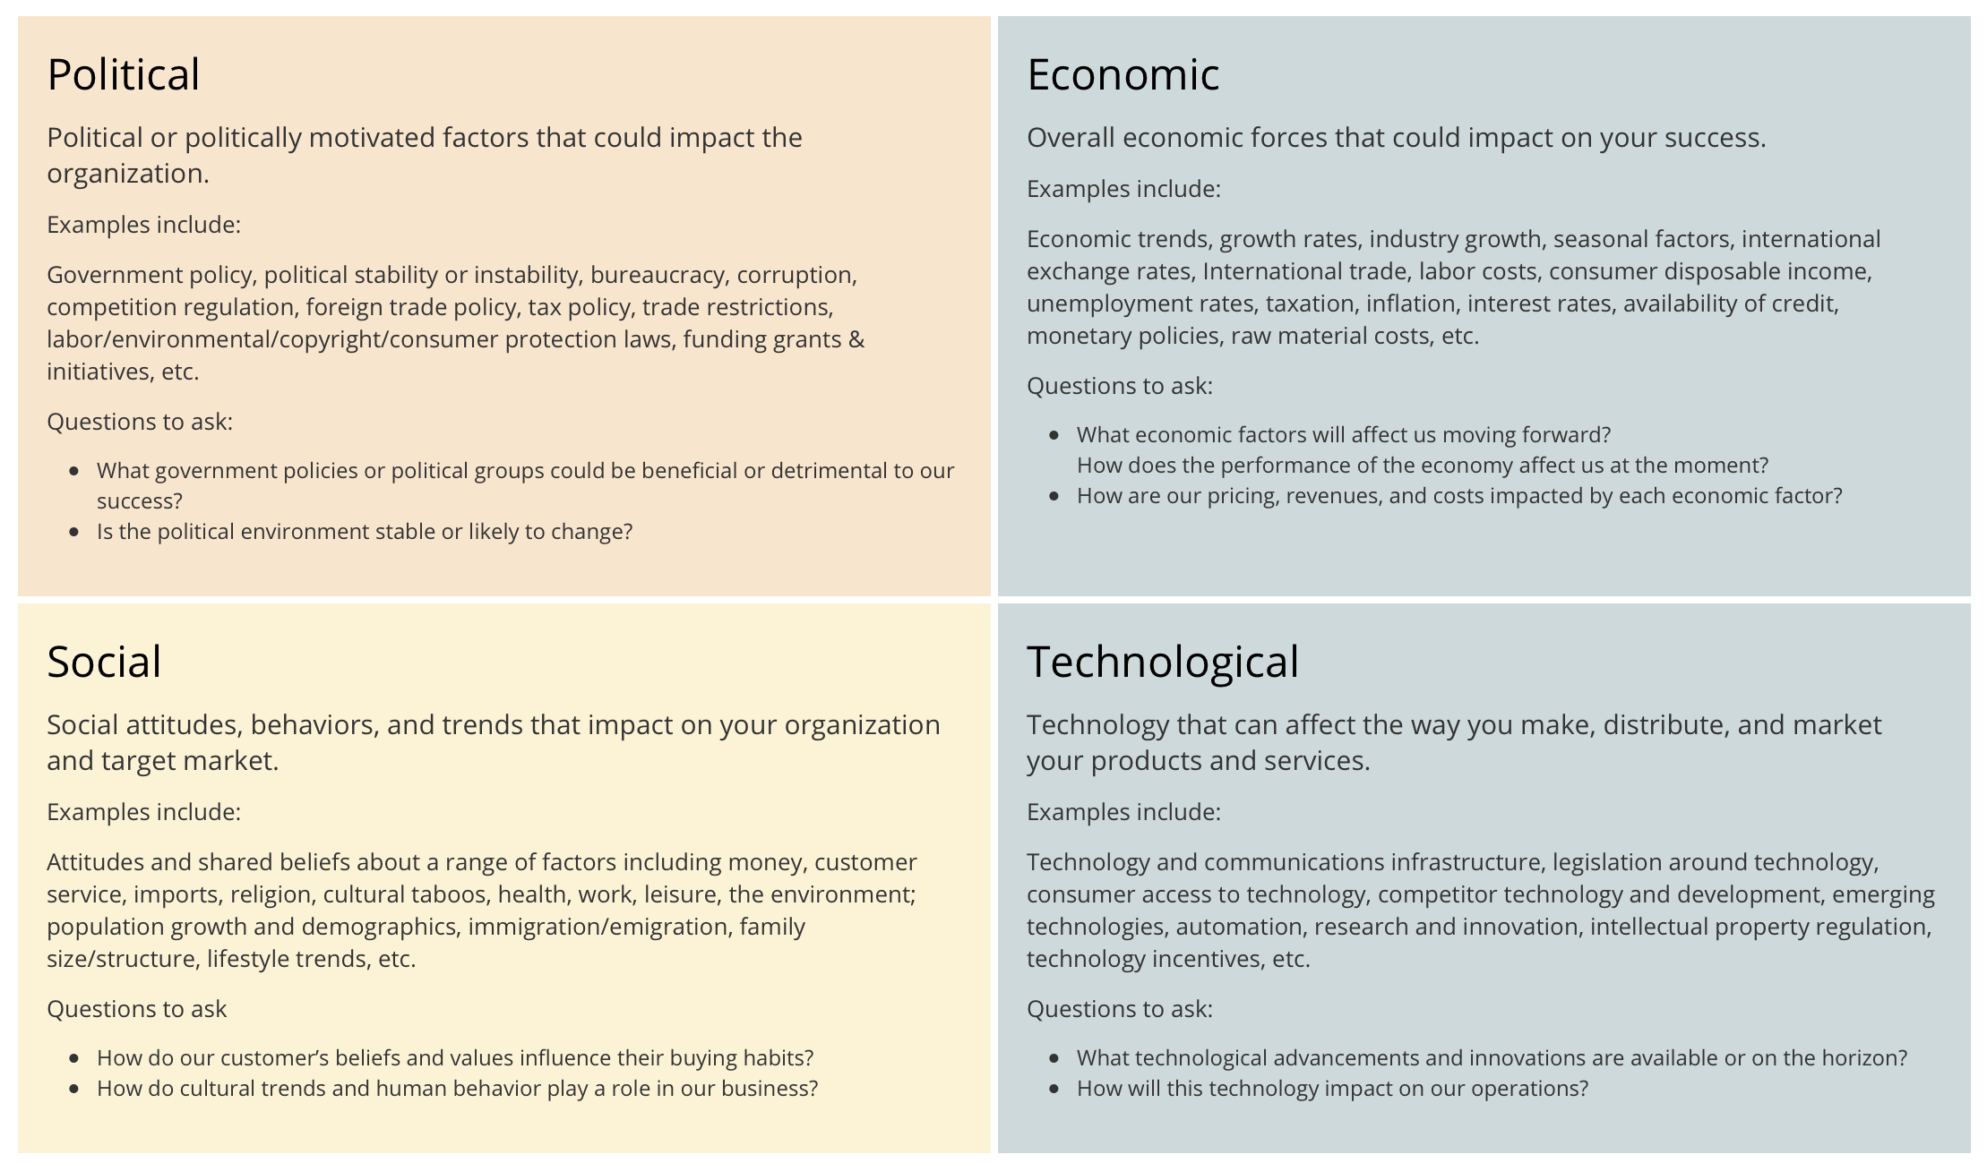
PEST is made up of four factors political, economic, Social and Technology and these are what is discussed when doing an analysis.

Political

As the table shows above when we talk about political there are many parts to this factor that must be taken into consideration.
- Government policy is one of the major elements when it comes to an organisation as they are the people in charge of rules and regulations that will allow organisations to form and be efficient.
- Competition is another element that is important because for a business to be successful it’s got become competitive as there is always going to be something else in competition with the products or services provided. This also means abiding by trading standards and government policies.
- Grants and funding are something that social enterprises may rely on to become an organisation and its harder to gain these grants and funding as its linked in with the other element of competition. A lot of people will have ideas that they want to become something and that will remain.

Economic

Economic factors will play a big part in the success of any business and will be very important in identifying needs.
- Unemployment is one economic element that has and could have an impact on an organisation. Some companies are not surviving in this industrial environment causing people to become redundant. This can lead to less money being spent in local economies which will impact how people spend their money. Social enterprise can target these areas and then create jobs for people to give them an opportunity to be involved in a common goal.
- Seasonal factors for any organisation that has seasonal work will always struggle during quiet periods. During these period’s changes could be made to cater for the type of season to keep a steady stream of customers. This will allow the business to be more sustainable all throughout the year.

Social

Social factors take all aspects of attitudes and behaviour that can Impact the company.

- A belief of a range of factors will always be a point of interest when taking social factors into thought. A belief that something should be done in a community such a revitalising an old leisure centre or creating a new environment for people to enjoy like skateparks. Listening to people thoughts and needs sparks an opportunity to make a difference and provide products or needs for a neglected area. Taking this opportunity will enable money to be reinvested back into their communities and help their local economies.
- The environment has been a hot social topic for a number of years, there has been many movements and projects to help battle climate change. Small projects that find a social need to clean up their communities or beaches may seem small but will overall help the bigger picture. Providing services such as recycling centres for people to it to will allow them to feel better as they feel they are contributing to helping the environment.

Technology

- Technology has enabled organisations to get their message about their goals and objectives across to just about anyone and anywhere. Not just this but business’ that provide products and services can advertise themselves to a wider audience. This not always a good thing as sometimes when something bad does go wrong then publicity can turn bad and reputations can be at stake.
- Companies now rely heavily on social media and other ways to advertise what they have to offer. New and upcoming organisations this can be their foot in the door to get people interested in them.
- Technology is forever changing, and new developments means more opportunities for business to adapt enabling them to produce more products quickly and efficiently. This does leave room for competitors to find a market to produce things cheaper and in bigger bulks.
- Online shopping is now impacting the way people shop. This means people are less likely to go to the shop when they can order it from their own home. This can lead to small independent business’ losing customers as there is less footfall on highstreets.
- Some traditional methods may slowly fade out due to technology being able to do their jobs more efficiently and a lot less cost effective.

SWOT Analysis

SWOT stands for strengths, weaknesses, opportunities and threats. SWOT examines the strengths, weaknesses, opportunities and threats that business face in their approaches towards their management strategies.
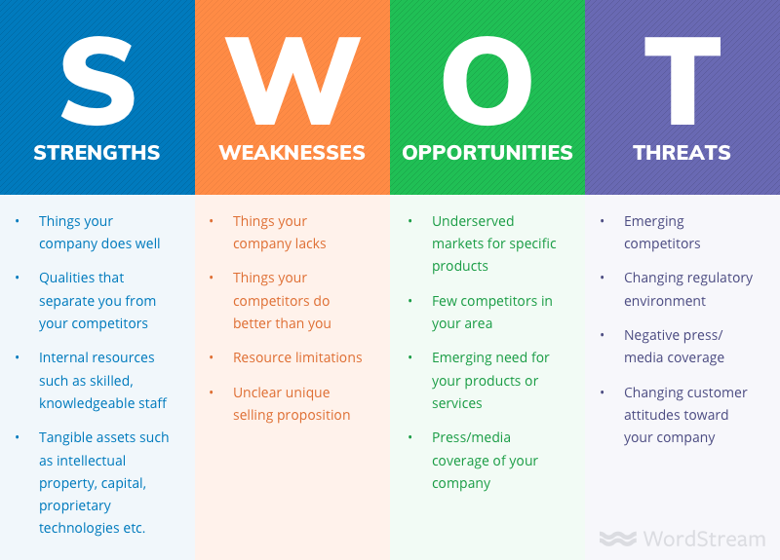

Strengths

The Co-operative groups strengths can begin at its reputation. It has been a long-standing organization since 1844 that has been providing people for many years. Over these years they have established many stores all across the UK building themselves a large place in the market. This will enable people to trust this brand in terms of reliable products when needed. Co-op is separated than most food retailers as it has a social enterprise structure to the way it works and is managed. Co-op has more of a social aim towards its way of management. The company employs skilled individuals to help run the organization. This will allow the company to operate efficiently minimizing mistakes and being able to solve problems.

Weakness

Risk of financing is an issue facing any organization but as this company is based on the income of customers, they always face the risk of losing money in certain projects. Funding may not come easy and store may close to competing stores in the area. Being member owned not every person will agree with all the decisions that are made and could cause conflict within the community. Being able to cater for all their employees across the organization can always be costly so hours and funding may be cut losing people jobs and careers (krow S, 2017).

Opportunities

The Co-operative being a social enterprise allows them multiple opportunities to expand and grow, not only this but they are also able to take their social mission with them helping support local communities all across the UK and further. Being the reliable brand people have grown to know they are trusted in the way they trade they produce making sure they work with more and more farmers to help local and regional economies. The more stores and projects Co-op are able to help with there will be employment opportunities to go alongside.

Threats

Threats to Co-op would be other competitors in the same market such as brands like Tesco and ASDA. They are providing products and services just like The Co-operative group in terms of food, clothing and delivery services. Prices are always one of the main competing methods these brands use to gain advantages over one another. One advantage some customer may feel when they purchase Co-op branded products is that 1% of their purchase goes toward a local cause.

Policy changes and trading changes can impact any organization as the way they can exchange. They may have issues getting product to and from one place causing stock shortages so they must place contingency plans in case it was to happen. Prices may change as a result of this and again changes must be made.

References

Groupmap, 2019, Pest analysis retrieved from: https://www.groupmap.com/map-templates/pest-analysis/
The Co-operative Group Limited, 2019 retrieved from: https://www.co-operative.coop/about-us/what-is-a-coop

Definitions, regional economy, 8/12/2016 retrieved from: https://www.definitions.net/definition/regional+economy

Co-operative UK, UK agricultural co-operatives: key facts,25/05/2019, retrieved from: https://www.uk.coop/agri/uks-agricultural-co-operative-sector

Susan Press, Co-op News, what are co-ops doing in their communities, 16/11/2016 retrieved from: https://www.thenews.coop/111096/sector/community/co-ops-communities/

Trevor Baxter, Saddleowrth, Independent, future proofing new schools success with help from co-op, retrieved from: https://saddind.co.uk/future-proofing-new-school-success-with-help-from-co-op-shoppers/

SWOT Analysis template, 2019 retrieved from: https://cacoo.com/templates/marketing-swot-analysis-template

Shailynn Krow, Bizfluent, Advantages & disadvantages for Co-ops, 26/09/2017, retrieved from: https://bizfluent.com/info-8185508-advantages-disadvantages-coops.html

