Organisational Structure & Culture
Programme: BA Business Management
Module: LCBB4003
Presented by Silviya Petkova (2131598)
Module Convenor: Dr Mohammad Rahman

Submitted on: 23/04/2023 1
Introduction: 1
Written Report: 2
Conclusions: 9
References: 10

Submitted on: 23/04/2023

Introduction:
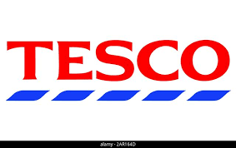
(Fig. 1)

This report will be presenting TESCO PLC Organisational Structure and Culture also how the company motivate and treat their employees. According to Tesco’s website (2023) Jack Cohen started selling surplus food from a stall in London’s East End in 1919. In 1924 the name TESCO is born from combination of Jack Cohen name and his partner T.E. Stockwell. In 1929, the first Tesco store is open in Edgware Nort London. In 1937 Jack Cohen buying more stores and expand the business, the company operating across London. At 1946 Tesco bring self-service in they stores, this impact as it given the customers better prices for the products purchase. New 500 shops are bought between 1955 and 1960, Tesco become large and famous brand. Tesco launched its Tesco Clubcard program in 1995. Today, Tesco has more than 6800 store worldwide and 80 million customers and 350 thousand employees. (TESCO Worldwide 2023). In present day the company hold 3rd place for popularity and 5ft position for fame (YouGov 2023). The Tesco groups also includes Tesco Bank, Tesco Mobile, a network of One stop convenience stores, Broker and dunnhumby.

Written Report:
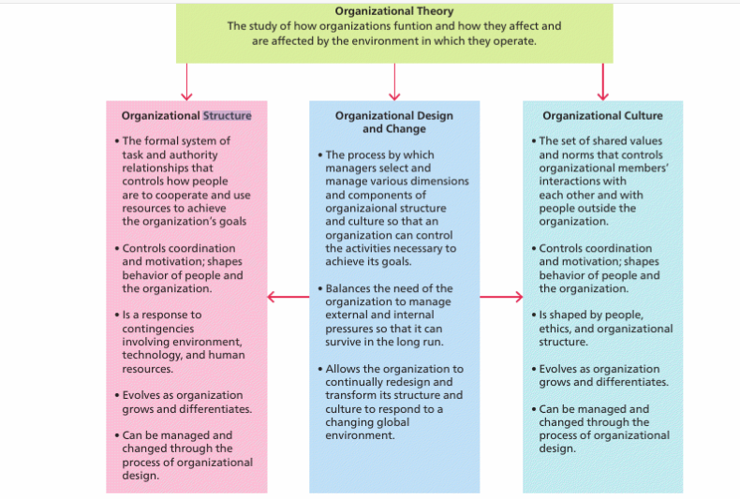
(Fig.2) Mullins (2019 p. 415)
At first place it is important to understand what describe organisation. ‘’Organizational structure is the framework of reporting relationships in an organization. These relationships can usually be diagrammed in the form of an organization chart. The organization chart does not necessarily reflect actual reporting or decision-making relationships in an organization, so we can make a distinction between the formal and the informal structure. ‘’ Clawson (2008). Mullins (2019) Organisational Theory also give clear example. Organization is group of people with shared values and norms. Organisational Structure is system of rules which control how people work together in aim to achieve the organisations goals, control motivation and coordination, the organisation structure can be change if is necessary depends on different needs. Organisational Culture is a set of shared values and norms that govern how members of an organisation interact with each other and with those outside the organisation. Both Structure and Culture interconnect with Organisational Design and Change, this is the process when managers select different ways to change components of organisational structure and culture in aim to achieve goals. The Global environment always changing so Organisations must be able to change depends on internal and external factors, so it can survive.
Tesco’s organisational structure is tall (hierarchical). This means that there are many leaders and management levels. Here managers have a narrower scope of control and usually a long chain of command. A law firm's organizational structure has three levels of management, top, middle and base (TESCO PLC 2023).
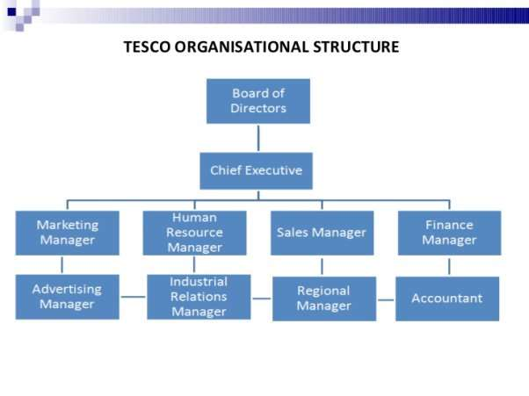
(Fig.3)
Tesco organisation can be present as a pyramid, on the top are board of directors, under them Chief Executive, then top managers for every main sector from the company as Marketing, HR, Sales, Finance, Adds etc. Those top managers have under them managers supervisors and employees. Usually, the employees are divided on small groups, they have exact responsibilities and tasks. They are supervised lead and motivated from the managers above. From fig.3 can be conclude that all important decisions are made from the top and stage by stage information goes to the bottom line of the pyramid.
Indeed career guide (2023) Advantages of hierarchical structure:
Control operation: good monitoring at all departments of the company.
Clear reporting: clearly knowing who is in charge, employees know to who must report and from who the commands coming.
Distinct career paths: the employees know clearly the way and opportunities for growing career in the company.
Disadvantages of hierarchical structure:
Restricted information flow: some information can be lost in the long way during corporate information chain
Decision – making can take longer: there are a few levels decision-making departments in hierarchical company structure, that means meeting must be made for every important decision also on the top level are many people whit different mind and sometimes decisions cannot be taken quick and easy.
Additional cost: additional layers of management require extra cost for wages, offices etc.
Communication difficulties: the communication is focused inside the team and often have lack of information transferred to the other units of the company. Transferring team members between groups sometimes is not smoothly and take extra time people to adapt to new leadership.
Departmental rivalry: teams, departments or managers can stand against each other in competition, these situations are not healthy for the company, provide toxic working environment.
Tesco PLS Organizational Culture:
The success of the organisation depends on meeting the needs of the employees in order to achieve the goals of the company. Mullins (2019) argues people usually behave as others behave towards them. Organisations depends on workforce, how the employee's complete goals and tasks, additionally the firm staff need proper motivation, rewards, actual feedback, healthy environment where every person can show best performance and full potential. It is important the commands to be clear, the information to be provide on time.
Tesco performance: (Fig.4)
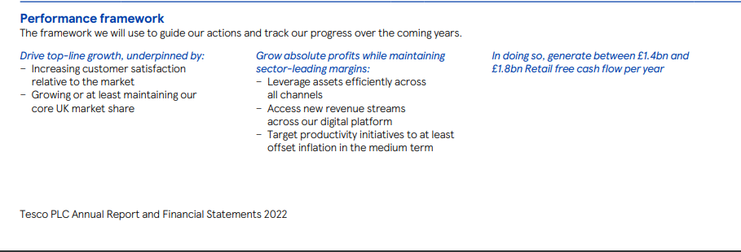
According to Tesco’s website (2023) Tesco Annual Report, the company progressing year after year in positive way, aim to grow or at least maintain market share in the core UK market. They are also working to increase the volume of absolute profit, planning to invest in strategic priorities. By doing this Tesco expect to generate between 1.4 and 1.8 bn pounds of Retail free cash flow each year.
Regardless of inflation Tesco plans to keep consumers affordable prices, Clubcard prices in aim to support the British families.
The company is working towards offering more vegetables in its ready meals also using sustainable packaging as result of partnership whit WWF.
Tesco PLC lunch lots of green projects to protect the environment. By 2030 the company plans to use 100 percent renewable electricity, by 2050 to become carbon neutral in its operations.
The company have community engagements programs, supporting poor families whit free products from the shops and have partnership whit British Red Cross to help when have local crisis.
(The Guardian, 2023) article reports that Tesco PLC makes changes in stores management, around 2100 jobs positions will be closed, therefore stalls for meat, fish and hot food will be excluded from the small stores. Additionally, the company plans to change the group leaders' managers whit low-paid shift leaders. Those changes in the company are necessary, so Tesco can be focused to provide low prices for its customers, explain the chief executive Jason Tarry.
Inspire that the financial year 2021/2022 annual revenue of Tesco is more than 56 billion British pounds, that is 3 billion more than year 2020/2021, the company choose to cut personal and make structure changes in aim to provide attractive prices for its customers.
Employees motivation:
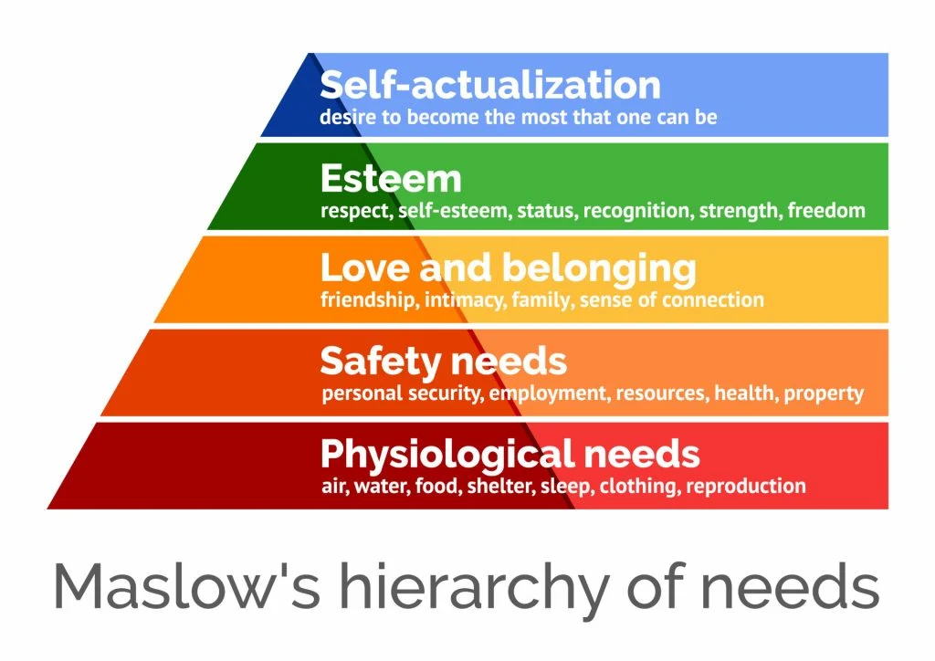
(Fig.5)
Motivation of the employees is important for organisations, motivate stuff will work better and will have done whit tasks for less time. Workers who are motivated have more concentration, they don’t create conflicts, chance for incidents at work are low. They are loyal to the company, work hard and except company successes as their one.
Maslow’s motivation theory can be used successfully in organisations as Tesco PLS. Maslow’s hierarchy of needs is present as pyramid on needs to be achieved. On the bottom of the pyramid are basic needs as food, water, etc. Second level place security, job, health, shelter etc. Therefore, love and belonging, needs of socialisation friendships, family. Esteem level, person have freedom and respect, status in the community on this level. On the top is Self-actualisation: individual need of person to become more and better adding more skills, knowledge, and self-fulfilment. Mullins (2019) explain that on the other side Maslow theory, it is not exactly created for employees, individuals have different priorities, and some people will find they comfort zone in Safety needs, some people will be in other zone of satisfaction. Anyway, there is a way the theory to be applied to working environment. On the bottom-line Physiological zone; worker needs of wage, bonus, healthy work environment. Therefore, Safety zone; job satisfaction, safe working conditions. Additionally Social zone; understanding from the immediate supervisor, friends at work. Next Esteem zone; responsible job, rang, feedback. On the top Self-actualisation zone; effortful job, chance for creativity, realisation at work, progress. Managers need wide set of skills, good understanding of human behaviour, they must be able to give clear commands besides they need to have good listening and except feedback. Pardee (1990) provides few definitions of motivation. Generally, motivation is that what lead person to act in specific way to achieve particular goal. In addition, people are motivated to gain more in aim to satisfy their needs. Motivation is internal force, need for achievement, self-direction and self-control. External factors as good rewarding system, high wages can be used for motivating workers, but that does not work every time.
Another theory that is suitable for motivating personnel is Herzberg's two factor theory. This theory has been created by Frederick Herzberg in 1959 (British Library Board ©). The theory claims that employees are not motivated by money, bonuses or reduced working hours, according to the author these are hygiene factors because they are related to the nature and environment of work. The hygiene factors are; company policy and administration, supervision, labour relation, status and security. These factors alone do not motivate employees. Herzberg also calls them dissatisfiers or sustaining factors because their absence or inadequacy causes job dissatisfaction. In these cases, the employee is simply forced to work to avoid punishment or reserve a reward. ,,Motivators” factors include; achievement, recognition, the work itself, responsibility, progress, and growth. Herzberg explains that the two types of factors are separate and distinct because they relate to two different sets of needs. According to the theory, factors contributing to job satisfaction are motivators (achievement, recognition, job satisfaction, responsibility, and opportunities for advancement and growth), and factors contributing to job dissatisfaction are hygienic (company policies, work environment, general management, the attitude of their manager). Herzberg explains that the two types of factors are separate and distinct because they relate to two different sets of needs. According to the theory, factors contributing to job satisfaction are motivators (achievement, recognition, job satisfaction, responsibility, and opportunities for advancement and growth), and factors contributing to job dissatisfaction are hygienic (company policies, work environment, general management, the attitude of their manager).
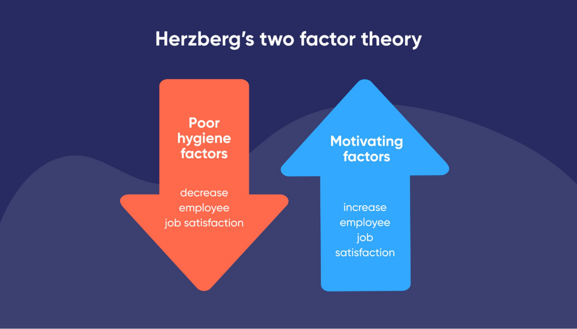 (Fig. 6 Herzberg’s two factor theory)
Managers must know that every person has a different needs and priorities, that requires various styles of leadership and unique approach. One of most powerful things that motivate is believe. The excellent reward system in the company also can be motivating for the employees but not always. Tesco hierarchical structure give opportunities employees to grow at professional level. The firm itself prefer to promote people who are already work in the company than to appoint outsiders to the responsible positions. Every person knows clearly how can grow career in the company. According to Tesco’s website (2023) they motivate their employees providing healthy working environment. Surveys addressed to the employees seeking for their opinion on different questions relate to the company. Increasing sick money, good pension shame, stuff discount, company shares options, wages increase and bonuses. Professional courses, first Aid courses, flexible working hours and days, providing opportunities for work even to people whit small children.

Conclusions:

The key to the organisational successes of Tesco is that the company does not limit itself to the sale of food products as it was at the beginning of its creation. The company expanded into other areas of business as banking, clothing sales, gas stations etc. The organisation does not lag behind in the development of technologies. Through inovations, Tesco manage to adapt to market changes and maintain its high quality of customer service. Building strong and trusting relationships is important to any business. Tesco uses market research to better understand its customers, this helps after data analyzing the company to determine markiting trends. Therefore, to ascertain customers preferences and needs in aim to keep them satisfied. Tesco will continue to trive because of its willingness to innovate and adapt to change. On other hand acording to Fadeyi (2020) Тesco still has work to do to improve the motivation of its employees, despite the training, dicount for collegaues etc. The company gives bonuses and benefits rarely and this affects the motivation of the staff in negative way.

References:

Clawson, J.G. and Pitts, T., 2008. Organizational Structure.
Fadeyi, A.P., 2020. An Analysis on the Application of Motivational Theories at Workplace and the Impact on Employee Engagement: A Study of Tesco Ireland (Doctoral dissertation, Dublin, National College of Ireland).
Herzberg’s two factor theory (https://www.bl.uk/people/frederick-herzberg#:~:text=He%20is%20best%20known%20for,motivation%20to%20work%20in%201959.), Accessed on 23rd April 2023
Fig. 1 (https://www.google.com/imgres?imgurl=https%3A%2F%2Fc8.alamy.com%2Fzooms%2F9%2F5c2988097b9f4eee8249a294ad39cbbb%2F2ar164d.jpg&tbnid=rKFLwD_QjLdVBM&vet=12ahUKEwian_b26JD-AhUFrycCHewwA-4QMygDegUIARDrAQ..i&imgrefurl=https%3A%2F%2Fwww.alamy.com%2Ftesco-logo-vector-on-a-white-background-image341160861.html&docid=7TCbG-yiTabWLM&w=640&h=404&q=tesco%20logo&ved=2ahUKEwian_b26JD-AhUFrycCHewwA-4QMygDegUIARDrAQ)
Fig. 6 (https://www.bluedonkey.co.uk/herzberg-two-factor-theory-lead-generation/), Accessed on 23rd April 2023
Fig. 3(https://aaimagestore.s3.amazonaws.com/july2017/0011616.003.jpg)
Fig.5(https://simplypsychology.org/wp-content/uploads/maslow-hierachy-of-needs-min-1024x724.jpg )
Indeed(2023) Carrer guide.Available at: https://uk.indeed.com/career-advice/career-development/hierarchical-structure (Accessed: Thursday, 6th of April ).
Fig.2
Mullins, Laurie, and Jacqueline E. McLean. Mullins: Organisational Behaviour in the Workplace, Pearson Education, Limited, 2019. ProQuest Ebook Central, https://ebookcentral.proquest.com/lib/trinity/detail.action?docID=5830196.
The Guardian (2023) Tesco to make big changes to stores, affecting 2100 jobs. Available at: https://www.theguardian.com/business/2023/jan/31/tesco-stores-jobs-supermarket-chain-managers (Accessed: 10 0f April)
Tesco (2023) Our History. Available at: Our history - Tesco PLC (Accessed: Friday, 31st of March)
Tesco (2023) Our History. Available at: Tesco worldwide- Tesco PLC (Accessed: Friday, 31st of March).
Tesco (2023) Tesco Annual Report 2022. Available at Tesco PLC (Accessed: Fryday, 7th of March)
Tesco Careers (2023) Avaiable at: https://www.tesco-careers.com/explore-our-world/life-at-tesco/ (Accessed: Monday 10 of April).
Pardee, R.L., 1990. Motivation Theories of Maslow, Herzberg, McGregor & McClelland. A Literature Review of Selected Theories Dealing with Job Satisfaction and Motivation.
YouGov (2023) The most famous supermarket chains . Avaiable at: https://yougov.co.uk/ratings/consumer/fame/supermarket-chains/all (Accessed: Tuesday , 4th of April ).

