Greggs – Change Initiative Plan
Samuel Whittaker – P145978 - UWTSD

Contents
Introduction 2
What this report is trying to achieve 2
Main Body 4
Definition of Change Management/Change Initiative Plan 4
Key steps in Change Management 4
Change Initiative Plan 8
Conclusion 15
References 16
Appendices 19

Introduction

What this report is trying to achieve
This report is a continuation of the Sustainability Leadership Challenge, identified within Greggs, and talked about in the video log. (Video log can be found in the appendices). The Sustainability Leadership Challenge was identified as Goal 12 of the United Nations Sustainable Development Goals (UN, 2015). Goal 12 from the UN SDGs was Responsible Consumption and Production. As the company that was used in the Leadership Challenge was based on local context. Information was easily obtainable from Greggs’ website and was based closely, on responsible sourcing and consumption/United Nations Goal 12. From the information obtained from Greggs’ own website, the video log identified that Greggs is already putting responsible sourcing as a leading part of their business. Greggs was aimed at ensuring high standards for themselves, as well as their supply chain, (Greggs, 2021). From researched information, obtained was Greggs’ Pledge, which was intricately linked to the UN Sustainable Development Goals. The Greggs Pledge was about “improving their people, protecting the planet, and working with partners, for the better”, (Greggs, 2020). The video log also picked up on some external sources of sustainability, which Greggs uses for reporting or uses in their products. For example, the GRI standard is obtained by organisations who wish to report on their “sustainability impacts in a consistent and credible way”, (GRI, 2021). Another outside source, which Greggs uses for their packaging was the FSC (a Global Forest Certification System). The FSC allows Greggs to identify manageable sources of forest, which can be used in Greggs’ packaging, without damaging the environment, (FSC, 2021).

So, from the video log, information was gathered which intricately linked Greggs and their own responsible sourcing, to the United Nations and their Sustainable Development Goals, in particular Goal 12 – Responsible Sourcing and Consumption.
This report will utilise the information gathered in the video log/sustainability leadership challenge and implement a ‘change initiative plan’ for Greggs. Based on information gathered from the video log, which showed as spoken about above, that Greggs is an ethical brand, but some improvements and reinforcements will be necessary, to implement a company wide change initiative plan.

Main Body

Definition of Change Management/Change Initiative Plan
One definition of Change Management is “thoughtfully and carefully re-aligning the organisation”, (Wedell, 2011).
Another definition of Change Management is defined as “anything required to change people”. (Kimberling, 2020). Change Management is intrinsically linked to the change initiative plan, as both are aimed at changing organisations/people. Change Management and subsequently the change initiative plan will be aimed at long-term change within Greggs. Bolstering existing environmental policies, while aiming for total/company-wide buy-in, (Lock, 2021). To effectively contribute change to Greggs’, there needs to be a successful implementation and company buy-in of this upcoming change initiative plan, within Greggs.
Change Management is focused on “changing people, aligning those people, and ensuring the organisation is addressing the issue/transformation is being addressed”, (Kimberling, 2020). So, Change Management can be seen as the main theme, while the change management plan is seen as sub-theme of Change Management.

Key steps in Change Management
There are a few key points in a Change Management system/plan.
Key point one – Executive and Stakeholder Alignment.
(Kimberling, 2020) finds the first key point is Executive and Stakeholder Alignment. Organisations can implement a Change Management system. However, without the organisation fully understanding why the change is happening, the message could get muddied and the decision to implement the change in the first place can be lost and makes executives question the organisation. (Kimberling, 2020). The organisation and key stakeholders both need to be in understanding on why this change is happening and why it should be for the better. (Kimberling, 2020). To ensure no confusion within the organisation. The message needs to be clear from the organisation and to its stakeholders. (Kimberling, 2020).
Greggs’ context
To put Executive and Stakeholder Alignment in context for Greggs, it requires getting the right message across. Why is Greggs going to be changing their management processes in favour of sustainability? Considering there have been significant cost savings tied to sustainability and an overall better company image, it would make sense in the wider context, why Greggs would want to change their message. But to make sure there is no confusion between the company and internal/external stakeholders, the message must be one of consistency, coming from Greggs. (Kimberling, 2020).
Key point two – Changing Business Processes.
The second key point in Change Management is Changing Business Processes. (Kimberling, 2020). Before there is an actual change to any human components in the Change Management system, there first needs to be changes to operations components. (Kimberling, 2020). “What are going to be changes to business processes?”, (Kimberling, 2020). Definitions of key changes to technologies, new processes, and how roles will change, are key in the business processes section of the change management system. (Kimberling, 2020).
Greggs’ context
Linking Greggs to point two, comes new job roles, new technologies and new ways of carrying out jobs. Defining what people’s new roles will be, will limit any confusion surrounding the new management changes. What and how will new technologies ensure people can do their job better. By providing clear and consistent, positive information, on those topics, Greggs can keep as much misinformation and confusion, limited to a minimum. (Kimberling, 2020).
Key point 3 – Designing New Roles and Responsibilities.
The third key step in Change Management is Designing New Roles and Responsibilities. (Kimberling, 2020). Within a Change Management system, new roles may be introduced, and to properly help people with those new roles, they need to be given information on what is changing and why. (Kimberling, 2020). It cannot just be a broad view of everything. It must dive deep into every person’s role within the organisation, to fully be integrated into the organisation. (Kimberling, 2020).
Greggs’ context
By changing business processes, comes new changes to job roles and existing technologies. A new change management system will mean there are bound to be new job roles designed. New job roles require help for the people. Information on why their job roles is changing will help people better understand, why it could be necessary for change, compared to entrenched methods of job roles. (Kimberling, 2020).
Key point four – Defining the culture.
The fourth key point in Change Management is Define the Culture. (Kimberling, 2020). A new culture/look for the organisation would require changing the people and culture, as both are intimately linked together. (Kimberling, 2020). To change the culture within an organisation, it “could take years to change a company’s culture”, (Kimberling, 2020). With a relatively new organisation, culture should be easier to change than a seasoned company, whose culture may have never or has not been changed in a long time. (Kimberling, 2020).
Greggs’ context
Changing the culture requires changing the people and changing the people requires changing the culture. As Greggs, is an established company, it may be harder for a cultural change, although as seen later in this report, a cultural change regarding a more sustainable company, may not seem as difficult as reported in point four. Greggs is already moving towards being a more sustainable company. (Kimberling, 2020).
Key point five – Taking Employees on the Journey.
The fifth key point in Change Management is Taking Employees on the Journey. (Kimberling, 2020). Showing employees how the organisation is today versus where the company could be in the future is necessary in a change management system. (Kimberling, 2020). A one size fits all approach is not going to work for organisations, as they need individual tailoring, which will help their organisation perform better. (Kimberling, 2020).
Greggs’ context
Greggs must bring the employees on this journey of change. Showing the employees how the organisation is today, will give them greater context on why the organisation needs to change for the future. Greggs can show employees the need for change through involving them in every step of the change management process/change initiative plan. (Kimberling, 2020).

Key point six – Benefits Realisation.
The sixth and final step in a Change Management plan is Benefits Realisation. (Kimberling, 2020). How can results be measured and shown to be improving in this new change management system? (Kimberling, 2020). Measuring can show if the actual change made any difference to the organisation or not. (Kimberling, 2020). If improvements have been made, then doubling down on that improvement will be the key. Whereas, if there is little or no improvement, how can the organisation move away from that method, into a newer, more improved method.
Greggs’ context
Greggs needs to be able to show or achieve proven results from this change management process/change initiative plan. Results can be key to show that the actual change is of use. Striking the key points of improvement and discarding inefficient methods of change.

Change Initiative Plan
This change initiative plan will go through five key areas. These areas are:
• Define – Defining the strategy for changing the organisation,
• Assess – Assessing how the change will be received,
• Design – Designing to inspire and engage the people affected,
• Implement – Implement and provide tools for people to succeed,
• Embed – Fully integrate to achieve maximum returns.
(Lock, 2021).

Part 1 – Define. (Lock, 2021).
The goal of change management/change initiative plan is to change people’s behaviour”, (Lock, 2021).
Change management can “reduce organisational risk, and increase success”, (Lock, 2021).
There needs to be a business case for a change initiative plan. As, is the case with Greggs (local context), sustainability is becoming a leading topic for organisations to use. Either to show customers they can change for the better, make more profits, or to protect the environment, among other topics. The business case for sustainability is becoming more and more apparent in the wake of the climate emergency the Earth is facing. From the video log, it was apparent that Greggs is already achieving good levels of sustainability. This change initiative plan is focusing on what is already in place and what can be done in favour of even more changes. Before going ahead with the plan, a clear definition of what the plan will be focused on is needed.
So, for Greggs’ change initiative plan, a keen interest in maintaining and improving the businesses existing policies and procedures for the future, in terms of sustainability is needed. With a company wide approach needed to ensure existing measures are met, while upskilling and informing employees and stakeholders of key changes going forward.
Part 2 – Assess. (Lock, 2021).
Assessing Greggs’ current sustainability plans
Changing Greggs into a sustainability leader through this change initiative plan requires careful planning at the first stage. Setting up the picture which will trickle down into the other steps of the change initiative plan. Assessing the current state of Greggs’ environmental policies and procedures has been made easy, as the information can be found easily on their website. (Greggs, 2021).
Key sustainability topics from Greggs’ website
Some key points from the Greggs’ website on sustainability are Net Zero Taskforce, Eco Shops, Plastic Reduction, energy, and water savings, reducing waste, and carbon footprint reductions. Currently Greggs is greatly achieving sustainability through its own actions. The plan is to use existing policies with some modifications in place in the change initiative plan. By assessing current Greggs’ environmental policies and procedures. There can be an understanding on how the system currently operates and what changes can be made for the future. (Lock, 2021). By overhauling sustainability or using existing policies and procedures at Greggs, the impact on the business would be huge for a major overhaul but as there are already systems in place to manage sustainability, impacts can be limited. There is already a drive for sustainability within the organisation, which does not require a complete cultural change from the organisation and employees. What does and will need changing is how to go further in terms of sustainability? Bringing forward targets and goals, which may seem unable to be carried out in a shorter time frame, but with a little extra push, can be achieved.
Systems are already in place to deal with sustainability, such as energy reductions and waste management. These procedures are as much reliant on employees in the stores, as Greggs is, in ensuring they are being carried out. It is important to see Greggs is doing work on sustainability already and that makes the change initiative plan easier to carry out.
Net Zero Taskforce
The Net Zero Taskforce is made up of people from across Greggs, who are determining the best course of action, in limiting the climate impact across Greggs. (Greggs, 2021). Greggs has the “ambition to be Net Zero by 2040”, (Greggs, 2021). Greggs’ ambition to be Net Zero by 2040 is a big statement of intent and is one of the current sustainability topics that Greggs is looking to achieve.
Eco shops of the future
Greggs is currently trialling a template for a shop which has sustainability embedded in its core. (Greggs, 2021). It is a template for “how shops are built, what they are made out of, and what technology and fittings go inside”, (Greggs, 2021). A current trial but it will make a huge difference going forward, for the future of Greggs’ shops. It will make a massive difference for sustainability as well.
Plastic reduction
“By 2025, Greggs wants to cut all unnecessary single use plastic from their shops and manufacturing sites”, (Greggs, 2021). Greggs has made great strides already to switch from single use plastic products to sustainable paper products. Such as, paper carrier bags, wooden cutlery, and cardboard packaging. (Greggs, 2021). Greggs currently is moving forward in the right direction, with sustainability.
Part 3 – Design. (Lock, 2021).
Designing the plan now requires taking the information gathered from the assessment stage, to compile and map out a framework, for the new plan. (Lock, 2021).

Plan overview
The change initiative plan is aimed at bolstering Greggs existing policies and procedures on sustainability. Aiming to target improvement on those same policies and procedures. Finally looking at any new policies and procedures could be potentially added on to flush out the plan.
Change Initiative Plan Goals
- Clear information,
- Clearly defined roles and responsibilities,
- Align leadership to ensure clear guidance,
- Monitor relevant benefits,
- Target existing policies and bolster them,
- Align stakeholders and keep them informed,
- Why the change is necessary,
- Changing company culture.
The goals of the change initiative plan are there to be used for the design implementation stage of the change initiative plan.
Attached in the appendices is a template for the change initiative plan.
The who, what, when, and how all need to be considered in the design and implementation stage. The Who for instance, could be executives. They could take charge of the larger, companywide policy changes. (The Net Zero taskforce, for instance). While lower-level changes, like new recycling bins for customers, can be owned by employees, with obvious guidance coming from executive level. The What for instance, can be the necessity to change for the betterment of the environment and a more respected company image, among stakeholders. The When for instance, could be over a short-term or long-term period. Depending on what new change needs to be implemented. The How for instance, could come from new job roles, technologies, or operations, depending on which specific section is required for each specific task.
Part 4 – Implement. (Lock, 2021).
Implementing the new change initiative plan – Ensuring existing policies are bolstered (Greggs is already carrying out sustainability through their business). Ensuring, if there are new technologies or job roles, they will be filled. Correct information on why the change is happening is key.
Gathering information from existing policies and procedures, like the Net Zero Taskforce, and recycling. Information like that can show change is possible but can it be improved upon?
Who is responsible for the big change like the taskforce for instance? Any outside stakeholders for instance, that could provide some insight, not seen from the inside of the company. What is the target of the taskforce and can it be improved upon, to bring forward the date? Well, the target currently is set at 2040, but can there be a significant change to 2030 even? If so, will that require new roles and responsibilities, as well as new technologies and operations, to achieve a greater Net Zero target of 2030 compared to 2040. Keeping the goals in mind, by providing the who, what, when and how, is critical for this plan to be implemented.
New roles will need to be introduced, to be able to achieve these goals. Designing a new Sustainability coordinator role, would be one step in driving forward, with any existing and new policies, Greggs is looking to bring about. Implementing plastic reduction changes, will need to be looked at by executive level, but everybody in Greggs should have a say in getting rid of single use plastics.
New technologies such as the new Eco Greggs shops, need to be effectively communicated and ensure sustainability will absolutely be at the heart of the new shops. Spin-off changes can be taken from the Eco shop, into non-eco Greggs shops, ensuring that is residual benefits run off.
The overall cultural change which will come from moving towards more sustainability, should bring Greggs more benefits than problems. It must be communicated effectively why the culture is changing. If there is no cultural change, then how will sustainability be at the heart of Greggs? It will not without it being at the forefront of the culture.
How will all these changes be achieved? Well by bringing together every employee and outside stakeholder, in coordination of sustainability. It will make it a lot easier, to achieve above the current levels of sustainability.
Part 5 – Embed. (Lock, 2021).
Embedding this change initiative plan into the organisation, is the last step. Embedding the bolstered policies and procedures can ensure greater achievement of targets for the future. Ensuring new roles and communicated effectively and what is actually required to carry those roles out. New technologies will help Greggs achieve greater sustainability, as technology will improve over time. Ensuring Greggs remains open and honest with themselves and their stakeholders, will ensure that this change initiative plan can be met and carried out effectively.

Conclusion
In conclusion to this report. It can be shown that Greggs is already achieving good levels of sustainability. The change initiative plan was concerned with bolstering those efforts, while also recommending some new goals, to greatly help Greggs achieve their targets even before than what Greggs has set.
By ensuring the change initiative plan will be communicated effectively, it can ensure no confusion is made when it comes to what is in the report and how it will be implemented properly. New roles and responsibilities need to be communicated when the time comes for change. The culture when it is time for the culture to change, will need to effectively communicate, as people influence culture, and culture influencers people.
Greggs can achieve greater sustainability, than they currently achieve or want to achieve through following the implementation of this plan. The goals set out in this plan, must be followed, as any miscommunication would ruin the plan and muddy the message, that Greggs wants to put out.

References
FSC, 2021. What is FSC?. [Online]
Available at: https://www.fsc-uk.org/en-uk/about-fsc/what-is-fsc
[Accessed 15 March 2021].
Greggs, 2016. Greggs IS0 14001 Certification. [Online]
Available at: https://corporate.greggs.co.uk/sites/default/files/Greggs%20ISO%2014001%20Recertificaiton%20Certificate.pdf
[Accessed 5 November 2020].
Greggs, 2017. Energy Management Policy. [Online]
Available at: https://corporate.greggs.co.uk/sites/default/files/CP%200190%20%20Energy%20Management%20Policy%20-%20Issue%202.pdf
[Accessed 5 November 2020].
Greggs, 2017. Having a positive impact. [Online]
Available at: https://corporate.greggs.co.uk/sites/default/files/681166_GREGGS_CSR_16PP_LEAFLET_AMD_LR.pdf
[Accessed 2 February 2021].
Greggs, 2018. Greggs Environmental Policy Statement. [Online]
Available at: https://corporate.greggs.co.uk/sites/default/files/SREC%200020%20-%203.1%20-%20Env%20Policy%20-Issue%206.pdf
[Accessed 13 April 2020].
Greggs, 2019. Greggs Social Responsibility. [Online]
Available at: https://corporate.greggs.co.uk/social-responsibility
[Accessed 5 February 2019].
Greggs, 2020. Animal Welfare Policy: Fish. [Online]
Available at: https://corporate.greggs.co.uk/sites/default/files/Animal%20Welfare%20Policy%20-%20Fish_1.pdf
[Accessed 15 March 2021].
Greggs, 2020. Corporate Ethical Procurement and Supply. [Online]
Available at: https://corporate.greggs.co.uk/sites/default/files/Ethics%20certificate.pdf
[Accessed 15 March 2021].
Greggs, 2020. Farm Animal Welfare Strategy. [Online]
Available at: https://corporate.greggs.co.uk/sites/default/files/FAW%20Strategy%202020%20-%2010th%20Sept%202020.pdf
[Accessed 15 March 2021].
Greggs, 2020. Field to Fork Policy. [Online]
Available at: https://corporate.greggs.co.uk/sites/default/files/Field%20to%20Fork%20Policy.pdf
[Accessed 15 March 2021].
Greggs, 2020. Greggs Environmental Policy Statement. [Online]
Available at: https://corporate.greggs.co.uk/sites/default/files/SREC%200020%20-%203.1%20Env%20Policy%20Statement.pdf
[Accessed 5 November 2020].
Greggs, 2020. Greggs Responsible Sourcing Policy. [Online]
Available at: https://corporate.greggs.co.uk/sites/default/files/Responsible%20Sourcing%20Policy.pdf
[Accessed 15 March 2021].
Greggs, 2020. Procurement Code of Conduct. [Online]
Available at: https://corporate.greggs.co.uk/sites/default/files/Responsible%20Sourcing%20%20-%20Procurement%20Code%20of%20Conduct%20NEW.pdf
[Accessed 15 March 2021].
Greggs, 2020. Waste Management. [Online]
Available at: https://corporate.greggs.co.uk/social-responsibility/environment/waste-management
[Accessed 13 April 2020].
Greggs, 2021. Greggs At a Glance. [Online]
Available at: https://corporate.greggs.co.uk/at-a-glance
[Accessed 1 February 2021].
Greggs, 2021. Greggs Environment. [Online]
Available at: https://corporate.greggs.co.uk/social-responsibility/environment
[Accessed 25 April 2021].
Greggs, 2021. Greggs Responsible Sourcing. [Online]
Available at: https://corporate.greggs.co.uk/responsibility/responsible-sourcing
[Accessed 15 March 2021].
Greggs, 2021. Palm Oil Policy. [Online]
Available at: https://corporate.greggs.co.uk/sites/default/files/Palm%20Oil%20Policy%20updated.pdf
[Accessed 15 March 2021].
GRI, 2021. GRI Standards. [Online]
Available at: https://www.globalreporting.org/standards/
[Accessed 13 March 2021].
Kimberling, E., 2020. What is Organisational Change Management?. [Online]
Available at: https://www.youtube.com/watch?v=Ir_7a3fgpFQ&ab_channel=EricKimberling-DigitalTransformation
[Accessed 23 April 2021].
Lock, D., 2021. Change Management Process. [Online]
Available at: https://daniellock.com/change-management-process/#wp-guid-contents
[Accessed 23 April 2021].
McKinsey, 2008. Enduring Ideas: The 7s Framework. [Online]
Available at: https://www.mckinsey.com/business-functions/strategy-and-corporate-finance/our-insights/enduring-ideas-the-7-s-framework#
[Accessed 25 April 2021].
UN, 2015. Sustainable Development - The 17 Goals. [Online]
Available at: https://sdgs.un.org/goals
[Accessed 23 April 2021].
UN, 2018. Do you know all 17 SDGs?. [Online]
Available at: https://www.youtube.com/watch?v=0XTBYMfZyrM&ab_channel=UnitedNations
[Accessed 23 April 2021].
Wedell, G., 2011. What is Change Management?. [Online]
Available at: https://www.youtube.com/watch?v=__IlYNMdV9E&ab_channel=GavinWedell
[Accessed 23 April 2021].

Appendices

Sustainability Leadership Challenge Vlog -https://www.youtube.com/watch?v=6pTzMzDbXTw&ab_channel=SamWhittaker

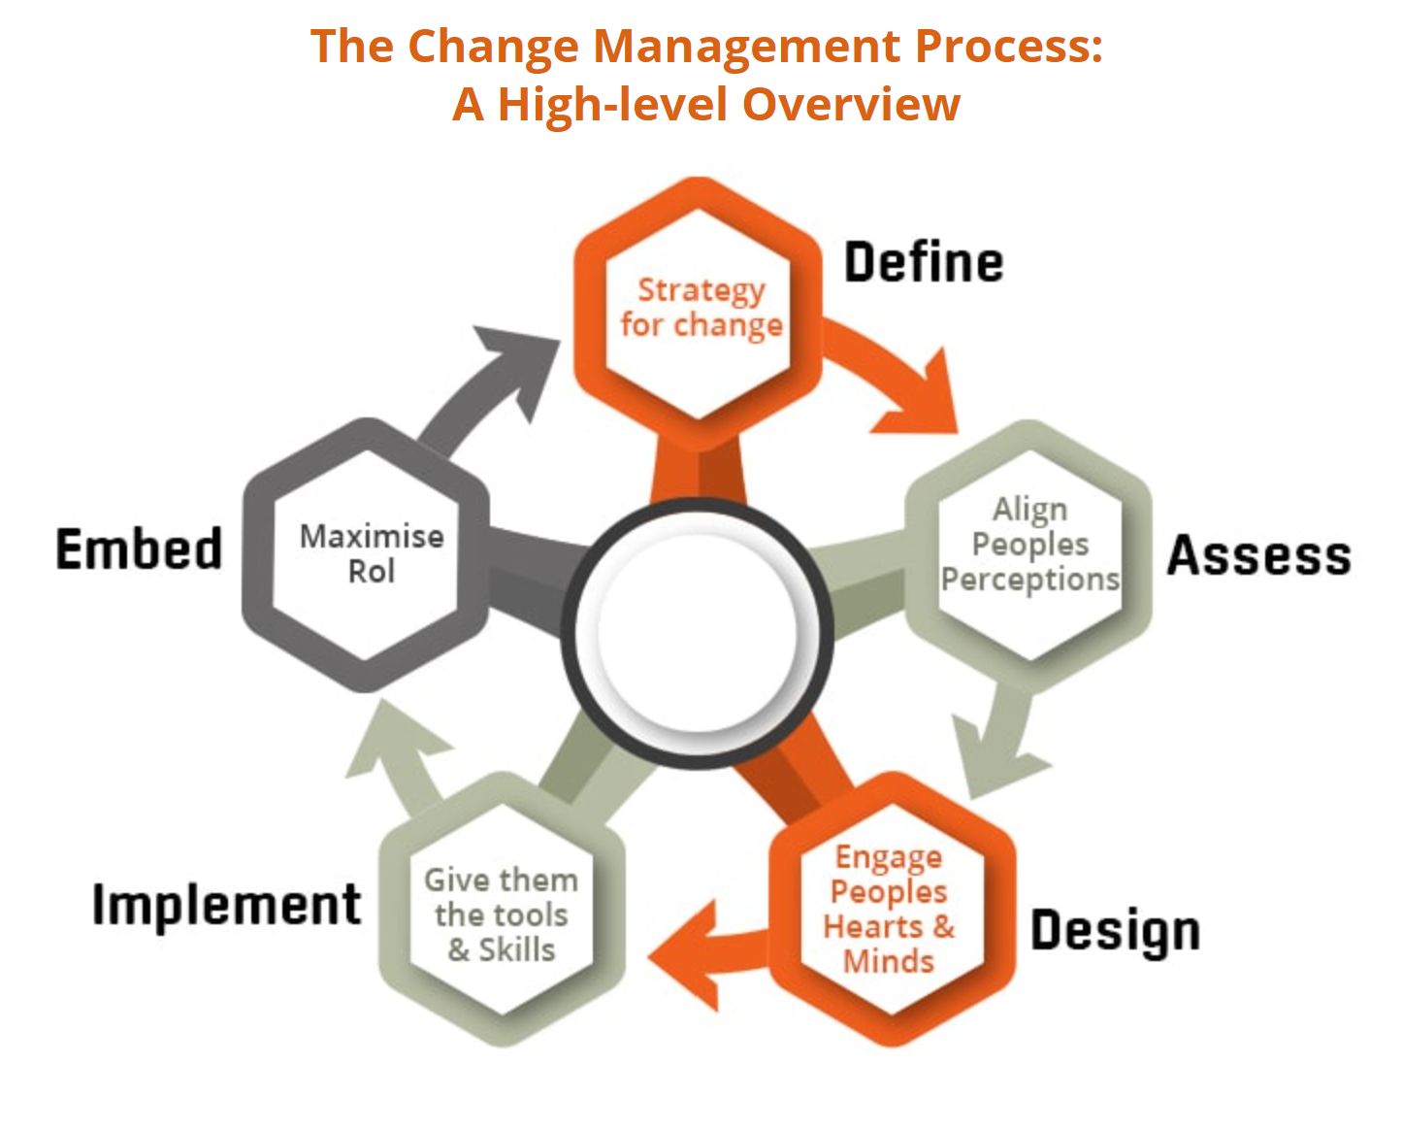
A guide for a Change Management plan. Sourced from (Lock, 2021).
Template for the change initiative plan.
Define – Existing Greggs policies and how they can link to a new change initiative plan. Define what will be the actual focus of the change initiative plan.
Assess – Current Greggs sustainability levels within the organisation. Linking in methods of improvement. Or goals to achieve higher targets of the same policy.
Design – A plan of action for using existing sustainability policies, in turn with reinforcing those methods, as well as implementing new methods. Who is doing what? When will it happen? How will it happen?
Implement – From designing a new change initiative plan, comes the actual implementation of the plan. Implementing the plan which will be the focus going forward for Greggs. Who is doing what? When will it happen? How will it happen?
Embed – The new plan becomes embedded within the organisation, providing levels of success can be met by the plan, with the approval of the organisation.

