

LOCATION: Swansea | LLEOLIAD: abertawe
LEVEL 5 | LEFEL 5
Mock EXAMINATION PERIOD | FFUG CYFNOD ARHOLIADAU
April 2023 | Ebrill 2023

MODULE CODE:
ACMA5012: Environmental Engineering and Sustainable Energy
TIME: 2 HOURS

answer all four QUESTIONS

Equipment or materials required – None
Adnoddau neu ddefnyddiau sydd eu hangen – Dim

QUESTION 1

1.1 Define sustainable development and sustainability.
(5 MARKS)
1.2 Define sustainable energy.
(5 MARKS)
1.3 Describe the energy transition that is currently underway, providing a comprehensive list and summary of the main features of fossil fuel based energy sources and renewable / environmental energy sources.
(15 MARKS)

QUESTION 2

2.1 Define and explain the law of demand and supply.
(5 MARKS)

2.2 Apply these laws to the supply of energy in the UK.
(5 MARKS)

2.3 What are the barriers to deployment of renewable energy sources? Describe the policy and market economic instruments that can support deployment of renewable energy sources.
(15 MARKS)

QUESTION 3

3.1 What is photovoltaic power?
(5 MARKS)
3.2 How is electricity generated in a PV cell? Provide a circuit diagram and explain the key components. Detail the equation to calculate current generation.
(10 MARKS)
3.3 Describe the key characteristics of the table below and provide an explanation for the changes in deployment illustrated.
(10 MARKS)

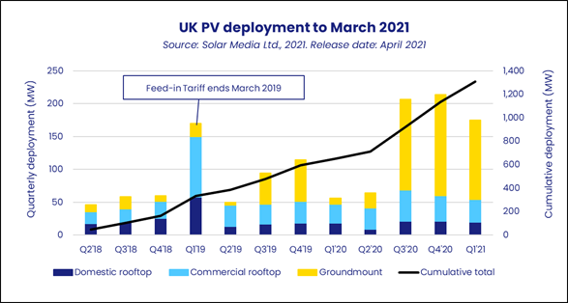

QUESTION 4

4.1 What is hydropower? What are the main characteristics of hydropower?
(5 MARKS)
4.2 What is the equation for assessing hydropower potential? How is water resource measured?
(5 MARKS)
4.3 Describe the positive and negative impacts of large scale hydropower using a specific installation as your case study.
(15 MARKS)

