To discuss the historical developments of street art and graffiti, with the focus on Banksy and other artist, which influence my own practice.

Name: Heather Louise Dumbleton.

Course: BA Fine Art: Studio, Site and Context.

ID Number: P143037.

Word Count: 5246

Dissertation Supervisor: Mrs Gwenllian Beynon.
To discuss the historical developments of street art and graffiti, with the focus on Banksy and other artist, which influence my own practice.
For my dissertation I have decided to research and evaluate several aspects of street art and graffiti. I will also research and evaluate aspects of art movements such as surrealism, pop-art and abstract art as a development of history within graffiti and street art. I am going to discuss artist that have influenced my own practice such as: Banksy, Jean–Michel Basquiat, Nelio, Elian, Nychos and other artist in which some of these artist have collaborated with. I am also going to write about their art work, techniques and their influences. I intend to discuss some of the aspects of history on graffiti and street art. I am also going to argue and challenge the beginnings of street art and where the involvement of street art has become such an influence to art and artist within the history of art movements in the twentieth century. Throughout this dissertation I will evaluate and discuss these artists work but I will be going deeper within discussing Banksy as he influences my own practice. I will have researched this by looking and using quotes from books, journals, videos and online resources which will show evidence and suggestions of my findings of street art as research material and to help me develop a greater understanding of the subject area in which I have chosen.
My first question to answer would be, what is exactly street art and graffiti? Graffiti is an art from that artist use to draw, mark or tag by mainly using spray paint, stencils and other techniques onto buildings, walls and anywhere they can so the public and other artist can view the art as well. Another term for Graffiti used by the public is, vandalism but that does not mean it is not seen as an art form. Graffiti and Street art are really ‘closely related and there is a great deal of crossover between the genres.’ (Jill. C: 2016) which suggest that street art and graffiti have links between them and that they are more or less very similar. This indicates that sometimes it is hard to recognise the difference between what is street art and what is graffiti. Graffiti and Street art both have similarities and differences, they both suggest the same meaning and sometimes the same expressions, but some people indicate that they are not the same thing and are completely different meanings, ‘the terms ‘street art’ and ‘graffiti’ as having two different connotation.’ (UK essays: 2015) this quote indicates that there is a separation of ideas between the two art movements.
‘Both are subversive art movements where work is displayed in public rather than a gallery setting. While graffiti artist place their work in public, generally speaking they are not interested in the public understanding their work; they want to speak to other graffiti artist. Street artist want everyone to view and be engaged by their work. They are trying to make a statement.’ (Jill. C: 2016)
Jill. C (2016) suggest that graffiti artist and street artist are different in the way they want to pursue their work and who they really want to communicate and associate with. Showing that street artist want to make ‘statements’ and graffiti artist want to connect with other artist. ‘Street art is a reaction.’ (Tapies, Pethick and Radford- Earle: 2016: 7) this suggest that street art is trying to make a statement and trying to retrieve a reaction from the viewer, whoever they may be. This also shows that it is why graffiti and street art are very similar in the way they work. Both art forms make statements in what they create within their artwork and communicate with the public as it is out there for anyone to see, therefore making the audience the public.

Chapter 1. The beginnings of Spray Paint, Graffiti and Street Art.

The beginning of my research is of the history and development of street art, graffiti and spray painting, I will also discuss the spray paint can itself and where it all begun. Did it start from cave paintings? The very first known findings of art on walls which is now known as graffiti and street art was from the Stone Age, ‘On the Indonesian island of Sulawesi we can still see the oldest recorded figurative cave painting from 39,900 BCE.’ (Luong and Pocked: 2016: 12), this implies that art on walls existed way before graffiti and street art was established.
So when did it really start? I would suggest it started in the Stone Age as drawings appeared on walls in caves around the world showing a deeper meaning such as a connections or voice towards other species, ‘It is assumed that the works were left to communicate to other ‘nomads’ through the use of storytelling, though of course our knowledge of social interaction and interpretative capacities remains inarguably limited.’ (Luong and Pocked: 2016: 12) and ‘the potential of the wall as an expression of self and its relationship with the other.’ (Walsh: 1996: 3). These two quotes above are a great demonstration of what Graffiti is all about and what graffiti is aiming towards. To let the other people see and understand what the artist is trying to tell them throughout the expression of their artworks.
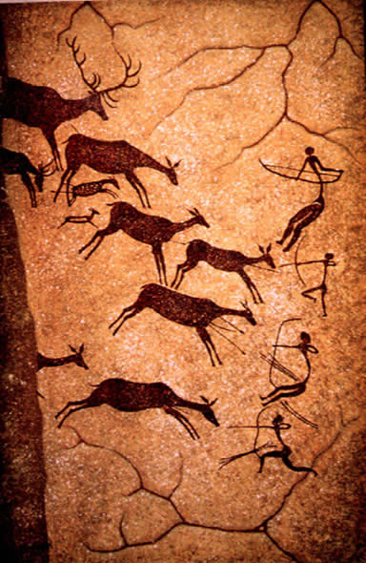
(Admin, 2008) Above is an example of a cave painting.
During my research I have come across many different types of shifts within Graffiti and Street art, such as paintings from the Stone Age to finding out that there were a variety of different forms of wall art within different eras. An example of this is in Ancient Egyptian, ‘Ancient Egyptians using visual art with a quite specific intent and purpose. Paintings, hieroglyphics and sculptors adorned public structures.’ (Luong and Pocked: 2016: 13). This shows that art on walls or drawing on the wall was a traditional for ancient Egyptians and without our ancestors knowledge this would soon turn into a dramatic movement or evaluation within the artistic world. Even Greeks and Romans had a part in using art directly onto walls ‘Greeks and Romans also invented the fresco technique….concentrated outburst of muralism during the Italian Renaissance.’ (Luong and Pocked: 2016: 13). From this early beginning it gives a sense of how deep and far back graffiti, street art, murals and art on walls has developed from and how advanced this form of art has become.
An important part of my research has lead me to discover and discuss the creation of the spray paint can and where the idea of the spray paint can came from. It all began in 1949 with a person called Ed Seymour, who was the ‘founder of Seymour of Sycamore and the inverter of the aerosol paint.’ (Seymour of Sycamore: 2017). Seymour was contemplating on ‘an easy way to demonstrate his aluminium coating for painting radiators. His wife suggested a makeshift spray gun, like those used for deodorizers’ (Greenham and Rubinstein: 2011). This shows that spray painting was not made for the consumption of art but of the use of painting quickly and easily to help tradesmen to do a job a lot easier than it would for them normally. ‘Ed Seymour combined paint with existing aerosol technology, creating the world’s first spray paint can.’ (Zimmer: 2017: 6) This suggest the way he made the spray paint can and that he was the first person to make this ingenious creation. He place’s the paint within, with just a few simple tools such as aerosol can and paint. It also indicates that the intention of spray painting was a totally different outcome to what it was meant to be used for, as for Graffiti is still an illegal act. It seems from one person’s idea a whole new invention is made.

(Seymour of Sycamore: 2017)
Spray paint cans became very popular product and developed quickly within industries ‘so popular that Seymour of Sycamore began customizing its own manufacturing equipment and eventually expanded into a new business’ (Greenham and Rubinstein: 2011) which then changed the way people used spray paint not just for radiators but larger objects such cars, vans and even for furniture. ‘The increasing availability of spray paint from brands such as Seymour, Krylon and Rust-Oleum gradually began to gain the attention of artist’ (Zimmer:2017: 6) the production of spray paint made it into the art world, where artist seemed to take an advantage of the new product, creating a beginning of Street Art and Graffiti movement.
‘While it is impossible to determine the first student or activist to aim an aerosol paint can at cardboard or buildings…who took advantage of the technology to make their tags well known in the ‘60s and ‘70s.’ (Moser: 2011)
This set out a new rebellion of art and the way artist captured their audience by using tags and creating a new way of advertising themselves out in the public domain. It is a great material to use on walls and outside in any weather, as it dried quickly and could be used on any surface which would be hard for a pencil, pen or even acrylic paint to absorbed onto, this is suggested by Greenham and Rubinstein (2011),
‘It worked well on building material and subway cars. More important, perhaps, the imprecise application lent it an inherent disregard. Its inability to be perfectly controlled also made it an apt metaphor for rebellion.’ (Greenham and Rubinstein: 2011).
The establishment of spray paint and graffiti has inspired many artist to experiment and explore the new material as a new art tool, however, other inventions of spray paint mechanisms were alive before the spray paint can, ‘Industrial pressurized paint guns had been used previously by artist such as Paul Klee and Man Ray’ (Zimmer: 2017: 7), this quote suggest that there were other products which used a similar method but not as easy to use as a spray paint can would be. Pal Klee and Man Ray are both very well-known artist who both worked in different art movements within the nineteenth century. Klee was a painter and Ray was mainly know for photographs and creating unique photographs and creating a new production of photographs called ‘Rayographs’. (Man Ray: no date)
As spray painting was making a new revolution for encouraging the artist to be out there in the world where the public are and rebel against all sorts of political and newly found domains. Another source which Danysz (2016) states is that ‘Modern graffiti seems to have begun around 1942, during the second world war’ (Danysz: 2016: 11) Danysz (2016) indicates that ‘Kilroy’ was written by a factory worker on products made within the factory while it was moving on a conveyer belt, mainly on helmets which were to go out to solders, this led to other influences such as solders to start writing graffiti, ‘Solders begin to write “Kilroy was here” everywhere, and especially on walls.’ (Danysz: 2016: 11) which led to a small movement for the art of graffiti.
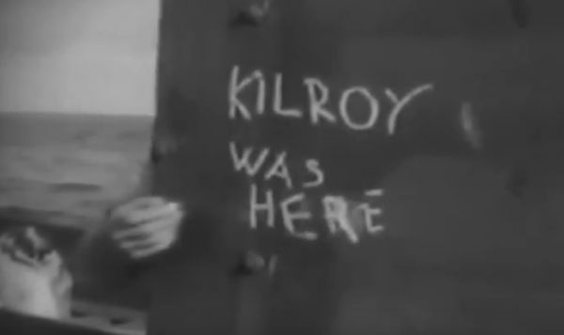
(Danysz: 2016: 12)
However, some argue that graffiti was developed at a later date. According to Gerardo (2015) ‘the history of spray paint art began officially around 1982 with Ruben Sadot Hernandez in the City of Mexico.’(Gerardo: 2015) this quote indicates that Ruben Sadot Hernandez was one of the first to use spray paint as a media and material for his art work in Mexico, he makes his art in the streets on paper while watching the world pass by. Him and many other artist such as Ricardo Huet, Rafael Martinez, Gerardo Amor and Cecilia Banos had similar attractions to spray painting and Hernandez ‘shared his ideas’ (Gerardo: 2015) with those other influenced artists. Ruben Sadott Hernandez was an inspiration to other artists he was a ‘man who had started an art movement’ (Robinson: 2014). Graffiti was this ‘new’ movement to many artist and it is was developing very quickly, ‘by 1986, more had joined the movement…in 1988 the technique had matured’ (Gerardo: 2015). These two sources argue that the beginnings of graffiti and street art developed on a much later date, than what the other resources have suggested to me.
Moreover, my research shows that spray painting was created and endured into an art movement way before the 1980’s but the origin of graffiti did seem to raise high within the 1970’s and 80’s and has been called modern graffiti. ‘Modern graffiti began in the big cities in the United States in the 1970’s. In New work, young people wrote their names, or ‘tags’, in open on walls around the city’ (Newton: no date). ‘New York in the 1970’s and 1980’s, the graffiti movement and spray paint flourished because of one another’ (Zimmer: 2017: 6) This shows that there was a revolution within the spray painting world and also inspired a lot of other genres such as ‘punk rock and hip hop’ (Zimmer: 2017: 6). In another sense other contemporary writers seem to find it hard to date back to the actual date or time that graffiti was created. For example ‘it is difficult to date the precision the appearance of a practice that some reduce to marking on the wall’ (Danysz: 2016: 13) showing a concept of different findings to prove where graffiti and street art really began has become a task in itself, not just for my own dissertation but for other writers as well.
A great example of graffiti is the Berlin Wall, which is one of the most creative and inspirational places for a graffiti and street artists. The Berlin wall was built to separate the,
‘East from the West in 1961. Nobody on the East side of the wall was allowed to approach it. In the West, on the other hand artist decided to use it to express themselves.’ (Danysz: 2016: 96)
As I have visited and seen the Berlin wall myself and I am aware of the effects the Berlin wall gives an artist like myself. The Berlin wall is a historical virtue within itself. Below is an image which I have taken of the Berlin wall during an educational visit to Berlin.
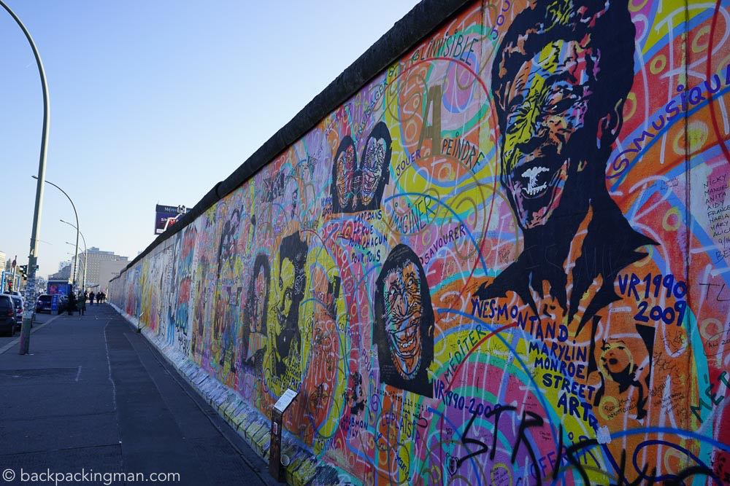
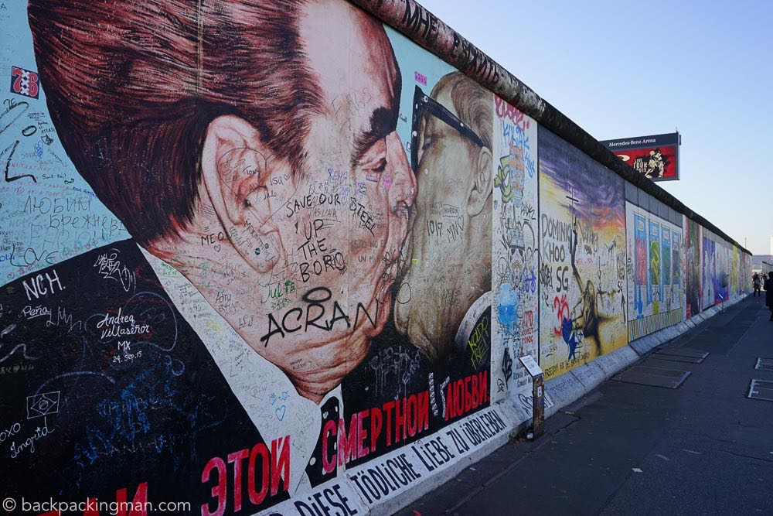
(Jonny: 2015)
Above are two photographs of The Berlin wall.
As my research developed I have discovered that graffiti and street art is produced and developed in many different cities all across the entire world, ‘Street art takes place in cities all over the world.’ (Young: 2016: 7) From New York to Valencia the cities filled with graffiti and street art has had a continuous development throughout the years and encourages different origins of spray painting. ‘San Francisco, New York, London, Bristol, Paris Tokyo, Sydney and Melbourne.’ (Young: 2016: 7) this quote gives us an indication that street art and graffiti is expressed all over the world. In Valencia, graffiti and street art is making its own shape and form around the city.
‘The architecture of Barrio del Carmen, the city’s historical centre, provides a backdrop for the city’s most creative artists to fuse cool colours and texture with pastel walls, and is a testimony to the creativity of the artists that gave it life.’ (Martin: 2007: 13)
This indicates that street art and graffiti are making an evolutional change around many different cities such as Valencia, which is also exploding with many types of street art.
Chapter 2. Abstract, Surrealism and Pop Art, Some Movements which have influence Graffiti and Street art.
Many centuries after these eras, new movements became involved within graffiti’s and street art influences. For example like ‘Dadaism, surrealism, constructivism and many more.’ (Luong and Pocked: 2016: 14). It states that these movements in the art world indicates that graffiti and street art has been influenced by the ideas of these movements in art for a long time just like many other art history developments within the centuries, I am going to explain this throughout my discussion on aspects of art movements.
The first movement I am going to talk about is the abstract movement in art which has had a major influence on graffiti and also shows the history development of graffiti and street art, during the abstract movement. Graffiti art was a new way people viewed, processed and developed their art. During the history and development of abstract art there has been a very inspirational changes within graffiti and street art, as there are many different processes of abstract art, such as Impressionism, Cubism, Expressionism and many more movements. The abstract movement became very popular for graffiti artist to explore and grow their ideas, it gave them the freedom to experiment with many different colours, shapes and brining their emotion to their art works. The abstract era seems to be ‘growing popularity of abstract art and/ or conceptual art’ (Rushmore: no date) this shows that it was a very dramatic change to the way people and artist saw art in the public domain, giving more of a memorising feel towards their street art. In many ways abstract suited graffiti and street art well as ‘the term ‘abstract’ in art refers to breaking away from depicting objects, from and figures’ (Graffitikings: 2017) which is what graffiti is all about, moving away from the ‘norm’ and separating the artist from the canvas, ‘conceptually, using spray paint puts a layer of removal between artist and canvas, the powerful force of spray paint meaning the artist never needed to actually touch the canvas.’ (Zimmer: 2017: 6) Danysz (2016) suggests that abstract art ‘was about breaking codes and pushing the limits of expression.’ (Danysz: 2016: 42) This quote by Danysz (2016) gives a great explanation of how Graffiti and street art ended up combining with the abstract movement. As for Graffiti and Street Art is there to get an artist expression out there within a public area for everyone to see.
This abstract movement which was during the twentieth century, also gives many diverse ideas and unique styles too many well know artist, such as a graffiti artist called Nelio. Nelio is a street artist who is ‘one of France’s leading post-graffiti artists’ (Parisian: 2014), which shows that abstract played a part within the graffiti movement during the twentieth century.
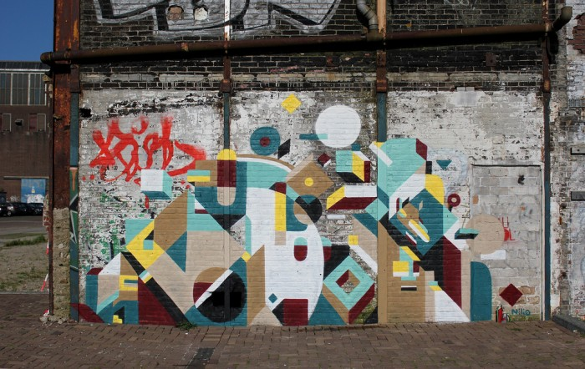
Nelio’s urban art (Nelio-Urban Art: no date)
Another artist called Elian who is from Argentina whose work is around the world including in New York and Berlin. ‘Elian has gained international acclaim for his works of bold geometric abstraction…he builds his piece through the precise placement of primary colour blocks.’ (Luong and Pocked: 2016: 37) This is indicating that this artist works with the elements of abstraction within his street art, by using the primary colours and techniques to accomplish his artwork.

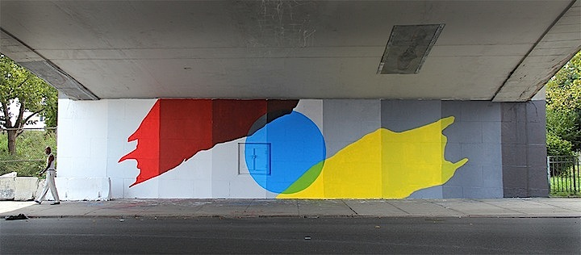Elian. Photo by artist, New York, 2013. (Luong and Pocked: 2016: 38 and 39)
Above is one of Elian’s Street art work in New York. He is very influenced by the abstract movement within a graffiti outcome. Simple shapes, primary colours and abstract forms show the influenced within his work. The brightness of the work is very eye catching and gives a good contrast of colours with the white wall it is decorating. It is eye catching especially as the rest of the street is plain and dull with its white and grey surroundings. It definitely captures you attention and distracts you from the plain and dullness of the surrounding area.
Surrealism is another movement in the art domain that has had an influence on graffiti and street art. Surrealism is an art movement which started around the 1920’s and was majorly influenced by the Dada movement.
Andre Breton who was a huge Surrealist artist and poet who lead groups of poets and artist within Paris defined Surrealism as a ‘psychic automatism in its pure state, by which one proposes to express verbally, in writing or by any other manner, the real function of thought.’ (Tate: no date). This suggest that Surrealism is an art form from an artist mind and is unlocked from the power of an artist imagination and the unconscious mind, which also gives an irrational revolution to the art form.
During the 1940’s ‘Brassai’s photographs of Graffiti’ (Walker: 2002: 32) was on a cover of a magazine article and ‘Brassai embarked on …photography of Parisian graffiti.’ (Walker: 2002: 155) these two quotes gives an example of an artist who worked with photographing Graffiti, it gives evidence that Graffiti has exceeded during the twentieth century. Brassai is an artist who works with photography during the surrealism movement during the 1900’s, Brassai is an artist from Hungarian. ‘Brassai is best known for his earlier photographs of Paris.’ (Troiano: 2016) this shows his art was photography based and that is what he is well known for. ‘For more than two decade from 1933-1956, Brassai documented carvings and etchings graffiti onto the walls of Paris’ (Troiano: 2016) However, ‘Surrealist credentials of Brassai’s graffiti photographs are more convincing.’ (Walker: 2002: 155) This give an intent that Brassai’s work was created within the Surrealism art movement and he was a Surrealist.
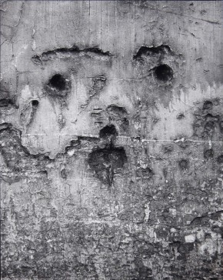
‘Brassai, from Graffiti Series III: ‘The Birth of the Face’, 1933-56.’ (Troiano: 2016)
‘It seems complex to describe surrealism as a purely artistic influence on street art today. The cultural movement was a revolutionary phenomenon that was widely celebrated since its manifested beginnings at the start of the twentieth century….Today information is easily accessible and visual influences can come from an endless variety of sources, with many muralists today quoted as having a strong interest in surrealist imagery.’ (Luong and Pocked: 2016: 49).
The quote by Luong and Pocked (2016) suggests that Surrealism has an influence on street art since the early 1900’s. To prove that this has as impact on artist, I have researched an artist called Nychos, he is an artist from Austria who creates gigantic murals and paints and explores the entrails of animals.
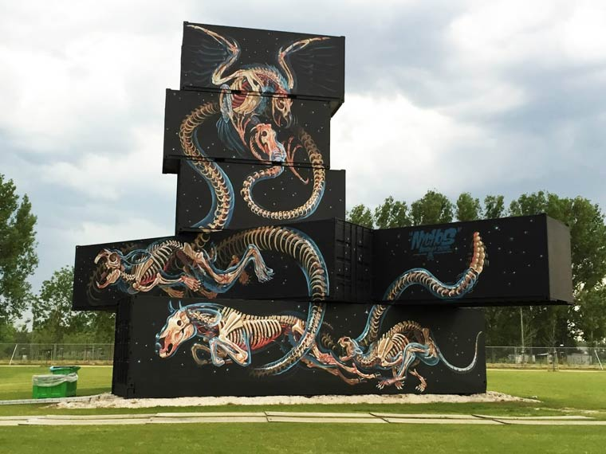
Nychos (2015) Waechter. (Luong and Pocked: 2016: 71)
I chose this image of Nychos work as it was very interesting to look at. It really captured my attention and the detail within his work is fascinating to explore and eye catching to the public. This huge piece of art work contrast well with the black, dark background and the vibrant image itself. He shows the mechanical structure of the entails of the animals he is displaying. The large scale gives depth of field within his work and definitely give a surreal feel to the work as it shows how he has this interest of the biology of animals and shows what he sees within his imagination, even though the images themselves are quite realistic. This image suggests that surrealism influenced this artist by the way the image is quite dreamlike while also softening and brightening the natural environment which it is surrounded by.
Through my research I have discovered that Pop Art was also a great influence within Graffiti and Street art. It wasn’t until around the 1950’s pop art was discovered and established. ‘Pop art started with the New York artists Andy Warhol’ (Tate: 2017). Andy Warhol is one of the most famous and influential artist during the Pop art era ‘Warhol was a key figure: his work represents one of art’s turning points, changing the role of the artist and his or her way of seeing and doing things’ (Cumming: 2005: 362). Andy Warhol is an American Pop Artist who worked on ‘the most immediately recognizable image of the Pop Art era’ (Bedaycre: 2006: 368) which was the famous Campbell’s soup tin and Marilyn Monroe screen prints.
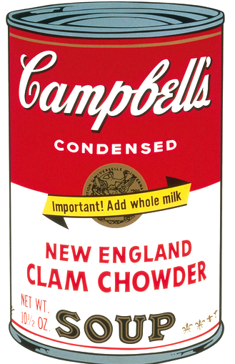
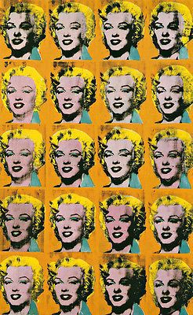

Andy Warhol (1968) Campbell’s Soup. Andy Warhol (1962) Twenty Marilyn’s. (Bedayce: 2006: 369) (Cumming: 2005: 362)
An artist who was influenced within the Pop Art era and by Andy Warhol, was another famous graffiti artist called, Jean-Michel Basquiat. Basquiat was a young self-taught artist and graffiti artist who worked and lived in New York. His work ‘powerfully reflected the obsessions and conflicts of his city and his decade.’ (Cumming: 2005: 398) which suggest that he worked with the political elements within his surrounding area in which he lived in and shows the effects in which his city caused him to feel. Basquiat was a very interesting artist within the art world with his paintings ‘he remains today as the world’s most recognizable black painter.’ (Johnston: 2008)
Jean-Mitchel Basquiat ‘has worked with Andy Warhol’ (unknown: Basquiat. Broom is real: unknown date). This suggest that he was influenced by Andy Warhol and the Pop Art movement. It also gives us an idea of what era his own work was developed from. ‘Both artist inspired each other with their vibrant colours, forms and passion in art.’ (Timetaler: 2013) they both influenced each other within their art work and began to work together, below is an image of one of their art works which they collaborated together.
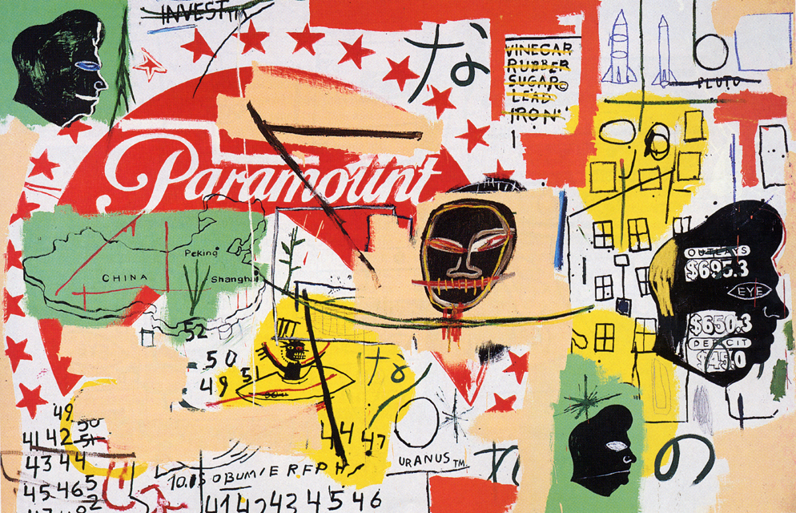
‘Andy Warhol and Jean-Michel Basquiat. Paramount (1984-85) mixed media.’ (Timetaler: 2013)
This piece by Warhol and Basquiat is a collage of their works pieced together to contrast against one another. The artwork is very eye catching to the viewer and gives a feel of child likeness within in its presentation. A carefree environment is captured within this piece and the vibrant colours clashing against the dark black figures and lines are making them stand out from the background, which I find amazingly interesting and is influential within my own practice.
Chapter 3. Banksy and My own practice.
‘Imagine a city where graffiti wasn’t illegal, a city where everybody could draw wherever they liked. Where every street was awash with a million colours and little phrases. Where standing at a bus stop was never boring…Imagine a city like that…’ (Banksy: 2006: 97).
This quote I chose to put into my dissertation is one of my favourite quotes by Banksy. I chose this because the way he describes the world as it is in his own mind, in some aspect I agree with what he states within this quote, however, many would disagree with it. As for some people still see graffiti and street art as ‘a rebellious way to damage private and public property.’ (Campos: 2010: 324) It is an illegal art from but on the other hand, Banksy seems to have changed that opinion by him being ‘arguably, the most influential, proactive and inspiring street artist in the world.’ (Tapies and Mathieson: 2016: 11)
Banksy is an anonymous graffiti artist who has influenced within my own practice. Banksy is from Bristol and ‘rose to international fame between the late 1900s and the present day.’ (Potter: 2017: 15) Banksy uses spray paint and his own designed stencils and his art is seen in many big cities such as Bristol, London and others around the world. Banksy’s work is very political based and goes against the grain and choses to address political issue within his own work.

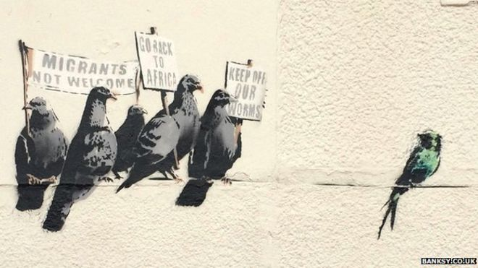
‘Banksy’s Aint-Imagration bird’s mural (2014)’ (BBC: 2014).
The image above really captured my attention politically and emotionally. It shows an aspect of Banksy political views on the world. It shows a deep meaning of ignorance and harshness within reality and in our day and age. The contrast of colour against the cream wall makes the image really stand out and is very eye catching. The meaning behind the spray paint stencil is very understanding and gives the viewer something to think about, such as how humanity is unkind, selfish and cruel to one another.
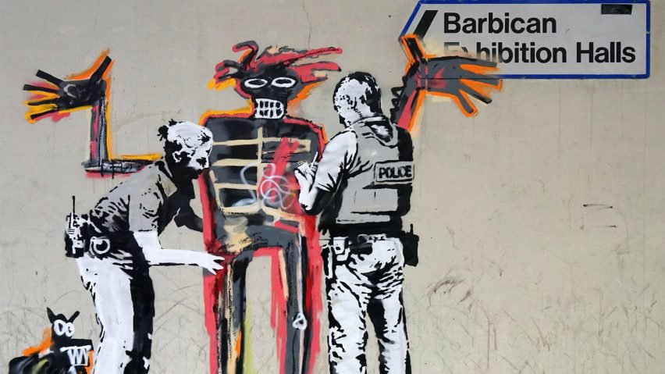
‘Banksy artworks appear on Barbican walls ahead of Jean-Michel Basquiat exhibition.’ (Morby: 2017)
During my research on Banksy I came across this art work above, I found it fascinating that two artist in which I have been researching have appear to merge together. As I am going to discuss this image, there is a huge contrast between the two artist art works. The black, white and grey stencil that Banksy has used on Basquiat’s painting fights against the colours of the piece. I like how Banksy has used a modern version of police to give an old and new feel to Basquiat’s art, a collaboration of two most influenced graffiti artists.
How does street art and Banksy influence my own practice? Wherever I seem to go there always seems to be some sort of graffiti or street art that catches my attention and makes me wonder what if it was my art work out there? I have travelled to many place such as Berlin and New York and street art seems to be wherever I am. At first I started experimenting with spray painting and how the spray paint layered on top of the other spray paint.

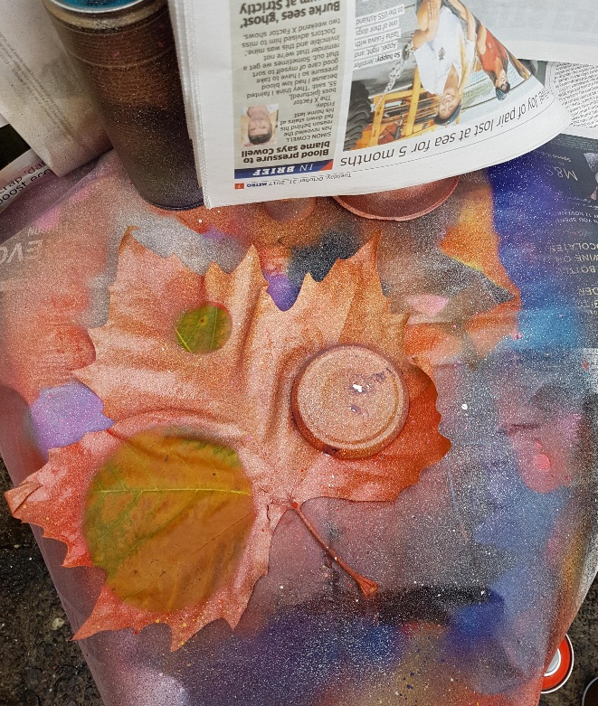
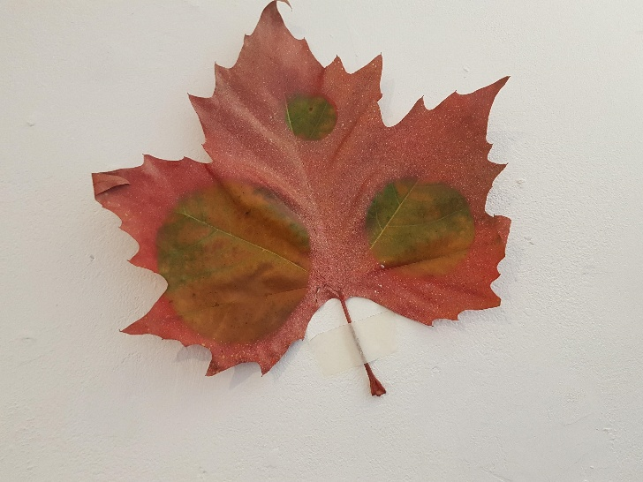
Above are two photographs of my own work. (Dumbleton: 2017)
I like the concept of stencil art and use it within my own practice. I use mainly round shapes to cover my painting and to spray paint around them, to create a three dimensional worlds, or worlds within worlds. I also use a lot of organic materials on which I spray paint onto, such as leaves. Stencil art and accidental art with spray paint is what I work with and many other mediums, I work with process more than just a finished outcome.
However, I first became aware of Banksy several years ago where he has been an influence to my own practice, I studied his work within my GCSE’s and now have come back to using his influence and I will hopefully develop and evolve my own practice using his influence and ideas.
My questions was to discuss the historical developments of street art and graffiti, with the influences and with the focus on Banksy and other artist, which influence my own practice. Throughout my research and development of my dissertation, it has showed me that there are many different ways of seeing street art and graffiti. My research suggest that graffiti has always been there just in many different forms and techniques. I have concluded that street art and graffiti are both similar and different by the way the street artist or graffiti artist wants to pursue their work. It’s also gave me a deeper insight on the history of street art, graffiti and the spray paint can.
The historical development of street art and graffiti have been greatly influenced from the Stone Age to art movements like Pop Art and Surrealism, all through the ages to the present day, for it has created a form of communications, statements and a connection to the entire world. Street art and graffiti have grown and developed through the different ages from cave paintings, ancient Egypt the twentieth century to the present day spray paint and stencil, which display unique forms and techniques. It is still seen as an illegal act in some cites but now it is more recognised as an art form which is Street art, with reflecting the influences of Surrealism, Pop art and stencil art. Street art is this ongoing process which is exciting, expressive and reflective of the artist thoughts, skills and techniques such as Banksy and Jean-Mitchel Basquiat. I greatly admire their thought provoking ideas they cast out into the streets.
My enjoyment and influence of Banksy has involved my own practice greatly, by Banksy thought provoking work and imagination, which has encouraged me to go beyond my own boundaries and beliefs with my own techniques and within my practice. While the awareness of my concepts behind my art which is the study of worlds within worlds on materials in which are organic and free.
Bibliography:
Books:
Banksy. (2006) Banksy. Wall and Piece. London: Century.
Bedaycre, C., Holubizky, I., Kelly, Dr J., Kerrigan, M., Mackay, Dr J., Martar, W., Middlemost, T., Robinson, M. and Zaczek, I. (2006). A Brief History of Art. London: Flame Tree Publishing.
Compost, C. (2010) 1000 Ideas for Graffiti and Street Art. Murals, tags and more from artist around the world. United States of America: Rockport Publisher.
Cumming, R. (2005) Art A Visual History. London: Dorling Kindersley Limited.
Danysz, M. (2016) A Street Art Anthology. France: Prompress Editions.
Luong, E., Poucke B. (2016) Street Art/ Today. Tielt: Uitgeverij Lannoo.
Martin, L. and Davis, J. (ed) (2009) Textura. Valencia Street Art. New York: Mark Batty Publisher.
Pears, R. and Shields, G. (2016) Cite Them Right. The Essential Referencing Guide. 10th edn. London: Palgrave.
Potter, P., Crutchley, L. and Shove, G. (ed). (2017) Banksy. You Are An Acceptable Level Of Threat. 6th edn. London: Carpet Bombing Culture.
Tapies, X. and Mathieson, E. (2016) Street Artist 2. The Complete Guide. London: Graffito Books Ltd.
Tapies. X., Pethick, S. and Radford-Earle, L. (eds) (2016) Where’s Banksy? London: Graffito Books Ltd.
Walker, I. (2002) City Gorged With Dreams. Surrealism and Documentary Photography in Interwar Paris. Manchester: Manchester University Press.
Walsh, M. (1996) Graffito. Berkeley, California: North Atlantic Books.
Young, A. (2016) Street Art World. London: Reaktin Books Ltd.
Zimmer, L. (2017) the Art of Spray Paint. Inspirations and Techniques from Masters of Aerosol. Massachusetts USA: Rockport Publishers.
Internet Resources:
Basquiat, Boom for Real. (2017) Available at: https://www.barbican.org.uk/ (Accessed: 10 November 2017)
Gerardo, A. (2015) Spray Paint Art Originator. Available at: http://gerardoamor.com/history/ (Accessed: 13 October 2017).
Graffiti kings. (2017 Abstract-Style Street Art: 7 Amazing Artists. Available at: http://graffitikings.co.uk/ (Accessed: 1 December 2017).
Greenbaum, H. and Rubinstein, D. (2011) Available at: https://www.nytimes.com (Accessed: 9 September 2017).
Jill, C. (2016) the Difference between Street Art and Graffiti. Available at: https://schriftfarbe.com/ (Accessed: 21 September 2017).
Man Ray. (no date) Available at: https://www.thearystory.org/artist-ray-man.htm (Accessed: 4 October 2017).
Moser, W. (2011) The Contentious Historical Origins of Spray Paint. Available at: http://www.chicagomag.com (Accesses: 3 December 2017).
Newton, R. (no date) Graffiti and Street Art – Level 1. Available at: http://learnenglishteens.britshcouncil.org/ (Accessed: 13 November 2017).
Robinson, G. (2014) Revolution in a can: spray-paint street artist. Available at: https://spraypaintartsecrets.com/ (Accessed: 3 July 2017).
Rushmore, RJ. (no date) Conceptual and Abstract Street Art. Available at: http://viralart.vandalog.com/ (Accessed: 22 November 2017).
Seymour. The Inventor of Aerosol Spray Paint. (2017) Available at: http://www.seymourpaint.com/ (Accessed: 16 August 2017).
TabooJivers (2011) Graffiti v. Post- Graffiti. Available at: https://taboojive.com/ (Accessed: 20 July 2017).
Tate (2017) Pop Art. Available at: http://www.tate.org.uk/ (Accessed: 14 November 2017)
Tate (no date) Surrealism. Available at: http://www.tate.org.uk/ (Accessed: 25 September 2017).
The Alternative Parisian (2014) Interview with French Abstract Graffiti Artist Nelio. Available at: http://undergroundparis.org/ (Accessed: 5 October 2017).
Timetaler. (2013) the Unfortunate Couple (1) – Andy Warhol and Jean-Mitchel Basquiat. Available at: http://thetimetaler.blogspot.co.uk (Accessed: 5 September 2017).
Troiano, C. (2016) ‘Graffiti’ photographs by Brassai. Available at: http://www.vam.ac.uk/ (Accessed: 17 October 2017).
UK Essay (2015) Is Street Art Really Art Essay. Available at: https://www.scanmyessay.com/ (Accessed: 13 August 2017).
Images:
Admin. (2008) Lascaux Cave Painting: The Prehistoric Sistine Chapel. Available at: https://www.oddee.com/ (Accessed: 3 August 2017).
BBC News. (2014) Banksy anti-immigration birds’ mural in Clacton-on-Sea destroyed. Available at: http://www.bbc.co.uk (Accessed: 2 November 2017).
Bedaycre, C., Holubizky, I., Kelly, Dr J., Kerrigan, M., Mackay, Dr J., Martar, W., Middlemost, T., Robinson, M. and Zaczek, I. (2006). A Brief History of Art. London: Flame Tree Publishing.
Cumming, R. (2005) Art A Visual History. London: Dorling Kindersley Limited.
Danysz, M. (2016) A Street Art Anthology. France: Prompress Editions.
Dumblemon, H. (2017) Stencil Art on Leaves. Swansea.
Jonny. (2015) Berlin Walls East Side Gallery Street Art. Available at: http://backpackingman.com/ (Accessed: 10 December 2017)
Luong, E., Poucke B. (2016) Street Art/ Today. Tielt: Uitgeverij Lannoo.
Morby, A. (2017) Banksy artworks appear on Barbican walls ahead of Jean-Mitchell Basquiat exhibition. Available at: http://www.dezeen.com (Accessed: 5 December 2017).
Nelio-Urban Art. (no date) Available at: http://blog.patternbank.com/ (Accessed: 8 December 2017).
Seymour. The Inventor of Aerosol Spray Paint. (2017) Available at: http://www.seymourpaint.com/ (Accessed: 16 August 2017).
Timetaler. (2013) the Unfortunate Couple (1) – Andy Warhol and Jean-Mitchel Basquiat. Available at: http://thetimetaler.blogspot.co.uk (Accessed: 5 September 2017).
Troiano, C. (2016) ‘Graffiti’ photographs by Brassai. Available at: http://www.vam.ac.uk/ (Accessed: 17 October 2017).
ProQuest Online Resources:
Johnston, C. (2008) Performing blackness at the heart of whiteness: The life and art of Jean-Mitchel Basquiat. Ann Arbor: ProQuest Dissertation and Theses.
Further Reading List:
Barlett, E., Rough, R., Pickard, P., Barton, R., Paolo, D., Warnham, H., Murphy, W., Lindquist, G. Frost, L., Longuet, N., Forge, S. and Mee, N (eds). (2017) Street Art. Discover Street Art in 140 Hotspots in 42 Cities worldwide. London, USA, Australia and Ireland: Lonely Planet Global Limited.
Bull, M. (2013) Banksy Location And Tours. Volume 1. 5th edn. Republic of Wilshire: Shellshock Publishing.
Butchhart, D., Nairne, E., and Johnson, L. (2017) Basquiat. Boom For Real. London: Prestel Publishing Ltd.
Chalfant, H. and Prigoff, J. (2009) Spray can Art. London: Thames and Hudson Ltd.
Clement, J. (2000) Widow Basquiat. A Memoir. Edinburgh: Payback Press.
Copper, M. and Chalfant, H. (1984/ 2003) Subway Art. London: Thames and Hudson.
Copper, M. and Sciorra, J. (1994) R.I.P New York Spray Can Memorials. London: Thames and Hudson.
Drew, B., Hart, E., Jenkins, D., Kenning, D., Till, C., Hatherley, O., Crook, P., Steedman, M. and Liverani, L. (2013) Reclaim The Mural. The Politics of London Murals. London: Whitechapel Gallery.
Emmerling, L. (no date) Basquiat. Germany: Taschen.
Fer, B. (1997) On Abstract Art. London: Yale University Press.
Hundertmark, C. (2003) the Art of Rebellion. World of Street Art. Cort Madera: Gingko Press Ltd.
Kenna, C. and Lobb, S. (1991) Mural Manual. 3rd edn. London: Greenwich Mural Workshop Ltd.
Leverton, M. (2011) Banksy. Myths and Legends. Great Britain: Carpet Bombing Culture. Manco, T. (2002) Stencil Graffiti. London: Thames and Hudson.
Manco, T. (2005) Street Logos. London: Thames and Hudson.
Maszynska, A. (1990) Abstract Art. London: Thames and Hudson.
McCormick, C., Schiller, M. and Schiller, S. (2015) Trespass. A History of Uncommission Urban Art. Germany: Tashen GmBH.
Potter, P., Jones, S. and Shove, G. (ed). (2011) Untitled. Street Art in the Counter Culture. Durham, UK: Pro-Actif Communications.
Rolston, B. (1991) Politics and Painting. Murals and Conflict in Northern Ireland. London: Associated University Presses, Inc.
Rothko, M. (1988) Mark Rothko’s Harvard Murals. Center for Conversation and Technical Studies. Cambridge, Massachusetts: Harvard University Art Museums.
Schacter, R. and Fekner, J. (2017) the World Atlas of Street Art and Graffiti. London: Aurum Press.
Videos:
Day, C. (2017) Saving Banksy. Available on: Netflix (Watched: 13 November 2017).
Tate, Media. (2008) Street Art Painting the City: London, Paris, Madrid. DVD Rom. (Watched: 15 November 2017).
Thompson, C. and Cagatay, A. (2012) How to Sell a Banksy. Available on: Netflix. (Watched: 14 November 2017).

