

Module Title: Entrepreneurship BMIH5001

Title of the Essay: Individual Business Model Canvas with Entrepreneurial Reflection using appropriate academic models.
Student Name: Mohammed Abdur Razzak
Student Id: 2215353
Lecturer Name: Ka Po Chong
Word Count: 2200

This essay uses the Business Model Canvas to develop and justify DelightDine Kitchen, a hospitality firm. The goal is to explain this concept's strategies. This article discusses the South Indian restaurant DelightDine Kitchen's strategy, value proposition, and competitive advantages. The BMC will structure idea parts and relationships. This study describes BMC's decision-making. The essay examines BMC segment strategies as they can ensure business success (Barringer and Ireland, 2018). A thorough analysis of DelightDine Kitchen's value proposition, client base, revenue streams, and other elements will reveal its business plan. The market feasibility of the proposed hospitality endeavour will be analysed using this analytical approach and current examples and industry sources.
South Indian restaurant named DelightDine Kitchen is the name of the new restaurant. This restaurant serves real South Indian food. South Indian dishes include Idli, Dosa, Sambar, Chutneys, and Filter Coffee (Nimri et al., 2021). In addition to the basics, DelightDine Kitchen serves spicy Dosas, Vada, Rasam, and Biryani. Fast food, takeaway, delivery and catering for all tastes are available at the restaurant. A traditional setting makes DelightDine Kitchen's eating experience authentic. The restaurant provides vegetarian, Tiffin, and South Indian. Thali Meals include regional delicacies and Indian sweets for variety (Similarweb.com, 2024). DelightDine Kitchen provides a complete and comprehensive culinary experience so every diner can enjoy a meal. DelightDine Kitchen, a top South Indian restaurant, describes its unique dining experience in this lengthy explanation.
Strategic partnerships help DelightDine Kitchen promote sustainability and community engagement. Like successful UK companies like Abel & Cole, the restaurant uses ethical and sustainable local suppliers. UK organic food delivery company Abel & Cole works with local farms to ensure product sustainability. Sustainable suppliers boost DelightDine Kitchen's environmental and local business efforts (Filimonau et al., 2020). Cultural and community groups work with DelightDine Kitchen. This resembles the successful UK National Theatre cultural partnership concept. Collaborations improve DelightDine Kitchen's community involvement (Burns, 2022). Collaborations with cultural institutions boost local arts and heritage, community image, and ethical and community-based competitiveness (Williams, 2021).
Genuine South Indian food is valued at DelightDine Kitchen. Restaurants prepare uniformly with regular chef training. Skills training improves staff performance and preserves cuisine. DelightDine Kitchen works with top UK suppliers. Riverford Organic Farmers sells organic food in the UK. DelightDine Kitchen and Riverford buy organic from local farms (Filimonau, Nghiem and Wang, 2021). DelightDine Kitchen uses local merchants for supply stability. This smart approach makes the restaurant more competitive and benefits local companies. Customers prefer food traceability and sustainability. DelightDine Kitchen stands apart from the competition by serving authentic, responsibly produced South Indian food from local vendors after this trend.
Like Michelin-starred UK restaurant The Ledbury, DelightDine Kitchen offers resources to make authentic South Indian food. Like The Ledbury, DelightDine Kitchen has talented South Indian cooks (Dabas, Sharma and Manaktola, 2021). Restaurant quality depends on cooking. Following Dishoom's UK immersive dining concept, DelightDine Kitchen seeks culturally aware workers. Dishoom creates a lively atmosphere, while DelightDine Kitchen serves authentic South Indian food. Strategic collaborations with local suppliers like Riverford Organic Farmers in the UK protect DelightDine Kitchen's resources (Panzone, Larcom and She, 2021). These partnerships give DelightDine Kitchen a fresh, authentic supply chain, improving its South Indian dining competitiveness.
For market diversity and sustainability, DelightDine Kitchen targets two client categories. The UK coffee chain Pret A Manger uses this method well. Pret A Manger serves a variety of food to locals and expats. South Indian expats seeking home cooking are DelightDine Kitchen's first customers (Nhamo, Dube and Chikodzi, 2020). Restaurants must serve authentic and traditional food to this group. South Indian food's great taste draws locals as second customers. A unique and immersive culinary experience draws residents to DelightDine Kitchen, like Pret A Manger. Their market advantage is targeting South Indian expats and natives to grow and sustain their clientele.
Dishoom, a UK restaurant chain that recreates Bombay cuisine, inspired DelightDine Kitchen's authentic South Indian food. DelightDine Kitchen capitalises on the desire for culturally enriching dining experiences by serving South Indian food. DelightDine Kitchen serves Dishoom-style South Indian food (Kim, Rahman and Bernard, 2020). To meet evolving dietary needs, UK vegetarian and vegan eatery Mildred's emphasises vegetarian alternatives. For a genuine experience, DelightDine Kitchen shows guests traditional cuisine and cooking methods. Authenticity and cultural diversity benefit hospitality.
Leading UK restaurant chains Wagamama and DelightDine Kitchen target varied customers with multi-channel marketing. Wagamama combines dine-in and online channels to increase accessibility. Guests wanting an immersive experience can dine at DelightDine Kitchen, like Wagamama's vibrant and communal dining rooms (Carter et al., 2020). Following the digital food-service trend, DelightDine Kitchen strategically uses online delivery and takeaway. This mirrors Deliveroo's success in helping restaurants grow. DelightDine Kitchen, like Deliveroo, collaborates with meal delivery aggregators to promote home-delivered South Indian dishes. DelightDine Kitchen competes by supplying varied consumer tastes and tracking hospitality trends via multiple channels.
The Ritz London inspired DelightDine Kitchen to prioritise service. The Ritz's personalised service makes stays memorable. To please clients, DelightDine Kitchen encourages personalisation and connection. DelightDine Kitchen's loyalty system resembles Costa Coffee's. Costa Coffee's loyalty programme values customers (Dube, Nhamo and Chikodzi, 2020). Our loyalty scheme at DelightDine Kitchen rewards frequent customers, increasing retention. Similar to Fortnum & Mason, DelightDine Kitchen connects with clients through South Indian cuisine's cultural relevance. Through cultural storytelling, Fortnum & Mason delivers customer's heritage and emotion. By providing a memorable dining experience, DelightDine Kitchen builds brand loyalty and a competitive edge in hospitality.
Strategic expenditures like Selfridges' quality and customer service affect DelightDine Kitchen's cost structure. DelightDine Kitchen, like Selfridges, invests much in worker salaries and ingredient procurement to provide an authentic South Indian dining experience. UK luxury hotels like The Dorchester teach personnel to maintain restaurant authenticity (Calinaud, Kokkranikal and Gebbels, 2020). Quality food and sustainability are important to DelightDine Kitchen and Whole Foods Market. Online and offline promotions are marketing costs like Marks & Spencer. We use traditional and digital marketing to promote DelightDine Kitchen and attract customers. Staff, ingredients, and marketing are intelligently allocated to give DelightDine Kitchen a competitive edge, following successful UK company models.
DelightDine Kitchen diversifies revenue like Harrods. DelightDine Kitchen, like Harrods, diversifies income for financial stability and market competitiveness. Dine-in sales are typical at DelightDine Kitchen and Harrods. This revenue stream targets interactive dining. Takeaway and delivery have helped UK restaurant chains like PizzaExpress meet demand for simple food (Zhao et al., 2021). DelightDine Kitchen hosts parties like Rhubarb. Success at the British Museum boosted South Indian culinary product sales. Diversifying revenue boosts DelightDine Kitchen's financial stability and competitiveness in the fast-paced hospitality business.
DelightDine Kitchen, a South Indian restaurant concept, follows UK hospitality trends and best practices. Critical analysis determines how these factors may affect concept success. South Indian food was prioritised for authenticity and variety (Chen, Riantama and Chen, 2020). Dishoom, a UK company that takes consumers to Bombay's lively streets, encourages this. Dishoom's success shows cultural eating is popular. By following this trend, DelightDine Kitchen targets a growing market. Customers seek ingredient traceability and quality, therefore authenticity and traditional preparation are emphasised. Model UK producer Riverford Organic Farmers is ethical and sustainable. DelightDine Kitchen attracts conscious clients with its social responsibility. South Indian expatriates and locals were key clients due to UK multiculturalism (Blackwell, 2011). Pret A Manger's UK success in serving locals and immigrants with a diverse menu supports this strategy. DelightDine Kitchen represents the diverse preferences of South Indian expatriates seeking familiarity and locals wanting to try new dishes, promoting market variety and sustainability.
South Indian food matches Dishoom's success and authenticity. Dishoom enriches eating with ethnic stories and tasty cuisine (Morkunas and Rudienė, 2020). To replicate this success and provide a superb dining experience, DelightDine Kitchen offers a cultural tour and dinner. Excellent Ritz London customer service inspired the personalised service and engagement concept. Like Costa Coffee in the UK, DelightDine Kitchen values customer loyalty. South Indian cuisine's cultural significance is stressed to connect with clients, like Fortnum & Mason's cultural storytelling. Successful UK eateries like Wagamama and PizzaExpress leverage online delivery and takeaway to attract clients (Freire and Gertner, 2020). Wagamama's lively dine-in and PizzaExpress's simple internet show this dual-channel strategy's success. A similar model makes DelightDine Kitchen more accessible and convenient. Harrods inspired the revenue diversification plan, which includes dine-in, takeaway, delivery, catering, and product sales. Harrods' multiple revenue streams ensure financial stability and competitiveness. A similar income diversification method allows DelightDine Kitchen to adapt to market shifts. Based on successful UK business models, pay, ingredient procurement, and marketing are prioritised. Luxury hotels like The Dorchester train authentic chefs (Barringer and Ireland, 2018). Whole Foods Market prioritises premium, sustainable products and quality ingredients. Marks & Spencer and other successful UK retailers raise awareness through traditional and digital platforms.
South Indian cooking restaurant DelightDine Kitchen caters to expats' and residents' tastes and follows UK hospitality trends. The cultural hub restaurant serves authentic Idli, Dosa, and Biryani with fast service, takeout, delivery, catering, and a traditional setting (Zhao et al., 2021). Business Model Canvas (BMC) assists crucial start-up decisions. Successful businesses like Dishoom stress authenticity and traditional cooking methods to fulfil the growing demand for immersive eating experiences. Pret A Manger-inspired targeting of two main clientele diversifies and sustains markets. Strategic connections with ethical and eco-friendly local suppliers like Riverford Organic Farmers develop socially responsible supply chains. The Ritz London and Costa Coffee are honest with their loyalty programmes and customised service. With a multi-channel customer reach, Wagamama and PizzaExpress boost convenience (Panzone, Larcom and She, 2021). Inspired by Harrods' success, income diversification includes dine-in, takeaway, delivery, catering, and product sales to strengthen finances. Staff training and premium items affect prices at luxury hotels like The Dorchester and Whole Foods Market.

In-class entrepreneurial and managerial tests, such as the GET2 Test and Entrepreneurial Questionnaire, help me to understand my entrepreneurial and managerial motives. Many questionnaires made me consider entrepreneurial and managerial issues. I may compare my business and managerial goals to my GET2 scores using the Gibbs reflective cycle (Jasper, 2013).
Several Entrepreneurial Questionnaire scenarios required substantial decisions. The best course of action for each circumstance required analysis. I was categorised as entrepreneurial using a questionnaire scoring algorithm. This technique showed my fearlessness, problem-solving, and strategic thinking in entrepreneurial circumstances (Weerakoon et al., 2019). These instances helped me assess my entrepreneurial, management, and decision-making styles. My real-world business skills were shown by the business questionnaire.
Answering the questionnaire validated me. I was confident in my company's future because my 41-point total score showed entrepreneurial traits. The figures verified my personality and decision-making style suit entrepreneurship (Panzone, Larcom and She, 2021). This gives me hope that I can overcome business hurdles and succeed in this competitive and challenging sector. It's nice that my intuition and proclivities match entrepreneurial success. My positive emotional response boosts my confidence to pursue entrepreneurial chances.
GET2 Test results validate my business practices. A 61% aggregate score indicates slight entrepreneurship bias. Browse the categories for my entrepreneurial ideas. My strong need for success, measured risk-taking, and locus of control scores indicate risk-taking, analysis, and control (Burns, 2022). These statistics show that theoretical entrepreneurship frameworks reflect my personality and entrepreneurial spirit. Evaluation helps me improve these skills and manage the entrepreneurial world by increasing my self-awareness.
GET2 and business Questionnaire responses match, reflecting my business style. These reviews demonstrate my qualities. It shows ambition, balanced risk-taking, and trust in personal control over external factors. This connection enhances evaluation reliability and validity, highlighting my entrepreneurial skills (Blackwell, 2011). My questionnaire and test results match, validating my business passion and entrepreneurial personality. This analytical method streamlines my entrepreneurial thinking, making future business decisions more thoughtful.
Lastly, this careful analysis reveals my entrepreneurial skills. The Entrepreneurial Questionnaire and GET2 Test confirm my entrepreneurial nature with high consistency. Theories, scenario-based reactions, and quantitative scores reveal an enterprising, strategic, and resilient person to tackle obstacles (Barringer and Ireland, 2018). This conclusion underpins my entrepreneurial journey, giving me confidence in my ability to identify business opportunities and seize and capitalise on them, guided by a deep understanding of my strengths and a systematic approach to overcoming hurdles.
This self-awareness-boosting introspection has helped me focus on my entrepreneurial skills. Because I appreciate advancement, I want to improve my entrepreneurial skills. Help from successful businesses will broaden my outlook and improve my strategy. I want to explore entrepreneurship prospects and apply my newfound knowledge to make excellent decisions and maximise results (Weerakoon et al., 2019). This self-awareness-based action plan helps me grow and succeed in competitive entrepreneurship. I wish to improve my entrepreneurial skills and grow personally and professionally through these activities.

References
Barringer, B.R. and Ireland, R.D. (2018). Entrepreneurship : Successfully Launching New Ventures. 4th ed. New York, Ny: Pearson.
Blackwell, E. (2011). How to Prepare a Business Plan. 5th ed. Kogan Page Publishers.
Burns, P. (2022). Entrepreneurship and Small Business : start-up, Growth and Maturity. 5th ed. Basingstoke (Gb): Palgrave Macmillan Education, Cop.
Calinaud, V., Kokkranikal, J. and Gebbels, M. (2020). Career Advancement for Women in the British Hospitality Industry: The Enabling Factors. Work, Employment and Society, [online] 35(4), p.095001702096720. doi:https://doi.org/10.1177/0950017020967208 [Accessed 30 Jan. 2024].
Carter, C.A., Pistiner, M., Wang, J. and Sharma, H.P. (2020). Food Allergy in Restaurants Work Group Report. The Journal of Allergy and Clinical Immunology: In Practice, 8(1), pp.70–74. doi:https://doi.org/10.1016/j.jaip.2019.09.013 [Accessed 1 Feb. 2024].
Chen, W.-K., Riantama, D. and Chen, L.-S. (2020). Using a Text Mining Approach to Hear Voices of Customers from Social Media toward the Fast-Food Restaurant Industry. Sustainability, 13(1), p.268. doi:https://doi.org/10.3390/su13010268 [Accessed 1 Feb. 2024].
Dabas, S., Sharma, S. and Manaktola, K. (2021). Adoption of digital marketing tools in independent businesses: experiences of restaurant entrepreneurs in India and the United Kingdom. Worldwide Hospitality and Tourism Themes, 13(2). doi:https://doi.org/10.1108/whatt-09-2020-0120 [Accessed 31 Jan. 2024].
Dube, K., Nhamo, G. and Chikodzi, D. (2020). COVID-19 cripples global restaurant and hospitality industry. Current Issues in Tourism, [online] 24(11), pp.1–4. doi:https://doi.org/10.1080/13683500.2020.1773416 [Accessed 29 Jan. 2024].
Filimonau, V., Nghiem, V.N. and Wang, L. (2021). Food waste management in ethnic food restaurants. International Journal of Hospitality Management, 92, p.102731. doi:https://doi.org/10.1016/j.ijhm.2020.102731 [Accessed 1 Feb. 2024].
Filimonau, V., Todorova, E., Mzembe, A., Sauer, L. and Yankholmes, A. (2020). A comparative study of food waste management in full service restaurants of the United Kingdom and the Netherlands. Journal of Cleaner Production, 258, p.120775. doi:https://doi.org/10.1016/j.jclepro.2020.120775 [Accessed 1 Feb. 2024].
Freire, J.R. and Gertner, R.K. (2020). The relevance of food for the development of a destination brand. Place Branding and Public Diplomacy. doi:https://doi.org/10.1057/s41254-020-00164-5 [Accessed 30 Jan. 2024].
Jasper, M. (2013). Beginning Reflective Practice. London: Cengage Learning.
Kim, Y., Rahman, I. and Bernard, S. (2020). Comparing online reviews of hyper-local restaurants using deductive content analysis. International Journal of Hospitality Management, 86, p.102445. doi:https://doi.org/10.1016/j.ijhm.2019.102445 [Accessed 1 Feb. 2024].
Morkunas, M. and Rudienė, E. (2020). The Impact of Social Servicescape Factors on Customers’ Satisfaction and Repurchase Intentions in Mid-Range Restaurants in Baltic States. Journal of Open Innovation: Technology, Market, and Complexity, 6(3), p.77. doi:https://doi.org/10.3390/joitmc6030077 [Accessed 29 Jan. 2024].
Nhamo, G., Dube, K. and Chikodzi, D. (2020). Restaurants and COVID-19: A Focus on Sustainability and Recovery Pathways. Counting the Cost of COVID-19 on the Global Tourism Industry, pp.205–224. doi:https://doi.org/10.1007/978-3-030-56231-1_9 [Accessed 1 Feb. 2024].
Nimri, R., Dharmesti, M., Arcodia, C. and Mahshi, R. (2021). UK consumers’ ethical beliefs towards dining at green restaurants: A qualitative evaluation. Journal of Hospitality and Tourism Management, [online] 48, pp.572–581. doi:https://doi.org/10.1016/j.jhtm.2021.08.017 [Accessed 30 Jan. 2024].
Panzone, L.A., Larcom, S. and She, P.-W. (2021). Estimating the impact of the first COVID-19 lockdown on UK food retailers and the restaurant sector. Global Food Security, 28(100495), p.100495. doi:https://doi.org/10.1016/j.gfs.2021.100495 [Accessed 1 Feb. 2024].
Similarweb.com (2024). Top Food & Drink Apps Ranking in United Kingdom on 30 January. [online] Similarweb.com. Available at: https://www.similarweb.com/top-apps/google/chile/food-drink/ [Accessed 29 Jan. 2024].
Weerakoon, C., McMurray, A.J., Rametse, N. and Arenius, P. (2019). Knowledge creation theory of entrepreneurial orientation in social enterprises. Journal of Small Business Management, 58(4), pp.834–870. doi:https://doi.org/10.1080/00472778.2019.1672709 [Accessed 28 Jan. 2024].
Williams, S. (2021). The Financial Times guide to business start up 2021/2023 : the most comprehensive guide for entrepreneurs. Harlow, England ; London ; New York: Pearson [Accessed 1 Feb. 2024].
Zhao, X., Lin, W., Cen, S., Zhu, H., Duan, M., Li, W. and Zhu, S. (2021). The online-to-offline (O2O) food delivery industry and its recent development in China. European Journal of Clinical Nutrition, [online] 75(2), pp.232–237. doi:https://doi.org/10.1038/s41430-020-00842-w [Accessed 2 Feb. 2024].

Appendix
BMC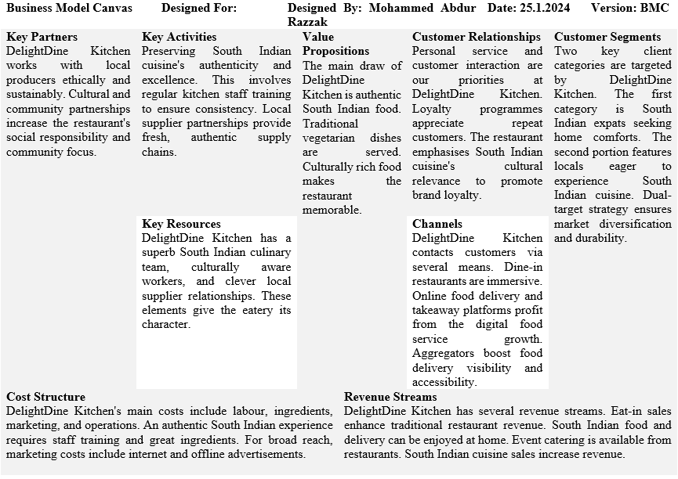

GET2 Results
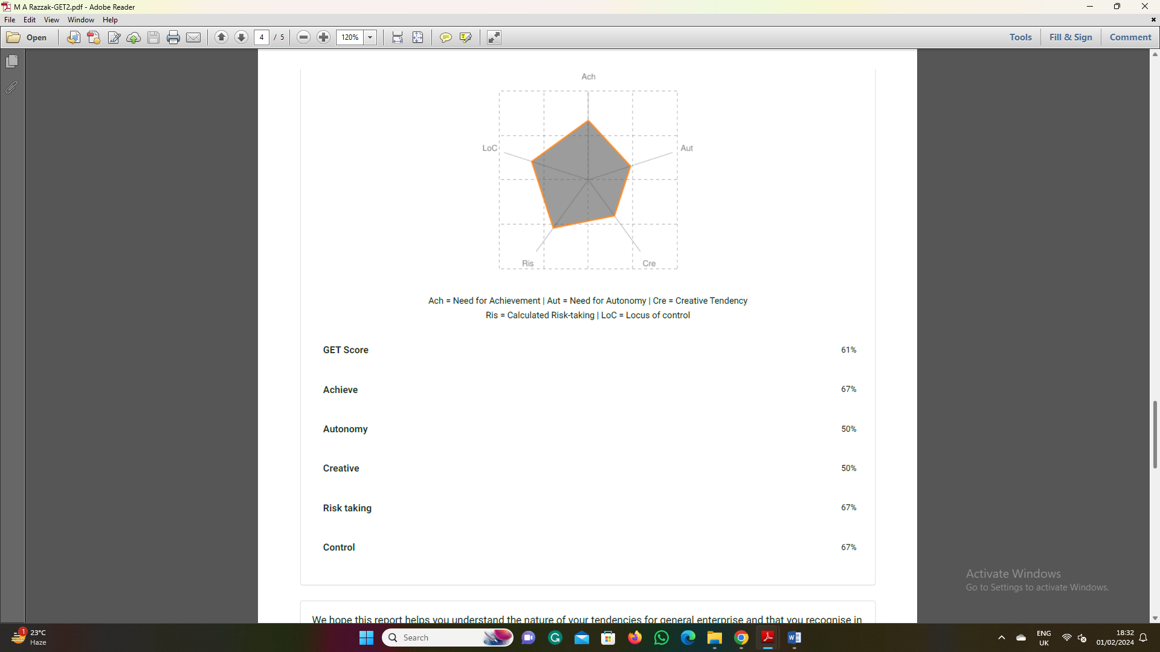

Entrepreneur questionnaire result


